Docker 201 - NodeJS & MongoDB Application

**Introduction:**

This is a simple web application build on NodeJS & MongoDB. The development environment of this application is containerized using docker technology.

**Steps to setup the project in local**

1. Download the code from <https://github.com/saseedharan88/docker-201>
2. Go into the main folder.
3. Run the following command to start the containers.
   1. docker-compose up -d
4. If any port issue, Kindly modify the port in **docker-compose.yml** file.

**Dockerfile**

**docker-compose.yml**

Docker Images:

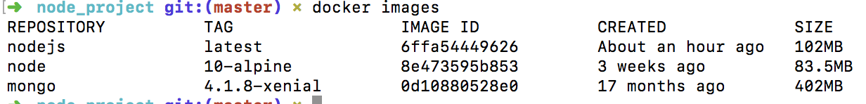

Docker containers:



Web application screen shots

