SUPERMARKET SALES ANALYSIS
Data Analytics Project
IBM SkillsBuild Data Analytics with AI Internship 2026
Prepared by: Sasethar Thirumal

Abstract
This project examines 500 supermarket sales transactions to turn raw transaction data into meaningful business insights. The analysis looks at product sales, branch performance, category performance, payment methods, customer-type spending, and customer ratings. Python is used to validate the data, calculate sales, summarize the results, and build visualizations. The findings are then converted into practical business decisions covering inventory planning, branch strategy, payment support, customer service, and membership offers.

Problem Statement
This project aims to study supermarket sales data and uncover useful insights about products, branches, categories, customers, payment methods, and ratings.

Objectives
- Load the supermarket sales dataset and review its structure.
- Detect missing, incorrect, or duplicate records.
- Verify the sales figures using Quantity × Unit Price.
- Summarize sales by product, branch, category, customer type, and payment method.
- Study customer ratings and average transaction values.
- Build visualizations that present the findings clearly.
- Turn the analytical findings into practical business decisions.

Dataset Description
The dataset holds 500 sales transactions across 13 fields: Invoice ID, Date, Branch, City, Customer Type, Gender, Product, Category, Quantity, Unit Price, Payment, Rating, and Sales.
Field | Type | Description
Invoice ID | Text | Unique ID for each transaction
Date | Date | Transaction date
Branch | Categorical | Store branch
City | Categorical | Branch city
Customer Type | Categorical | Member or Normal
Gender | Categorical | Customer gender
Product | Categorical | Product purchased
Category | Categorical | Product category
Quantity | Numeric | Units purchased
Unit Price | Numeric | Price per unit
Payment | Categorical | Payment method
Rating | Numeric | Customer rating on a 5-point scale
Sales | Numeric | Sales amount of the transaction

Methodology
- Data loading: Read the Excel/CSV dataset into Pandas.
- Data quality checks: Review the structure, missing values, duplicate rows, and data types.
- Sales validation: Compute Sales = Quantity × Unit Price and compare it against the Sales column provided.
- Aggregation: Group the transactions to obtain totals, counts, and averages.
- Visualization: Draw charts for product, branch, category, payment, customer type, and monthly performance.
- Interpretation: Turn the observations into insights and business recommendations.

Data Quality Results
The dataset has 500 rows and 13 columns. The checks showed no missing values and no duplicate rows. Sales were recalculated separately using Quantity × Unit Price, and the largest absolute difference was practically zero, which confirms the supplied Sales values are correct.

Key Analysis Results
Analysis | Result | Value
Highest-selling product | Cheese | ₹27,906.30
Best-performing branch | Branch C (Mumbai) | ₹72,469.45
Highest-selling category | Beverages | ₹56,108.24
Most-used payment method | UPI | 127 transactions
Average Member transaction | Member | ₹483.14
Average Normal transaction | Normal | ₹497.07
Average customer rating | All customers | 3.99 / 5

Visual Analysis
The project notebook produces visualizations for product-wise sales, branch-wise sales, category-wise sales, payment-method usage, average spending by customer type, and monthly sales trends. These charts make performance easier to compare and help explain the findings to business users.
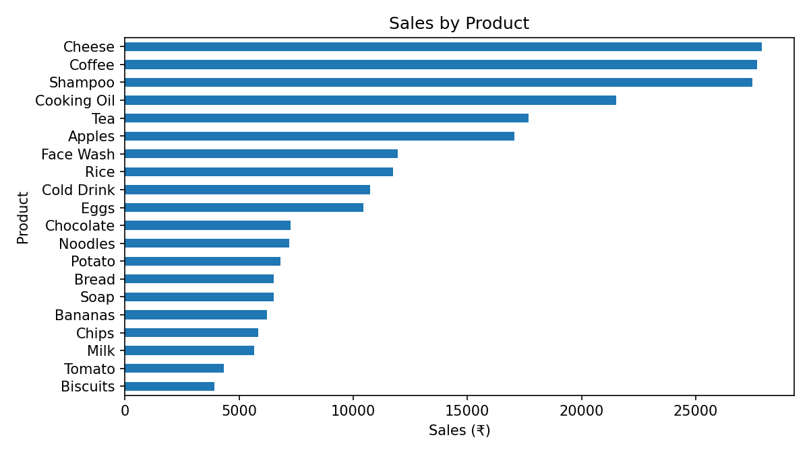
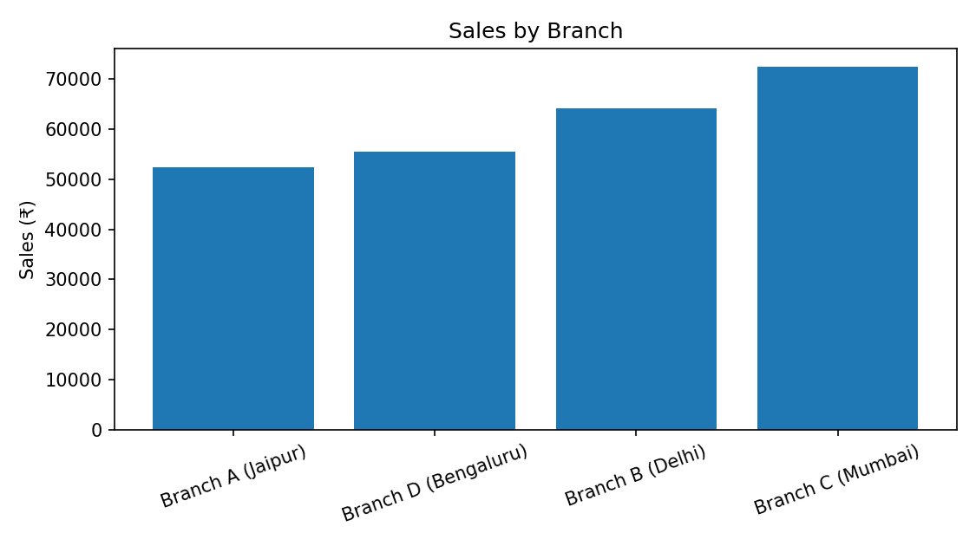

Business Insights
- Cheese is the top-selling product by total sales, which points to strong demand for it.
- Branch C in Mumbai records the highest total sales among all branches.
- Beverages is the top-selling category and deserves extra focus in inventory planning.
- UPI is the most commonly used payment method, so a dependable UPI payment experience matters.
- In this dataset, Normal customers spend slightly more per transaction on average than Members.
- An average customer rating of 3.99/5 indicates mostly positive feedback, with some room left to improve service.

Business Decisions and Recommendations
- Maintain enough stock of fast-selling products and categories to avoid stock-outs.
- Look into what drives Branch C's strong performance and find practices that other branches can adopt.
- Keep UPI as a main payment option while still offering other payment methods.
- Enhance customer service and the in-store experience to raise the average rating.
- Use customer spending patterns to design membership offers and customer-retention programs.

Technologies Used
- Python
- Pandas
- NumPy
- Matplotlib
- Seaborn
- Jupyter Notebook / Google Colab
- Excel/CSV

Project Files
- SasetharThirumal_SupermarketSalesAnalysis.ipynb — full project analysis code.
- requirements.txt — Python libraries needed to run the notebook.
- README.md — project overview, dataset link placeholder, technologies, and setup steps.
- SasetharThirumal_ProjectReport.docx — full project documentation.

Conclusion
This analysis shows how supermarket transaction data can be turned into simple, actionable business insights. The project highlights the best-performing products and branches, the top sales category, payment preferences, differences in customer spending, and overall customer satisfaction. These findings can guide inventory planning, branch-level strategy, payment operations, customer-service improvements, and membership planning.

Dataset Link
https://docs.google.com/spreadsheets/d/1mn7_O6PWUkqu0KLn9CqrIkbvAMjoLStTVt2aJXMdA_I/edit?usp=drivesdk

