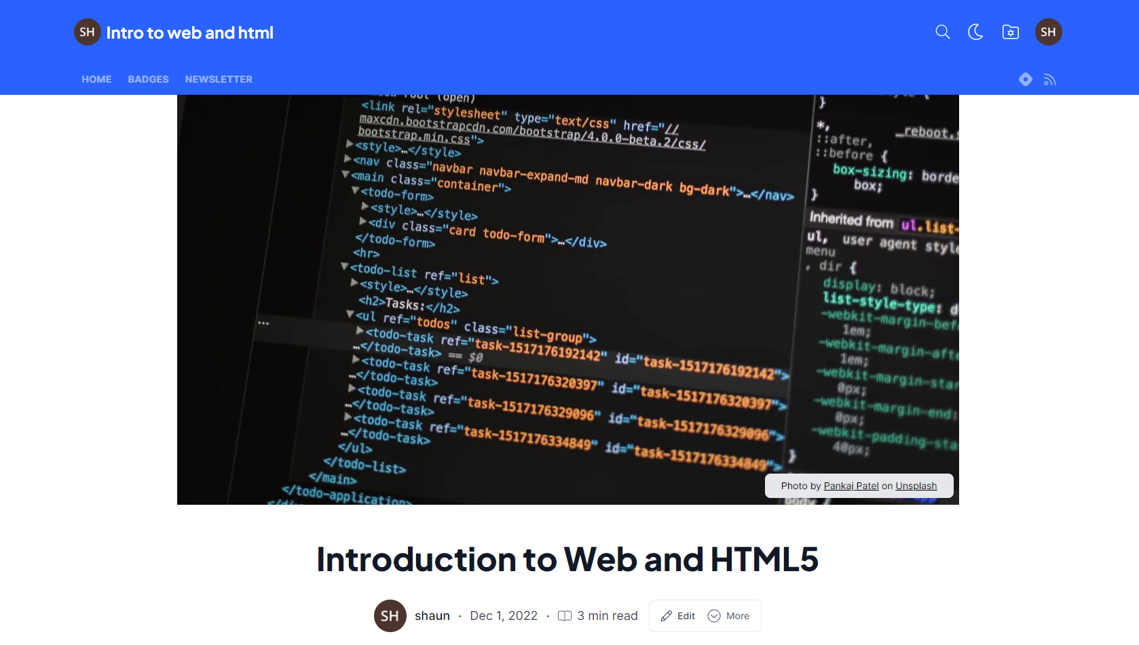

About me I am currently enrolled in a Javascript course with ineuron and we are learning about the web and html and here is what i have learnt and know so far.

Intro to web for the simple message sent at the birth of internet through Arpanet, the internet has grown dramatically. content creators and develops alike join to forge new internet thought graphics,text and images and so much more.

into to html html or hypertext markup language is the basic language like English for the web where we write or code web pages in our website . The first file or page to name or start your website is index.html. this page is what is recognize by web servers (just a small note Apache is most popular web server around.... Of course there are others) which basically serves (get and respond to queries for the web site) on web pages for people to view all around the world. To start 'coding' our first web page, we will used tags or elements in the index.html page but i will focus on just four tag. The first is the <!DOCTYPE html> which was first use on the internet for the web servers to recognize the type of document to render as there were many formats or documents on the web page. there are still others but we will focus on the html which in itself had many versions where version 5 is the latest one. Secondly, the head tag is where all the meta data is located that is data about data more on this later. when we need to create headings, we can use the h1 and h2, these are large fonts use to highlight the start of a section or paragraph. The p tag or paragraph tag is use to indicate the start and end of a paragraph.

slight Intro to IDE. We need to use an IDE or integrated developer editor. This could be as simple as notepad but hi we are developers so we use stuff like Atom and VS code. We will focus on VS code for this course because that's what the teacher is using (he said not to limit oneself to one editor as most can perform similar functions) and easier to follow along. This type of editor has a type on intellegence called emmet which allows to code faster with snippets of code with in the editor so much so that with a simple exclamation mark ! and tab, a basic html page with html, head and body tags is displayed in this editor. To learn about the h1, h2 and p tag, you simply just need to type the start of tag for example h1, press tab and emmet will automatically close the tag. additinally, there are extensions which basically extend the functions of this awesome editor(by the way you can in most other programming languages known to man such as c#, python,c++,php and so on). The main extension used in this class is live server which provides a preview of the code as soon as you save. The server can load a webpage on local host(that is your computer with ip address 127.0.0.1 alongside a port number:5050- dont worry about this for now). there as soon as your save your work the results can be seen in a web page or directly in VS code- it depends on which live server extensions you installed). that's all for now. thank you for reading.

**Subscribe to my newsletter**

Read articles from **Intro to web and html** directly inside your inbox. Subscribe to the newsletter, and don't miss out.

SUBSCRIBE

[#iwritecode #hiteshchoudary #html](https://quantumkid.hashnode.dev/tag/iwritecode-hiteshchoudary-html)

**WRITTEN BY**

[**shaun**](https://hashnode.com/@sasgaralli)

**Please note that I have also created this in hasdnode:**

[**https://quantumkid.hashnode.dev/introduction-to-web-and-html5**](https://quantumkid.hashnode.dev/introduction-to-web-and-html5)