Assignment 2: Analyzing and Implementing Divide-and-Conquer Algorithms

I Chen
Student ID: 00506167
MSCS532 — Algorithms and Data Structures
Assignment 2
October 31, 2026

Introduction
Divide-and-conquer is a fundamental algorithmic paradigm that breaks a problem into smaller subproblems, solves each recursively, and combines the results. This paper analyzes two classic divide-and-conquer sorting algorithms—Merge Sort and Quick Sort—by examining their theoretical time complexity, solving their recurrence relations through multiple methods, and comparing their practical performance on various input distributions.

1. Merge Sort

1.1 Problem Description and Key Steps
Merge Sort solves the problem of arranging elements in a sequence into non-decreasing order. It operates in three steps:
1. Divide: Split the array into two halves at the midpoint.
2. Conquer: Recursively sort each half.
3. Combine: Merge the two sorted halves into a single sorted array by comparing elements from each half and placing the smaller element first.

1.2 Time Complexity Analysis
Merge Sort divides the array in half at each level of recursion (log n levels) and performs O(n) work at each level to merge. This gives a consistent running time regardless of input order:
• Best case: Θ(n log n) — even when input is already sorted, the algorithm still divides and merges.
• Average case: Θ(n log n)
• Worst case: Θ(n log n)
Since the running time is Θ(n log n) in all cases, we can also state that it is O(n log n) (upper bound) and Ω(n log n) (lower bound). The space complexity is O(n) due to the auxiliary arrays created during merging.

1.3 Recurrence Relation
The recurrence relation for Merge Sort is:
T(n) = 2T(n/2) + Θ(n), with T(1) = Θ(1)

Substitution Method: We claim T(n) = O(n log n). Assume T(k) ≤ ck log k for all k < n. Then T(n) = 2T(n/2) + cn ≤ 2·c(n/2)·log(n/2) + cn = cn·log(n/2) + cn = cn·(log n − 1) + cn = cn·log n. This confirms T(n) ≤ cn log n, so T(n) = O(n log n).
Recursion-Tree Method: At level 0, the cost is cn. At level 1, there are two subproblems each of size n/2, totaling cn. At level i, there are 2^i subproblems each of size n/2^i, with total cost cn. The tree has log₂n levels, so the total cost is cn · log₂n = Θ(n log n).
Master Method: Using T(n) = aT(n/b) + f(n) with a = 2, b = 2, f(n) = Θ(n). We compute log_b(a) = log₂(2) = 1. Since f(n) = Θ(n^1) = Θ(n^(log_b a)), this is Case 2 of the Master Theorem: T(n) = Θ(n log n).

1.4 Practical Implications
Merge Sort's guaranteed O(n log n) performance makes it ideal for applications where worst-case predictability is critical, such as external sorting of large files that do not fit in memory. Database systems like PostgreSQL use variants of Merge Sort for disk-based sorting because its sequential access pattern works well with disk I/O. However, its O(n) auxiliary space can be a disadvantage in memory-constrained environments.

2. Quick Sort

2.1 Problem Description and Key Steps
Quick Sort also solves the sorting problem using divide-and-conquer, but with a different strategy:
1. Choose a pivot element from the array.
2. Partition: Rearrange elements so that all elements less than the pivot come before it and all elements greater come after it.
3. Recursively apply Quick Sort to the sub-arrays before and after the pivot.
Unlike Merge Sort, the key work happens during the partition step (divide), and the combine step is trivial since the array is sorted in place.

2.2 Time Complexity Analysis
Quick Sort's performance depends heavily on pivot selection:
• Best case: Θ(n log n) — occurs when the pivot consistently divides the array into two equal halves.
• Average case: Θ(n log n) — expected with random pivot selection.
• Worst case: Θ(n²) — occurs when the pivot is always the smallest or largest element (e.g., sorted input with first-element pivot).
Using O and Ω notation: Quick Sort is O(n²) in the worst case and Ω(n log n) in the best case. The average-case complexity is Θ(n log n). The space complexity is O(log n) on average for the recursion stack, but O(n) in the worst case.

2.3 Recurrence Relation
Best/average case recurrence:
T(n) = 2T(n/2) + Θ(n)
Worst case recurrence (maximally unbalanced partition):
T(n) = T(n−1) + Θ(n)

Substitution Method (worst case): We claim T(n) = O(n²). Assume T(k) ≤ ck² for all k < n. Then T(n) = T(n−1) + cn ≤ c(n−1)² + cn = cn² − 2cn + c + cn = cn² − cn + c ≤ cn². This confirms T(n) = O(n²).
Recursion-Tree Method (worst case): At level 0, cost is cn. At level 1, cost is c(n−1). At level i, cost is c(n−i). The tree has n levels, and the total cost is c·Σ(i=0 to n) i = c·n(n+1)/2 = Θ(n²).
Master Method (best/average case): The best-case recurrence T(n) = 2T(n/2) + Θ(n) is identical to Merge Sort's. With a = 2, b = 2, log_b(a) = 1, and f(n) = Θ(n) = Θ(n^(log_b a)), Case 2 gives T(n) = Θ(n log n). Note: the Master Method does not directly apply to the worst-case recurrence T(n) = T(n−1) + Θ(n) because it is not in the form T(n) = aT(n/b) + f(n).

2.4 Practical Implications
Despite its O(n²) worst case, Quick Sort is often the fastest sorting algorithm in practice due to its in-place operation and excellent cache locality. Modern implementations use strategies like median-of-three pivot selection to avoid worst-case behavior. Many standard libraries, including C's qsort and Java's Arrays.sort for primitives, use Quick Sort variants. Introsort, used in C++'s std::sort, starts with Quick Sort but switches to Heap Sort when recursion depth exceeds 2·log₂(n), guaranteeing O(n log n) worst-case performance (Musser, 1997).

3. Implementation and Comparison

3.1 Experimental Setup
Both algorithms were implemented in Python and benchmarked on four dataset sizes (1,000; 5,000; 10,000; and 50,000 elements) across three input distributions: random, sorted, and reverse-sorted. Each test was run three times and averaged. Execution time was measured using Python's time module, and peak memory usage was tracked using the tracemalloc module.

3.2 Performance Results
Table 1: Execution Time (seconds) and Peak Memory (KB)

Algorithm | Dataset | Size | Time (s) | Memory (KB)
Merge Sort | Random | 1,000 | 0.0034 | 17.1
Quick Sort | Random | 1,000 | 0.0067 | 8.8
Merge Sort | Sorted | 1,000 | 0.0018 | 19.6
Quick Sort | Sorted | 1,000 | 0.0044 | 8.5
Merge Sort | Reverse | 1,000 | 0.0016 | 19.6
Quick Sort | Reverse | 1,000 | 0.0050 | 8.8
Merge Sort | Random | 10,000 | 0.0496 | 165.0
Quick Sort | Random | 10,000 | 0.0725 | 79.6
Merge Sort | Sorted | 10,000 | 0.0293 | 195.4
Quick Sort | Sorted | 10,000 | 0.0663 | 79.2
Merge Sort | Reverse | 10,000 | 0.0313 | 195.4
Quick Sort | Reverse | 10,000 | 0.0982 | 79.5
Merge Sort | Random | 50,000 | 0.3505 | 861.9
Quick Sort | Random | 50,000 | 0.5858 | 392.3
Merge Sort | Sorted | 50,000 | 0.2238 | 976.6
Quick Sort | Sorted | 50,000 | 0.4689 | 391.8
Merge Sort | Reverse | 50,000 | 0.2375 | 976.6
Quick Sort | Reverse | 50,000 | 0.6507 | 392.3

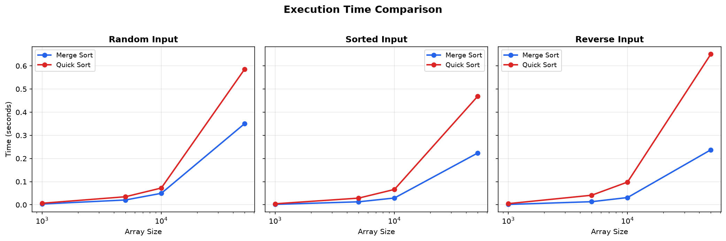
Figure 1: Execution time comparison across input distributions
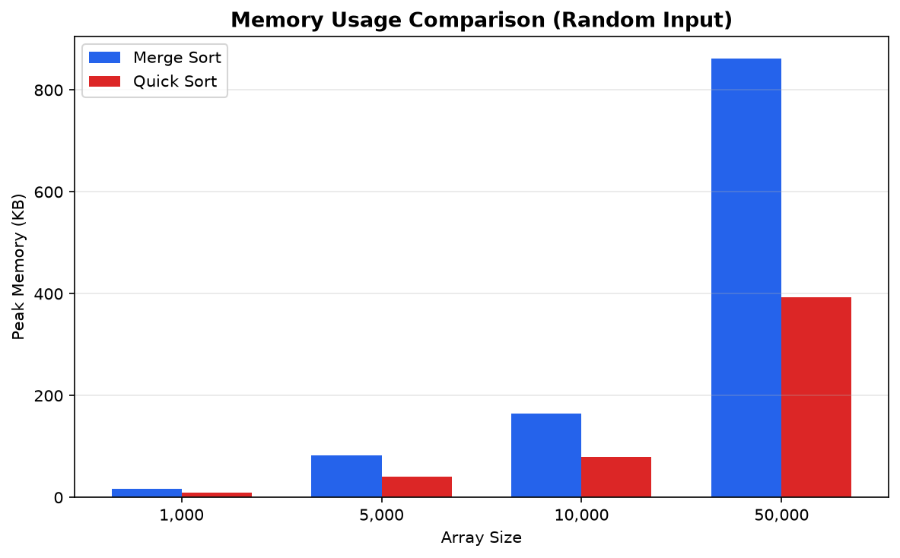
Figure 2: Peak memory usage comparison on random input

3.3 Analysis of Results
The benchmark results reveal several notable patterns that illustrate the gap between theoretical analysis and practical performance:

Execution Time: Merge Sort was consistently faster than Quick Sort across all input types and sizes in our Python implementation. This is largely due to Python's interpreted nature and the overhead of function calls—Quick Sort's in-place swaps and recursion incur more Python-level overhead than Merge Sort's list operations, which are backed by optimized C code in CPython. In compiled languages like C or C++, Quick Sort typically outperforms Merge Sort on random data due to better cache locality.
Memory Usage: As expected from theory, Quick Sort used approximately half the memory of Merge Sort. Merge Sort's O(n) auxiliary space is clearly visible in the data—memory usage scales linearly with input size (from ~17 KB at n=1,000 to ~862 KB at n=50,000). Quick Sort's memory footprint remained lower due to its in-place partitioning.
Input Distribution Effects: Both algorithms performed faster on sorted and reverse-sorted inputs than on random data. For Merge Sort, this is because the merge step performs fewer comparisons when data has existing order. For Quick Sort, the median-of-three pivot selection prevented the worst-case O(n²) behavior that would occur with naive first-element pivot selection on sorted inputs. Quick Sort showed slightly more variation across input types than Merge Sort, consistent with its input-dependent theoretical complexity.
Theory vs. Practice: While both algorithms share the same Θ(n log n) average-case complexity, their practical performance differs due to constant factors hidden in asymptotic notation. Python's dynamic typing, reference counting, and interpreted execution amplify these constant factors differently for each algorithm. This demonstrates why benchmarking with realistic data and target platforms is essential, as Big-O analysis alone cannot predict which algorithm will be faster in practice.

4. Conclusion
This analysis demonstrates that while Merge Sort and Quick Sort both achieve O(n log n) average-case time complexity through divide-and-conquer, they present different tradeoffs. Merge Sort offers predictable O(n log n) worst-case performance at the cost of O(n) extra space, making it suitable for external sorting and stability-sensitive applications. Quick Sort offers better space efficiency with O(log n) stack space and superior cache behavior in compiled languages, but requires careful pivot selection to avoid O(n²) worst-case degradation. Modern hybrid algorithms like Introsort combine the strengths of both approaches. The benchmarking results confirm that asymptotic analysis, while essential for understanding algorithmic scaling, must be supplemented with empirical testing to account for implementation-level and platform-specific factors.

GitHub Repository
https://github.com/sasha-ichen-uc/MSCS532_Algo_Data_Structure_Assignment1

References
Cormen, T. H., Leiserson, C. E., Rivest, R. L., & Stein, C. (2022). Introduction to Algorithms (4th ed.). MIT Press.
Musser, D. R. (1997). Introspective sorting and selection algorithms. Software: Practice and Experience, 27(8), 983–993.
Sedgewick, R., & Wayne, K. (2011). Algorithms (4th ed.). Addison-Wesley.
Hoare, C. A. R. (1962). Quicksort. The Computer Journal, 5(1), 10–16.

