Assignment 2: Analyzing and Implementing Divide-and-Conquer Algorithms

I Chen
Student ID: 00506167
MSCS 532: Algorithms and Data Structures
Assignment 2
November 1, 2026

Introduction
Divide-and-conquer is one of the most widely used algorithmic strategies in computer science. The idea is straightforward: break a problem into smaller subproblems, solve them recursively, and combine the results. Sorting is a natural fit for this approach because arrays can be split cleanly and the subproblem structure is easy to reason about. This paper looks at two divide-and-conquer sorting algorithms, Merge Sort and Quick Sort. For each one, I walk through the time complexity using Big-O, Big-Omega, and Big-Theta notation, solve the recurrence relations using three different methods, and then compare how the two algorithms actually perform in practice on different kinds of input data.

Merge Sort

Problem Description and Key Steps
Merge Sort takes an unsorted array and produces a sorted one in non-decreasing order. It works in three steps. First, the array is split in half at the midpoint. Second, each half is sorted recursively using the same process. Third, the two sorted halves are merged back together by comparing elements from each half one at a time and placing the smaller one into the result. The important thing about the merge step is that since both halves are already sorted by the time they are being combined, only a single pass through the data is needed. This is true no matter what the original input looks like, which is why Merge Sort has such consistent performance.

Time Complexity Analysis
Each level of recursion splits the array in half, so there are log₂n levels total. At each level, the merge operations go through all n elements once, doing O(n) work. This gives a total running time of Θ(n log n) in every case. Even if the input is already sorted, the algorithm still does the same divisions and merges, so the best case is still Θ(n log n). The average and worst cases are the same. Since the time is Θ(n log n) across the board, it is also O(n log n) as an upper bound and Ω(n log n) as a lower bound. The space complexity is O(n) because of the temporary arrays used during merging (Cormen et al., 2022).

Recurrence Relation
The recurrence for Merge Sort is:
T(n) = 2T(n/2) + Θ(n), with T(1) = Θ(1)
This says there are two recursive calls on halves of the array, plus linear work to merge. I solve this using three methods below.
Substitution Method. We guess that T(n) = O(n log n) and try to prove it. Assume T(k) ≤ ck log k for all k < n. Then T(n) = 2T(n/2) + cn ≤ 2c(n/2) log(n/2) + cn = cn(log n − 1) + cn = cn log n. The guess holds, so T(n) = O(n log n).
Recursion-Tree Method. At the top level the cost is cn. At level 1 there are two problems of size n/2, each costing cn/2, so the total is still cn. This pattern repeats at every level. There are log₂n levels, so the total comes out to cn · log₂n = Θ(n log n).
Master Method. The recurrence fits the form T(n) = aT(n/b) + f(n) with a = 2, b = 2, f(n) = Θ(n). We get log_b(a) = log₂(2) = 1, and since f(n) = Θ(n¹) = Θ(n^(log_b a)), this is Case 2 of the Master Theorem, giving T(n) = Θ(n log n).

Practical Implications
The guaranteed O(n log n) performance makes Merge Sort a good choice when you need predictable behavior regardless of input. For example, database systems like PostgreSQL use Merge Sort variants for external sorting when the dataset is too large to fit in memory. The algorithm reads and writes data in long sequential runs, which works well with disk I/O since it avoids the random access patterns that make disk operations slow. Merge Sort is also stable, meaning it preserves the original order of equal elements, which matters when sorting by multiple keys. The main downside is the O(n) extra space needed for the temporary arrays during merging. For large in-memory sorts, that overhead can add up (Cormen et al., 2022).

Quick Sort

Problem Description and Key Steps
Quick Sort also sorts an array using divide-and-conquer, but the work is distributed differently. Instead of doing an easy split and a hard merge like Merge Sort, Quick Sort does a hard partition and then does not need to merge at all. The algorithm picks a pivot element, then rearranges the array so everything less than the pivot is on the left and everything greater is on the right. After that, the pivot is already in its correct final position. The same process is applied recursively to the left and right sides. Since the partitioning is done in place, there is no combine step needed (Hoare, 1962).

Time Complexity Analysis
How well Quick Sort performs depends heavily on how the pivot is chosen. In the best case, each pivot splits the array roughly in half, and the running time is Θ(n log n). The average case is also Θ(n log n) when pivots are chosen randomly or with a reasonable strategy. The worst case happens when the pivot is always the smallest or largest element. For example, if you pick the first element as the pivot and the array is already sorted, every partition produces one empty side and one side with n−1 elements. This makes each level of recursion remove only one element, and the running time becomes Θ(n²). To summarize: Quick Sort is O(n²) in the worst case, Ω(n log n) in the best case, and Θ(n log n) on average. Space complexity is O(log n) on average for the recursion stack, but can go up to O(n) in the worst case (Sedgewick & Wayne, 2011).

Recurrence Relation
For the best and average case, the recurrence is:
T(n) = 2T(n/2) + Θ(n)
For the worst case with maximally unbalanced partitions:
T(n) = T(n−1) + Θ(n)

Substitution Method (worst case). Assume T(k) ≤ ck² for all k < n. Then T(n) = T(n−1) + cn ≤ c(n−1)² + cn = cn² − 2cn + c + cn = cn² − cn + c ≤ cn². So T(n) = O(n²).
Recursion-Tree Method (worst case). The cost at level 0 is cn, at level 1 it is c(n−1), at level 2 it is c(n−2), and so on. The tree has n levels, and adding everything up gives c · n(n+1)/2 = Θ(n²).
Master Method (best/average case). The balanced recurrence T(n) = 2T(n/2) + Θ(n) is the same form as Merge Sort. With a = 2, b = 2, log_b(a) = 1, and f(n) = Θ(n^(log_b a)), Case 2 applies and gives T(n) = Θ(n log n). Note that the Master Method cannot be used for the worst-case recurrence T(n) = T(n−1) + Θ(n) since it does not fit the required form T(n) = aT(n/b) + f(n).

Practical Implications
Even though Quick Sort has an O(n²) worst case, it tends to be the fastest general-purpose sorting algorithm in practice. The reason is that it sorts in place without allocating extra arrays, and its memory access pattern has good cache locality since elements are compared and swapped within contiguous regions. These constant-factor advantages are why many standard libraries use Quick Sort variants, including C's qsort and Java's Arrays.sort for primitives. To deal with the worst case, most modern implementations use median-of-three pivot selection, which picks the median of the first, middle, and last elements. This makes sorted input an average case rather than a worst case. Introsort, proposed by Musser (1997), goes a step further by monitoring recursion depth and falling back to Heap Sort if it exceeds 2 log₂n. This guarantees O(n log n) worst-case performance while still getting Quick Sort's speed in the common case. C++'s std::sort uses this approach.

Implementation and Comparison

Experimental Setup
I implemented both algorithms in Python and ran them on four dataset sizes (1,000; 5,000; 10,000; and 50,000 elements) with three types of input: random, already sorted, and reverse-sorted. The Quick Sort implementation uses median-of-three pivot selection with in-place partitioning. Each test was run three times and the results were averaged. I used Python's time module for execution time and tracemalloc for peak memory usage.

Performance Results
Table 1: Execution Time (seconds) and Peak Memory (KB)

Algorithm | Dataset | Size | Time (s) | Memory (KB)
Merge Sort | Random | 1,000 | 0.0034 | 17.1
Quick Sort | Random | 1,000 | 0.0067 | 8.8
Merge Sort | Sorted | 1,000 | 0.0018 | 19.6
Quick Sort | Sorted | 1,000 | 0.0044 | 8.5
Merge Sort | Reverse | 1,000 | 0.0016 | 19.6
Quick Sort | Reverse | 1,000 | 0.0050 | 8.8
Merge Sort | Random | 10,000 | 0.0496 | 165.0
Quick Sort | Random | 10,000 | 0.0725 | 79.6
Merge Sort | Sorted | 10,000 | 0.0293 | 195.4
Quick Sort | Sorted | 10,000 | 0.0663 | 79.2
Merge Sort | Reverse | 10,000 | 0.0313 | 195.4
Quick Sort | Reverse | 10,000 | 0.0982 | 79.5
Merge Sort | Random | 50,000 | 0.3505 | 861.9
Quick Sort | Random | 50,000 | 0.5858 | 392.3
Merge Sort | Sorted | 50,000 | 0.2238 | 976.6
Quick Sort | Sorted | 50,000 | 0.4689 | 391.8
Merge Sort | Reverse | 50,000 | 0.2375 | 976.6
Quick Sort | Reverse | 50,000 | 0.6507 | 392.3

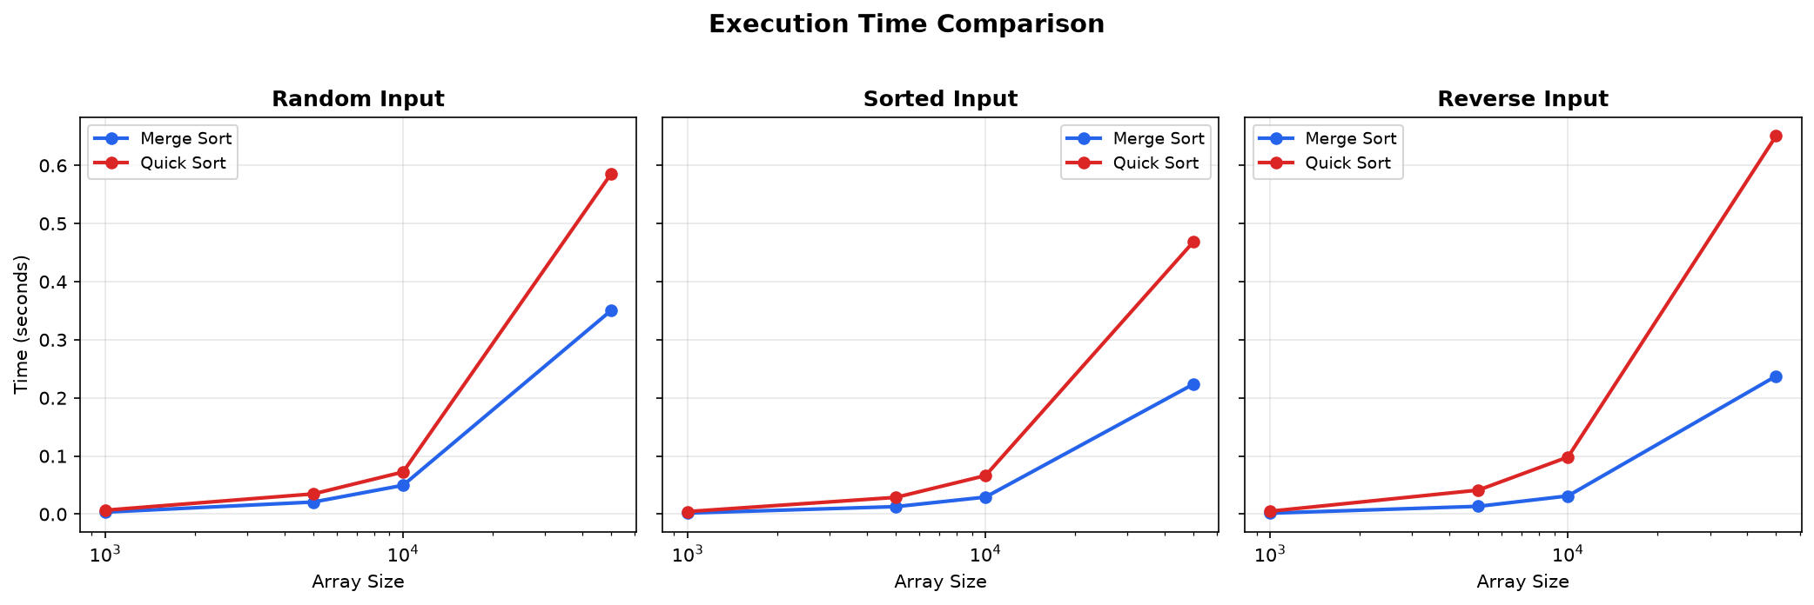
Figure 1: Execution time comparison across input distributions
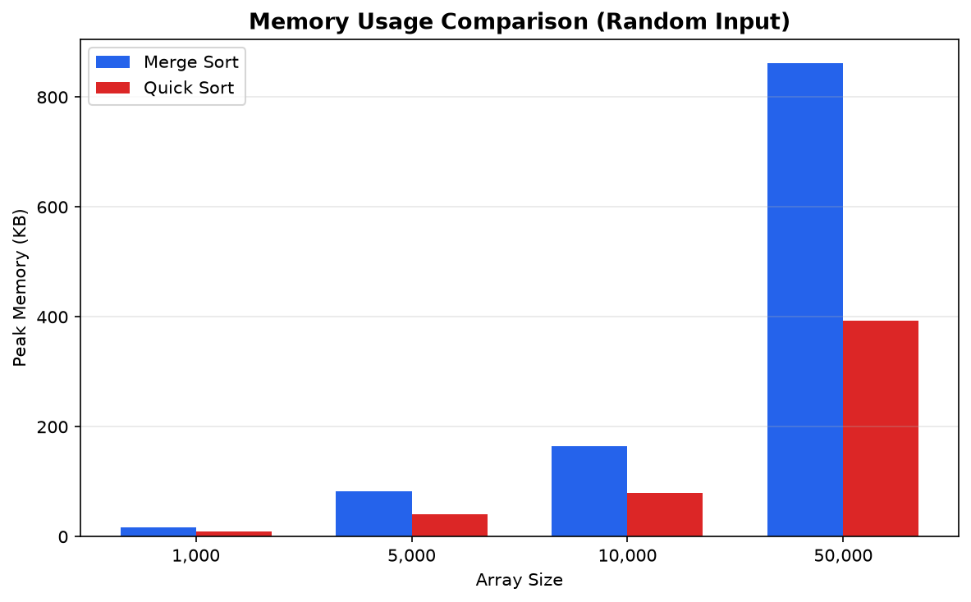
Figure 2: Peak memory usage comparison on random input

Analysis of Results
One of the more surprising results is that Merge Sort was faster than Quick Sort across every input type and size. This goes against the usual expectation that Quick Sort is faster in practice, but it makes sense when you consider that this is Python. Quick Sort relies on a lot of in-place swaps and recursive calls, and each of those operations is relatively expensive in an interpreted language because of the overhead from dynamic typing and function call dispatch. Merge Sort, on the other hand, uses list slicing, appending, and extending, which are all backed by optimized C code inside CPython. So the interpreter overhead gets spread out over bulk operations. In a compiled language like C or C++, where function calls are cheap and cache behavior matters more, Quick Sort would likely come out ahead.
The memory numbers lined up with what the theory predicts. Merge Sort used roughly twice as much memory as Quick Sort at every size, going from about 17 KB vs 9 KB at n = 1,000 up to 862 KB vs 392 KB at n = 50,000. This reflects the O(n) extra space that Merge Sort needs for its temporary arrays. Quick Sort stays lower because it partitions in place and only needs O(log n) space for the recursion stack.
Both algorithms ran faster on sorted and reverse-sorted inputs compared to random data. For Merge Sort this happens because the merge step can finish early when one half runs out of elements before the other, so fewer comparisons are needed. For Quick Sort, the median-of-three pivot selection kept it from hitting the O(n²) worst case on sorted input, which is what would happen with a naive first-element pivot. That said, Quick Sort still showed more variation between input types than Merge Sort did, which is consistent with its input-dependent complexity.
Overall, these results show that Big-O analysis is important for understanding how an algorithm scales, but it does not tell the whole story. Two algorithms that are both Θ(n log n) can have very different actual runtimes depending on the language, the hardware, and how memory access patterns interact with the CPU cache. Benchmarking on the target platform with realistic data is still necessary to make a well-informed choice.

Conclusion
Merge Sort and Quick Sort both use divide-and-conquer to sort, but they make different tradeoffs. Merge Sort gives you guaranteed O(n log n) performance and stability, but at the cost of O(n) extra memory. Quick Sort is more space-efficient with O(log n) stack space, and in compiled languages it tends to be faster due to better cache behavior, but it requires good pivot selection to avoid the O(n²) worst case. The benchmark results showed that in Python specifically, Merge Sort was faster because of how CPython handles list operations versus recursive function calls. This is a good reminder that asymptotic complexity is not the only thing that matters. Modern algorithms like Introsort (Musser, 1997) take a practical approach by combining Quick Sort, Heap Sort, and Insertion Sort, switching between them based on what is happening at runtime rather than committing to one strategy.

GitHub Repository
https://github.com/sasha-ichen-uc/MSCS532_Algo_Data_Structure_Assignment1

References
Cormen, T. H., Leiserson, C. E., Rivest, R. L., & Stein, C. (2022). Introduction to algorithms (4th ed.). MIT Press.
Hoare, C. A. R. (1962). Quicksort. The Computer Journal, 5(1), 10–16. https://doi.org/10.1093/comjnl/5.1.10
Musser, D. R. (1997). Introspective sorting and selection algorithms. Software: Practice and Experience, 27(8), 983–993.
Sedgewick, R., & Wayne, K. (2011). Algorithms (4th ed.). Addison-Wesley.

