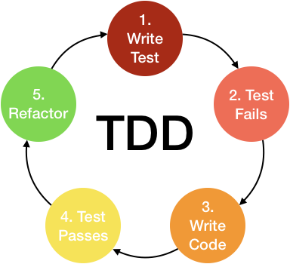

Firstly, unit tests names foreach task where written so that they could be used as a guide to help preventing certain bugs. Since the tests were not yet implemented, the tests failed. The next step was that of implementing the tests. This time the tests passed. The last step for unit tests was that of refactoring the code doing tasks such as eliminating redundancy, removing dead code and renaming variables correctly.

After unit testing, the system was ready for integration testing. Stubs and drivers where implemented accordingly using the Top down and Bottom up approaches. After the mentioned testing the project is ready for user acceptance testing.