**Task B - 3.2A:**

I am proposing to use the Comma separated values (CSV) format for the log file because I believe that data can be converted easily from this format. Moreover, tabular data, which is stored in plain text looks neat and can be read easily.

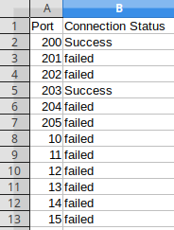

**Task C – 3.3B:**

The Mutex locks provides protection to the log files. This protection consists of denying different threads from accessing the log file while currently in use by other threads. The mutex is included with the pthread.h library. Unlike other libraries when including it with the #include keyword is not enough. -pthread should also be added inside the compilation script.

The mutex should first be initialized, once initialized, lock and unlock can be used accordingly. When a file is locked, it can’t be accessed by another thread until the unlock function is executed.

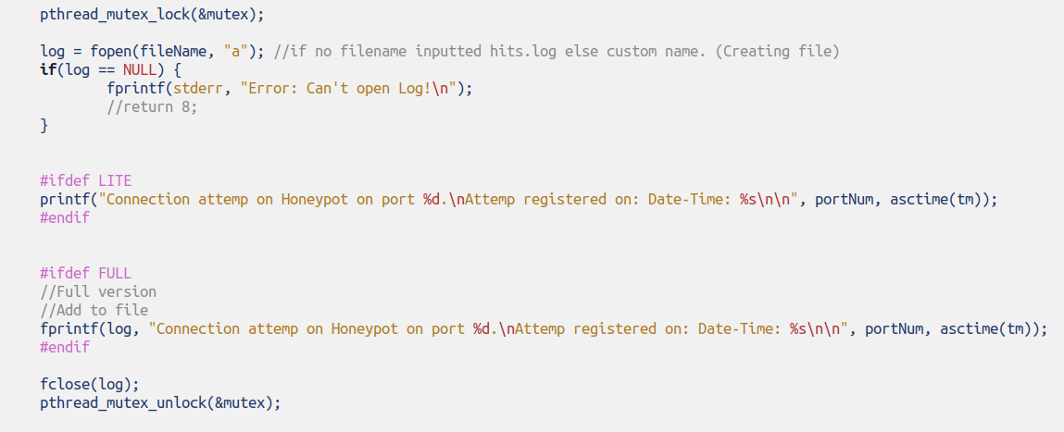

Another benefit of mutex apart from ensuring file protection is that of preventing race conditions. A race condition happens when a piece of code outputs different results according to execution order. Inconsistent results are a problem. On the other hand, locks will induce an order of execution which will result in consistent outputs.