SCHEDULING OF BATCH OPERATIONS – MODEL BASED OPTIMIZATION APPROACH

Abstract. The coordinated use of computers throughout the entire spectrum of manufacturing and business operations has been growing during the 1990s and is expected to continue during the 21st century. With the continued increases in computing power and advances in telecommunications, the use of optimization has expanded as well, including planning and scheduling. General access to a common database and enterprise information are provided to managers, engineers and operators so that optimum decisions can be made and executed in a timely and efficient manner. One of the richest aspects of life is our ability to shape our own destiny through the choices that we make. We have to decide, over time, how best to allocate a scarce resource (our time) amongst a number of competing demands. The outcome of each decision that we take is uncertain and affects our situation and the options that will be available to us in the future. Consciously or otherwise, we try to make choices with the aim of achieving certain goals or in order to maximize some measure of ”utility” or “pleasure”. Similar resource allocation problems are found in a large number of industrial, financial and computing settings. Here the parameters tend to be easier to quantify, in terms of money or time for example. An optimal strategy for allocating the resource is then deemed to be one that maximizes or minimizes some measure of performance. It is problem of this nature that the study of scheduling seeks to address.

Key Words: Scheduling, Optimization, Model, Time, Batch Operations

BATCH PROCESS FEATURES

For years, continuous operations have been the most prevalent mode in chemical processing. In recent years, however, there has been a renewed interest in batch processes for a variety of reasons. The most appealing feature of batch processes is their flexibility in producing multiple products in a single plant through sharing of process equipment. The batch operations are economically desirable, especially when small amounts of complex, high-value-added chemicals are produced or when a large number of products are made using similar production paths.

The manufacture of all chemical products involves three key elements: a process or recipe, which describes the set of chemical and physical steps, required to make product, a plant comprising a set of equipment within which these steps are executed and a market, which defines the amounts, timing and qualities of the product, required. A distinguishing feature of continuous operations is the one-to-one correspondence between the recipe steps and the plant equipment items: the flowsheet is the physical realization of the recipe and its structure remains fixed in time. In batch plants, the structure of the recipe and the plant equipment network structure are in general distinct. Moreover, the equipment configuration may change each time that a different product is made. Thus, in the batch case there exists an additional engineering decision level: the assignment of recipe steps to equipment items over specific intervals of time. These assignments decisions are inherently discrete in nature, introducing a combinatorial aspect to operational and design problems, which are not normally present in the continuous process case. Such problems can be modeled mathematically in an optimization framework.

THE SCHEDULING PROBLEM

A key problem which arises in batch operations is the scheduling of the plant to meet specified product requirements. Specifically, given the mode of operation, the product orders, the product recipes, the number and capacity of the various types of existing equipment, the list of equipment types allowed for assignment to each task, any limitations on shared resources (such as utilities or manpower) and any operating or safety restrictions, the scheduling problem is to determine the order in which tasks use equipment and resources and the detailed timing of the execution of all tasks so as to optimize plant performance. The scheduling problem involves three closely linked elements:

* Assignment of units and resources to tasks
* Sequencing of the tasks assigned to specific units
* Determination of the start and stop times for the execution of all tasks.

For instance, given two reactors (U1 and U2) and six product batches (A-F) which need to be processed, the assignment step might involve allocating A, B and C to U1 and D, E and F to U2 [1]. The sequencing step would involve determining the processing order on each unit (e.g. first B, then C, and then A on U1), while the timing step would assign specific start and stop times for each batch on each unit. The above problem elements are shared by scheduling problems arising in a wide range of applications – ranging from machine shops to transportation systems to class room allocation. The assignment component of the problem involves binary decisions (assign U1 to task A or not) as does the sequencing component (position A first in the sequence or not). The timing component can be a discrete decision problem or not depending upon whether time is treated as a continuum or divided into individual time quanta. It is the binary decisions which provide the challenge to scheduling problem solution. Indeed, the theoretical worst case analysis of computational complexity has shown that even the conceptually simplest forms of scheduling problems (those involving only sequencing considerations such as the sequencing of products on a single process with set-up costs which are dependent on the product processing order) can exhibit exponential growth in computational effort with increasing problem size. The staged nature of a processing network, consisting of a number of units in series, allows four different storage operations:

* Unlimited (infinite number) intermediate storage (UIS)
* Finite (specified number) intermediate storage (FIS)
* No intermediate storage (NIS)
* Zero wait or no wait (ZW or NW)

The interstage storage capacity is measured in terms of the number of units, not the physical size of storage, since it is usually assumed that each storage unit can temporarily hold any product batch [2]. In both the NIS and ZW modes, there is no storage between stages. While a batch, after its completion in a processing unit, may be held in it temporarily in the NIS, UIS or FIS modes, it must be transferred to the downstreams unit immediately in the ZW mode. In the situations where unstable intermediates are produced and must be immediately processed in succeeding steps, the ZW mode of operation is used. In a batch/semicontinuous plant, the general short-term scheduling problem is characterized by:

* A set of N products or product batches to be produced
* A set of M available processing units
* A sequence for each product in which operations are to be performed
* A set of fixed processing times for each product from each equipment item
* A matrix of fixed transfer times for each product from each equipment item
* A matrix of fixed (possibly sequence-dependent) setup times or costs between every pair of products in each equipment item
* Constraints on the production order for some products (precedence constraints)
* A suitable performance or cost criterion to be optimized
* The nature of the intermediate storage between processing stages
* The structure of processing network

The solution of the scheduling problem is critically affected by the performance criterion, the intermediate storage and the structure of the network. In terms of performance criteria, different objective functions can be used. Minimum total time required to produce all products or makespan is one of the most studied objective functions. To sum up, a single, universal solution approach to all scheduling problems does not exist and it is highly unlikely that one will ever be found.

SOLUTION ALGORITHMS – MODEL-BASED OPTIMIZATION

The categories of solution algorithms which have been advanced for the solution of scheduling problems include: rule-based dispatching methods, randomized search methods, artificial intelligence related methods, simulation approaches and model-based optimization methods. Model-based optimization employs a mathematical model of the application as the basis for conducting a systematic search of the solution domain using numerical and logical methods, such as linear programming. The advantage of a model is that it offers a rigorous measure of the quality. However, model formulation may require considerable expertise and the optimization process can be quite computationally intensive.

Short-term scheduling (as the model-based optimization technique) involves sequencing and scheduling the production of N products across M processing units to optimize a suitable performance criterion [3]. This problem can be looked upon as a combination of two interlinked subproblems: sequencing and timetable. Sequencing involves determining the order in which the products are to be processed to obtain the best possible schedule. The timetable of production for a given sequence involves determining the starting and finishing times of each product on all processing units. An interesting feature of most scheduling problems is that, while they are deceptively simple, they are very hard to solve. Determination of the production sequence and the timetable is a combinatorial optimization problem. The number of candidate solutions grows exponentially as the size of the problem increases. For example, in a flowshop, the number of candidate permutation schedules is N! where N is the number of products. A detailed schedule for a given production sequence is carried out by recurrence relations. Recurrence relations are a set of expressions that can be used recursively to generate the start and finish times of each product in all processing and storage units. For a simplified UIS flowshop, the relations are quite simple:

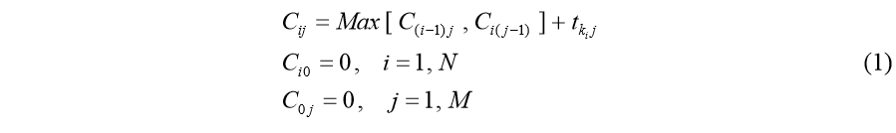

where Cij is the completion time of the i-th job (task) in the sequence on the j-th processor (unit) and ikj t is the processing time of product ki on unit j. Here, the completion time refers to the time at which a product finishes processing on a unit. The schedule obtained from the application of the equations (1) to the sequence 12-3-4 in the problem of Table 1 is shown in Fig. 1.

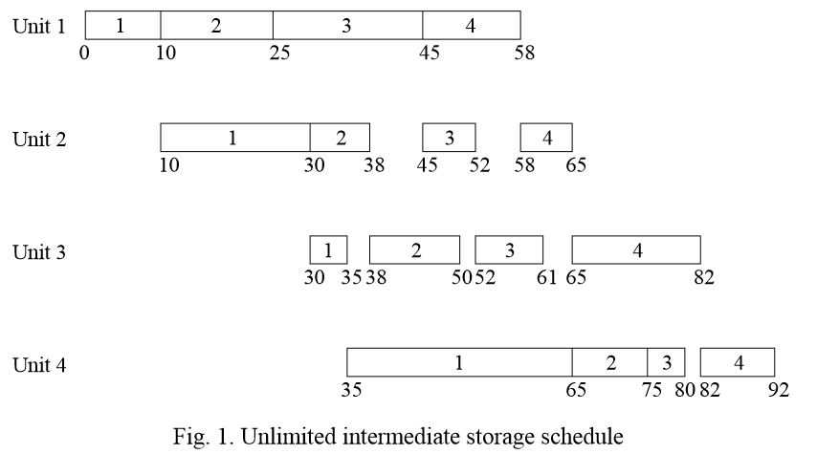

The recurrence relations indicate that the completion time of a job on a unit is its processing time plus the time at which processing can start. This implicitly assumes that the transfer time of the job from one unit to another is negligible. Applying these quations recursively, the completion times for the entire sequence of jobs on all processing units can be calculated with an amount of computational effort proprotional to MxN. As the complexity of the flowshop increases, the recurrence relations become more complex to formulate.

CONCLUSION

Production scheduling is of immense importance in noncontinuous processes of the chemical process industry. Application of the scheduling methodology can significantly improve the productivity and cost-effectiveness of batch processes. The determination of completion times for a given product sequence in serial multiproduct noncontinuous plants is examined thoroughly. The categories of solution algorithms which have been advanced for the solution of scheduling problems include: rule-based (heuristics) dispatching methods, randomized search methods, artificial intelligence related methods, simulation approaches and model-based optimization methods. The advantage of a model-based optimization approach is that it offers a rigorous measure of the quality and the feasibility of any solution that is obtained.