**Specific library coponent**

It is lighting component that hyas LWC components inside for two modes : a) quick action as button; b) standard page. Library component can upload new files in any formats and save it in special library. Create and remove links between entity and files. Select only one or multiple records for creating links.

Parameters:

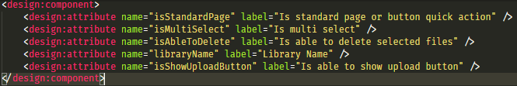

Structure:

Apex classes: SL_ctrl_LibraryFormHandler; SL_ctrl_LibraryFormHandler_test; SL_TestDataFactoryNew

SL_LibraryForm

slLibraryFormForPage

(isStandardPage == true)

slLibraryForm

(isStandardPage == false)