Assignment Documentation
NumPy and Pandas
Name: Aleksandr Chernysh
Batch: 2
Date: 28 October 2026
Files submitted:
• numpy_Aleksandr_Chernysh.ipynb
• pandas_Aleksandr_Chernysh.ipynb
• Documentation_Aleksandr_Chernysh.pdf
• Video_Aleksandr_Chernysh.mp4

Part 1: NumPy Report

1.1. Section 1: Know your data
a) Code screenshot and b) Output screenshot
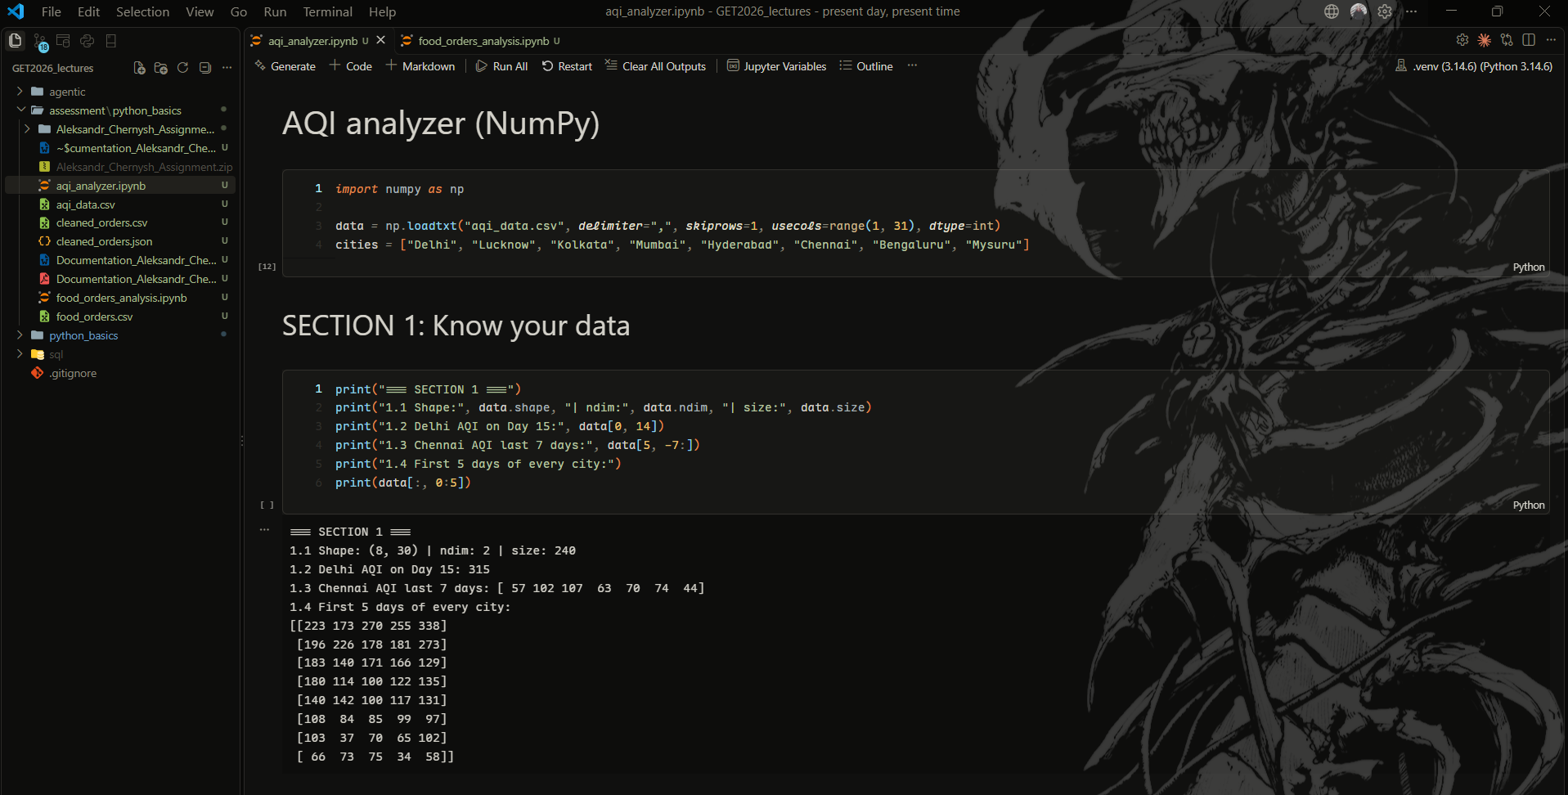
c) Explanation
What I did
Loaded the AQI numbers with the given loadtxt line, used the given list of city names, and checked the array size. Picked out single values and slices.
Why this method
skiprows=1 skips the header and usecols=range(1, 31) takes only the 30 day columns, so the city name column is not read as a number. Day 15 is index 14 because counting starts at 0.
What the result tells me
Shape is (8, 30): 8 cities, 30 days. Delhi on Day 15 was 315.

1.2. Section 2: Statistics
a) Code screenshot
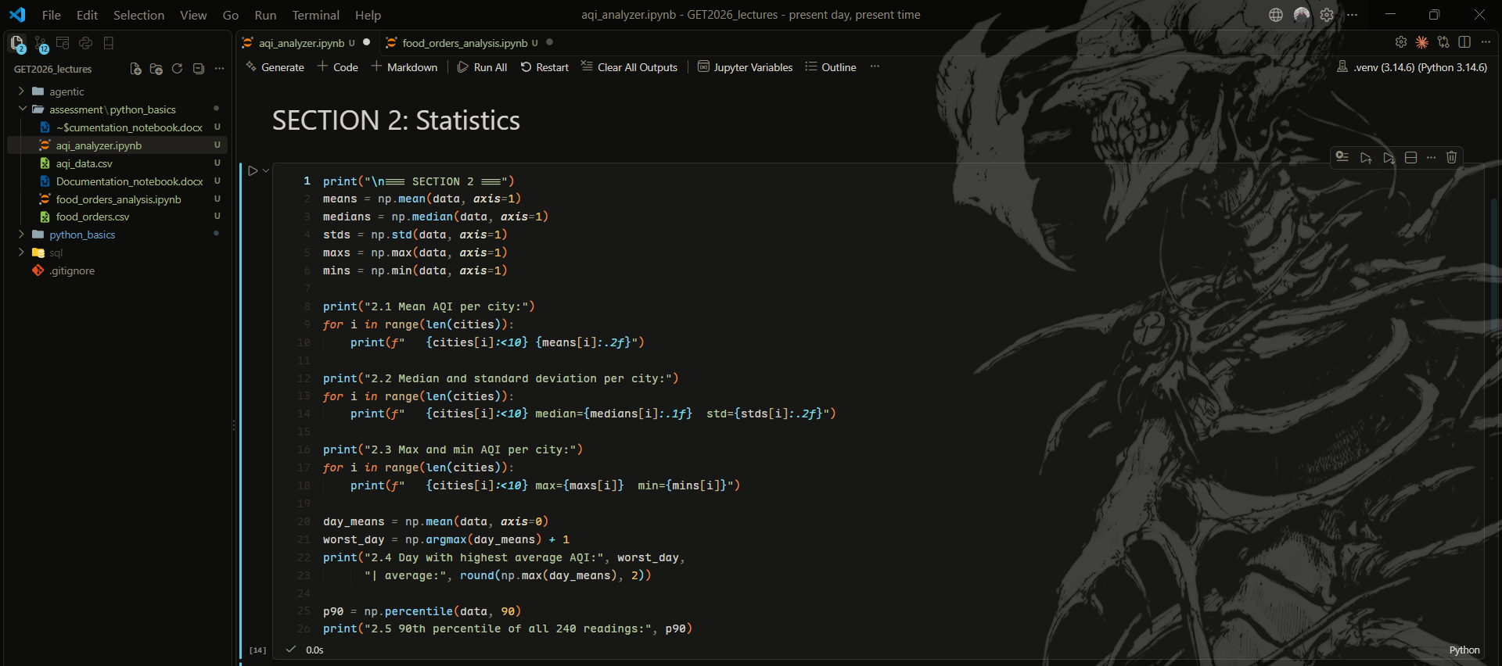
b) Output screenshot
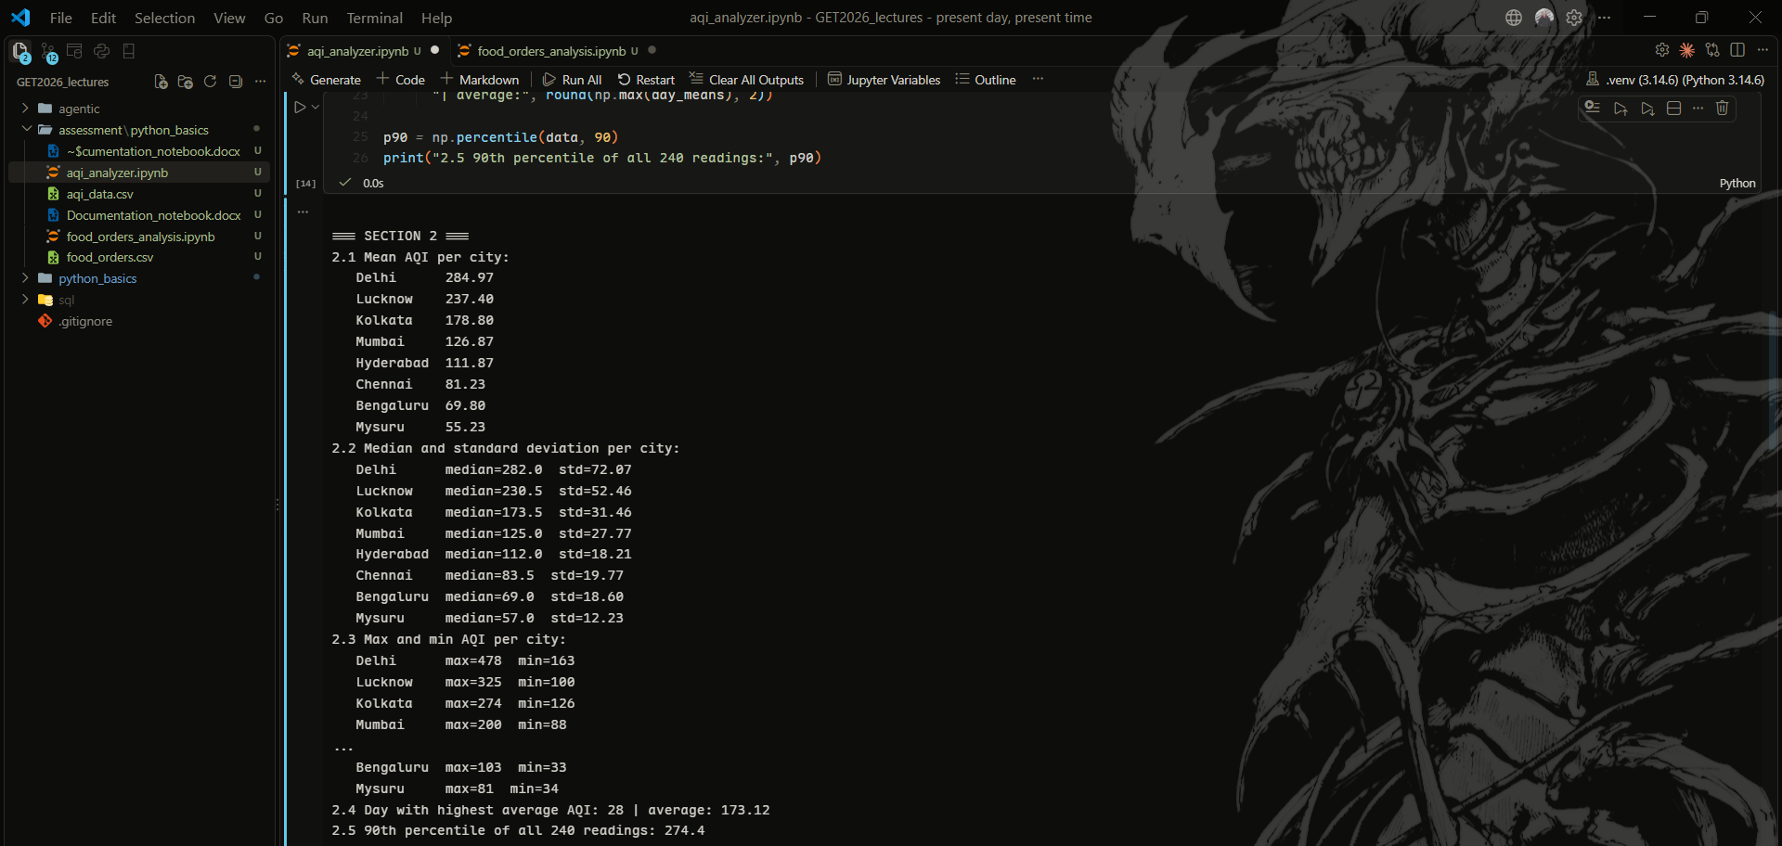
c) Explanation
What I did
Found mean, median, std, max and min for each city, the worst day, and the 90th percentile.
Why this method
axis=1 goes along a row, so I get one number per city. axis=0 gives one number per day.
What the result tells me
Delhi has the highest mean AQI (284.97). The worst day was Day 28 (average 173.12).

1.3. Section 3: Masking and np.where
a) Code screenshot
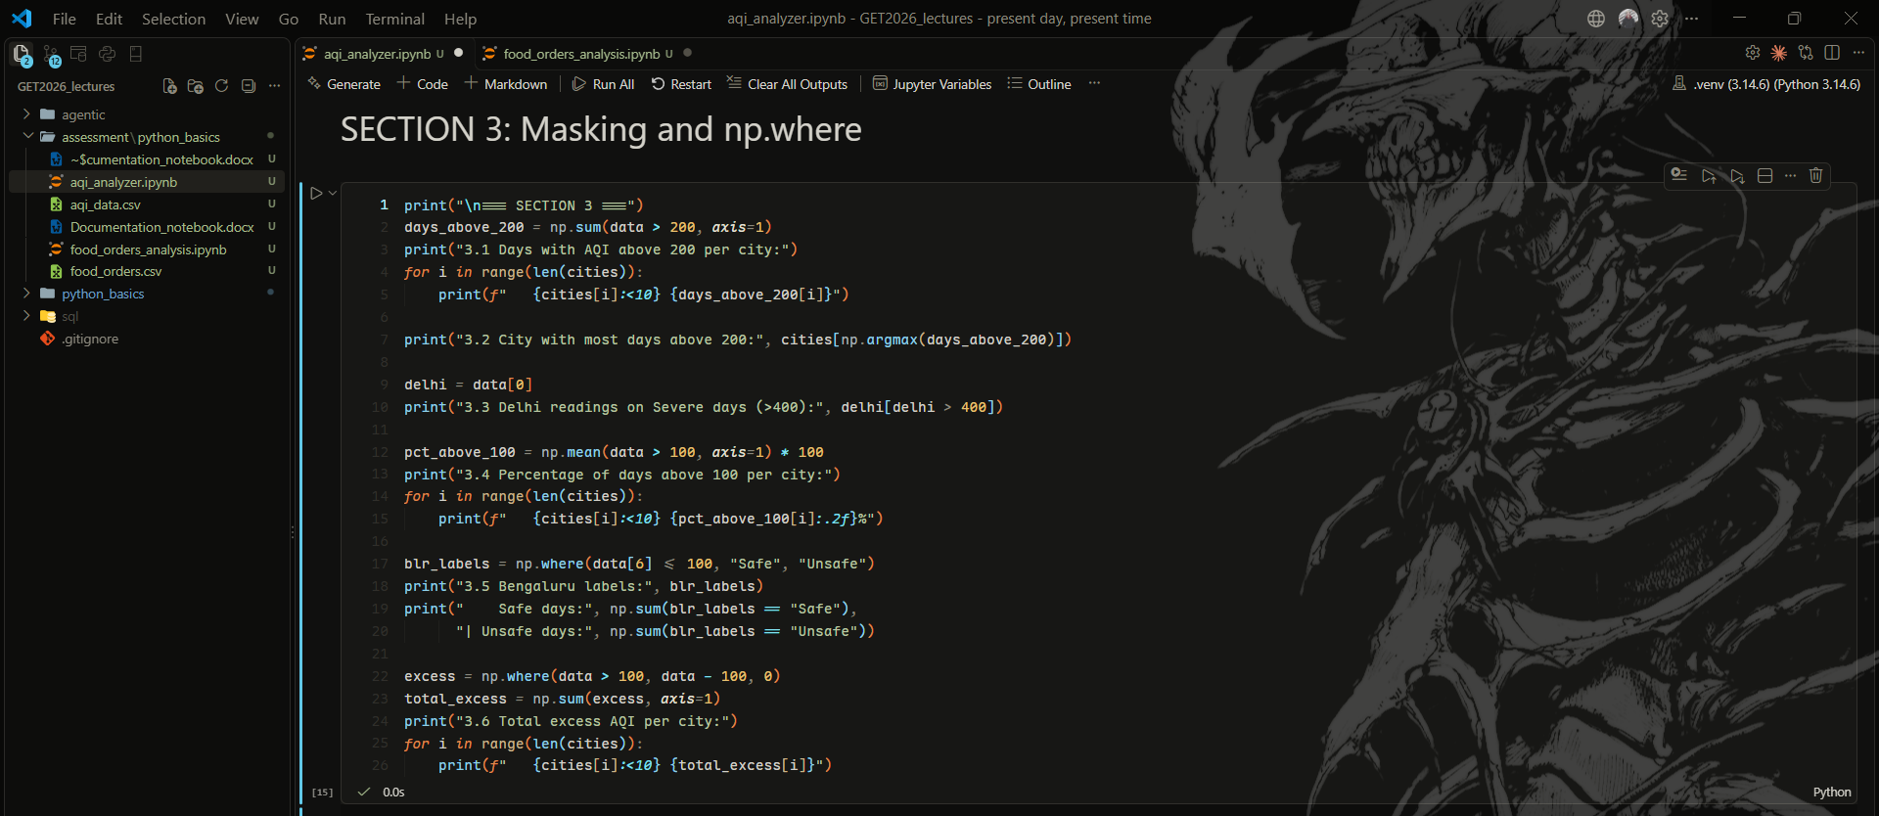
b) Output screenshot
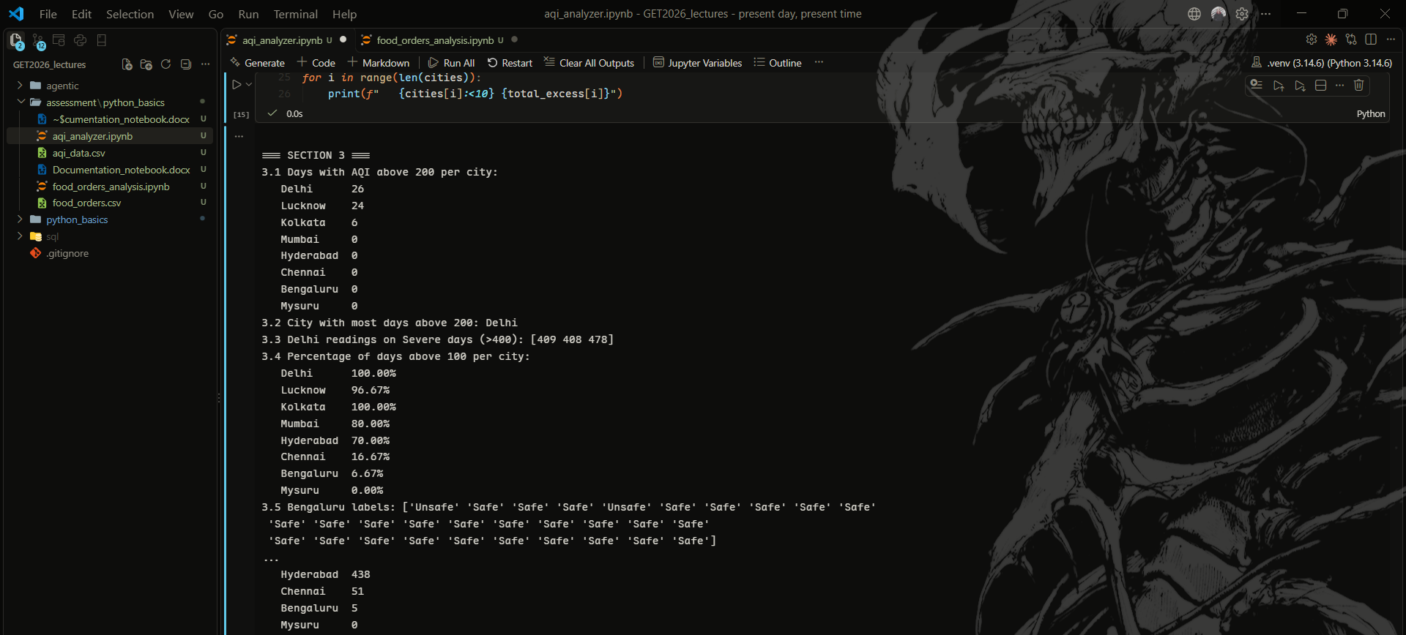
c) Explanation
What I did
Counted bad days per city, found Delhi's Severe days, and labelled Bengaluru days as Safe or Unsafe.
Why this method
data > 200 gives True/False, and sum() counts the True values. np.where works on the whole array, no loop needed.
What the result tells me
Delhi was above 200 on 26 of 30 days. Bengaluru had 28 Safe days and 2 Unsafe.

1.4. Section 4: Trends and matrix operations
a) Code screenshot
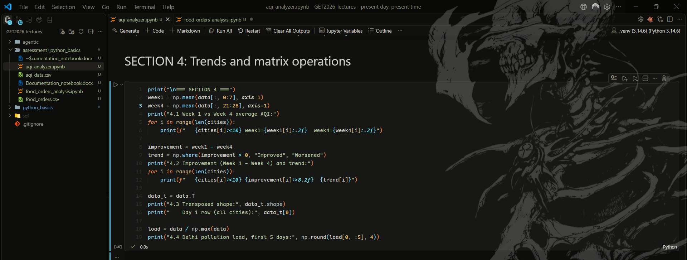
b) Output screenshot
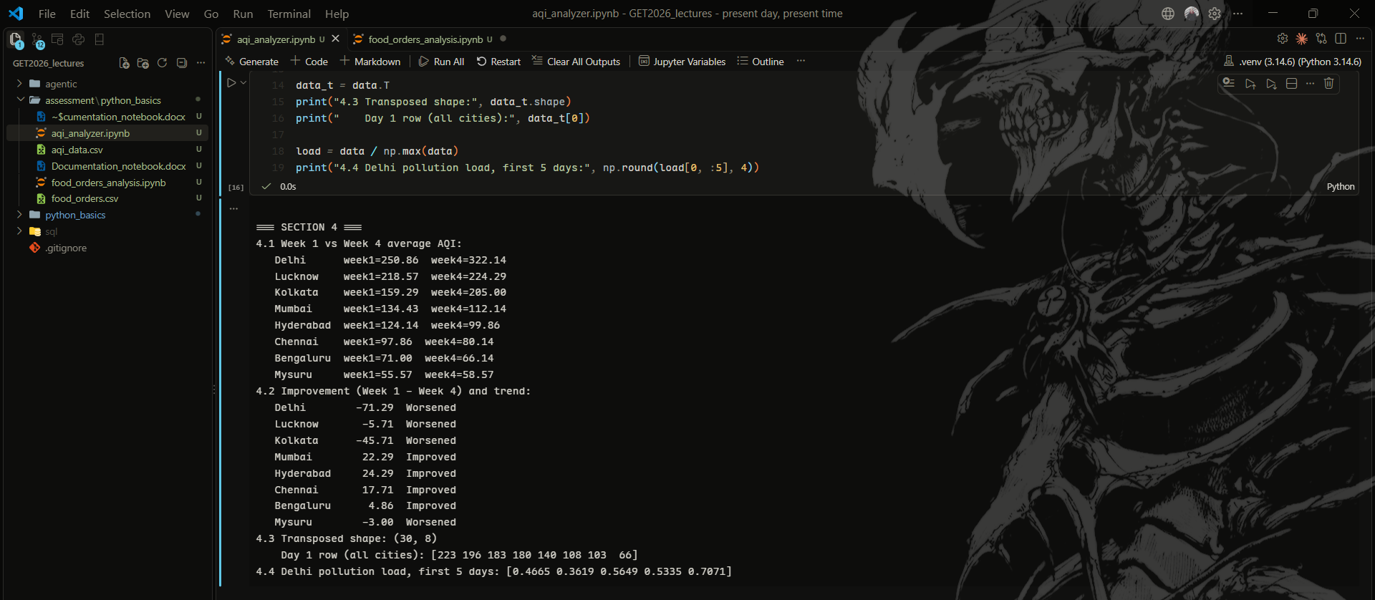
c) Explanation
What I did
Compared Week 1 and 4 for each city, transposed the matrix, and scaled all values from 0 to 1.
Why this method
Week 1 minus Week 4: positive means AQI went down (better). I divided by the overall max (478) so all cities use the same scale.
What the result tells me
Delhi got worse by 71.29 points. 4 of 8 cities improved.

1.5. Section 5: Report
a) Code screenshot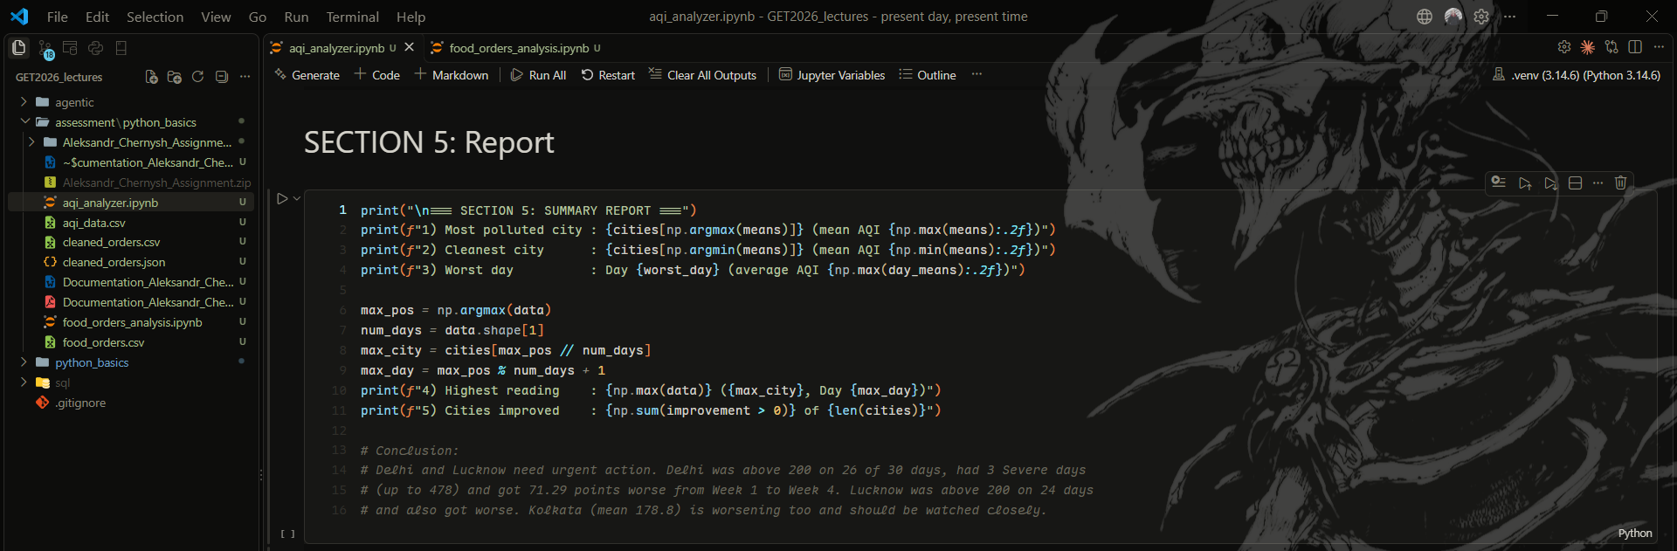
b) Output screenshot
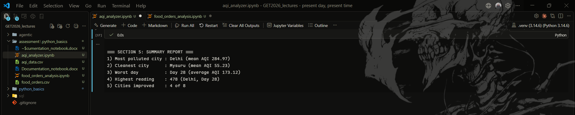
c) Explanation
What I did
Printed a short summary of the most important results and wrote a conclusion.
Why this method
Reused results from earlier sections. argmax gives a flat position, so // 30 gives the city and % 30 gives the day.
What the result tells me
Most polluted is Delhi (284.97), cleanest is Mysuru (55.23). Highest reading was 478 in Delhi on Day 28.

Part 2: Pandas Report

2.1. Part A: Load and inspect
a) Code screenshot
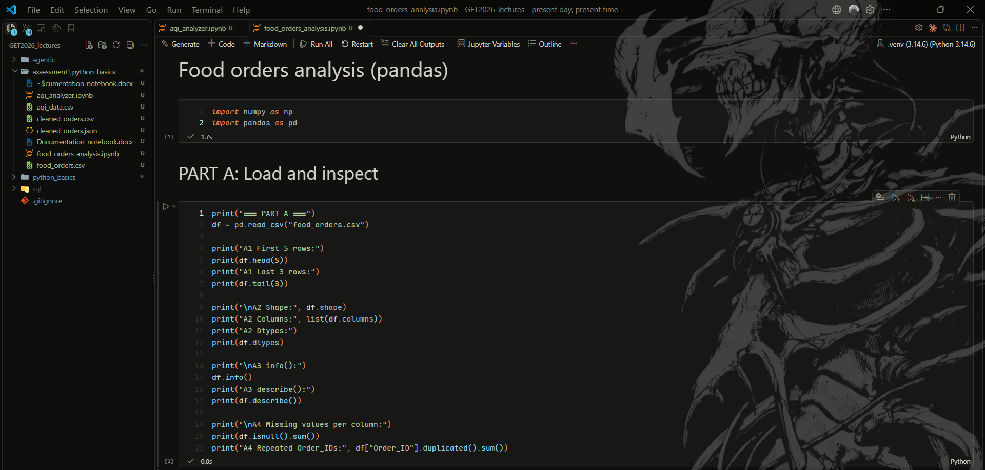
b) Output screenshot
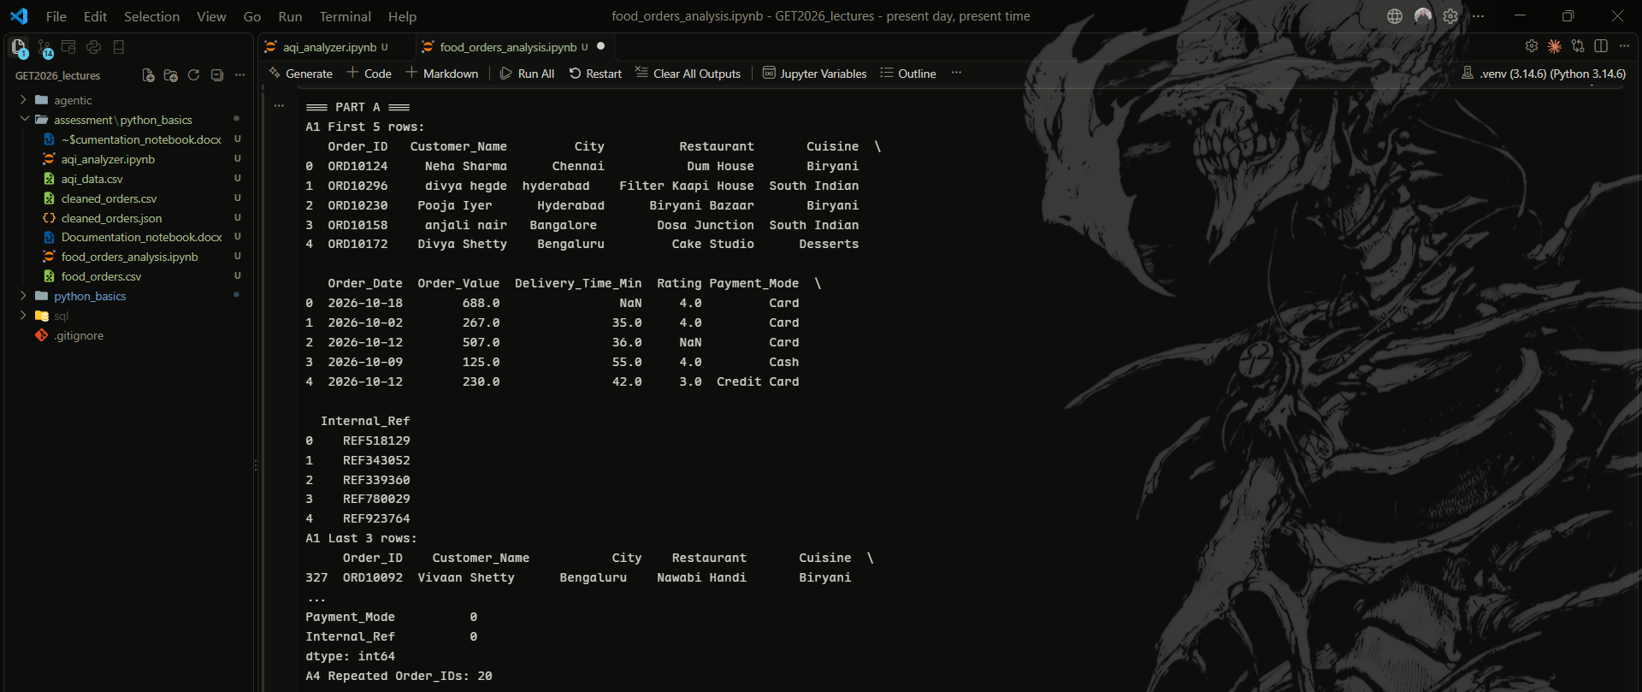
c) Explanation
What I did
Loaded the CSV and looked at the rows, columns, types, missing values and duplicates.
Why this method
I checked the data first so I know what needs cleaning. I checked duplicates by Order_ID because every order must be unique.
What the result tells me
330 rows, 11 columns. Rating has 34 missing values and there are 20 repeated Order_IDs.

2.2. Part B: Clean the data
a) Code screenshot
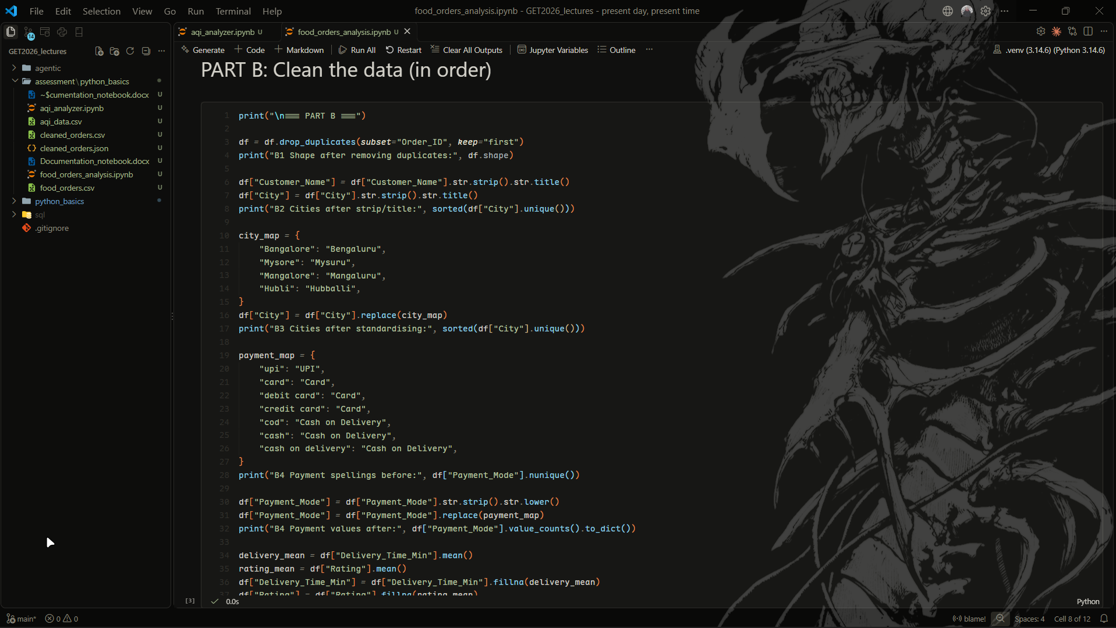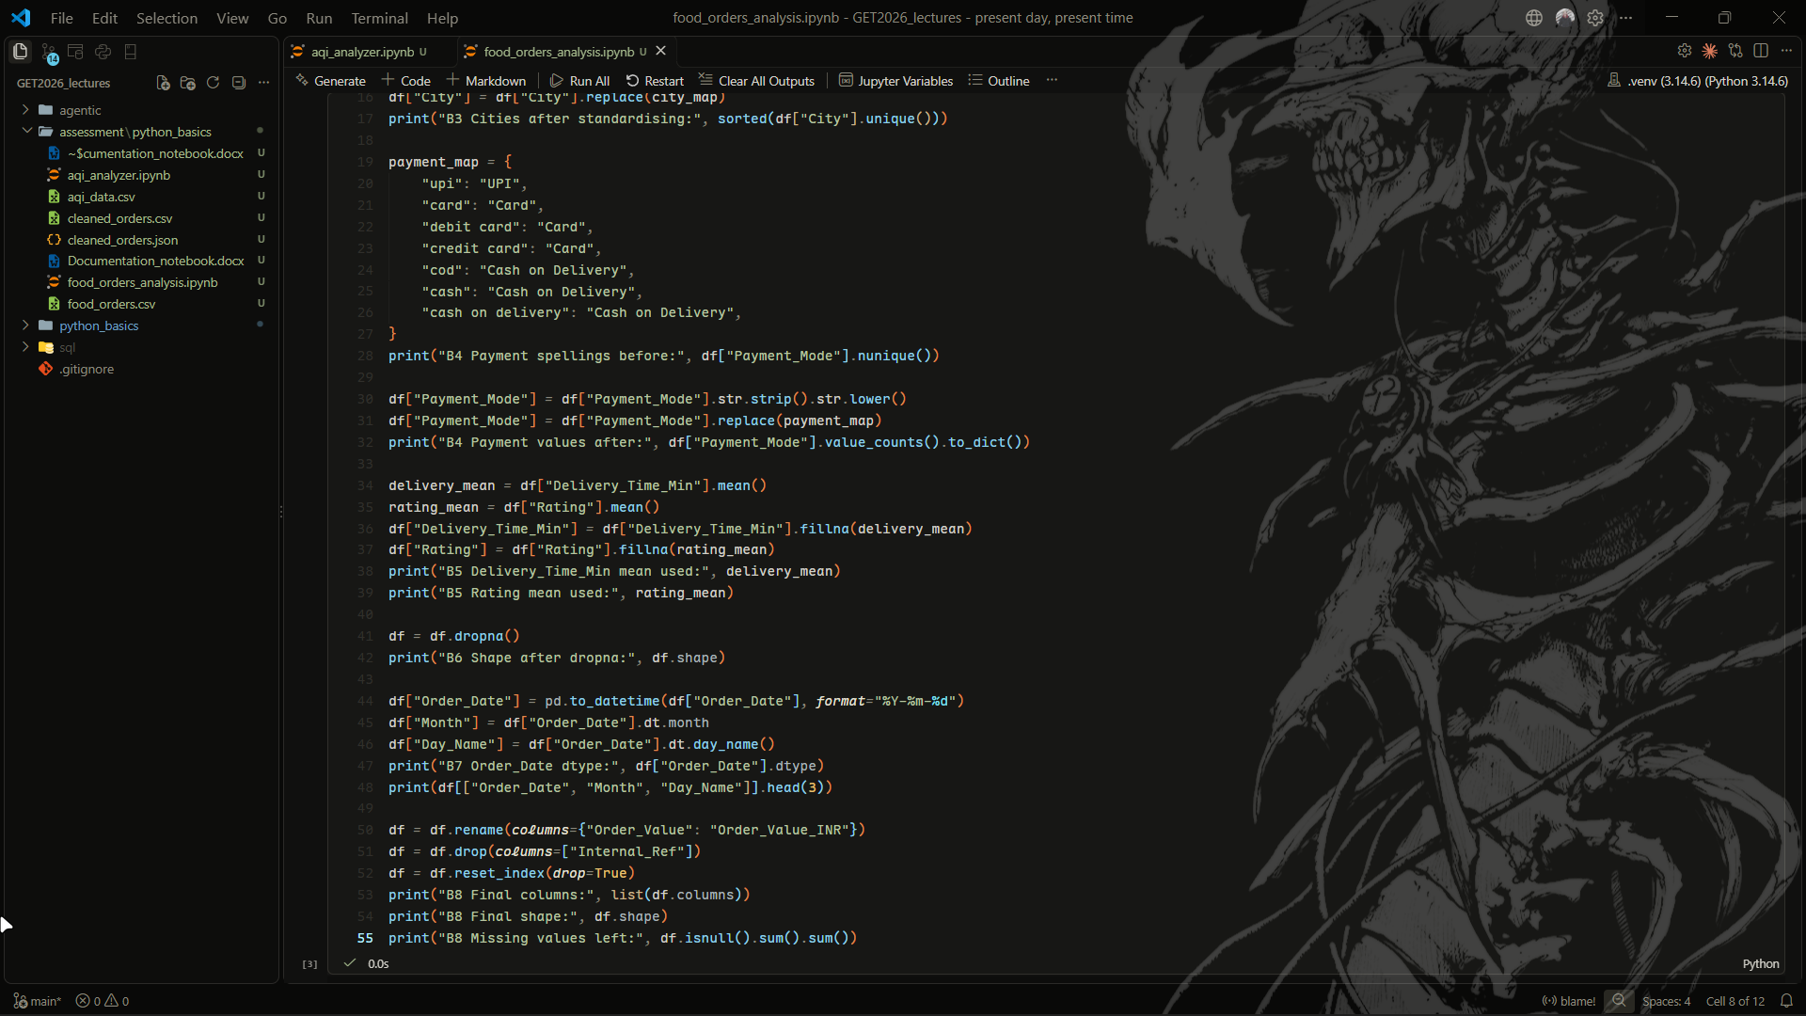
b) Output screenshot
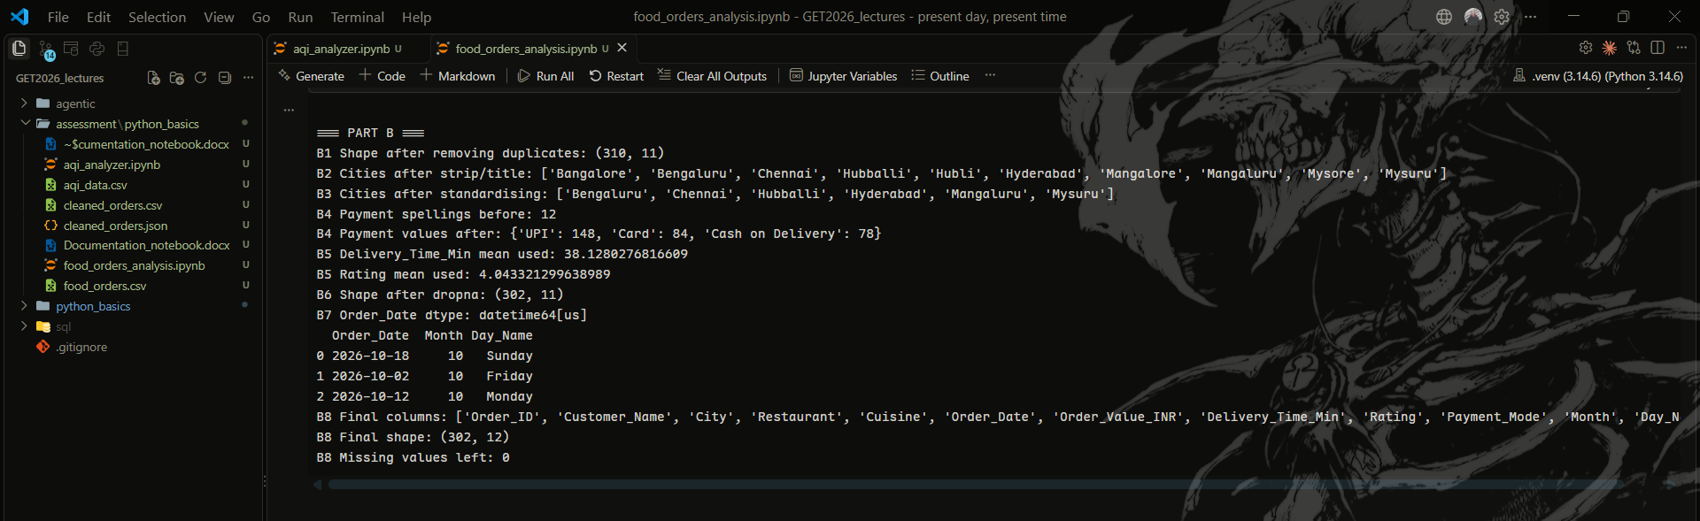
c) Explanation
What I did
Removed duplicates, fixed spaces and spelling in cities, made payments lowercase and mapped them to 3 values, filled gaps, dropped bad rows, fixed dates.
Why this method
I filled missing values before dropna(), otherwise dropna() would delete rows that only miss a rating. I did not fill Order_Value because I can't guess money.
What the result tells me
From 330 rows to 302, with 0 missing values left. Payment had 12 spellings, now 3.

2.3. Part C: Analysis
a) Code screenshot
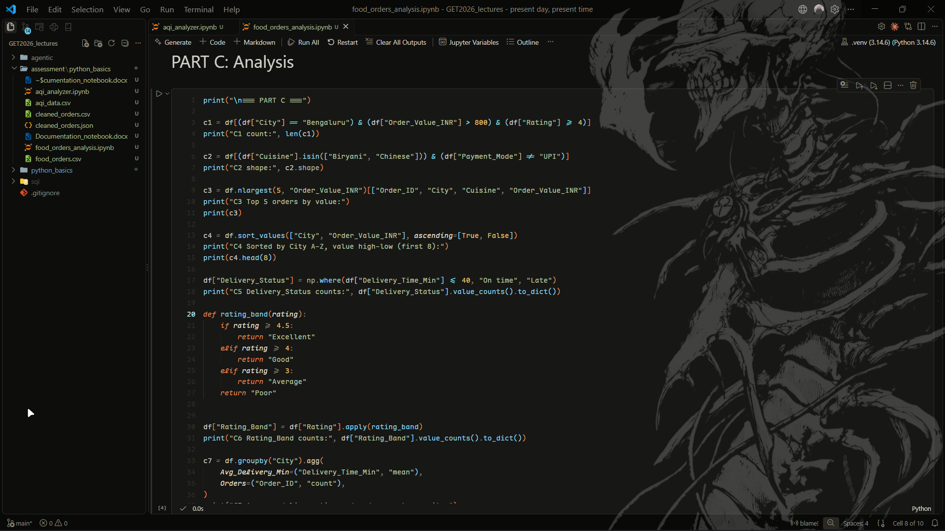
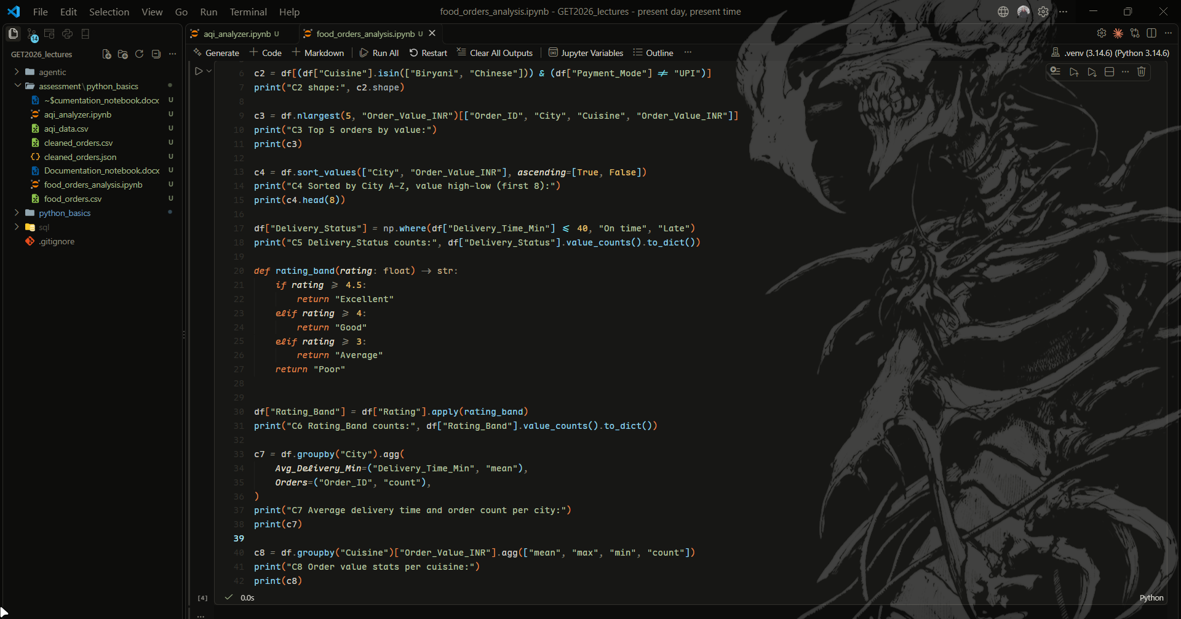
b) Output screenshot
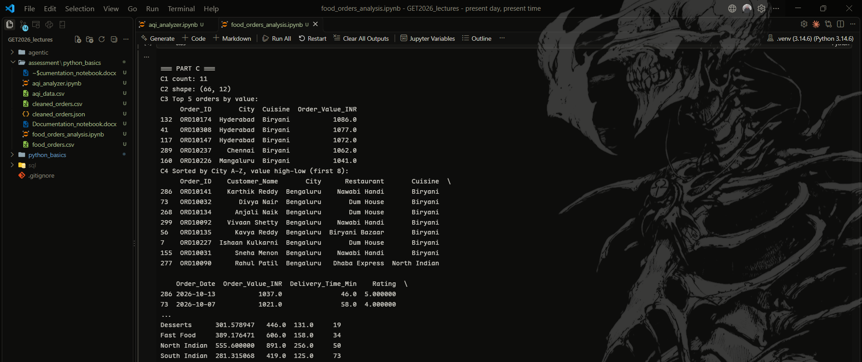
c) Explanation
What I did
Filtered orders, found the top 5, sorted, added On time/Late and rating band columns, grouped by city and cuisine.
Why this method
I used & instead of "and" because "and" doesn't work on a whole column. Each condition needs its own brackets.
What the result tells me
116 of 302 orders were Late. Bengaluru is slowest (44.5 min) and Biryani is most expensive (717.15 INR).

2.4. Part D: Export and verify
a) Code screenshot and b) Output screenshot (cleaned_orders.csv and cleaned_orders.json are visible in the folder on the left, plus both printed shapes)
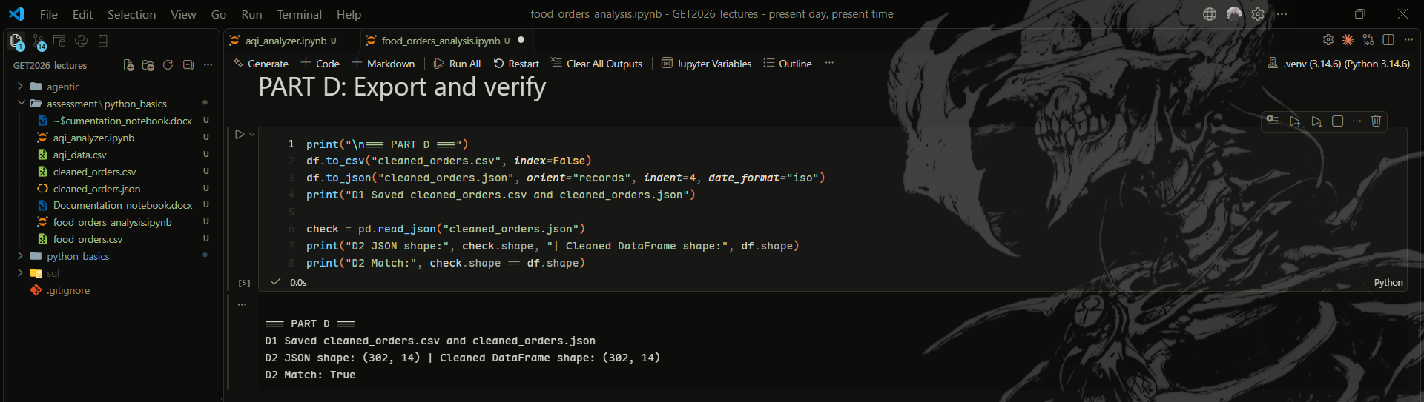
c) Explanation
What I did
Saved the clean data as CSV and JSON, then loaded the JSON back to check it.
Why this method
index=False stops an extra index column. Loading the file back proves nothing was lost.
What the result tells me
Both shapes are (302, 14), so the file matches the data.

2.5. Part E: Insights
a) Code screenshot
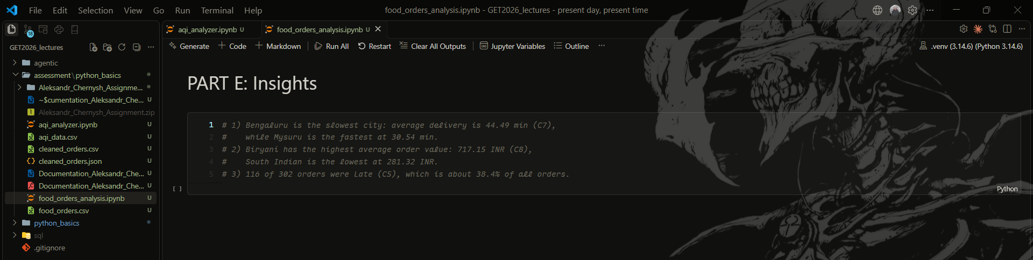

Declaration
AI tool usage: I used Claude to help me generate the skeleton of this report as well as prettify the print statements in my programs.

