EECE 503M: Software Security Sacha Hannoun
Assignment 1 Report: SQL Injection
Fixed code repository: <paste your GitHub repo link here>
Objective 1: Return an Unexpected Ticket
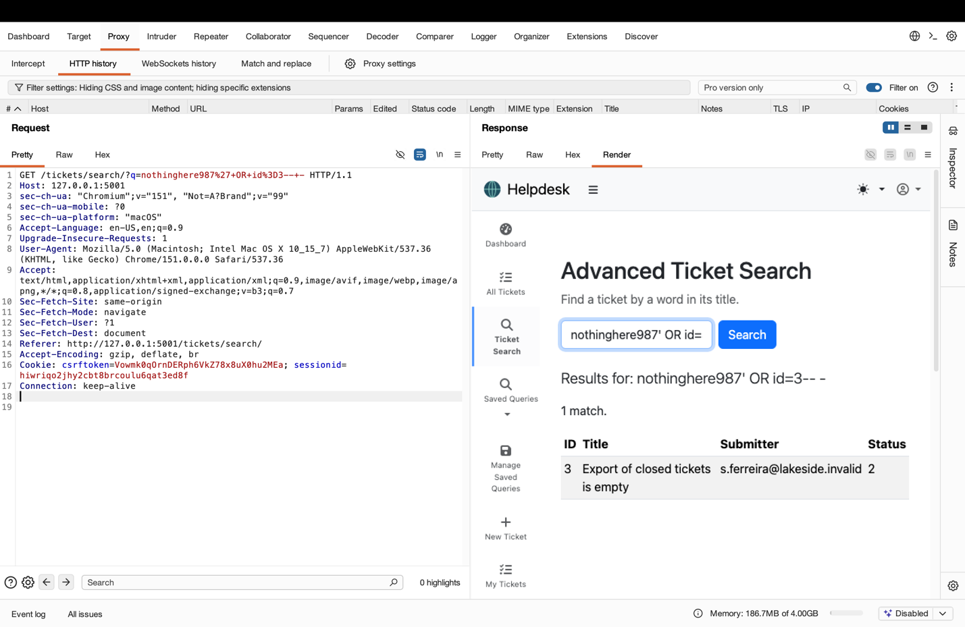
Payload: nothinghere987' OR id=3-- -
Explanation: The payload ends the original search string and adds the condition OR id=3, while -- - comments out the rest of the query. Since no ticket title contains nothinghere987, the search should return nothing. Because of the injection, ticket 3 is returned instead, showing the search can be forced to return an unrelated ticket.

Objective 2: Return Every Ticket
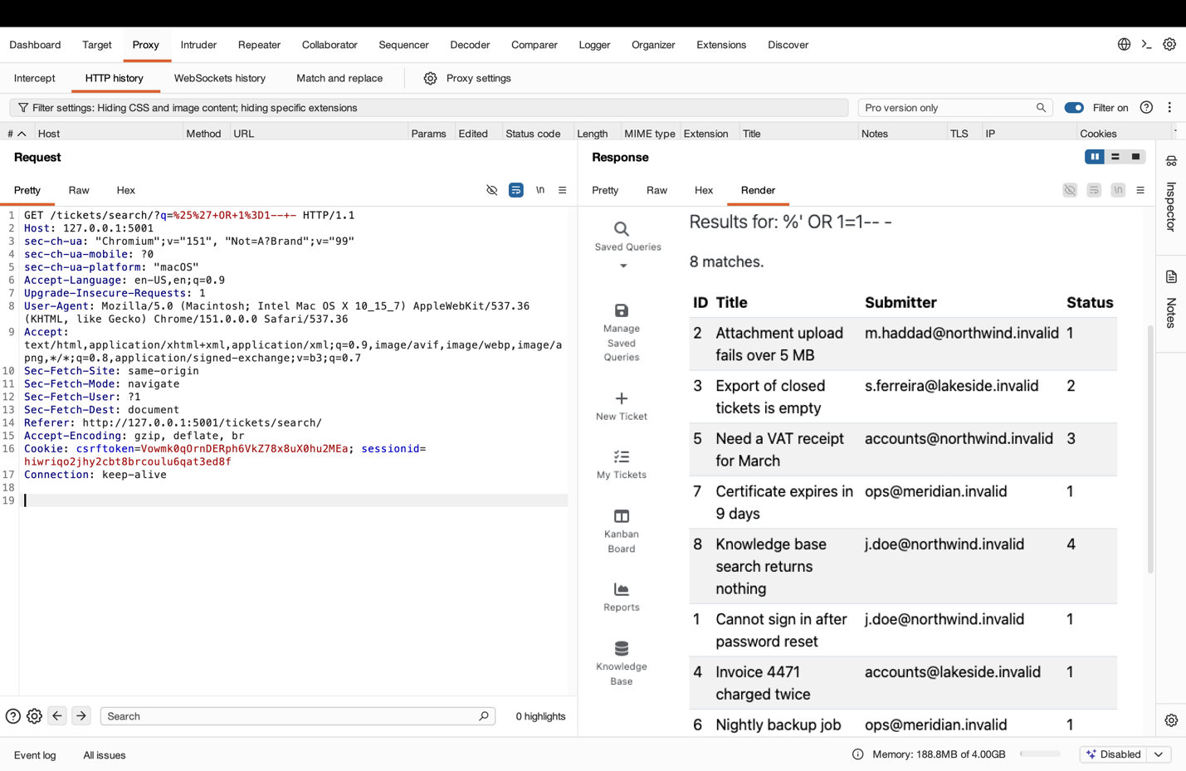
Payload: %' OR 1=1-- -
Explanation: The payload closes the original string with %', then adds the always-true condition OR 1=1, and -- - comments out the rest. The database ignores the intended filter and returns all 8 tickets instead of only matching ones.
Objective 3: Return Usernames and Password Hashes
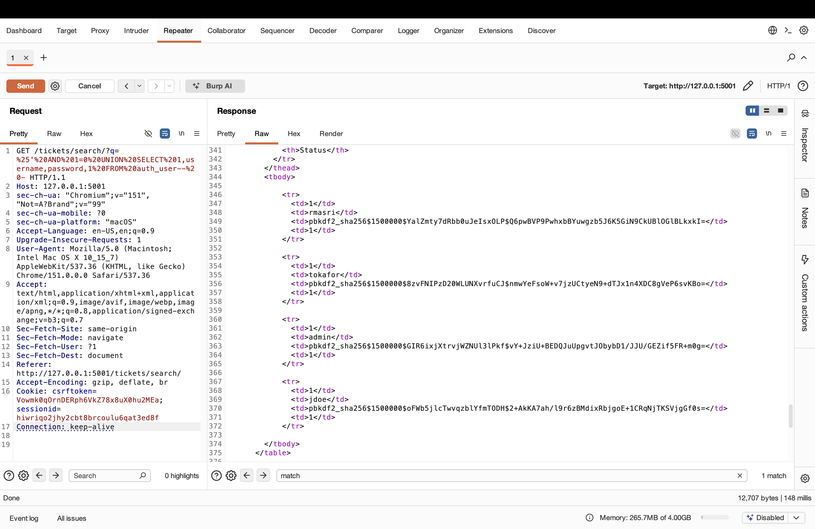
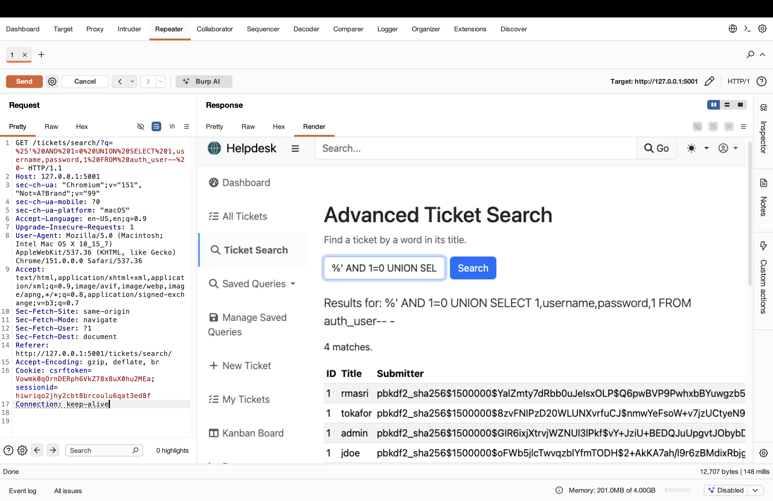
Payload: %' AND 1=0 UNION SELECT 1, username, password, 1 FROM auth_user-- -
Explanation: AND 1=0 makes the original search return nothing, so the only rows that come back are from the injected UNION SELECT, which reads from the auth_user table. The staff usernames appear in the Title column and their password hashes in the Submitter column. This confirms a UNION-based SQL injection that exposes data from another table.
Objective 4: Boolean-Based Blind SQL Injection
A Python script automated the extraction of the administrator's password hash using a boolean-based blind injection. It tested one character at a time by sending crafted requests and checking whether the application returned any results. From these true/false answers it rebuilt the hash until all 89 characters were recovered.
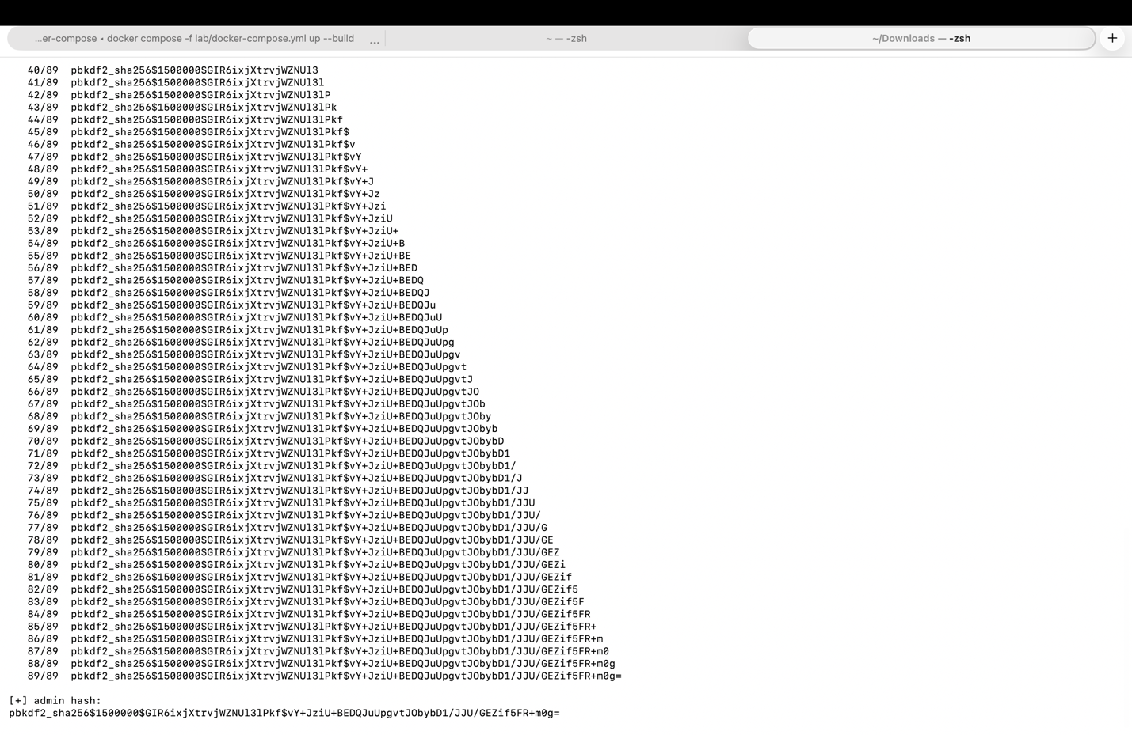
Recovered administrator hash: pbkdf2_sha256$1500000$GIR6ixjXtrvjWZNUl3IPkf$vY+JziU+BEDQJuUpgvtJObybD1/JJU/GEZif5FR+m0g=
Objective 5: Time-Based Blind SQL Injection
A time-based blind injection script recovered the same hash without any data showing in the response. The page looks identical every time, so the script made the database pause when a guess was correct and measured the response delay. It verified the timing oracle, found the hash length was 89 characters, and recovered the hash one character at a time by timing. It reconstructed the complete stored password hash.
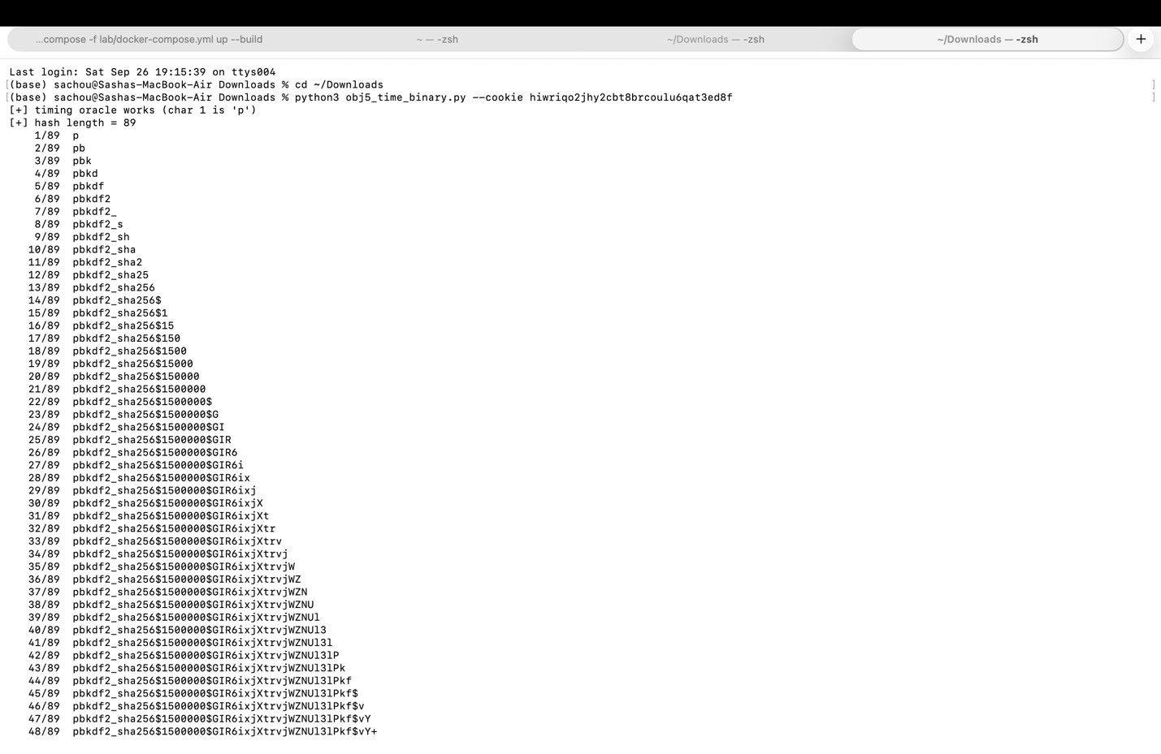
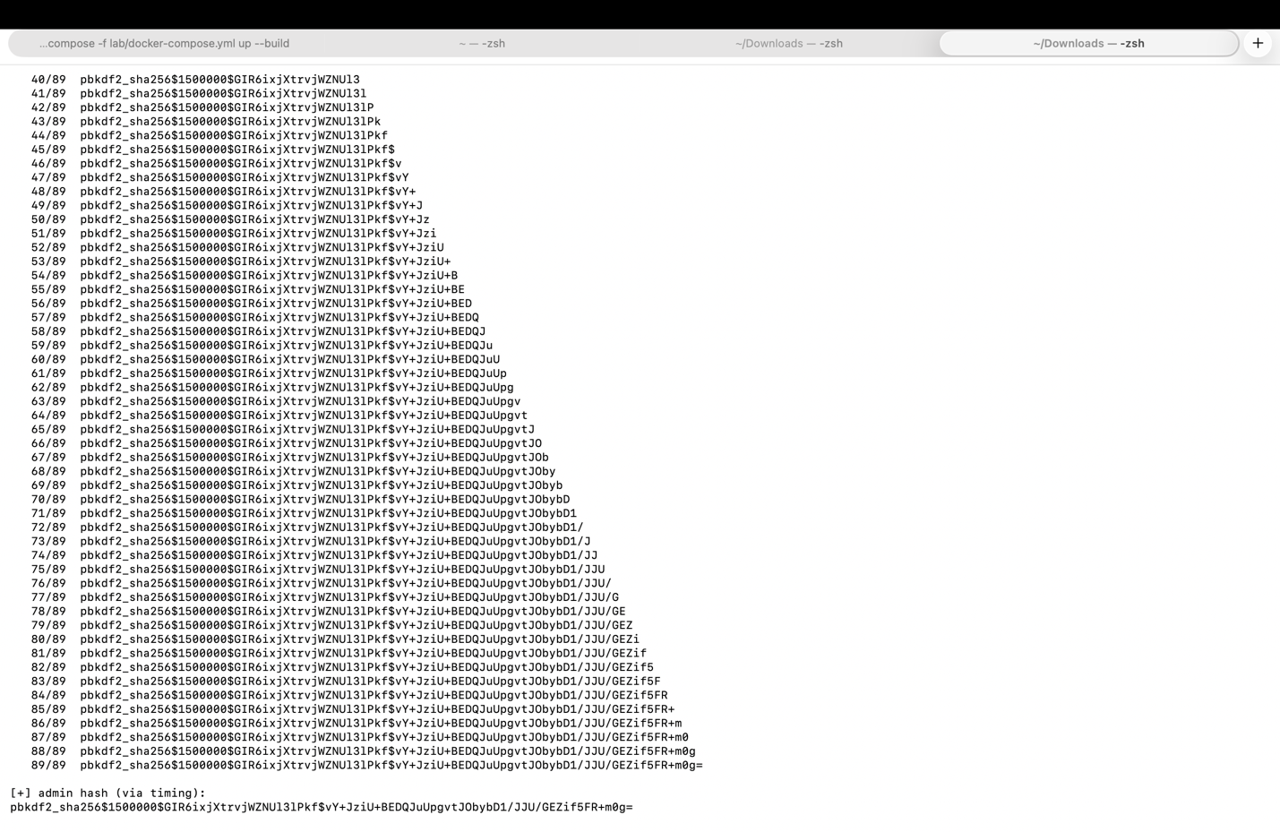
Remediation: Fixing the Vulnerability
The bug is in src/helpdesk/views/staff.py, in the advanced_ticket_search function. The original code built the SQL by joining the user's input straight into the query string.
The fix replaces the raw SQL with Django's ORM, which passes the search term as a bound parameter instead of pasting it into the query. The database then treats the input as plain data, so injection is no longer possible.
Verification: Attacks After the Fix
After applying the fix and letting the app reload, the same attacks were run again. They now return 0 matches because the input is treated as literal text, while a normal search still works.
The 'return every ticket' attack now returns 0 matches:
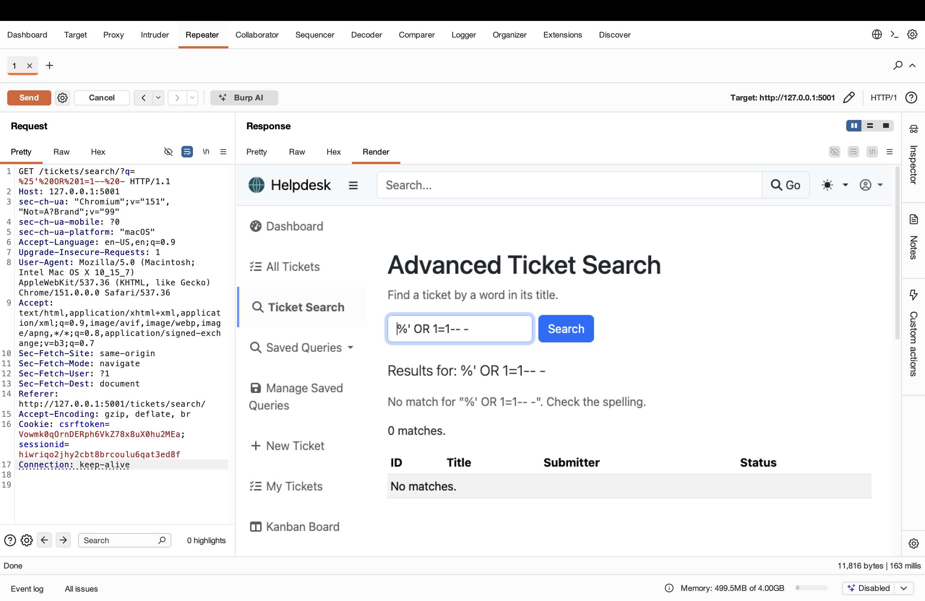
The UNION credential-theft attack now returns 0 matches so no usernames or hashes leak:
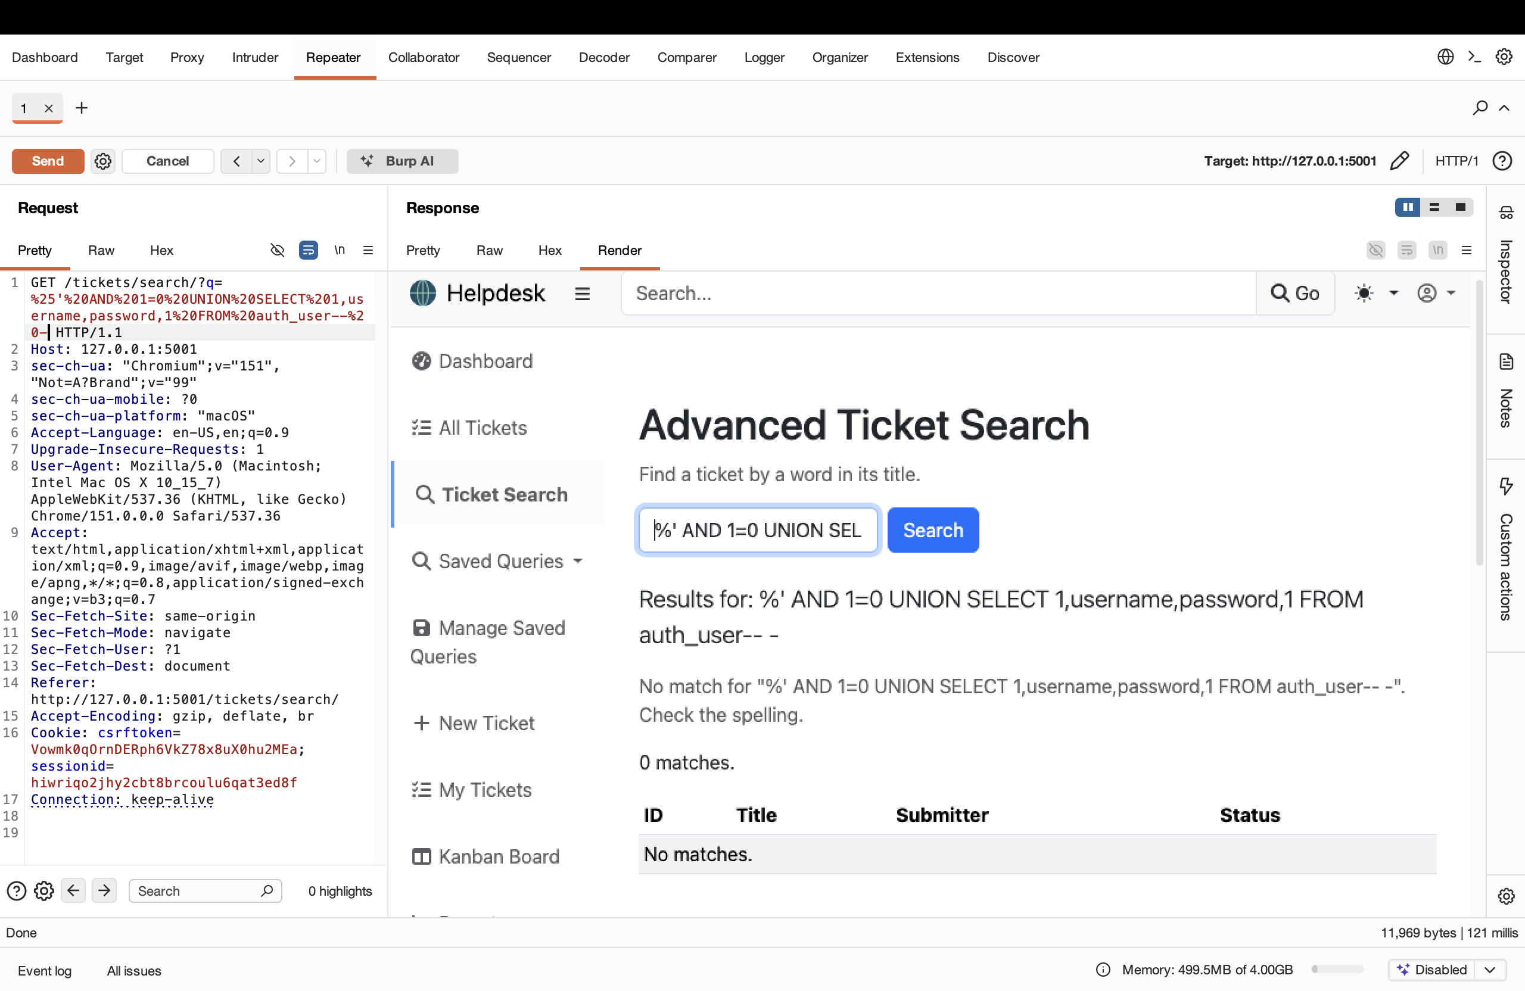
A normal search (invoice) still returns the correct ticket, showing the fix did not break the feature:
