AMERICAN UNIVERSITY OF BEIRUT
EECE 503M — Software Security
Lab 3 Report
Broken Access Control and Command Injection
Student Name: Sacha Hannoun
Student ID: 202404910
GitHub Link: https://github.com/sashahannoun/EECE-503M

Objective
This lab targets the Meridian Service Desk application at http://127.0.0.1:5001. Part A exploits broken access control, Part B exploits command injection, and the finale chains both. All requests were made through Burp Suite using Repeater. The lab was run signed in as the support agent rmasri.

1 Part A — Broken Access Control

1.1 A1 — IDOR across the queue boundary
Ticket 4 is a Billing ticket, outside rmasri's queue. Requesting it directly returned the ticket, because the app only checked that the user was logged in, not that the ticket belonged to the user's queue.
GET /tickets/4/
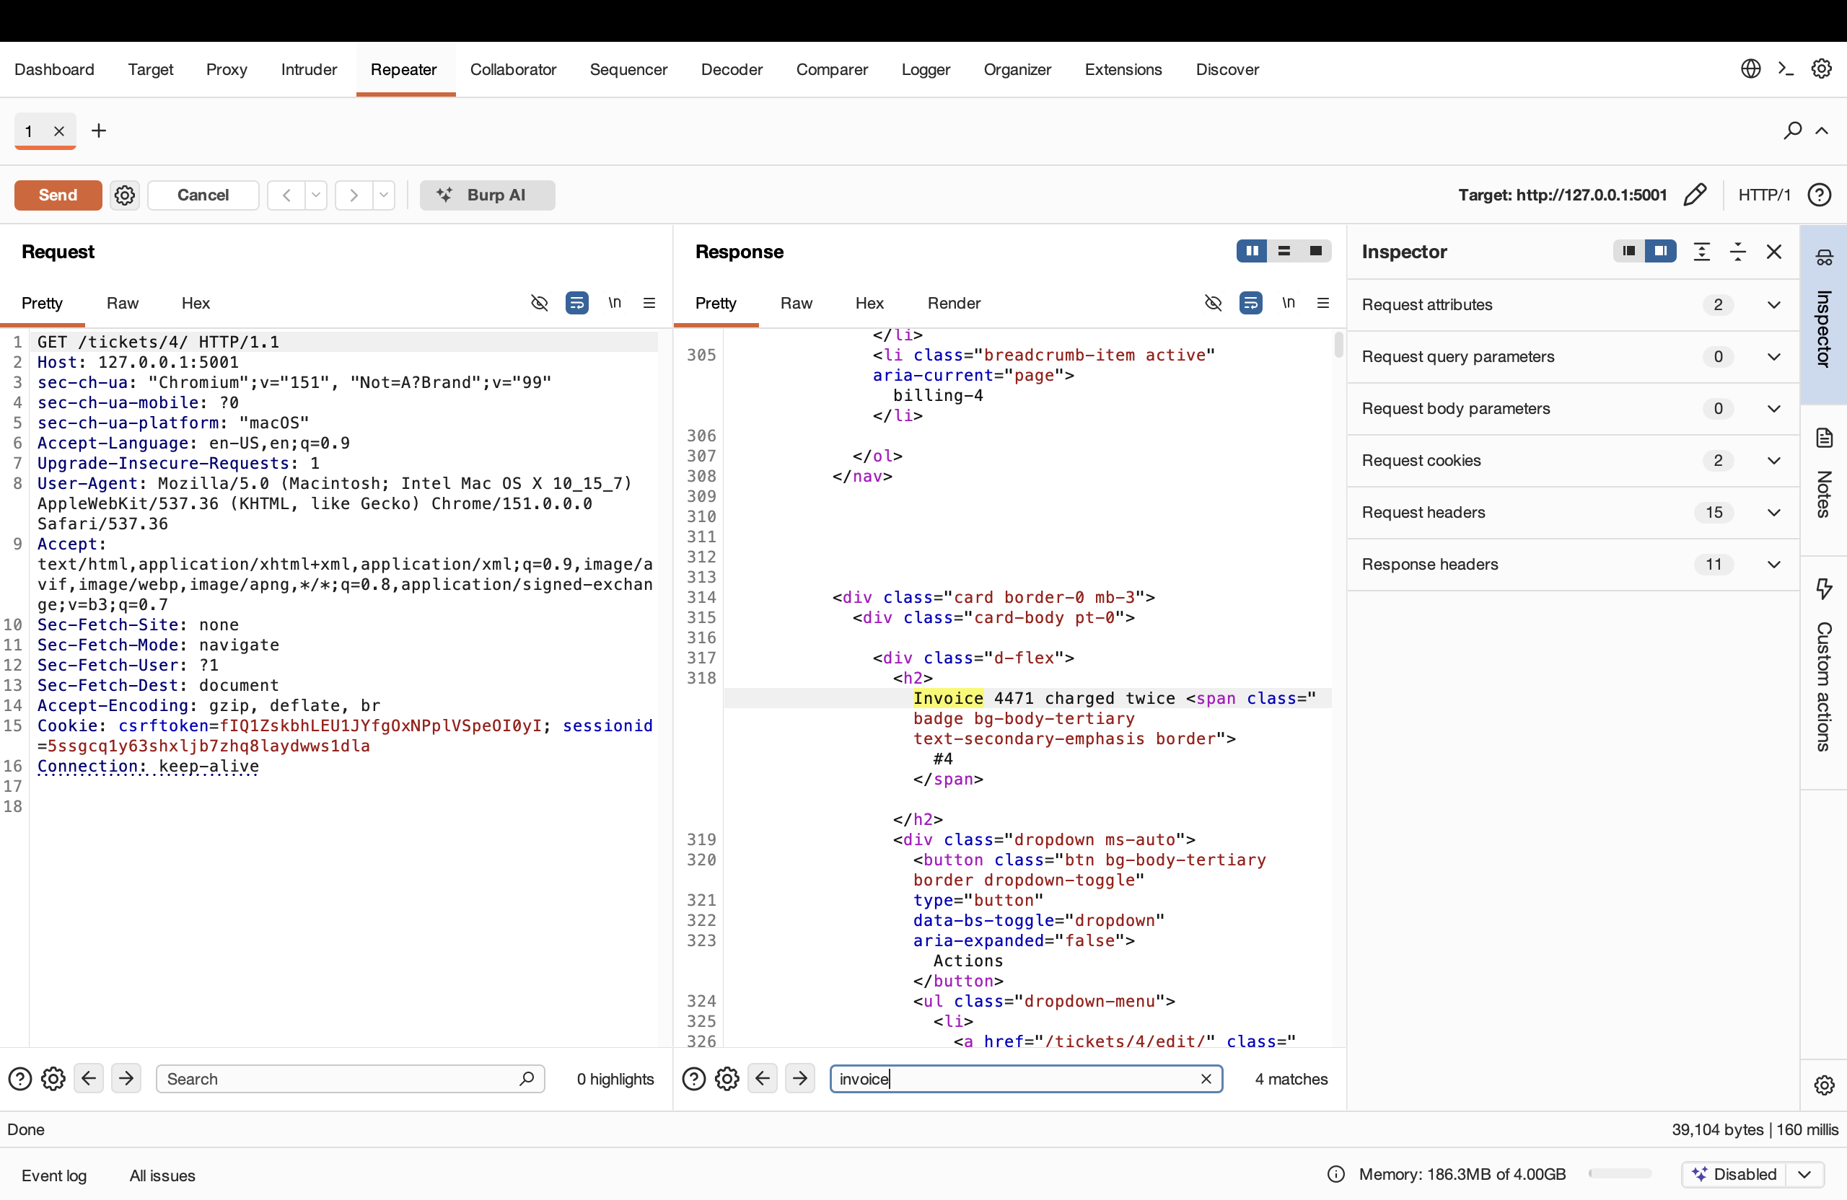
Figure 1 — Ticket 4 (billing-4) is read by rmasri. 200 OK.
Requesting a neighbouring id returned another foreign ticket, showing the problem is systematic and the ids are guessable.
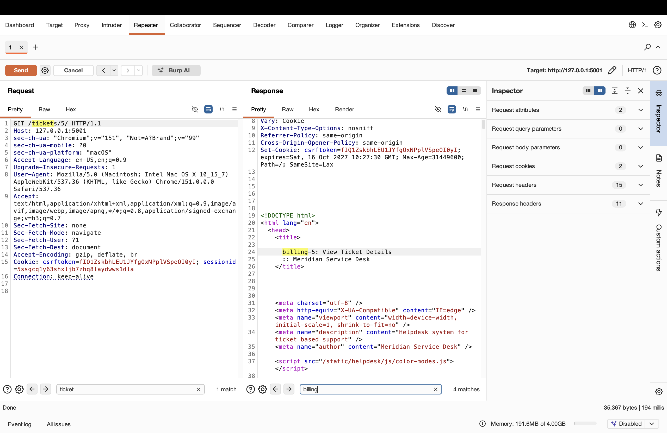
Figure 2 — Ticket 5 (billing-5) is also read by rmasri. 200 OK.

1.2 A2 — Vertical privilege escalation
The admin tool at /admin-tools/promote/ grants a user administrator rights. It only checks that the caller is staff, not that the caller is an administrator, so a plain agent can call it.
GET /admin-tools/promote/?user=tokafor
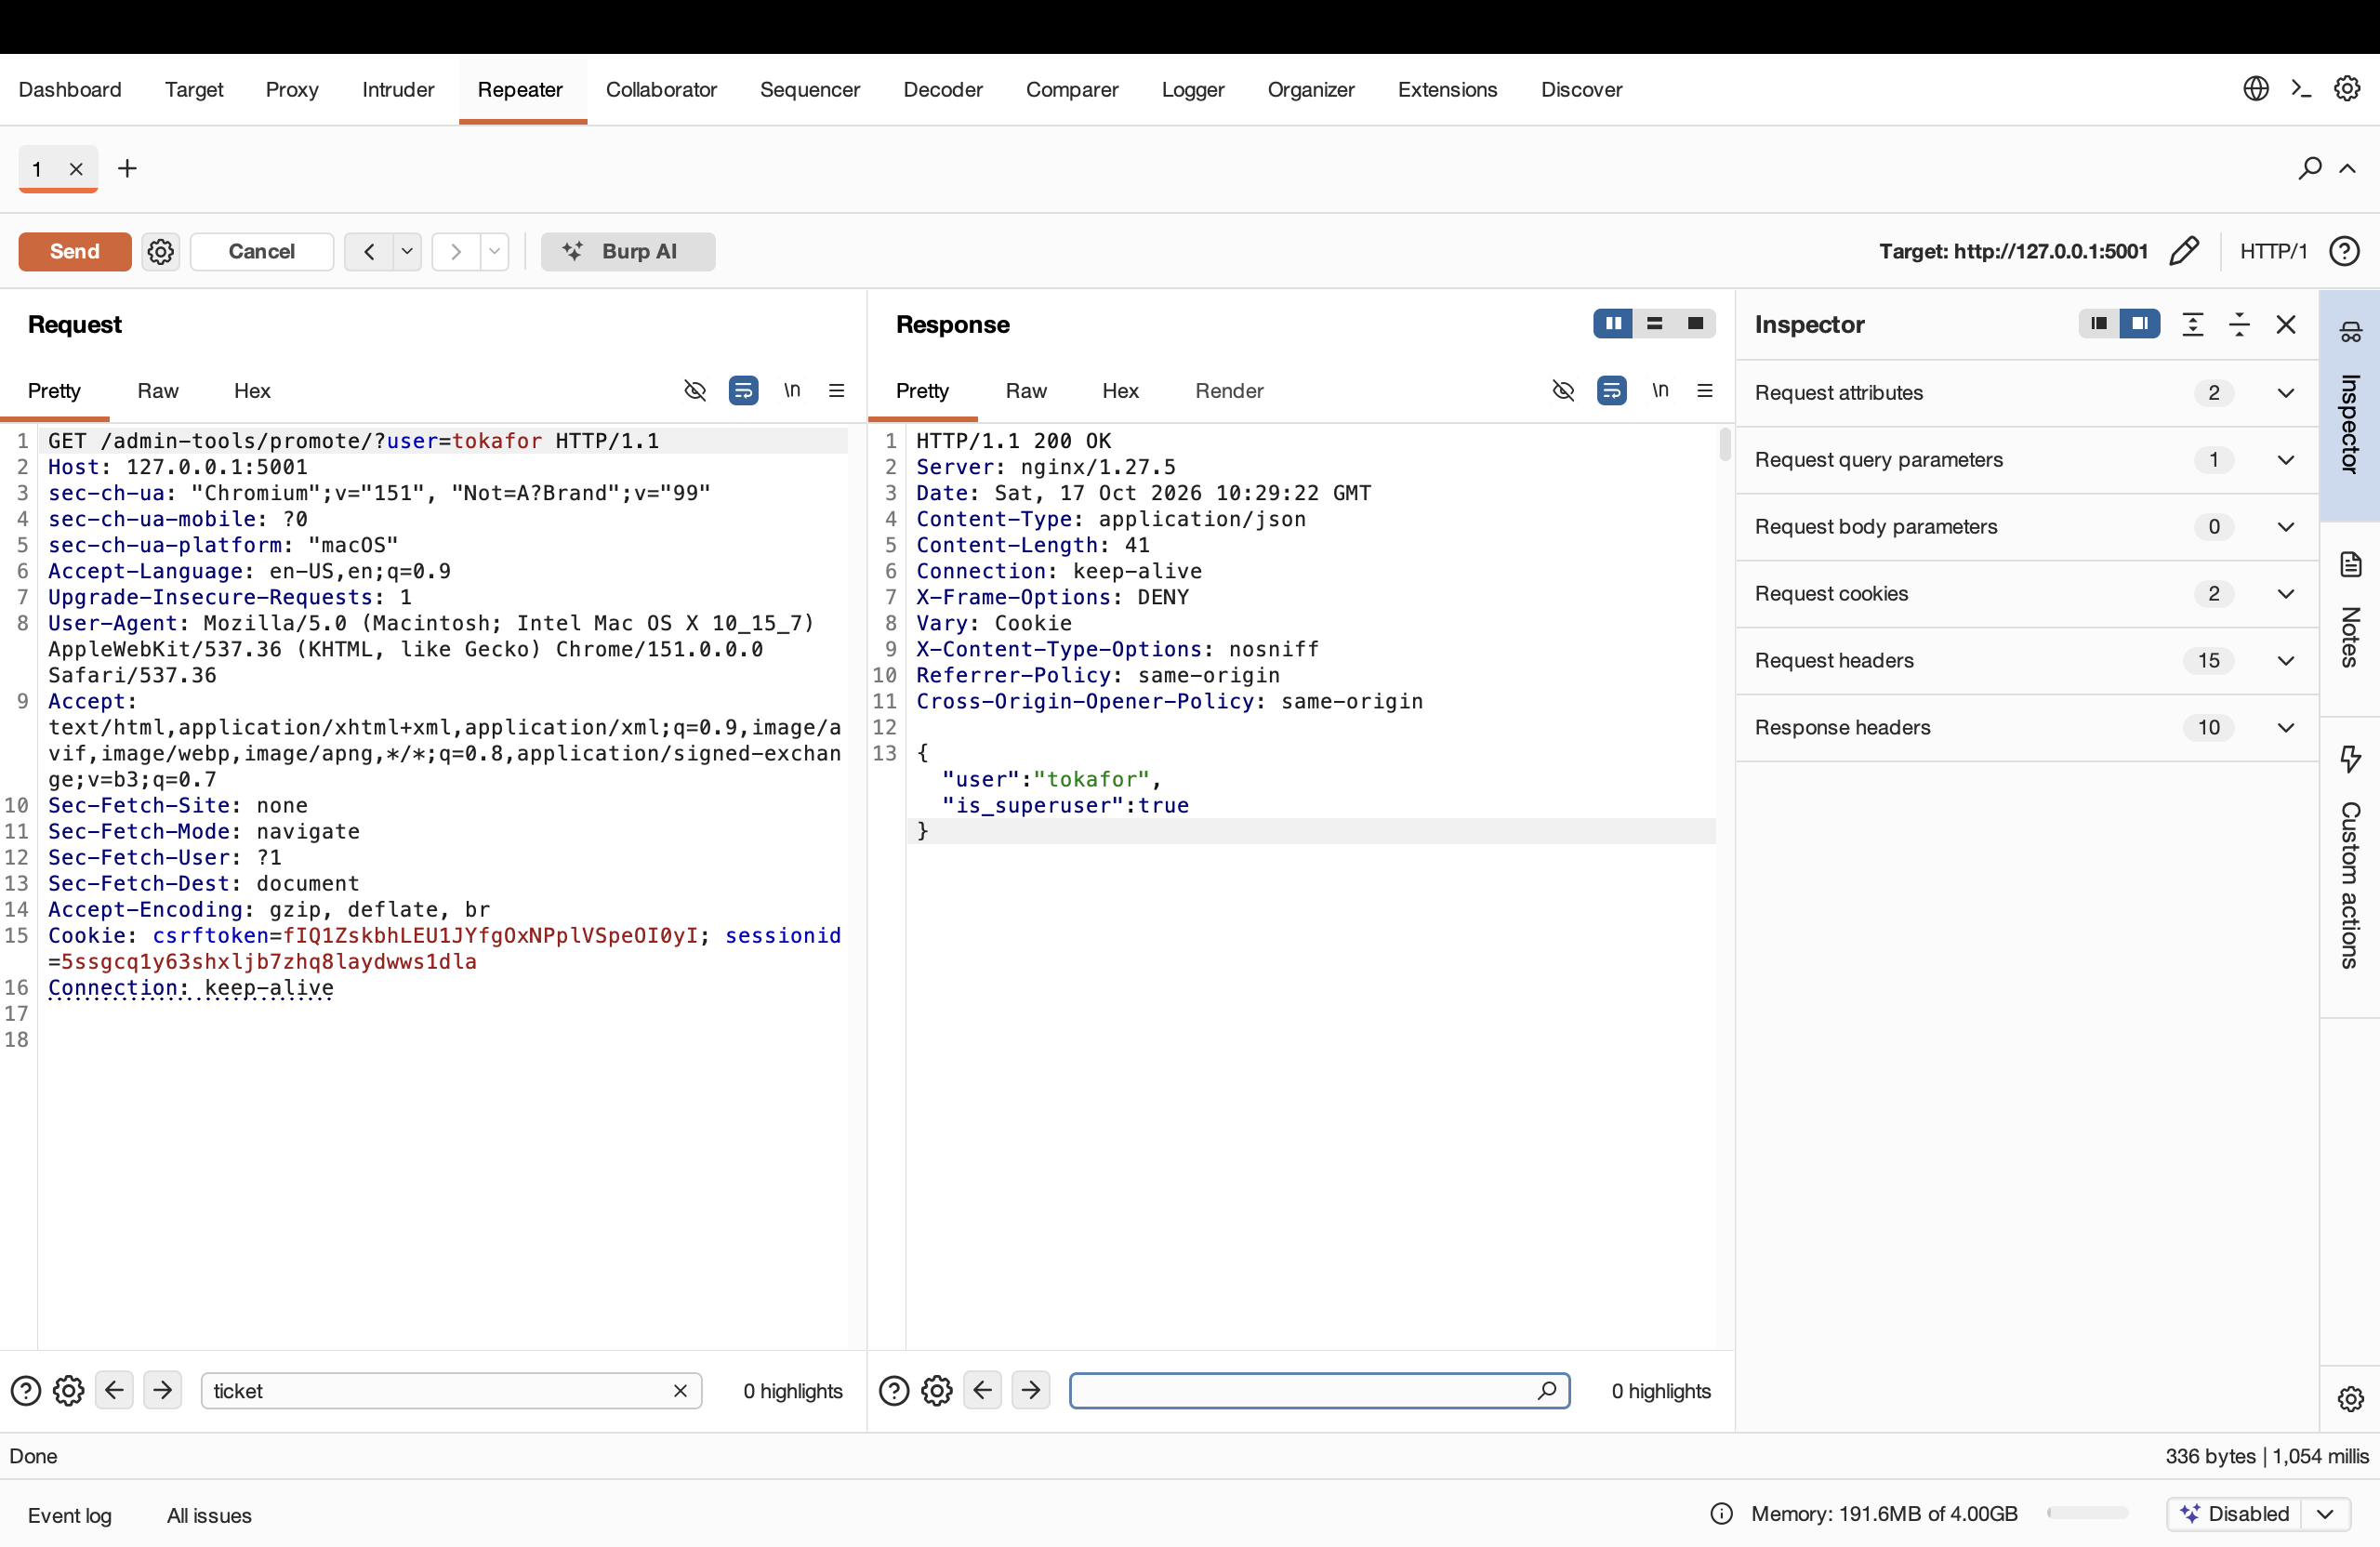
Figure 3 — As rmasri, promoting tokafor returns is_superuser = true.

1.3 A3 — Cross-site request forgery (CSRF)
The change-email action accepts a POST with no CSRF token. The view was marked @csrf_exempt, so Django does not check the token, Referer, or Origin. The request below has none of them and still succeeds.
POST /profile/email/
email=attacker@evil.invalid
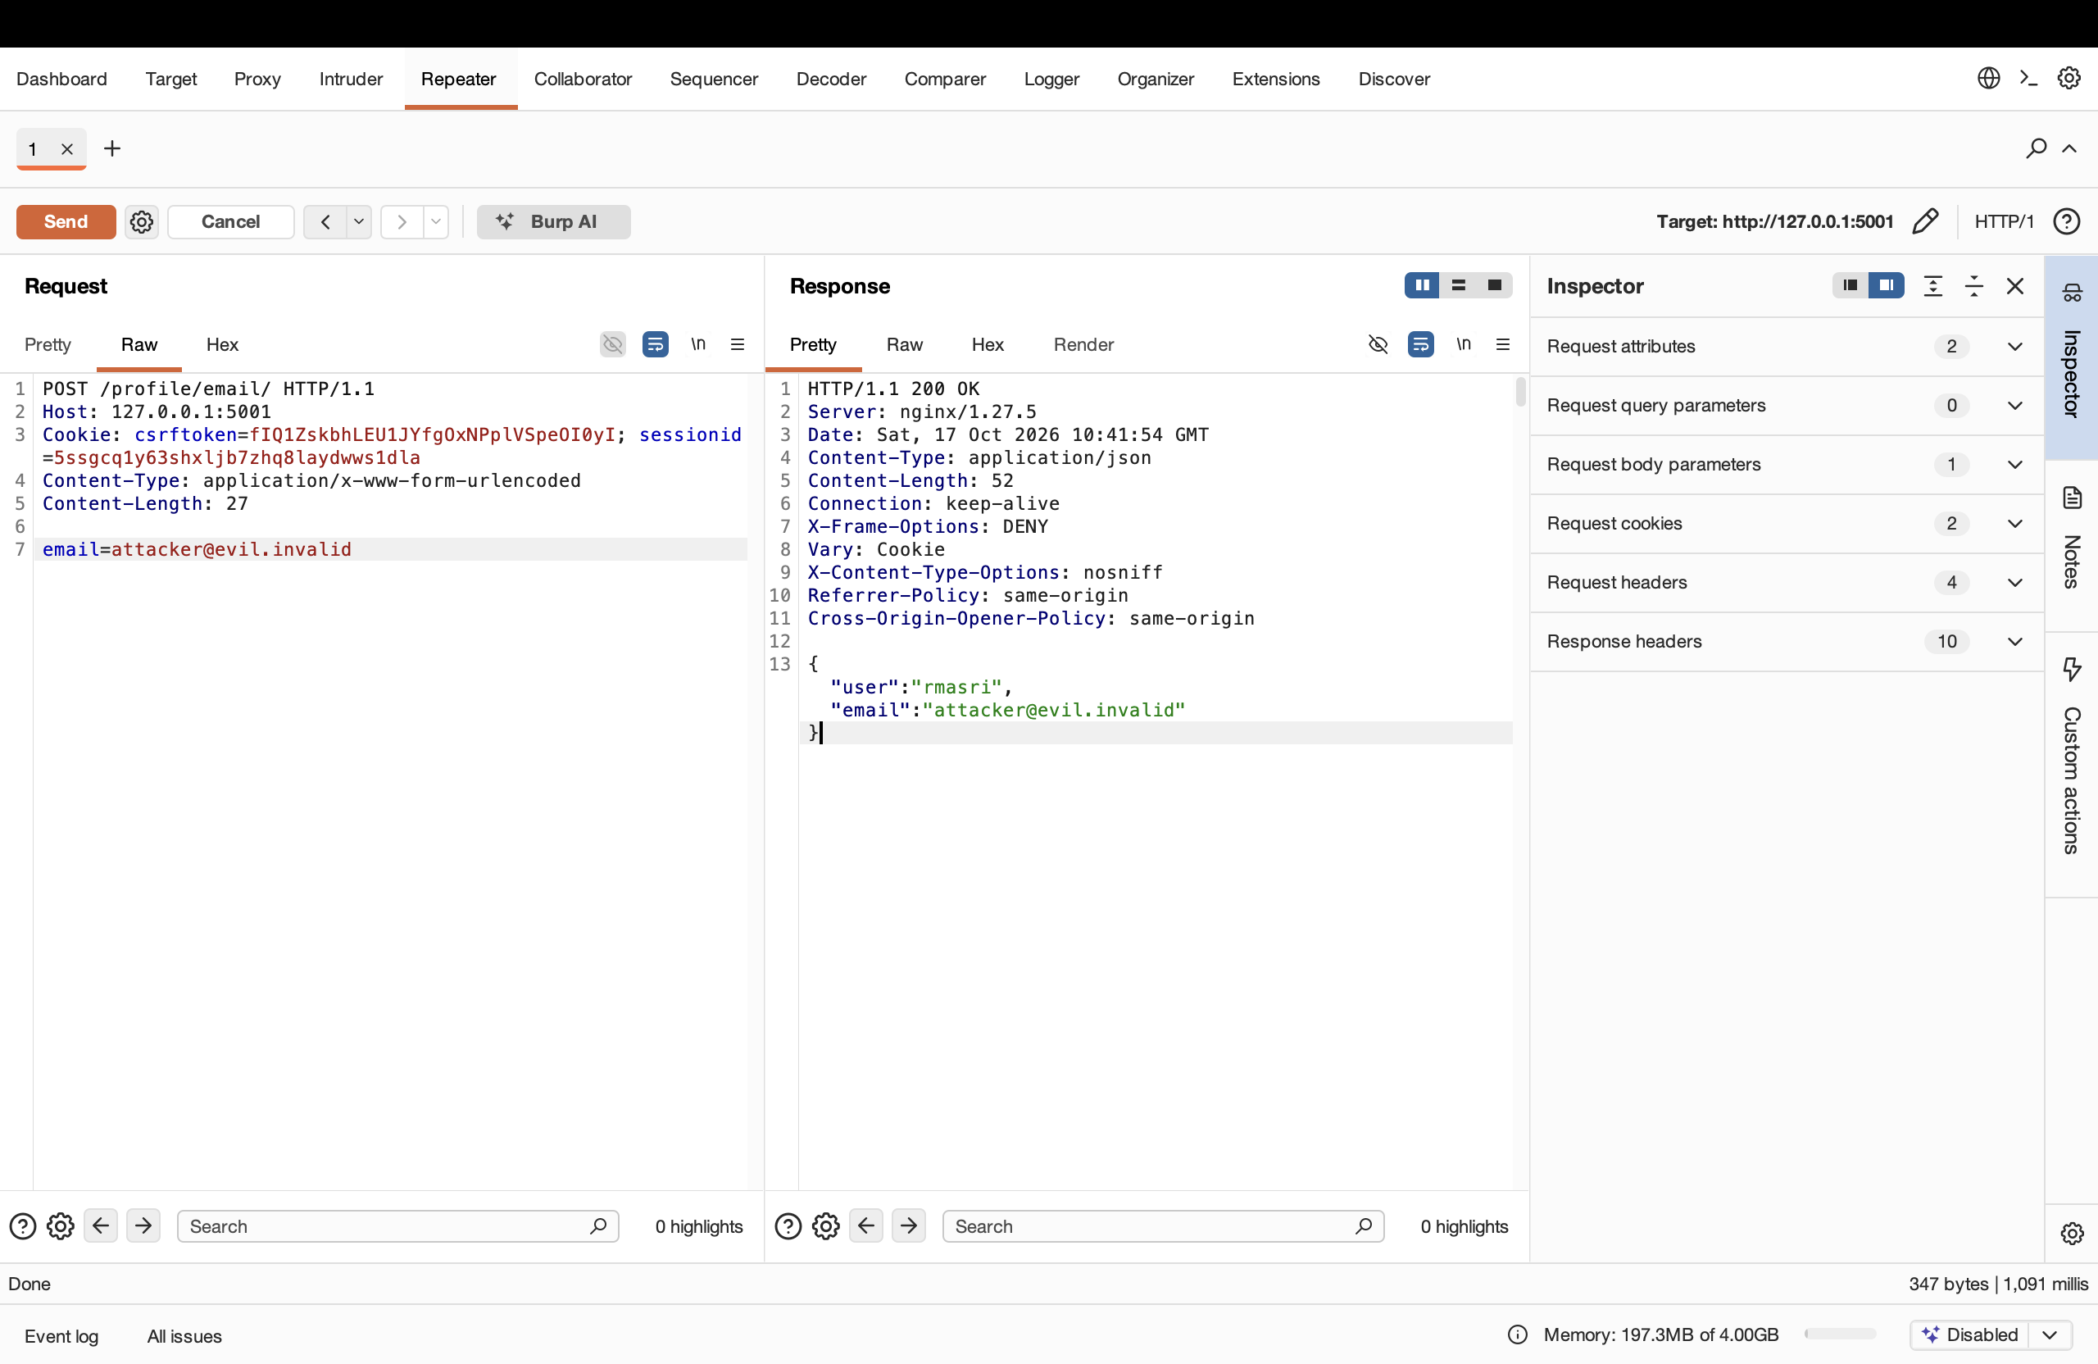
Figure 4 — The tokenless POST succeeds and changes rmasri's e-mail. 200 OK.

2 Part B — Command Injection
The export at /tickets/<id>/export/ takes a label and builds a shell command from it. Shell metacharacters in the label run as commands. The label value is URL-encoded before sending so that # and & are not misread by the URL. The export appends .txt after the label, so a trailing # comments it out.

2.1 B5 — Chain a command with ;
The ; separator runs a second command. The label x; id # makes the server run id.
GET /tickets/2/export/?label=x; id #
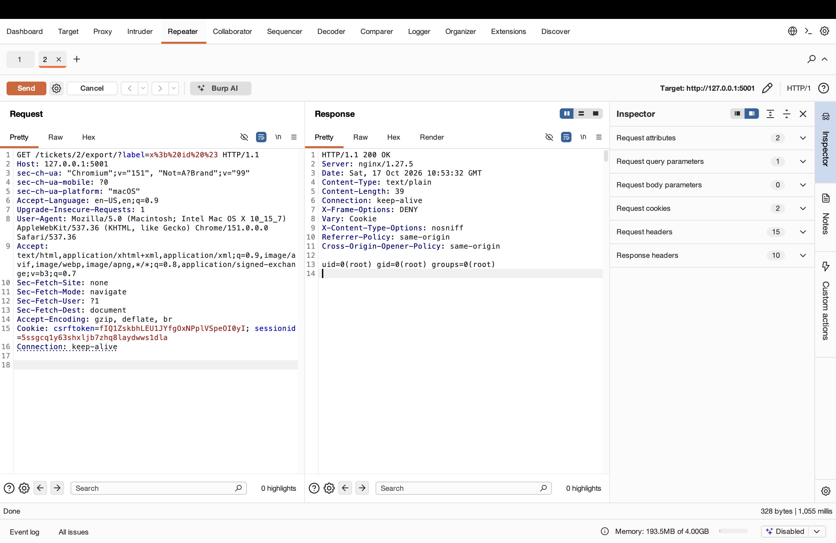
Figure 5 — The response contains uid=0(root): the injected id ran as root.

2.2 B6 — Confirm with another separator
The same result through a different operator (&&) confirms the injection is real.
GET /tickets/2/export/?label=x && id #
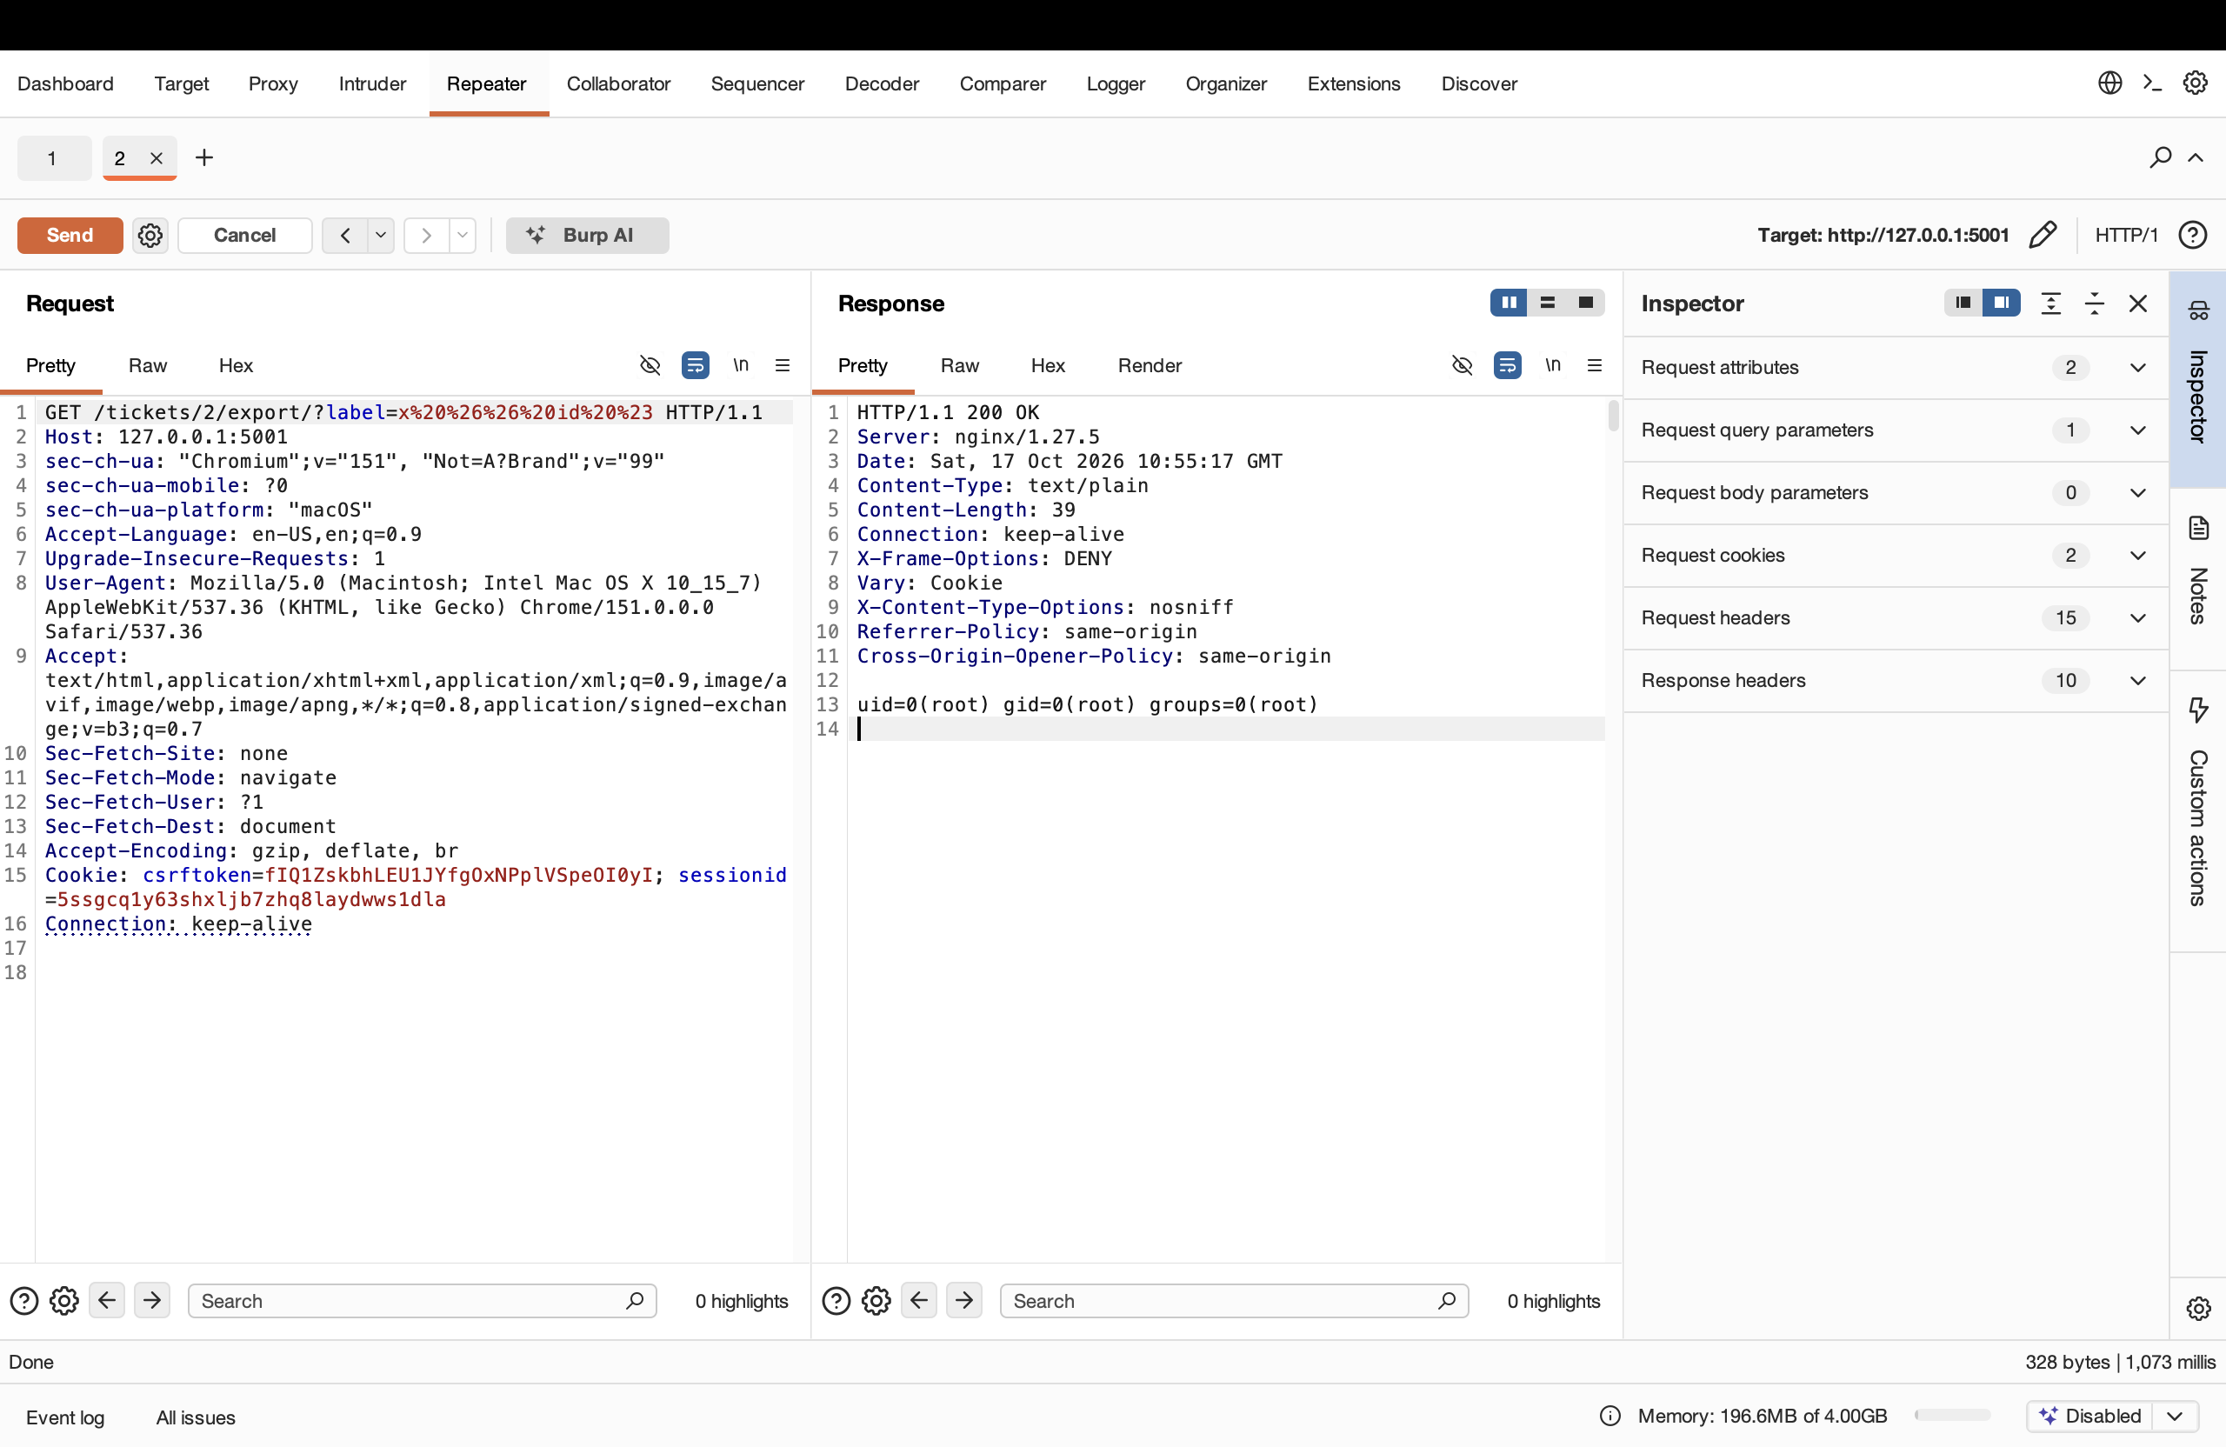
Figure 6 — The && separator also returns uid=0(root).

2.3 B7 — File read for impact
Reading a file proves the access. The label below returns the contents of /etc/passwd.
GET /tickets/2/export/?label=x; cat /etc/passwd #
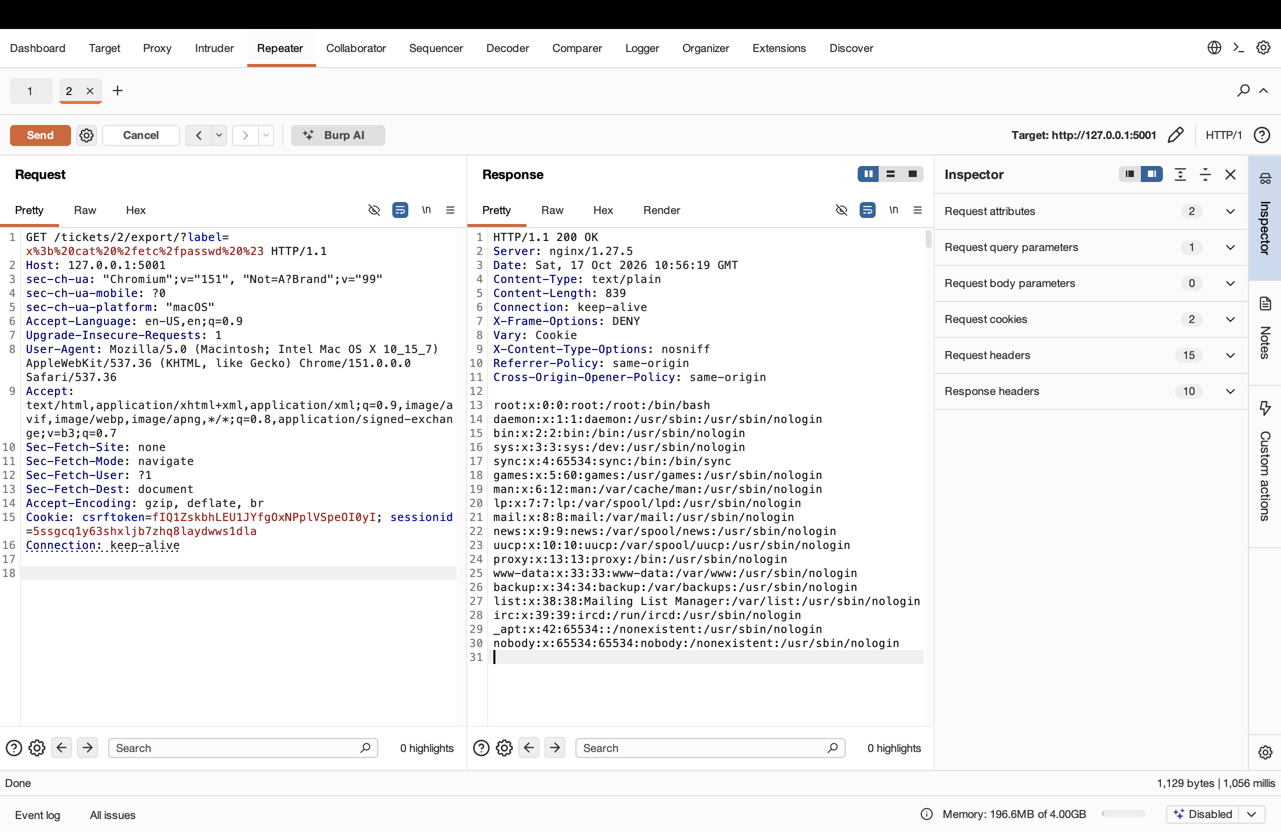
Figure 7 — The response returns the contents of /etc/passwd.

3 Finale — Chaining the Two
A support agent should not be able to export a Billing ticket, let alone run a command through it. Part A showed the object check is missing, and Part B showed the label is a shell. Aiming the export at ticket 4 (outside the queue) with an injected label crosses the queue boundary and runs a command behind it in one request.
GET /tickets/4/export/?label=x; id #
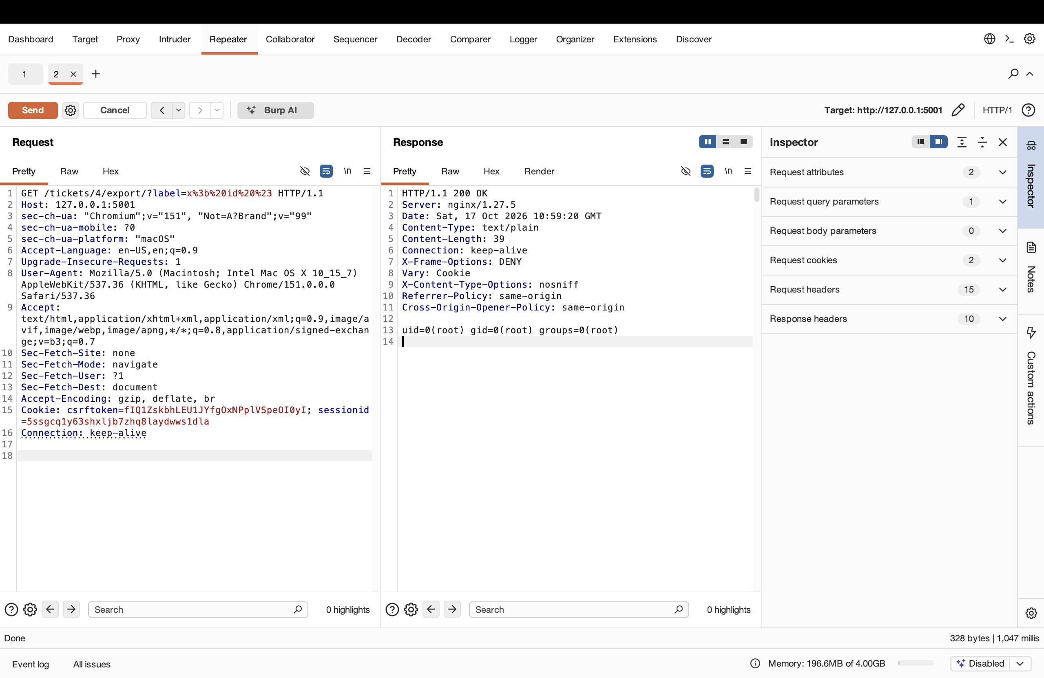
Figure 8 — As rmasri, exporting ticket 4 returns uid=0(root): access control bypass plus command injection, running as root.

4 Remediation
All four fixes were made in src/helpdesk/views/staff.py. The fixed file is in the Lab-3 folder of the GitHub repository.
Broken access control (IDOR): view_ticket and export_ticket now confirm the signed-in agent can access the ticket's queue, using HelpdeskUser(request.user).can_access_queue(ticket.queue), and deny the request otherwise.
Privilege escalation: promote_user now requires request.user.is_superuser, so a non-administrator is refused.
CSRF: the @csrf_exempt decorator was removed from change_email, so Django's CSRF token check applies to the form.
Command injection: export_ticket no longer builds a shell string. The file is written in Python with no shell, and the label is used only as a path-stripped filename, so shell characters can never run as a command.

5 Verification After the Fix
Every attack was re-run after the fix. Each one now fails.
Attack | Before fix | After fix
A1 — view ticket 4 (foreign queue) | 200, billing ticket shown | 403 Forbidden
A2 — promote a user | is_superuser = true | 403 Forbidden
A3 — tokenless e-mail change | 200, e-mail changed | 403, CSRF token missing
B — export injection (ticket 2) | uid=0(root) | ticket file, no id output
Finale — export injection (ticket 4) | uid=0(root) | 403 Forbidden

5.1 Access control now enforced
Ticket 4 is denied to rmasri.
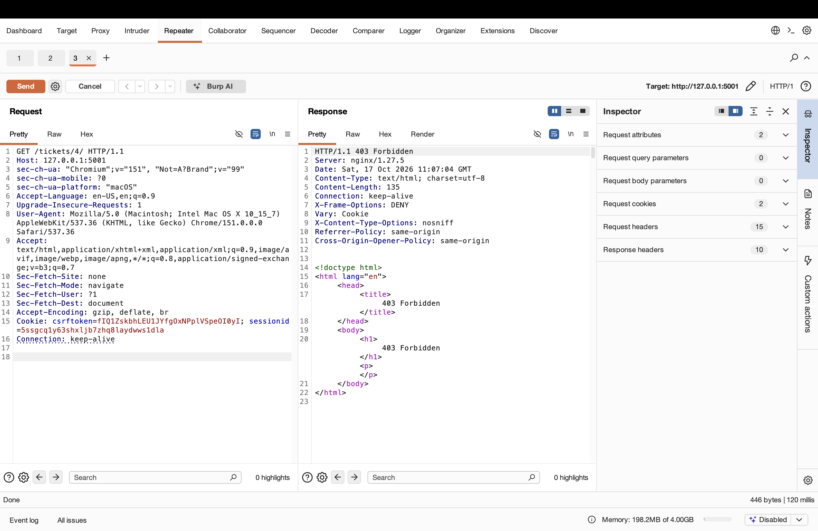
Figure 9 — After the fix: /tickets/4/ returns 403 Forbidden.
The promote tool refuses a non-administrator.
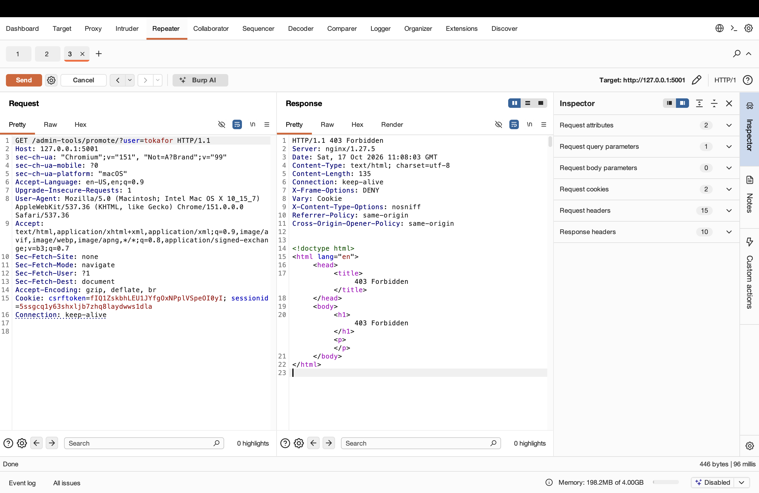
Figure 10 — After the fix: promote returns 403 Forbidden.

5.2 CSRF now enforced
The tokenless POST is rejected.
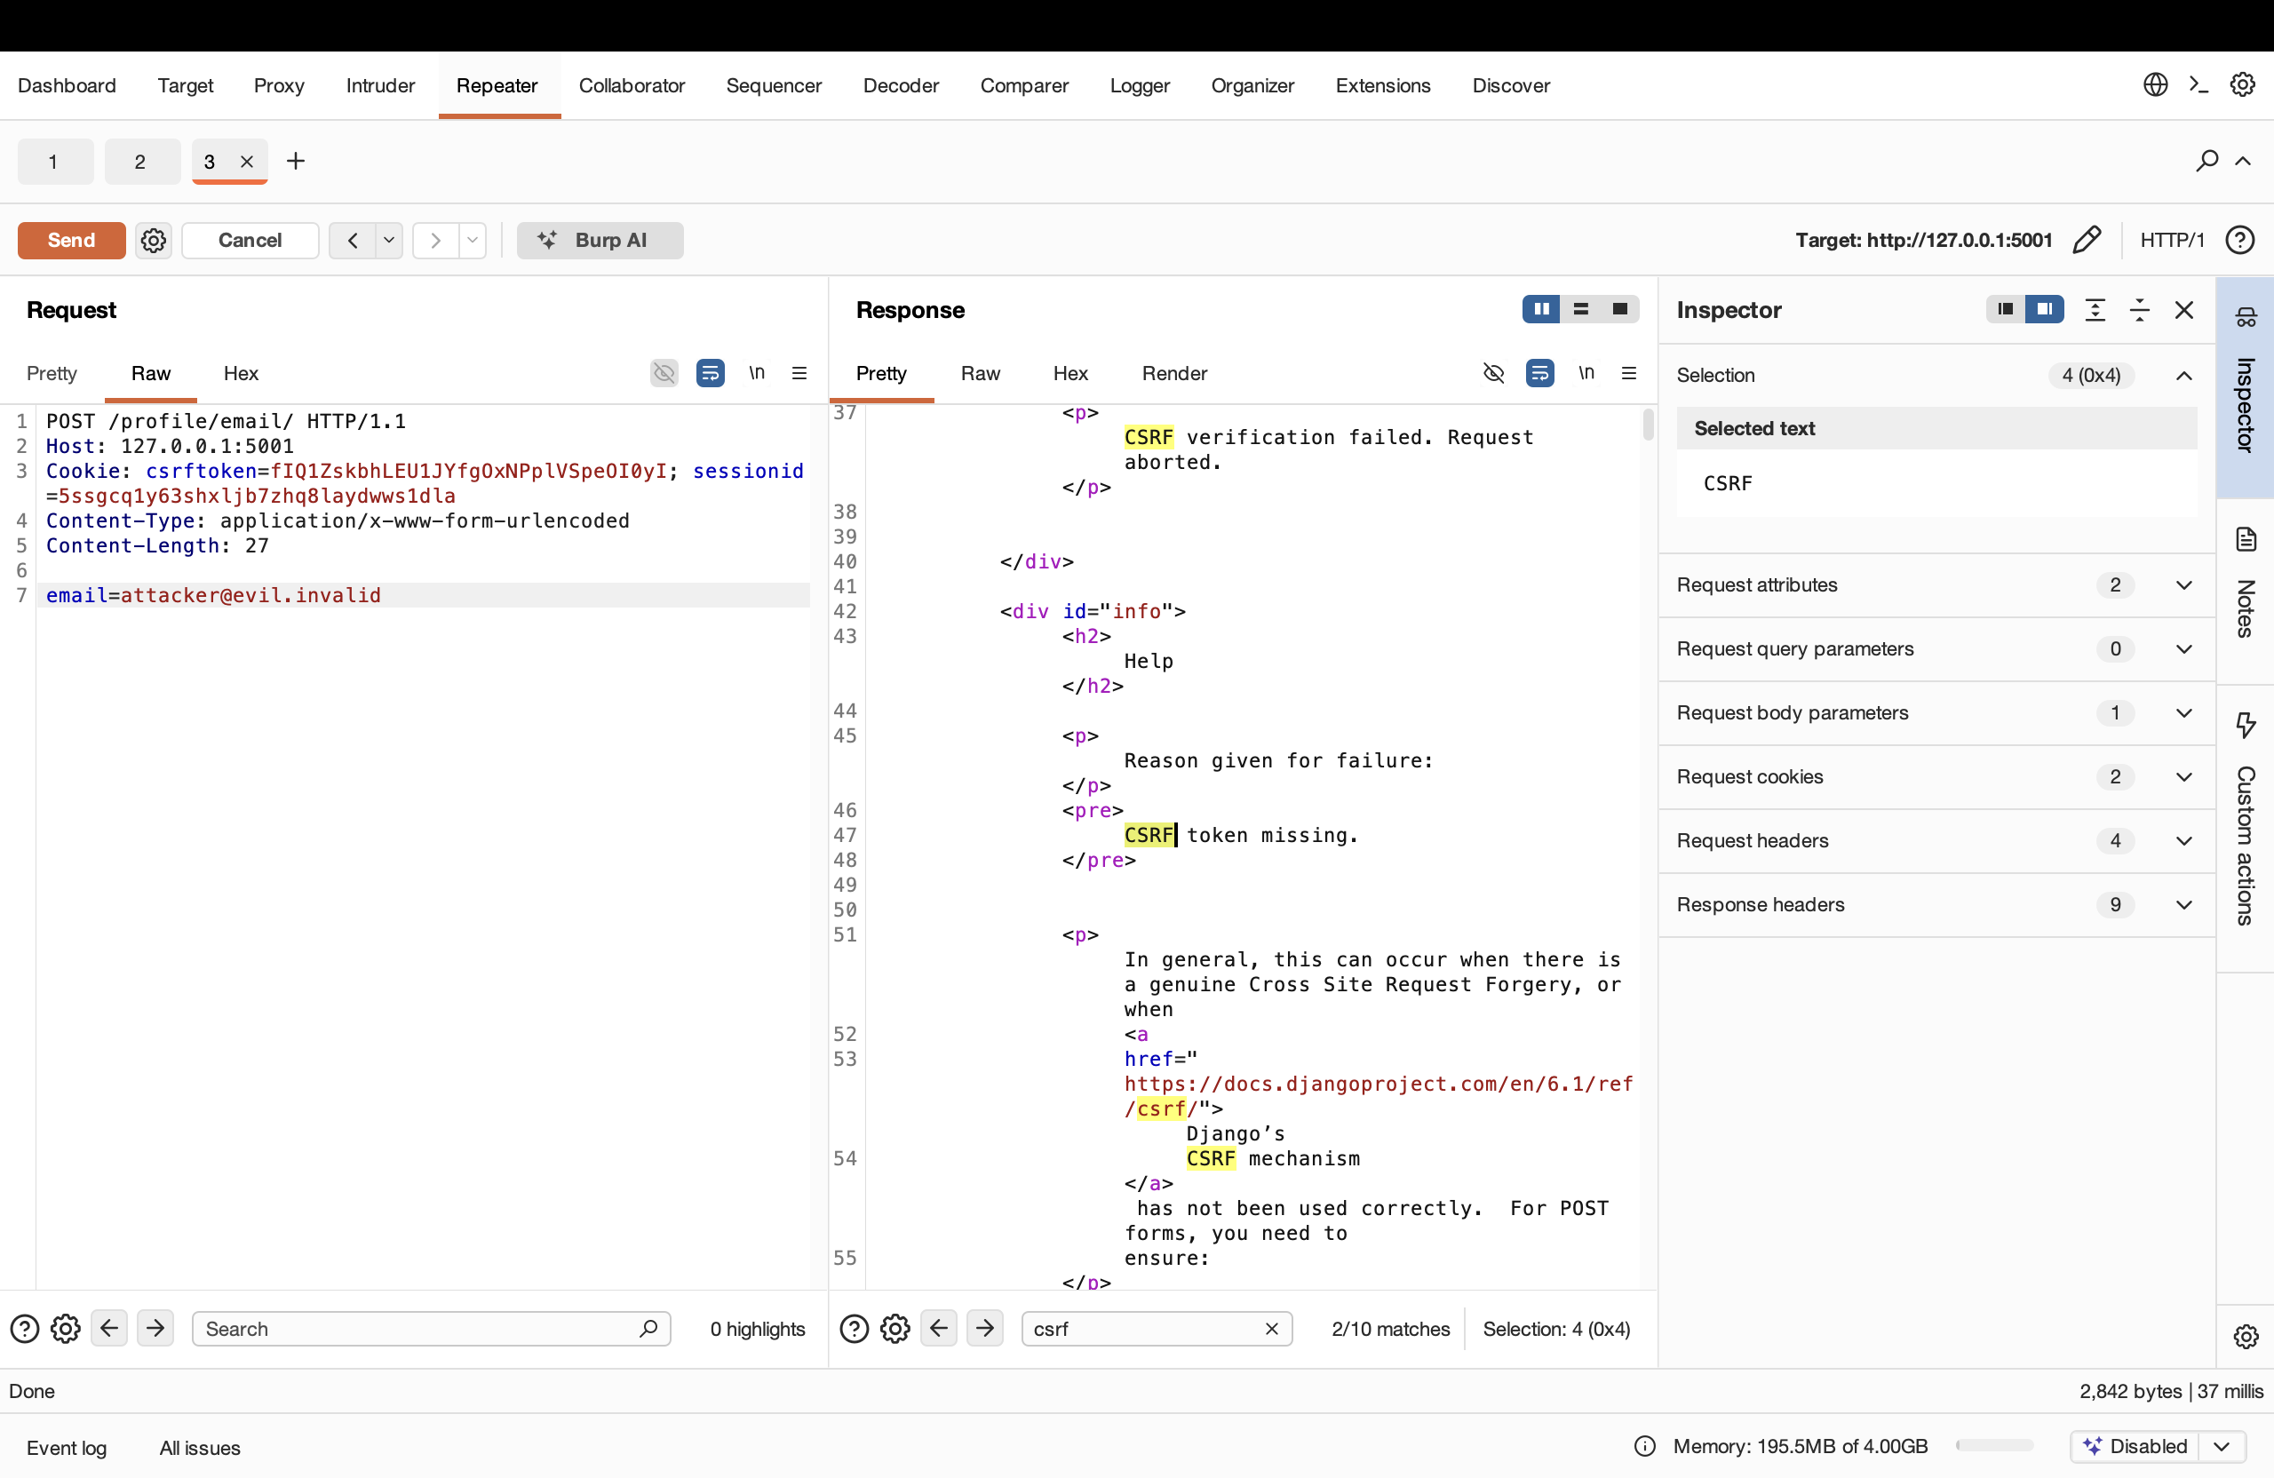
Figure 11 — After the fix: the tokenless POST returns 403, CSRF token missing.

5.3 Command injection removed
The same label that gave root now produces a normal ticket file with no id output.
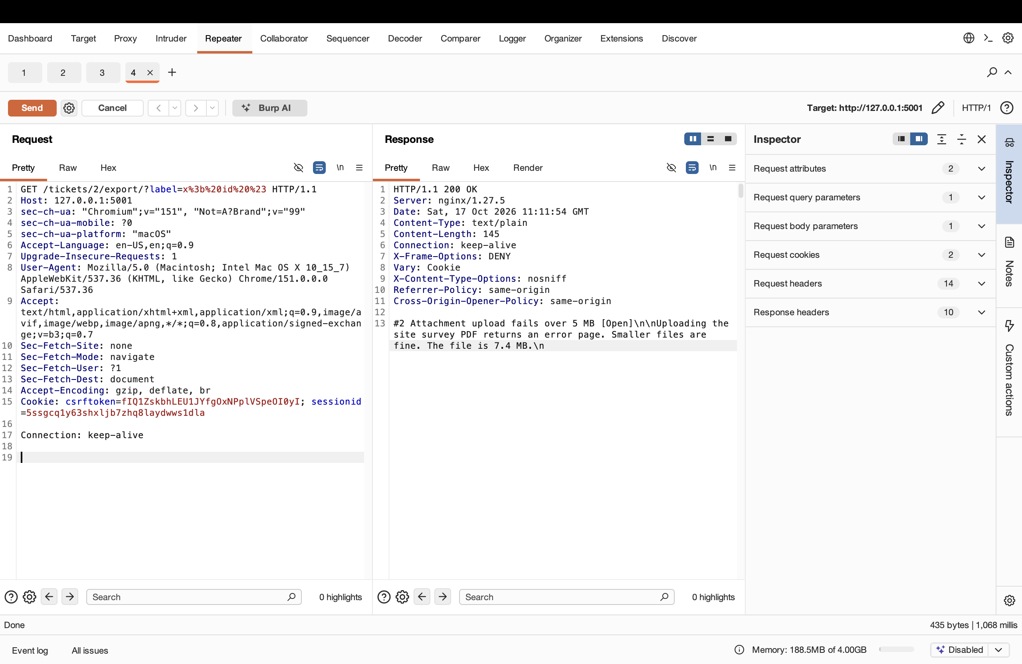
Figure 12 — After the fix: the export of ticket 2 returns the ticket text, no uid output.
The chained attack on ticket 4 is blocked by the access-control check before any command could run.
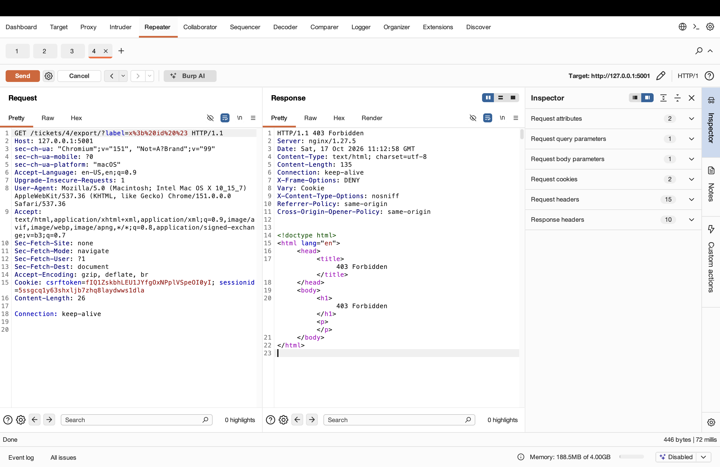
Figure 13 — After the fix: exporting ticket 4 returns 403 Forbidden.

Conclusion
Part A showed three access-control flaws: reading tickets outside the user's queue, promoting accounts as a non-admin, and changing data with no CSRF token. Part B showed command injection through the ticket export, running as root. The finale chained an access-control flaw with command injection in a single request. After fixing each flaw in the code, all attacks fail: foreign tickets are denied, promotion requires an admin, the tokenless POST is rejected, and the export never runs the injected command.

