
AMERICAN UNIVERSITY OF BEIRUT
EECE 503M — Software Security
Lab 2 Report
File Upload and Path Traversal
Student Name: Sacha Hannoun
Student ID: 202404910
GitHub Link: https://github.com/sashahannoun/EECE-503M

1 Part A — Path Traversal

1.1 A1 — Reading /etc/passwd
The staff-only download endpoint builds a file path by joining the caller-supplied path parameter onto the media directory and opens it, without confirming the result stays inside that directory. Signed in as the agent account (rmasri), the following request was issued through Burp:
GET /attachments/download/?path=../../../../../../etc/passwd
The ../ segments walk out of the media directory to the filesystem root. The server returned HTTP 200 and the contents of /etc/passwd, confirming the traversal. The response header Content-Disposition: attachment; filename="passwd" shows the application treated the traversal target as an ordinary download.
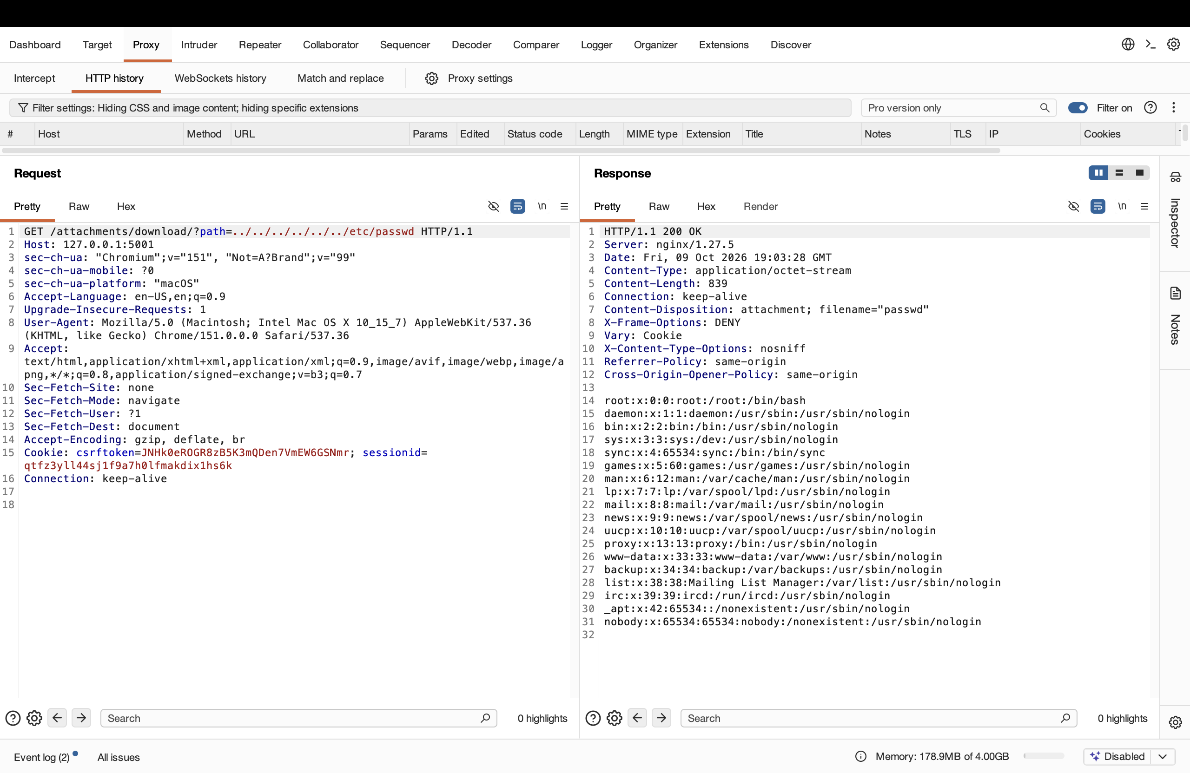
Figure 1 — Burp request and response: /etc/passwd returned via the download endpoint (HTTP 200).

1.2 A2 — Reading a higher-value target
The same vulnerability was pointed at /proc/self/environ, which holds the environment of the process that served the request — where the application keeps its secrets:
GET /attachments/download/?path=../../../../../../proc/self/environ
The response leaked the application's live environment, including MERIDIAN_SECRET_KEY (the Django signing key, which allows forging valid session cookies and tokens) and the full PostgreSQL credentials (user, password, database, host). This shows the true impact of a traversal read: not merely reading a file, but reading the file that unlocks everything else. The variables are null-separated, which is why they appear run together. The issue is therefore rated Critical.
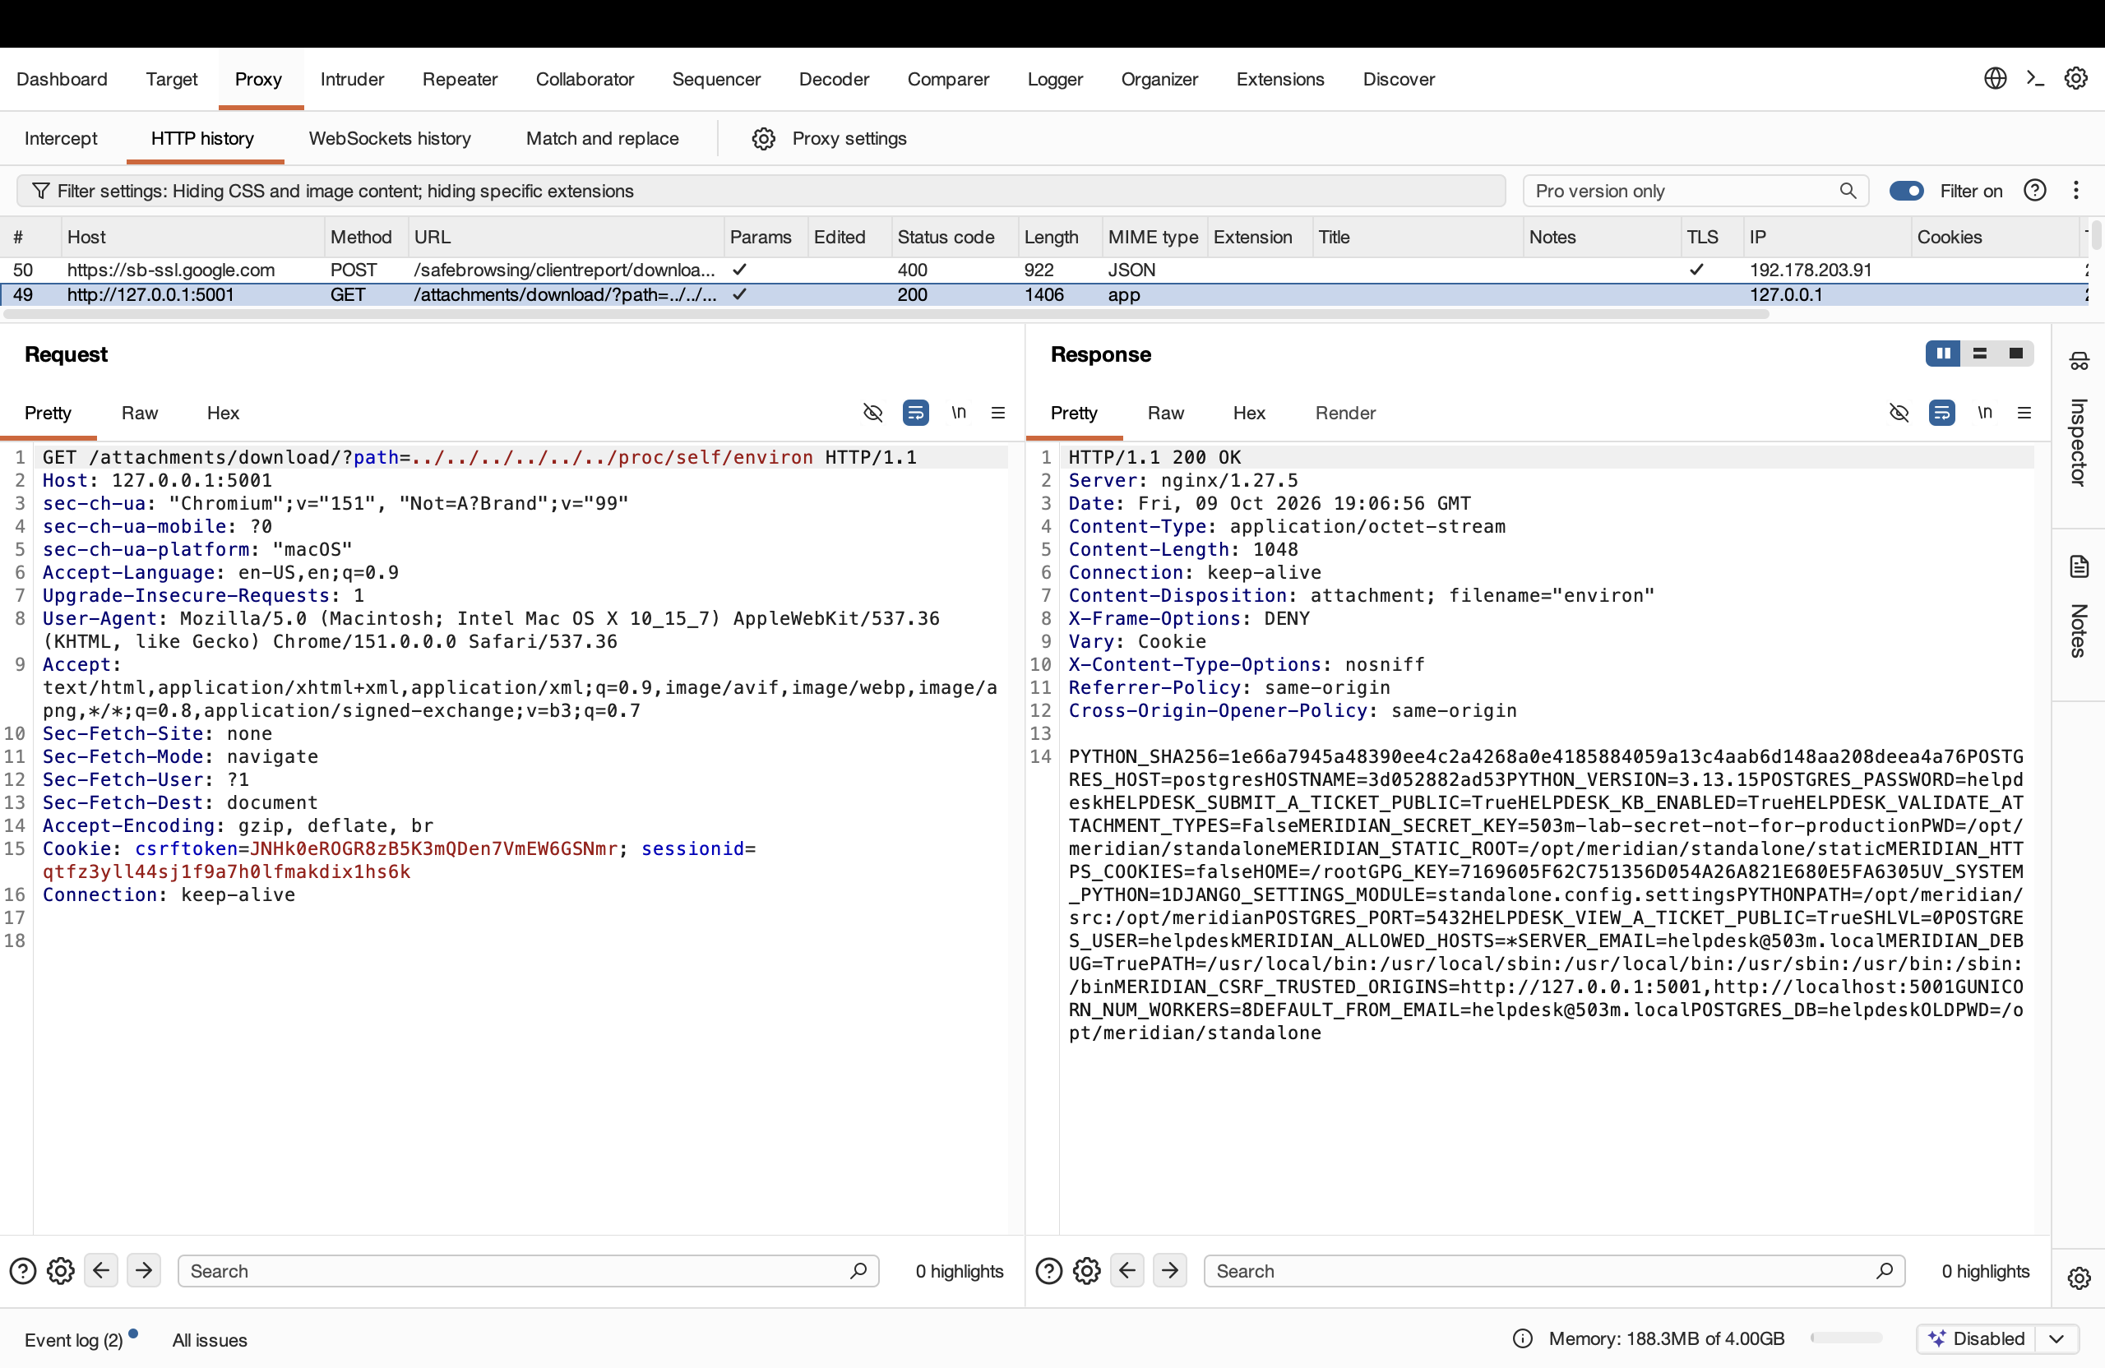
Figure 2 — /proc/self/environ leaks the Django secret key and database credentials.

2 Part B — Upload to Execution

2.1 B1 — Web shell (shell.php)
A file named shell.php containing a one-line PHP web shell was uploaded through the public form. The application accepted it and stored it, labelling it text/php, 39 bytes — it trusted the extension and declared type with no content check.
<?php system($_GET["cmd"] ?? "id"); ?>
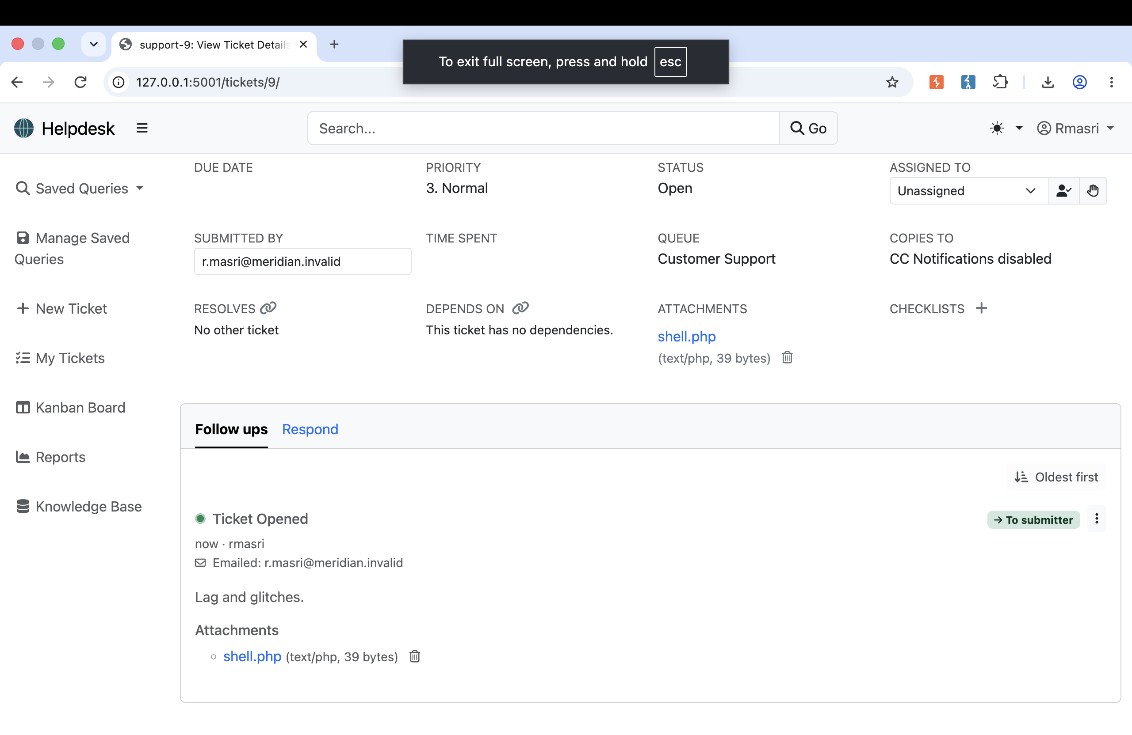
Figure 3 — The uploaded shell.php is accepted and stored on the ticket (text/php, 39 bytes).
Requesting the stored file with ?cmd=id returned its raw source as an application/octet-stream download rather than executing it, because the nginx configuration shipped for this build maps no PHP handler to the media directory. The response headers (Accept-Ranges, ETag, Last-Modified) are the signature of a static file served from disk. The upload itself is the application-layer failure; whether it then executes depends on the server handler, which is the second condition Part C removes.
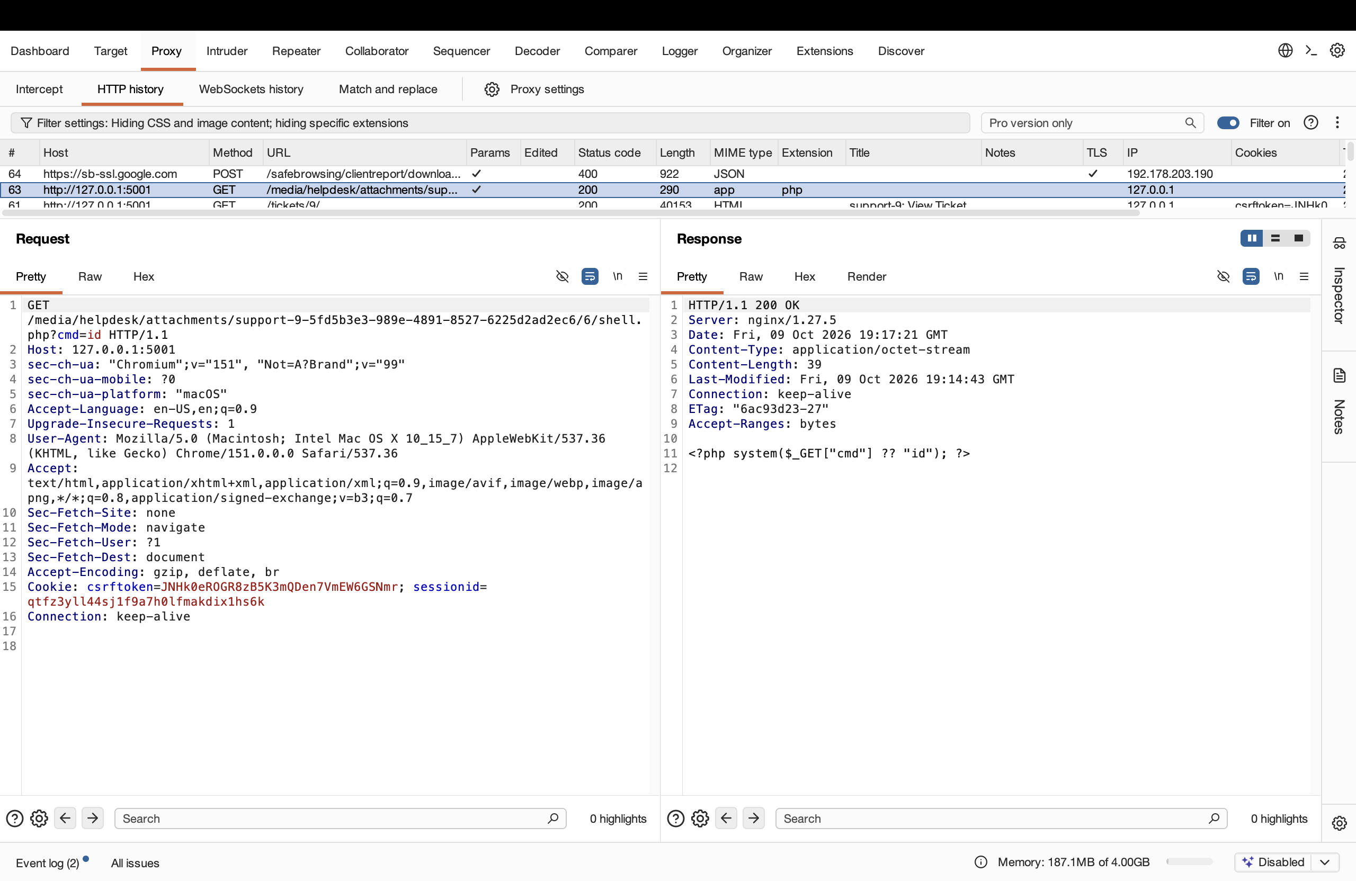
Figure 4 — The stored shell.php is served as octet-stream source (not executed) on this build.

2.2 B2 — Active documents (notice.html / logo.svg)
Even without a server-side interpreter, an uploaded file can execute in the browser of whoever opens it. A file notice.html containing a script was uploaded; opening its /media/... URL caused nginx to serve it as text/html, so the browser rendered it and ran the script in the application's own origin. The script set the page title to xss-by-upload, visible in the browser tab, proving code execution next to the victim's session cookie.
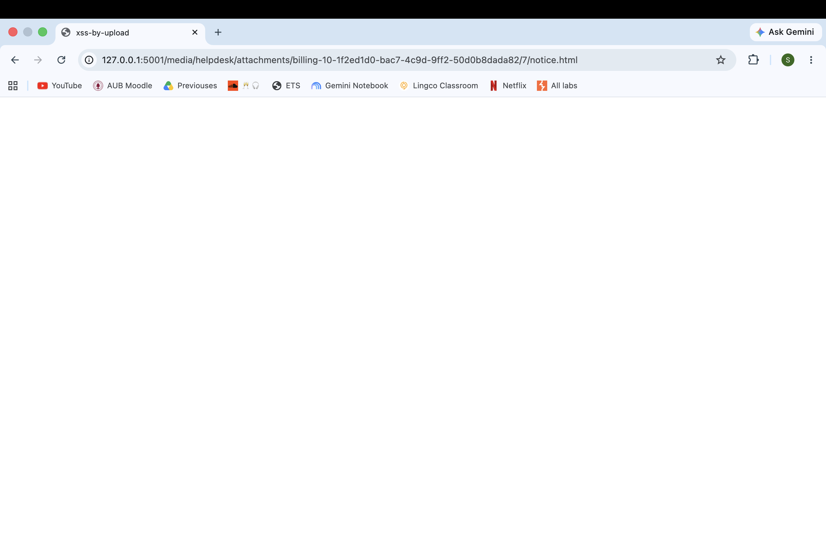
Figure 5 — notice.html runs in the app's origin: the tab title becomes "xss-by-upload".
Repeated with an image extension: logo.svg containing an embedded <script> was uploaded; opening it caused the browser to render the SVG as a document and execute alert(document.domain), which displayed 127.0.0.1. SVG is XML that can carry script, so it passes any "images are safe" allowlist. The useful distinction is passive data (PNG, JPEG) versus active document (HTML, SVG, PDF); only a check that reads the bytes can tell them apart.
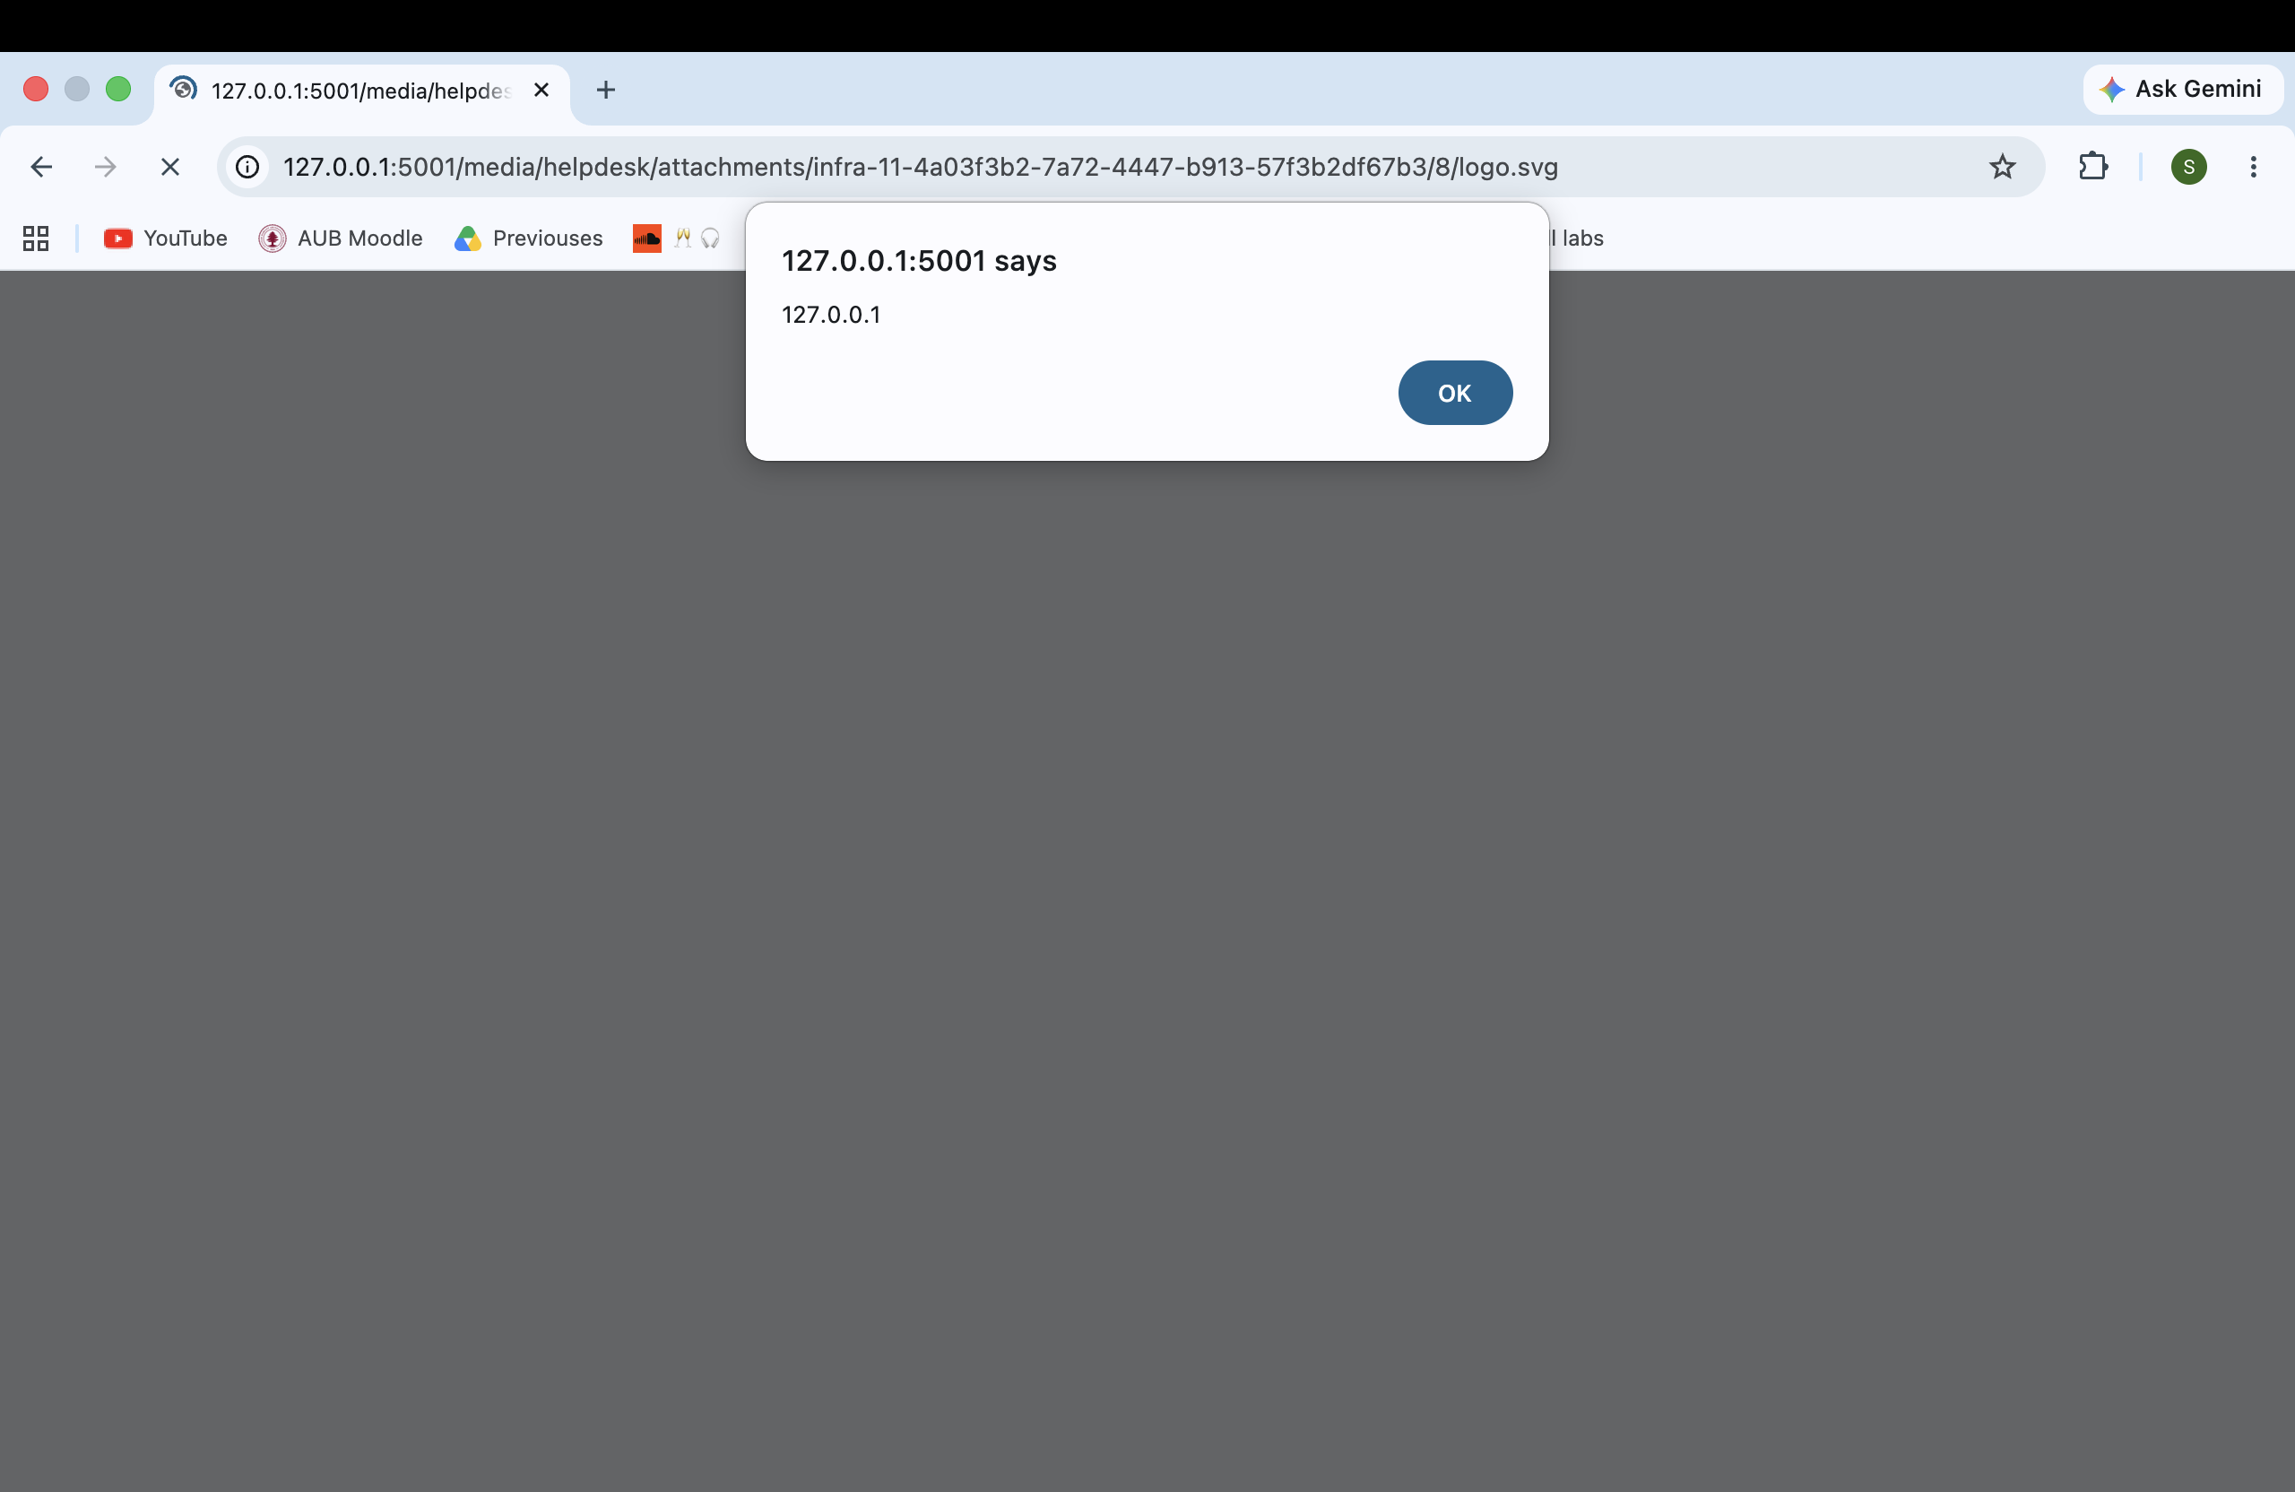
Figure 6 — logo.svg executes alert(document.domain); an image extension bypasses an extension-based allowlist.

2.3 B3 — Validation probe
To confirm how little was validated, a double-extension file shell.php.png (PHP body, image extension) was uploaded. It was accepted and stored, labelled image/png, because the application trusted the declared type and the final extension without inspecting the bytes. Opening its URL caused the browser to attempt to render it as an image (a broken-image icon). The captured upload request shows the attacker-chosen filename="shell.php.png" and Content-Type being taken at face value.
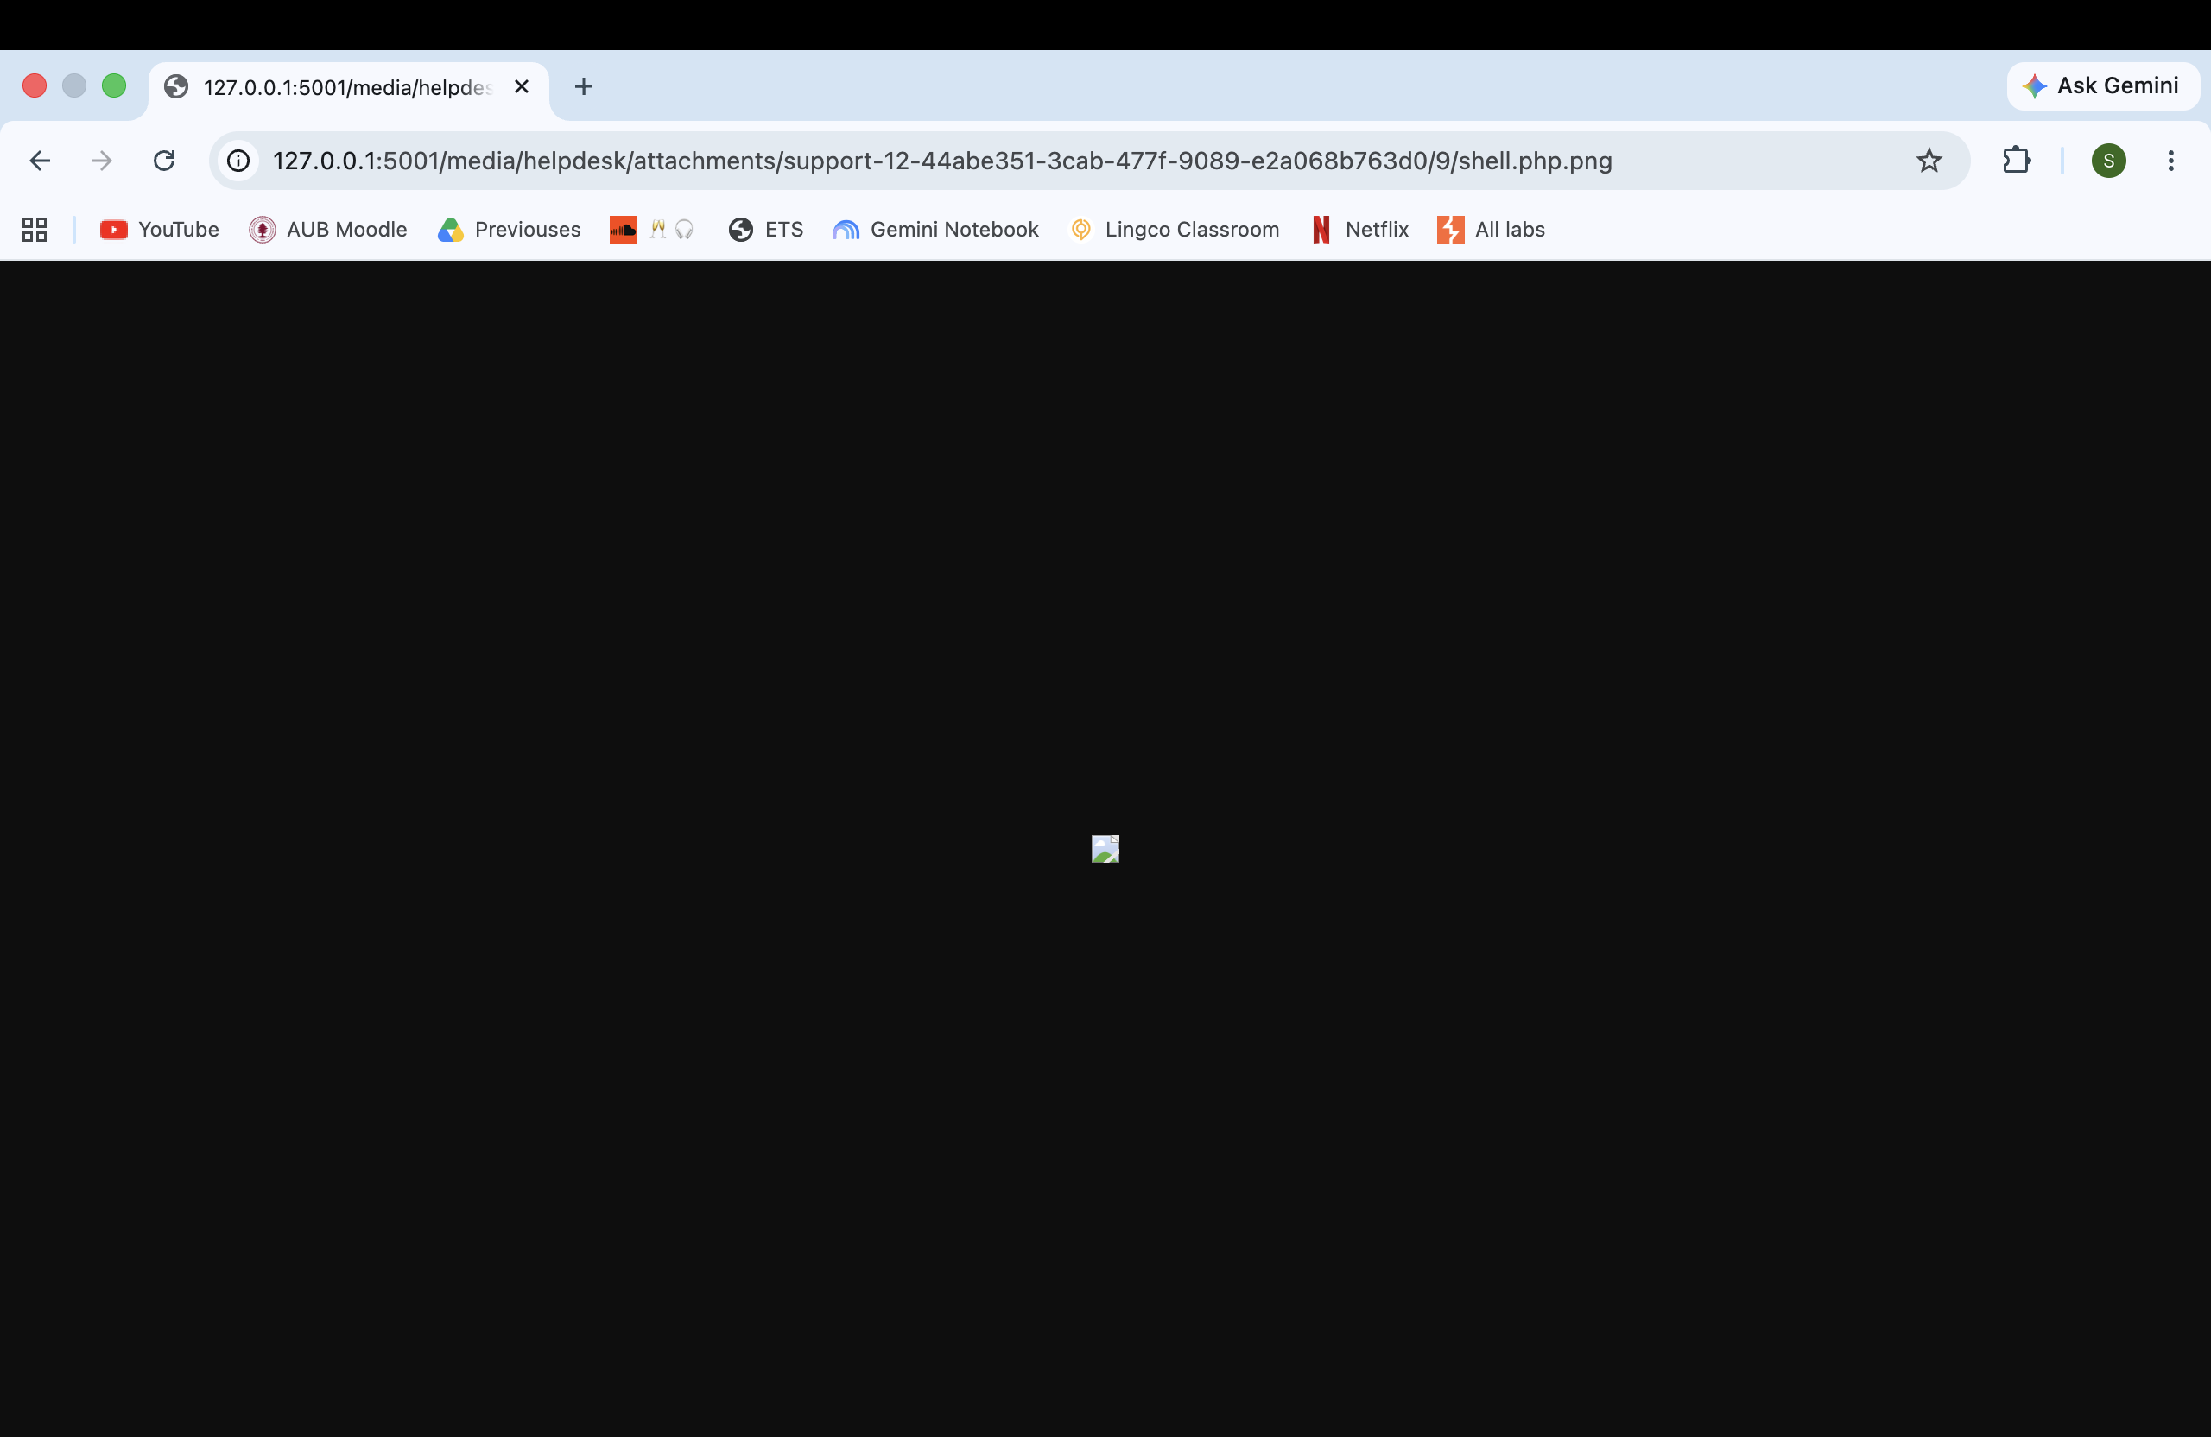
Figure 7 — shell.php.png is accepted as image/png; the browser tries to render it as an image.

3 Part C — Remediation Applied
The fix hardens both the web server and the application: defence in depth, so that if one check fails the next layer still holds. All changes were applied in the meridian-servicedesk clone and are committed to the repository.

Layer 1 — nginx: make the media directory inert
The /media/ location was rewritten so uploaded files can never be rendered or executed:
location ^~ /media/ { alias /srv/media/; types { } default_type application/octet-stream; add_header Content-Disposition "attachment" always; add_header X-Content-Type-Options "nosniff" always; autoindex off; }
The ^~ modifier stops nginx consulting any .php regex handler for this path, so an uploaded .php is never handed to an interpreter (defeats B1). Emptying the types table and setting default_type to application/octet-stream means .html is no longer text/html and .svg no longer image/svg+xml, so the browser picks no parser (defeats B2). Content-Disposition: attachment forces a download, and X-Content-Type-Options: nosniff stops the browser sniffing the bytes to re-guess the type. The three directives only work together; always applies them to error responses too.

Layer 2 — Django: validate uploads, store safely, close the traversal
Three application changes were made. First, the upload validator (validate_file_extension) enforces an extension allowlist, rejects any filename containing more than one dot (so shell.php.png is refused, not just shell.php), and verifies that files claiming an image extension really decode as images:
name = os.path.basename(value.name) ext = os.path.splitext(name)[1].lower() if name.count(".") > 1: raise ValidationError("Filenames may contain only one '.'") if ext not in HELPDESK_VALID_EXTENSIONS and ext not in ("", "."): raise ValidationError("Unsupported file extension: " + ext) if ext in {".jpg", ".jpeg", ".png", ".gif", ".bmp", ".webp"}: from PIL import Image value.seek(0); Image.open(value).verify() # rejects a non-image with an image name
Second, both attachment_path methods store each upload under a random server-generated name instead of the attacker's filename, so a name like ../../etc/cron.d/evil can never decide where the bytes land or what they are called; the original name is kept only as a display label:
ext = os.path.splitext(os.path.basename(filename))[1].lower() return os.path.join(path, f"{uuid.uuid4().hex}{ext}")
Third, the download view resolves the final path and confirms it stays inside the media directory before opening it — resolve first, then check containment — rejecting anything that escapes, which closes A1 and A2:
media_root = os.path.realpath(settings.MEDIA_ROOT) full = os.path.realpath(os.path.join(media_root, rel)) if os.path.commonpath([media_root, full]) != media_root or not os.path.isfile(full): raise Http404("No such attachment")
Validation was enabled with HELPDESK_VALIDATE_ATTACHMENT_TYPES=True, and os.path.commonpath is used rather than a startswith check, which would be fooled by a sibling directory such as /srv/media-evil.

Layer 3 — Fail safely
Django DEBUG mode was set to False (MERIDIAN_DEBUG=False). With DEBUG on, an error page leaks the stack trace, the settings, and an interactive console; turning it off ensures errors never carry a filesystem path and the debug console is never exposed. The generic error returned by the download view is part of the same principle: fail closed, and reveal nothing about the storage layout.

4 Part D — Post-Fix Verification
Each attack was re-run after remediation to confirm it now fails. The table summarises the results; the figures that follow are the captured evidence.
Attack | Expected after fix | Result
download/?path=../../../../etc/passwd (A1/A2) | Resolved path leaves MEDIA_ROOT; request rejected with a generic error | Pass — "Invalid path"
.svg upload at the submit form | Refused by the extension allowlist before storage | Pass — rejected
shell.php.png double-extension upload | Refused by the multi-dot filename rule | Pass — rejected
An allowed upload (myfile.txt) | Stored under a random server-generated name, not the user's filename | Pass — uuid name
shell.php / .html served from /media/ | Served as application/octet-stream download; never executed or rendered | Pass — inert

4.1 Traversal blocked (A1 / A2)
The download endpoint was requested again with the same traversal payload. Instead of returning /etc/passwd, the resolved path is detected as leaving the media directory and the request is rejected with a generic "Invalid path" error. /proc/self/environ is blocked the same way.
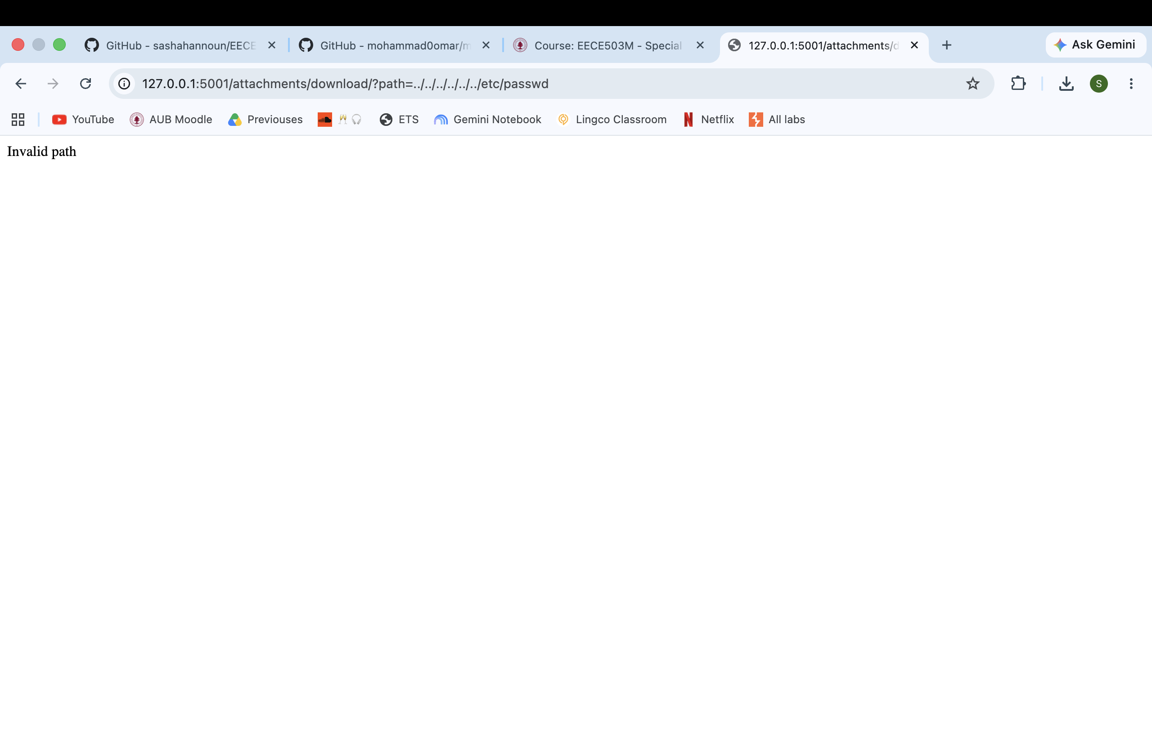
Figure 9 — After the fix: the traversal request returns a generic "Invalid path" and no file.

4.2 Malicious uploads rejected (B-class)
Uploading logo.svg is now refused at the submit form by the extension allowlist.
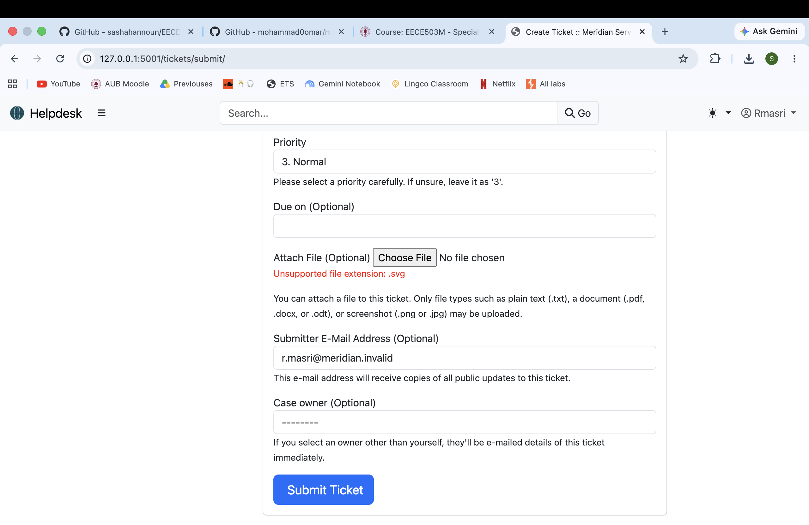
Figure 10 — After Layer 2: a .svg upload is rejected ("Unsupported file extension: .svg").
Uploading the double-extension shell.php.png is refused by the multi-dot filename rule, closing the B3 bypass.
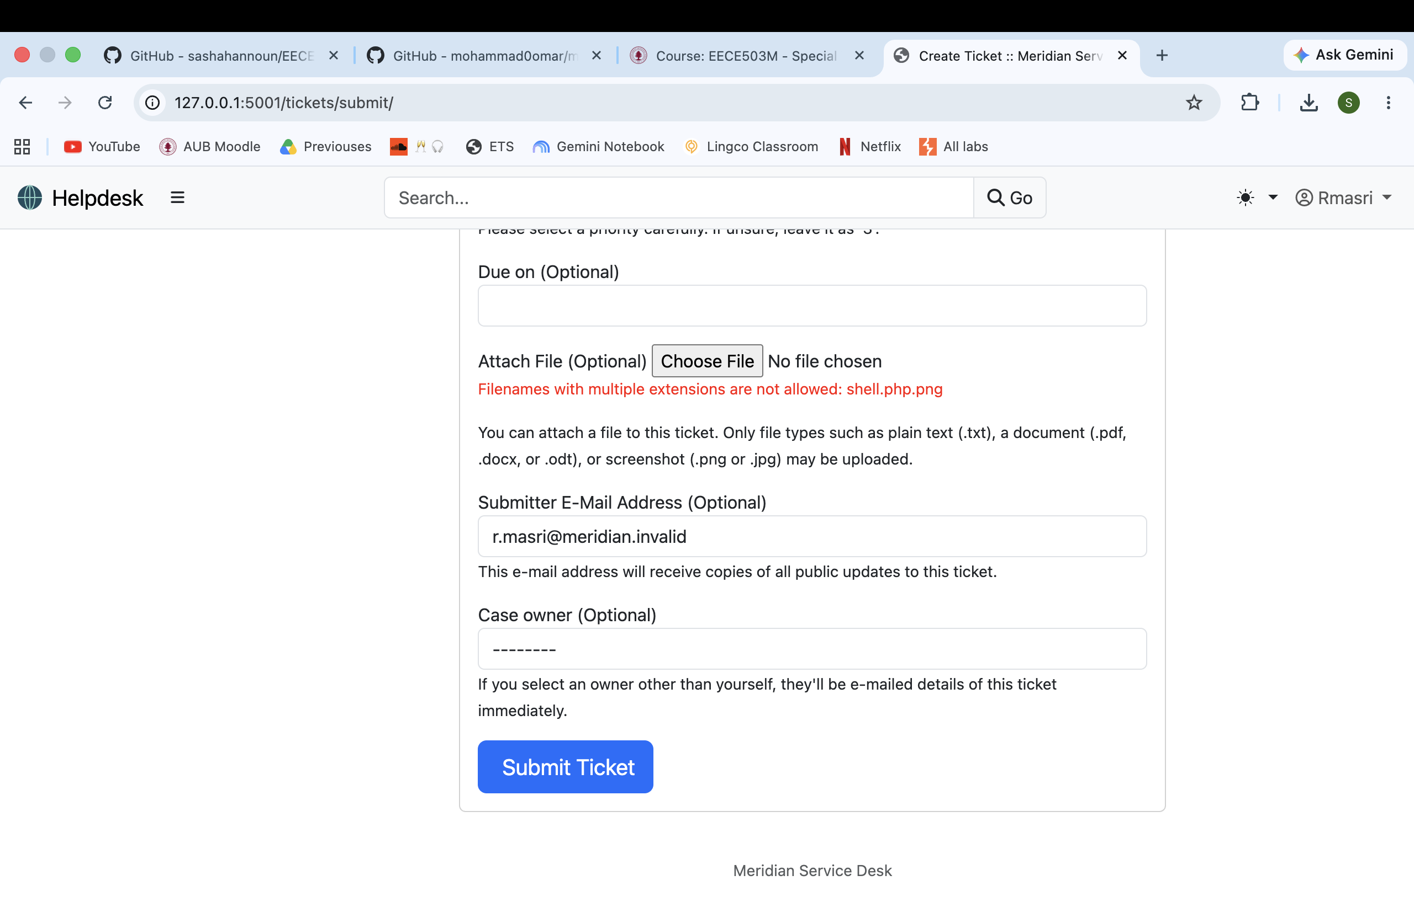
Figure 11 — After Layer 2: shell.php.png is rejected ("Filenames with multiple extensions are not allowed").

4.3 Allowed uploads stored under a safe name
A permitted file (myfile.txt) uploads successfully, but is stored under a random server-generated name rather than the submitted one. The ticket shows the friendly label myfile.txt, while the actual stored URL ends in 9018f5b59591437e9bcb157f0b71a794.txt — a random hex name. The attacker no longer controls the stored filename or path.
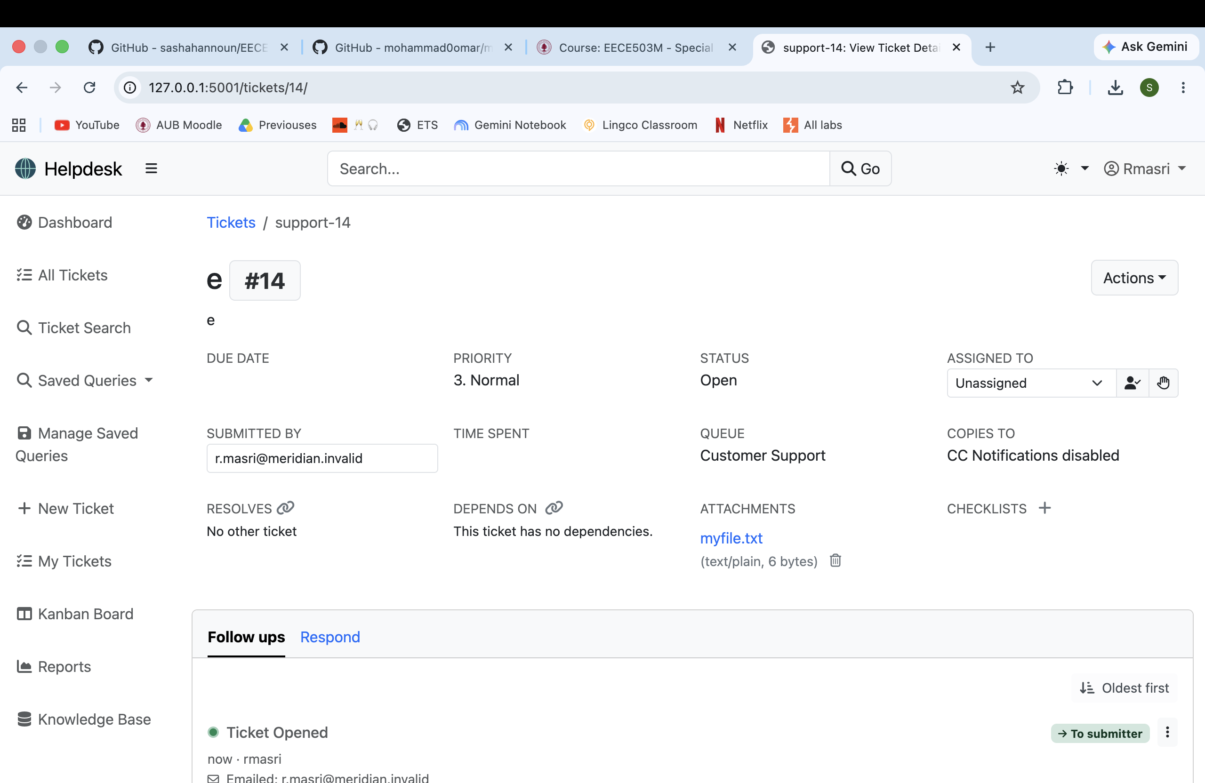
Figure 12 — After the fix: an allowed upload is stored under a random uuid filename, not the user's filename.
Together these confirm the vulnerability is closed at both the server and application layers. The previously weaponised shell.php, notice.html and logo.svg are served as inert octet-stream downloads; malicious uploads (.php, .html, .svg, shell.php.png) are refused at submission; uploads are stored under names the server chooses; and the download endpoint returns a generic error for any path that resolves outside the media directory, so /etc/passwd and /proc/self/environ no longer leak.

Conclusion
The lab demonstrated that two application-level vulnerabilities: an unvalidated path join and an unrestricted file upload allowed attackers to expose sensitive information and execute malicious code. The issue was with the application’s input handling, not the web server or operating system. The solution is to validate all user input, securely manage uploaded files, ensure file paths remain within allowed directories, and fail safely without exposing sensitive error information.

