Andrew Fuchs
Notes on Projection Routines

No Near point without Projection Vector
Project onto Surface and Return
- Step 1: Call projection routine ncl_pt_proj_sf .
- Reference: neproj1@ncl_pt_project_sf



  - Check if the surface is a plane. If so, simply project the point onto the plane a return the result. Otherwise, project the point onto the surface using S_SFPT2.
  - Call SFPT2 to project the point onto the surface.
  - SFPT2 calls SFPT to project the point, sets error flag based on the return and returns the result.
  - If an error is returned, eight points on a circle centered at the given UV point of radius 0.1 are checked as alternate points.
  - If none of these points work either, then an error is returned.
  - Define a plane at the projection point using the surface normal vector. Project the given point onto the plane return this point as the projection point.
- Reason: Simple projection routine without conditions.
- Reference: neproj1.c@ncl_pt_proj_sf, neproj1.c@S_SFPT2, sfpt.f@sfpt2, sfpt.f@sfpt

Near Point with No Projection Vector
Project Given Point
- Step 1: Project given point onto surface using S_pt_proj_nearpt and save it as the current projection point.

Find Test Point for Comparison
- Step 2: Search for a possible closer surface point to the near point than the current projection of the given point.

- First create a 5x5 grid of UV points spanning [0,1]x[0,1] domain.
- Evaluate the surface at each grid point.
- Select from the grid the UV values and corresponding surface point of the closest point on the surface to the near point and use them as the test point.

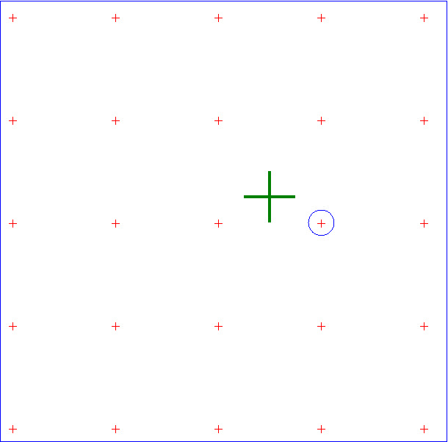
+ : Near Point
+ : The UV grid point selected as test point.

- Reason: Helps ensure the most appropriate starting location is used.
- Reference: neproj1.c@ncl_pt_project_sf

Project Given Point onto Surface Based on Found Test Point
- Step 3: Call S_pt_proj_nearpt to project the given point onto the surface using the selected test point’s corresponding UV point as the starting UV value.
  - Call S_SFPT2 to project the point onto the surface.
      - S_SFPT2 calls SFPT2 to project the point onto the surface.
      - SFPT2 calls SFPT to project the point, sets error flag based on the return and returns the result.
      - If an error is returned, eight points on a circle centered at the given UV point of radius 0.1 in UV space are checked as alternate points.
      - If none of these points work either, then an error is returned.

Refine Projection
- S_pt_proj_nearpt contains a loop that changes the non-standard convergence flag used by SFPT2 to ensure the best projection is selected.
- Depending on the value of the non-standard convergence flag (IFL(385), value=0:3) SFPT2 will deviate by its desired direction along the surface while searching for the projection point. It searches in the desired direction, in the opposite direction, and at 90 and 270 degrees to the desired direction based on the value of the flag.

Make Selection
- Step 4: Compare the distances from the current projection and new projection of the given point to the near point and set the closest one to be the returned projection.
- Reason: Ensures the returned point is the best one possible in the given neighborhood.
- Reference: neproj1@S_pt_proj_nearpt, neproj1.c@S_SFPT2, sfpt.f@sfpt2, sfpt.f@sfpt

No Near point with Projection Vector
Project onto Surface and Return
- Step 1: Call projection routine ncl_pt_proj_sf
- Reference: neproj1@ncl_pt_project_sf

- Check if the surface is a plane. If so, simply project the point onto the plane a return the result. Otherwise, project the point onto the surface using S_SFPT2.
  - Call SFPT2 to project the point onto the surface.
  - SFPT2 calls SFPT to project the point, sets error flag based on the return and returns the result.
  - If an error is returned, eight points on a circle centered at the given UV point of radius 0.1 are checked as alternate points.
  - If none of these points work either, then an error is returned.
  - Project this point onto the projection vector.
- If/While the projection is not within tolerance of the surface, continue to project along the vector until the point is within tolerance.
- Step 2: Return the resulting point.
- Reason: Ensures the projected point is in fact on the projection vector and within tolerance of the surface.
- Reference: neproj1.c@ncl_pt_proj_sf, neproj1.c@S_SFPT2, sfpt.f@sfpt2, sfpt.f@sfpt

Near point with Projection Vector
Prepare for Projection
- Step 1: Project the near point onto the line defined by the given point and the projection vector and use the projection as the new near point.
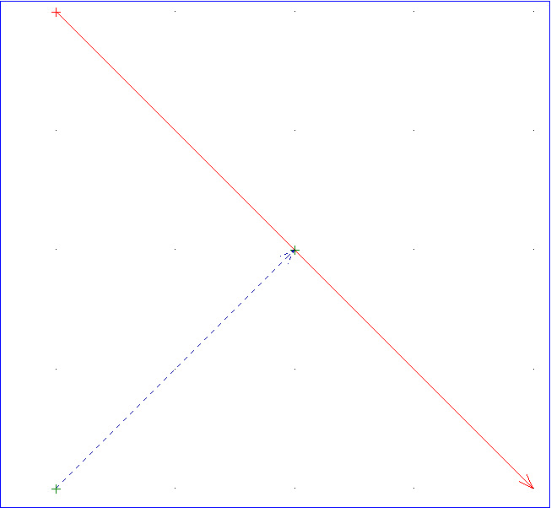

- Reason: Ensures the near point being used for projection lies on the vector, which will ensure the projected point will follow the vector.
- Reference: neproj1.c@ncl_pt_project_sf

Project onto Surface and Return
- Step 2: Call the projection routine ncl_pt_proj_sf with the new near point.
  - Check if the surface is a plane. If so, simply project the given point onto the plane along the vector and return the result. Otherwise, project the point onto the surface using S_SFPT2.
  - Call SFPT2 to project the point onto the surface.
  - SFPT2 calls SFPT to project the point, sets error flag based on the return and returns the result.
  - If an error is returned, eight points on a circle centered at the given UV point of radius 0.1 are checked as alternate points.
  - If none of these points work either, then an error is returned.
  - Project this point onto the projection vector.
  - If/While the projection is not within tolerance of the surface, continue to project along the vector until the current point is within tolerance.
- Step 3: Return the resulting point.
- Reason: Ensures the projected point is in fact on the projection vector and within tolerance of the surface.
- Reference: neproj1.c@ncl_pt_proj_sf, neproj1.c@S_SFPT2, sfpt.f@sfpt2, sfpt.f@sfpt

Notes:
- SFPT2
  - Sets the error flag based on ifl(385).
  - Returns the results given by SFPT.
  - Reference: sfpt.f@sfpt2
- SFPT
  - Projects the given point onto the plane and returns the corresponding point along with the surface norm vector at the point and the UV values associated with the point.
  - Reference: sfpt.f@sfpt

