UVM Testbench Verification Plan

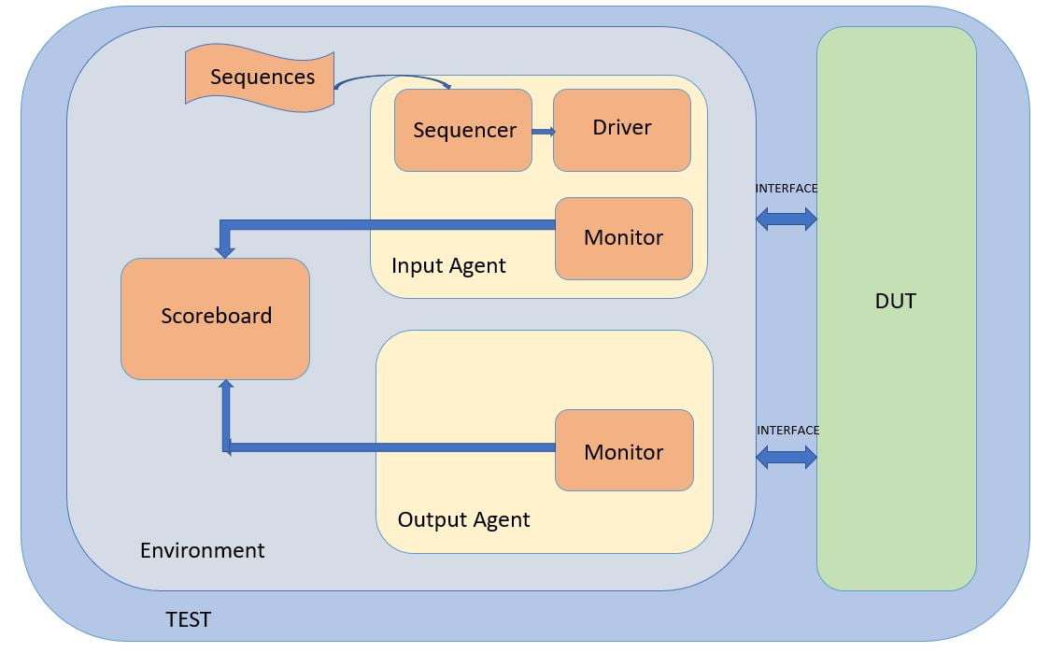

In a UVM (Universal Verification Methodology) verification environment, the testbench is the top-level module where the entire verification infrastructure is instantiated and managed. Below is an expanded and detailed description of the UVM hierarchy and components, focusing on the test cases, environment setup, agents, and other crucial verification elements.

### Testbench Hierarchy and Structure

#### Testbench Module

The **testbench module** serves as the top-level entity in the UVM hierarchy. It is responsible for creating and configuring the test environment, instantiating the test class, and coordinating the overall simulation.

#### **Test Class**

The **test class** is instantiated within the testbench module. This class is pivotal as it sets up the test environment and includes various test libraries. The test class is responsible for:

* Creating an instance of the environment.
* Configuring and initializing various test scenarios.
* Running the tests and managing their execution.

### **Test Cases**

A set of specific test scenarios are defined to verify different aspects of the DUT. These test cases include:

1. **Fifo_base_test**: This is a fundamental test that checks the basic functionality of the FIFO (First In, First Out) structure, ensuring that data is correctly enqueued and dequeued.
2. **fifo_full_and_empty_test**: This test focuses on verifying the behavior of the FIFO when it is full and empty. It checks for proper handling of edge cases such as overflow and underflow conditions.
3. **Fifo_random_test**: This test employs random stimulus to validate the robustness and reliability of the FIFO under various conditions. It helps uncover any hidden issues that might not be apparent with deterministic tests.
4. **Concurrent_wr_rd_test**: This test verifies the FIFO's capability to handle concurrent write and read operations, ensuring data integrity and correct synchronization.

### **Environment**

The **environment** in UVM is a comprehensive and pivotal component responsible for setting up the entire verification context. It includes the instantiation of agents, monitors, functional coverage, and scoreboards, all of which work together to ensure thorough verification of the DUT. The environment acts as a container for these components, orchestrating their interactions and ensuring they function harmoniously.

#### **Agents in the Environment**

In this specific UVM environment, two primary agents are instantiated: the **Write Agent** and the **Read Agent**. Each agent is a self-contained unit responsible for specific verification tasks and consists of sequences, sequencers, drivers, and monitors.

#### **Write Agent**

The **Write Agent** is responsible for generating and driving write transactions to the DUT. It comprises several components:

* **Write Sequence**: This component generates the write transactions.
* **Write Sequencer**: It orchestrates the flow of transactions from the sequence to the driver.
* **Write Driver**: Converts transaction-level details into signal-level operations and drives them to the DUT.

#### **Read Agent**

The **Read Agent** manages the read operations from the DUT. It consists of the following components:

* **Read Sequence**: Responsible for enabling the read pointer and generating read transactions.
* **Read Sequencer**: Manages the flow of transactions to the read driver.
* **Read Driver**: Converts transaction-level details into signal-level operations and drives them from the DUT.

### **Monitors**

### In a UVM (Universal Verification Methodology) environment, **monitors** play a crucial role in the verification process. They are passive components that observe the transactions between the agents and the DUT (Design Under Test) without affecting the DUT's behavior. Monitors capture the activities on the signal interfaces, collect data, and send this information to other verification components such as the scoreboard and functional coverage.

### **Types of Monitors**

### **Write Monitor**:

### **Function**: Observes and captures the transactions on the DUT's write interface.

### **Details**: It tracks the signals driven by the write driver to ensure that the transactions are being carried out correctly. The write monitor collects data on each write operation, including the data values, addresses, control signals, and any protocol-specific information.

### **Read Monitor**:

### **Function**: Observes and captures the transactions on the DUT's read interface.

### **Details**: It monitors the signals driven by the read driver to verify the read operations. The read monitor collects data on each read transaction, including the data values read from the DUT, addresses, control signals, and any protocol-specific details.

### **Responsibilities of Monitors**

### Monitors are responsible for several key tasks in the verification environment:

### **Data Collection**:

### Monitors collect detailed information about the transactions taking place on the DUT's interfaces. This includes capturing signal values, timestamps, and any relevant control information.

### They ensure that all observed data is accurately recorded and available for further analysis.

### **Non-Intrusive Observation**:

### Monitors operate passively, meaning they do not drive any signals or interact with the DUT directly. Their role is purely observational, ensuring they do not influence the DUT's behavior.

### **Data Broadcasting**:

### Monitors broadcast the collected data to other verification components such as the scoreboard and functional coverage.

### This broadcast mechanism ensures that all relevant data is made available for comparison, analysis, and coverage collection.

### **Protocol Checking**:

### Monitors can include protocol checkers to ensure that the DUT complies with the specified protocol rules. They can detect protocol violations and report them for debugging.

### **Integration with Other Components**

### **Scoreboard**:

### Monitors send the captured transaction data to the scoreboard, which uses this information to compare the DUT's actual behavior with the expected behavior.

### The scoreboard relies on accurate data from the monitors to identify any discrepancies or mismatches between the DUT and the reference model.

### **Functional Coverage**:

### Monitors provide data to the functional coverage components, which use it to track coverage metrics.

### This data helps in determining how thoroughly the DUT has been tested and ensures that all significant scenarios and corner cases are covered.

### **Functional Coverage**

### Functional coverage is a crucial aspect of the UVM (Universal Verification Methodology) environment. It ensures that the design under test (DUT) is thoroughly verified against all specified functional requirements. By capturing and analyzing coverage data, functional coverage helps in identifying which parts of the DUT have been tested and which parts still need to be exercised, thus guiding the verification process to achieve comprehensive test coverage.

### **Key Components of Functional Coverage**

### **Covergroups**:

### **Definition**: Covergroups are collections of related coverage points (coverpoints) that are grouped together to represent a specific functional aspect of the DUT.

### **Purpose**: They provide a structured way to define and collect coverage data for various scenarios and conditions that the DUT must handle.

### **Example**: A covergroup for a FIFO might include coverpoints for checking different levels of occupancy, read and write operations, and boundary conditions like full and empty states.

### **Coverpoints**:

### **Definition**: Coverpoints are individual points within a covergroup that represent specific events, conditions, or states that need to be tested.

### **Purpose**: They capture data for specific functional aspects of the DUT, such as signal values, state transitions, or combinations of inputs.

### **Example**: A coverpoint might track the number of times the FIFO is full, or the values written to and read from the FIFO.

### **Cross Coverage**:

### **Definition**: Cross coverage involves tracking combinations of two or more coverpoints to ensure that interactions between different conditions are tested.

### **Purpose**: It helps in verifying that the DUT behaves correctly under various combinations of inputs and states.

### **Example**: A cross coverage between the write and read operations of a FIFO to ensure that all possible combinations of writes and reads are tested.

### **Scoreboard**

The **scoreboard** is a critical component in the UVM (Universal Verification Methodology) environment, acting as the reference model or "golden" DUT against which the actual DUT's behavior is compared. It ensures that the DUT produces the correct outputs for given inputs by comparing the observed results with the expected results. The scoreboard is essential for functional verification, as it helps detect mismatches and discrepancies, facilitating early identification and resolution of bugs.

#### **Key Components of a Scoreboard**

1. **Expected Data Storage**:
   * **Definition**: This component stores the expected results for various transactions.
   * **Purpose**: It provides a reference against which the actual DUT outputs are compared.
   * **Implementation**: Typically implemented using queues or other data structures to hold expected values.
2. **Comparison Logic**:
   * **Definition**: This logic performs the comparison between the actual results observed from the DUT and the expected results.
   * **Purpose**: To detect mismatches and discrepancies between the DUT's behavior and the reference model.
   * **Implementation**: Can include simple equality checks, tolerance-based comparisons, or more complex verification algorithms depending on the nature of the data and the DUT.
3. **Mismatch Handling**:
   * **Definition**: Handles any detected mismatches between the actual and expected results.
   * **Purpose**: To log errors, provide detailed information about the mismatches, and potentially trigger additional actions (e.g., debug processes).
   * **Implementation**: Typically involves logging mechanisms and possibly integration with other UVM components for further actions.
4. **Analysis Ports**:
   * **Definition**: Interfaces that allow the scoreboard to receive data from monitors and other verification components.
   * **Purpose**: To collect observed data for comparison.
   * **Implementation**: UVM analysis ports are commonly used to connect the scoreboard with monitors.

#### **Responsibilities of a Scoreboard**

1. **Data Collection**:
   * Receives actual transaction data from the DUT via monitors.
   * Collects expected transaction data from reference models or stimuli generators.
2. **Data Comparison**:
   * Compares the actual output from the DUT with the expected output.
   * Identifies mismatches and discrepancies between the DUT behavior and the reference model.
3. **Mismatch Reporting**:
   * Logs any detected mismatches along with detailed information to aid in debugging.
   * Reports errors to the testbench for further action, such as logging or triggering debug sequences.
4. **Coverage Integration**:
   * Provides data to functional coverage components to ensure that all relevant scenarios are being tested and covered.

**Present Coverage is around 94%, but will improve in upcoming Milestone 5 :**

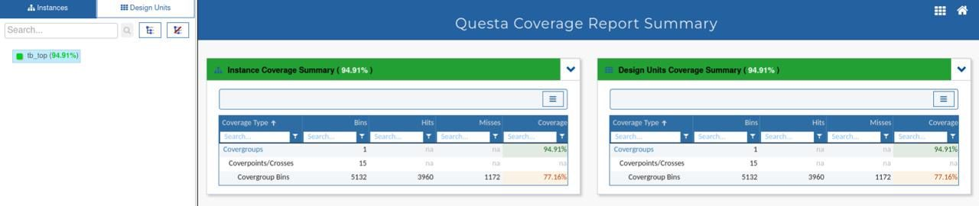

GitLink : [Team3_AsyncFIFO_S24_ECE593/M4 at main · sashakatne/Team3_AsyncFIFO_S24_ECE593 (github.com)](https://github.com/sashakatne/Team3_AsyncFIFO_S24_ECE593/blob/main/M4)