Group 1:

The implementation of group one was simple. The datapath already included all of the modules need to implement group one which includes the following instructions: add, sub, slt, andi, and nor. In order to implement each of the instructions I used the appropriate function code based instruction type and the operation that needed to be done. I added the information directly to the mips-control file following the format to the already provided add operation. I implemented each step individually and tested each step separately before creating a test bench that mixed the various combinations of instructions. The test bench instructions were created by adding the instruction to the assembly file which allowed me to get a hexadecimal value that was transferred to the program.txt file. The output of the test file can be see below as well as the instructions implemented.

Figure 1 Group 1 Test Code:

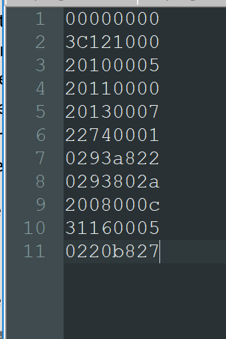 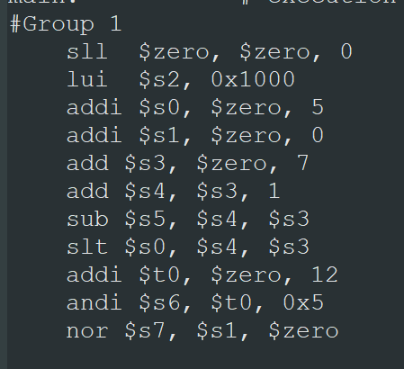

Figure 2 Group 1 Waveform:

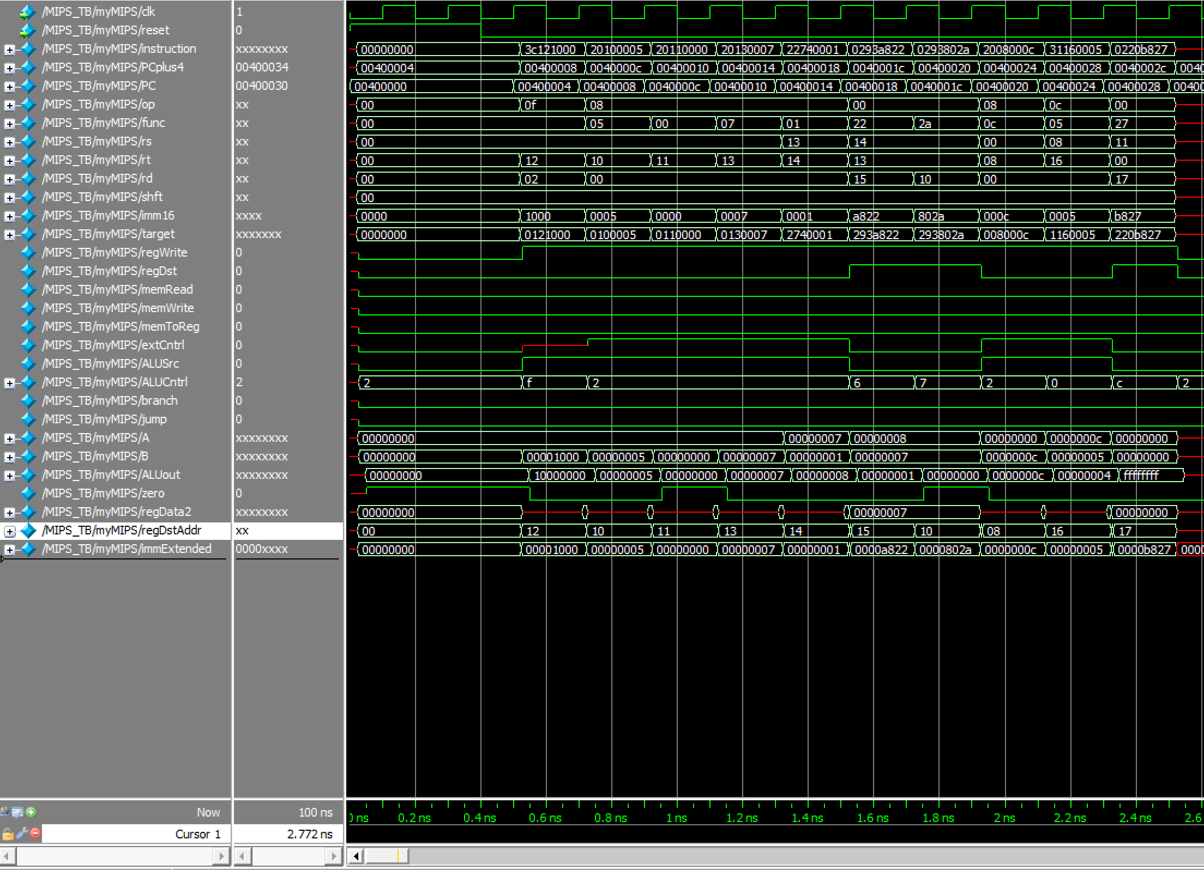

Group 2:

In order to implement group 2 I needed to change the mips file. The original datapath didn’t include a data memory module. I added a data memory module to the datapath in order to

Figure 2: Group 2 Waveform

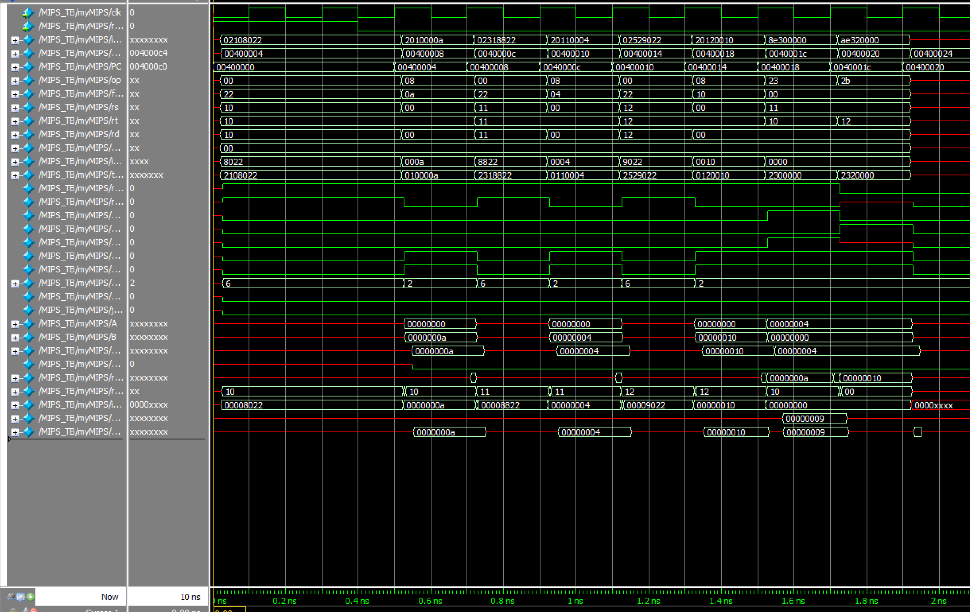

Group 3:

