BANK ACCOUNT MANAGEMENT SYSTEM
A DBMS Capstone Project Report submitted in partial fulfillment of the requirements for the award of the degree of

BACHELOR OF TECHNOLOGY
in

ARTIFICIAL INTELLIGENCE AND MACHINE LEARNING

Submitted By

G.Sashank – 25B11AI316

G.Manoj – 25B11AI385
V.Pavithra – 25B11AI520
B.Harika – 25B11AI527
Under the esteemed guidance of

Mrs. G L Narasamba Vanguri MTech, (Ph.D.)

AssistantProfessor


DEPARTMENT OF ARTIFICIAL INTELLIGENCE AND MACHINE LEARNING

ADITYA UNIVERSITY
(Formerly Aditya Engineering College (A))
Aditya Nagar, ADB Road, Surampalem, Andhra Pradesh, India

2026 – 2027


Aditya Nagar, ADB Road, Surampalem, Andhra Pradesh, India
DEPARTMENT OF ARTIFICIAL INTELLIGENCE AND MACHINE LEARNING

CERTIFICATE

This is to certify that the DBMS Capstone Project report entitled “Bank Account Management System” is being submitted by G.SASHANK (Roll No. 25B11AI316), G.MANOJ (Roll No. 25B11AI385), V.PAVITHRA(Roll No. 25B11AI520) and B.HARIKA(Roll No. 25B11AI527) in
partial fulfillment of the requirements for the award of the B.Tech. degree in Artificial Intelligence and Machine Learning. The work documented in this report was carried out as part of the Capstone Project for the course Database Management Systems (2501IT05) during the academic year 2026–2027, and records the database design, implementation, and documentation undertaken by the team.

Project Guide Head of the Department

Mrs.G L Narasamba Vanguri Mtech,(Ph.D.) Dr. K. Naga Bhargavi, M. Tech, Ph.D.
Associate professor Associate Professor & HOD

External Examiner

DECLARATION

We hereby declare that the DBMS Capstone Project entitled “Bank Account Management System” is a genuine work carried out by us. The database design, SQL implementation, queries and documentation presented in this report are our own work, completed under the guidance of Mr. T. Srinivasulu, Department of Artificial Intelligence and Machine Learning, Aditya University, Surampalem. We further declare that this work has not been submitted, in full or in part, for the award of any degree of this or any other educational institution.

Project Associates
G SASHANK (25B11AI316)
G MANOJ (25B11AI385)
V PAVITHRA (25B11AI520)
B HARIKA (25B11AI527)

Date: 14 September 2026 Place: Surampalem

ACKNOWLEDGEMENT

It is with immense pleasure that we express our indebted gratitude to our project guide Mr. T. Srinivasulu, Department of Artificial Intelligence and Machine Learning, who guided us throughout the capstone project. We are thankful for the constant encouragement and valuable suggestions received at every review stage.
We are grateful to Dr. K. Naga Bhargavi, Head of the Department, for inspiring us and for arranging the facilities and resources needed for this project.
We extend our sincere thanks to the Management, Dr. M. Sreenivasa Reddy, Deputy Pro-Chancellor, Dr. M. B. Srinivas, Vice-Chancellor, and Dr. A. Ramesh, Pro Vice-Chancellor (Engineering & Sciences), for providing an excellent academic environment.
Not to forget, we thank the Teaching and Non-Teaching Staff, our parents and our friends, who have directly or indirectly supported us in completing this project on time.

Project Associates
G SASHANK (25B11AI316)
G MANOJ (25B11AI385)
V PAVITHRA (25B11AI520)
B HARIKA (25B11AI527)

ADITYA UNIVERSITY
Surampalem
Department of Computer Science and Engineering

DBMS CAPSTONE PROJECT


Project Documentation Report
Project Title: Bank Account Management System
Submitted by:
Course: Database Management System (DBMS) Course Code: DBMS
Faculty Coordinator:
Academic Year: 2026–27
Date of Submission: 14 September 2026
GitHub Repository Link: https://github.com/sashank-1916/bank-account-management-dbms.git

S.No | Student Name | Roll Number
1 | G SASHANK | 25B11AI316
2 | G MANOJ | 25B11AI385
3 | V PAVITHRA | 25B11AI520
4 | B HARIKA | 25B11AI527

ABSTRACT

The Bank Account Management System is a relational database project designed to manage core banking operations across multiple branches.
The system consists of six main entities: Branch, Customer, Employee, Account, TransactionRecord, and Loan, connected through foreign-key relationships to maintain data
integrity.
Built using SQL and normalized up to Third Normal Form (3NF), the system uses NOT NULL, UNIQUE, and CHECK constraints to maintain accurate and valid data.
The system supports customer management, savings/current/fixed-deposit accounts, deposits, withdrawals, transaction recording, and loan tracking. SQL queries demonstrate joins, aggregate functions, GROUP BY/HAVING, subqueries, and reporting operations.

TABLE OF CONTENTS

Chapter | Title | Page No.
 | Certificate | i
 | Declaration | ii
 | Acknowledgement | iii
 | Project Documentation Report | iv
1 | ABSTRACT | v
 | List of Figures | vii
 | List of Tables | vii
2 | INTRODUCTION | 1
 | 2.1 Background | 1
 | 2.2 Purpose of the Database | 1
3 | PROBLEM STATEMENT | 1
4 | OBJECTIVES | 1
5 | TOOLS & TECHNOLOGIES USED | 2
6 | DATABASE DESIGN | 2
 | 6.1 Identified Entities | 2
 | 6.2 Entity Attributes | 2
 | 6.3 ER Diagram | 4
 | 6.4 Relationships & Cardinality | 4
 | 6.5 Relational Database Schema | 4
 | 6.6 Normalization | 6
7 | DATABASE IMPLEMENTATION | 8
 | 7.1 DDL — Database and Table Creation | 8
 | 7.2 Sample Data — DML. | 10
 | 7.3 Constraints & Data Integrity | 10
 | 7.4 SQL Operations & Queries | 10
 | 7.5 Sample Outputs / Screenshots | 12
8 | MODULES & FUNCTIONALITIES | 14
9 | GITHUB REPOSITORY & TEAM RESPONSIBILITIES | 14
10 | ENHANCEMENTS & FUTURE IMPROVEMENTS | 15
11 | CONCLUSION | 15
12 | REFERENCES | 15
 | APPENDIX | 16
 | A. Complete SQL Script | 16
 | B. Additional Screenshots / Outputs | 16

LIST OF FIGURES
LIST OF TABLES

Figure No. | Title of the Figure | Page No.
6.3 | ER Diagram | 4
Figure 1 | Customer records / basic SELECT output | 12
Figure 2 | Active savings accounts / filtering output | 12
Figure 3 | Aggregate or GROUP BY output | 13
Figure 4 | Join or subquery output | 13

Table No. | Title of the Table | Page No.
5 | TOOLS & TECHNOLOGIES USED | 2
6.1 | Identified Entities | 2
6.2 | Entity Attributes | 2
6.4 | Relationships & Cardinality | 4
6.5 | Relational Database Schema | 4
7.2 | Sample Data — DML. | 10
7.3 | Constraints & Data Integrity | 10
7.4 | SQL Operations & Queries | 10
8 | MODULES & FUNCTIONALITIES | 14
9 | GITHUB REPOSITORY & TEAM RESPONSIBILITIES | 14

INTRODUCTION

Background

Banking systems handle large amounts of structured information related to customers, branches, accounts, employees, loans, and financial transactions. A relational database is required to store this information consistently and to maintain relationships between the different records. In this project, the banking domain is represented using six related tables: Branch, Customer, Employee, Account, Loan, and TransactionRecord. The schema separates data into appropriate entities and uses keys and constraints to reduce duplication and protect data integrity. SQL queries are then used to retrieve, update, aggregate, and analyse the stored information.

Purpose of the Database
The database provides a centralized structure for managing branch details, customer identity and contact information, employee details, account balances and statuses, loan information, and account transaction history. It can support banking staff and administrators who need to retrieve customer/account information, maintain balances, record transactions, monitor loans, and generate summary information. The relationships between the tables allow related information to be accessed through SQL joins and subqueries instead of maintaining disconnected records.

PROBLEM STATEMENT
Traditional branch-wise record keeping can lead to duplicate customer information, inconsistent records and difficulty in tracking transactions.
The proposed system centralizes branch, customer, employee, account, loan and transaction information into a single relational database.
The system provides structured data management, referential integrity, validation and SQL-based reporting for efficient banking operations.

OBJECTIVES
- Objective 1: Design a relational schema containing six related banking entities.
- Objective 2: Implement primary keys, foreign keys, NOT NULL, UNIQUE, CHECK, and DEFAULT constraints for data integrity.
- Objective 3: Populate the database with representative branch, customer, employee, account, loan, and transaction records.
- Objective 4: Demonstrate SQL retrieval, updates, joins, aggregate functions, GROUP BY/HAVING, and subqueries.
- Objective 5: Document the database design, implementation, sample data, queries, and team responsibilities

TOOLS & TECHNOLOGIES USED

Category | Tool / Technology Used
Database Server | SQ-compatible relational database
Query / Admin Tool | SQL client / SQL environment
Front-end (if any) | Not specified in the uploaded SQL files
Operating System | Not specified in the uploaded files
Version Control | GitHub


DATABASE DESIGN

Identified Entities

S.No | Entity Name | Description
1 | Branch | Stores bank branch identification, location, IFSC code, manager, and creation date.
2 | Customer | Stores customer identity, contact, KYC-related identifiers, address, and creation date.
3 | Employee | Stores employee details, branch assignment, designation, qualification, salary, and contact information.
4 | Account | Stores customer bank accounts, branch, account type, balance, opening date, and status.
5 | TransactionRecord | Stores deposits, withdrawals, transfers, amounts, dates, modes, and descriptions for accounts.
6 | Loan | Stores customer loans, branch, loan type, amounts, interest, duration, EMI, status, and sanction information.

Entity Attributes

Entity | Attribute | Data Type | Key (PK/FK/—) | Attribute Type
Branch | BranchID | INTEGER | PK | Simple
Branch | BranchName | VARCHAR(50) | — | Simple
Branch | IFSCCode | VARCHAR(11) | — | Simple
Branch | City | VARCHAR(50) | — | Simple
Customer | CustomerID | INTEGER | PK | Simple
Customer | Name | VARCHAR(30) | — | Simple
Customer | Email | VARCHAR(20) | — | Simple
Customer | DOB | DATE | — | Simple
Customer | Phone | VARCHAR(15) | — | Simple
Customer | Aadhaar_No | VARCHAR(12) | — | Simple

Employee | EmployeeID | INTEGER | PK | Simple
Employee | BranchID | INTEGER | FK | Simple
Employee | Name | VARCHAR(30) | — | Simple
Employee | Designation | VARCHAR(50) | — | Simple
Employee | Salary | DECIMAL(12,2) | — | Simple
Employee | Phone | VARCHAR(12) | — | Simple
Account | AccountNumber | VARCHAR(20) | PK | Simple
Account | CustomerID | INTEGER | FK | Simple
Account | BranchID | INTEGER | FK | Simple
Account | AccountType | VARCHAR(20) | — | Simple
Account | Balance | DECIMAL(15,2) | — | Simple
Account | OpenDate | DATE | — | Simple
TransactionLog | TnxID | INTEGER | PK | Simple
TransactionLog | AccountNumber | VARCHAR(20) | FK | Simple
TransactionLog | TnxType | VARCHAR(15) | — | Simple
TransactionLog | Amount | DECIMAL(15,2) | — | Simple
TransactionLog | TnxDate | DATE | — | Derived/Default
Loan | LoanID | INTEGER | PK | Simple
Loan | Account_No | INTEGER | FK | Simple
Loan | LoanType | VARCHAR(50) | — | Simple
Loan | PrincipalAmount | DECIMAL(15,2) | — | Simple
Loan | InterestRate | DECIMAL(5,2) | — | Simple
Card | Card_No | CHAR(16) | PK | Simple
Card | Account_No | INTEGER | FK | Simple
Card | Card_Type | VARCHAR(10) | — | Simple
Card | Expiry_Date | DATE | — | Simple

ER Diagram

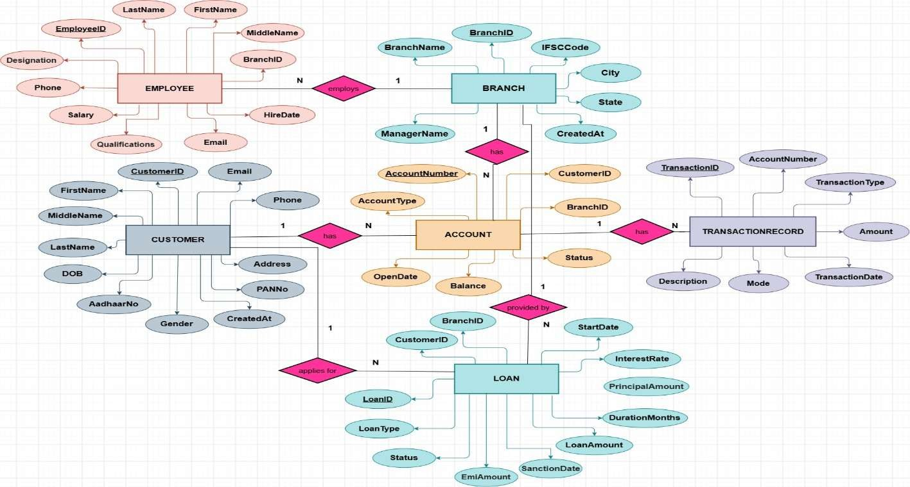

Relationships & Cardinality

Entity 1 | Relationship | Entity 2 | Cardinality (1:1 / 1:N / M:N)
Branch | employs | Employee | 1:N
Branch | has | Account | 1:N
Branch | handles | Loan | 1:N
Customer | owns | Account | 1:N
Customer | takes | Loan | 1:N
Account | has | TransactionRecord | 1:N


Relational Database Schema

Table Name | Column Name | Data Type | PK/FK/— | Constraints
Branch | BranchID | INTEGER | PK | NOT NULL, FOREIGN KEY  → Branch
Branch | BranchName | VARCHAR(50) | — | NOT NULL
Branch | IFSCCode | VARCHAR(11) | — | NOT NULL, UNIQUE,  CHECK length=11
Branch | City | VARCHAR(50) | — | NOT NULL
Branch | State | VARCHAR(50) | — | NOT NULL
Branch | ManagerName | VARCHAR(50) | — | NOT NULL
Branch | CreatedAt | DATE | — | DEFAULT CURRENT_DATE
Customer | CustomerID | INTEGER | PK | NOT NULL, FOREIGN KEY  → Customer
Customer | FirstName | VARCHAR(30) | — | NOT NULL
Customer | MiddleName | VARCHAR(30) | — | NULL allowed
Customer | LastName | VARCHAR(30) | — | NOT NULL
Customer | DOB | DATE | — | NOT NULL
Customer | Gender | VARCHAR(10) | — | CHECK Male/Female/Other
Customer | AadhaarNo | VARCHAR(12) | — | NOT NULL, UNIQUE,  CHECK length=12
Customer | PANNo | VARCHAR(10) | — | NOT NULL, UNIQUE,  CHECK length=10
Customer | Email | VARCHAR(100) | — | NOT NULL, UNIQUE
Customer | Phone | VARCHAR(12) | — | NOT NULL
Customer | Address | VARCHAR(100) | — | NOT NULL
Customer | CreatedAt | DATE | — | DEFAULT CURRENT_DATE
Employee | EmployeeID | INTEGER | PK | PRIMARY KEY
Employee | BranchID | INTEGER | FK | NOT NULL, FOREIGN KEY  → Branch
Employee | FirstName | VARCHAR(30) | — | NOT NULL
Employee | MiddleName | VARCHAR(30) | — | NULL allowed
Employee | LastName | VARCHAR(30) | — | NOT NULL
Employee | Designation | VARCHAR(50) | — | NOT NULL
Employee | Qualifications | TEXT | — | NULL allowed

Table Name | Column Name | Data Type | PK/FK/— | Constraints
Employee | Salary | DECIMAL(12,2) | — | NOT NULL, CHECK >= 0
Employee | Phone | VARCHAR(12) | — | NOT NULL
Employee | Email | VARCHAR(100) | — | NOT NULL, UNIQUE
Employee | HireDate | DATE | — | NOT NULL
Account | AccountNumber | VARCHAR(20) | PK | NOT NULL, FOREIGN KEY  → Account
  Account | CustomerID | INTEGER | FK | NOT NULL, FOREIGN KEY  → Customer
Account | BranchID | INTEGER | FK | NOT NULL, FOREIGN KEY  → Branch
Account | AccountType | VARCHAR(20) | — | NOT NULL, CHECK  Savings/Current/Fixed Deposit
Account | Balance | DECIMAL(15,2) | — | NOT NULL, DEFAULT 0, CHECK >= 0
Account | OpenDate | DATE | — | NOT NULL
Account | Status | VARCHAR(15) | — | NOT NULL, DEFAULT  Active, CHECK allowed statuses
TransactionRecord | TransactionID | INTEGER | PK | PRIMARY KEY
TransactionRecord | AccountNumber | VARCHAR(20) | FK | NOT NULL, FOREIGN KEY  → Account
TransactionRecord | TransactionType | VARCHAR(15) | — | NOT NULL, CHECK  Deposit/Withdrawal/Transfer
TransactionRecord | Amount | DECIMAL(15,2) | — | NOT NULL, CHECK > 0
TransactionRecord | TransactionDate | DATE | — | DEFAULT CURRENT_DATE
TransactionRecord | Mode | VARCHAR(20) | — | NOT NULL, CHECK  Online/ATM/Branch/UPI/Net Banking
TransactionRecord | Description | VARCHAR(255) | — | NULL allowed
Loan | LoanID | INTEGER | PK | PRIMARY KEY
Loan | CustomerID | INTEGER | FK | NOT NULL, FOREIGN KEY  → Customer
Loan | BranchID | INTEGER | FK | NOT NULL, FOREIGN KEY  → Branch
Loan | LoanType | VARCHAR(50) | — | NOT NULL, CHECK allowed loan types
Loan | LoanAmount | DECIMAL(15,2) | — | NOT NULL, CHECK > 0
Loan | PrincipalAmount | DECIMAL(15,2) | — | CHECK > 0
Loan | InterestRate | DECIMAL(5,2) | — | NOT NULL, CHECK 0–100
Loan | StartDate | DATE | — | NOT NULL
Loan | DurationMonths | INTEGER | — | NOT NULL, CHECK > 0
Loan | EmiAmount | DECIMAL(10,2) | — | CHECK >= 0
Loan | Status | VARCHAR(20) | — | NOT NULL, DEFAULT  Active, CHECK allowed statuses
Loan | SanctionDate | DATE | — | NULL allowed

Normalization
UNF → 1NF → 2NF → 3NF
UNF: Banking information could be represented as a large combined record containing branch, customer, account, loan, employee, and transaction details.

1NF: The design separates repeating groups and keeps attributes atomic. For example, customer names are split into FirstName, MiddleName, and LastName, and Address is stored as one field.
2NF: Each entity is separated into its own table with a primary key so non-key attributes depend on the complete key.
3NF: Relationships are represented using foreign keys, so branch, customer, account, loan, employee, and transaction facts are stored in their appropriate tables rather than being repeatedly duplicated. This reduces update, insertion, and deletion anomalies.


DATABASE IMPLEMENTATION

DDL — Database and Table Creation
-- Drop tables if they exist
DROP TABLE IF EXISTS TransactionRecord; DROP TABLE IF EXISTS Loan;
DROP TABLE IF EXISTS Account; DROP TABLE IF EXISTS Employee; DROP TABLE IF EXISTS Customer; DROP TABLE IF EXISTS Branch;

-- 1. BRANCH TABLE
CREATE TABLE Branch (
BranchID INTEGER PRIMARY KEY, BranchName VARCHAR(50) NOT NULL, IFSCCode VARCHAR(11) NOT NULL UNIQUE, City VARCHAR(50) NOT NULL,
State VARCHAR(50) NOT NULL, ManagerName VARCHAR(50) NOT NULL, CreatedAt DATE DEFAULT CURRENT_DATE,
CONSTRAINT chk_ifsc_len CHECK (LENGTH(IFSCCode) = 11)
);

-- 2. CUSTOMER TABLE (Atomic attributes, 1NF/2NF/3NF compliant) CREATE TABLE Customer (
CustomerID INTEGER PRIMARY KEY, FirstName VARCHAR(30) NOT NULL,
MiddleName VARCHAR(30), LastName VARCHAR(30) NOT NULL, DOB DATE NOT NULL,
Gender VARCHAR(10) CHECK (Gender IN ('Male', 'Female', 'Other')), AadhaarNo VARCHAR(12) NOT NULL UNIQUE,
PANNo VARCHAR(10) NOT NULL UNIQUE, Email VARCHAR(100) NOT NULL UNIQUE, Phone VARCHAR(12) NOT NULL, Address VARCHAR(100) NOT NULL,
CreatedAt DATE DEFAULT CURRENT_DATE,
CONSTRAINT chk_aadhaar CHECK (LENGTH(AadhaarNo) = 12), CONSTRAINT chk_pan CHECK (LENGTH(PANNo) = 10)
);

-- 3. EMPLOYEE TABLE
CREATE TABLE Employee (
EmployeeID INTEGER PRIMARY KEY, BranchID INTEGER NOT NULL, FirstName VARCHAR(30) NOT NULL,
MiddleName VARCHAR(30), LastName VARCHAR(30) NOT NULL,
Designation VARCHAR(50) NOT NULL, Qualifications TEXT,
Salary DECIMAL(12, 2) NOT NULL CHECK (Salary >= 0), Phone VARCHAR(12) NOT NULL,
Email VARCHAR(100) NOT NULL UNIQUE, HireDate DATE NOT NULL,
FOREIGN KEY (BranchID) REFERENCES Branch(BranchID)
);


-- 4. ACCOUNT TABLE

CREATE TABLE Account (
AccountNumber VARCHAR(20) PRIMARY KEY, CustomerID INTEGER NOT NULL,
BranchID INTEGER NOT NULL,
AccountType VARCHAR(20) NOT NULL CHECK (AccountType IN ('Savings', 'Current', 'Fixed Deposit')),
Balance DECIMAL(15, 2) NOT NULL DEFAULT 0.00 CHECK (Balance >= 0), OpenDate DATE NOT NULL,
Status VARCHAR(15) NOT NULL DEFAULT 'Active' CHECK (Status IN ('Active', 'Inactive', 'Frozen', 'Closed')),
FOREIGN KEY (CustomerID) REFERENCES Customer(CustomerID), FOREIGN KEY (BranchID) REFERENCES Branch(BranchID)
);

-- 5. TRANSACTION TABLE
CREATE TABLE TransactionRecord ( TransactionID INTEGER PRIMARY KEY, AccountNumber VARCHAR(20) NOT NULL,
TransactionType VARCHAR(15) NOT NULL CHECK (TransactionType IN ('Deposit', 'Withdrawal', 'Transfer')),
Amount DECIMAL(15, 2) NOT NULL CHECK (Amount > 0),
TransactionDate DATE DEFAULT CURRENT_DATE,
Mode VARCHAR(20) NOT NULL CHECK (Mode IN ('Online', 'ATM', 'Branch', 'UPI', 'Net
Banking')),
Description VARCHAR(255),
FOREIGN KEY (AccountNumber) REFERENCES Account(AccountNumber)
);

-- 6. LOAN TABLE CREATE TABLE Loan (
LoanID INTEGER PRIMARY KEY, CustomerID INTEGER NOT NULL, BranchID INTEGER NOT NULL,
LoanType VARCHAR(50) NOT NULL CHECK (LoanType IN ('Home', 'Car', 'Personal', 'Education', 'Business')),
LoanAmount DECIMAL(15, 2) NOT NULL CHECK (LoanAmount > 0), PrincipalAmount DECIMAL(15, 2) CHECK (PrincipalAmount > 0),
InterestRate DECIMAL(5, 2) NOT NULL CHECK (InterestRate >= 0 AND InterestRate <= 100),
StartDate DATE NOT NULL,
DurationMonths INTEGER NOT NULL CHECK (DurationMonths > 0), EmiAmount DECIMAL(10, 2) CHECK (EmiAmount >= 0),
Status VARCHAR(20) NOT NULL DEFAULT 'Pending' CHECK (Status IN ( 'Approved', 'Pending', 'Closed', 'Rejected', 'Active', 'Default')),
SanctionDate DATE,
FOREIGN KEY (CustomerID) REFERENCES Customer(CustomerID), FOREIGN KEY (BranchID) REFERENCES Branch(BranchID)
);

Sample Data — DML.

Table | No. of Records | Sample Data / Screenshot Reference
Branch | 5 | dml.sql — Branch seed records
Customer | 10 | dml.sql — Customer seed records
Employee | 12 | dml.sql — Employee seed records

Account | 15 | dml.sql — Account seed records
Loan | 5 | dml.sql — Loan seed records
TransactionRecord | 50 | dml.sql — Transaction seed records


Constraints & Data Integrity

Constraint / Validation | Applied On | Purpose | Evidence / Screenshot
PRIMARY KEY | All six tables | Uniquely identifies each record and prevents duplicate key values. | ddl.sql
FOREIGN KEY | Employee, Account, Loan, TransactionRecord | Maintains valid relationships between related tables. | ddl.sql
NOT NULL | Required fields across tables | Prevents missing values in required attributes. | ddl.sql
UNIQUE | Branch.IFSCCode; Customer.AadhaarNo/PANNo/Em ail; Employee.Email | Prevents duplicate unique identifiers/contact values. | ddl.sql
CHECK | Gender, AccountType, Balance, Status, transaction type/mode, loan values, lengths | Restricts invalid or out-of-range values. | ddl.sql
DEFAULT | Branch.CreatedAt; Customer.CreatedAt; Account.Balance/Status; TransactionDate; Loan.Status | Provides default values when not explicitly supplied. | ddl.sql

SQL Operations & Queries
.

S.No | Operation / Query | Purpose | SQL Query / Screenshot Ref.
1 | Basic SELECT — all customers | Retrieve customer records. | queries(2).sql Q1
2 | Filtered SELECT — active savings accounts | Find active savings accounts ordered by balance. | queries(2).sql Q2
3 | LIKE filtering | Search customers by name or email domain. | queries(2).sql Q3
4 | Balance lookup | Check the balance of account 10001. | queries(2).sql Q4
5 | UPDATE + INSERT | Deposit ₹5,000 into account 10001 and record the transaction. | queries(2).sql Q5
6 | UPDATE + INSERT | Withdraw ₹1,000 when sufficient balance exists and record the transaction. | queries(2).sql Q6
7 | Transaction history | Display account transaction history in descending date order. | queries(2).sql Q7
8 | SUM aggregate | Calculate total funds across all accounts. | queries(2).sql Q8

S.No | Operation / Query | Purpose | SQL Query / Screenshot Ref.
9 | GROUP BY + aggregates | Calculate account count, average balance, and total balance by account type. | queries(2).sql Q9
10 | GROUP BY + aggregates | Calculate active loan count, total sanctioned amount, and average interest rate by loan type. | queries(2).sql Q10
11 | JOIN + GROUP BY + HAVING | Find branches whose total account balance exceeds ₹500,000. | queries(2).sql Q11
12 | JOIN + GROUP BY + HAVING | Find customers holding more than one account. | queries(2).sql Q12
13 | Subquery | Find customers whose total account balance exceeds the average account balance. | queries(2).sql Q13
14 | Subquery + ORDER BY + LIMIT | List transactions for the highest-balance account. | queries(2).sql Q14


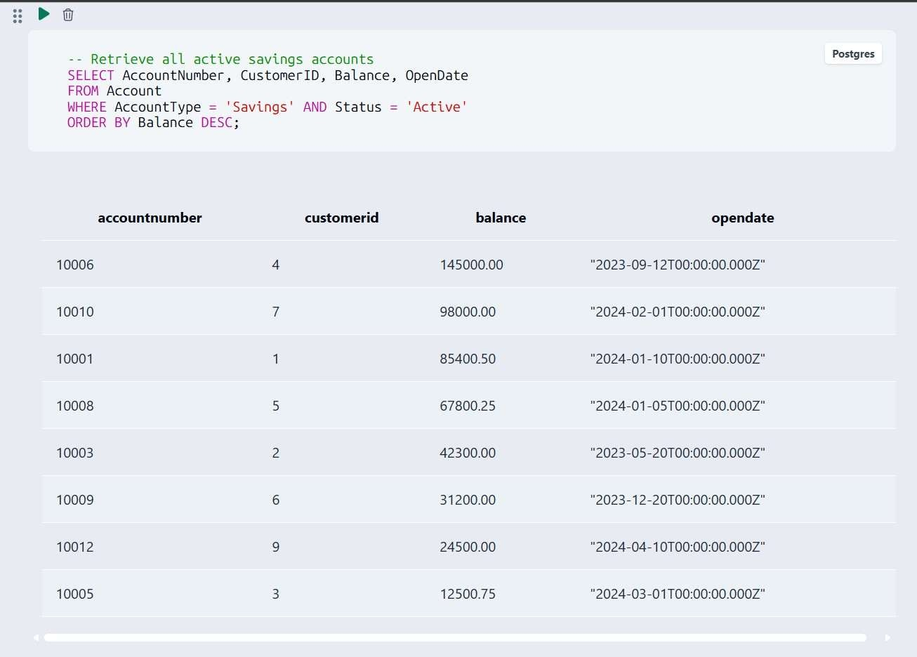
Sample Outputs / Screenshots
Figure 1: Customer records / basic SELECT output


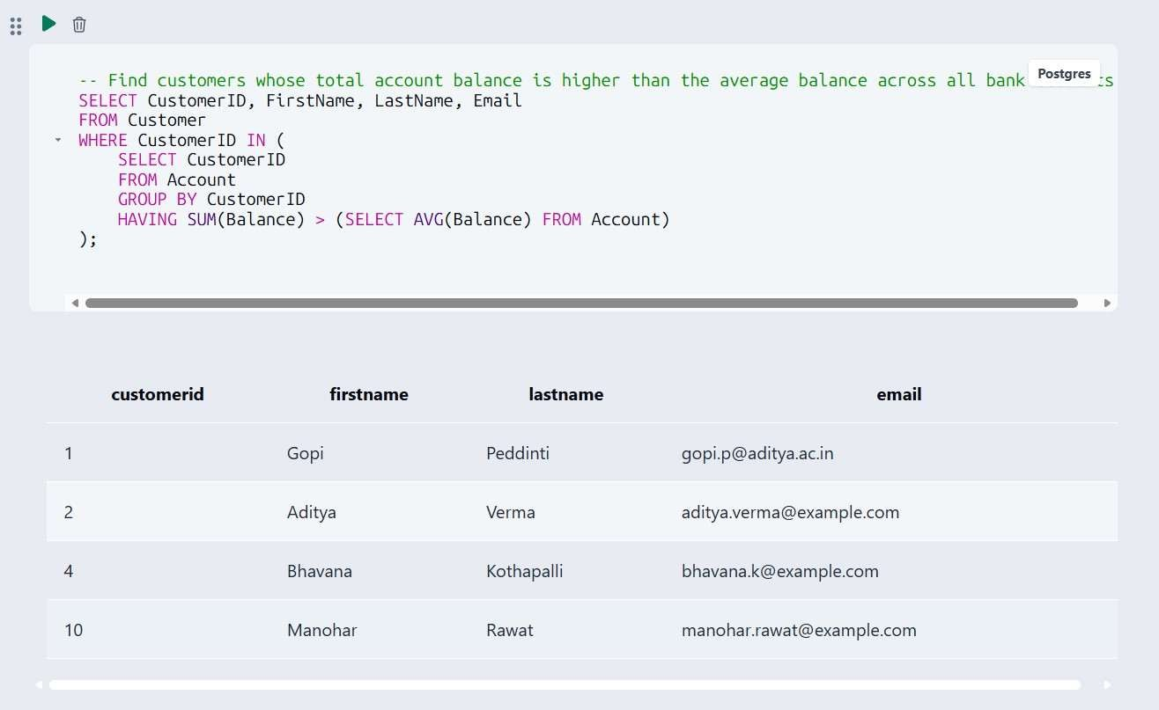
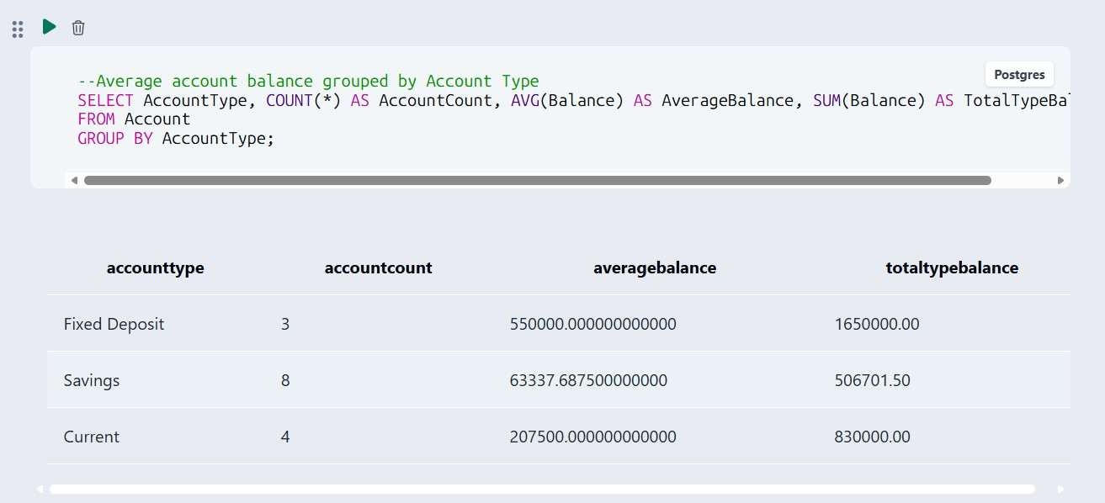
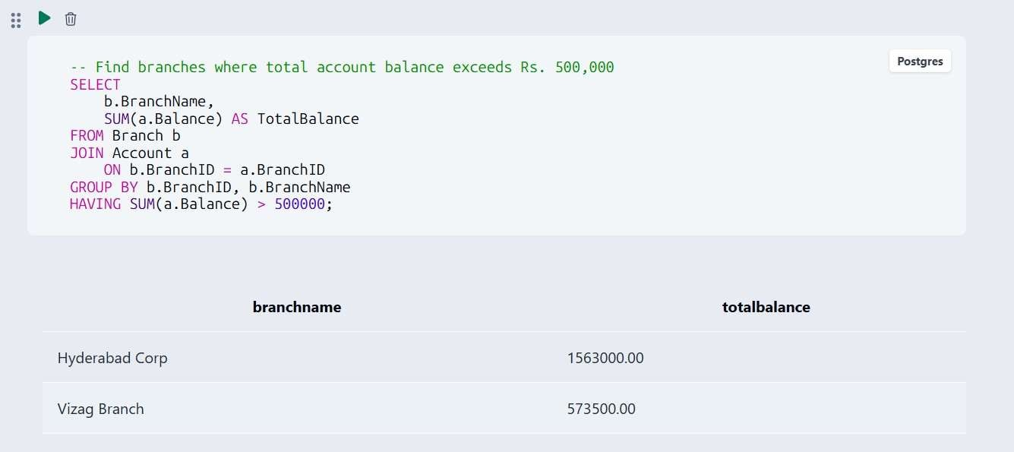
Figure 2: Active savings accounts / filtering output

Figure 3: Aggregate or GROUP BY output

Figure 4: Join or subquery output

MODULES & FUNCTIONALITIES

S.No | Module Name | Functionality
1 | Branch Management | Stores and organizes branch identification, IFSC, location, manager, and creation information.
2 | Customer Management | Maintains customer identity, KYC-related identifiers, contact details, and address.
3 | Employee Management | Maintains employees and their association with branches, including designation, qualification, salary, and contact information.
4 | Account Management | Stores account ownership, branch, account type, balance, opening date, and status.
5 | Transaction Management | Records deposits, withdrawals, and transfers with amount, date, mode, and description.
6 | Loan Management & Analysis | Stores loan details and supports loan and banking analysis through aggregate and grouped SQL queries.

GITHUB REPOSITORY & TEAM RESPONSIBILITIES
Repository Link: https://github.com/sashank-1916/bank-account-management-dbms.git

Student Name | Roll Number | Role / Responsibility | Contribution Status
B HARIKA | 25B11AI527 | Wrote DDL scripts (tables, keys, constraints) | Completed
G MANOJ | 25B11AI385 | Designed ER diagram & relational schema | Completed
V PAVITHRA | 25B11AI520 | Wrote CRUD, Join & Aggregate queries | Completed
G SASHANK | 25B11AI316 | Compiled documentation & screenshots | Completed

ENHANCEMENTS & FUTURE IMPROVEMENTS
Future improvements can extend the current database with stronger transaction controls, user authentication and role-based access, richer reporting and dashboards, automated loan EMI calculations, audit logging, stored procedures/triggers where supported, indexing for frequently queried columns, and a front-end interface for banking staff. The uploaded SQL files do not include these additional features, so they are proposed enhancements rather than implemented features in the current submission.

CONCLUSION
The Bank Account Management System successfully models the main banking entities and their relationships using a relational database structure. The DDL defines six tables with primary keys, foreign keys, NOT NULL, UNIQUE, CHECK, and DEFAULT constraints. The DML script supplies representative records for branches, customers, employees, accounts, loans, and transactions. The query script demonstrates selection and filtering, balance updates, transaction logging, joins, aggregate functions, GROUP BY/HAVING, and subqueries. The project therefore meets its core objectives of relational design, data integrity, sample-data population, and practical SQL analysis. The team also divided the work across DDL development, ER/schema design, query development, and documentation/screenshot compilation.

REFERENCES
- Uploaded project DDL script: ddl.sql.
- Uploaded project DML/sample-data script: dml.sql.
- Uploaded SQL query script: queries.sql.
- Aditya University — DBMS Capstone Project documentation template.
- GitHub repository: Bank Account Management System (project repository).

APPENDIX

Complete SQL Script
The final SQL implementation is supplied through the uploaded project files:

    - ddl.sql — database table definitions, keys, foreign keys, and constraints.
    - dml.sql — sample data for all six tables.
    - queries.sql — representative SQL operations and analytical queries.
Repository: https://github.com/sashank-1916/bank-account-management-dbms.git

Additional Screenshots / Outputs
Additional evidence can include SQL execution screenshots showing table creation, sample data, customer/account retrieval, balance updates, aggregate results, joins, GROUP BY/HAVING results, and subquery outputs. No execution screenshots were included in the uploaded source files, so this section is intentionally left for the team to add its actual screenshots.

