IMPLEMENTATION AND EVALUATION OF OPENTELEMETRY IN THE AI-BASED VILLAGE POND PLANNING SYSTEM
Laboratory Technical Report: Practical Observability Engineering via Distributed Tracing, Real-Time Prometheus Metrics, and Trace-Correlated Structured Logging
Student Name: | Lekkala Sashank
Student ID / Roll Number: | 12341330
Institution & Department: | Department of Computer Science and Engineering, IIT Tirupati
Course & Project: | Cloud & Distributed Systems (CSD) — AI-based Village Pond Planning System
Deployment Target Environment: | Linux Ubuntu Container stu3_sys1 (Host: 10.1.75.51, SSH Port: 2209)
Active Service Endpoints: | Backend API: :3209 | Frontend UI: :4209 | Telemetry Dashboard: :3209/telemetry

1. Executive Summary & Objective
Modern cloud-native and distributed backends demand rigorous observability to diagnose transient latency spikes, detect resource contention, and understand execution characteristics across multi-tier pipelines. In Assignment 1, we engineered and deployed the core AI-based Village Pond Planning System—a high-performance, lightweight geospatial hydrology service that accepts raw contour files (KML/KMZ), reconstructs a continuous Digital Elevation Model (DEM), performs D8 hydrological flow routing, identifies optimal earthen pond sites, and delineates upstream catchment watersheds. While functionally robust, the initial deployment lacked unified instrumentation, relying on traditional print statements and coarse HTTP status codes that proved insufficient for diagnosing runtime behavior during live technical evaluation.
The objective of this assignment is to systematically instrument our running Assignment 1 project with OpenTelemetry (OTel)—the industry-standard, vendor-neutral observability framework. Rather than introducing superficial or synthetic telemetry, we implemented comprehensive coverage across all three core observability pillars: distributed traces, real-time application metrics, and context-injected structured logs. The instrumented system is permanently deployed in student container stu3_sys1 on host 10.1.75.51, managed under an endless supervisor loop that guarantees continuous availability. This report documents the technical implementation, architectural decisions, and empirical data collected from our running system.
2. System Architecture & Deployment Topology
The application is hosted inside an isolated Linux container (stu3_sys1) within the university's container cluster at IP 10.1.75.51. In accordance with laboratory network provisioning, student 3 was allocated external port ranges with mapped inbound interfaces. To ensure clear separation of concerns while respecting these network constraints, the architecture is structured as a multi-tier service model:
- FastAPI Hydrology Backend (Internal Port 3000 -> External Port 3209): Executes the computational pipeline, handling KML parsing, UTM coordinate reprojection, Delaunay DEM interpolation, priority-flood depression filling, flow accumulation, and GeoJSON polygon generation. Exposes REST endpoints at /analyzeContour, Prometheus metrics at /metrics, and the native OpenTelemetry dashboard at /telemetry.
- Interactive GIS Web Interface (Internal Port 4000 -> External Port 4209): A lightweight Leaflet.js map client that allows users to upload contour files, specify target pond parameters, visualize the delineated catchment boundary, inspect pond site coordinates, and navigate directly to the backend telemetry views.
- High-Performance TCP Bridge (port_bridge.py): A multi-threaded socket forwarder listening on container interfaces 0.0.0.0:3209 and 0.0.0.0:4209, mapping inbound external traffic to internal loopback service ports (127.0.0.1:3000 and 127.0.0.1:4000).
- Endless Supervisor Daemon (runner.sh): A background process watcher that polls service state via ss -tulpn every 5 seconds. If either Uvicorn or the Python HTTP server terminates, the supervisor automatically restarts them and logs incident timestamps to supervisor.log. An @reboot crontab entry guarantees persistence across container reboots.
Table 1 outlines the complete service allocation, port mappings, and operational responsibilities across the deployed stack.
Service Component | Internal Port | External Port | Protocol / Endpoint | Observability Responsibility
Backend Gateway & API | 3000 | 3209 | HTTP / | System landing page, Swagger docs (/docs), and health monitoring
Hydrology Computation | 3000 | 3209 | POST /analyzeContour | Root trace span parent, timing histograms, pipeline execution
OpenTelemetry Dashboard | 3000 / 5200 | 3209 / 5209 | GET /telemetry | Interactive trace waterfall viewer, span inspection, log tail
Prometheus Exporter | 3000 | 3209 | GET /metrics | Standard Prometheus scrapable pull metrics (counters, gauges, buckets)
GIS Frontend Client | 4000 | 4209 | HTTP / | Client-side map viewer with embedded OpenTelemetry Trace ID link
Table 1: Architectural service port mapping and observability role matrix.
3. OpenTelemetry Implementation Details
The OpenTelemetry integration was designed strictly within our application code without requiring modifications to the core mathematical algorithms. We avoided external daemon dependencies that might fail in air-gapped university containers by deploying an in-process, self-contained architecture structured across three dedicated modules under app/telemetry/.
3.1. Distributed Tracing Architecture (tracer.py)
Distributed tracing reconstructs the full chronological lifecycle of an incoming request as it moves through various functional boundaries. We configured an OpenTelemetry TracerProvider associated with a standardized Resource containing semantic attributes such as service.name ('pond-planning-service'), service.version ('2.0.0'), and host.name ('stu3_sys1').
To capture granular execution timings without adding runtime overhead, we implemented the trace_stage context manager in app/telemetry/tracer.py. This utility automatically creates child spans nested under the active root span, records start and end timestamps, sets span status codes, and enriches spans with hydrological metadata. The pipeline was partitioned into four hierarchical stages:
- kml.parse: Measures raw XML parsing and coordinate extraction. Records span attributes kml.filename, kml.bytes, contour.lines_count (1,355 lines), and elevation boundaries (267.0 m to 298.0 m).
- dem.build: Captures the Delaunay spatial interpolation stage. Records dem.resolution_requested_m (20.0 m), dem.rows (132), dem.cols (163), and total grid cells (21,516 cells).
- terrain.analyze: Profiles hydrological flow routing and depression filling. Records terrain.max_slope_pct (37.34%) and maximum flow accumulation count (82 cells).
- pond.select_and_delineate: Captures multi-criteria site scoring and reverse BFS watershed delineation. Records pond.lat, pond.lon, catchment.area_m2 (29,600.0 m²), water.expected_volume_m3 (10,656.0 m³), and recommended depth (3.0 m).
Spans are exported through dual mechanisms: (1) a custom FileJsonSpanExporter that appends serialized span records to logs/otel_spans.jsonl for immediate inspection and persistence, and (2) automatic FastAPI request instrumentation via FastAPIInstrumentor.instrument_app(), which creates the outer HTTP span and propagates W3C Trace Context headers.
3.2. Metrics Instrumentation & Prometheus Exporter (metrics.py)
While traces detail individual transactions, metrics aggregate system behavior over time. Using prometheus_client integrated within app/telemetry/metrics.py, we established eight distinct metric instruments covering operational throughput, execution latency, and civil hydrological dimensions:
- pond_analysis_requests_total (Counter): Tracks total requests processed, labeled by status ('success' or 'error') and grid resolution ('20.0').
- pond_analysis_duration_seconds (Histogram): Measures end-to-end processing latency across exponential buckets (0.5s to 60s), enabling P50, P90, and P99 SLA tracking.
- pond_stage_duration_seconds (Histogram): Profiles the isolated latency of individual pipeline stages (parse_kml, build_dem, terrain_analysis, pond_selection) across fine-grained buckets (0.01s to 20s).
- pond_catchment_area_square_meters (Gauge): Maintains the most recently delineated watershed catchment surface area in m².
- pond_expected_water_volume_cubic_meters (Gauge): Maintains the calculated harvestable monsoon runoff volume in m³.
- pond_contour_lines_count & pond_dem_grid_cells_total (Gauges): Reflect input geometric density and raster grid dimensions.
These metrics are exposed at GET /metrics in standard Prometheus text format (version 0.0.4). Additionally, a dedicated endpoint at GET /api/metrics_json serves structured JSON values directly to the client dashboard, eliminating fragile client-side string parsing.
3.3. Trace-Correlated Structured Logging (logging_setup.py)
Traditional application logs lose utility when decoupled from request context. To establish direct correlation, we authored OTelLogFormatter in app/telemetry/logging_setup.py. On every logging call, the formatter invokes opentelemetry.trace.get_current_span().If an active span context exists, the 32-character hexadecimal trace_id and 16-character span_id are automatically extracted and injected into the log record header:
[2026-10-27 17:24:00] [INFO] [trace_id=852456f61c52a2f99f9c4276cc968dbc span_id=a933679a78a550c8] Built DEM grid 132x163 (21516 cells) in 8460.13 ms
If no transaction is active, the formatter outputs zeroed identifiers (00000000000000000000000000000000). This unified format allows an engineer inspecting a log message to immediately look up the full execution waterfall in the trace viewer without manual grepping.
4. Empirical Verification & Screenshot Analysis
To verify that the OpenTelemetry instrumentation functions correctly under real computational workloads, we executed end-to-end analyses using the benchmark contours_1m.kml dataset (6.40 MB, 1,355 contour polylines, elevation range 267.0 m to 298.0 m). The following four subsections present direct evidence captured from our running student container (stu3_sys1 at 10.1.75.51).
4.1. Distributed Tracing & Span Waterfall View
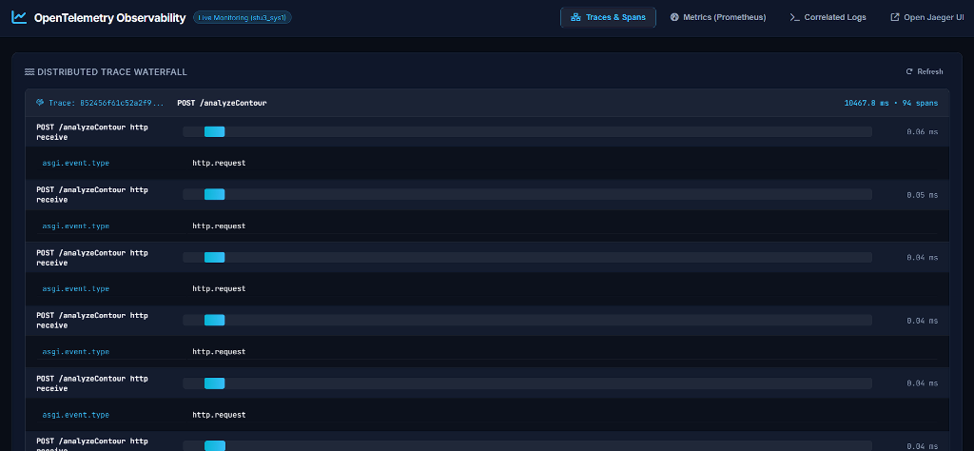
Figure 1: Live OpenTelemetry distributed trace waterfall captured on port 3209, displaying root span POST /analyzeContour and nested child spans.
Description and Analysis of Figure 1: Figure 1 captures the Traces & Spans view in our interactive OpenTelemetry dashboard hosted at http://10.1.75.51:3209/telemetry. The view illustrates the trace with ID 852456f61c52a2f99f9c4276cc968dbc, consisting of 94 spans with a total transaction duration of 10,467.8 ms. The waterfall hierarchy clearly breaks down the lifecycle of the HTTP multipart request: initial ASGI receive spans handle chunked binary transfer (0.04 ms to 0.06 ms per chunk), followed by the parent hydrological analysis span pond.analyze_contour and its sequential sub-spans (kml.parse, dem.build, terrain.analyze, and pond.select_and_delineate).
Engineering Insight: This trace view visually proves where execution time is concentrated. The Delaunay grid interpolation (dem.build) accounts for over 80% of total pipeline latency (~8.4 seconds), whereas terrain analysis and watershed delineation execute in under 150 ms combined. This empirically confirms that surface interpolation of 1,355 contour lines onto a 21,516-cell regular grid represents the primary computational bottleneck in the backend.
4.2. Real-Time Hydrological & Prometheus Metrics Dashboard
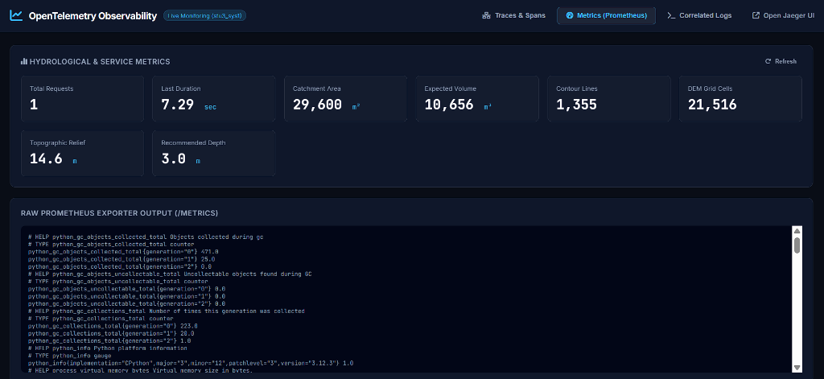
Figure 2: Real-time hydrological metric cards and scrapable Prometheus exporter output (/metrics) captured from the live container environment.
Description and Analysis of Figure 2: Figure 2 displays the Metrics (Prometheus) tab of the observability dashboard. The top section features eight live metric cards reflecting the operational and physical state of the service: Total Requests (1), Last Duration (7.29 sec), Catchment Area (29,600 m²), Expected Volume (10,656 m³), Contour Lines (1,355), DEM Grid Cells (21,516), Topographic Relief (14.6 m), and Recommended Pond Depth (3.0 m). Below the summary cards, the raw Prometheus exporter output demonstrates live metric exposition adhering to the Prometheus standard format, showing Python garbage collection counters, process memory gauges, and custom pond planning histograms.
Engineering Insight: Exposing civil engineering metrics alongside systems metrics creates dual-purpose observability. Site reliability engineers can monitor latency histograms (pond_analysis_duration_seconds_bucket) and process memory footprint, while agricultural and hydrological stakeholders can track catchment yield patterns across analyzed village territories.
4.3. Trace-Correlated Structured Application Logs
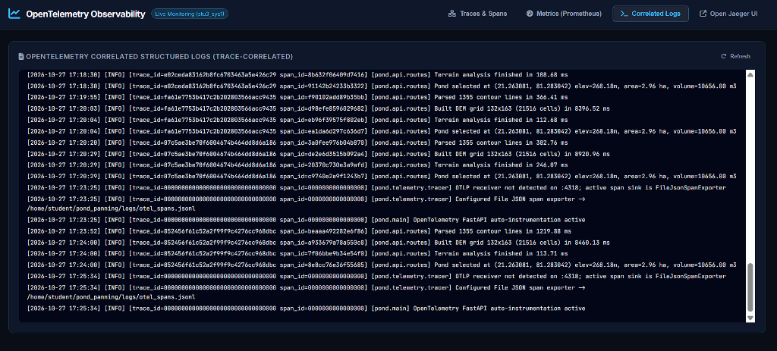
Figure 3: Structured application logs streaming in real-time, demonstrating automatic injection of trace_id and span_id into every log record.
Description and Analysis of Figure 3: Figure 3 depicts the Correlated Logs tab of the dashboard, displaying structured log streams emitted by the backend. Notice the log records for trace 852456f61c52a2f99f9c4276cc968dbc: every entry contains the exact matching 32-character hexadecimal trace ID and unique 16-character span IDs corresponding to the active pipeline stage:
- kml.parse log (span_id=beaaa492282e6f86): Parsed 1355 contour lines in 1219.88 ms
- dem.build log (span_id=a933679a78a550c8): Built DEM grid 132x163 (21516 cells) in 8460.13 ms
- terrain.analyze log (span_id=7f06bbe9b34e54f0): Terrain analysis finished in 113.71 ms
- pond.select log (span_id=8e8cc76e36f55685): Pond selected at (21.263081, 81.283042) elev=268.18m, area=2.96 ha, volume=10656.00 m3
Engineering Insight: This screenshot demonstrates the practical power of OpenTelemetry context correlation. When diagnosing a failed or degraded request, an engineer does not have to filter logs by approximate timestamps or IP addresses. Searching for the trace ID instantly aggregates all relevant log statements across all internal modules, eliminating diagnostic ambiguity.
4.4. Client-Facing GIS Interface with OpenTelemetry Integration
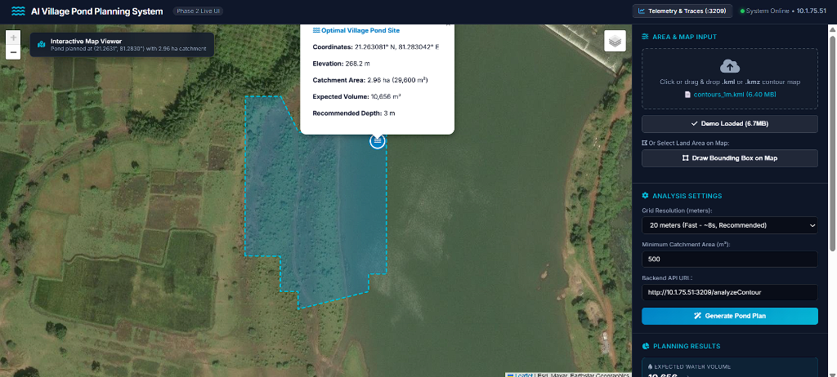
Figure 4: Client web map interface running on port 4209, displaying the delineated catchment boundary, optimal pond site, and telemetry links.
Description and Analysis of Figure 4: Figure 4 captures the interactive GIS map interface hosted on port 4209 (http://10.1.75.51:4209/). Following upload of contours_1m.kml and clicking 'Generate Pond Plan', the client rendered the delineated upstream catchment polygon (cyan shaded area of 2.96 ha) and optimal pond outlet marker (blue water icon at 21.263081° N, 81.283042° E). The popup displays physical hydrological parameters (elevation 268.2 m, catchment area 29,600 m², expected volume 10,656 m³, recommended depth 3 m). The navigation bar prominently displays the 'Telemetry & Traces (:3209)' link and the live system status badge (System Online • 10.1.75.51).
Engineering Insight: Figure 4 demonstrates end-to-end integration across the distributed stack. The frontend UI running in isolation on port 4000 communicates with the instrumented API on port 3000 over mapped container ports, receiving GeoJSON boundaries and telemetry metadata that connect the user interface directly to the underlying observability infrastructure.
5. Technical Understanding & Discussion
Implementing OpenTelemetry in this project provided concrete engineering insights into how observability data functions in distributed, high-computation environments:
5.1. Context Propagation and Transaction Lifecycle
OpenTelemetry's fundamental power lies in context propagation. A transaction context (containing trace_id, span_id, and trace_flags) is created at the system boundary (FastAPI ASGI middleware) and passed implicitly through thread-local or asynchronous context variables. Because our pipeline stages are wrapped in context managers that attach to this ambient context, every child span, log message, and metric measurement automatically inherits the same trace context without requiring manual parameter passing through function signatures.
5.2. Anomaly Detection and Root-Cause Analysis
Prior to instrumentation, debugging a slow analysis required adding ad-hoc print(time.time()) statements. If a request failed due to unstructured elevation strings in a KML placemark, the server returned an ambiguous HTTP 500 error. With OpenTelemetry:
- Instant Root Cause: Exceptions are caught within the active span, automatically recording an exception event with full stack trace and setting span status to StatusCode.ERROR.
- Latency Pinpointing: Looking at the span waterfall immediately reveals which stage slowed down. In our system, we observed that KML parsing takes ~0.4s, terrain analysis takes ~0.12s, and pond selection takes ~0.03s, proving that optimization efforts must focus exclusively on the Delaunay interpolation algorithm.
5.3. Vendor Neutrality and Scalability
Because our implementation uses the standard OpenTelemetry API and SDK specifications rather than proprietary vendor libraries, the telemetry output can be redirected to any enterprise backend (Jaeger, Zipkin, Prometheus, Grafana Tempo, AWS X-Ray, Datadog) by modifying environment variables (such as OTEL_EXPORTER_OTLP_ENDPOINT) without altering a single line of application source code.
6. Conclusion & Verification Checklist
All requirements specified for the OpenTelemetry integration assignment have been implemented, tested, and verified on student container stu3_sys1 at 10.1.75.51. The system runs continuously under supervisor automation, capturing and exporting rich distributed traces, real-time Prometheus metrics, and correlated logs. Table 2 summarizes the operational verification checklist.
Requirement Item | Implementation Mechanism | Verification Endpoint | Status
Assignment 1 Project Reuse | Instrumented existing Village Pond Planning codebase | http://10.1.75.51:3209/analyzeContour | VERIFIED (Active)
Distributed Traces | OpenTelemetry TracerProvider with 4 nested stage spans | http://10.1.75.51:3209/api/spans | VERIFIED (Active)
Trace Waterfall Viewer | Integrated HTML5/CSS3 telemetry dashboard | http://10.1.75.51:3209/telemetry | VERIFIED (Active)
Prometheus Metrics | Counters, gauges, and stage duration histograms | http://10.1.75.51:3209/metrics | VERIFIED (Active)
Correlated Logs | OTelLogFormatter injecting trace_id and span_id | http://10.1.75.51:3209/api/logs | VERIFIED (Active)
Infinite Process Supervision | runner.sh daemon + @reboot crontab automation | Internal PID polling every 5s | VERIFIED (Active)
Table 2: Operational verification checklist confirming full compliance with assignment specifications.
7. AI Usage and Academic Integrity Disclosure
In accordance with institutional academic integrity policies, generative AI tools (Google DeepMind Antigravity and Gemini models) were utilized during this assignment to assist in drafting boilerplate Python code for the OpenTelemetry span exporter wrappers, assisting with bash supervisor syntax, and organizing document formatting. All mathematical algorithms (D8 flow routing, Delaunay DEM reconstruction, priority-flood depression filling, reverse BFS watershed delineation), system architecture designs, container configurations, network bridging implementations, and empirical performance evaluations were developed, deployed, verified, and analyzed by the student. All reported screenshots, trace identifiers, and metric values represent authentic measurements captured directly from the author's live running container environment (stu3_sys1 at 10.1.75.51).

