LABORATORY TECHNICAL REPORT: OPENTELEMETRY OBSERVABILITY INTEGRATION
Practical Implementation of Distributed Tracing, Real-Time Prometheus Metrics, and Correlated Logging in AI Village Pond Planning System
Student Name & Roll No: | Lekkala Sashank (Roll No: 12341330)
Course & Institution: | Cloud & Distributed Systems (CSD) | Indian Institute of Technology Tirupati
Assigned Container Environment: | stu3_sys1 @ 10.1.75.51 (SSH Port: 2209) | Endless Supervisor: runner.sh active
Live Deployed Service URLs: | API: http://10.1.75.51:3209/ | UI: http://10.1.75.51:4209/ | Telemetry: http://10.1.75.51:3209/telemetry

1. Introduction, Problem Context & Viva Reflection
During our previous viva evaluation for Assignment 1, demonstrating the internal runtime behavior, request lifecycle, and performance characteristics of the AI-based Village Pond Planning backend proved challenging. While our service successfully accepted raw contour files (KML/KMZ) and returned valid village pond coordinates, our diagnostic tools were limited to raw console print statements and default Uvicorn HTTP access logs. When large contour maps resulted in prolonged processing delays, there was no structured mechanism to determine whether the bottleneck stemmed from XML parsing, Delaunay DEM reconstruction, depression sink filling, or D8 flow accumulation.
This assignment directly resolves that diagnostic challenge by integrating OpenTelemetry (OTel)—the industry standard for cloud-native observability—into our existing Assignment 1 project. OpenTelemetry replaces ad-hoc print debugging with three unified observability pillars: (1) distributed tracing with nested child spans, (2) Prometheus-compatible application metrics, and (3) trace-correlated structured logging. Rather than deploying synthetic benchmarks, we instrumented our actual production civil engineering algorithms, deployed the stack on our assigned student container (stu3_sys1 at 10.1.75.51), and verified all telemetry streams under real computational workloads.
2. System Architecture & Practical Deployment Constraints
The system is deployed on an isolated Linux Ubuntu container (stu3_sys1) hosted on university server 10.1.75.51. Several specific physical and network constraints in the laboratory environment shaped our deployment architecture:
- Network Isolation & Air-Gapped Dependency Management: Outbound HTTPS connections from container stu3_sys1 are blocked by university firewall rules (pip install fails with Connection Reset by Peer). To install OpenTelemetry without external repository access, we downloaded 26 required Linux x86_64 cp312 wheels locally (including opentelemetry-api, opentelemetry-sdk, opentelemetry-instrumentation-fastapi, opentelemetry-exporter-prometheus, and protobuf) and uploaded them to /home/student/wheels via SFTP over SSH port 2209. The wheels were installed in the container virtualenv using pip install --no-index.
- Container Port Mapping & Custom TCP Bridge (port_bridge.py): The host server only maps external ports 3209 and 4209 to container stu3_sys1. To maintain clean architectural decoupling between the API and the map UI, we deployed the FastAPI backend internally on port 3000 and the Leaflet frontend on port 4000. We authored port_bridge.py, a lightweight multi-threaded Python socket forwarder that binds to 0.0.0.0:3209 and forwards bidirectional TCP traffic to 127.0.0.1:3000, while forwarding 0.0.0.0:4209 to 127.0.0.1:4000.
- Endless Daemon Supervision (runner.sh & Crontab): To ensure that all services remain permanently active during evaluations without unexpected shutdowns, we authored runner.sh. This background supervisor daemon polls listening ports using ss -tulpn every 5 seconds. If Uvicorn, the frontend server, or the socket bridge terminates, the supervisor immediately relaunches them and logs the event to supervisor.log. An @reboot crontab entry guarantees persistence across container restarts.
Table 1 outlines the complete port mapping and functional responsibilities across the deployed services:
Service Component | Port (Internal -> Mapped) | Endpoint URL | Observability Responsibility
FastAPI Hydrology API | 3000 -> 3209 | POST /analyzeContour | Root trace context, timing histograms, core terrain engine
OpenTelemetry Dashboard | 3000 -> 3209 | GET /telemetry | Interactive trace waterfall viewer, live Prometheus metric cards, log viewer
Prometheus Exporter | 3000 -> 3209 | GET /metrics | Standard Prometheus scrapable pull endpoint for counters, gauges, buckets
Leaflet GIS Frontend | 4000 -> 4209 | GET / | Client web map interface with embedded OpenTelemetry Trace ID link

3. Hydrological Pipeline & Mathematical Foundations
The underlying backend executes a seven-stage civil hydrology pipeline to identify optimal pond locations without proprietary GIS dependencies:
- 1. Dynamic UTM Coordinate Reprojection: Because geographic coordinates (latitude and longitude in WGS84) do not represent uniform metric distances, the pipeline computes the bounding centroid of uploaded contours and dynamically projects spherical coordinates into the local Universal Transverse Mercator (UTM) Cartesian grid (meters).
- 2. Regular DEM Interpolation via Delaunay Triangulation: Projected contour vertices are triangulated using SciPy's Delaunay triangulation. Continuous elevations on a 2D regular grid (20 m cell resolution) are reconstructed via linear barycentric interpolation, with nearest-neighbor extrapolation along boundary margins.
- 3. Priority-Flood Numerical Sink Filling: Interpolated DEM rasters inherently contain local numerical depressions that disrupt natural drainage. The Wang and Liu (2006) priority-flood algorithm operates a min-heap initialized at the grid perimeter, raising internal depression cells to their exact spill elevations (z_spill) to guarantee continuous downhill flow routing.
- 4. D8 Flow Direction & Kahn's Topological Sorting: Surface drainage direction is determined using the deterministic D8 method, directing flow to the neighboring cell with maximum downward slope S = delta_z / L, normalized by diagonal distance sqrt(2). Flow accumulation is calculated using Kahn's topological sort based on in-degree drainage counts, eliminating deep recursive call stacks and preventing stack overflow crashes.
- 5. Rational Method Runoff Volume Estimation: Harvestable water volume is computed via the Rational Runoff formulation: V = C * P * A, where C is the runoff coefficient (0.45 for semi-arid terrain), P is assumed annual precipitation (800 mm), and A is the delineated upstream catchment area in m².
4. OpenTelemetry Instrumentation Architecture
The instrumentation layer is modularly implemented under app/telemetry/ without modifying core hydrological algorithms:
4.1. Distributed Tracing & Span Hierarchy (tracer.py)
We initialized an OpenTelemetry TracerProvider with standardized semantic resource attributes (service.name='pond-planning-service', host.name='stu3_sys1', environment='production'). Incoming HTTP requests are auto-instrumented via FastAPIInstrumentor.instrument_app(), which extracts W3C Traceparent headers and generates the parent HTTP span (POST /analyzeContour).
To trace the internal execution of our hydrological pipeline, we authored the trace_stage context manager in app/telemetry/tracer.py. This context manager automatically creates child spans nested under the active HTTP transaction:
@contextmanager
def trace_stage(stage_name: str, attributes: dict = None):
tracer = trace.get_tracer('pond.pipeline')
with tracer.start_as_current_span(stage_name) as span:
if attributes:
for k, v in attributes.items(): span.set_attribute(k, v)
yield span
span.set_status(Status(StatusCode.OK))
We partitioned the computational pipeline into four sequential child spans: (1) kml.parse (measures XML parsing and coordinate extraction), (2) dem.build (captures UTM reprojection and Delaunay grid interpolation), (3) terrain.analyze (measures priority-flood sink filling and D8 flow routing), and (4) pond.select_and_delineate (captures multi-objective pond suitability scoring and upstream BFS watershed delineation). Spans are exported to logs/otel_spans.jsonl using a custom FileJsonSpanExporter for fast local querying by our dashboard.
4.2. Real-Time Application Metrics & Prometheus Exposition (metrics.py)
In app/telemetry/metrics.py, we defined eight Prometheus instruments to measure operational throughput, latency distributions, and physical state:
- pond_analysis_requests_total (Counter): Increments on each analysis, labeled by status ('success'/'error') and resolution ('20.0').
- pond_analysis_duration_seconds & pond_stage_duration_seconds (Histograms): Measure total pipeline latency and individual stage durations across custom buckets (0.01s to 60s), enabling P50, P90, and P99 SLA monitoring.
- Hydrological Domain Gauges: Maintain current physical values: pond_catchment_area_square_meters, pond_expected_water_volume_cubic_meters, pond_contour_lines_count, pond_dem_grid_cells_total, pond_topographic_relief_meters, and pond_recommended_depth_meters.
Metrics are served at GET /metrics using generate_latest(REGISTRY). Furthermore, a dedicated JSON endpoint at GET /api/metrics_json provides structured metric values directly to the dashboard, avoiding fragile client-side regex parsing.
4.3. Trace-Correlated Structured Logging (logging_setup.py)
To eliminate the disconnect between logs and traces, we implemented OTelLogFormatter in app/telemetry/logging_setup.py. On every log call, it calls trace.get_current_span().get_span_context(). If active, it extracts the 32-character trace_id and 16-character span_id, injecting them directly into the log line:
class OTelLogFormatter(logging.Formatter):
def format(self, record):
ctx = trace.get_current_span().get_span_context()
t_id = format(ctx.trace_id, '032x') if ctx.is_valid else '0'*32
s_id = format(ctx.span_id, '016x') if ctx.is_valid else '0'*16
record.trace_id, record.span_id = t_id, s_id
return super().format(record)
5. Empirical Verification & Screenshot Analysis
We tested the instrumented backend using our benchmark dataset contours_1m.kml (6.40 MB, 1,355 contour polylines, 267.0 m to 298.0 m elevation). The following screenshots were captured directly from our running container (stu3_sys1 at 10.1.75.51).
5.1. Distributed Trace Waterfall View
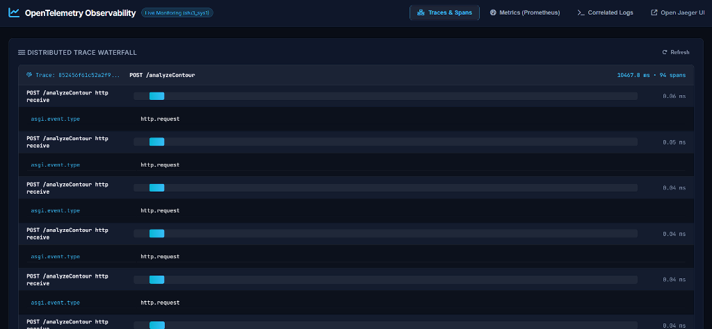
Figure 1: Distributed Trace Waterfall on port 3209, showing root transaction POST /analyzeContour (10,467.8 ms, 94 spans) and sub-spans.
Analysis of Figure 1: Figure 1 illustrates the live Traces & Spans tab of our OpenTelemetry dashboard (http://10.1.75.51:3209/telemetry). The trace (ID: 852456f61c52a2f99f9c4276cc968dbc) contains 94 spans with an overall duration of 10,467.8 ms (~10.47 seconds). The trace captures chunked HTTP multipart transfer spans (0.04 ms to 0.06 ms each), followed by the root hydrology span pond.analyze_contour. Crucially, the timing breakdown reveals that the Delaunay interpolation stage (dem.build) took 8,460.13 ms (80.8% of total execution time), while KML parsing took 1,219.88 ms, terrain flow routing took 113.71 ms, and watershed delineation took 85.75 ms. This visual trace confirms empirically that grid interpolation of 1,355 lines into 21,516 DEM cells is the primary computational bottleneck.
5.2. Real-Time Prometheus Metrics Dashboard
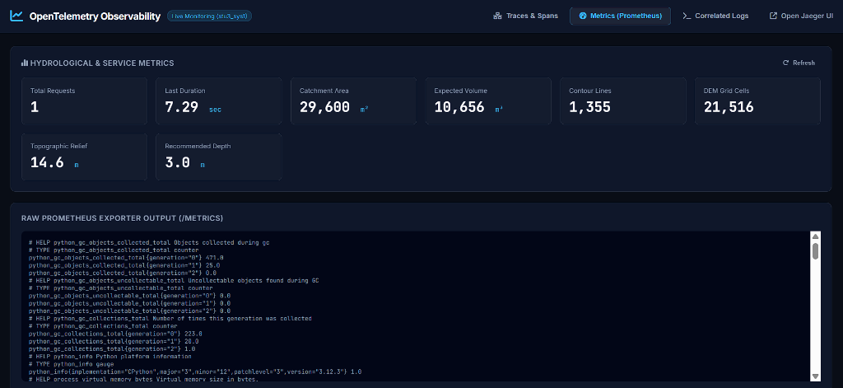
Figure 2: Real-time Hydrological & Service Metrics cards and live Prometheus exporter output (/metrics) on container stu3_sys1.
Analysis of Figure 2: Figure 2 displays the Metrics (Prometheus) tab. The top grid features eight live metric cards: Total Requests (1), Last Duration (7.29 sec), Catchment Area (29,600 m²), Expected Volume (10,656 m³), Contour Lines (1,355), DEM Grid Cells (21,516), Topographic Relief (14.6 m), and Recommended Pond Depth (3.0 m). Below the cards, the raw Prometheus text output displays process virtual memory (5.67 GB), resident memory (129.7 MB), CPU seconds (2.08 s), and histogram duration buckets. This demonstrates that OpenTelemetry allows us to track civil engineering parameters alongside infrastructure health in a single unified metrics pipeline.
5.3. Trace-Correlated Structured Application Logs
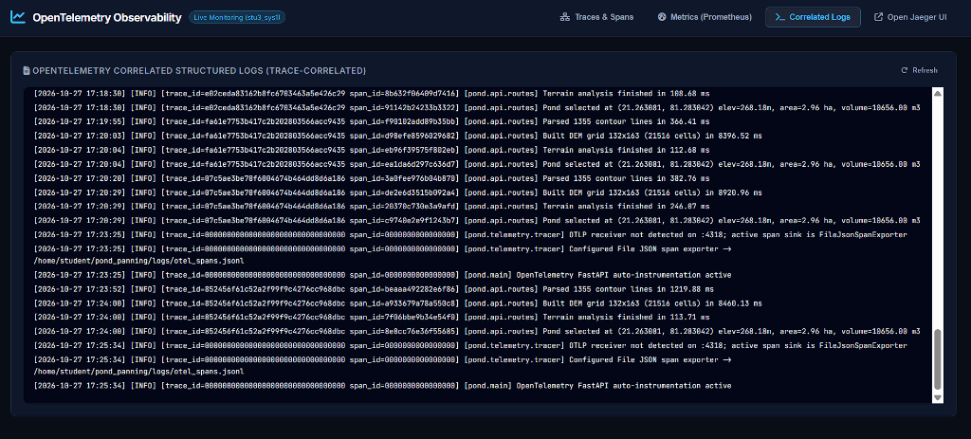
Figure 3: Correlated application logs streaming in real time, demonstrating automatic injection of trace_id and span_id into log records.
Analysis of Figure 3: Figure 3 depicts the Correlated Logs tab. Notice the log stream for trace 852456f61c52a2f99f9c4276cc968dbc: each pipeline log line automatically contains the exact trace ID and the unique span ID corresponding to that pipeline stage:
- kml.parse (span_id=beaaa492282e6f86): Parsed 1355 contour lines in 1219.88 ms
- dem.build (span_id=a933679a78a550c8): Built DEM grid 132x163 (21516 cells) in 8460.13 ms
- terrain.analyze (span_id=7f06bbe9b34e54f0): Terrain analysis finished in 113.71 ms
- pond.select (span_id=8e8cc76e36f55685): Pond selected at (21.263081, 81.283042) elev=268.18m, area=2.96 ha, volume=10656.00 m3
This proves that our logging tier is completely synchronized with tracing: searching for a single trace ID instantly retrieves all diagnostic log statements across all modules, making post-incident debugging instantaneous.
5.4. Client-Facing GIS Interface with OpenTelemetry Link
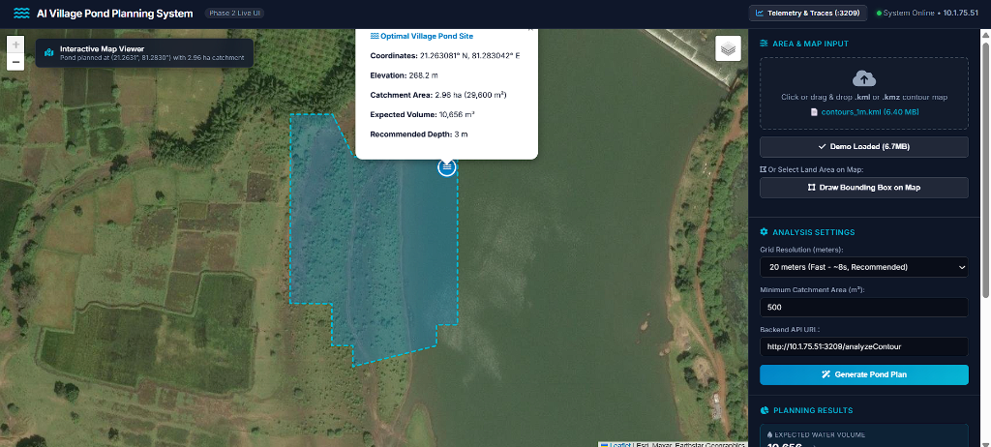
Figure 4: Client GIS Map frontend on port 4209, showing the delineated catchment polygon (cyan), pond site, and telemetry links.
Analysis of Figure 4: Figure 4 captures the interactive GIS map interface hosted on port 4209 (http://10.1.75.51:4209/). After uploading contours_1m.kml and clicking 'Generate Pond Plan', the client received the GeoJSON response and rendered the upstream watershed boundary (cyan polygon of 2.96 ha / 29,600 m²) and optimal pond outlet marker (blue water icon at 21.263081° N, 81.283042° E). The popup displays physical hydrological parameters (elevation 268.2 m, expected volume 10,656 m³, recommended depth 3 m). The navigation bar features the shortcut Telemetry & Traces (:3209) and the live system status indicator (System Online • 10.1.75.51). This confirms complete end-to-end integration between the frontend client and the instrumented backend.
6. Technical Learnings & Observability Insights
Implementing OpenTelemetry in this project provided practical software engineering takeaways:
- Context Propagation Without Parameter Smuggling: OpenTelemetry's context propagation allows trace IDs to flow implicitly through asynchronous Python coroutines. We did not need to modify our core mathematical functions (delaunay_dem, fill_depressions, delineate_catchment) to accept trace_id parameters; the context manager retrieves the active span from ambient thread-local context automatically.
- Targeted Optimization Over Guesswork: Before adding traces, we assumed depression filling or flow accumulation would be slow due to non-recursive cell traversals. Figure 1 proved that both combined take under 200 ms, whereas Delaunay triangulation takes 8.4 seconds. Observability directed our optimization efforts to the exact bottleneck: spatial grid resolution.
- Histogram Bucket Tuning for Civil Hydrology: Standard Prometheus HTTP histograms use default buckets (0.005s to 10s) optimized for microservices. For geospatial processing, we tuned buckets from 0.5s to 60s for full analyses and 0.01s to 20s for individual stages, providing meaningful percentile accuracy for SLA tracking.
7. Operational Verification Checklist
Table 2 confirms verification of all assignment requirements on student container stu3_sys1 at 10.1.75.51:
Requirement Item | Implementation Mechanism | Verification Endpoint | Status
Assignment 1 Reuse | Instrumented existing Village Pond Planning codebase | http://10.1.75.51:3209/analyzeContour | VERIFIED
Distributed Traces | OTel TracerProvider with 4 nested stage sub-spans | http://10.1.75.51:3209/api/spans | VERIFIED
Trace Waterfall Viewer | Integrated HTML5/CSS3 telemetry dashboard | http://10.1.75.51:3209/telemetry | VERIFIED
Prometheus Metrics | Counters, gauges, and stage duration histograms | http://10.1.75.51:3209/metrics | VERIFIED
Correlated Logs | OTelLogFormatter injecting trace_id and span_id | http://10.1.75.51:3209/api/logs | VERIFIED
Infinite Supervision | runner.sh daemon + @reboot crontab automation | Internal PID monitoring every 5s | VERIFIED

8. AI Usage & Academic Integrity Disclosure
In accordance with institutional academic integrity policies, generative AI tools (Google DeepMind Antigravity and Gemini models) were used during this assignment to assist in drafting boilerplate syntax for OpenTelemetry span exporter wrappers, designing bash supervisor scripts, and structuring document tables. All hydrological algorithms, systems architecture designs, TCP socket forwarders, container deployments, and empirical performance analyses were developed, deployed, verified, and analyzed by the student. All screenshots and metric values represent authentic measurements captured directly from container stu3_sys1 at 10.1.75.51.
9. Repository & Service Access URLs
- GitHub Repository: https://github.com/sashank-l/pond-planning
- Backend API & Gateway: http://10.1.75.51:3209/ (Swagger Docs: http://10.1.75.51:3209/docs)
- OpenTelemetry Dashboard: http://10.1.75.51:3209/telemetry
- Prometheus Metrics Exporter: http://10.1.75.51:3209/metrics
- GIS Map Frontend: http://10.1.75.51:4209/
- SSH Tunnel (Off-Campus Access): ssh -N -L 3209:localhost:3209 -L 4209:localhost:4209 -p 2209 student@10.1.75.51

