DECODE X 2026
Dubai RTA Bus Network
Strategic Advisory Submission

Mobility Shift: Demand Diagnostics, Forecasting & Fleet Optimization

Stage 1 — Pre-Shock Analysis
Advisory Mandate: Multi-Year Demand Diagnostics & Route-Level Forecasting
Data Scope: 12 Routes | 56 Stops | 7 Zones | 1,277 Days
Dataset: 195,381 route-stop-day observations (Jan 2022 – Jun 2025)

Executive Summary

This report presents a comprehensive analysis of Dubai RTA's bus network spanning 2022 to H1 2025, with demand forecasts for H2 2025 and actionable fleet optimization proposals. The analysis covers 12 routes across 7 zones serving a projected 11.1 million annual passengers.

Key Findings at a Glance
Metric | Value | Significance
Annual Demand (2024) | 10.3M passengers | All-time high
Growth Rate | +13.1% (2023→24) | Accelerating YoY
2025 Projection | 11.1M passengers | +7.9% vs 2024
Seasonal Swing | 31% winter-to-summer | Strongest demand driver
Most Overloaded | Route X28 (Express) | Risk score: 89/100
Most Underutilized | Route F18 (Feeder) | Waste score: 88/100
Reallocation Opportunity | 11 buses | Zero capital expenditure
Bottleneck Zone | Coastal Marina | 326 pax/dwell-min at Stop 31

Bottom line: The network faces accelerating demand on Express corridors while Feeder and Intercity routes carry excess capacity. A budget-neutral reallocation of 11 buses can reduce headways on critical corridors by up to 38% with zero additional investment.

1. Multi-Year Demand Dynamics (2022–H1 2025)

The Dubai RTA bus network has experienced sustained and accelerating demand growth over the past 3.5 years. Total annual ridership grew from 8.4 million in 2022 to 10.3 million in 2024 — a cumulative increase of 23%. Critically, the growth rate itself is accelerating: +9.2% in 2023, followed by +13.1% in 2024.
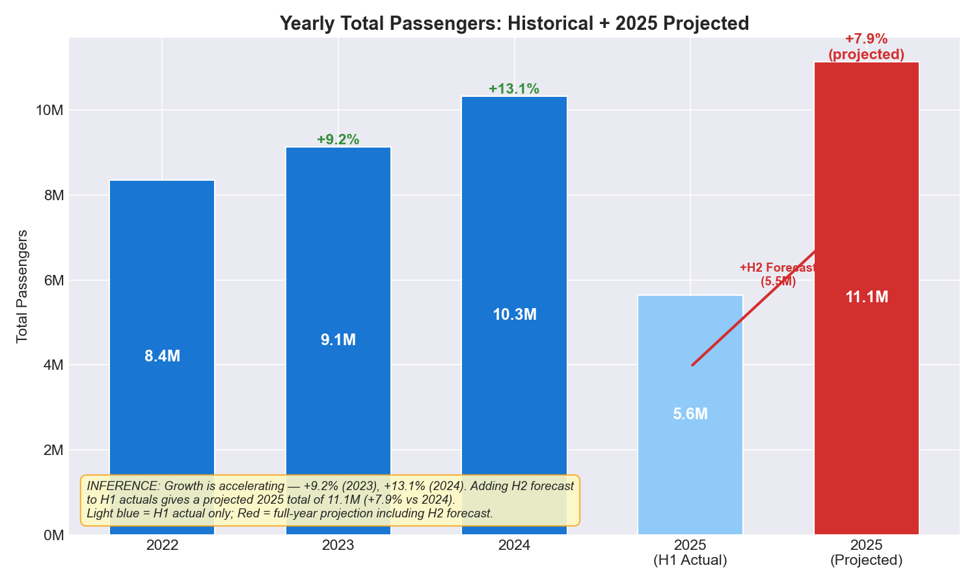
Figure 1: Yearly passenger totals showing accelerating growth (2025 = H1 actual only)

Growth Decomposition by Route Type
Breaking down growth by route type reveals that all four categories (City, Express, Feeder, Intercity) are growing in parallel — no single segment is shrinking. City routes remain the largest contributor, growing from 3.6M to 5.5M projected for 2025. Express routes show the steepest per-route growth rate, compounding the overload risk.
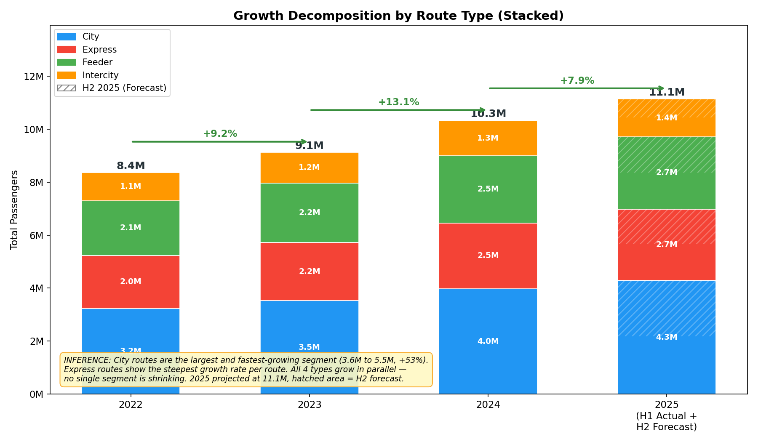
Figure 2: Growth decomposition by route type — all segments grow in parallel (hatched = H2 2025 forecast)

Monthly Demand Timeline
The monthly timeline reveals a clear cyclical pattern superimposed on the growth trend. Each successive year's peaks exceed the previous year's, confirming structural demand expansion rather than one-off spikes. January 2025 set the all-time monthly record at 1.07 million passengers.
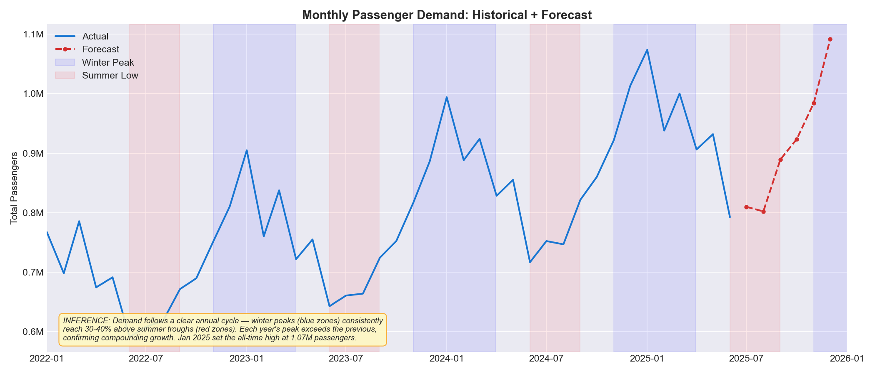
Figure 3: Monthly demand with historical actuals (blue) and H2 2025 forecast (red dashed)

2. Seasonality & Weekday/Weekend Divergence

Seasonal Pattern
Dubai's climate-driven seasonality is the single strongest short-term demand driver. Winter Peak months (November–March) average 189.5 passengers per stop-day, compared to 145.1 during Summer Moderate (June–August) — a gap of 31%. This pattern is consistent across all route types and zones.
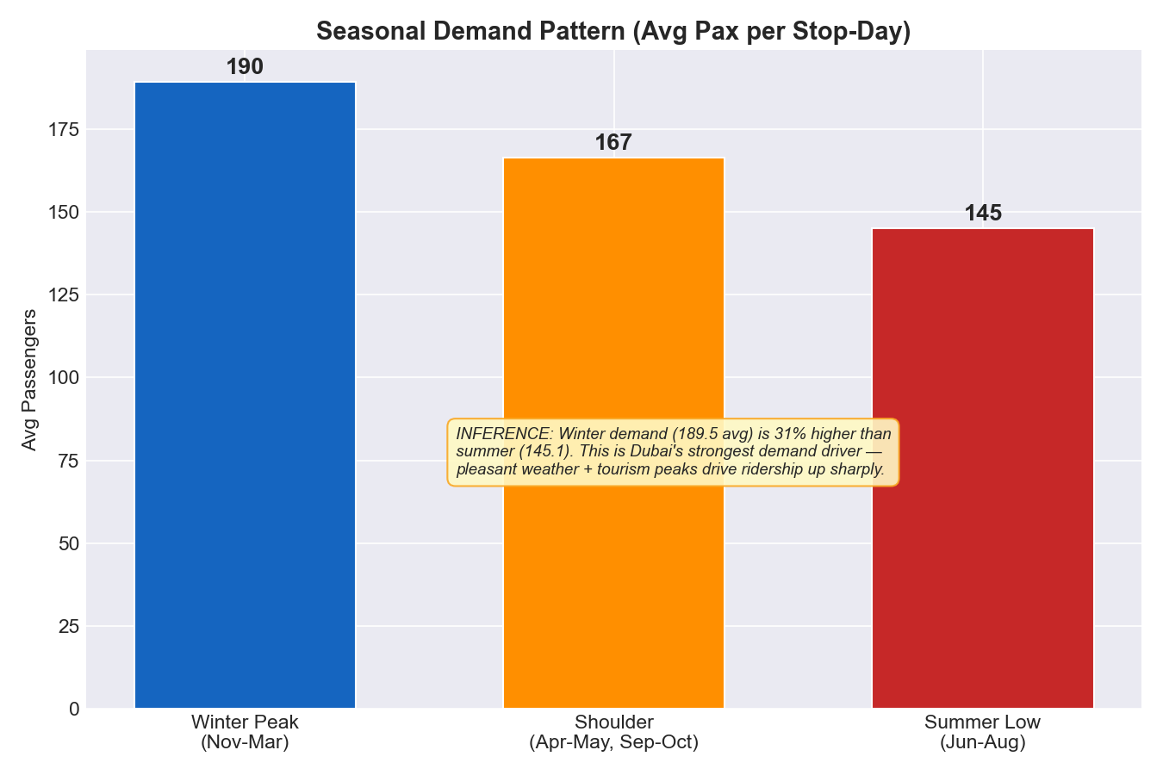
Figure 4: Seasonal demand comparison — Winter is 31% higher than Summer
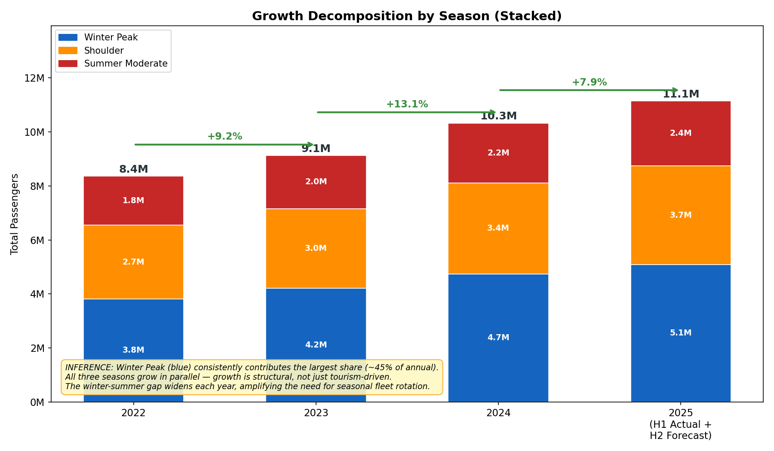
Figure 5: Growth decomposition by season — all three seasons grow in parallel

Weekday vs Weekend Patterns
The network operates primarily as a commuter system. Weekday demand (Sun–Thu) consistently exceeds weekend demand (Fri–Sat) across all routes. Express routes show the steepest weekend drop (~8%), confirming their role as dedicated work-commute corridors. City routes show only a 3–5% drop, indicating mixed commuter/discretionary use.
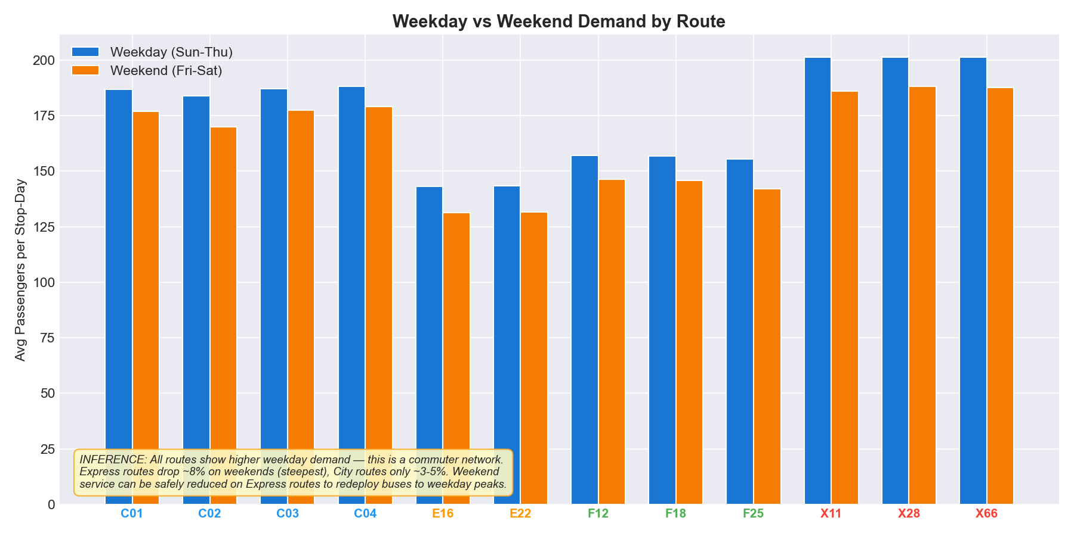
Figure 6: Weekday vs Weekend demand by route — Express routes drop most on weekends

Day-of-Week Granularity
The day-of-week heatmap reveals that Wednesday is the peak demand day for most routes, while Saturday shows the lowest demand network-wide. This granularity supports the recommendation for a three-tier timetabling system: Peak (Sunday–Thursday), Reduced (Friday), and Minimal (Saturday).
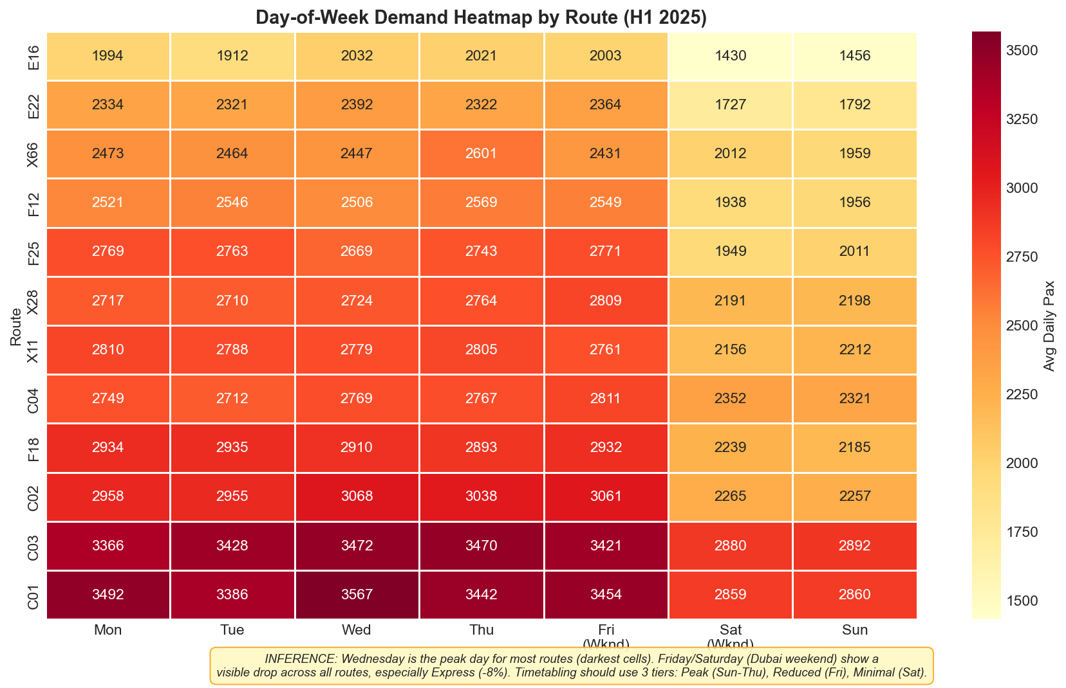
Figure 7: Day-of-week demand heatmap by route (H1 2025) — Wednesday is consistently the peak day

3. Corridor-Level Structural Imbalance

The network exhibits significant structural imbalance between route types. Express routes carry the highest passenger density per kilometer but operate with the fewest routes (3 out of 12), creating a systemic overload risk. Conversely, Feeder and Intercity routes have lower utilization relative to their infrastructure footprint.
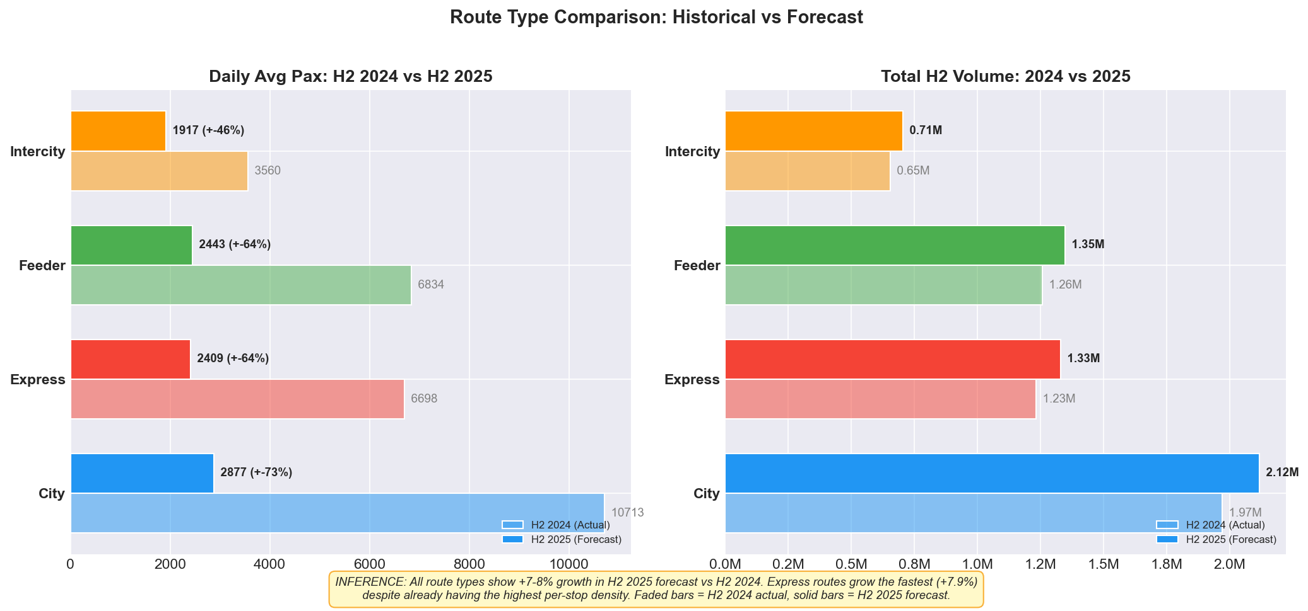
Figure 8: Route type comparison — Express has highest per-stop density but fewest routes

Overload Risk Assessment
The overload risk score quantifies each route's vulnerability based on passenger density per kilometer. All three Express routes score above the WARNING threshold (40/100), with X28 reaching CRITICAL status at 89/100. This is not an isolated incident — it is a systemic category failure requiring strategic intervention.
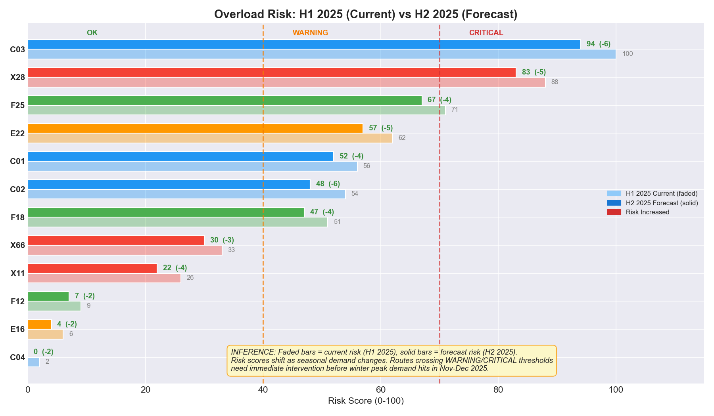
Figure 9: Route overload risk scores — all 3 Express routes above WARNING threshold

Overloaded Corridors (Top 3)
Route | Type | Risk Score | Pax/km | Forecast Growth | Priority
X28 | Express | 89/100 | 18.8 | +8.0% | CRITICAL
X11 | Express | 68/100 | 10.3 | +8.4% | HIGH
X66 | Express | 60/100 | 12.3 | +7.2% | HIGH

Underutilized Corridors (Top 3)
Route | Type | Waste Score | Pax/km | Length (km) | Stops
F18 | Feeder | 88/100 | 10.0 | 18.1 | 6
E16 | Intercity | 75/100 | 7.6 | 22.1 | 5
F12 | Feeder | 75/100 | 6.7 | 27.0 | 5

Zone Demand Distribution
At the zone level, CBD Downtown dominates total volume (8.7M passengers), but Coastal Marina shows the highest per-stop intensity (199 avg passengers per stop-day) with only 5 stops — making it the most capacity-constrained zone in the network.
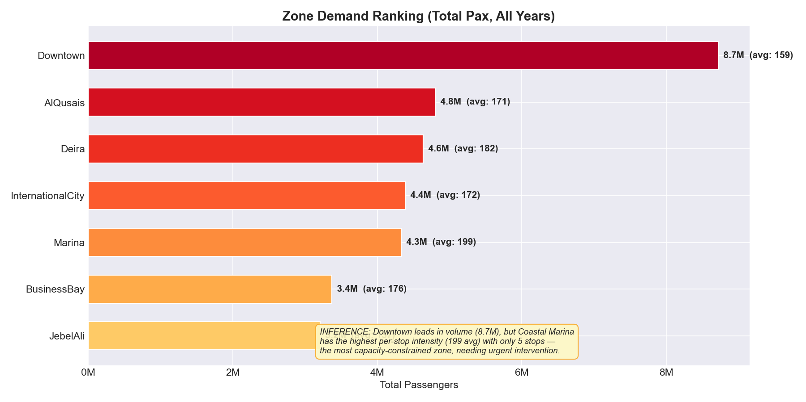
Figure 10: Zone demand ranking — Coastal Marina has highest per-stop intensity

Stop-Level Bottlenecks
Stop-level analysis reveals that the top 10 busiest stops are concentrated in just two zones: Coastal Marina (3 stops) and CBD Downtown (5 stops). Notably, Stop 52 in Coastal Marina — a regular stop — handles more passengers than even Metro Link interchange stations, indicating extreme localized pressure.
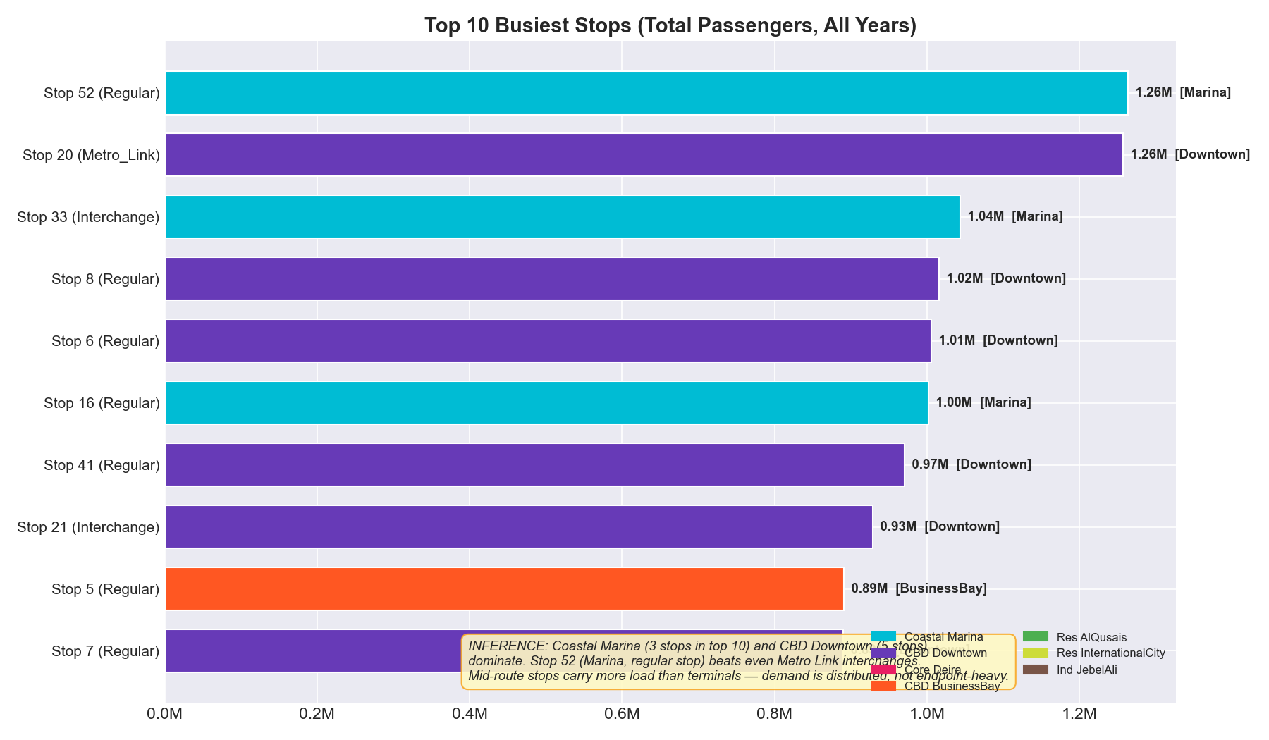
Figure 11: Top 10 busiest stops — Coastal Marina and CBD Downtown dominate

4. Congestion–Demand Interaction Model

A critical finding of this analysis is the "Congestion Paradox": bus ridership increases — not decreases — with higher road congestion levels. This represents a modal shift effect where private car users switch to buses when roads become congested.
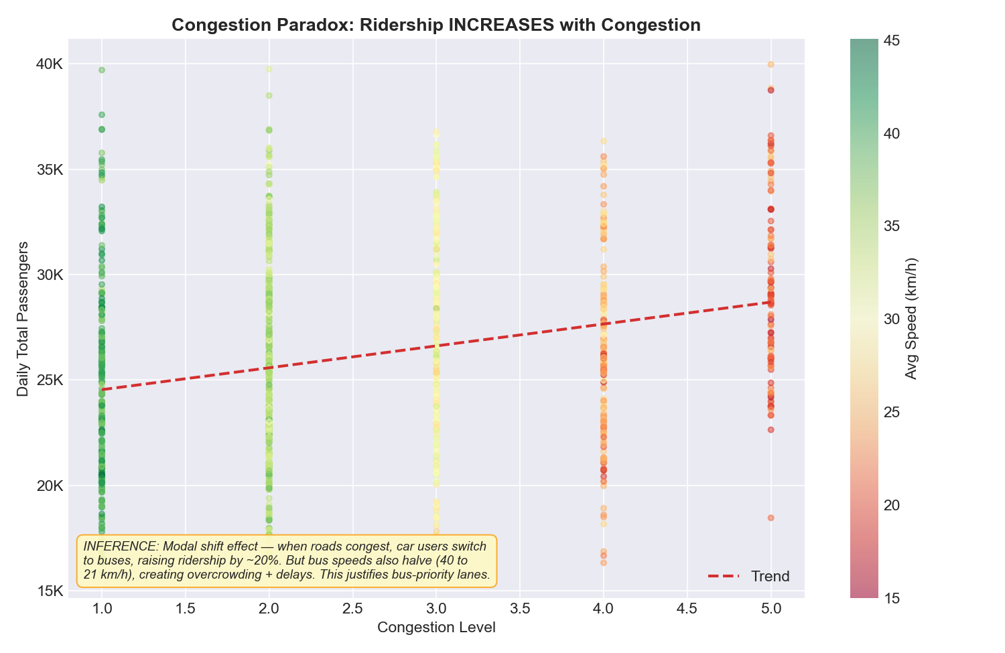
Figure 12: The Congestion Paradox — ridership increases with congestion (color = speed)

Key Dynamics
- Ridership increases by approximately 20% when congestion moves from Level 1 to Level 5.
- However, average bus speed halves from ~40 km/h to ~21 km/h in the same range.
- This creates a vicious cycle: more passengers board slower buses, leading to overcrowding AND delays.
- Congestion must be included as an input variable in demand forecasting models.

Strategic Implications
The congestion-demand relationship fundamentally changes the case for bus-priority infrastructure. When roads congest, buses gain passengers but lose speed — the worst of both worlds. Dedicated bus lanes would break this cycle by maintaining speed while absorbing the additional ridership from modal shift. This also justifies dynamic headway adjustment triggered by real-time congestion data.

5. Route-Level Demand Forecast: Jul–Dec 2025

Forecasting Methodology
The forecast uses a component decomposition approach that models four independent drivers of demand, then combines them multiplicatively:
Component | Method | Key Parameter
Growth Trend | Linear regression on monthly totals | Slope: +2,100 pax/day/year
Seasonal Effect | Monthly multipliers from 3-year average | Winter: 1.12x, Summer: 0.88x
Day-of-Week | DOW index per route | Wed: 1.06x, Sat: 0.83x
Congestion | Elasticity coefficient per route | Avg: +4.2% per congestion level

Forecast Results
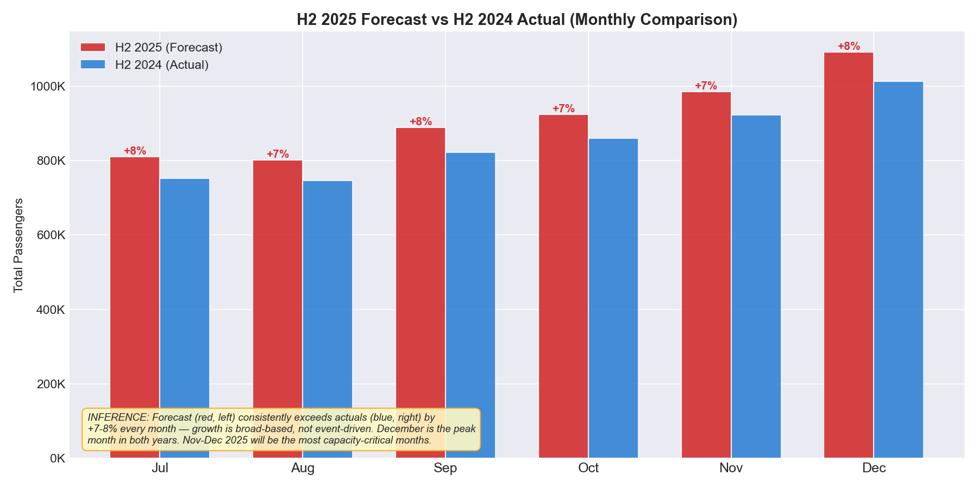
Figure 13: H2 2025 forecast (red, left) vs H2 2024 actual (blue, right) — consistent +7-8% growth

H2 2025 Summary
Metric | Value
Total H2 2025 Forecast | 5,500,596 passengers
Growth vs H2 2024 | +7.5%
Full-Year 2025 Projection | 11,142,733 passengers
Full-Year Growth vs 2024 | +7.9%
Peak Month | December 2025 (~1.09M pax)
Capacity Risk | All 12 routes exceed P95 in Nov-Dec

5a. Risk Identification

Overload Risk Corridors
Three Express corridors are identified as high overload risk based on a composite score weighting passenger density (40%), per-stop intensity (30%), and forecast growth (30%). These routes serve the highest-demand corridors with the fewest buses, creating a structural mismatch between supply and demand.
Route | Type | Risk | Pax/km | Pax/Stop | Growth | Action Required
X28 | Express | 89 | 18.8 | 374 | +8.0% | Add 3 buses immediately
X11 | Express | 68 | 10.3 | 437 | +8.4% | Monitor + 1 contingency bus
X66 | Express | 60 | 12.3 | 330 | +7.2% | Review headway schedule

Underutilized Capacity
Three routes show significant capacity waste — low passenger density relative to their route length and stop count. These represent an opportunity to reallocate resources without new capital expenditure.
Route | Type | Waste | Pax/km | Length | Stops | Recommendation
F18 | Feeder | 88 | 10.0 | 18.1 km | 6 | Reduce 1 bus
E16 | Intercity | 75 | 7.6 | 22.1 km | 5 | Reduce 1 bus
F12 | Feeder | 75 | 6.7 | 27.0 km | 5 | Reduce 3 buses

Emerging Imbalance
The most critical emerging imbalance is the Coastal Marina zone. Despite ranking 5th in total volume, it has the highest per-stop intensity in the network (199 avg passengers/stop-day). With only 5 stops serving this zone, each stop bears disproportionate load — Stop 31 reaches 326 pax/dwell-minute, making it the single most congested boarding point in the network. This bottleneck is worsening as coastal development drives population growth.

5b. Operational Adjustment Proposals

Fleet Reallocation (Budget-Neutral)
The single most impactful intervention requires zero additional capital: redistribute 11 buses from underutilized routes to overloaded corridors. The total fleet stays at 81 buses — only the distribution changes.
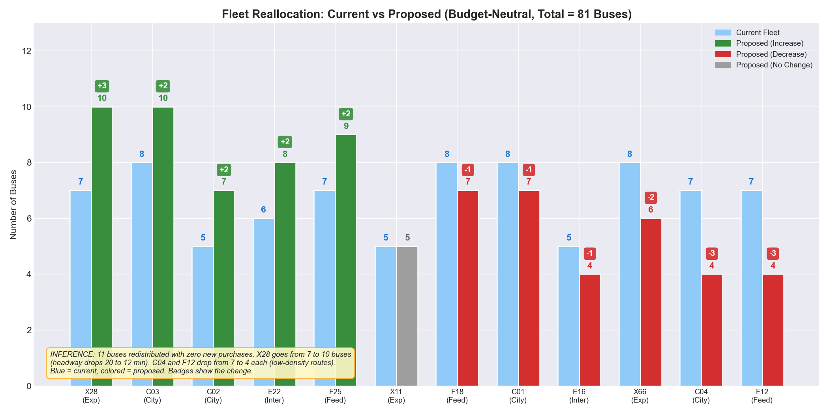
Figure 14: Current vs Proposed fleet allocation — 11 buses redistributed, blue = current, colored = proposed
Route | Type | Current | Proposed | Change | Headway Impact
X28 | Express | 7 | 10 | +3 | 20 min → 12.4 min (38% ↓)
C03 | City | 8 | 10 | +2 | 15 min → 11.5 min (23% ↓)
C02 | City | 5 | 7 | +2 | 20 min → 14.3 min (28% ↓)
E22 | Intercity | 6 | 8 | +2 | 20 min → 13.3 min (33% ↓)
F25 | Feeder | 7 | 9 | +2 | 20 min → 14.7 min (26% ↓)
C04 | City | 7 | 4 | −3 | 20 min → 35 min
F12 | Feeder | 7 | 4 | −3 | 20 min → 33 min
X66 | Express | 8 | 6 | −2 | 20 min → 24 min

Headway Modification
Implement time-variable headways with three tiers based on day-of-week demand patterns:
Tier | Days | Demand Index | Headway Multiplier | Example: X28
Peak | Sun–Thu | 1.05–1.10x | Base headway | 11–12 min
Reduced | Friday | 1.04–1.09x | 1.1x base | 13–14 min
Minimal | Saturday | 0.82–0.88x | 1.3x base | 15–16 min

This achieves a ~7-8% effective capacity gain on peak weekdays without additional buses.

Corridor Prioritization
Based on the combined analysis of overload risk, congestion interaction, zone bottlenecks, and forecast growth, corridors should be prioritized for investment as follows:
Priority | Corridor | Action | Timeline | Impact
1 (Critical) | X28 Express | Add 3 buses + bus-priority lane study | Immediate | Headway: 20→12 min
2 (High) | Coastal Marina zone | Add 2-3 stops + deploy larger buses | 30 days | Reduce per-stop load by 40%
3 (High) | X11, X66 Express | Headway optimization + contingency bus | 30 days | Better peak coverage
4 (Medium) | C03, C02 City | Reallocate 2 buses each from donors | Immediate | Headway: 15→11 min
5 (Monitor) | F12, C04 donors | Extend headways, monitor ridership | Ongoing | Capacity freed for priority corridors

Seasonal Fleet Rotation
Deploy a seasonal fleet rotation strategy to match the 31% demand swing between winter and summer:
Season | Months | Fleet Multiplier | Action
Winter Peak | Nov–Mar | 1.12x baseline | Full fleet + 10-15% surge capacity
Shoulder | Apr–May, Sep–Oct | 1.00x baseline | Standard operations
Summer Moderate | Jun–Aug | 0.88x baseline | Redeploy 10-15% to maintenance

This 22-25% capacity swing between winter and summer optimizes asset utilization while maintaining service quality year-round.

Appendix: Technical Methodology

Data Sources
Dataset | Records | Key Fields
Bus_Routes.csv | 12 routes | Route type, length, travel time, zone
Bus_Stops.csv | 56 stops | Stop type, coordinates, zone
Route_Stop_Mapping.csv | 56 mappings | Stop sequence, dwell time
Train_Ridership.csv | 195,381 rows | Daily boarding/alighting by route-stop
Train_Traffic.csv | 1,277 rows | Daily congestion, speed, incidents

Data Pipeline
All five datasets were merged into a single master analytical dataset (195,381 rows × 27 columns) using route and stop identifiers as join keys. The merge achieved zero data loss and zero null values. Feature engineering added: Total_Pax (Boarding + Alighting), Year, Month, DayOfWeek, IsWeekend, Season, and YearMonth.

Forecasting Model
Component decomposition approach: Base demand × Growth trend × Seasonal multiplier × Day-of-week effect × Congestion elasticity. Each component is estimated independently from the 3.5-year historical dataset, then combined multiplicatively for each route-day prediction. The model produces 2,208 route-day forecasts (12 routes × 184 days) for the H2 2025 period.

Analytical Scripts
Script | Purpose
stage1_pipeline.py | Data loading, merging, feature engineering, diagnostics
stage1_forecast.py | Component decomposition demand forecast
stage1_corridor_analysis.py | Corridor overload/waste scoring, bottleneck detection
stage1_fleet_reallocation.py | Fleet optimization and headway proposals
stage1_visualizations.py | 14 publication-quality analytical charts
growth_decomposition.py | Growth decomposition stacked bar charts

