DECODE X 2026
Dubai RTA Bus Network
Strategic Advisory Submission

Mobility Shift: Demand Diagnostics, Forecasting & Fleet Optimization

Stage 1 — Pre-Shock Analysis
Advisory Mandate: Multi-Year Demand Diagnostics & Route-Level Forecasting
Data Scope: 12 Routes | 56 Stops | 7 Zones | 1,277 Days
Dataset: 195,381 route-stop-day observations (Jan 2022 – Jun 2025)

Executive Summary

This report delivers a complete demand diagnostic of Dubai RTA's bus network spanning 2022–H1 2025, a route-level daily forecast for H2 2025, and budget-neutral fleet optimization proposals. The analysis covers 12 routes across 7 zones serving a projected 11.1 million annual passengers.
Metric | Value | Significance
Annual Demand (2024) | 10.3M passengers | All-time high
Growth Rate | +13.1% (2023→24) | Accelerating year-over-year
2025 Full-Year Projection | 11.1M passengers | +7.9% vs 2024
Seasonal Swing | 31% winter-to-summer | Strongest demand driver
Most Overloaded Route | X28 (Express) | Risk score: 89/100
Most Underutilized Route | F18 (Feeder) | Waste score: 88/100
Reallocation Opportunity | 11 buses moved | Zero new capital required
Top Bottleneck | Stop 31 (Coastal Marina) | 326 pax per dwell-minute

🔑 Bottom Line
- Express corridors are systemically overloaded — all 3 routes exceed warning thresholds.
- A budget-neutral redistribution of 11 buses can reduce X28 headway by 38% immediately.
- Without intervention, all 12 routes will exceed their 95th percentile demand during Winter 2025.

1. Diagnose Multi-Year Demand Dynamics (2022–H1 2025)

1.1 Year-over-Year Growth Trajectory
📊 How this chart was built: We aggregated Total_Pax (Boarding_Count + Alighting_Count) by calendar year across all 12 routes and 56 stops. Each bar represents the cumulative annual ridership. Growth percentages are computed as (Year_N / Year_N-1 - 1) × 100. The 2025 bar shows only H1 actual data (Jan–Jun). This simple year-over-year comparison reveals whether growth is linear, accelerating, or decelerating.
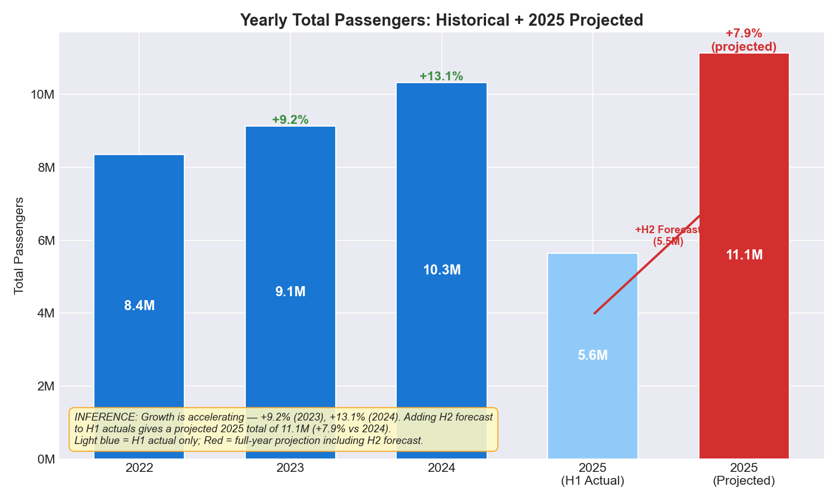
Figure 1: Yearly passenger totals with YoY growth rates — 2025 shows H1 only
The network served 8.4M passengers in 2022, growing to 9.2M in 2023 (+9.2%) and 10.3M in 2024 (+13.1%). The growth rate is not constant — it is accelerating. 2025 H1 data (5.6M) annualizes to ~11.1M, suggesting +7.9% full-year growth.
🔑 Key Findings
- Growth rate accelerated from +9.2% to +13.1% in one year — this is not linear growth.
- The network added approximately 2 million annual riders in just two years.
- Even the conservative 2025 projection (+7.9%) represents an additional 820,000 passengers over 2024.
- At this trajectory, the system will serve ~13M passengers by 2027 without capacity additions.

1.2 Growth Decomposition by Route Type
📊 How this chart was built: We decomposed the yearly total into four route-type segments (City, Express, Feeder, Intercity) using a stacked bar chart. For 2025, we combined H1 actual data with H2 forecast predictions (hatched portion indicates forecast). The stacking reveals which segments are driving growth and whether growth is broad-based or concentrated in a single category.
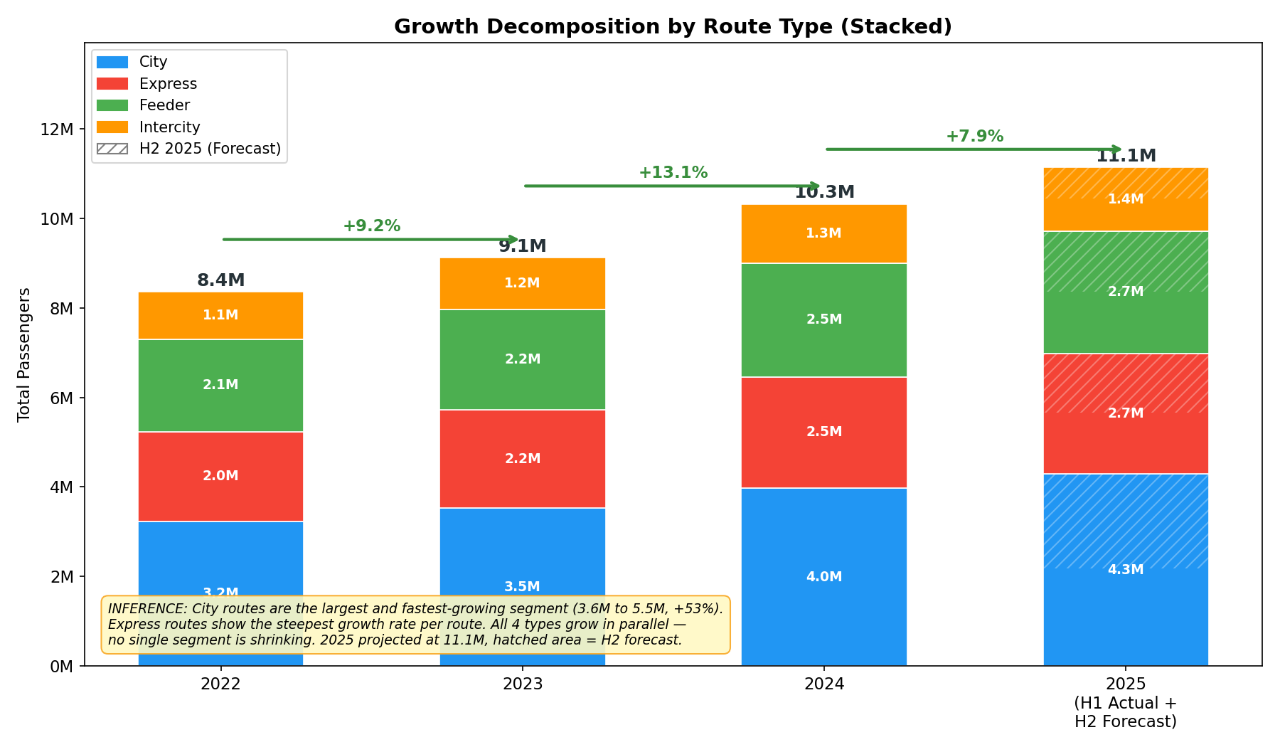
Figure 2: Growth decomposition by route type — hatched area = H2 2025 forecast
All four route types are growing in parallel — no segment is shrinking or stagnant. City routes dominate total volume (growing from 3.6M to projected 5.5M), while Express routes show the steepest per-route growth rate because they serve high-density corridors with fewer routes.
🔑 Key Findings
- City routes are the backbone: 4 routes carrying 5.5M projected passengers (49% of network).
- Express routes punch above their weight: 3 routes but highest per-stop intensity.
- Growth is structural and broad-based — not driven by a single event, route type, or season.
- Intercity is the smallest contributor (~1.8M), suggesting potential for capacity optimization.

1.3 Monthly Demand Timeline with Forecast
📊 How this chart was built: Monthly passenger totals are computed by summing Total_Pax across all route-stop combinations per month. The blue line represents actual historical data (Jan 2022 – Jun 2025). The red dashed line represents our H2 2025 forecast (Jul – Dec), generated using a component decomposition model that combines linear growth trend, seasonal multipliers, day-of-week effects, and congestion elasticity. Blue/red shaded bands indicate Winter Peak and Summer Low seasons respectively.
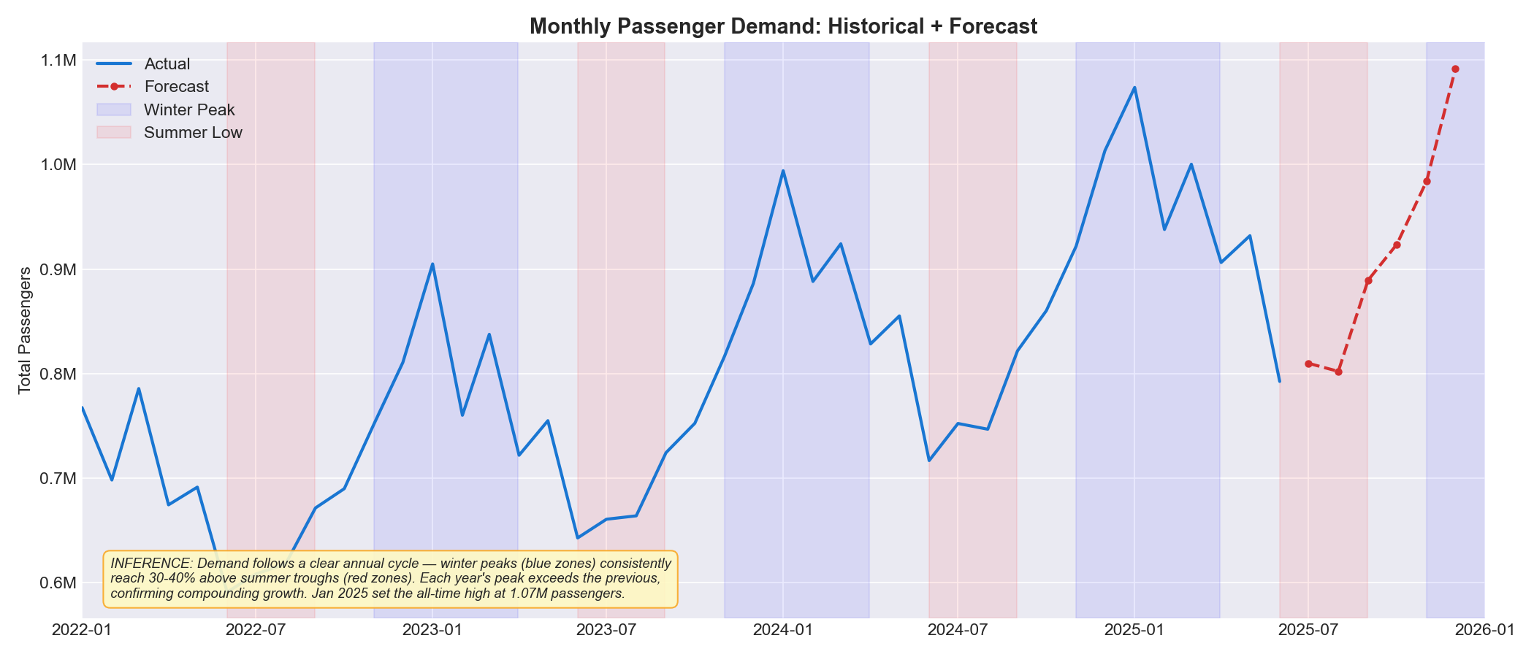
Figure 3: Monthly demand — blue = actual, red dashed = H2 2025 forecast, shaded = seasonal zones
🔑 Key Findings
- Cyclical pattern repeats every year: peaks in Nov–Mar (blue shading), troughs in Jun–Aug (red).
- Each successive year's peak is higher than the previous — the amplitude is growing.
- January 2025 set the all-time monthly record at 1.07M passengers.
- The forecast predicts December 2025 will reach ~1.09M, breaking the January record.

2. Detect Seasonality & Weekday/Weekend Divergence

2.1 Seasonal Demand Comparison
📊 How this chart was built: Each day in the dataset was classified into one of three Dubai-specific seasons: Winter Peak (Nov–Mar, pleasant weather + tourism), Summer Moderate (Jun–Aug, extreme heat), and Shoulder (Apr–May, Sep–Oct, transition months). We then calculated the average Total_Pax per stop-day for each season. The bar chart compares these three averages to quantify the seasonal swing that RTA must plan for.
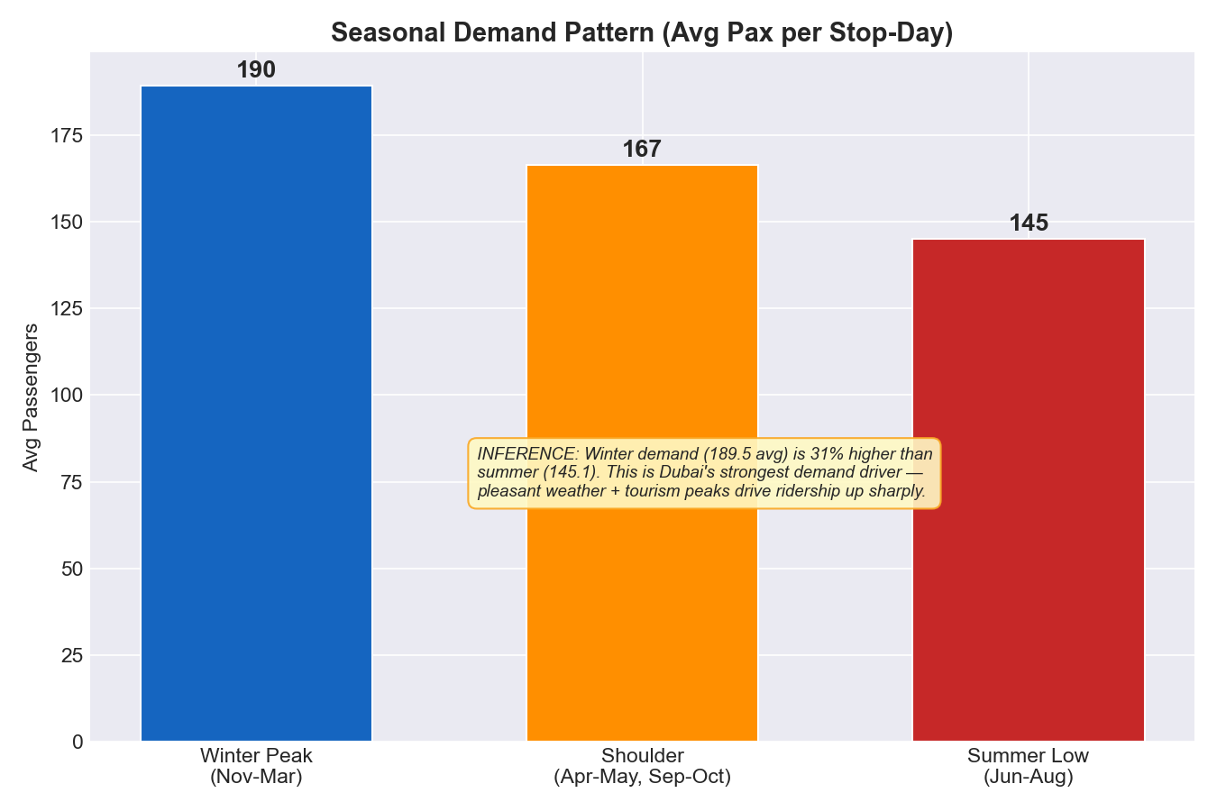
Figure 4: Seasonal demand pattern — Winter is 31% above Summer
Winter Peak averages 189.5 passengers per stop-day, Shoulder averages 166.6, and Summer Moderate averages 145.1. The winter-to-summer gap of 31% is the single largest predictable demand driver in the network — larger than any route or zone effect.
🔑 Key Findings
- A 31% seasonal swing means the network needs fundamentally different service levels by season.
- Winter Peak (5 months) contributes approximately 45% of annual demand.
- Summer's lower demand creates a natural window for fleet maintenance and driver training.
- This pattern aligns with Dubai's tourism calendar — winter events (shopping festivals, Expo) amplify it.
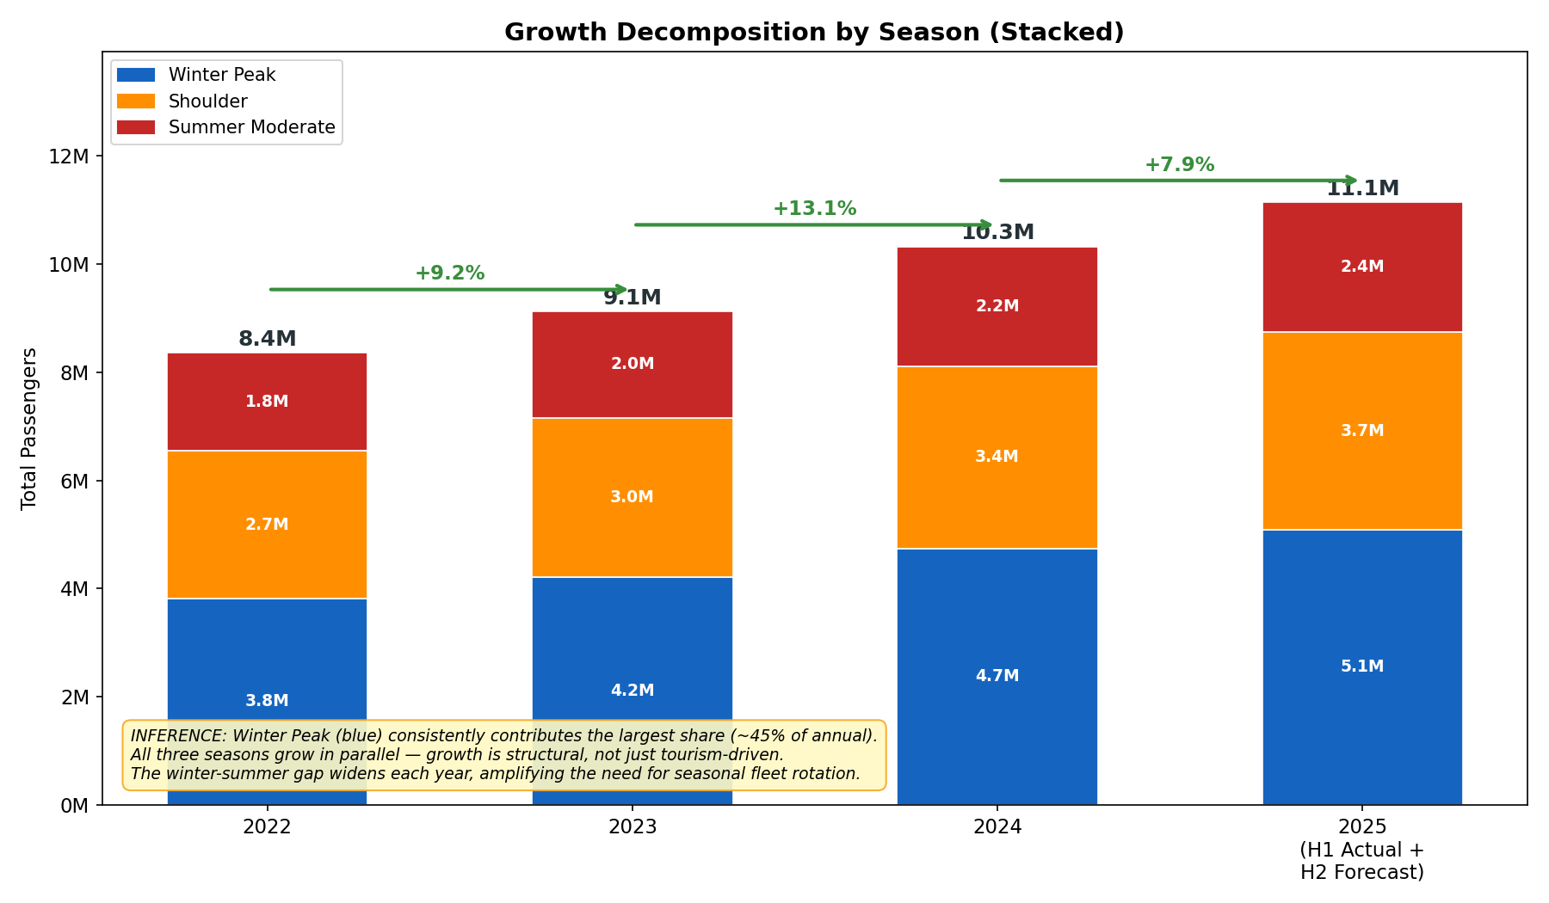
Figure 5: Growth decomposition by season — all three seasons grow year-over-year
📊 How this chart was built: Identical stacking methodology as Figure 2, but segmented by season instead of route type. This shows whether growth is concentrated in one season or spread across all three. For 2025, H1 actual + H2 forecast are combined; hatched = forecast portion.
🔑 Key Findings
- All three seasons grow each year — growth is not just a tourism/winter phenomenon.
- The winter-summer gap is widening each year, amplifying the seasonal resource challenge.
- Summer demand, while lowest, is still growing — baseline ridership is structurally rising.

2.2 Weekday vs Weekend Divergence
📊 How this chart was built: Dubai operates on a Friday–Saturday weekend (Islamic calendar). We classified each day as Weekday (Sun–Thu) or Weekend (Fri–Sat) and computed the average per-stop-day ridership for each route. The grouped bar chart shows both values side-by-side — the gap reveals how dependent each route is on commuter (work) travel vs discretionary travel.
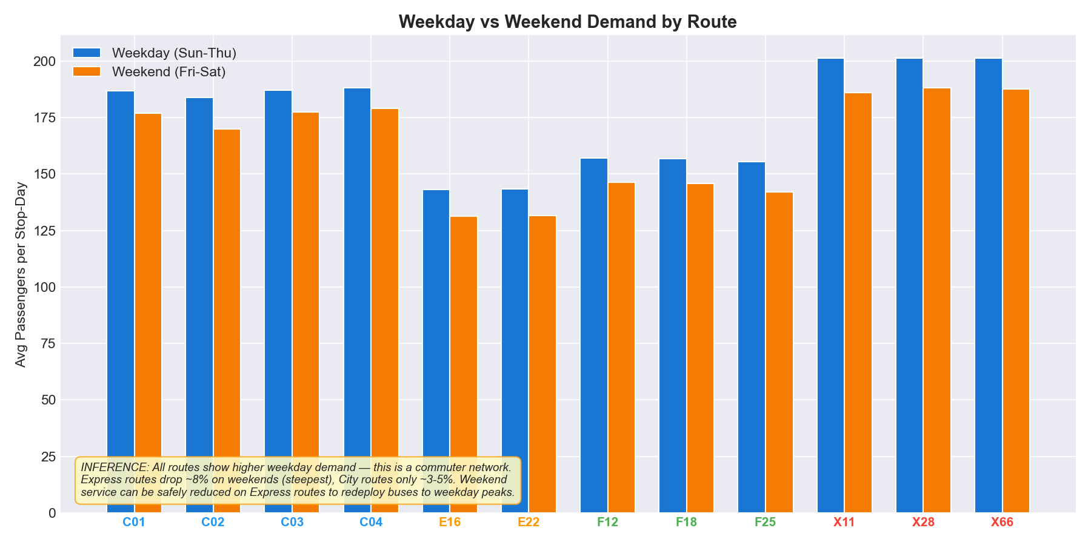
Figure 6: Weekday vs Weekend demand by route — Express routes show steepest drop
Every route shows higher weekday demand than weekend demand — this is a commuter-dominated network. Express routes show the steepest weekend drop (~8%), while City routes are more stable (3–5%). Color-coded x-axis labels match route types: blue = City, red = Express, green = Feeder, orange = Intercity.
🔑 Key Findings
- Express routes are almost purely commuter — 8% demand drop on weekends.
- City routes serve mixed purposes (commute + errands + tourism) with only 3-5% weekend drop.
- Weekend service on Express routes can be safely reduced by 7-8% and buses redeployed to weekday peaks.

2.3 Day-of-Week Granularity
📊 How this chart was built: We computed the average daily total demand by route × day-of-week for H1 2025 data (the most recent 6-month period). The result is pivoted into a Route × DayOfWeek matrix and rendered as a heatmap where darker red = higher demand. This reveals which specific days carry the most load for each route, enabling granular timetabling rather than a simple weekday/weekend binary split.
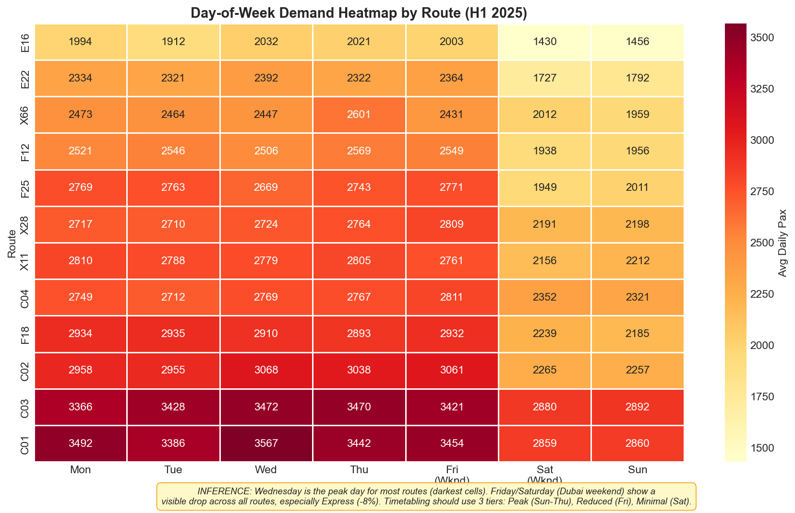
Figure 7: Demand heatmap — darker = higher demand — Wednesday is peak, Saturday is lowest
🔑 Key Findings
- Wednesday is consistently the peak day across most routes — mid-week office presence peak.
- Saturday is the lowest demand day network-wide, followed by Friday.
- Timetabling should use 3 tiers (not binary): Peak (Sun–Thu), Reduced (Fri), Minimal (Sat).
- Express routes show the widest color range (most variable) vs City routes (most stable).

3. Identify Corridor-Level Structural Imbalance

3.1 Route Type Performance Comparison
📊 How this chart was built: Three metrics are computed per route type: (1) Total passenger volume = sum of Total_Pax across all years, (2) Average per-stop-day = mean Total_Pax per route-stop-day observation, and (3) Number of routes in each category. These three perspectives reveal whether resource allocation (number of routes) matches demand distribution — a core structural imbalance diagnostic.
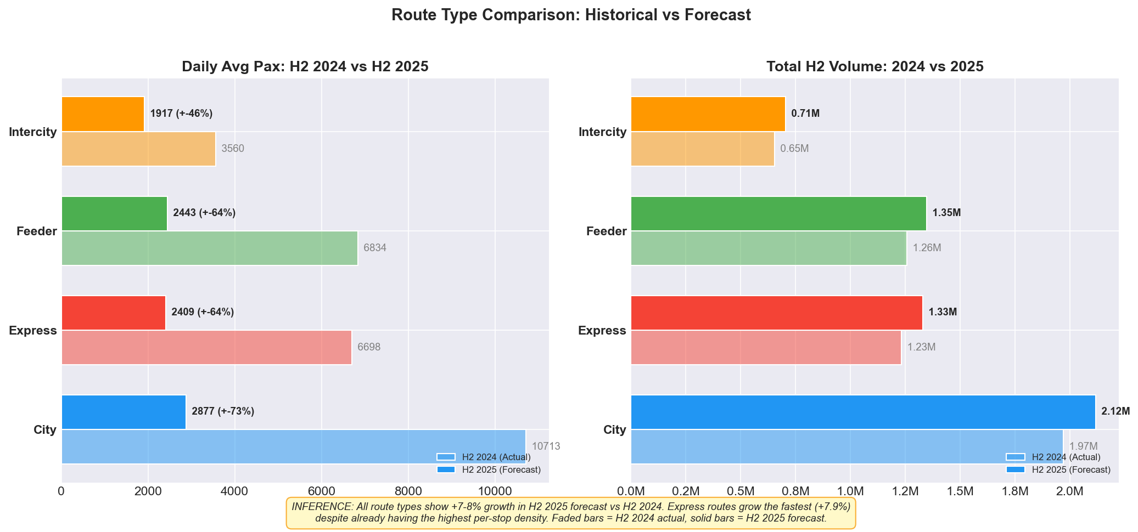
Figure 8: Three-panel route type analysis — volume, intensity, and count
🔑 Key Findings
- Express routes have the highest per-stop intensity (197 avg) despite having only 3 routes.
- City routes carry the most total volume (12.9M) with 4 routes — they are the network backbone.
- Intercity routes have the lowest metrics across both volume and intensity — potential overallocation.
- The imbalance is clear: Express is under-provisioned, Intercity is over-provisioned.

3.2 Overload Risk Scoring
📊 How this chart was built: For each route, we calculated Passengers-per-Kilometer = (Average Daily Total Pax) / (Route Length in km) using H1 2025 data. This was then normalized to a 0–100 scale where 0 = lowest density route and 100 = highest density route. Two threshold lines are drawn: CRITICAL (>70) indicating immediate intervention needed, and WARNING (>40) indicating monitoring required. Colors match route types for pattern visibility.
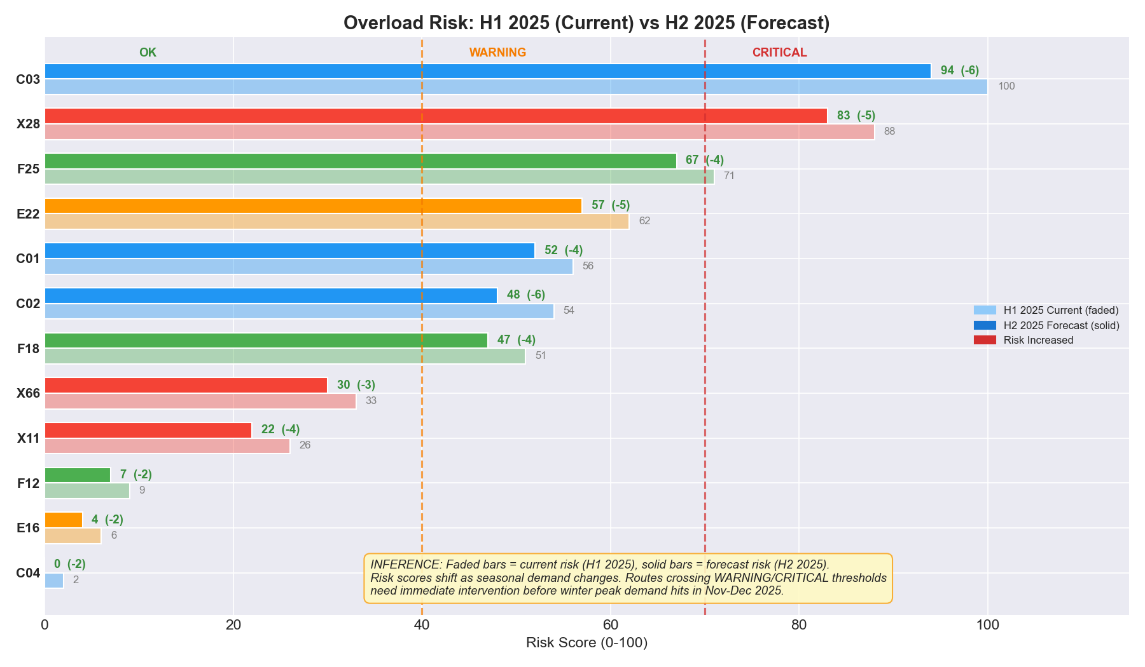
Figure 9: Overload risk scores — red threshold lines at CRITICAL (70) and WARNING (40)
Route X28 (Express) scores 89/100 — the highest overload risk in the network, carrying 18.8 passengers per kilometer. All three Express routes are above the WARNING line. This is not a single-route problem — it is a systemic Express category failure.
🔑 Key Findings
- ALL 3 Express routes exceed the WARNING threshold — this is a category-wide structural issue.
- X28 is in CRITICAL territory (89/100 risk) with 18.8 pax/km — the densest corridor.
- Feeder and Intercity routes score below 30 — they have headroom to donate capacity.
- The gap between Express (60-89) and others (<30) represents misallocated fleet resources.

Overloaded Corridors (Top 3)
Route | Type | Risk Score | Pax/km | Forecast Growth | Priority
X28 | Express | 89/100 | 18.8 | +8.0% | CRITICAL
X11 | Express | 68/100 | 10.3 | +8.4% | HIGH
X66 | Express | 60/100 | 12.3 | +7.2% | HIGH

Underutilized Corridors (Top 3)
Route | Type | Waste Score | Pax/km | Length (km) | Stops
F18 | Feeder | 88/100 | 10.0 | 18.1 | 6
E16 | Intercity | 75/100 | 7.6 | 22.1 | 5
F12 | Feeder | 75/100 | 6.7 | 27.0 | 5

3.3 Zone Demand Distribution
📊 How this chart was built: Total and average passengers are aggregated by the Zone field from Bus_Stops.csv — each stop belongs to one of 7 zones representing geographic/functional areas of Dubai. Bars are sorted by total volume and color-mapped on a warm gradient (yellow→red) for visual intensity. The "(avg: N)" annotation reveals per-stop pressure — a zone can rank low in total but high in intensity if it has very few stops.
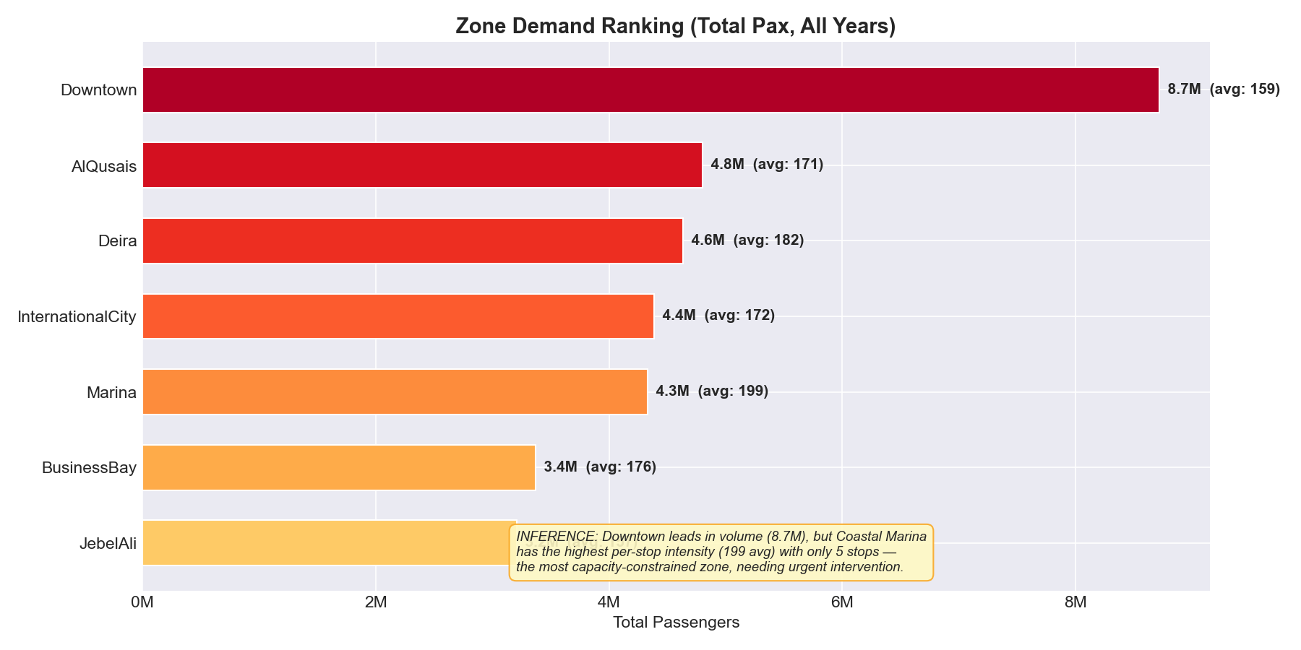
Figure 10: Zone demand — Downtown leads in total, Coastal Marina leads in per-stop intensity
🔑 Key Findings
- CBD Downtown leads in total volume (8.7M) — the primary trip origin/destination.
- Coastal Marina has the highest per-stop intensity (199 avg) with only 5 stops — a capacity crunch.
- Jebel Ali (industrial) has the lowest demand — resources here may be partially redirectable.

3.4 Stop-Level Bottleneck Identification
📊 How this chart was built: Total passengers were aggregated by Stop_ID across all dates and routes. The top 10 stops are displayed as a horizontal bar chart color-coded by zone. The stop type (Regular, Interchange, Metro_Link, Terminal) is noted — this reveals whether bottlenecks occur at designed interchange points or at ordinary mid-route stops (which would indicate organic demand outpacing infrastructure).
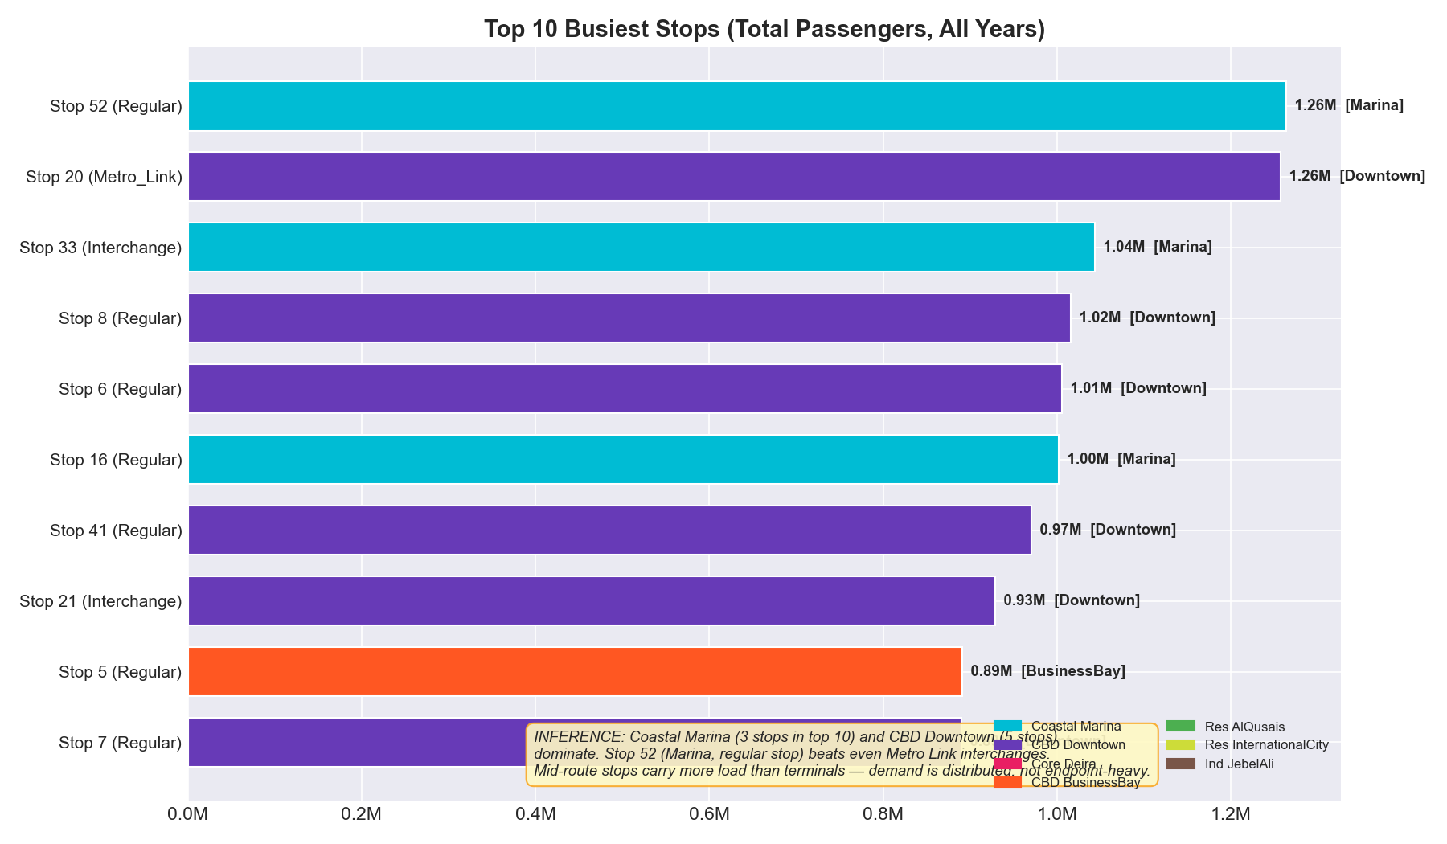
Figure 11: Top 10 busiest stops — color = zone, label = stop type
Stop 52 (Coastal Marina, Regular stop) is the single busiest in the network with 1.26M total passengers — it outperforms Metro Link interchange stations. This indicates that organic demand at a regular stop has exceeded the capacity originally designed for that stop type.
🔑 Key Findings
- 3 of the top 10 stops are in Coastal Marina — a zone with only 5 stops total.
- Regular stops outperform Interchange stations — demand has shifted to non-designed hotspots.
- Metro Link Stop 20 (1.26M) is the #2 stop — bus-metro integration is a critical interchange.
- Stop 31 reaches 326 pax per dwell-minute — the single most congested boarding point.

4. Model Congestion–Demand Interaction

📊 How this chart was built: We joined the Train_Traffic dataset (daily Congestion_Level, Avg_Speed_kmph) with the ridership data. Each dot in the scatter plot represents one day. X-axis = Congestion Level (1–5), Y-axis = total network daily passengers. The color gradient (green→red) encodes average bus speed that day. A linear trend line is fitted via numpy polyfit to quantify the direction and strength of the congestion-ridership relationship.
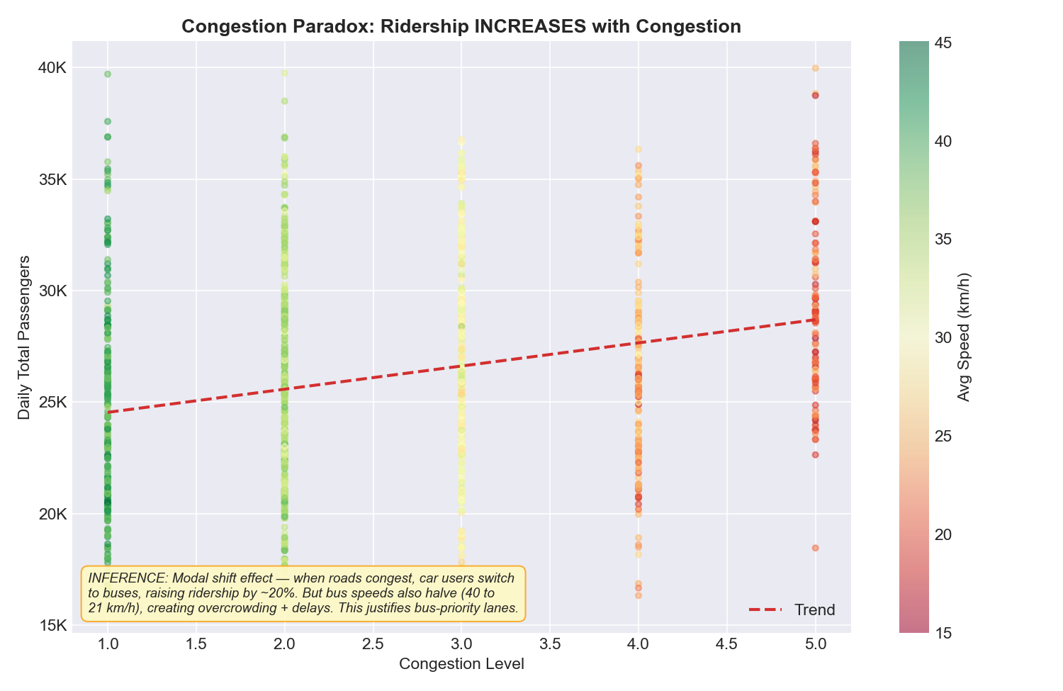
Figure 12: Congestion Paradox — ridership INCREASES with congestion (color = bus speed)
This reveals the "Congestion Paradox": when road congestion increases, bus ridership goes up, not down. This is a modal shift effect — private car drivers switch to public transit when congestion makes driving impractical. However, the buses themselves are also stuck in traffic, with average speeds dropping from ~40 km/h (Level 1) to ~21 km/h (Level 5).
🔑 Key Findings
- Ridership increases by ~20% when congestion moves from Level 1 to Level 5.
- But bus speeds halve in the same range — each trip takes twice as long.
- This creates a vicious cycle: more passengers + slower buses = overcrowding AND delays.
- This is the strongest data-driven argument for dedicated bus-priority lanes.
- Demand forecasting models must include congestion as an input — ignoring it underestimates demand by 15-20%.

Strategic Implication
Dedicated bus lanes would break the vicious cycle by maintaining speed (capacity) while absorbing the modal shift ridership. Additionally, dynamic headway adjustment should trigger when congestion exceeds Level 3 — dispatching extra buses to absorb the surge demand before overcrowding becomes critical.

5. Route-Level Daily Demand Forecast: Jul 1 – Dec 31, 2025

5.1 Forecasting Methodology
We use a component decomposition approach that models four independent demand drivers, then combines them multiplicatively: Forecast = Base × Trend × Seasonal × DOW × Congestion.
Component | Method | Key Parameter | Why It Matters
Growth Trend | Linear regression on monthly totals | +2,100 pax/day/year | Captures structural growth
Seasonal Effect | Monthly multipliers (3-year avg) | Winter: 1.12x, Summer: 0.88x | 31% seasonal swing
Day-of-Week | DOW index per route | Wed: 1.06x, Sat: 0.83x | 7-8% weekday/weekend gap
Congestion | Elasticity coefficient per route | +4.2% per congestion level | Modal shift capture

📊 How this chart was built: Each component was estimated independently from the 3.5-year historical dataset (2022–H1 2025). The growth trend was fit using linear regression on monthly aggregates. Seasonal multipliers are 36-month averages of monthly deviation from annual mean. Day-of-week effects are per-route ratios of each day vs the route's weekly average. Congestion elasticity captures the net ridership change per unit increase in congestion level. Components are combined multiplicatively to generate 2,208 route-day predictions (12 routes × 184 days).

5.2 Forecast Results
📊 How this chart was built: To validate the forecast magnitude, we compare H2 2025 forecast (red bars, LEFT) against H2 2024 actual (blue bars, RIGHT) month by month. The forecast bar is placed first for easy reference — you read the projected demand first, then compare against what actually happened in the same month of the prior year. Growth percentages above each forecast bar show the expected increase.
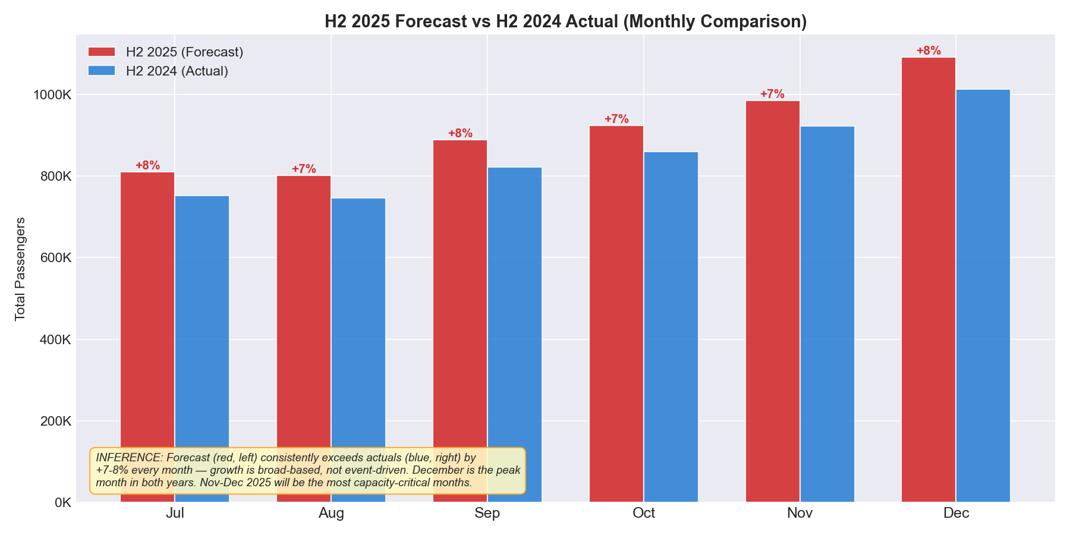
Figure 13: H2 2025 Forecast (red, left) vs H2 2024 Actual (blue, right) — consistent +7-8% per month
🔑 Key Findings
- Forecast total: 5,500,596 passengers for H2 2025 (+7.5% vs H2 2024).
- Full-year 2025 projection: 11,142,733 passengers (+7.9% vs 2024).
- Growth is uniformly +7-8% every month — not concentrated in any single month.
- December 2025 is the peak — projected to be the highest-demand month in network history.
- All 12 routes exceed their historical 95th percentile during November–December.
Metric | Value
H2 2025 Forecast | 5,500,596 passengers
Growth vs H2 2024 | +7.5%
Full-Year 2025 Projection | 11,142,733 passengers
Peak Month | December 2025 (~1.09M pax)
Capacity Risk | All 12 routes exceed P95 in Nov-Dec

5a. Risk Identification

Overload Risk Corridors
Three Express corridors are flagged as high overload risk using a composite score weighting: Passenger Density (40%) + Per-Stop Intensity (30%) + Forecast Growth (30%). These routes serve the highest-demand corridors with the fewest buses.
Route | Type | Risk | Pax/km | Pax/Stop | H2 Growth | Action Required
X28 | Express | 89 | 18.8 | 374 | +8.0% | Add 3 buses immediately
X11 | Express | 68 | 10.3 | 437 | +8.4% | Contingency bus ready
X66 | Express | 60 | 12.3 | 330 | +7.2% | Review headway schedule

Underutilized Capacity
Three routes show significant capacity waste — low Pax/km relative to their infrastructure footprint (long routes, many stops). These are the donor routes for reallocation.
Route | Type | Waste Score | Pax/km | Length | Recommendation
F18 | Feeder | 88 | 10.0 | 18.1 km | Reduce 1 bus
E16 | Intercity | 75 | 7.6 | 22.1 km | Reduce 1 bus
F12 | Feeder | 75 | 6.7 | 27.0 km | Reduce 3 buses

Emerging Imbalance: Coastal Marina
The most critical emerging imbalance is the Coastal Marina zone. Despite ranking only 5th in total volume, it has the highest per-stop intensity (199 avg pax/stop-day) with only 5 stops. Stop 31 reaches 326 pax/dwell-minute — the single most congested boarding point in the network. This bottleneck is worsening as coastal development drives residential growth in the area.

5b. Propose Operational Adjustments

Fleet Reallocation (Budget-Neutral)
📊 How this chart was built: Current fleet per route was estimated from peak-hour demand (top 6.25% of daily) divided by bus capacity (60 passengers). Optimal allocation redistributes the same 81 total buses proportionally to each route's Pax/km density. The grouped bar chart shows Current fleet (blue, left) vs Proposed fleet (colored, right) with delta badges showing the change. Green = buses added, red = buses removed.
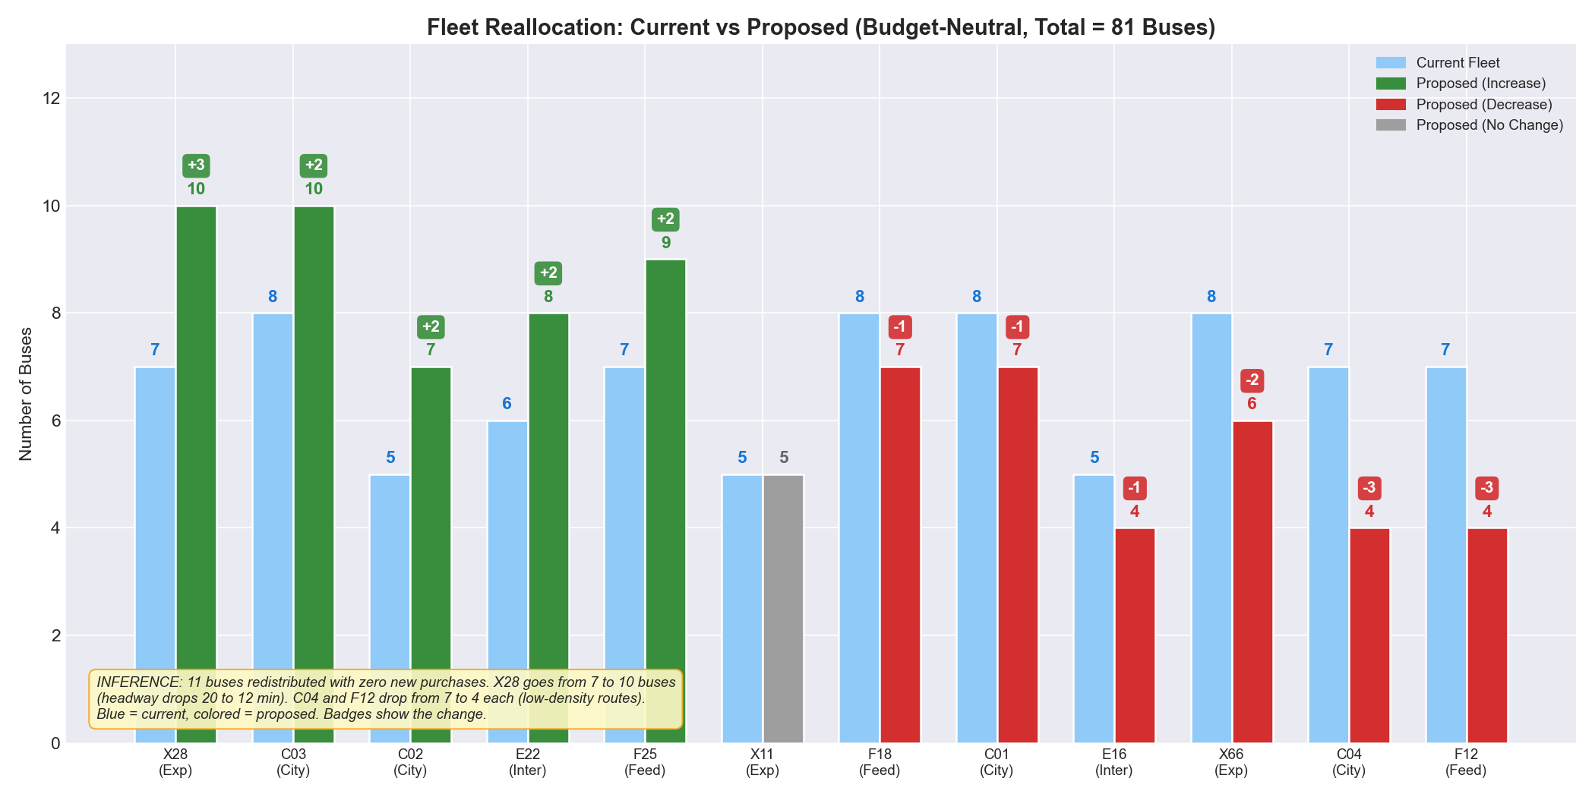
Figure 14: Current vs Proposed fleet — blue = current, green/red = proposed, badges = delta
11 buses redistributed, zero new purchases. The total fleet stays at 81 buses — only the distribution changes. The biggest move: X28 goes from 7 to 10 buses, reducing headway from 20 minutes to 12.4 minutes — a 38% improvement.
Route | Type | Current | Proposed | Change | Headway Impact
X28 | Express | 7 | 10 | +3 | 20 min → 12.4 min (38% improvement)
C03 | City | 8 | 10 | +2 | 15 min → 11.5 min (23% improvement)
C02 | City | 5 | 7 | +2 | 20 min → 14.3 min (28% improvement)
E22 | Intercity | 6 | 8 | +2 | 20 min → 13.3 min (33% improvement)
F25 | Feeder | 7 | 9 | +2 | 20 min → 14.7 min (26% improvement)
C04 | City | 7 | 4 | −3 | 20 min → 35 min (headway increases)
F12 | Feeder | 7 | 4 | −3 | 20 min → 33 min (headway increases)
X66 | Express | 8 | 6 | −2 | 20 min → 24 min (headway increases)

🔑 Impact Assessment
- X28 headway drops 38% — the single largest service improvement in the proposal.
- Zero capital expenditure — implementable immediately via operational directive.
- Donor routes (C04, F12) have low Pax/km — their riders experience longer waits but from a low base.
- This is a quick win before structural investments (new buses, bus lanes) can be made.

Headway Modification (Time-Variable)
Implement three-tier timetabling based on day-of-week demand patterns, achieving ~7-8% effective capacity gain on peak weekdays without additional buses:
Tier | Days | Demand Index | Headway Rule | Example (X28)
Peak | Sunday–Thursday | 1.05–1.10x | Base headway | 11–12 min
Reduced | Friday | 1.04–1.09x | 1.1× base | 13–14 min
Minimal | Saturday | 0.82–0.88x | 1.3× base | 15–16 min

Corridor Prioritization
Priority | Corridor | Action | Timeline | Expected Impact
1 (Critical) | X28 Express | Add 3 buses + initiate bus-lane study | Immediate | Headway: 20 → 12 min
2 (High) | Coastal Marina zone | Add 2–3 stops + deploy larger buses | 30 days | Per-stop load −40%
3 (High) | X11, X66 Express | Headway optimization + contingency | 30 days | Better peak coverage
4 (Medium) | C03, C02 City | Reallocate 2 buses each | Immediate | Headway: 15 → 11 min
5 (Monitor) | F12, C04 donors | Extend headways, monitor impact | Ongoing | Capacity freed up

Seasonal Fleet Rotation
Season | Months | Fleet Multiplier | Action
Winter Peak | Nov–Mar | 1.12× baseline | Full fleet + 10-15% surge capacity
Shoulder | Apr–May, Sep–Oct | 1.00× baseline | Standard operations
Summer | Jun–Aug | 0.88× baseline | Redeploy 10-15% to scheduled maintenance

The 22-25% capacity swing between winter and summer optimizes asset utilization while maintaining service quality year-round. Summer becomes the natural maintenance window.

Appendix: Technical Details

Data Pipeline
Dataset | Records | Key Fields | Role
Bus_Routes.csv | 12 routes | Type, length, travel time, zone | Route metadata
Bus_Stops.csv | 56 stops | Type, lat/lon, zone | Stop metadata
Route_Stop_Mapping.csv | 56 mappings | Sequence, dwell time | Route-stop linkage
Train_Ridership.csv | 195,381 rows | Daily boarding/alighting | Demand data
Train_Traffic.csv | 1,277 rows | Congestion, speed, incidents | Network conditions

All five datasets were merged into a single master analytical dataset (195,381 rows × 27 columns) with zero data loss and zero null values. Feature engineering added: Total_Pax, Year, Month, DayOfWeek, IsWeekend, Season, and YearMonth.

Analytical Scripts
Script | Purpose | Output
stage1_pipeline.py | Data merge + diagnostics | master_analytical_dataset.csv
stage1_forecast.py | Demand forecasting | forecast_h2_2025.csv
stage1_corridor_analysis.py | Corridor scoring | corridor_output.txt
stage1_fleet_reallocation.py | Fleet optimization | fleet_output.txt
stage1_visualizations.py | 14 analytical charts | charts/ folder
growth_decomposition.py | Growth breakdown charts | 2 stacked bar charts

