STRATASEARCH

An Intelligent Document Search and Analysis Platform

A Project Based Learning Report Submitted in partial fulfilment of the requirements for the award of the degree

of

Bachelor of Technology
in The Department of CSE
DATA STRUCTURES AND ALGORITHMS - 3
25CS2103E

Submitted by
2510030040 : Narsipura Arnavi
2510030126 : Vuppala Rithvik
2510030267 : J Sashank

Under the guidance of
Dr. Aftab Yaseen



Department of Computer Science and Engineering
Koneru Lakshmaiah Education Foundation, Aziz Nagar
Aziz Nagar – 500075
OCT - 2026.
Abstract

StrataSearch is an intelligent document search and analysis platform to help the user search and analyze a collection of documents. The system uses various string-matching and text-processing algorithms to find relevant content for a user query.

The platform is embedded with algorithms such as KMP, Rabin-Karp, Z Algorithm, Aho-Corasick and Suffix Array with LCP. It also provides step-wise visualization of algorithm execution so that users can understand the working of pattern matching for each algorithm. In addition, the system provides benchmarking and telemetry to evaluate algorithm performance, and a citation graph to visualize document connections.

The project combines data structures and algorithms with a practical document-search application. It provides both search functionality and algorithm visualization, making it useful for understanding the working and performance of different string-processing techniques.
List of Figures
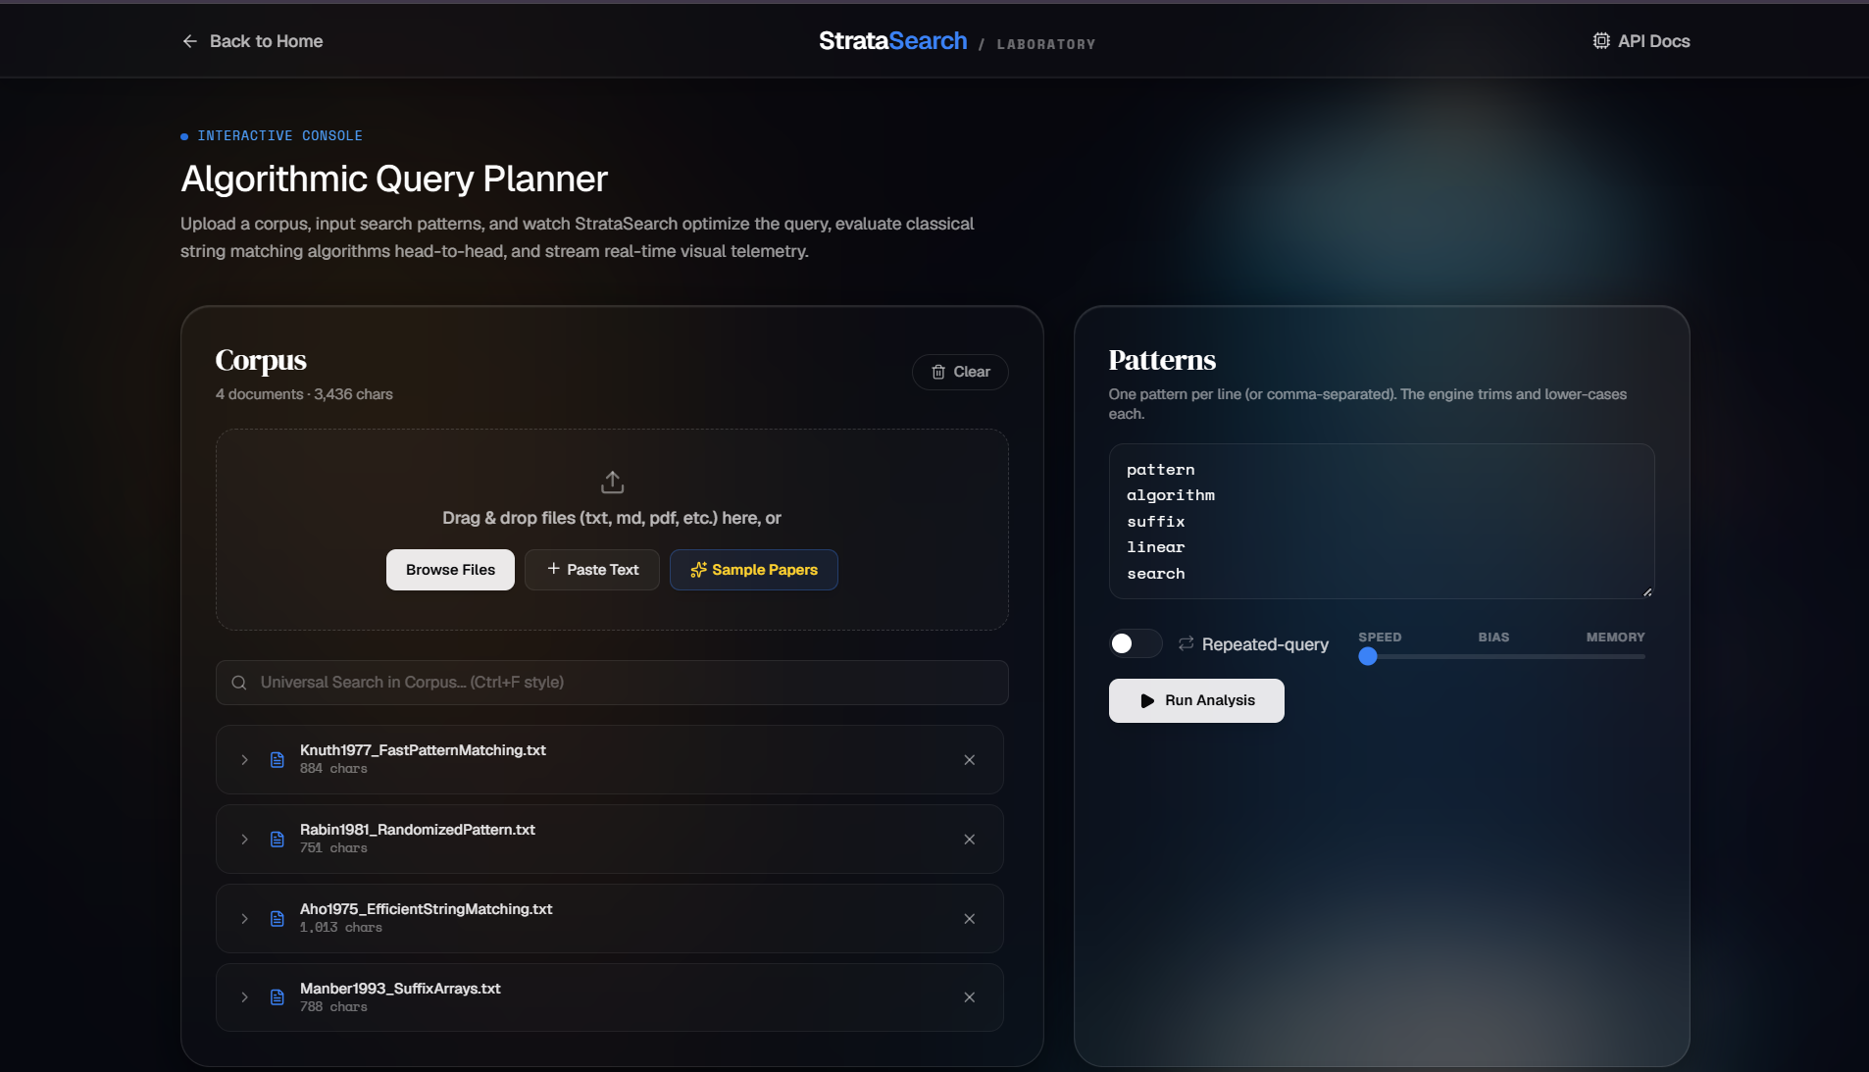
Fig. 1. StrataSearch Dashboard Interface

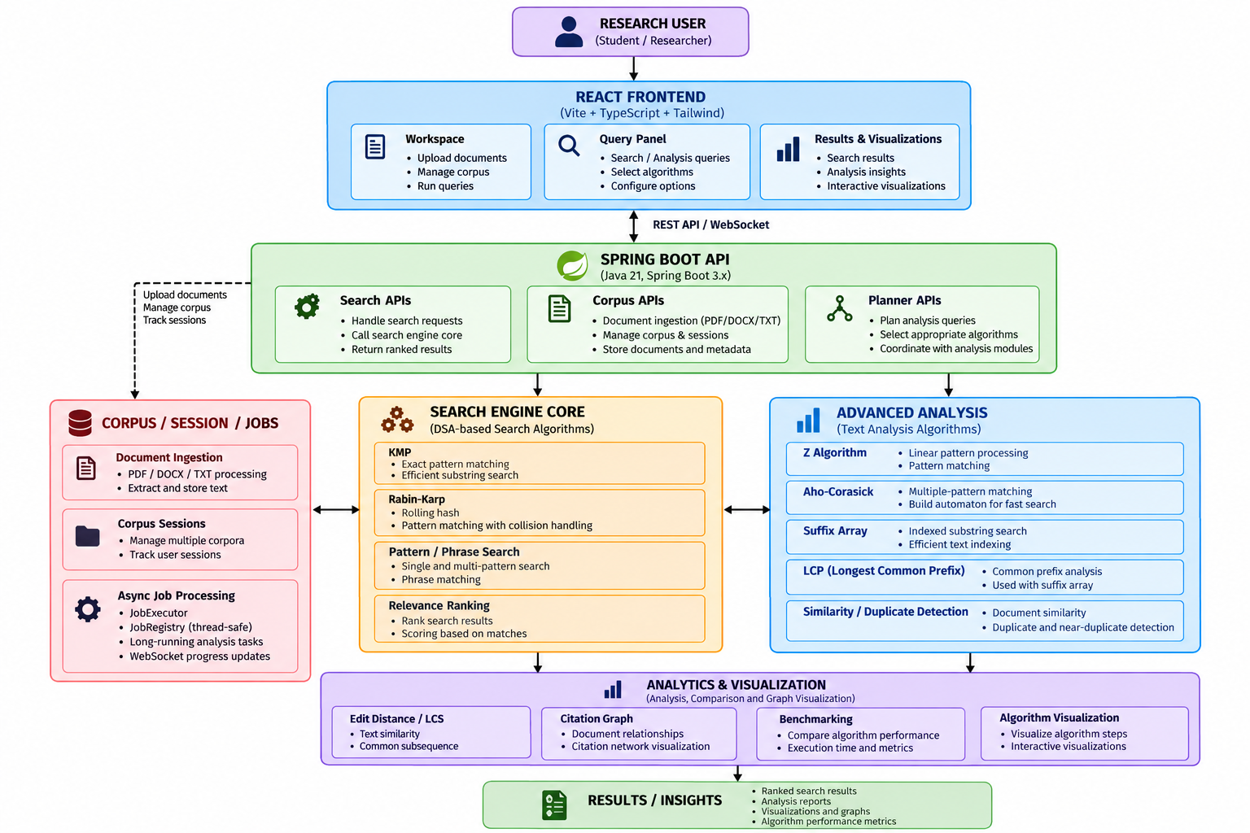
Fig. 2. StrataSearch System Architecture

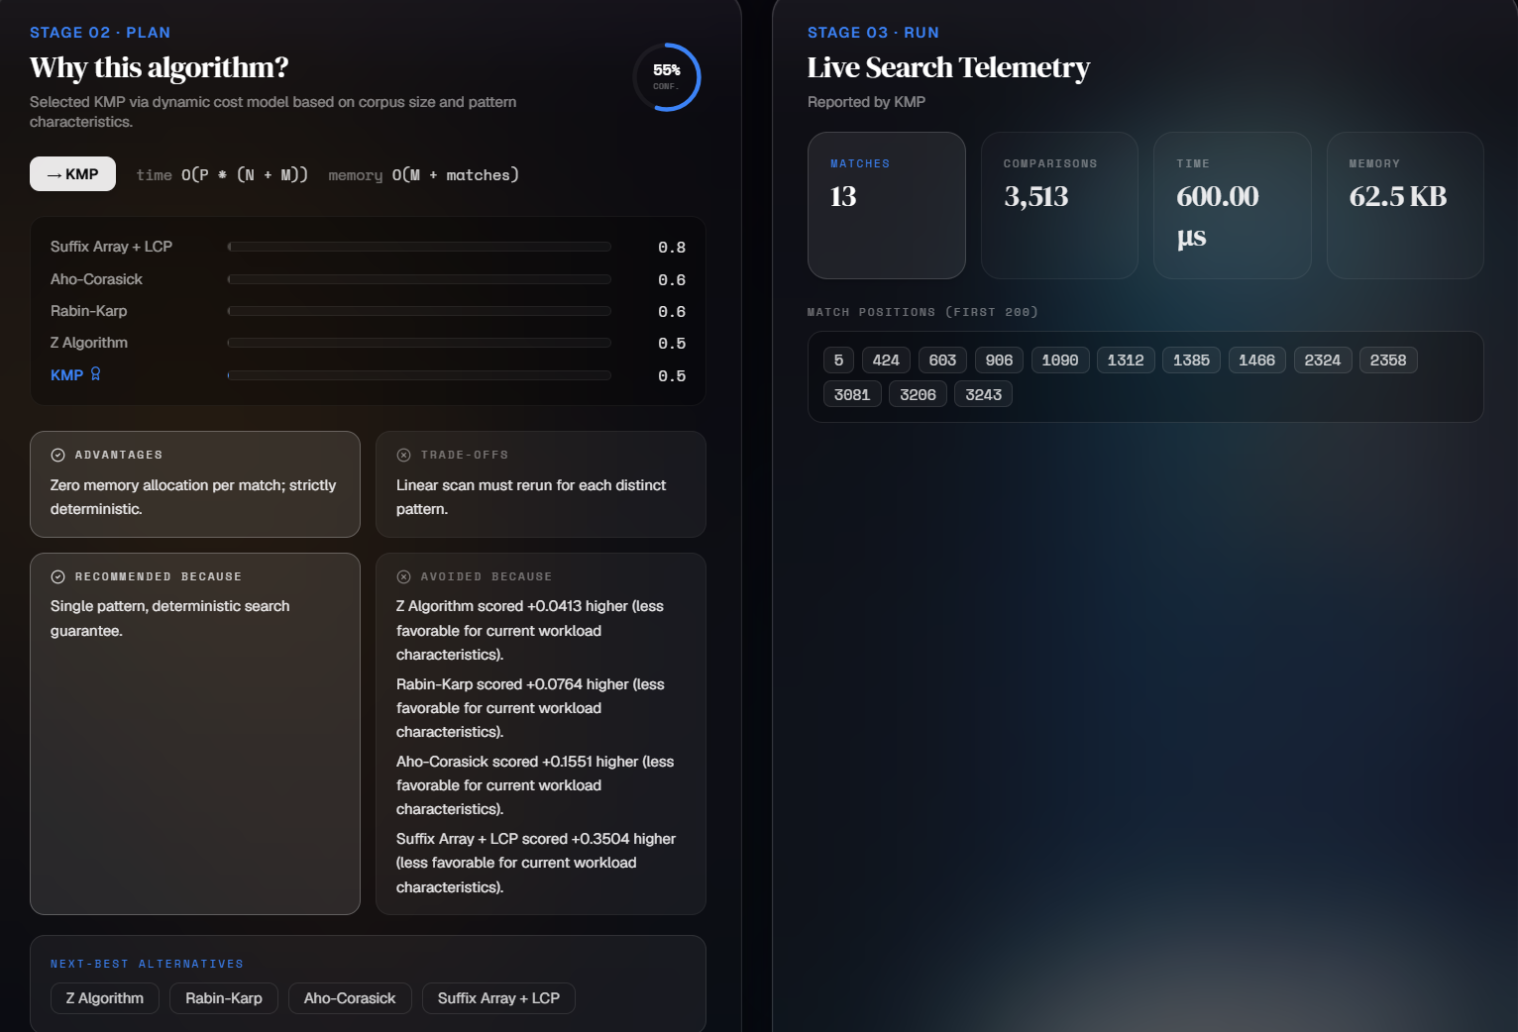
Fig. 3. Algorithm Selection Interface

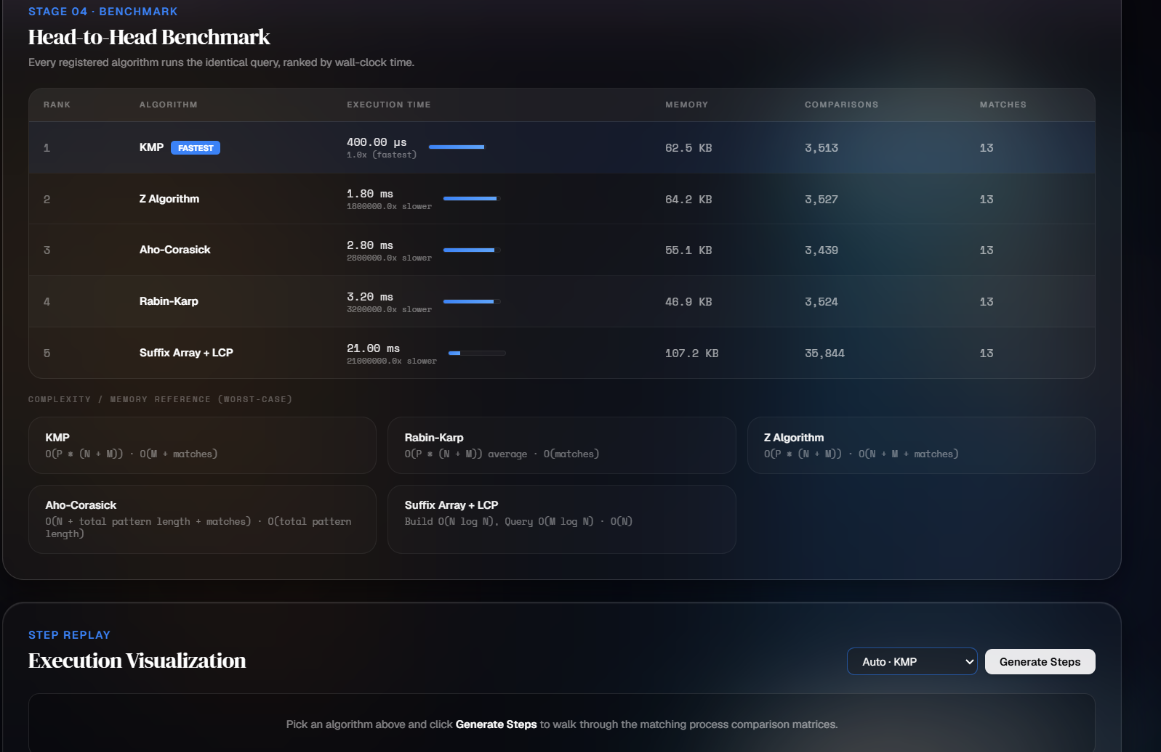
Fig. 4. Benchmark and Telemetry Analysis

Fig. 5. Citation Graph Visualization

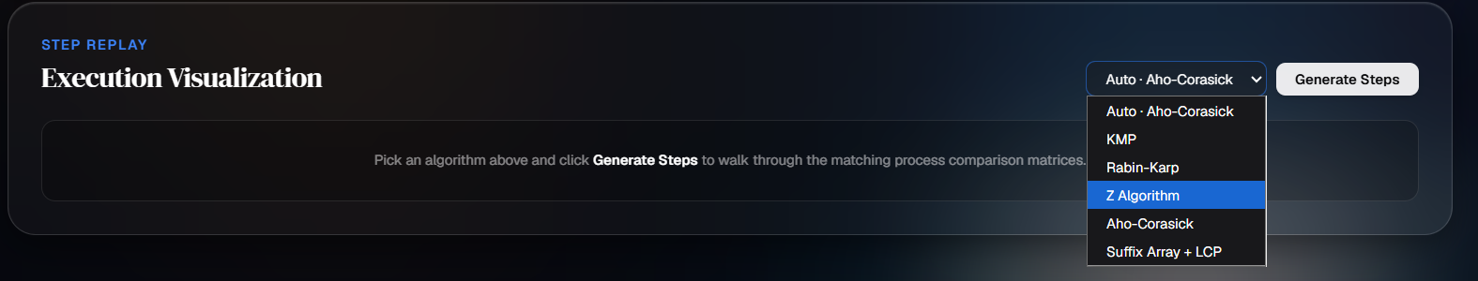
Fig. 6. Algorithms Available in StrataSearch

List of Tables
Table 1: Algorithms Used in StrataSearch
S. No. | Algorithm | Category | Purpose in StrataSearch
1 | KMP (Knuth-Morris-Pratt) | String Matching | Exact pattern matching in document text
2 | Rabin-Karp | String Matching | Pattern matching using rolling hash
3 | Z Algorithm | String Processing | Pattern preprocessing and substring matching
4 | Aho-Corasick | Multi-Pattern Matching | Simultaneous matching of multiple patterns
5 | Suffix Array | Text Indexing | Efficient indexed substring search
6 | LCP (Longest Common Prefix) | Text Analysis | Detecting common prefixes and repeated text
7 | Edit Distance | Similarity Analysis | Measuring the difference between two texts
8 | LCS (Longest Common Subsequence) | Similarity Analysis | Measuring common subsequences between documents
9 | Relevance Ranking | Search Analysis | Ranking documents according to search relevance
10 | Citation Graph | Graph Analysis | Representing relationships between research documents

Table 2: Algorithm Complexity Comparison

Algorithm | Best / Typical Time Complexity | Worst-Case Time Complexity | Space Complexity
KMP | O(n + m) | O(n + m) | O(m)
Rabin-Karp | O(n + m) expected | O(nm) | O(1) auxiliary
Z Algorithm | O(n + m) | O(n + m) | O(n + m)
Aho-Corasick | O(n + output) after automaton construction | Depends on output / construction | Depends on automaton
Suffix Array | Depends on construction method | Depends on construction method | O(n) or method-dependent
LCP | O(n) after suffix-array construction | O(n) | O(n)
Edit Distance | O(nm) | O(nm) | O(nm)
LCS | O(nm) | O(nm) | O(nm)

Table 3: Experimental Test Cases

Test Case | Input / Scenario | Algorithm(s) | Objective | Expected Observation
TC1 | Small document, single exact pattern | KMP, Rabin-Karp | Measure basic exact matching | Both should perform efficiently
TC2 | Medium document, single exact pattern | KMP, Rabin-Karp, Z Algorithm | Compare single-pattern matching | Linear-time algorithms should scale well
TC3 | Large document, single pattern | KMP, Rabin-Karp | Evaluate scalability with text size | KMP should maintain predictable linear performance; Rabin-Karp depends on hashing/collisions
TC4 | Large document with repeated pattern occurrences | KMP, Z Algorithm | Test multiple match detection | Correctly identify all pattern positions
TC5 | Multiple search patterns in one document | Aho-Corasick | Evaluate multi-pattern matching | More efficient than independently scanning for every pattern
TC6 | Large text requiring indexed substring search | Suffix Array, LCP | Evaluate indexed text analysis | Efficient substring/repetition analysis after preprocessing
TC7 | Two similar documents | Edit Distance, LCS | Measure document similarity | Smaller edit distance / larger LCS indicates greater similarity
TC8 | Duplicate or near-duplicate documents | Similarity + Edit Distance/LCS | Detect duplicate documents | Highly similar documents should be identified
TC9 | Research-paper collection with citation relationships | Citation Graph | Analyze document relationships | Documents and citation relationships represented as a graph
TC10 | Small, medium, and large inputs | KMP, Rabin-Karp, Z, Aho-Corasick | Benchmark algorithm performance | Compare execution time and scalability

Table of Contents

  - Introduction
  - Methodology
- System Architecture and Data Flow
- Document Search and Query Processing
- Knuth-Morris-Pratt Algorithm
- Rabin-Karp Algorithm
- Z Algorithm
- Aho-Corasick Algorithm
- Suffix Array and LCP
- Algorithm Execution Visualization
- Benchmarking and Telemetry
- Citation Graph
  - Experiments
    - Query Entry and Document Retrieval
    - Running and Visualising the Algorithm
    - Test Cases & Capacity Optimization Performance
  - Results
    - Analysis of Time and Space Complexity
    - Comparison of algorithm performances
    - Benchmarking, Telemetry and Citation Graph Analysis
  - Conclusion and Future Work
  - References
- INTRODUCTION
It can be difficult for users to search large sets of documents when they are looking for particular words, phrases, or patterns. Since different string-matching algorithms employ different methods for searching, their performance may depend on the input. Although traditional search systems generally give the results, they do not explain how the search algorithm functions internally.
StrataSearch is an intelligent document search and analysis platform which uses Data Structures and Algorithms in order to carry out document searching. Users can input a query in order to search for content that matches within documents. The platform includes a number of string matching algorithms, such as KMP, Rabin-Karp, Z Algorithm, Aho-Corasick, and Suffix Array with LCP.
StrataSearch also offers visualization of algorithm execution, so that users can see the various steps involved in pattern matching. This visualization comes with features such as play, pause, step and speed adjustment, which make it easier to understand the execution.

The system also has the capability to carry out benchmarking and to provide telemetry so that the performance of different algorithms can be observed and compared; it includes a citation graph which shows the citation relationships between documents and displays these connections visually.
The aim of the project implementation is to design a combined document search, string matching algorithms, visualization, benchmarking, and citation analysis application. The project is intended to demonstrate the capabilities of Data Structures and Algorithms in terms of document search and analysis.
Objectives
- To provide efficient document searching using string matching algorithms.
- To implement multiple pattern matching algorithms.
- To visualize algorithm execution step by step.
- To compare algorithm performance using benchmarking.
- To observe algorithm execution using telemetry.
- To represent citation relationships between documents.
- To provide an interactive platform for understanding string-search algorithms.

METHODOLOGY

The methodology of the StrataSearch tool involves document processing, query-based searching, algorithm execution, visualization, benchmarking, and citation relationship analysis.

  - System Architecture and Data Flow
The StrataSearch tool uses a frontend-backend architecture. In this case, the user interacts with the frontend to provide search queries and select the desired algorithm. The backend gets the request and executes the required algorithm to process the data and gets the result, which is then sent back to the frontend to be visualized.
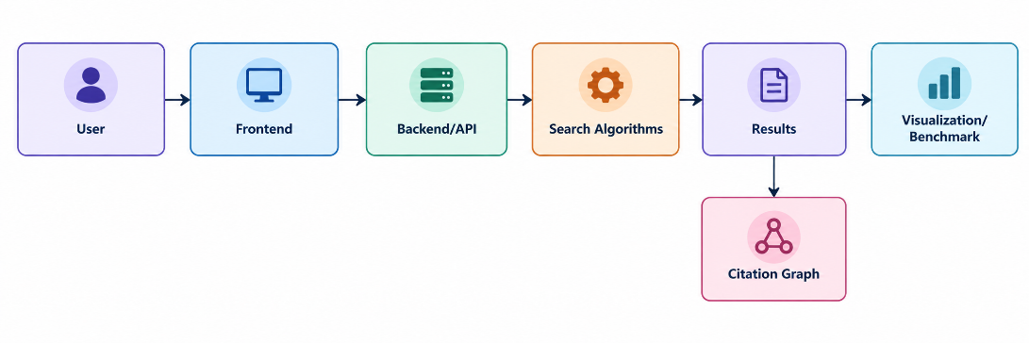
  - Document Search and Query Processing
A search process commences when a user enters a query. The backend executes the query and performs a search on the available document content using the selected string matching algorithm.
The results are relayed to the frontend where the search result and algorithm execution can be seen.
  - String Matching Algorithm
StrataSearch supports multiple string matching algorithms for searching and pattern processing.
KMP
The Knuth-Morris-Pratt (KMP) algorithm makes use of an auxiliary LPS (Longest Prefix which is also Suffix) array to prevent unnecessary character comparisons while searching for occurrences of the pattern in the text. The running time of KMP is O(N+M).
Rabin-Karp
The Rabin-Karp algorithm works by rolling a hash of the search pattern against a window of the same size in the text being searched. In case of hash matches, actual pattern and text segments are compared. The average-case running time of the Rabin-Karp algorithm is O(N+M) but the worst-case time complexity is O(NM).
Z Algorithm
The Z Algorithm constructs a Z-array that stores the lengths of the longest matching prefixes for each position in a string. The algorithm can be used for pattern matching in linear time, i.e., O(N + M). The Z Algorithm is one of the basic algorithms that the project implements and visualizes.
Aho-Corasick
The Aho-Corasick algorithm is designed to search for multiple patterns simultaneously. It also uses a trie and failure links, like the Aho-Corasick automaton.

Suffix Array + LCP
The Suffix Array is a data structure that stores the starting indices of all suffixes of a string sorted lexicographically. The LCP (Longest Common Prefix) array complements the Suffix Array by storing the lengths of the longest common prefixes between consecutive suffixes.
Together, they support efficient string searching and analysis.
  - Algorithm Execution Visualization
StrataSearch offers a step-by-step algorithm visualization for the following algorithms:
- KMP
- Rabin-Karp
- Z Algorithm
- Aho-Corasick
- Suffix Array + LCP
The visualization player provides Play, Pause, Step, and Speed controls, allowing users to observe the execution of the selected algorithm.

  - Benchmarking and Telemetry
The platform provides benchmarking and telemetry facilities for observing algorithm execution and performance, allowing for comparison between algorithms in terms of behaviors during search.
  - Citation Graph
The citation graph encodes information about the relationship between documents based on what documents cite each other, with nodes representing documents and edges representing citations explicitly.

EXPERIMENTS

Experiments were carried out to confirm the proper functioning of the search and visualization tools in StrataSearch.

The tool was tested with various search queries and algorithms. The same or similar search tasks can be executed with the help of different algorithms to study their behavior.

The main activities of experiments include the following:

- Entering a search query.
- Searching the available document content.
- Selecting a search algorithm.
- Generating algorithm execution steps.
- Visualizing the execution.
- Observing benchmark and telemetry information.
- Viewing citation relationships between documents.

TEST CASE | INPUT | OPERATION | EXPECTED RESULT
Test 1 | Search query | Document search | Relevant matches are displayed
Test 2 | Search query + KMP | Pattern matching | KMP execution is generated
Test 3 | Search query + Rabin - Karp | Pattern matching | Rabin-Karp execution is generated
Test 4 | Search query + Z-Algorithm | Pattern matching | Z Algorithm execution is generated
Test 5 | Search query + Aho-corasick | Pattern matching | Aho-Corasick execution is generated
Test 6 | Search query + Suffix Array + LCP | String search | Suffix Array/LCP execution is generated

RESULTS

The implementation of StrataSearch proves that multiple string matching algorithms can be incorporated into a common document search platform.

The visualization interface allows the user to select different algorithms and generate their execution steps. This makes it possible to see how different algorithms process a search query.

CONCLUSION AND FUTURE WORK
Conclusion :
StrataSearch successfully integrates document search process with string matching algorithms and algorithm visualization. The application implements multiple algorithms, including KMP, Rabin-Karp, Z Algorithm, Aho-Corasick and Suffix Array with LCP.

The visual component enables the users to view the algorithms’ execution process step-by-step. Benchmarking and telemetry capabilities allow investigating additional information about algorithms’ performance, while the citation graph displays the connections between documents

The project serves as an excellent example of how the Data Structures and Algorithms field can be integrated into the practical document search and analyze scenario.

Future Work :
Future research can be devoted to developing the analysis capabilities of the platform, implementing more advanced document similarity and corpus analysis algorithms, visualizing the results, and offering various options for comparing and analyzing documents.

REFERENCES

- D. E. Knuth, J. H. Morris Jr., and V. R. Pratt, “Fast Pattern Matching in Strings,” SIAM Journal on Computing, vol. 6, no. 2, pp. 323–350, 1977.
- R. M. Karp and M. O. Rabin, “Efficient Randomized Pattern-Matching Algorithms,” IBM Journal of Research and Development, vol. 31, no. 2, pp. 249–260, 1987.

- A. V. Aho and M. J. Corasick, “Efficient String Matching: An Aid to Bibliographic Search,” Communications of the ACM, vol. 18, no. 6, pp. 333–340, 1975.

- U. Manber and G. Myers, “Suffix Arrays: A New Method for On-Line String Searches,” SIAM Journal on Computing, vol. 22, no. 5, pp. 935–948, 1993.

- T. H. Cormen, C. E. Leiserson, R. L. Rivest, and C. Stein, Introduction to Algorithms, 4th ed., MIT Press, 2022.

- M. Crochemore and W. Rytter, Jewels of Stringology, World Scientific, 2002.

