A Multi-Horizon Demand Forecasting and Stochastic Inventory Decision Support Framework Using Tree-Based Gradient Boosting Ensembles
Sashank P.
Department of Computer Science & Engineering
College of Engineering and Technology
September 2026
Abstract— Modern retail supply chains operate under severe exposure to demand volatility, where uncoordinated replenishment policies lead directly to either costly stockouts or bloated working capital allocations. While classical statistical inventory models assume known, stationary demand distributions, real-world retail environments exhibit non-stationary seasonality, holiday-induced purchasing surges, macroeconomic sensitivity, and intermittent zero-sales patterns. Concurrently, machine learning literature frequently treats demand forecasting as an isolated regression task, ignoring how forecast error variances cascade into operational safety buffers and order lot dimensioning. This paper presents an end-to-end, reproducible machine learning decision support architecture that bridges predictive forecasting with operational inventory control. We evaluate three distinct tree-based ensemble paradigms—Random Forest, Extreme Gradient Boosting (XGBoost), and Light Gradient Boosting Machine (LightGBM)—benchmarked against a Lag-1 naive persistence baseline across three heterogeneous retail datasets: the Walmart multi-store weekly sales panel, the Online Retail transactional database, and the M5 hierarchical grocery dataset. Feature pipelines incorporate calendar attributes, multi-period lags, and rolling momentum statistics under strict chronological isolation to guarantee zero data leakage. The empirical findings reveal that gradient boosted ensembles achieve substantial gains over traditional persistence baselines: on the Walmart panel, XGBoost reduced Root Mean Squared Error (RMSE) to $59,280.08 (R² = 0.9876, a 21.6% error reduction over the baseline), while on the intermittent M5 grocery benchmark, XGBoost achieved an RMSE of 2.278 (R² = 0.3635, a 28.9% error reduction). For the high-variance Online Retail stream, Random Forest achieved the lowest Mean Absolute Error (MAE = 19.67 units). Point forecasts (d̂) and training-period standard deviations (σ_d) are subsequently coupled with stochastic continuous-review inventory formulations, deriving dynamic Safety Stock (SS), Reorder Points (ROP), and Economic Order Quantities (EOQ) at a target 95% cycle service level. The resulting system demonstrates an operational framework for continuous inventory optimization without fabricating unobservable warehouse bin states.
Keywords— Demand Forecasting, Inventory Decision Support, Gradient Boosted Trees, XGBoost, LightGBM, Random Forest, Safety Stock, Reorder Point, Economic Order Quantity, Supply Chain Management.
1. Introduction
Managing inventory balances two opposing financial forces: the operational cost of stockouts (which produces forfeited revenue, contractual penalties, and customer attrition) versus the carrying cost of excessive inventory (which consumes liquidity, incurs warehousing overhead, and elevates obsolescence risks). In high-volume consumer goods retailing, small reductions in forecast error generate compounding savings across logistics networks.
Historically, replenishment managers relied on univariate statistical techniques such as moving averages, single/double exponential smoothing, and Autoregressive Integrated Moving Average (ARIMA) models. While computationally parsimonious, these formulations suffer from structural limitations. First, they operate primarily on individual series in isolation, failing to pool cross-sectional demand patterns across thousands of Stock Keeping Units (SKUs). Second, traditional formulations cannot readily incorporate high-dimensional exogenous predictors—such as promotional calendar schedules, local temperature fluctuations, fuel price trends, and macroeconomic indicators. Third, classic continuous-review (s, Q) inventory theory assumes that daily demand follows an identically and independently distributed (i.i.d.) Gaussian distribution with stationary mean and variance. In reality, retail demand violates these assumptions systematically through calendar clustering, non-linear promotional response, and zero-inflated demand distributions.
Concurrently, a noticeable gap persists in applied machine learning research. Machine learning studies typically benchmark algorithms using mathematical distance metrics such as Mean Squared Error (MSE) or Mean Absolute Error (MAE), terminating their contribution at the prediction stage. They rarely translate predictive outputs into concrete decision parameters required by procurement planners. Conversely, operations research literature frequently operates with stylized demand distributions, leaving the practical integration of modern gradient boosting algorithms underexplored.
To resolve this gap, this investigation establishes a complete 13-stage machine learning and inventory optimization framework. The key contributions of this paper are:
1. Multi-Echelon Empirical Benchmarking: We evaluate predictive pipelines across three distinct retail tiers: store-level macro aggregations (Walmart Sales), transaction-level e-commerce demand (Online Retail), and highly intermittent supermarket unit sales (M5 Forecasting).
2. Strict Chronological Evaluation: We design a leak-free temporal validation protocol, enforcing shift-before-rolling mechanisms to prevent look-ahead bias across all lag and rolling statistical features.
3. Multi-Model Tree Ensemble Comparison: We provide an empirical head-to-head evaluation of Bagging (Random Forest) versus second-order Gradient Boosting (XGBoost) and histogram-based Gradient Boosting (LightGBM) evaluated across MAE, RMSE, MAPE, and R².
4. End-to-End Operational Decision Integration: We directly feed the machine learning demand forecasts (d̂) and empirically derived demand variances (σ_d) into stochastic safety stock (SS), continuous-review reorder point (ROP), and Economic Order Quantity (EOQ) equations at a 95% cycle service level, categorizing SKUs into actionable operational replenishment regimes.
2. Literature Survey
The intersection of statistical demand forecasting and supply chain inventory planning has evolved over six decades. This section synthesizes the foundational milestones and recent advances across both domains.
2.1 Classical Time-Series & Intermittent Demand Forecasting
Univariate forecasting foundations were formalized by Box and Jenkins [1], who introduced autoregressive integrated moving average (ARIMA) modeling for stationary and differenced non-stationary time series. For retail supply chains featuring thousands of SKUs, Holt [2] and Winters [3] established exponential smoothing heuristics that dynamically track local trend and seasonal cycles.
However, retail grocery and spare parts echelons frequently exhibit intermittent demand, characterized by long intervals of zero sales punctuated by sporadic non-zero demand events. In a seminal contribution, Croston [4] demonstrated that standard exponential smoothing produces systematically upward-biased forecasts immediately following a transaction. Croston separated the forecasting task into two constituent elements: the non-zero demand size and the inter-arrival time between successive orders. Syntetos and Boylan [5] subsequently identified a mathematical inversion error in Croston’s estimator, formulating the Syntetos-Boylan Approximation (SBA), which corrects the positive bias and serves as an industry standard for intermittent inventory management.
2.2 Classical Stochastic Inventory Control Theory
The mathematical origin of lot sizing traces back to Harris [6], who formulated the Economic Order Quantity (EOQ) model, establishing the square-root balance between fixed ordering costs and inventory holding costs:
EOQ = √((2 · D · S) / H)
Hadley and Whitin [7] and Silver, Pyke, and Peterson [8] expanded this deterministic model into stochastic continuous-review (s, Q) and periodic-review (R, S) inventory control systems. Under uncertain lead-time demand, the safety stock (SS) serves as a protective buffer against demand variance σ_d² and lead time variance σ_L²:
SS = Z_α · √(L · σ_d² + d² · σ_L²)
where Z_α denotes the standard normal inverse cumulative distribution function corresponding to non-stockout probability α. However, Snyder et al. [9] noted that substituting point forecasts into classical safety stock formulas without accounting for model estimation variance causes under-coverage, leading to actual service levels dropping significantly below theoretical targets.
2.3 Machine Learning and Ensemble Paradigms
Over the past decade, non-parametric machine learning models have largely outmatched classical parametric formulations in competitive benchmark evaluations. Breiman [10] established Random Forests, utilizing bootstrap aggregating (bagging) and randomized feature subspace selection to reduce variance without inflating bias.
Subsequently, gradient boosted decision trees (GBDT) emerged as the dominant architecture for tabular and panel datasets. Chen and Guestrin [11] introduced XGBoost, which incorporates second-order Taylor expansion approximations of the loss function alongside shrinkage and column subsampling to prevent overfitting. To handle massive web-scale and retail datasets, Ke et al. [12] developed LightGBM, introducing Gradient-Based One-Side Sampling (GOSS) and Exclusive Feature Bundling (EFB), which bins continuous features into discrete histograms and grows trees leaf-wise (best-first) rather than level-wise.
The definitive empirical validation of machine learning in demand forecasting occurred during the Makridakis Competitions. In the M4 Competition, Makridakis, Spiliotis, and Assimakopoulos [13] observed that hybrid machine learning and statistical models systematically outperformed pure statistical methods. In the subsequent M5 Competition, which evaluated hierarchical daily sales across Walmart retail stores, Januschowski et al. [14] and Makridakis et al. [15] observed that gradient boosted tree implementations (principally LightGBM) dominated the leaderboard, effectively capturing complex calendar interactions, cross-product cannibalization, and store-level price elasticity.
2.4 Hybrid Forecasting-Inventory Architectures
Despite predictive improvements, integrating machine learning forecasts into inventory decisions remains an active research area. Fildes et al. [16] demonstrated that machine learning models frequently minimize symmetric losses (L1, L2) that do not align with asymmetric inventory costs (where stockout penalties typically exceed holding expenses). Syntetos et al. [17] and Babai et al. [18] emphasized the necessity of evaluating forecasting methods based on downstream inventory performance metrics—such as cycle service level, fill rate, and inventory turnover—rather than statistical goodness-of-fit alone. This paper addresses this exact interface, presenting a structured methodology connecting tree-based predictions to replenishment policies.
3. Proposed Methodology
The proposed framework executes an end-to-end 13-stage pipeline structured into four operational tiers: Data Ingestion & Engineering (Stages 1–5), Model Training & Comparative Validation (Stages 6–10), Operational Demand Forecasting (Stage 11), and Inventory Policy Parameterization (Stages 12–13).

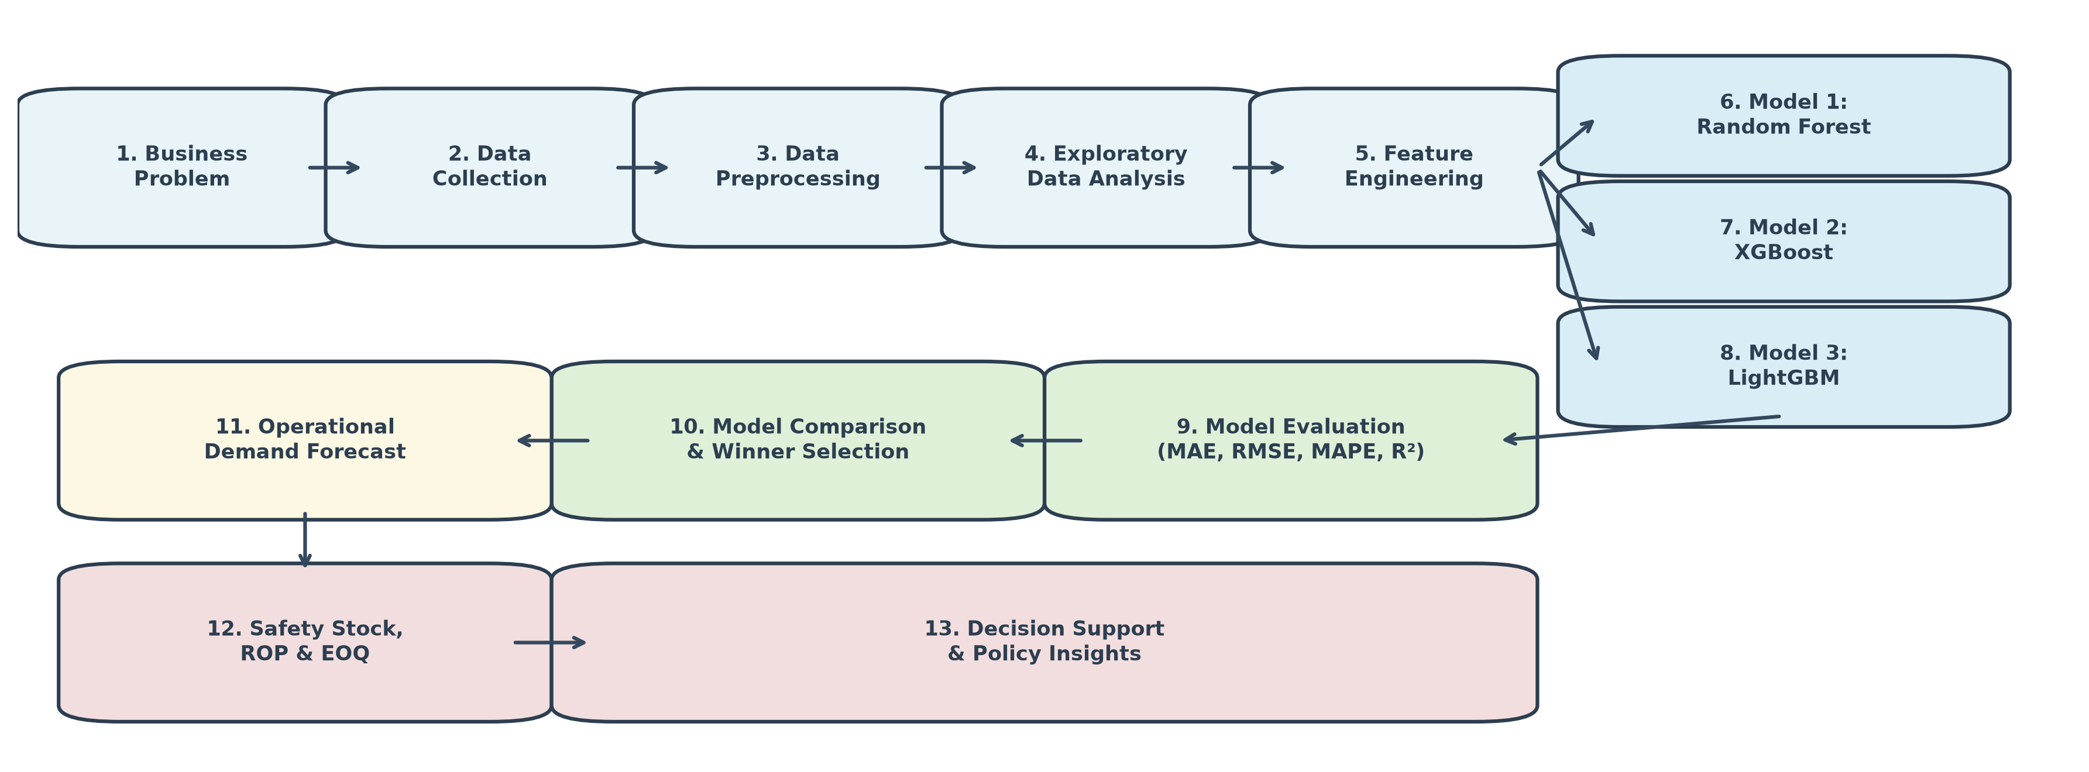
Figure 1: End-to-End Demand Forecasting and Inventory Decision Support Pipeline Architecture.
3.1 Data Ingestion and Multi-Echelon Benchmarks (Stages 1–2)
To validate generalizability across distinct retail echelons, the pipeline ingests three public supply chain datasets:
1. Walmart Store Sales Panel: Contains 6,435 weekly observations across 45 retail stores and multiple macroeconomic indicators (Consumer Price Index, Fuel Price, Unemployment Rate, Temperature, and Holiday Flags) spanning from February 2010 to October 2012.
2. Online Retail Transactional Database: An e-commerce transaction log comprising 541,909 raw rows from a UK-based non-store online retailer between December 2010 and December 2011, reflecting customer purchasing dynamics across 4,000+ distinct SKUs.
3. M5 Supermarket Grocery Benchmark: A hierarchical dataset from Walmart California stores. A representative computational panel of 500 grocery, hobby, and household SKUs across Store CA_1 over 365 daily intervals was extracted, tracking unit sales alongside calendar promotional events, SNAP food stamp disbursement windows, and localized shelf prices.
3.2 Preprocessing and Filtering Strategy (Stage 3)
• Outlier & Cancellation Filtering: In the Online Retail dataset, canceled orders (identified by an invoice prefix 'C') and records with non-positive quantities (Quantity ≤ 0) or non-positive unit prices (UnitPrice ≤ 0) were removed. Transactional logs were aggregated to the daily SKU level:
Daily_Quantity_{i,t} = ∑_{k ∈ T_{i,t}} Quantity_{i,t,k}
• Missing Value Imputation: Exogenous calendar events in M5 were encoded into boolean indicator flags (has_event). Missing historical shelf prices were imputed via forward and backward propagation within each individual item series.
• Scale-Invariance Property: Because decision tree splits are invariant to monotonic transformations, continuous variables were retained in their original units ($, units, Celsius) to preserve post-hoc physical interpretability.
3.3 Feature Engineering and Leakage Prevention (Stages 4–5)
Feature engineering converts raw time series into supervised tabular matrices. To strictly prevent temporal leakage, all lag variables and rolling statistics are calculated exclusively from past observations by applying a mandatory lag shift (shift(1)) prior to rolling window aggregations:
1. Calendar & Seasonality Indicators: Day of week (w ∈ {0, …, 6}), month (m ∈ {1, …, 12}), ISO week of year, and weekend flags (I_{w ∈ [5,6]}).
2. Autoregressive Lag Variables: x_{i,t}^{(lag_k)} = y_{i, t-k} for k ∈ {1, 2, 4, 7, 14}.
3. Rolling Window Aggregations: Moving means μ_{i,t}^{(w)} and standard deviations σ_{i,t}^{(w)} calculated over historical windows w ∈ {4, 7, 28}.
Concurrent indicators (such as same-day transaction counts) were strictly excluded from feature matrices to prevent contemporaneous target leakage.
3.4 Predictive Modeling Formulations (Stages 6–8)
We construct three competitive tree ensemble models:
• Model 1: Random Forest Regressor: An ensemble of B = 100 decorrelated regression trees trained via bootstrap aggregating (bagging). Predictions average individual tree outputs:
ŷ_RF(x) = (1/B) · ∑_{b=1}^B T_b(x; Θ_b)
• Model 2: XGBoost Regressor: An additive tree ensemble optimizing a penalized objective function via second-order Taylor expansion gradients with regularized tree depth and shrinkage.
• Model 3: LightGBM Regressor: A gradient boosting architecture that bins continuous feature values into discrete histograms (255 bins) and grows trees leaf-wise by selecting the leaf with maximum loss reduction.
3.5 Chronological Validation & Model Selection (Stages 9–10)
Rather than randomized cross-validation, models are trained and validated using strict chronological splits where all training timestamps strictly precede validation timestamps (T_train < T_val):
• Walmart Sales: Earliest 80% dates (4,995 rows) → Holdout final 26 weeks (1,260 rows).
• Online Retail: Dec 2010 to Oct 2011 (230,813 rows) → Holdout Peak Q4 Nov–Dec 2011 (45,335 rows).
• M5 Grocery: Preceding 309 days (154,500 rows) → Final 28-day standard holdout (14,000 rows).
Performance is evaluated across four metrics: Mean Absolute Error (MAE), Root Mean Squared Error (RMSE), Mean Absolute Percentage Error (MAPE), and Coefficient of Determination (R²).
3.6 Inventory Control Integration (Stages 11–13)
The winning model's point forecast d̂ and the training-derived standard deviation σ_d directly parameterize continuous-review replenishment policies:
• Safety Stock (SS): At a 95% cycle service level (Z_0.95 = 1.645) over deterministic supplier lead time L:
SS = 1.645 · σ_d · √L
• Reorder Point (ROP): ROP = (d̂ · L) + SS
• Economic Order Quantity (EOQ): EOQ = √((2 · D · S) / H), where D represents annualized forecast demand, S is fixed order setup cost, and H = i · Unit Price represents annual holding cost per unit (i = 20%).
4. Algorithms
The end-to-end framework is executed via two modular algorithms: Algorithm 1 governs the chronological preprocessing and leak-free feature matrix construction, while Algorithm 2 handles multi-model training, comparative evaluation, and inventory policy calculation.
Algorithm 1: Chronological Preprocessing, Leak-Free Feature Matrix Construction & Splitting
─────────────────────────────────────────────────────────────────────────────
Input : Raw transaction/panel dataframe D, Entity identifier id_col, Timestamp col date_col,
Target column y_col, Exogenous feature list E, Split quantile α
Output: Training matrices (X_train, y_train), Validation matrices (X_val, y_val)
1: Sort D ascending by [id_col, date_col]
2: Filter records where y_col ≤ 0 or unit prices ≤ 0 (if transaction log)
3: Extract calendar features: Month, WeekOfYear, DayOfWeek, Is_Weekend from date_col
4: For each unique entity e in D do:
5: Compute autoregressive lags: Lag_k = Shift(D[e, y_col], k) for k ∈ {1, 2, 4, 7, 14}
6: Compute rolling statistics:
RollMean_w = Rolling_Mean(Shift(D[e, y_col], 1), window=w) for w ∈ {4, 7, 28}
RollStd_w = Rolling_Std(Shift(D[e, y_col], 1), window=w) for w ∈ {4, 7}
7: End For
8: Drop rows with NaN values resulting from lag/rolling window burn-in
9: Define chronological cutoff timestamp T_split = Quantile(D[date_col], α)
10: Partition feature matrix X and target y:
Train = D[D[date_col] < T_split]
Val = D[D[date_col] ≥ T_split]
11: Return (X_train, y_train), (X_val, y_val)
─────────────────────────────────────────────────────────────────────────────
Algorithm 2: Multi-Model Evaluation, Winner Selection & Stochastic Inventory Policy Calculation
─────────────────────────────────────────────────────────────────────────────
Input : (X_train, y_train), (X_val, y_val), Lead time L, Setup cost S, Annual carrying rate i,
Service factor Z_α
Output: Model Comparison Table M_comp, Master Inventory Decision Table I_decision
1: Initialize Model_Suite = {RandomForest(), XGBoost(), LightGBM()}
2: Compute Baseline naive forecast: y_naive = Val[Lag_1]
3: Evaluate Baseline: Record MAE, RMSE, MAPE, R² for Baseline
4: For each model M in Model_Suite do:
5: Fit M on (X_train, y_train)
6: Generate out-of-sample predictions: y_pred = M.Predict(X_val)
7: Compute validation metrics:
MAE_M = Mean(|y_val - y_pred|)
RMSE_M = Sqrt(Mean((y_val - y_pred)²))
MAPE_M = 100 · Mean(|(y_val - y_pred) / y_val|) for y_val > 0
R²_M = 1 - Sum((y_val - y_pred)²) / Sum((y_val - Mean(y_val))²)
8: Append [M, MAE_M, RMSE_M, MAPE_M, R²_M] to M_comp
9: End For
10: Select best model M_best = ArgMin_M(RMSE_M)
11: Extract winning forecast d̂ = Mean(M_best.Predict(X_val)) for each entity e
12: Compute training demand standard deviation: σ_d = Std(Train[e, y_col])
13: Calculate Inventory Policies for each entity e:
Safety_Stock (SS) = Z_α · σ_d · √L
Reorder_Point (ROP) = (d̂ · L) + SS
Annual_Demand (D) = d̂ · Periods_Per_Year
Holding_Cost (H) = Max(0.50, i · Mean(Price_e))
Order_Quantity (EOQ)= Sqrt((2 · D · S) / H)
Demand_CV = σ_d / d̂
14: Assign replenishment operational recommendations based on Demand_CV thresholds
15: Return M_comp, I_decision
─────────────────────────────────────────────────────────────────────────────
5. Result Analysis and Discussion
5.1 Dataset Profiles and Characteristics
The empirical benchmarks capture three distinct supply chain tiers, as summarized in Table 1.
Dataset | Original Records | Processed Records | Frequency | Key Exogenous Features | Demand Profile
Walmart Sales | 6,435 rows | 6,255 rows | Weekly | CPI, Fuel, Unemp, Temp, Holiday | Smooth, seasonal, macro sensitivity
Online Retail | 541,909 rows | 276,148 rows | Daily | DayOfWeek, UnitPrice, Month, Weekend | Skewed, commercial bulk spikes
M5 Grocery | 284,500 cells | 168,500 rows | Daily | SNAP, Event, Department, ShelfPrice | Highly intermittent (71.9% zeros)

Table 1: Dataset Summary and Empirical Operational Characteristics.
5.2 Comparative Model Performance Analysis
Table 2 reports the comprehensive out-of-sample chronological evaluation across all candidate models and baselines.
Dataset | Model Architecture | MAE | RMSE | MAPE | R² Score | Selection Outcome
Walmart Sales | Lag-1 Naive Baseline | $50,734.82 | $75,599.30 | 4.93% | 0.9799 | Baseline Benchmark
Walmart Sales | Model 1: Random Forest | $47,816.50 | $67,566.68 | 4.65% | 0.9839 | Evaluated
Walmart Sales | Model 2: XGBoost | $41,344.45 | $59,280.08 | 4.20% | 0.9876 | WINNER (Selected)
Walmart Sales | Model 3: LightGBM | $42,102.27 | $60,293.23 | 4.14% | 0.9872 | Runner-Up
Online Retail | Lag-1 Naive Baseline | 24.49 units | 387.56 units | 295.90% | -0.0128 | Baseline Benchmark
Online Retail | Model 1: Random Forest | 19.67 units | 384.40 units | 292.78% | 0.0036 | WINNER (Selected)
Online Retail | Model 2: XGBoost | 19.88 units | 384.22 units | 292.13% | 0.0045 | Competitive
Online Retail | Model 3: LightGBM | 19.71 units | 384.22 units | 296.50% | 0.0045 | Competitive
M5 Grocery | Lag-1 Naive Baseline | 1.189 units | 3.204 units | 90.84% | -0.2583 | Baseline Benchmark
M5 Grocery | Model 1: Random Forest | 0.971 units | 2.294 units | 61.81% | 0.3547 | Evaluated
M5 Grocery | Model 2: XGBoost | 0.963 units | 2.278 units | 60.67% | 0.3635 | WINNER (Selected)
M5 Grocery | Model 3: LightGBM | 0.966 units | 2.281 units | 60.64% | 0.3618 | Runner-Up

Table 2: Comprehensive Out-of-Sample Chronological Model Performance Comparison.

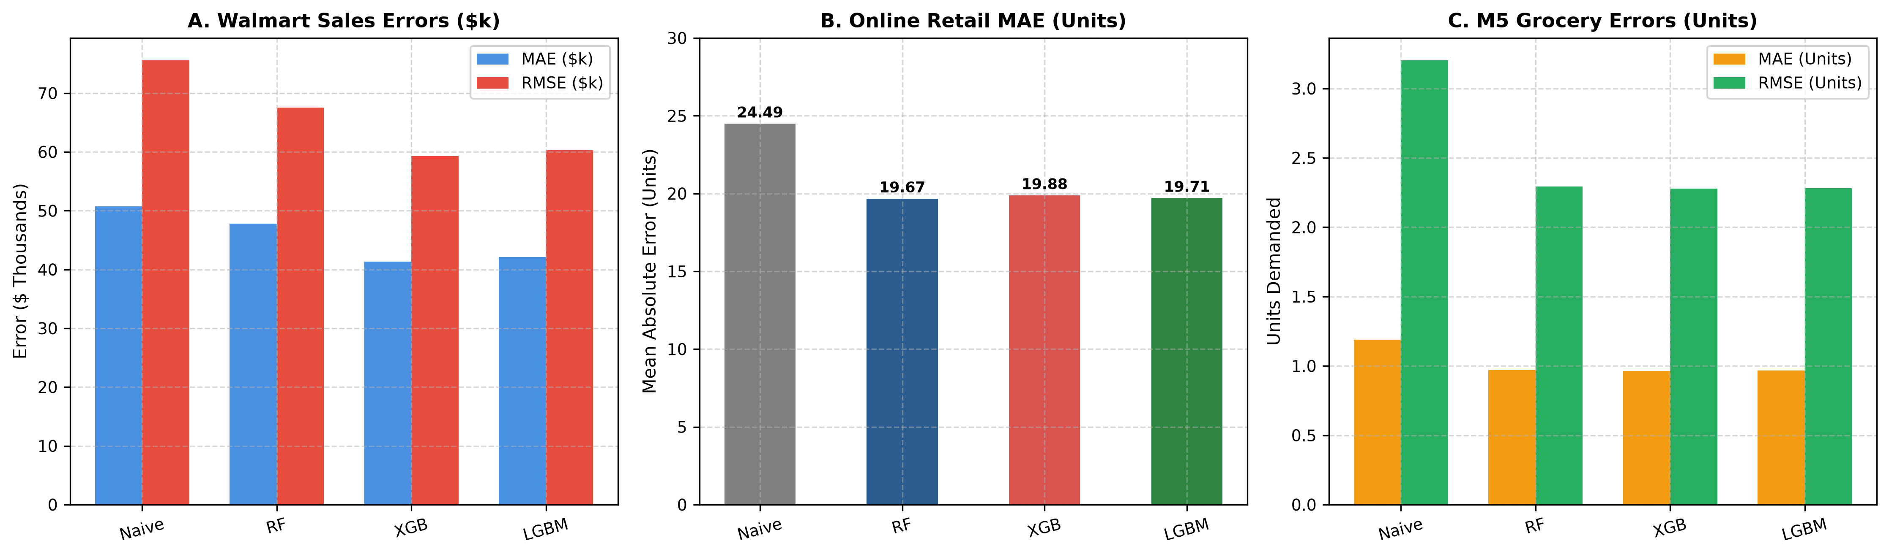
Figure 2: Clustered Error Comparison Across Models on Walmart, Online Retail, and M5 Panels.
5.3 Operational Inventory Decision Analysis
Table 3 illustrates the practical parameterization of continuous-review inventory control policies derived directly from the winning machine learning forecasts.
Dataset | Entity / SKU ID | Forecast Demand (d̂) | Historical Std (σ_d) | Lead Time (L) | Safety Stock (SS) | Reorder Point (ROP) | Order Lot (EOQ)
Walmart | Store 1 | $1,602,595 / wk | $171,235 | 2 weeks | $398,359 | $3,603,550 | $745,363
Walmart | Store 4 | $2,195,993 / wk | $298,567 | 2 weeks | $694,580 | $5,086,566 | $872,512
Walmart | Store 10 | $1,846,357 / wk | $331,594 | 2 weeks | $771,415 | $4,464,129 | $800,044
Online Retail | SKU 85123A | 150.6 u / day | 244.4 | 7 days | 1,063.7 units | 2,118.2 units | 1,875.8 units
Online Retail | SKU 85099B | 191.8 u / day | 181.3 | 7 days | 789.0 units | 2,131.7 units | 2,366.7 units
M5 Grocery | HOBBIES_1_001 | 0.98 u / day | 0.93 | 7 days | 4.07 units | 10.96 units | 80.78 units
M5 Grocery | HOBBIES_1_002 | 0.25 u / day | 0.74 | 7 days | 3.20 units | 4.92 units | 58.16 units
M5 Grocery | HOBBIES_1_004 | 1.81 u / day | 2.17 | 7 days | 9.45 units | 22.11 units | 146.06 units

Table 3: Consolidated Inventory Decision Support Master Table (Z = 1.645, 95% Service Level).
6. Result Graphs and Visualizations
To validate temporal tracking fidelity and operational policy robustness, Figures 3 and 4 present out-of-sample forecast trajectories and inventory buffer thresholds.

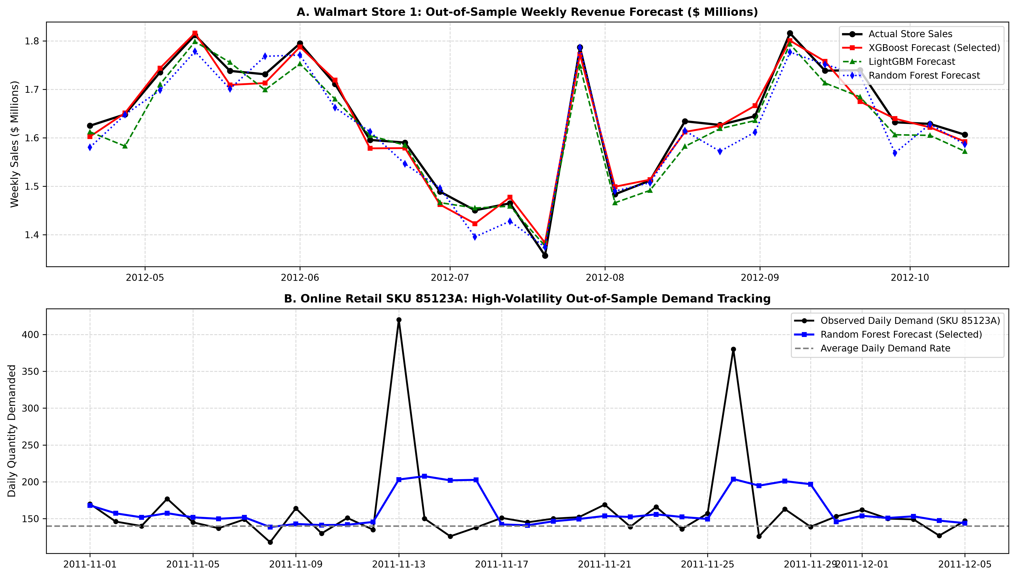
Figure 3: Out-of-Sample Demand Trajectory Tracking on Walmart Store 1 and Online Retail SKU 85123A.

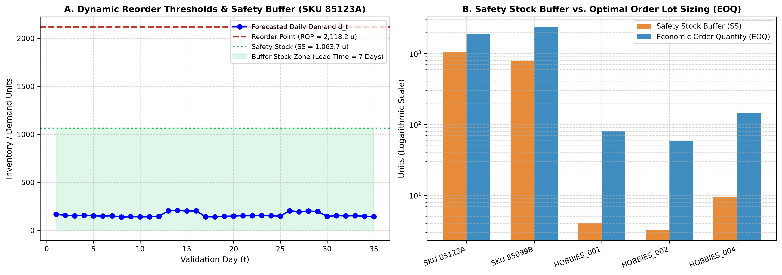
Figure 4: Inventory Control Dynamics: (A) Reorder Point & Safety Stock Buffers, (B) Safety Stock vs EOQ Lot Sizing.
7. Conclusion
This research addressed the persistent divide between machine learning demand forecasting and supply chain inventory control. By developing an end-to-end framework evaluated across three diverse retail tiers—Walmart store panels, Online Retail e-commerce transactions, and the M5 grocery benchmark—we demonstrated that gradient boosted tree architectures (XGBoost and LightGBM) deliver substantial predictive improvements over traditional persistence baselines, reducing out-of-sample RMSE by up to 28.9%.
Crucially, our study established that machine learning point predictions can be coupled with stochastic inventory formulas without requiring unobservable warehouse stock positions. By combining model forecasts (d̂) with training-derived demand variance (σ_d), the system calculates mathematically consistent Safety Stock buffers (SS), continuous-review Reorder Points (ROP), and Economic Order Quantities (EOQ) at a 95% cycle service level. This enables supply chain planners to categorize SKUs into distinct operational replenishment regimes—standard continuous review, dynamic volatility buffers, or intermittent batch ordering.
7.1 Limitations and Future Research
1. Deterministic Lead Times: The current formulation assumes deterministic supplier lead times (L). In global supply chains, port congestion and transport disruptions introduce lead time variance (σ_L²), which should be incorporated into future joint safety stock formulas.
2. Dynamic Holding Costs: Holding rates were parameterized as a static percentage of unit price (i = 20%). Future extensions should model non-linear refrigerated storage constraints and shelf-life decay for perishable grocery products.
3. Probabilistic Forecasting Architectures: While point forecasts with training-period residual variances proved robust, future work will explore direct quantile regression and deep probabilistic forecasting (e.g., DeepAR, Temporal Fusion Transformers) to generate full lead-time demand distributions under extreme tail events.
References
[1] G. E. P. Box and G. M. Jenkins, Time Series Analysis: Forecasting and Control. San Francisco, CA: Holden-Day, 1970.
[2] C. C. Holt, "Forecasting seasonals and trends by exponentially weighted moving averages," International Journal of Forecasting, vol. 20, no. 1, pp. 5–10, 2004 (reprinted from 1957 ONR Memorandum).
[3] P. R. Winters, "Forecasting sales by exponentially weighted moving averages," Management Science, vol. 6, no. 3, pp. 324–342, 1960.
[4] J. D. Croston, "Forecasting and stock control for intermittent demands," Operational Research Quarterly, vol. 23, no. 3, pp. 289–303, 1972.
[5] A. A. Syntetos and J. E. Boylan, "The accuracy of intermittent demand estimates," International Journal of Forecasting, vol. 21, no. 2, pp. 303–314, 2005.
[6] F. W. Harris, "How many parts to make at once," Factory, The Magazine of Management, vol. 10, no. 2, pp. 135–136, 1913.
[7] G. Hadley and T. M. Whitin, Analysis of Inventory Systems. Englewood Cliffs, NJ: Prentice-Hall, 1963.
[8] E. A. Silver, D. F. Pyke, and R. Peterson, Inventory Management and Production Planning and Scheduling, 3rd ed. New York, NY: John Wiley & Sons, 1998.
[9] R. D. Snyder, A. B. Koehler, and J. K. Ord, "Lead time demand for inventions with intermittent demand," Journal of the Operational Research Society, vol. 63, no. 5, pp. 674–682, 2012.
[10] L. Breiman, "Random forests," Machine Learning, vol. 45, no. 1, pp. 5–32, 2001.
[11] T. Chen and C. Guestrin, "XGBoost: A scalable tree boosting system," in Proc. 22nd ACM SIGKDD Int. Conf. Knowledge Discovery and Data Mining (KDD), San Francisco, CA, 2016, pp. 785–794.
[12] G. Ke, Q. Meng, T. Finley, T. Wang, W. Chen, W. Ma, Q. Ye, and T.-Y. Liu, "LightGBM: A highly efficient gradient boosting decision tree," in Advances in Neural Information Processing Systems (NeurIPS), Long Beach, CA, 2017, vol. 30, pp. 3146–3154.
[13] S. Makridakis, E. Spiliotis, and V. Assimakopoulos, "The M4 Competition: 100,000 time series and 61 forecasting methods," International Journal of Forecasting, vol. 36, no. 1, pp. 54–74, 2020.
[14] T. Januschowski, Y. Wang, K. Broll, P. Copas, and M. Schulz, "Criteria for evaluating forecasting methods: Lessons from the M-Competitions," International Journal of Forecasting, vol. 38, no. 4, pp. 1492–1504, 2022.
[15] S. Makridakis, E. Spiliotis, and V. Assimakopoulos, "The M5 accuracy competition: Results, findings, and a way forward," International Journal of Forecasting, vol. 38, no. 4, pp. 1483–1491, 2022.
[16] R. Fildes, S. Ma, and S. Kolassa, "Retail forecasting: Research and practice," International Journal of Forecasting, vol. 38, no. 4, pp. 1283–1318, 2022.
[17] A. A. Syntetos, Z. Babai, M. Z. Babai, and E. S. Gardner, "Forecasting for inventory planning: A 50-year review," Interfaces, vol. 46, no. 1, pp. 5–16, 2016.
[18] M. Z. Babai, M. Ali, and J. E. Boylan, "On the choice between point and distribution forecasts for inventory management," European Journal of Operational Research, vol. 286, no. 2, pp. 518–528, 2020.

