Case 4 – 74 yo W with N/V, malaise

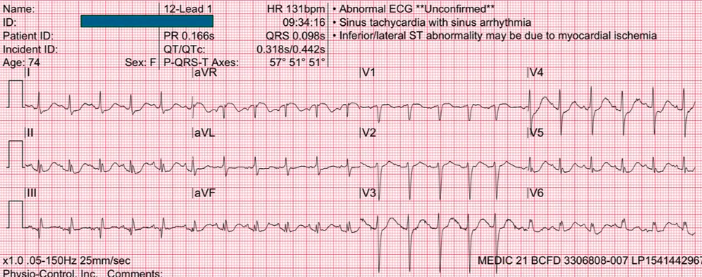

Now, case number 4 and we are continuing on with the same. Take a look on AVR
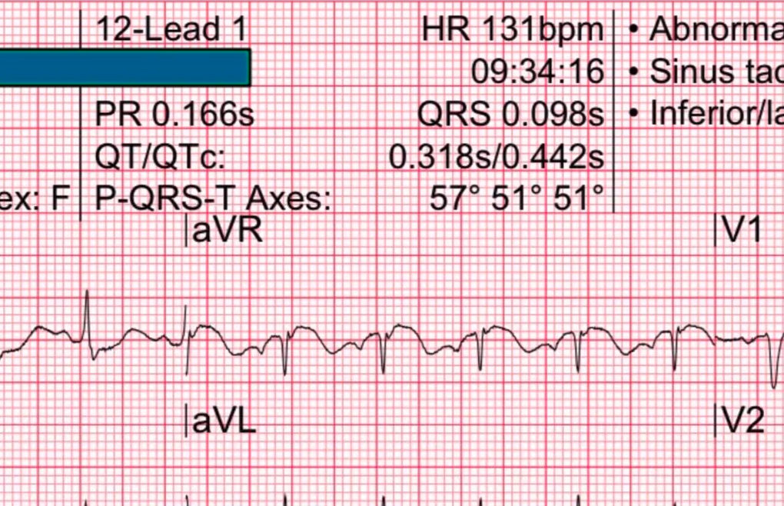
There is an elevation in AVR once again. And by now hopefully everyone understands – there is a differential for ST elevation in AVR.
We talked about hyper K.
We talked about sodium channel blocking conditions
We talked about SVT
We talked about diffuses ischemia from sepsis and shock

... and this is another one. 74 year old woman coming up with Nausea, vomiting and malaise. This could well be an anterior equivalent in a 74 year old woman. Nausea, vomiting and malaise – i will take very seriously for the possibility of ischemia and as the computer interpretation is pointing out – there is inferior leads and,
- lateral leads
... ST segment depression.

Inferior Leads ST Depression
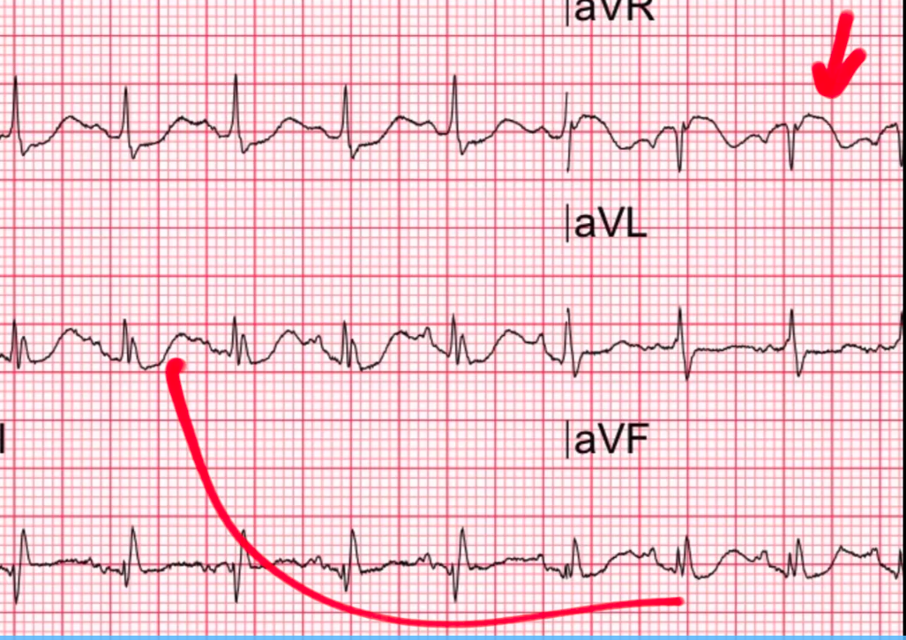

Lateral Leads ST Depression

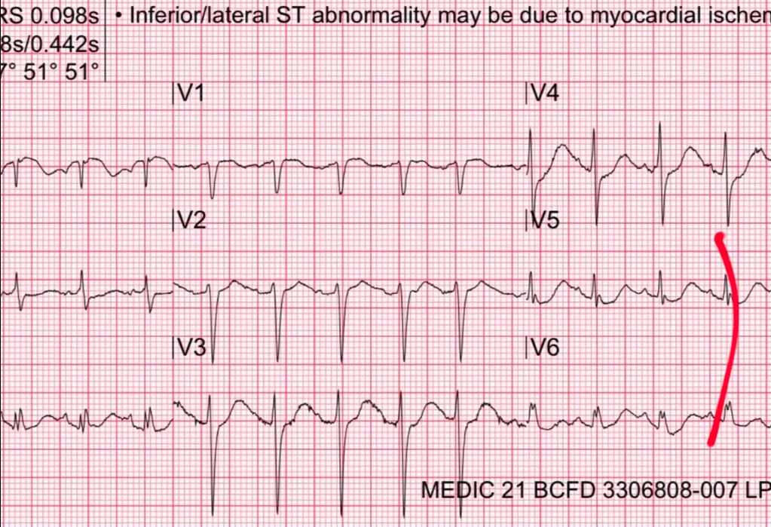

Lead I – ST Depression
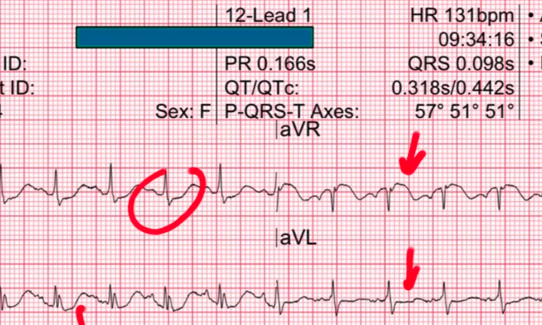

In Lead I there is some nice ST segment depression. Maybe a little bit in AVL.Infernal lateral signs of myocardial ischemia. So, if the computer is correct in noting those things. And so, you might be concerned with ST segment changes in so maybe we are dealing with one of those ACS causes of ST elevation in AVR. But there is something else unusual about this.
Whenever you look at the 12 Lead – we said this before dont just jump directly to the most obvious diagnosis. The most obvious diagnosis here is that there is ischemia. But go through the stepwise approach of 12 lead
Rate
Rhythm
Axis
Intervals
What about the intervals? Well the PR looks okay...
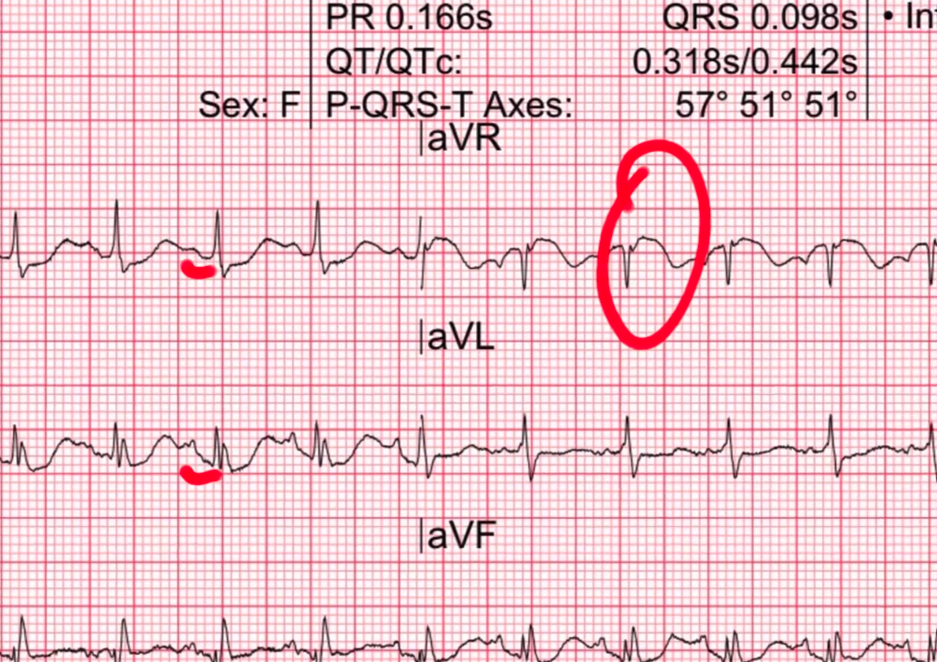

There is some decent looking PR’s , QRS’s are narrow. What about the QT? QT looks kind of wide – doesn’t it... This is not a normal QT. Normally, the computer is pretty good with the intervals. But, you cannot 100% of the time assume that it is right. You’ve gotta look yourself also. You don’t need to pull your calculator out and calculate Bazette’s formula with everything but take a quick look over there with QT.

Let’s take a look at V5 as a simple example
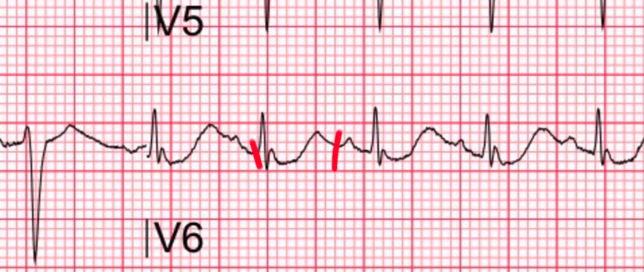

That is a really long QT interval. If you just want to guesstimate, Figure out where the QRS complexes are and the T-wave should end before the half way mark between the two QRS complexes.
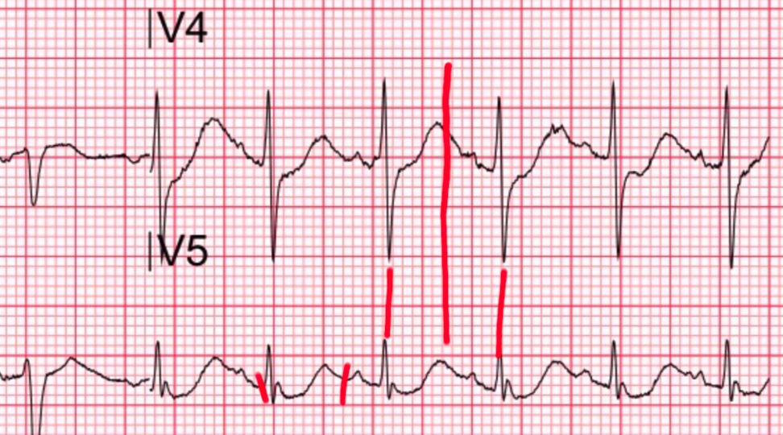

We can see that the T-wave is ending way after the halfway point between the two QRS complexes. This is kind of a rough way to tell that this QT is too long. This is a long QT. Myocardial Ischemia can prolong the QT a little bit. But when you see ST depression and size of ischemia with a really long QT. We have gotta think of some other things that prolong the QT.

So, what prolongs the QT? Well, there is whole bunch of medications that can do it. There is also Hypo K, Hypo Mag, Hypo Calcimia ... all of your hypo electrolytes. And one of those electrolytes are notorious for producing pseudo ischemic patterns. That is hypoKalemia.
HypoKalemia can drop your ST segments and give you the appearance that what you ar elooking at is ischemia.
You will notice again that the ST segment is sagging down and then it jumps up there. And that is something that I have referred to in the past as the Nikelikam pattern. Nikelicam is a term that I made up by the way. If you google it you can actually find it. But, it is not a published term.
NikEleKam – and this is my term for severe hypokalemia and what you end up finding is a QRS complex coming down.. it goes down and it pops up like that and then you get your next p wave. This is big U wave and this is an inverted T wave.
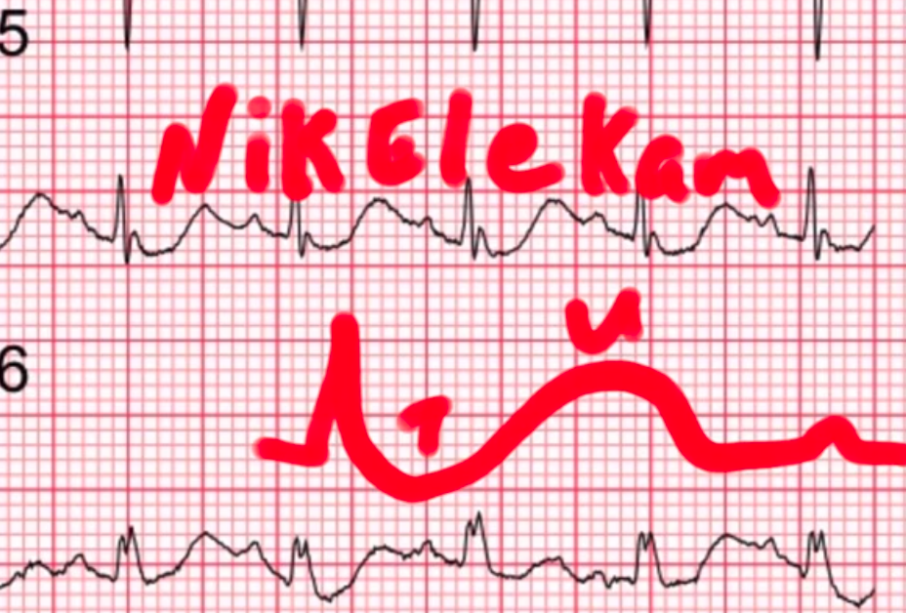
Its kind of a biphasic pattern. Reverse of what we see in wellens sign. This is a very characteristic pattern that you find in which hypokalemia.

Where did the term NikeliKam come from?
Well, When I was looking at a bunch of EKG’s that kids were around and I thought , how do I name something after myself. So I named it after my kids. So, I named this as a Nikelicam pattern after:
Nik – Nikhil
Ele – Elena
Kam – Kameron
I refer to that as NikeliCam T wave pattern. Again what you will see here is slowing downwards – that is the T wave and then it pops up into a Big U wave and it produces a appearance of prolonged QT. It is actually a T- U fusion. And the T wave is kinda going down
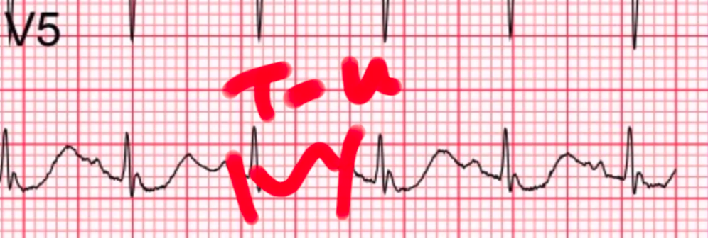
In some other leads to get a ST segment depression. It looks a lot like ischemia. What separates this from ischemia is that – it is not a true ischemia. There is a prolonged QT.
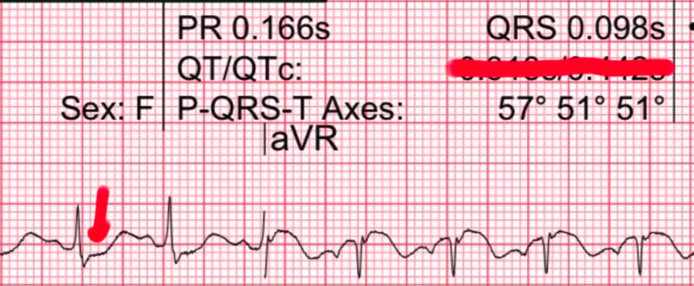

Computer will often get the intervals wrong. You gotta still look at the intervals yourself. You do not have to measure them. But sometimes, you will look at the interval and say – you know what, I don’t think the computer is right and you will make a big difference there. This patient turned out to be moderately – Hypokalemic. And, Hypokalemia definitely mimics cardiac ischemia by dropping those ST segments and T waves.

We will do a segment on Hypokalemia mimicing cardiac ischemia in an upcoming session because I have seen quite a few cases in it is worth discussing and really hammering home.
So this is another time a non ACS condition can produce ST elevation in AVR and this is well described – at lease on ECG weekly but it is not necessarily well known – hypokalemic can do it as well.

Alright, so lets finally move on.
Conclusion: Hypokalemia (3.1 mEq/L) mimics ischemia, QTc incorrect.


