Case 3 - 15 yo girl with palpitations

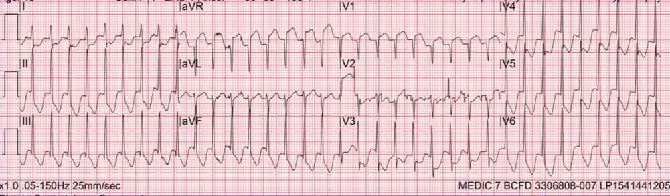

Case number 3 is a 15 year old girl who came in with palpitations and take a look at AVR. I think, we are seeing beam here today:

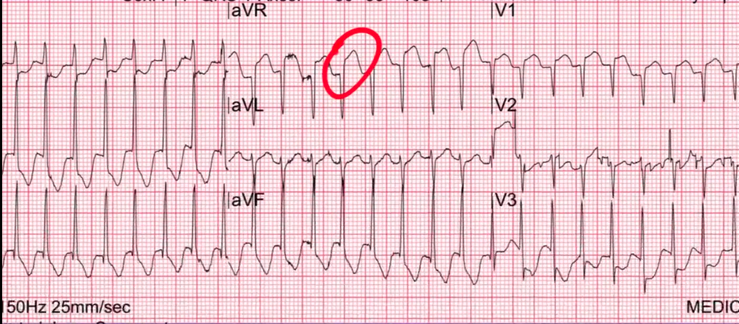

There is big time elevation in AVR. With ST segment depression in other leads:

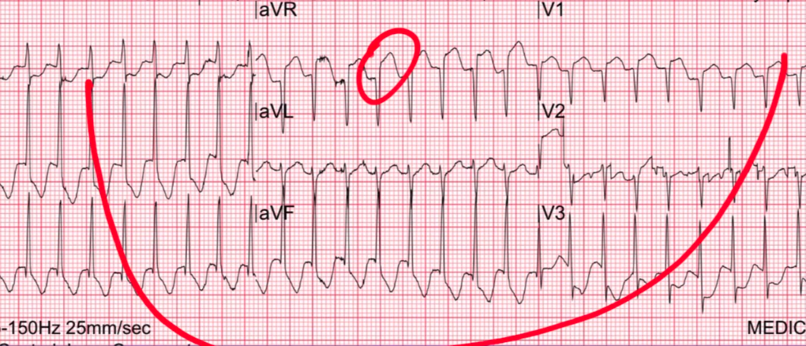

And what have we learnt about ST segment in AVR and multilead ST depression? Well then you are worried about left main and triple vessel and proximal led but, you have got to correlate it with the clinical presentation.
This patient is presented with palpitation. This is looking like a plain old SVT. And we know that SVT can produce elevation in AVR and SVT can produce these ST segment changes diffusely. What are you going to do with this patient? Send her to the cath lab? Of course not! You are going to do a vagal maneuver or give her denosine or some other AV nodal blocker.

And all time we ever need to be worried about AVR with SVT is if it persists after they conver. Pretty much the ST will come right down. And the studies have shown that all of the ST changes that you are looking at on this 12 lead ECG – they do not corelate with positive stress test or positive cath.
For some physiologic reason, SVT and also rapid Afib and also rapid aFlutter also produce all kinds of ST segment changes. But as long as the resolve on getting the rate down and normal – you don’t need to worry about it. Send her to a stress test and nothing else. This is a very common entity with SVT.
So this is another time when you can get this realy concerning elevation in AVR as well as all these other ST changes in other leads.

