Case 5: 64 yo W with atypical CP, nausea
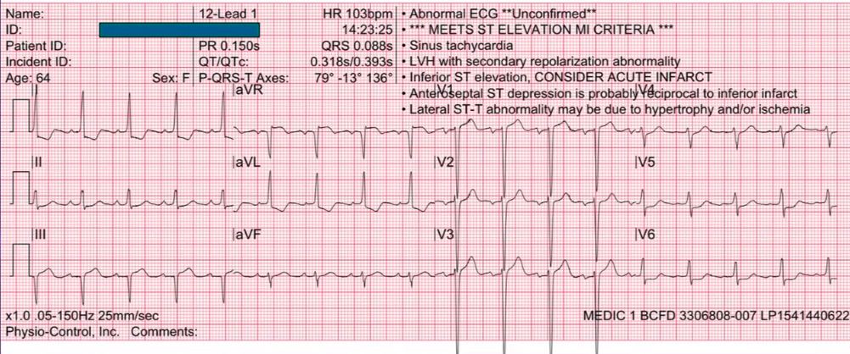

64 year old woman coming with atypical chest pain and nausea. So this could possibly be an <<not audible>>. Computer thinks that you are looking at a STEMI. There is an ST elevation in AVR
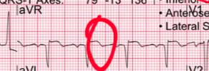
also there is ST depression in lateral leads.

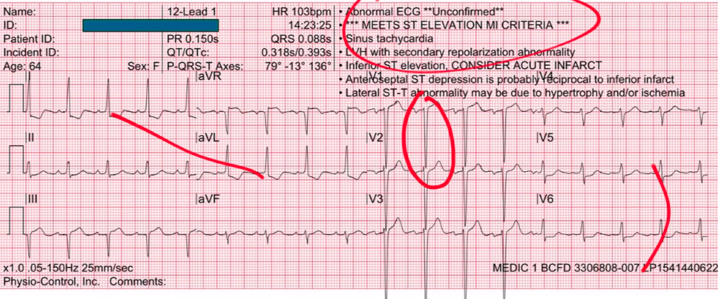

Also, there is ST elevation in V1, V2 and also V3 and so it is reasonable to worry about STEMI. And so it is reasonable to worry about STEMI in this particular case

But, when you go through your :
Rate
Rhythm
Axis
Intervals

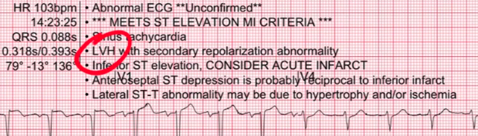

you look for ischemia, hypertrophy and you discover that this patient does have LVH. This is one place that the computer is right. What we know about LVH is that LVH is one of those annoying conditions that mimics ischemia. I hate LVH. I will tell you upfront. I hate LVH, because LVH is so difficult to distinguish from true ischemia. LVH can produce ST elevation, LVH can produce ST segment depression.
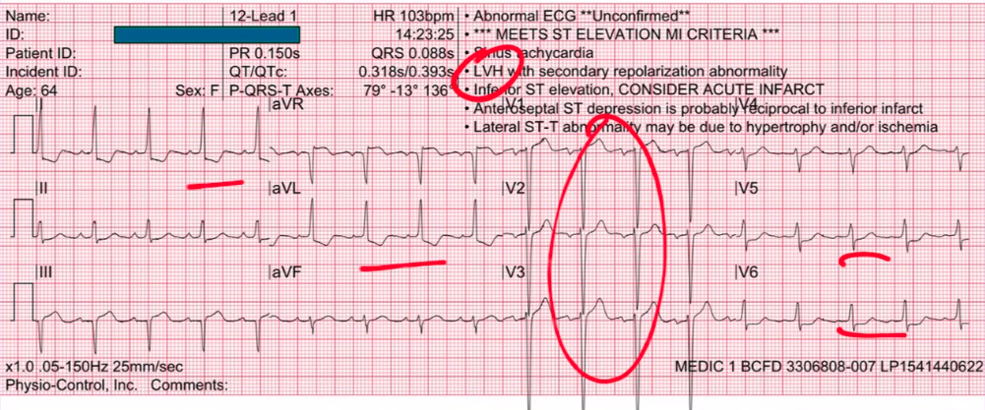
and it can look an awful lot like ischemia. Now usually, when LVH gives you ST depression, it gives you asymmetric depression like this
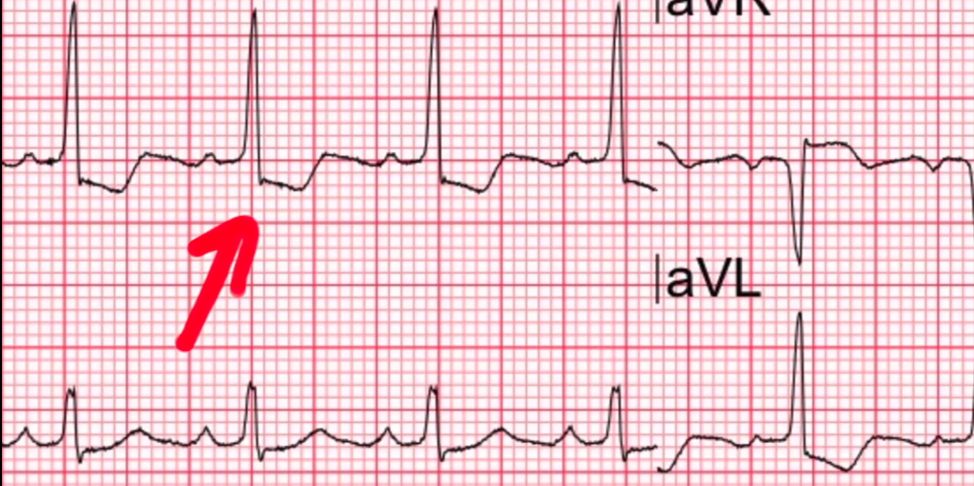
so rather than giving you symmetric T wave inversions like that, which tends more often to be
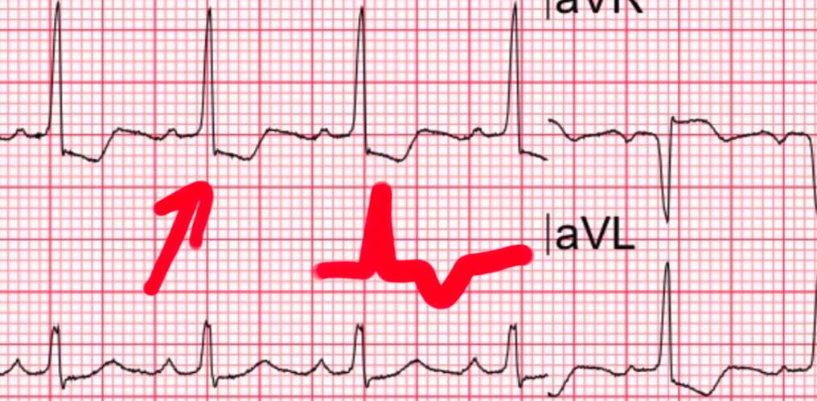
ischemia -

LVH typically gives you this assymetric ST segment depression or assymetric T wave inversions
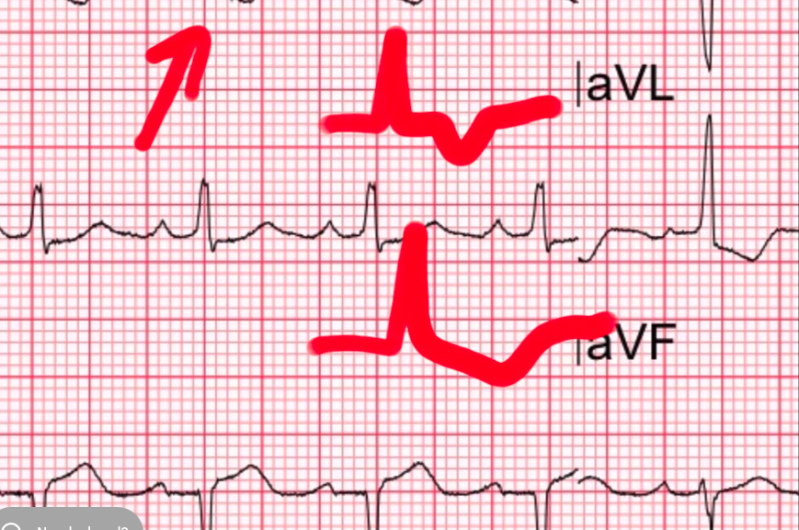
as you can see in these other places
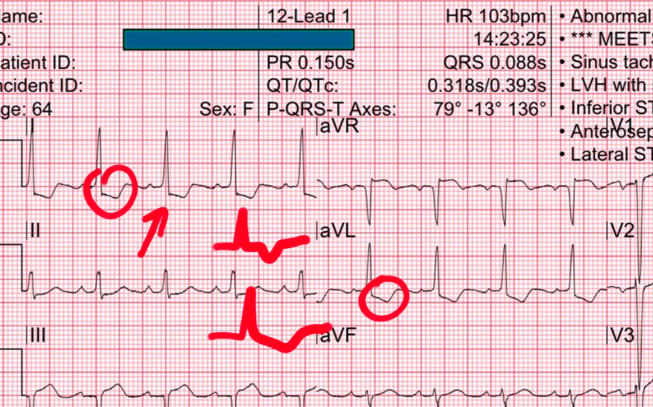
thats referred to LVH with a strain pattern. So, when in the AVL, I can buy that those are releated to LVH. But when you look at the lateral leads. This is kind of concerning, because rather than an assymetric pattern like that, you are seeing ST segment depression which is horizontal:
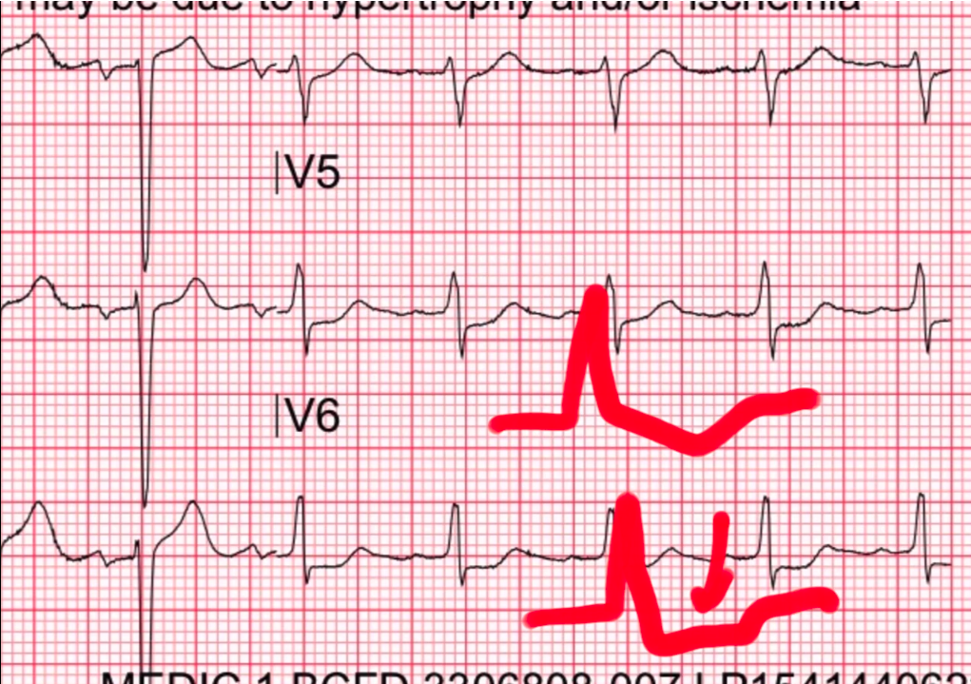
.. and the textbooks will tell you that horizontal ST segment depression is more likely cardiac ischemia than LVH which is true. But, more likely it is not the same thing as saying – it is a 100%.

LVH can sometimes produce ST segment depression – that looks just like this
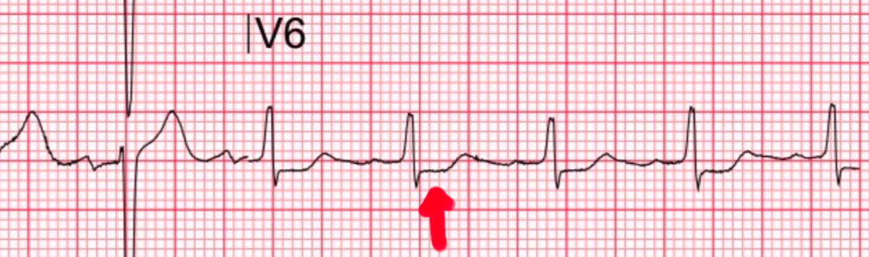

Just because it is horizontal ST depression does not mean it is true ischemia. So the bottom line is what do you do when you see an EKG that is concerning like this but not definitive.
In this, there is LVH so you know it could possible just be LVH restrained. But, it is elderly woman with atypical symptoms, so it could be STEMI or what do you do – you get a good history.... You get a good HPI, you do a physical examination. If you are good at UltraSound – you can do a quick UltraSound. If you are not good at UltraSound like me.. You call cardiology and ask them to cath the patient or ask them to weigh in.
This is what exactly the physicians in this case did. This was a difficult case – so they called cardiology and without activating the Cath lab, they said look – cardiology can yoy take a look at this , we will make a joint decision together. The cardiology looks at this and says this is a tough case. You know what... why dont we get serial EKGs and we will get a couple of quick troponins. So they did serial EKG every 10 to 15 minutes for about first hour and there is no evolving changes – which is very very helpful to say that it is not ischemia. It is not definite, they got a troponin at arrival and they repeated the troponin 1 hour later and there is nothing moving – in terms of the troponin and so they felt a lot more comfortable saying that this patient doesn’t need to go to the cath lab immediately and over the course of next couple of hours the Serial EKGs showed no evolving changes.

They weren’t able to get an old EKG – that would have been helpful. And this turned out to simply be LVH with strain and the patient ended up doing fine. It did not evolve in the serial EKG testing.
This is a great case of just how difficult LVH can be. Look at what LVH with strain can do:
ST elevation in AVR
ST elevation in some of your right precordial leads
ST depression laterally
Sometimes, you can get ST elevation in inferior leads as well
LVH is really difficult – that is why I hate LVH. LVH can be very ugly. And I have said this before, if LVH were a baby even momma would say, it is ugly. Thats how ugly LVH is and how difficult LVH is. You have gotta get better at LVH and the only way to do that is is to look at case after case after case after case.... Gradually, you will start to get more comfortable with all the different permutations and morphologies that LVH can take on. And your sensitivity and specificity with LVH strain versus STEMI will gradually improve. It is only going to come when you look at a tonne of different LVH cases.
So anyway as you can guess this week focus was not just pre-hospital cases but a whole bunch of cases
ST segment elevation in AVR that mimics cardiac ischemia – and the computer will often call these cases STEMI as well.

References:
LVH with a strain pattern:
https://litfl.com/left-ventricular-hypertrophy-lvh-ecg-library/
Troponin Test:
https://www.ucsfhealth.org/medical-tests/troponin-test

