Digital Alarm Clock-Using Arduino
Title:
Digital Alarm Clock Using Arduino using DS1307RTC and 7-Segment Display.
Abstract:
The project Digital Alarm Clock is built using Arduino Board using C language concepts. In this project we allow user to set or adjust time for alarm using the 3 push input buttons which helps user to turn on the alarm clock, adjust the time for alarm and also to turn off the clock and use it as a normal clock. When alarm time is equal to the current time the Arduino starts producing a sound to indicate the alarm time, we can turn off the alarm or we can also snooze it, so that it rings again after some particular time interval.
The C concepts like variables with appropriate data types, constants, arrays, functions, control statements, if else ladders, loops, enumerations are used for making more reliable, interactive project. Libraries are used to handle the display, buttons, alarm of the Digital Alarm clock.

Problem Statement:
We often depend on mobile phones for alarm and time, but these phones can be distraction, run out of battery ...etc.
This project focuses on creating a Digital Alarm Clock Using Arduino and Programmed using concepts of c language. Which is accurate and Distraction free for students.

Software Components:
COMPONENT | PURPOSE | QUANTITY
Arduino IDE | Used to compile, write and upload program into Arduino board | 1
Sev Seg Library | Controls the 4-digit 7-segment display | 1
Button Library | Reads and processes input from buttons. | 1
Alarm Tone Library | Manages and generate the alarm sound | 1
Clock Library | Helps to keep time accurate | 1
Configuration File | Stores timing values,  pin numbers ..etc | 1

Hardware Components:
COMPONENT | PURPOSE | QUANTITY
Arduino Uno | Runs the code | 1
DS1307  RTC  Module | Helps to run real-time clock with power backup i.e which works even when power is off | 1
4-Digit 7-Segment Display | Helps to show the real time | 1
Push Buttons | Used to set alarm and toggle the state of alarm feature of clock | 3
Buzzer | Produces Alarm Sound | 1
Jumper Wires | Connects all components for the given circuit | ~20
Bread Board | For connecting the components in the circuit or project without soldering | 1

Architecture Diagram:
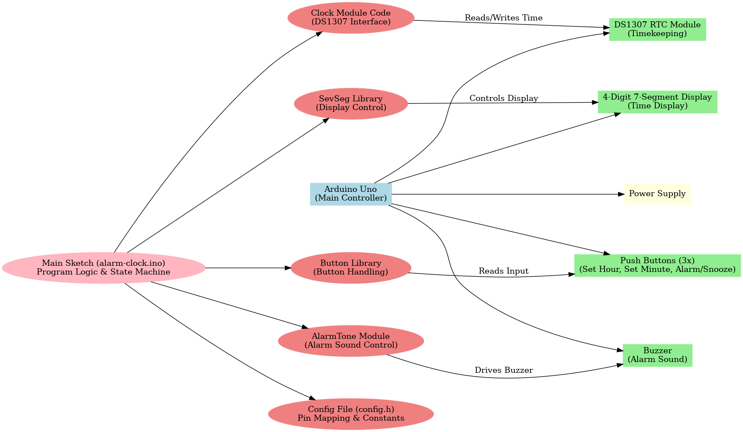

This Architecture Diagram for the project describes the relation between software components ,hardware components, main controller and also connections and data flow between the components.

Flow Diagram:
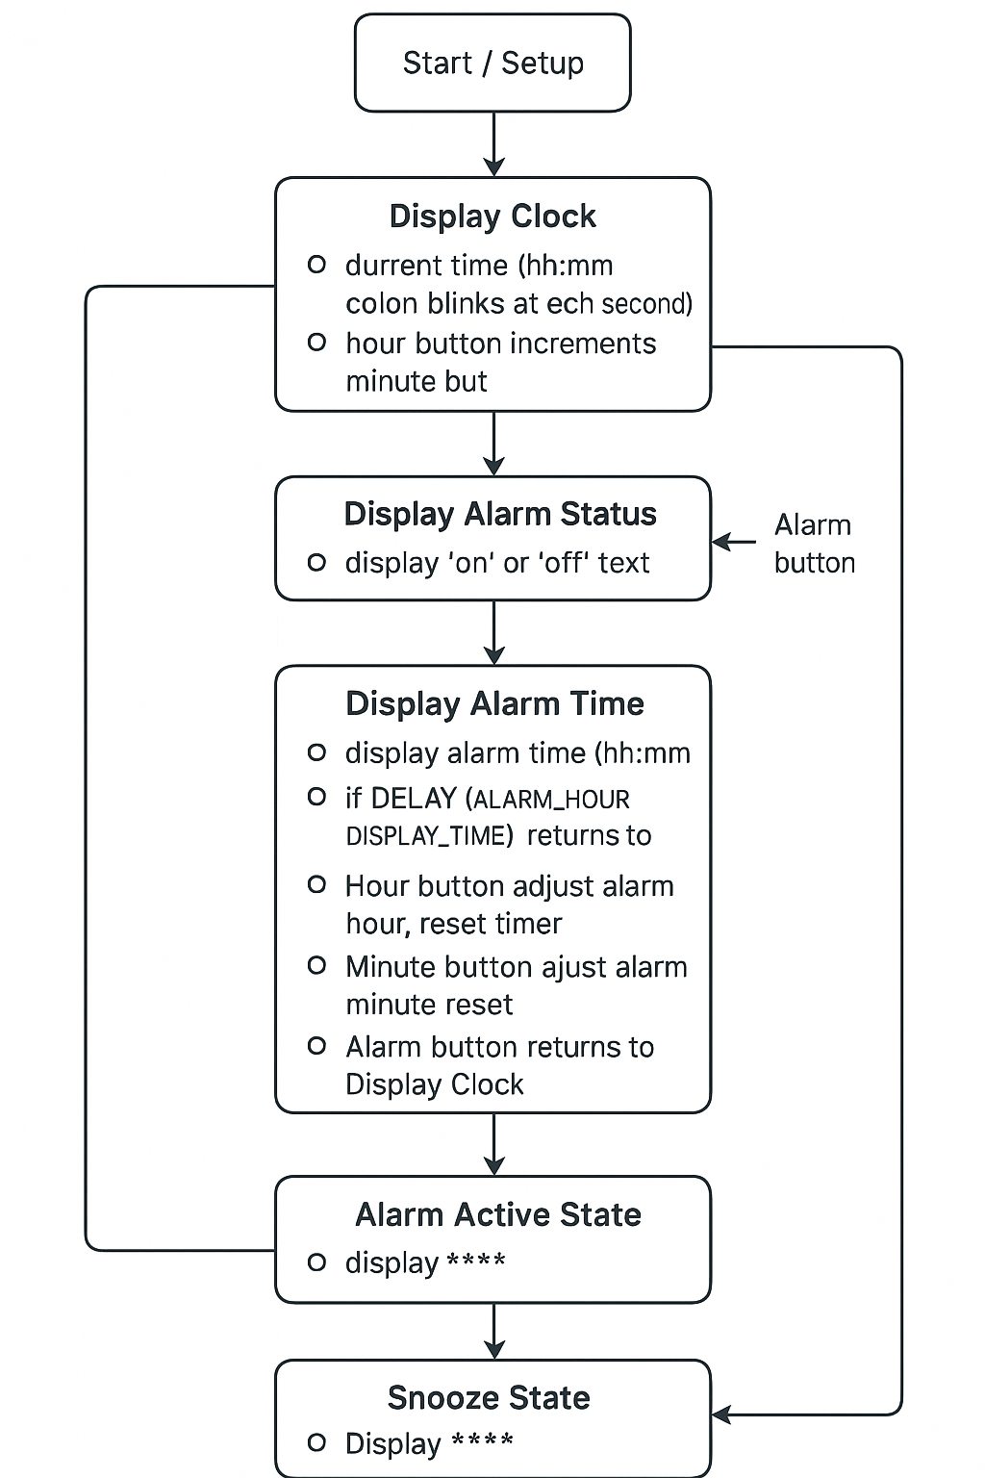
‘C’ concepts present:
Constants – Values that never change while the program runs.
Variables and data types – Places to store numbers, states, or other data.
Object-oriented programming – Using ready-made blueprints (classes) to create objects like buttons.
Functions – Reusable blocks of code that do a specific job.
Switch-case – Choosing between different actions in a clean way.
Loops – Running certain code over and over again.
Conditional statements – “If this happens, then do that” checks.
Function calls – Asking the program to run a function when needed.
Libraries and abstraction – Using prebuilt code to simplify tasks like controlling the display.
Pin and hardware abstraction – Giving hardware pins easy-to-read names.

Conclusion:
This project explains the use of c concepts in the given Arduino based Digital Alarm clock . The project also helps to successfully integrate hardware and software components to work a perfect and accurate Alarm clock using Ardiuno.

