Intro to CS

Final Project Documentation

Submitted by Cameron Shetler & Sashank Silwal

Project: The Flu

ABOUT

The Flu is a single player game, where the player can jump and shoot at “mega germs.” There are multiple types of germs, with corresponding motion and lives. The player can jump on germs to kill them or shoot them with “antidotes” they have collected. When the player comes in contact with a germ when not jumping, the player loses a life. When a germ is shot, its life count decreases. When its life count reaches zero, it is effectively killed. The screen is shifting upward at a constant speed, and if the player falls or crosses the red line at the bottom of the screen, the player loses a life. The player has three lives.

There are three levels with increasing difficulty.

The first level has only one type of germ moving in the x direction, and the screen moves at a slower speed.

The second level adds a germ that can move in both the x and y direction, as well as flying rocks moving horizontally across the screen. The speed of the screen movement is increased.

In the final level, the player can only shoot the germ to kill it but can go to the checkpoint to exit the game without killing the germ. The speed of the screen at this level is zero.

The final screen prints the number of germs the player killed at each level.

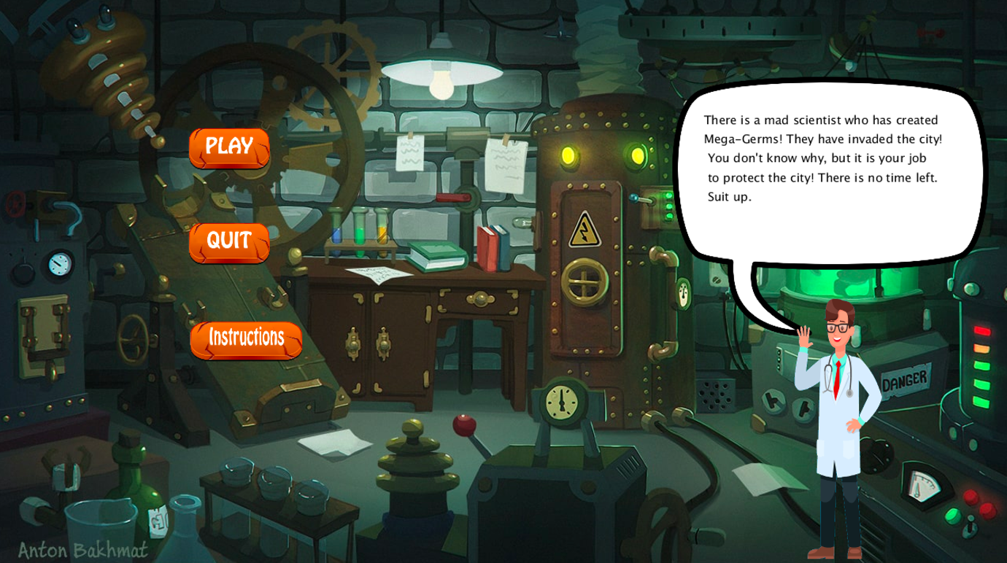

Game Intro

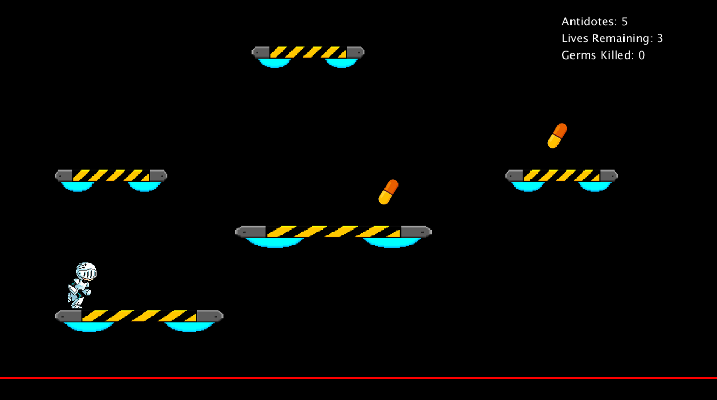

Playing the game

Info page between levels

HOW TO RUN THE GAME:

Open the “The_Flu.pyde” file on processing. Press the “play” button on the top left corner.

The menu of the game is opened. On the screen are buttons for the instruction, to quit the game, and to play the game. To return to the title screen from the instructions page, there is a “back” in the bottom left. The play button must be double clicked to open. Have fun!