**AUGMENTED FURNITURE**

**SASHANK S 2016103060**

**1 PROBLEM STATEMENT:**

The architects conceive the interior visual aspect of a house based on sketches and drawings. These drawing schemes are perfectly understandable by technicians that are responsible for their implementation, but to the client, most of the time, they seem somewhat unrealistic and ungraspable in terms of visual model. This issue is especially sensitive when the inner components are actually pieces of different kinds of furniture and other decoration stuff. The ideal situation should be to offer the client a preview of what is designed to decorate his home and even better, to be able in real-time, to make changes in some of the design details and previewing the results.

**2.INTRODUCTION:**

The AR is an area of computer graphics that allows the introduction of the concept of mixed reality in our daily lives . It is obtained by simultaneous visualization of synthetic visual objects (which are generated with the aid of the computer) with the real ones. Thanks to this, the AR is a natural choice in terms of technology to support the visualization of interior designs, allowing the development of differentiated and innovative products in the field of furniture industry.

This app was designed and is being developed taking into account two different approaches 1) **AR with markers** and 2) **AR without markers**. Visual markers are widely used in existing AR applications. Marker-based AR systems commonly use live video as input. As a result, the performance of a marker-based AR system strongly depends on the tracking system used for marker detection and pose estimation. AR with markers is already considered a well established approach. Another way less used to create AR visualizations is with a markless tracking approach. Techniques developed for **Markerless** Augmented Reality (MAR) can be classified in two major types: **model based** and **Structure from Motion (SfM)** based. With model based techniques, knowledge about the real world is obtained before tracking occurs and is stored in a 3D model that is used for estimating camera pose. In SfM based approaches, camera movement throughout the frames is estimated without any previous knowledge about the scene, being acquired during tracking. The main aim in this case is to obtain a method to estimate the position, orientation and the three-dimensional movement of a camera from the captured images, using for it the only calibrated camera and without the need to add any type of markers to the scene.

**2.1 INSTANT TRACKING:**

The Instant Tracker instantly scans the planar surface in the camera frame and recognizes the space with sensors. You can find the rendered 3D object on the space. Unlike Image and Object Recognition, which rely on pre-mapped targets to trigger the display of digitally augmented elements, Instant Tracking is markerless. So, instead of requiring a mark, it tracks features of the physical environment itself to overlay AR content. [**SLAM**](https://www.wikitude.com/wikitude-slam/) based Instant Tracking is, therefore, highly dependent on the characteristics of the physical scene in which the AR experiences is taking place. The Instant Tracking algorithm works in two distinct states:

* **Initialization State**: the origin of the tracking procedure is defined by pointing the device and aligning an indicator. User must actively confirm when the alignment is satisfactory before transitioning to the tracking state.
* **Tracking State**: in this state the environment is being tracked continuously, allowing augmentations to be placed within the scene.

**2.2 SLAM**

Simultaneous Localization and Mapping is a technology which understands the physical world through feature points.   
This makes it possible for AR applications to Recognize 3D Objects & Scenes, as well as to Instantly Track the world, and to overlay digital interactive augmentations.

**2.3 AUGMENTED REALITY:**

Augmented reality is an enhanced version of the real physical world through the use of visual elements, sound or other sensory stimuli. It is a growing trend among companies involved in mobile computing and business applications in particular. Amid the rise of [data collection](https://www.investopedia.com/terms/d/datamining.asp) and analysis, one of augmented reality’s primary goals is to highlight specific features of the physical world, increase understanding of those features and derive smart and accessible insight that can be applied to real-world applications.

**3.PROBLEM DESCRIPTION:**

When Clients go to a furniture store they may want to know if their selection suits their décor. Using this app they can augment their furniture into their homes thereby enabling them to make a better decision during their purchase. Firstly they have to select the furniture that they want to buy. Next they have capture a ground plane and immediately their object will be augmented onto their plane. We make use of instant tracking and marker less AR thereby allowing the client to move the piece of furniture about wherever they want.

**4. ARCHITECTURE:**



**4.1 GENERAL OUTLINE**

**5 IMPLEMENTATION**

**5.1.1 SELECT FURNITURE:**

The client can select which furniture he/she wants and move to the next scene.

**5.1.2 CAPTURE GROUND PLANE:**

Capture Ground plane so as to begin instant tracking. The Model will be augmented onto the plane

**5.1.3. ADJUST THE POSITIONING**

The models position on the plane and the angle of augmentation can be adjusted

**5.1.4 INSTANT TRACKING INITIALIZATION:**

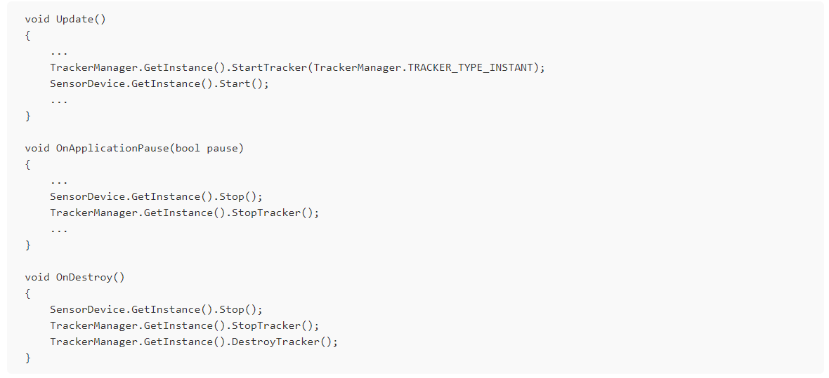

**5.1.5 USING TRACKING INFORMATION**

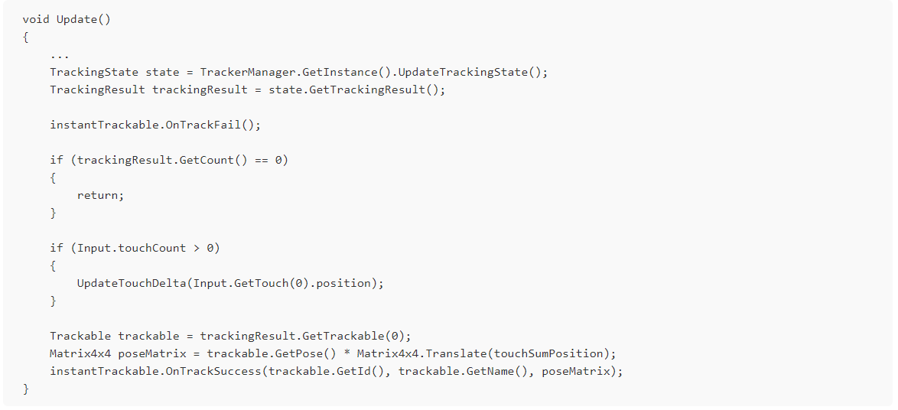

**5.2Tools:**

We used **MAXST** Augmented reality SDK to perform the augmentation.

MAXST AR SDK is an AR engine for developing augmented reality apps. This all-in-one solution has all the features you will ever need when developing augmented reality apps, including six key features of the SDK for recognizing and tracking 2D images and 3D spaces, as well as a cloud server-based image recognition feature.

Features

* Image Tracker  
  The Image Tracker recognizes and tracks planar target images. Videos including transparent ones as well as 3D models and animations can be rendered based on them.
* Marker Tracker

The content can be augmented on markers with regular patterns. MAXST provides 8,192 unique markers.

* Instant Tracker  
  The Instant Tracker finds a planar surface in the camera frame and continues to scan the surroundings. You can place 3D objects in alignment with the surface.
* Visual SLAM  
  The Visual SLAM(Simultaneous Localization and Mapping) creates and saves 3 dimensional maps of target spaces for more exquisite AR project.
* Object Tracker  
  The Object Tracker loads up map files created and saved with Visual SLAM and superimposes AR experiences on them.
* QR/Barcode Scanner  
  The QR/Barcode Scanner recognizes barcodes and QR codes.
* Cloud Recognizer  
  Cloud Recognizer provides cloud-based image recognition features for projects that require large amounts of target images and frequent data updates.

**7.Conclusion:**

We have created a system which users can interact easily without any problems.

The main feature is that user can interact with the augmented object in real time.

Further improvements may include better stability in the tracking system with the advent of SLAM and feature based tracking.

**USE CASE DIAGRAM:**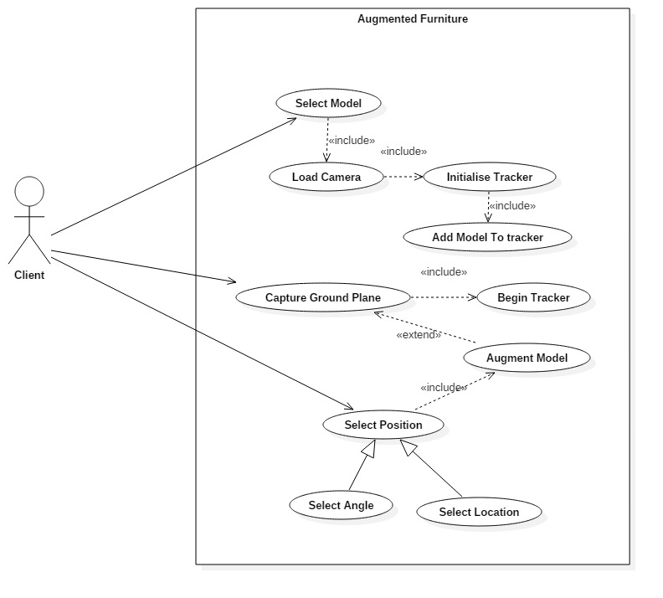

**USE CASE DESCRIPTION:**

|  |  |  |
| --- | --- | --- |
| USE CASE 1 | Select Model | |
| Goal in Context | Model of furniture should be selected | |
| Preconditions | The users knows which model he wants | |
| Success End Condition | The camera opens and user can start to map their ground plane. | |
| Failed End Condition | The Camera doesn’t load | |
| Primary,  Secondary Actors | Client | |
| Trigger | None | |
| DESCRIPTION | Step | Action |
|  | 1 | User scrolls through the list |
|  | 2 | User selects desired model |

|  |  |  |
| --- | --- | --- |
| USE CASE 2 | Load Camera | |
| Goal in Context | The camera must be loaded | |
| Preconditions | The users has selected a model | |
| Success End Condition | The AR camera loads to display the users surroundings | |
| Failed End Condition | AR camera crashes | |
| Primary,  Secondary Actors | None. | |
| Trigger | Select model | |
| DESCRIPTION | Step | Action |
|  | 1 | The AR camera gets necessary permissions from the user |
|  | 2 | The AR camera Loads |
| EXTENSIONS | Step | Included Action |
|  | 2a | Tracker is initialised |
| SUB-VARIATIONS |  | Branching Action |
|  | 1 | The user may decide to change the model |

|  |  |  |
| --- | --- | --- |
| USE CASE 3 | Initialize Tracker | |
| Goal in Context | The Tracker must be initialized to start instant tracking | |
| Preconditions | The AR camera scene has to be loaded | |
| Success End Condition | Tracker is successfully initialized. | |
| Failed End Condition | Model cant be augmented | |
| Primary,  Secondary Actors | None. | |
| Trigger | Loading the AR Camera | |
| DESCRIPTION | Step | Action |
|  | 1 | Finding the instant tracker object. |
|  | 2 | Starting the instant tracker |
|  | 3 | Starting the gyroscope and other sensors |
| EXTENSIONS | Step | Included Action |
|  | 2a | Adding the selected model as a child of the tracker. |

|  |  |  |
| --- | --- | --- |
| USE CASE 4 | Add model to tracker | |
| Goal in Context | The make the model a child of the tracker object to enable augmenting it | |
| Preconditions | Model should be selected. Tracker must be Initialized | |
| Success End Condition | Model is a child of the tracker | |
| Failed End Condition | Model wont be augmented | |
| Primary,  Secondary Actors | None. | |
| Trigger | Tracker is initialized | |
| DESCRIPTION | Step | Action |
|  | 1 | Enable the selected model. |
|  | 2 | Make it a child of the tracker object |
| EXTENSIONS | Step | Branching Action |
|  | 3a | The sliders are initialized to the object to enable rotation |

|  |  |  |
| --- | --- | --- |
| USE CASE 5 | Capture Ground Plane | |
| Goal in Context | The user to capture the ground plane for augmentation | |
| Preconditions | The AR scene must be initialized | |
| Success End Condition | The instant tracking begins | |
| Failed End Condition | Model wont be augmented | |
| Primary | Client | |
| Trigger | purchase request comes in. | |
| DESCRIPTION | Step | Action |
|  | 1 | Find Ground Plane. |
| EXTENSIONS | Step | Included Action |
|  | 1a | Begin Tracking every second |

|  |  |  |
| --- | --- | --- |
| USE CASE 6 | Begin Instant Tracking | |
| Goal in Context | To Track the captured plane at all times | |
| Preconditions | Capture a ground plane | |
| Success End Condition | The Model will be successfully placed on the ground | |
| Failed End Condition | Model may float in space or may not be displayed | |
| Primary,  Secondary Actors | None. | |
| Trigger | Ground plane is captured | |
| DESCRIPTION | Step | Action |
|  | 1 | Capture Tracking state at each instant |
|  | 2 | Update camera background at each instant |
| EXTENSIONS | Step | Included Action |
|  | 2a | Augment the model |

|  |  |  |
| --- | --- | --- |
| USE CASE 7 | Augment Model | |
| Goal in Context | Model should be augmented in space | |
| Preconditions | Begin instant Tracking | |
| Success End Condition | Model will be augmented in space | |
| Failed End Condition | Model may float in space or may not be displayed | |
| Primary,  Secondary Actors | None. | |
| Trigger | Capture Ground plane | |
| DESCRIPTION | Step | Action |
|  | 1 | Position of the model is determined by the use. |
|  | 2 | Calculate position matrix based on real world info. |
|  | 3 | Place the model on the position |

|  |  |  |
| --- | --- | --- |
| USE CASE 8 | Get Position | |
| Goal in Context | Location of model where it has to be placed is determined | |
| Preconditions | Model is augmented and instant tracking has begun | |
| Success End Condition | Model is moved to that position | |
| Failed End Condition | Model remains stuck in that position | |
| Primary,  Secondary Actors | Client | |
| Trigger | Client touches the screen | |
| DESCRIPTION | Step | Action |
|  | 1 | Save initial position when model is augmented |
|  | 2 | Calculate position of touch with respect to initial position. |
|  | 3 | Place model at calculated position. |
| EXTENSIONS | Step | Included Action |
|  | 2a | Model is augmented at that postion. |

|  |  |  |
| --- | --- | --- |
| USE CASE 9 | Get Angle | |
| Goal in Context | To rotate the model in space. | |
| Preconditions | Sliders are assigned to the augmented models | |
| Success End Condition | Model is rotated In space | |
| Failed End Condition | Model remains stuck in space | |
| Primary,  Secondary Actors | Client | |
| Trigger | Client adjusts the sliders | |
| DESCRIPTION | Step | Action |
|  | 1 | Sliders are adjusted. |
|  | 2 | Values of the sliders are assigned to the models transform angles. |
| EXTENSIONS | Step | Included Action |
|  | 2a | Model is augmented |

**CLASS DIAGRAM:**

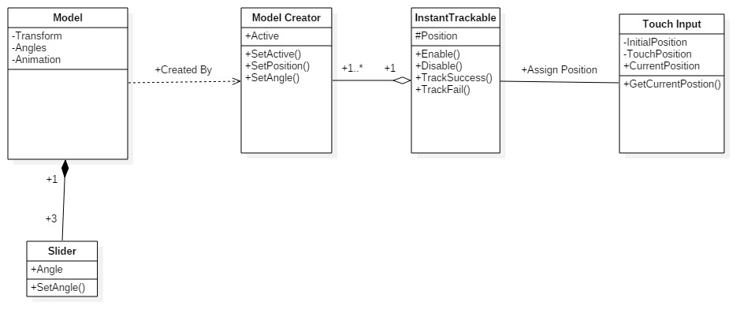

**SEQUENCE DIAGRAM:**

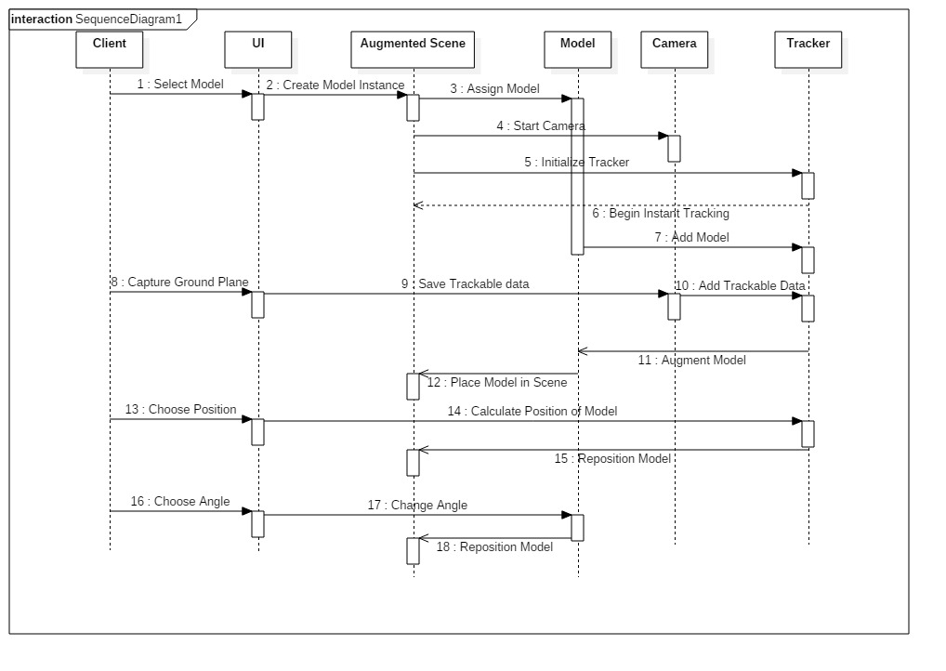

**ACTIVITY DIAGRAM:**

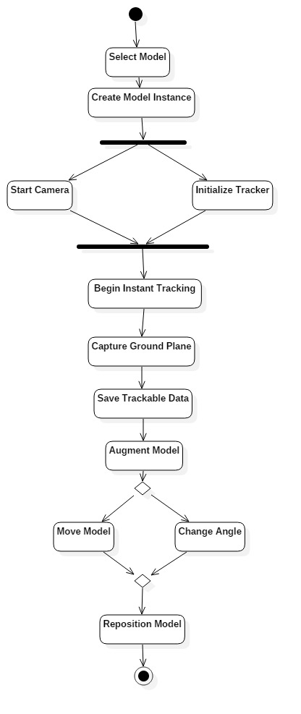

**STATE DIAGRAM:**

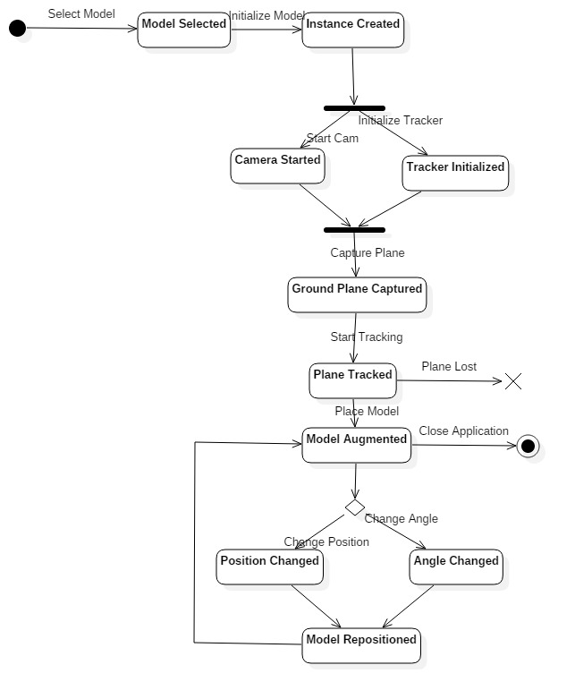

**UI:**

