Volume and pka influence on compound penetration through the constriction zone of OmpF porin

Aleksandra Olshanova and Dina Khasanova

Introduction

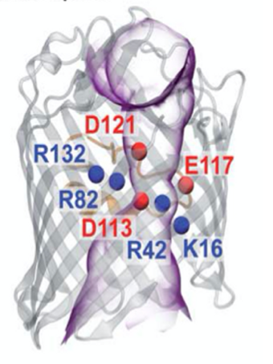Gram-negative bacteria pose significant challenges in healthcare, agriculture, and environmental health due to its remarkable ability to develop resistance against multiple antibiotics. The complex gram-negative membrane architecture acts as a formidable barrier to the accumulation of compounds within bacterial cells, leading to a decrease in their effectiveness [1]. One way that Gram-negative bacteria can become more permeable is through the action of specific proteins known as porins. Porins are channels that span the outer membrane and allow certain molecules to pass through [2]. The structure of outer membrane protein F (OmpF) from Escherichia Coli is illustrated in **Figure 1.**

**Figure 1.** OmpF channel [2].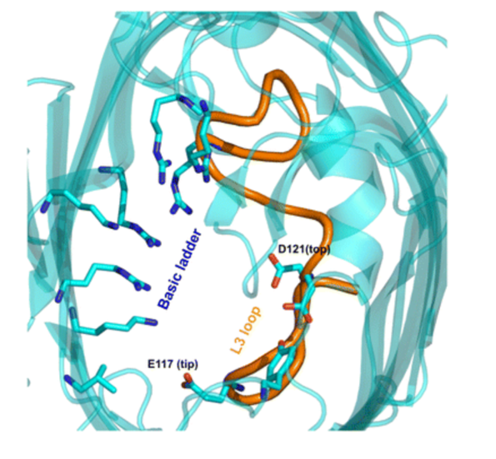

Statement of problem

There is a narrow region inside the porin channel which has an electrostatic field formed by the acidic residues present in L3 loop, and a cluster of basic residues on the opposite side of the pore (**Figure 2**). This field assumes a significant role in determining the selectivity of permeating molecules based on their size and charge [3].

**Figure 2**. Constriction zone of OmpF porin [4].

Objective of the project

The main focus of this project is to calculate and examine the properties of compounds that influence their ability to penetrate the narrow region of OmpF porin. Since the electrostatic field within the constriction zone plays a crucial role in penetration, particular emphasis will be placed on charge-related properties including pKa. Moreover, the size of the molecule appears to have a significant impact on permeation, making volume calculations a crucial aspect of the project.

Materials and methods

The dataset used in this study was obtained from Richter, M., Drown, B., Riley, A. et al. and can be found in their publication titled “Predictive compound accumulation rules yield a broad-spectrum antibiotic” in Nature (2017). (<https://doi.org/10.1038/nature22308>) [5].

1. Volume calculations

*Structures preparation*

For all volume calculations, the optimized 3D structures were used. Initial structure preparation and 3D minimization was performed with LigPrep (Schrödinger, USA ) using OPLS_2005 force fields. Protonation states were determined using Epik at pH 7.4. Docking was performed using Standard-Precision (SP) Glide with default settings [6].

Initially, the docking algorithm generated between 13 to 15 conformations for each compound. These conformations exhibit diverse positions within the channel. In this particular project, the choice of a conformation for volume calculations is predicated on its location within the narrow region of a porin channel (suitable pose was chosen manually). The **Figure 3** illustrates the location of 2-6 compound inside the channel.

**Figure 3.** The location of 2-6 compound inside

the channel.

*Computational details for volume calculations*

The density functional theory (DFT) computations were performed using Gaussian 16. For DFT calculations, a 6-31+G(d,p) basis set with diffuse and polarization functions on all atoms in combination with an ultrafine grid was employed. The influence of the DFT functional was tested by comparing results obtained with M06-2X and B3LYP.

Ten separate volume calculations were conducted for each compound. Subsequently, the resulting values were used to determine the mean, minimum, maximum, and standard deviation.

All calculation analysis were performed by Python script (attached to Supplementary).

1. pKa calculations

*Structures preparation*

For all pka calculations, the structures were not optimized. Input files were generated from SMILES string.

*Computational details for pka calculations*

The density functional theory (DFT) computations were performed using Gaussian 16. For DFT calculations, a 6-31+G(d,p) basis set with diffuse and polarization functions on all atoms in combination with an ultrafine grid was employed. The M06-2X DFT functional in combination with SMD (Solvent = Water) was selected for the computation of the pKa since it offered the best combination of accuracy, reliability, and cost [7].

All calculation analysis were performed by Python script (attached to Supplementary).

Volume

Investigated structures

As part of the project, the relationships between the permeability coefficient and the volume of molecules were investigated. A total of 12 molecules were considered, listed below (**Fig**. ), from the initial dataset. These molecules were chosen to cover a spectrum of permeability coefficient values, ranging from the lowest to the highest. To distinguish between the volumes of the molecules, a visual approach was implemented.



**Fig.** Structures of molecules for volume calculations

Results and Discussion

Volume calculation

After acquiring the resulting values, two distinct plots were generated to gain insights into the relationship between the permeability coefficient and molecule volume (**Fig.** ).

The first graph demonstrates the correlation between **the mean value** of molecule volume after 10 independent iterations and the permeability coefficient. Meanwhile, the second picture utilizes the box plot method to visually represent the distribution of numerical volume values for each compound, ranging from **the minimum to the maximum**. This allows for a clear visualization of the variations in volume scores among compounds with different permeability coefficients.

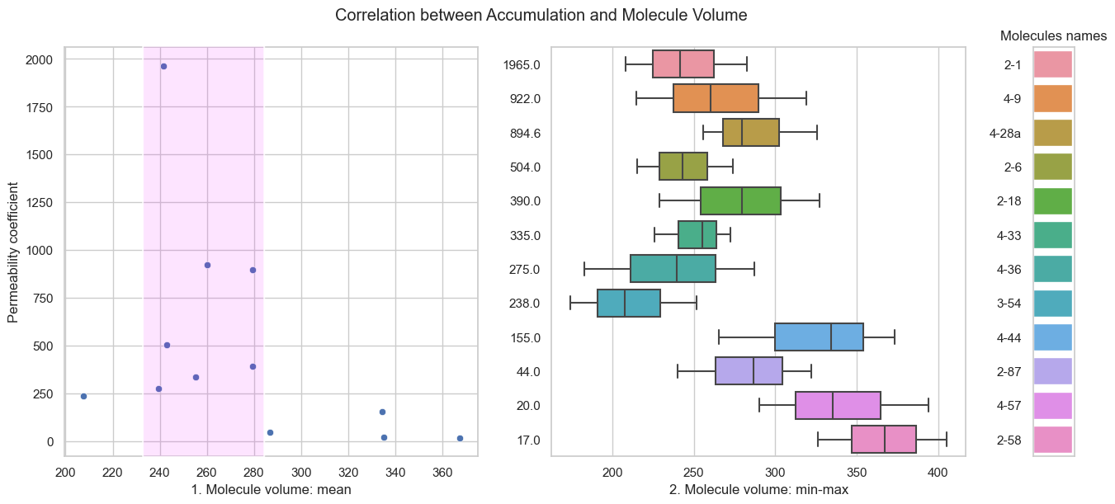

**Fig. 1**: Correlation between permeability coefficient and molecule volume (mean); **2**: Correlation between permeability coefficient and the distribution of numerical volume values for each compound.

Based on the obtained plots, it is evident that the volume of a molecule has a significant influence on the permeability coefficient. As the molecule volume increases, there is a clear trend of decreasing permeability coefficient (**Fig**.). However, it is important to note that the dataset used in this project is relatively small, which limits the certainty of any conclusions drawn.

Additionally, there is a noticeable pattern indicating that smaller molecules tend to have lower permeability coefficients (**Fig.** ). This can be attributed to their inability to interact with crucial residues in the narrow region of the channel. According to the literature, these residues play a vital role in compound interactions and enhance permeation [].

As a result, to successfully permeate through the channel, a compound should have a volume range of 240 to 280 cm3/mol.

To establish a reliable volume value for permeation, it is essential to conduct multiple calculations. In this case, running 10 independent calculations for each molecule was necessary due to the observed differences between the minimum and maximum values (**Fig**. ). Despite these variations, the second plot still exhibits a correlation between the permeability coefficient and molecule volume.

The influence of the DFT functional

After recognizing the impact of volume on the permeability coefficient, the subsequent part of the project was focused towards exploring the influence of the DFT functional on volume calculations. Numerous studies have investigated the performance of MO6-2X and B3LYP in various scientific fields, and following their suggestion the MO6-2X functional seems better. The decision was made to carry out a similar experiment using a limited dataset (5 molecules) in order to either confirm or disprove the hypothesis on the volume calculation.

The volume was calculated by using a 6-31+G(d,p) basis set with the MO6-2X and B3LYP functionals for the same set of molecules (**Fig**. ) with 10 independent iterations per compound. The box plot method was used to show the distribution of numerical volume values for both functionals.

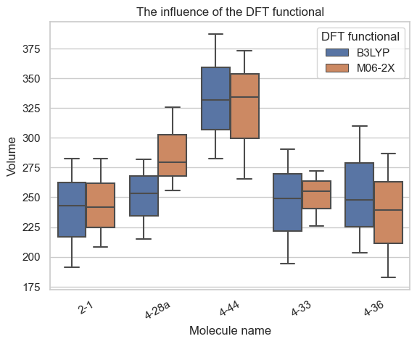 

**Fig**. The influence of the DFT functional on volume calculations

Based on the data presented in the plot (Fig. ), it is clear that these two DFT functionals yielded different results when used for volume calculations on the selected molecules. Although there is no apparent trend in the mean value behavior of these functionals, a correlation between different molecules is still noticeable.

The box plot variability is considered less for the MO6-2X functional that might be better for obtaining more precise results. The reason might be related to the point that the M06-2X ranks highly-substituted isomers as more stable than B3LYP does, and ranks linear isomers quite low in relative stability compared to B3LYP [https://faculty.tru.ca/nmora/ctc-PFOS%20Stability%20Comparison.pdf ]. The most significant difference was noticed in the case of the 4-28a molecule. This particular compound has a higher number of substituents compared to the other molecules, which could potentially lead to the higher volume value of MO6-2X in this specific case.

pKa calculations

Next part of the project was focused on pKa calculation for set () of molecules.

Picture!

The implemented approach for calculations uses an isodesmic reaction where the pKa value is computed relative to a chemically related reference compound for which the pKa value has been measured experimentally. In this project, the reference reaction employed involves the dissociation of ammonium into ammonia and a proton, which exhibits a pKa value of 9.24. [Bjerrum, J., et al. Stability Constants, Chemical Society, London, 1958.]. In other words, the free energy of the reaction was estimated according to the reaction

HA(water) + NH3(water)– ⇌ A-(water) + NH4+(water) [], (1)

[[10.1021/acs.jpca.0c08283](https://doi.org/10.1021%2Facs.jpca.0c08283)]

where HA explored molecules, A– their conjugate bases, and H+ is the proton in water.

The used isodesmic method allowed the simple calculations and satisfactory results without the need to consider proton free energy. Below, there is a derivation of final formula for determining the pKa of a compound that doesn't rely on the solvated proton's free energy.

HA(water)  ⇌ H+(water)  + A- (water)  (ΔGr1)

NH3(water)  +H+(water)  ⇌ NH4+ (water) (ΔGr2)

Gibbs energy of the above reactions can be calculated by their corresponding equation:

ΔGr1 = ΔGA- + ΔGH+ - ΔGHA = pKaRTln10

ΔGr2 = ΔGNH4+ - ΔGNH3 - ΔGH+ = pKa(NH4+/NH3) RTln10

The Gibbs energy for the isodesmic reaction (1) can be calculated as a sum of ΔGr1 and ΔGr2.

ΔGsum = ΔGr1 + ΔGr2 = ΔGA- - ΔGHA + ΔGNH4+ - ΔGNH3 , (2)

where ΔGA-, ΔGHA, ΔGNH4+, ΔGNH3 will be found after Gaussian calculations.

At the same time,

ΔGsum = ΔGr1 + ΔGr2 = pKaRTln10 + pKa(NH4+/NH3) RTln10,

which leads to the final formula below:

pKa =  - pKa(NH4+/NH3),

where **R**is the gas constant, **T** is the temperature, **pKa(NH4+/NH3)** = 9.24 calculated experimentally, **ΔGsum** is obtained from the equation (2).

References

1. Zgurskaya H.I. et al. Permeability barrier of Gram-Negative cell envelopes and approaches to bypass it. ACS Infectious Diseases. **2015**. 1(11). P. 512-522.
2. Haloi N. et al. Rationalizing the generation of broad-spectrum antibiotics with the addition of a positive charge. Chemical Science. **2021**. 12. P. 15028-15044.
3. Brigitte K. Z., Benoît R. The Binding of Antibiotics in OmpF Porin. Structure. **2013**. 21(1). P. 76-87.
4. Milenkovic St. et. al. How physical properties of bacterial porins match environmental conditions. Physical Chemistry Chemical Physics. **2023**. 25.
5. Richter M. et al. Predictive compound accumulation rules yield a broad-spectrum antibiotic. Nature. **2017**. 545. P.  299–304.
6. Schrödinger Release 2022-3: Maestro, Schrödinger, LLC, New York, NY, **2021**.
7. Busch M. How to predict the p*K*a of any compound in any solvent. ACS Omega. **2022**. *7* (20). P. 17369-17383.