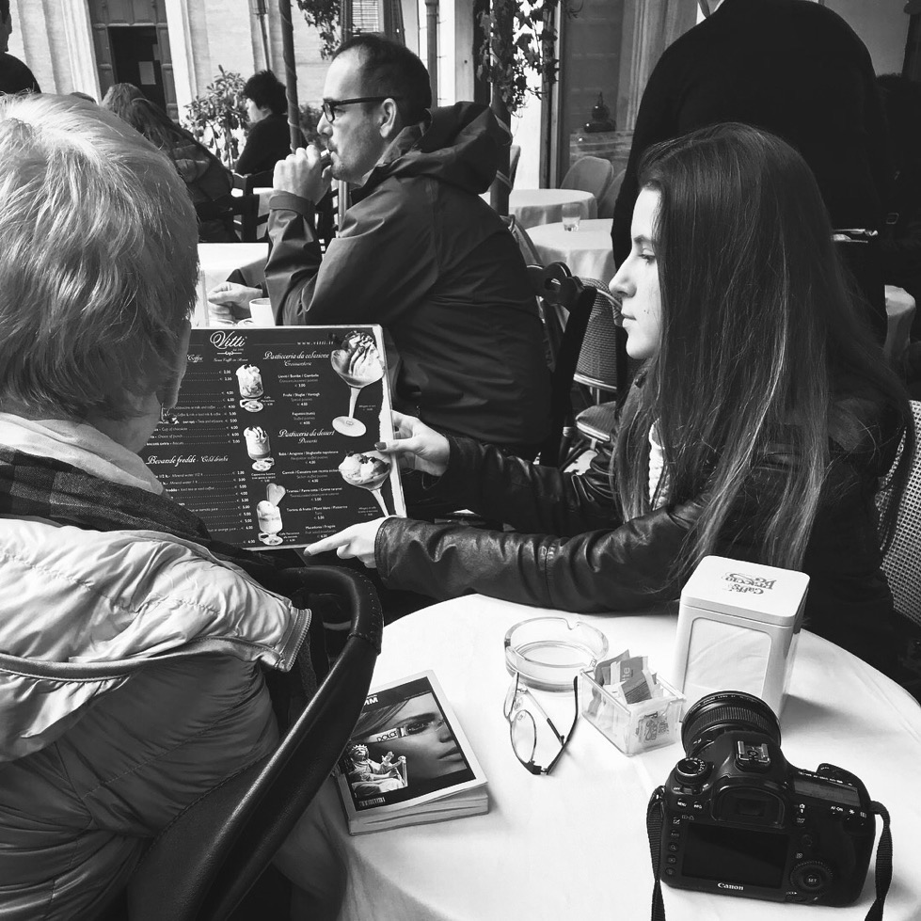

Sasha | 123 | sasha@lolmail.ru

# About me

I Love Coding

# Work Experience

**Moscow Bulochka Inc** *2020–2024*Eating bulochki and making shutochki

**Chinese food Inc** *2025–2026*Eating noodles and fried milk

# **My Skills**

* Eating
* Cooking
* Joking