TASK 2.2

1. Familiar with AWS Free Tier
2. Register AWS
3. I got acquainted tutorias
4. Launch a Linux Virtual Machine with Amazon Lightsail
5. Launch EC2 Linux Virtual Machine with CentOS

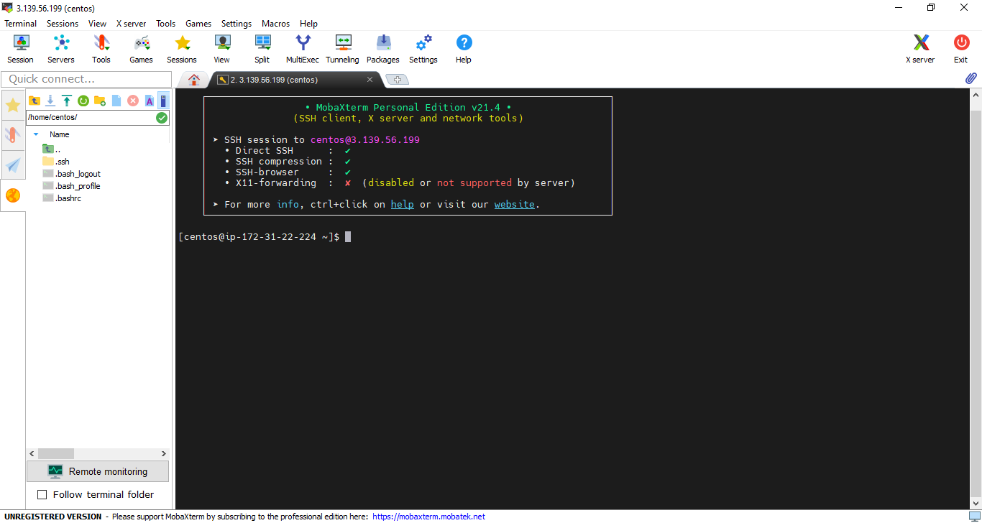

6. Create a snapshot of your instance to keep as a backup 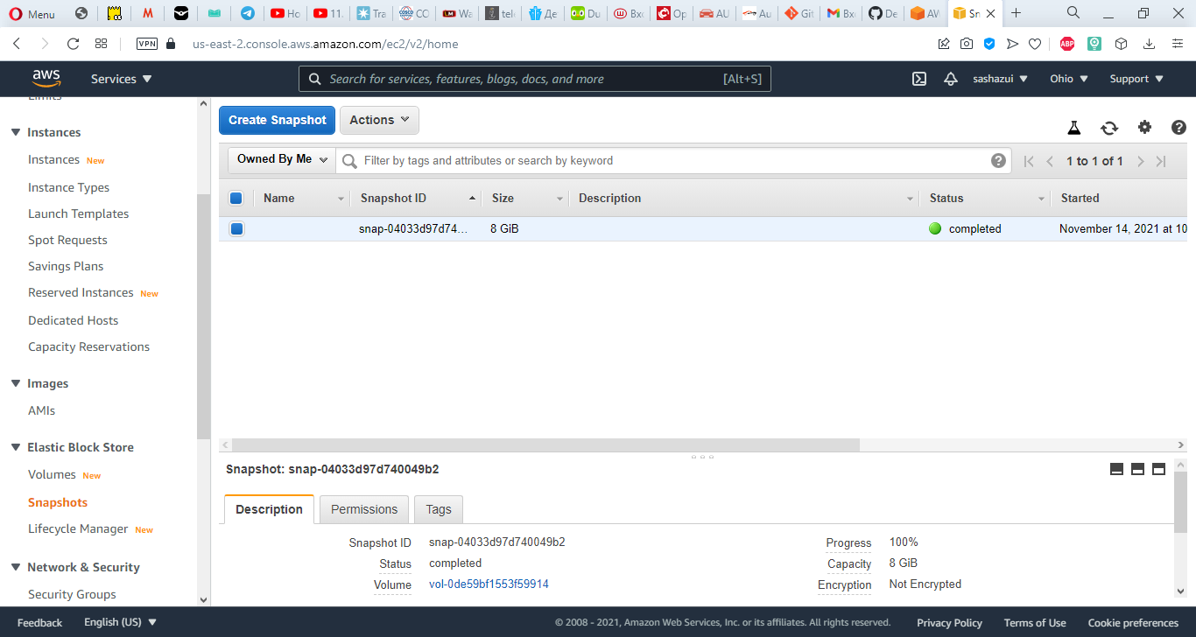

7. Create and attach a Disk_D (EBS), and add file to Disk_D

8. Launch instance from backup

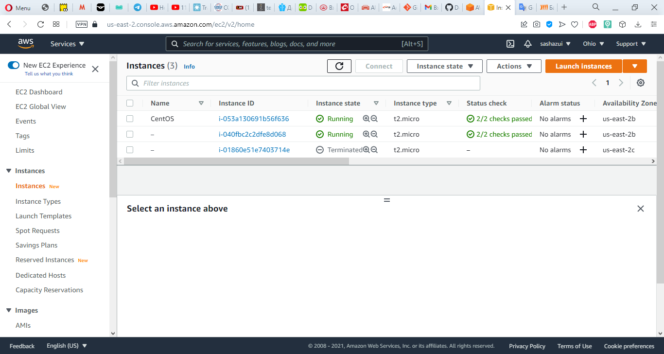

9. Detach Disk_D from the 2nd instance and attach disk_D to the new instance. 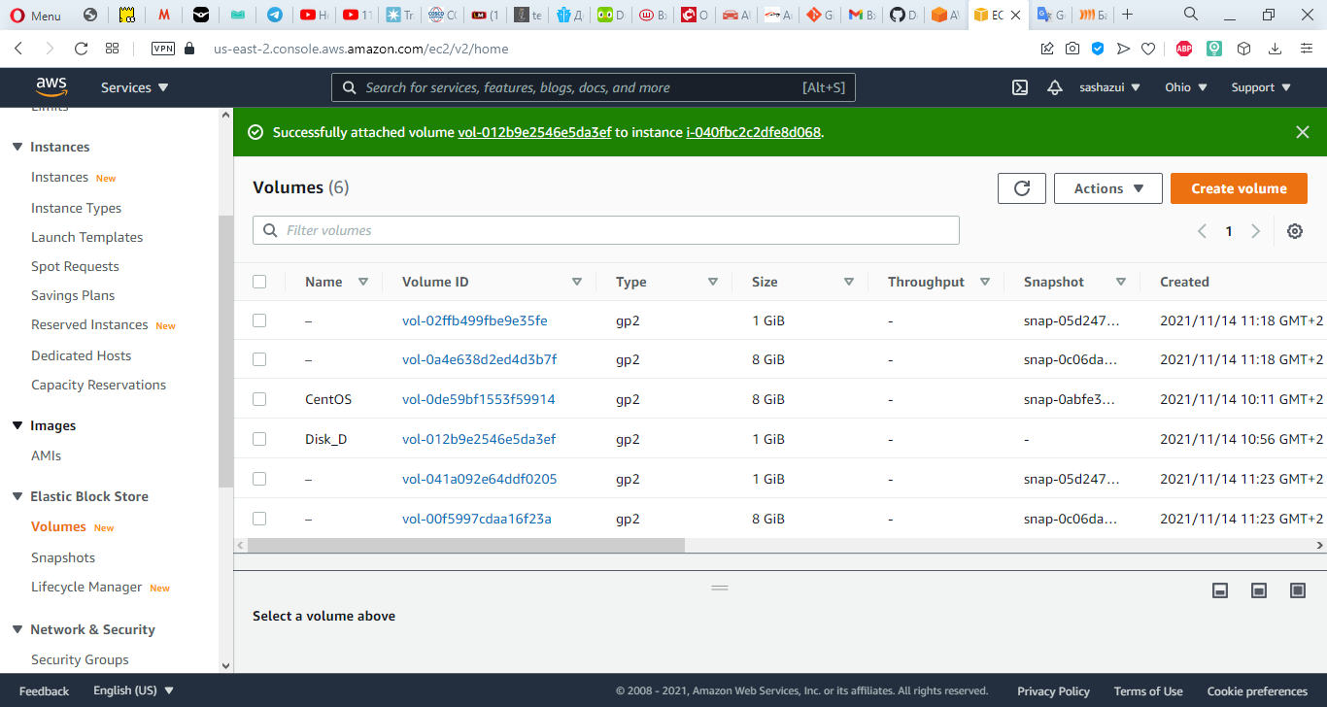

10. Launch and configure a WordPress instance with Amazon Lightsail

11. Create Amazon Simple Storage Solution (S3)

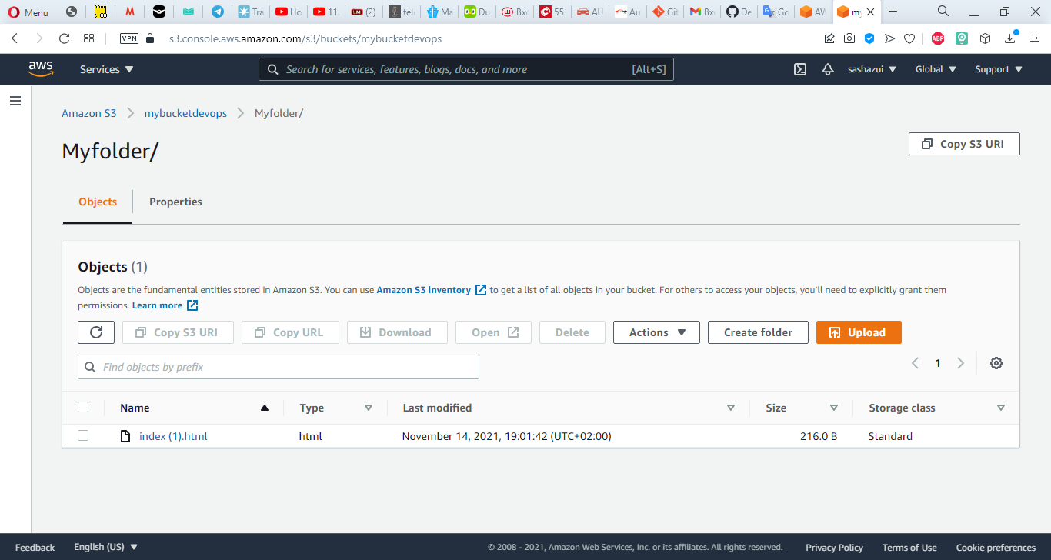

12. Create a user AWS IAM, configure CLI AWS and upload any files to S3

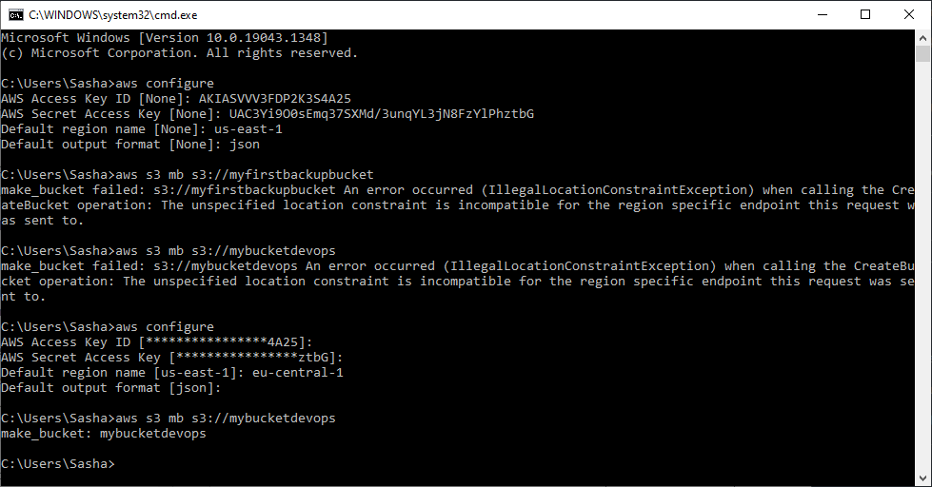

13. Explore the possibilities of creating your own domain and domain name for your site

14. Deploy Docker Containers on Amazon Elastic Container Service (Amazon ECS). Repeat, create a cluster, and run the online demo application or better other application with custom settings.

15. Create a static website on Amazon S3, publicly available (link1 or link2 - using a custom domain registered with Route 53).