Laundry Modifications

In below screen we have added fields to add delivery date and address

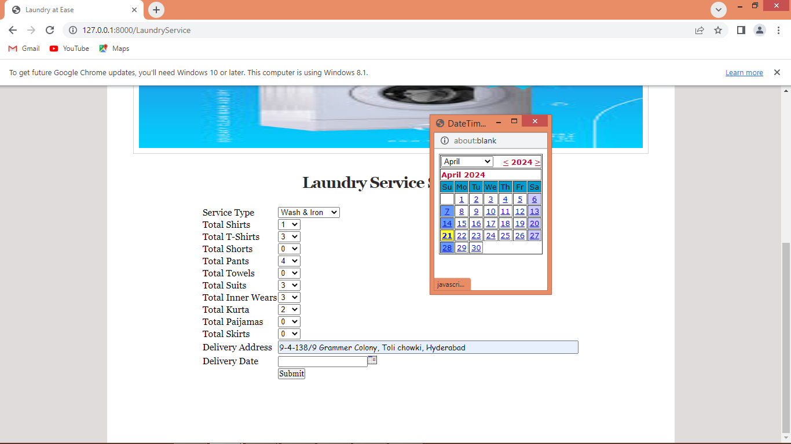

In above screen user will enter laundry details and then enter address and select delivery date and then will get below page to upload image

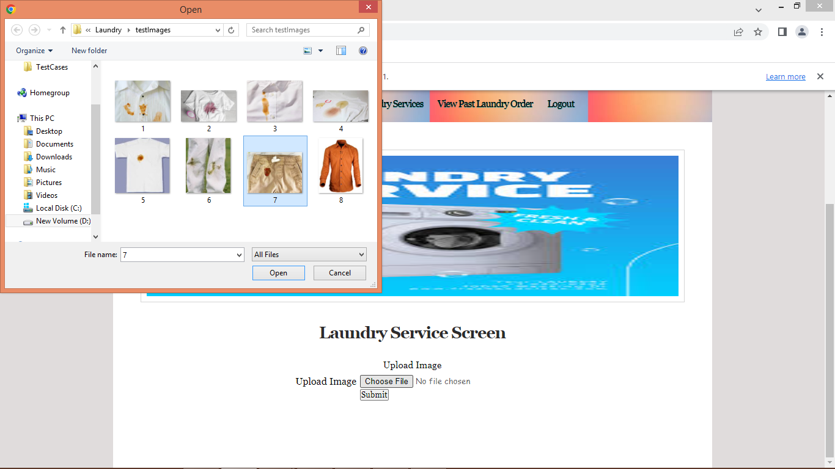

In above screen uploading image and then press submit button to get below output

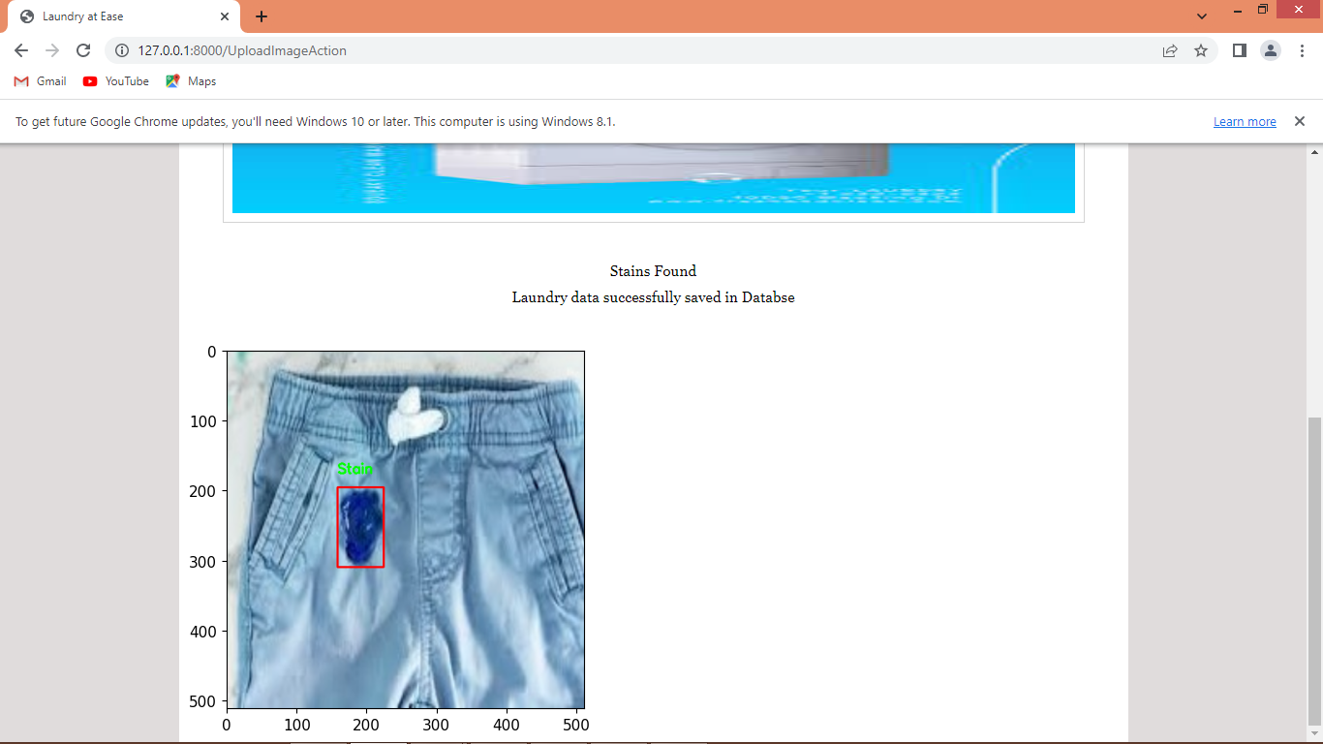

In above screen laundry order successfully saved in database and now admin will login and view and deliver order

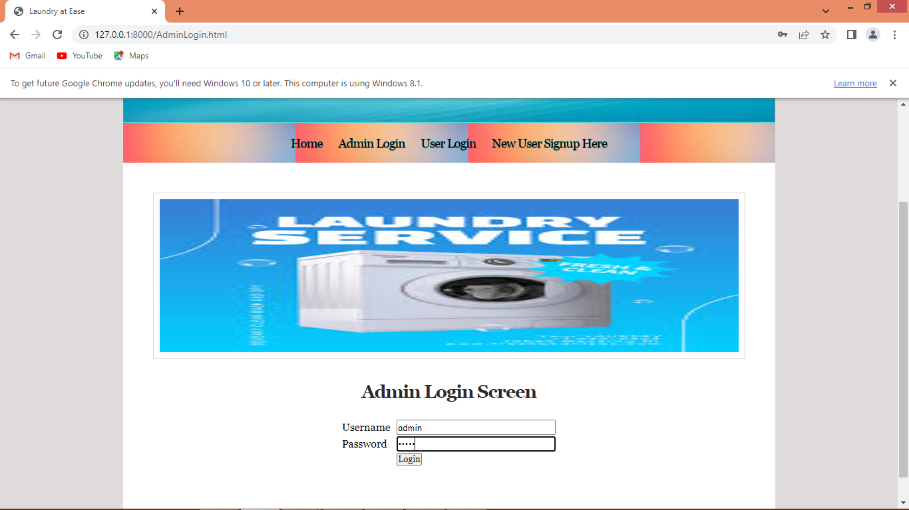

In above screen admin is login and after login will get below page

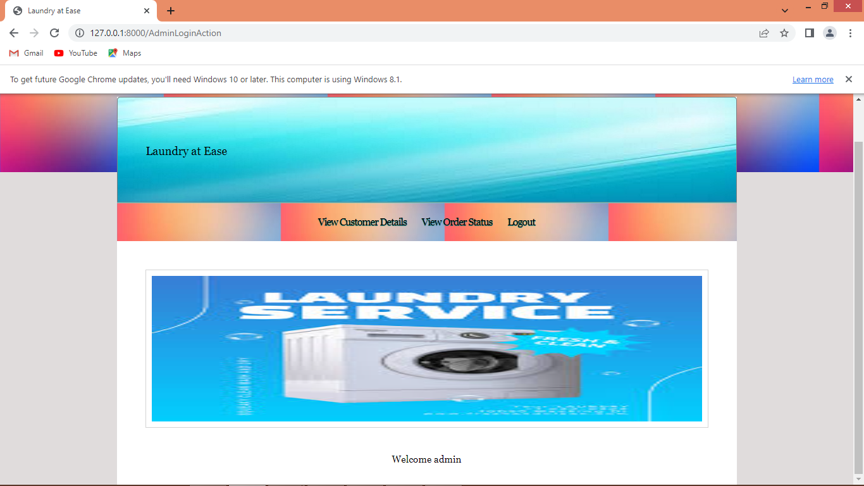

In above screen admin will click on ‘View Customers’ link to view details like below screen

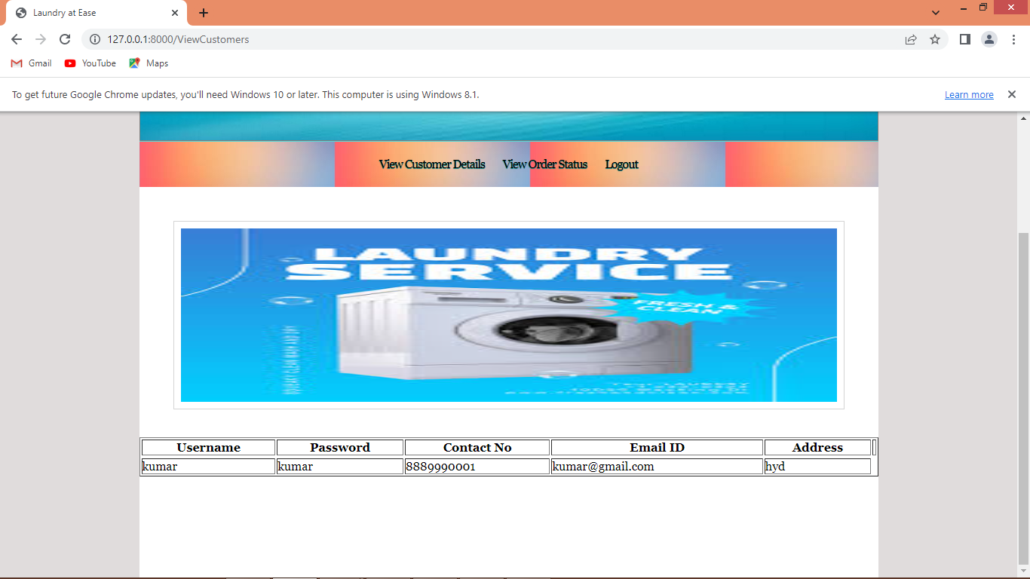

In above screen admin can view all customer’s details and now click on ‘View Order Status’ link to get below page

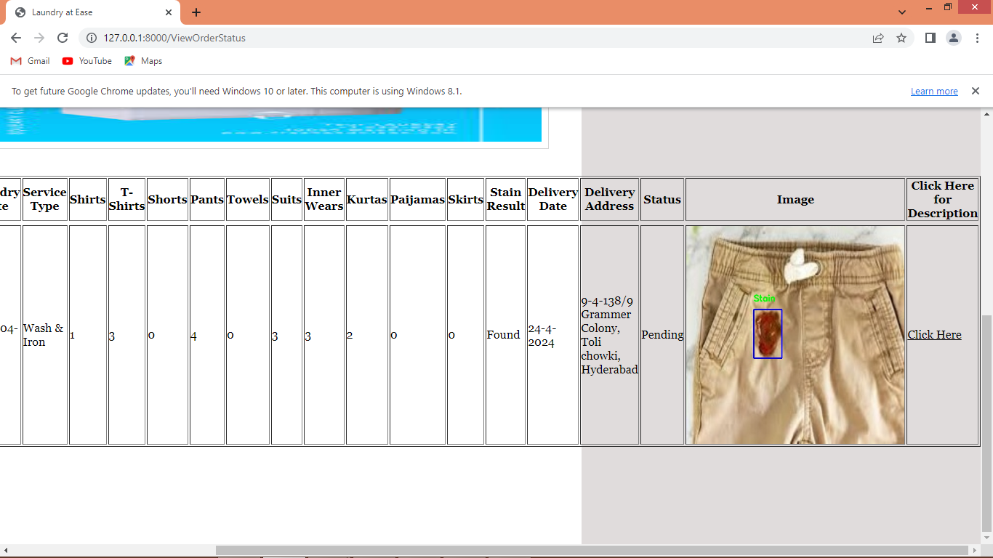

In above screen admin will view all order details and once order completed then admin will click on ‘Click Here’ link to write description and deliver order

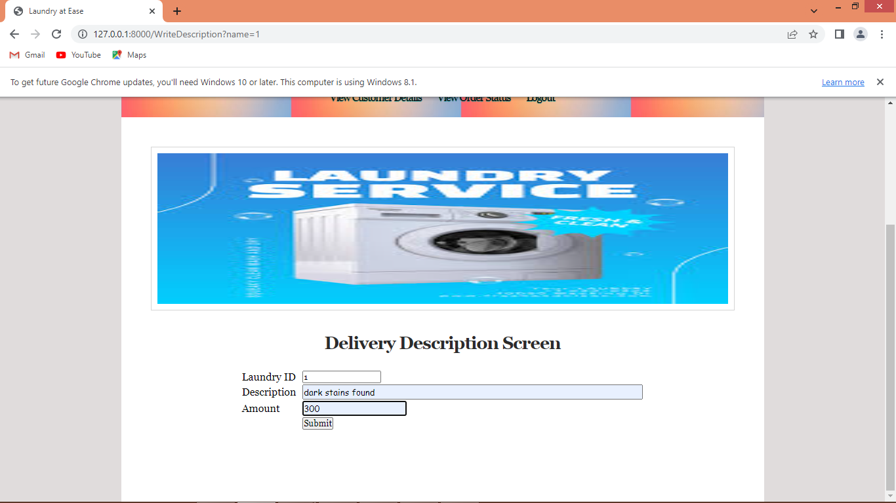

In above screen admin will write some description and then press button to complete order and once order complete then ‘Click Here’ option will be disabled

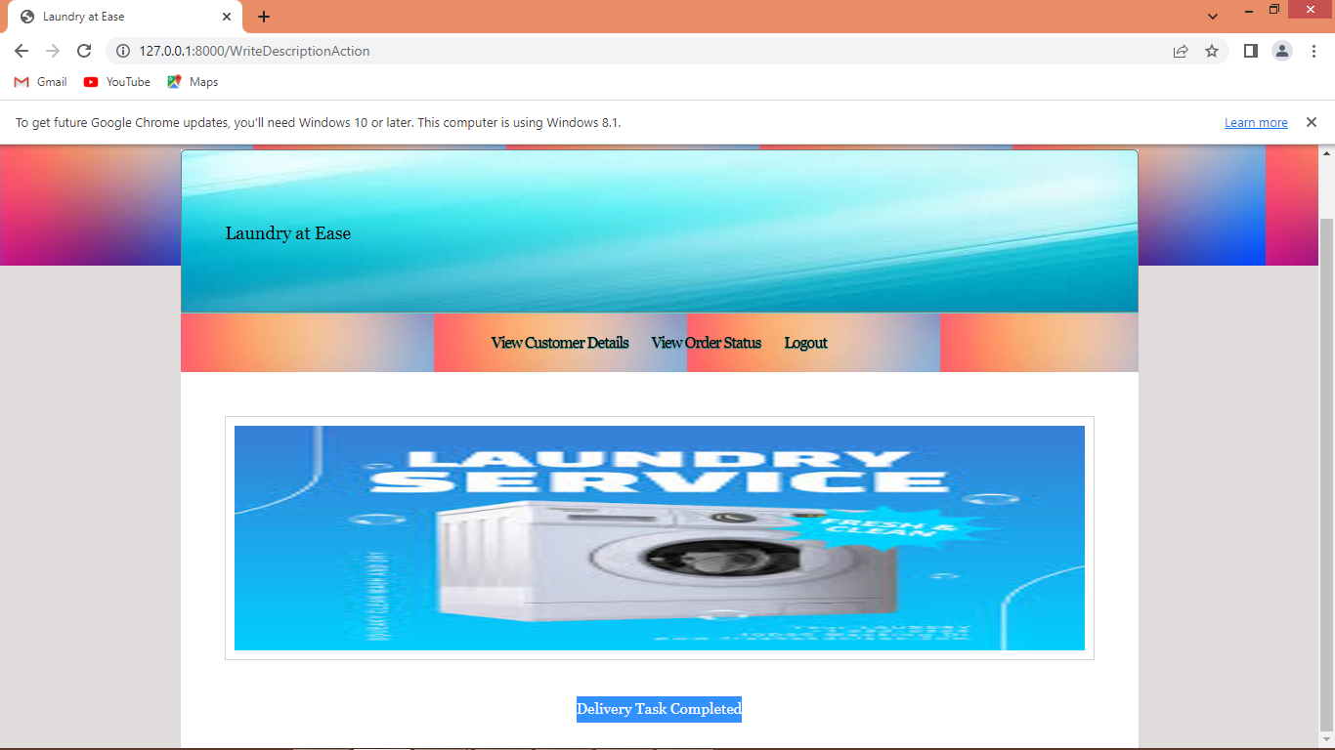

In above screen can see delivery task completed.

So in above screens we have completed all the modifications given by you