Laundry at Ease

In this project as per your requirement we have designed following modules

1. User Sign up: using this module user can sign up with the application
2. User Login: using this module user can login to system
3. YOLO Performance Graph: using this module we can visualize YOLO performance graph contains metrics like loss and precision
4. Laundry Services: using this module user will input all laundry details along with image. If your using any other mode except wash then you can upload without stain images or any other image
5. View Past Laundry Order: using this module user can view all his past orders details.

SCREEN SHOTS

To run project double click on run.bat file to start python server and get below page

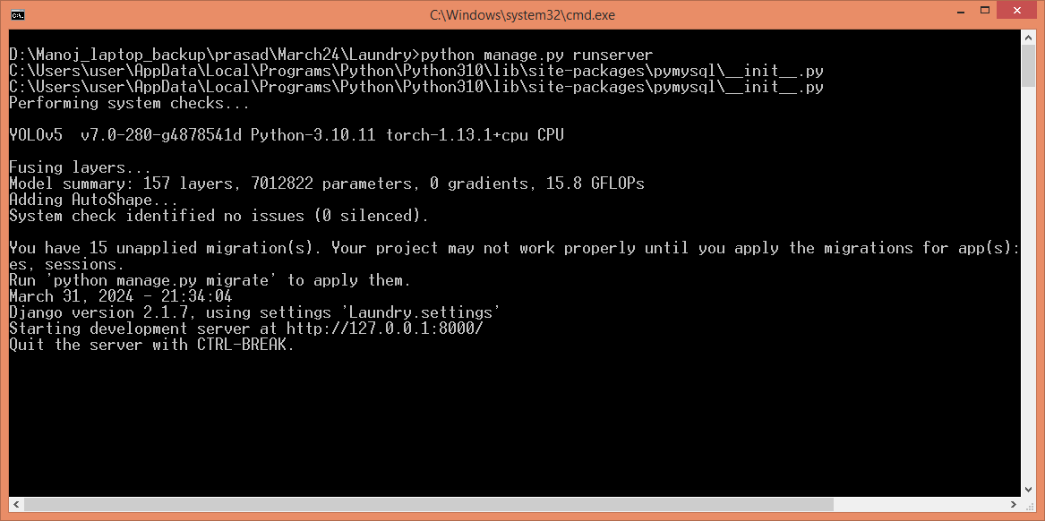

In above screen python server started and now open browser and enter URL as <http://127.0.0.1:8000/index.html> and press enter key to get below page

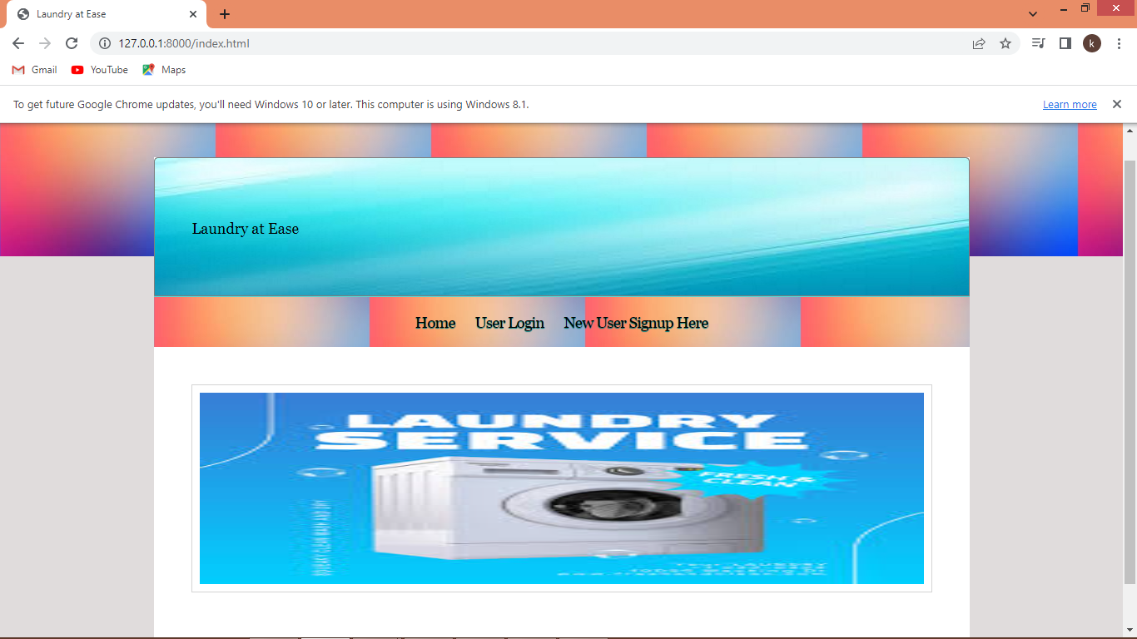

In above screen click on ‘New User Sign up’ link to get below page

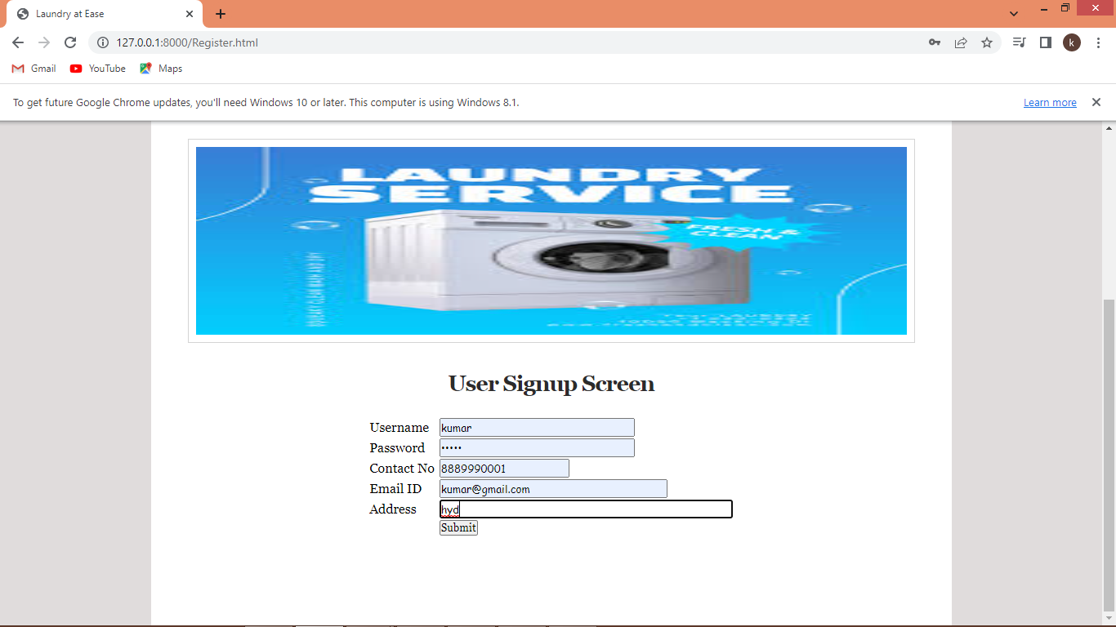

In above screen user entering sign up details and then press button to get below page

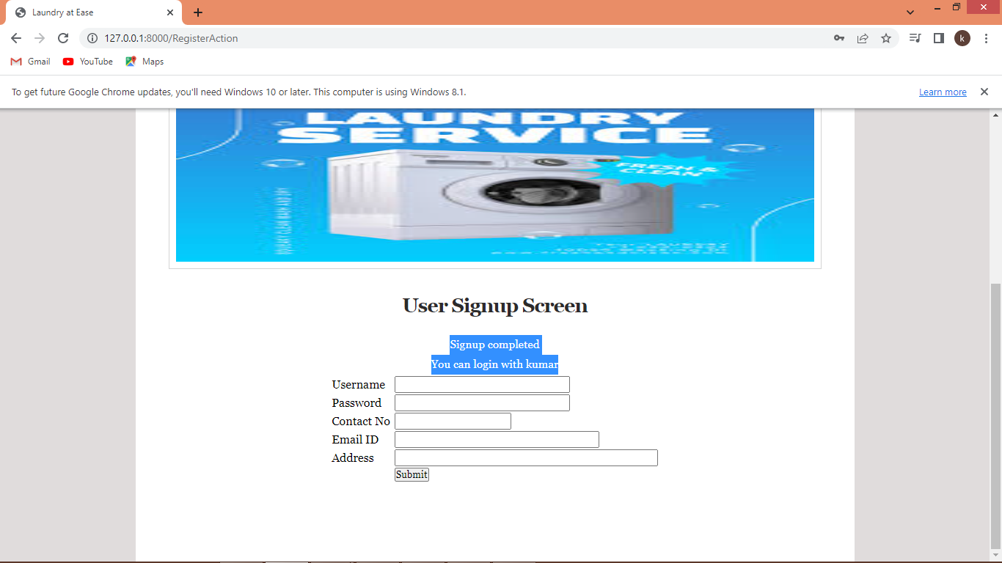

In above screen sign up completed and now click on ‘User Login’ link to get below page

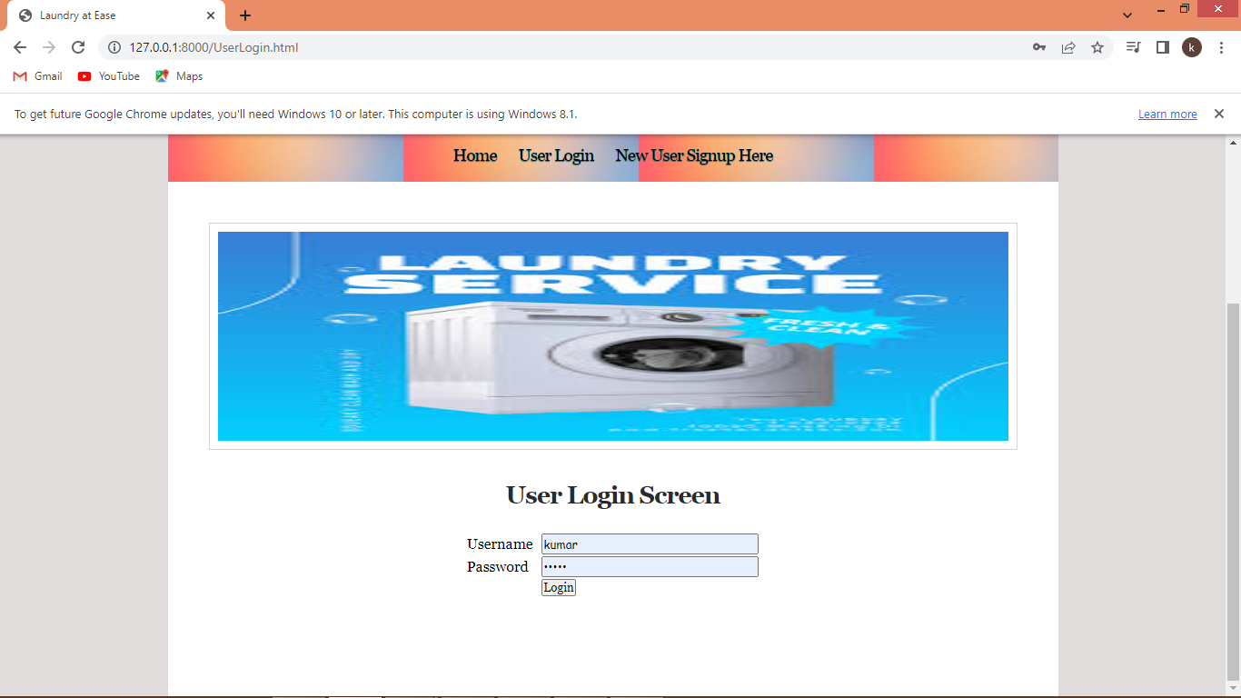

In above screen user is login and after login will get below page

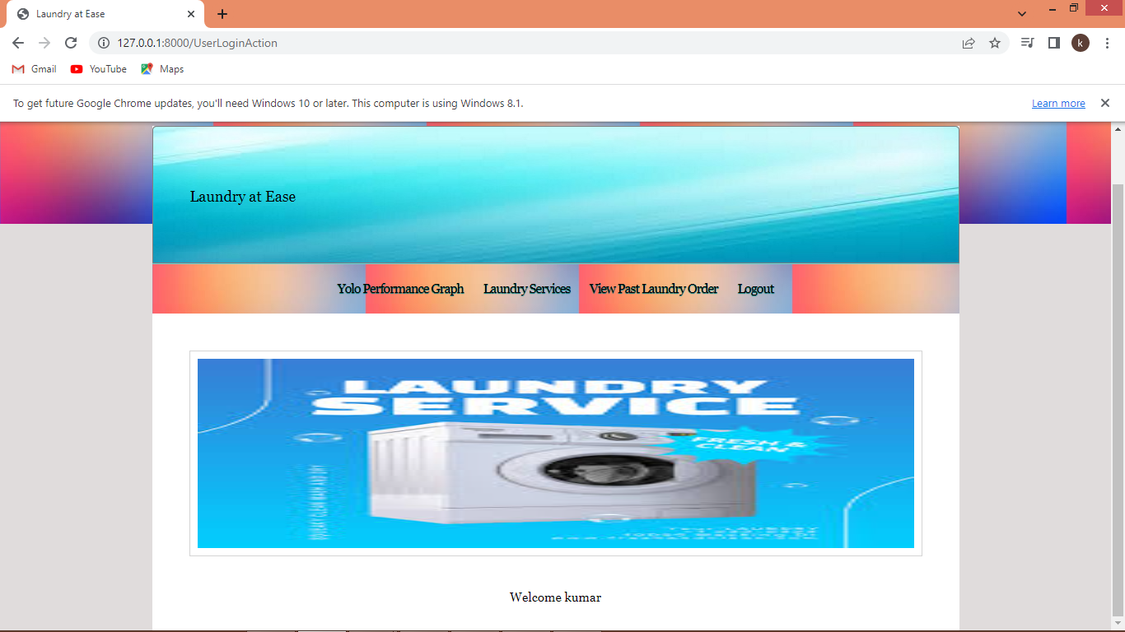

In above screen click on ‘YOLO performance Graph’ link to get below graph

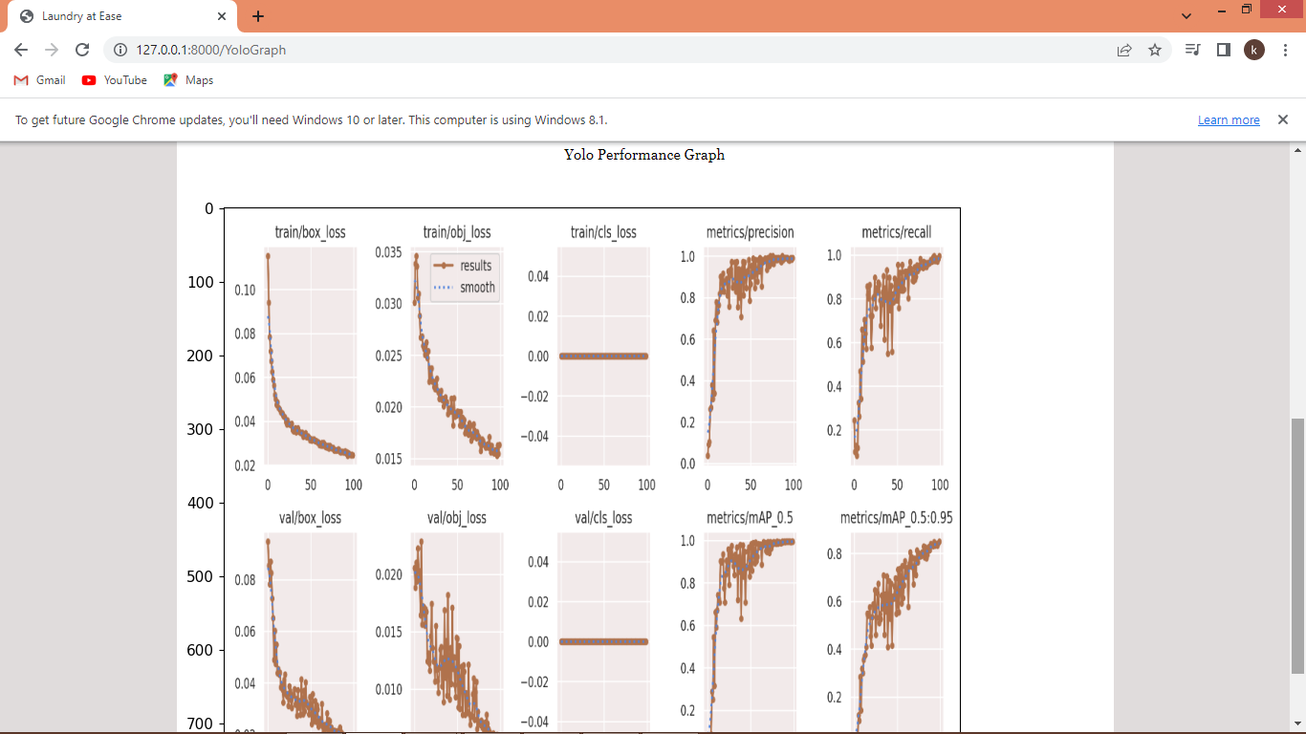

In above graph can see YOLO training loss and precision graph and now click on ‘Laundry Services’ link to get below page

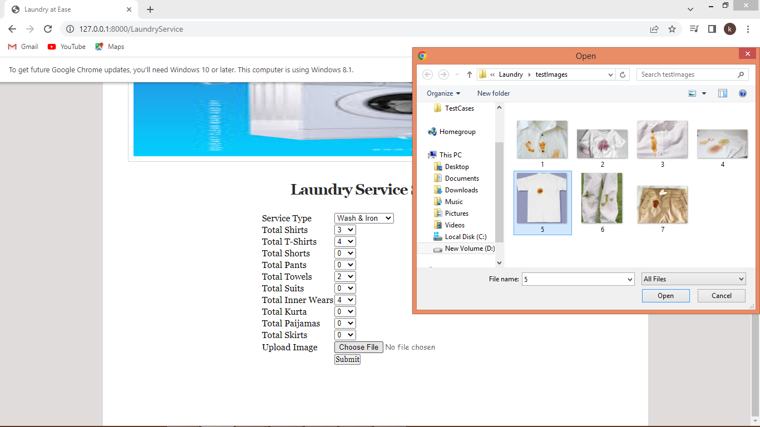

In above screen you can select service type and then select quantity of each laundry item and then select image and then click on ‘Open’ and ‘Submit’ button to get below page

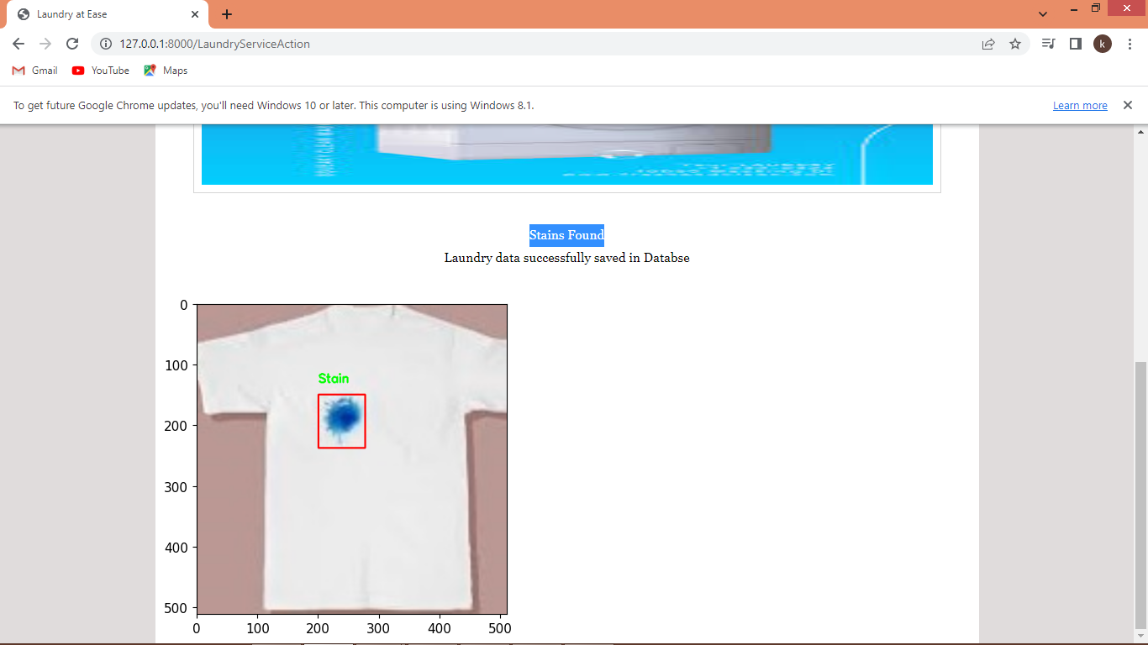

In above screen from uploaded image stain is found and then showing in bounding boxes and similarly you can upload and test other laundry images

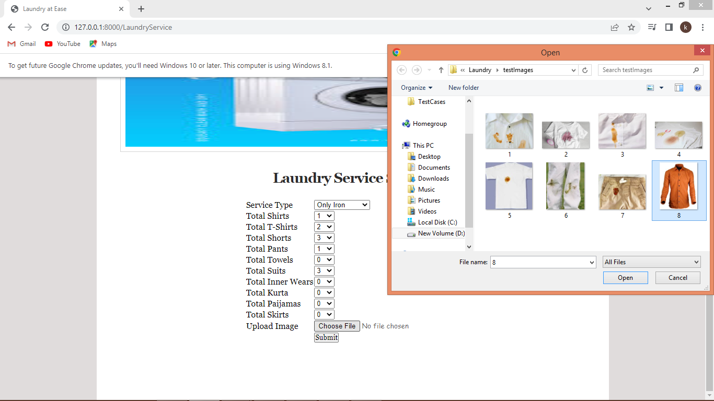

In above screen giving laundry for iron only and then uploading image without any stains and press button to get below page

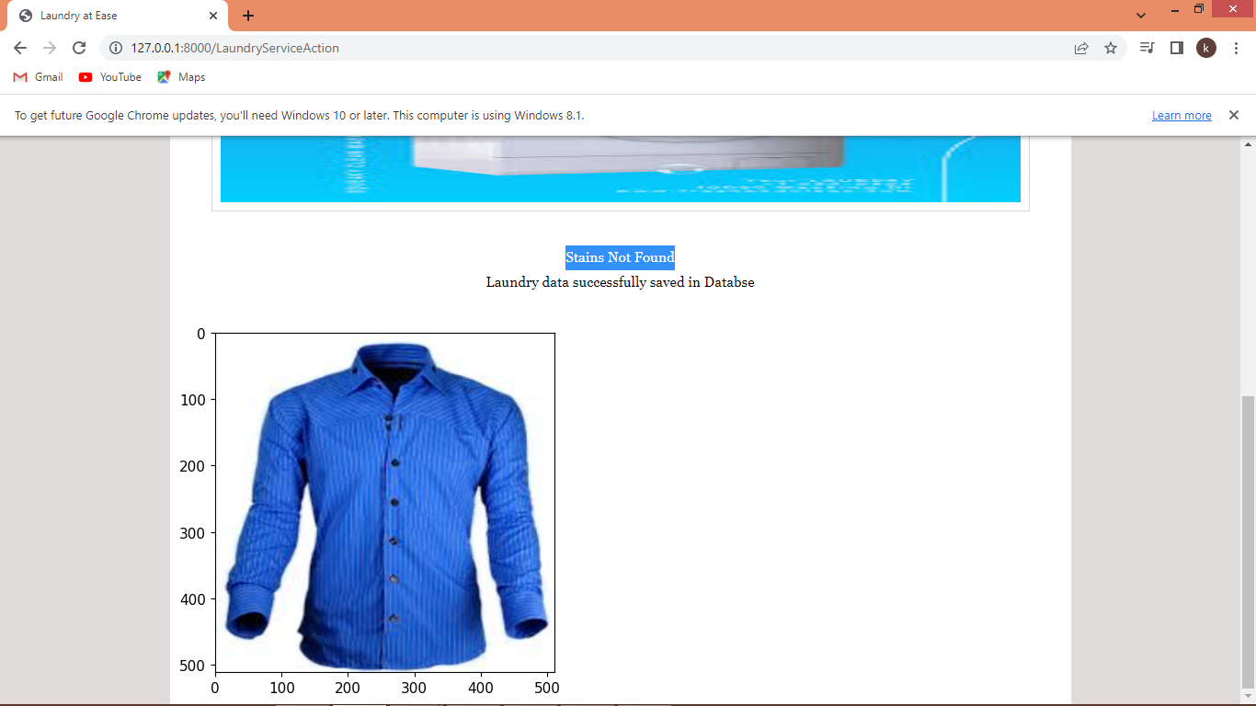

In above screen in blue colour text can ‘Stains Not Found’ and similarly you can test with any images. Now click on ‘View Laundry’ link to view all past orders history

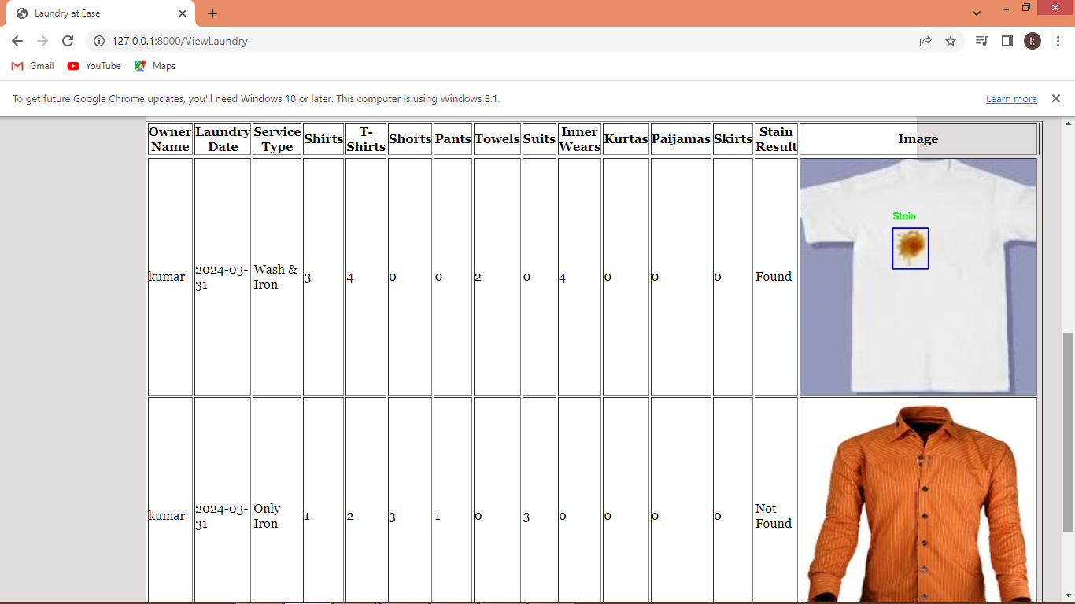

In above screen user can see all past laundry orders.

So in above screens we have completed all requirements given by you