Verizon Wireless
Enterprise Developer Website
Registration
Reference Guide
Version 2.5

1 Registration 3
1.1 Registration Steps 3
2 Completing the Alliance Profile 5
3 Solution Application Process 7
4 JMA Acceptance 12
5 Uploads of Spotlight Page Materials 14
6 Managing Your Solutions 19
Figure 1 Login Screen 3
Figure 2 Registration Screen 4
Figure 3 Registration Complete Screen 5
Figure 4 Company Information Selection Screen 6
Figure 5 Company Information Screen 7
Figure 6 Manage Applications 8
Figure 7 Create Enterprise Applications 9
Figure 8 Basic Info Screen 10
Figure 9 Additional Info Screen 11
Figure 10 Application Success Screen 12
Figure 11 View JMA Status 13
Figure 12 JMA Acceptance Screen 14
Figure 13 Tools Selection Screen 15
Figure 14 Tools Screen 16
Figure 15 Spotlight Page Tool 17
Figure 16 Document Upload Screen 18

Registration
The first step for a developer is to obtain an ID and Password on the www.vzwdevelopers.com website. Once you have an ID you can upload information about your company and any Enterprise applications you would like to present to VZW for consideration.

Registration Steps
- Go to www.vzwdevelopers.com
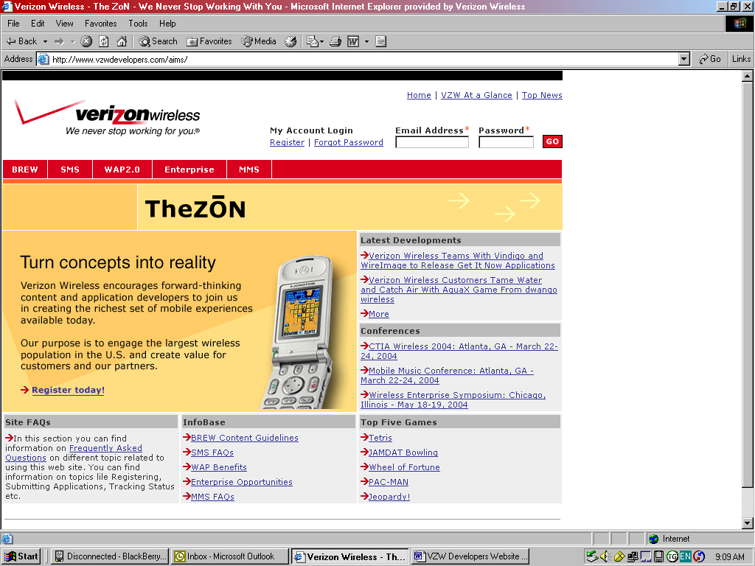
- Click Register.
Figure 1 Login Screen

- Fill out all the requested information.

Figure 2 Registration Screen
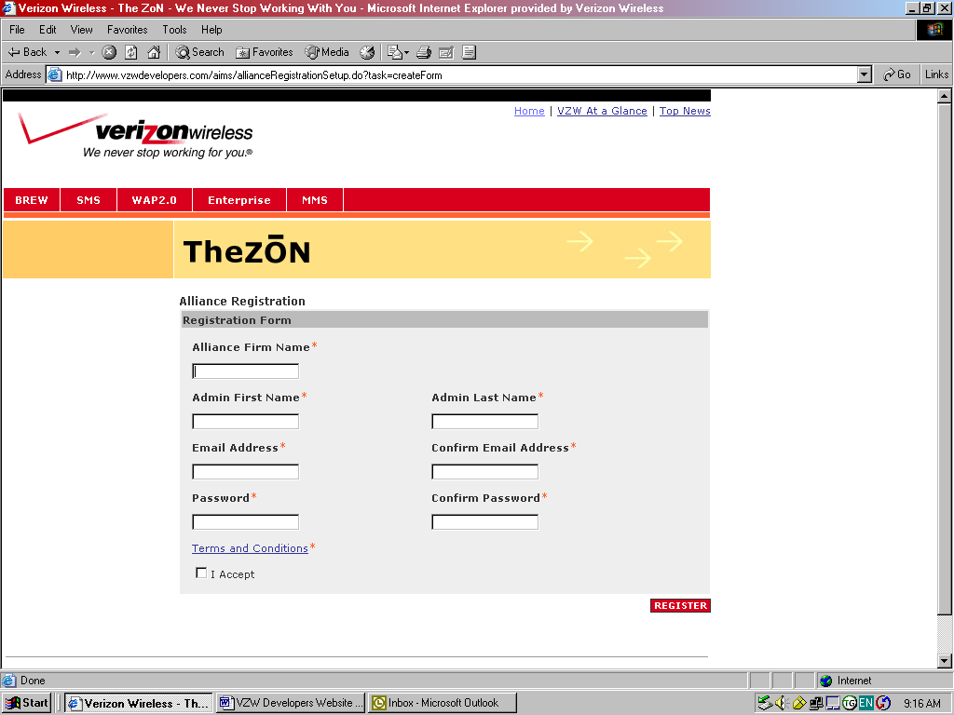

- Once registration is complete you will be logged into the site and by typing your user name and password, you can log in at any time.

Figure 3 Registration Complete Screen
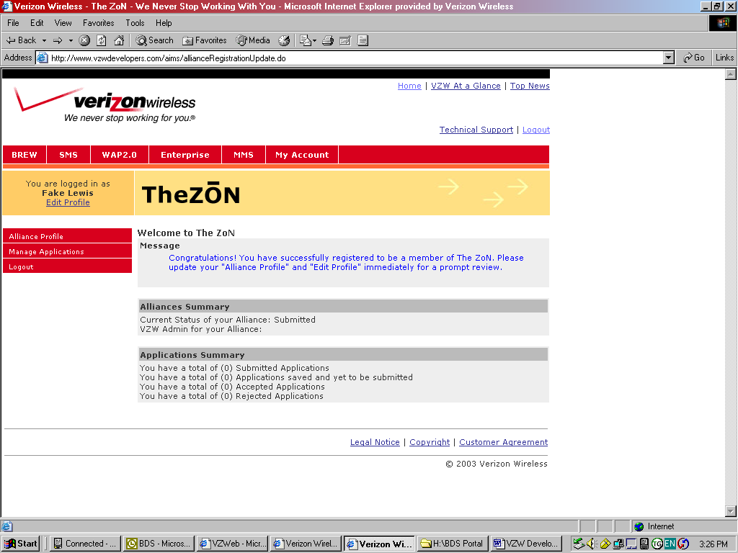

Completing the Alliance Profile

- Now you should select “Alliance Profile” and fill out a company profile to be considered for a national or area Joint Marketing Agreement (JMA).

Figure 4 Company Information Selection Screen
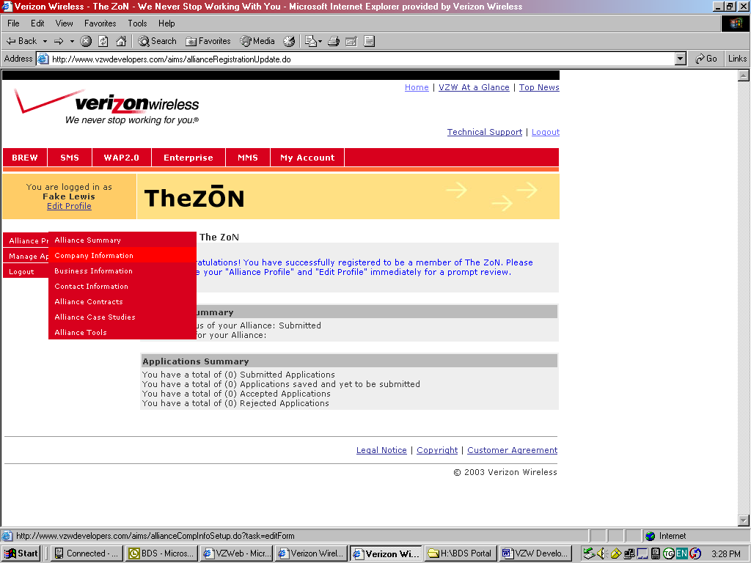

Figure 5 Company Information Screen
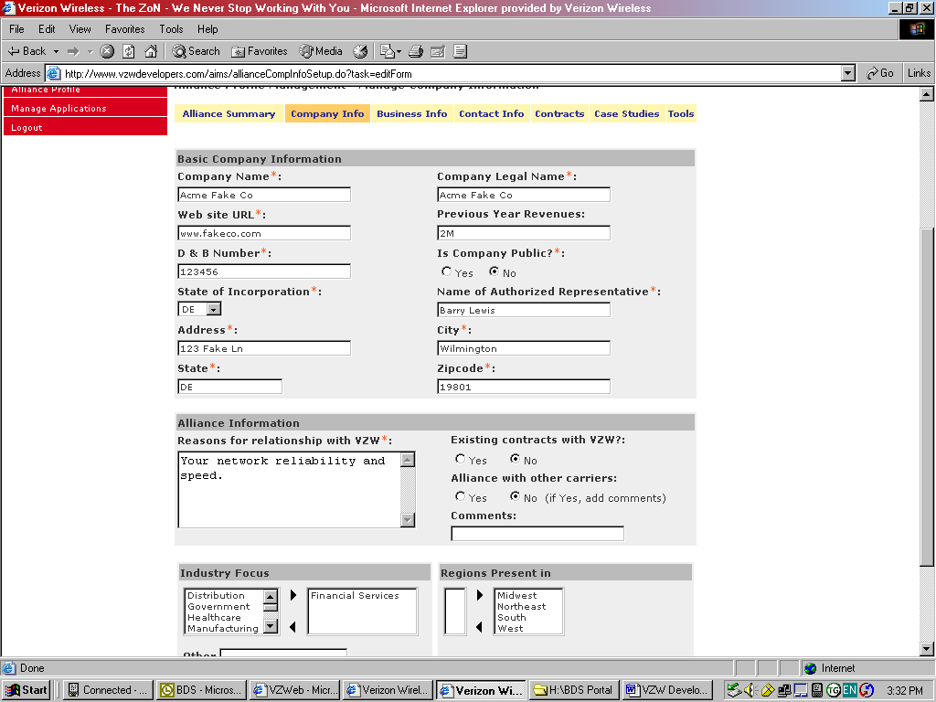

- You should also enter the necessary information under the “Company Info”, “Business Info” and “Contact Info” tabs (Including whether you are a national company or if you primarily do business in certain areas of the country).

The next step is to register your solution for consideration

Solution Application Process

Even if you already have a JMA with VZW, you must use this process to have each and every solution independently considered. For example, Company ABC may have an email solution and a VPN solution, but we might not have a need for another VPN solution, and therefore we might accept the email solution but probably would reject the VPN solution.

Once you have an ID on vzwdevelopers.com you can now apply to have your Enterprise software solution(s) considered at any time.

- You would select “Manage Applications” and then “New Applications” to begin.

Figure 6 Manage Applications
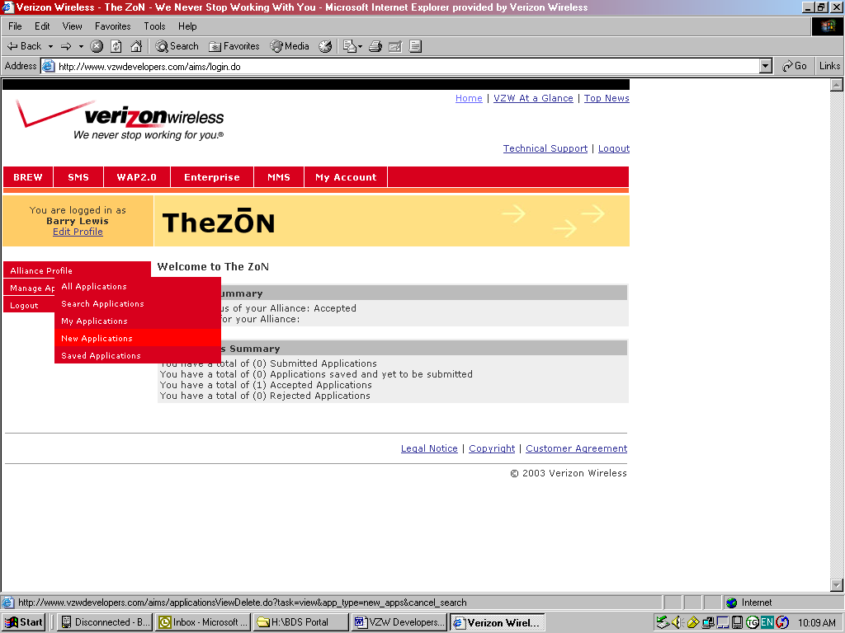

2. You would then select “Enterprise” to have your Enterprise Solution considered and then you would select “Create”.

Figure 7 Create Enterprise Applications
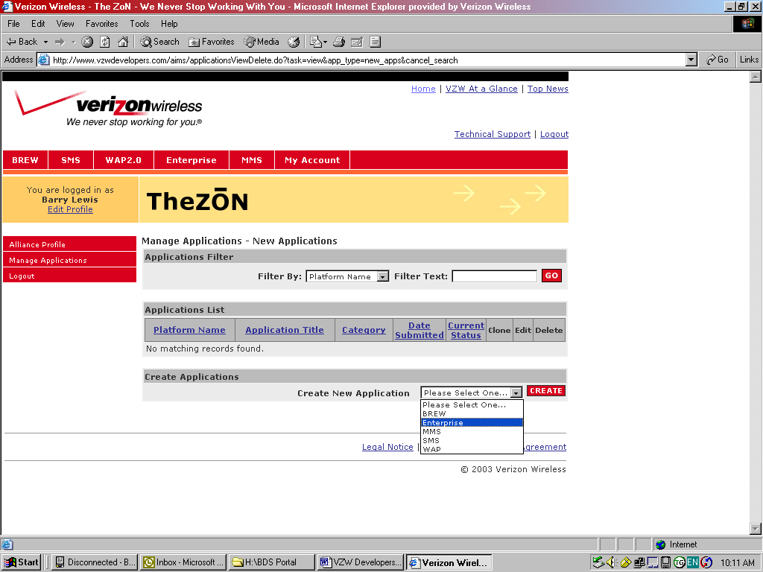

3. Once this was done, you would be taken to the “Basic Info” screen where you would enter information about your solution. The fields marked with an asterisk are required.

Figure 8 Basic Info Screen
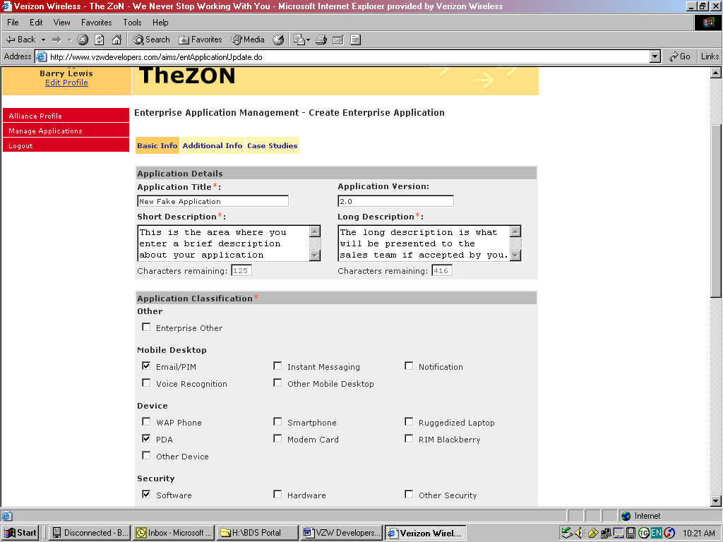

- You should also select the “Additional Info” tab to enter other information that will help our Product Manager or Area JMA Manager to make an informed decision (i.e. presentations etc). You would also specify whether your solution should be considered “Nationally” or whether it should be considered at the “Area” level.

Figure 9 Additional Info Screen
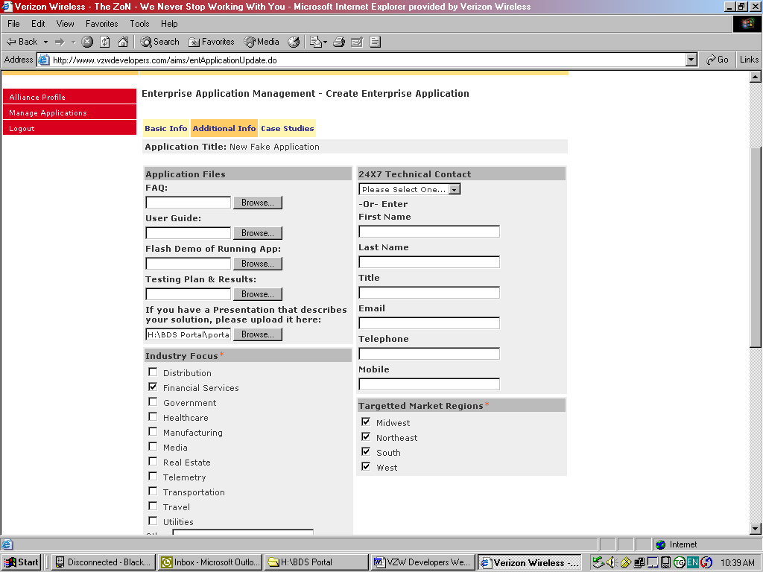

- Once this is done you should either select “Save” to save your solution information if you would like to return later to complete it, or “Submit” to submit your solution for consideration. Note: We will not be able to review the solution until you submit it.

Figure 10 Application Success Screen
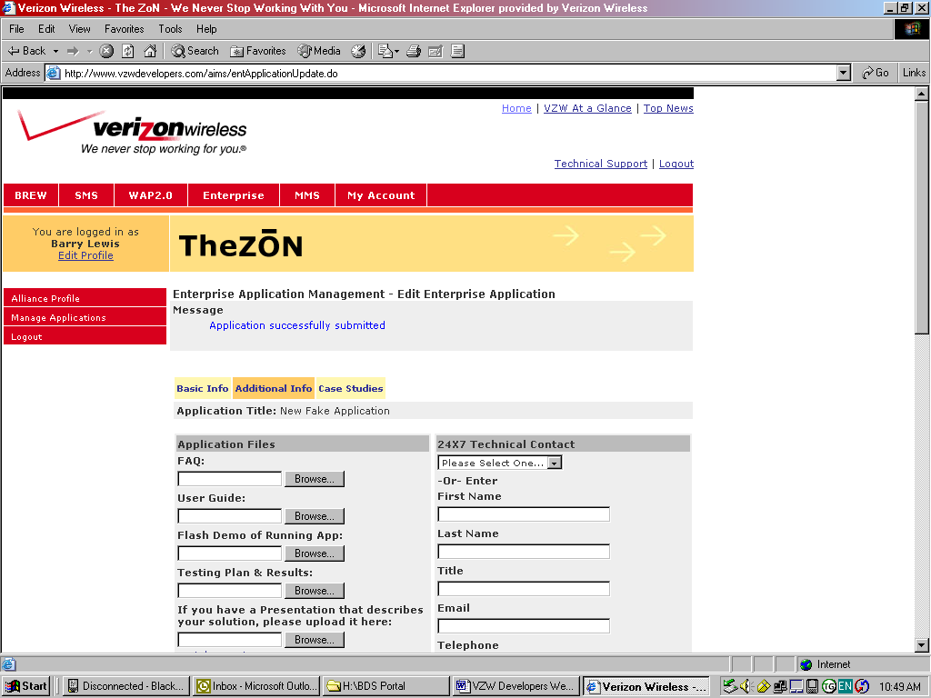

If we accept your solution, you will be notified. If you already have a JMA with VZW and you are simply submitting a new solution for consideration, the next step would be to upload materials to your spotlight page. This is the page that will be accessed by our sales force (Skip to Section 5). If you do not yet have a JMA with VZW, then VZW will use the information you have provided about your company and about your solution(s) to determine whether a JMA is warranted, and if a JMA is issued you will be notified (See Section 4)

JMA Acceptance

If a JMA is issued, you must log into vzwdevelopers.com and read the JMA and decide whether to accept it or reject it.

- Log into the site and go to Alliance Contracts.
- Click the document link to review the JMA
- If you are in agreement, input your initials in the initials box and click “Accept”

Figure 11 View JMA Status
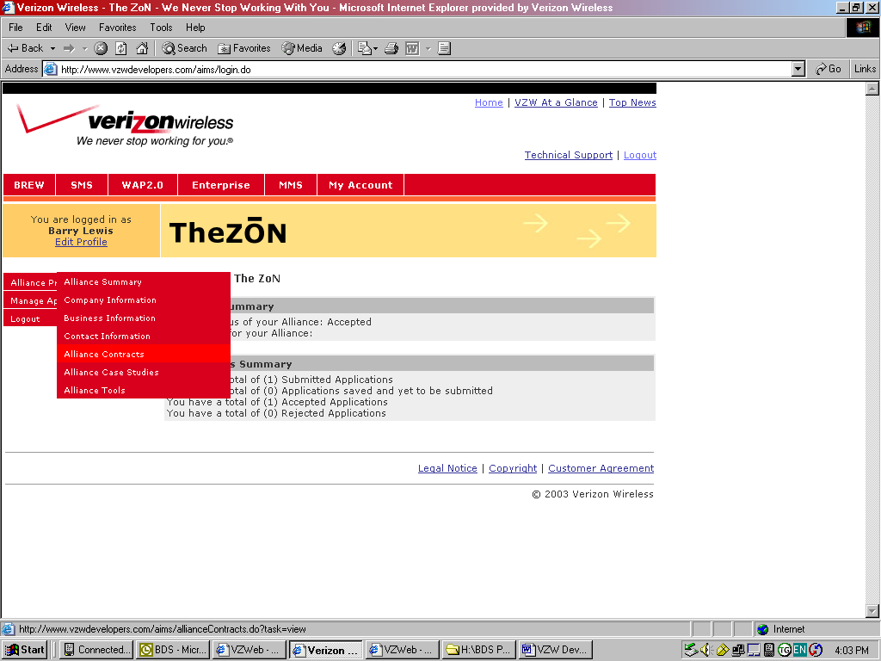

Figure 12 JMA Acceptance Screen
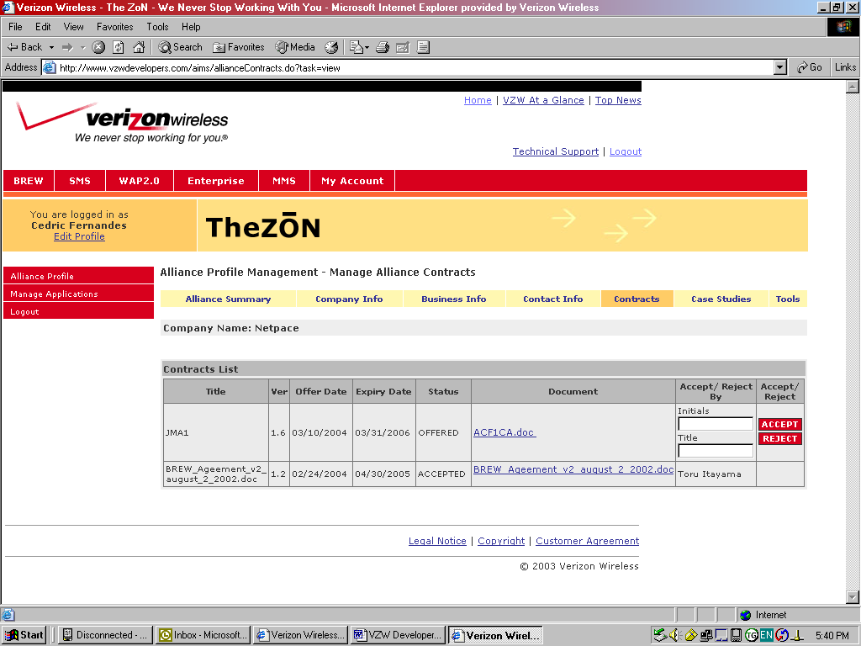

Once the JMA has been accepted, you are ready to upload materials to your spotlight page.

Uploads of Spotlight Page Materials

The following are the steps a developer needs to follow to upload various materials for their spotlight page, once their solution has been accepted.

- The first step for you, once your application has been accepted, is to log into www.vzwdevelopers.com and select “Manage Applications” and then select “My Applications”.

Figure 13 Application Selection Screen
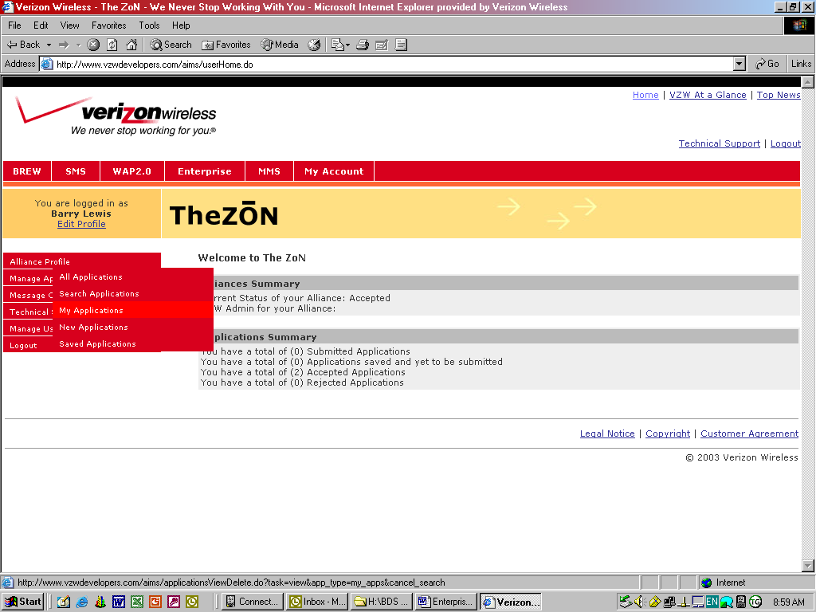

- Next select the relevant “Accepted” Enterprise application.

Figure 14 My Applications Screen
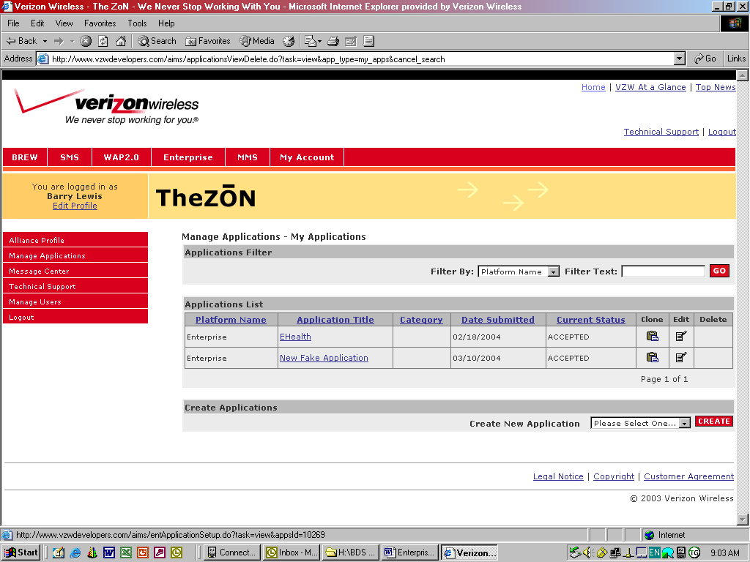

- Select the “Edit” icon next to the relevant application and select the “Spotlight” tab. This tab will allow you to upload materials to your spotlight page.

Figure 15 Selection of Spotlight Page Tool
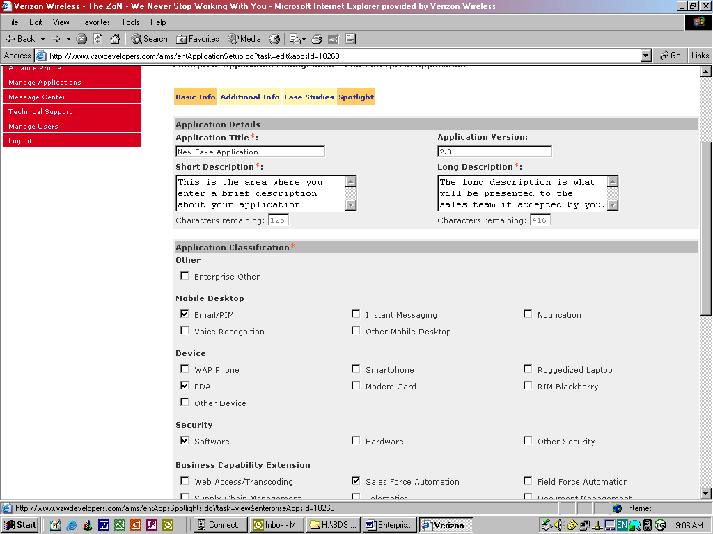

- Once you have selected the Spotlight Page tab, you can select the “Quick Reference Guide” link on the spotlight page tool bar and download a blank template to your computer. Once you have completed the QRG, you can select “Create” to upload the QRG to your spotlight page.

Figure 16 QRG Download Screen
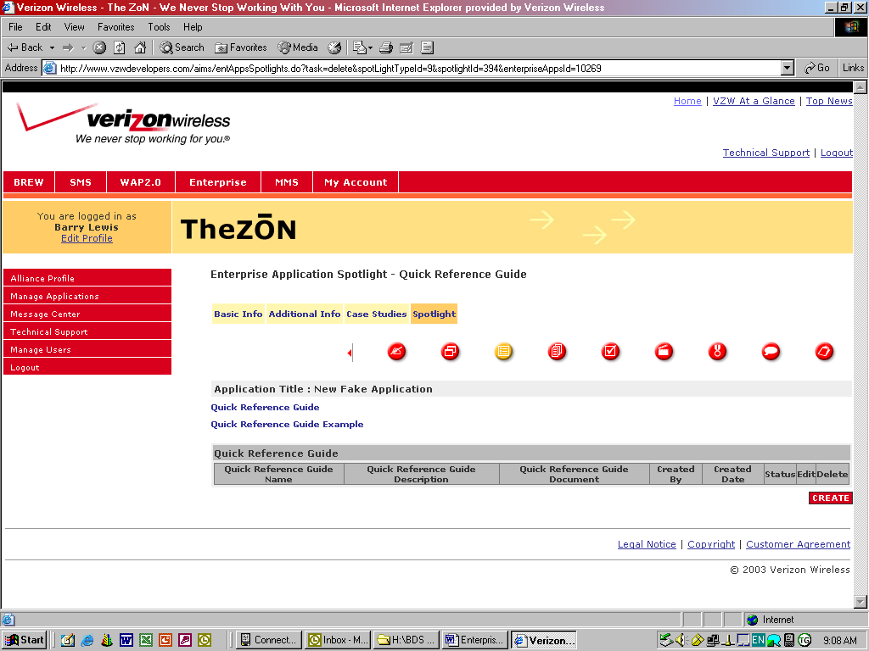

- For each icon (Sales Presentations etc.) you would select the icon, select create and upload the relevant document from your computer to your spotlight page.

Figure 17 Document Upload Screen
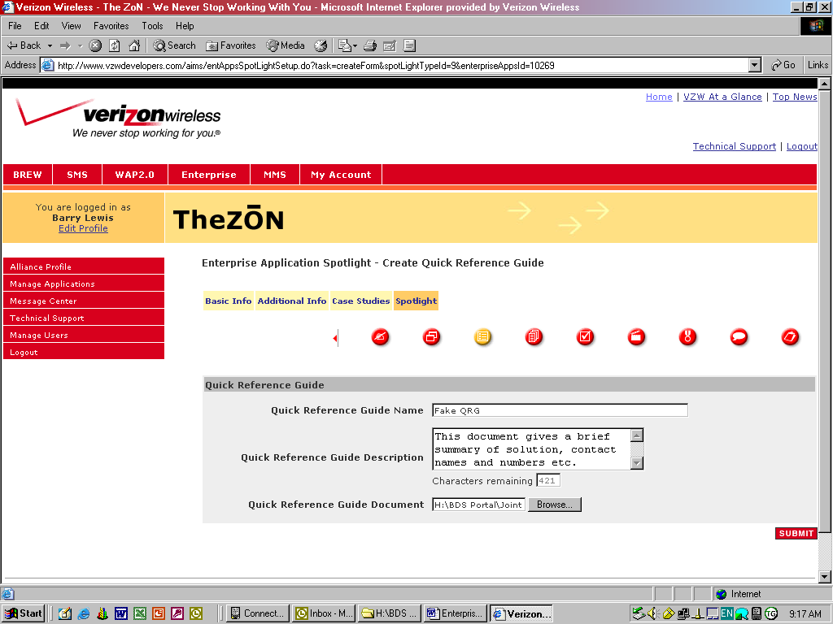

- Now that the file has been uploaded, you can edit it, or delete it etc. at will. However, it will not be displayed on the Spotlight Page until the Product Manager or Area JMA Manager approves the material.

Managing Your Solutions

Now that you have entered into a JMA and have one or more solutions being presented to our sales force, they will reach out to you if their customers have a need for your solution. However, we also encourage you to reach out to our sales force. Our most successful developers are proactive in their efforts to pursue joint opportunities.

