Files Needed
- WinCVS client
- ssh

The url to get the files - http://209.157.27.218:6666/downloads/

Configure ssh
Note : Any references to username should be replaced by the userid on the cvs server (typically the Netpace email id)

- Extract the required files from the ssh.zip file into any directory. The files in the zip are ssh.exe, scp.exe, ssh-keygen.exe, zlib.dll and gmp.dll.
- Add a variable HOME with the value of the directory where ssh files were extracted. (If you want you can choose another directory, such as a home directory for your private files.)
- Next, find the PATH variable. Add the SSH installation directory to it.
- Send a request for a cvs account to me at sbagdadi@netpace.com . I will set up a username/password for cvs access on Mercedes (cvs server)
- Test the SSH installation. Start an MS-DOS shell, and try to connect using ssh. The cvs server is named mercedes.netpace.com
ssh –p 32970 -l username mercedes.netpace.com
You should be prompted for your password on mercedes.netpace.com. This is typically the same as the username when the account is created.
After logging in to Mercedes change the password by typing the passwd command in the unix shell
- To setup CVS for password-less usage make a directory called ".ssh" (DOTssh that is) in the directory you specified as HOME.
Enter an MS-DOS prompt and type the following:
ssh-keygen -C <comment> -f ./.ssh/identity

<comment> is an identifier placed in the public key (use your email address). Just press enter when it asks you for a passphrase. You don't want a passphrase. This creates identity and identity.pub in the .ssh directory.
- Now you need to set up the server to accept your keys. Run the secure copy command to send the identity.pub key to the server
scp –P 32970 ./.ssh/identity.pub username@mercedes.netpace.com:~/.ssh/authorized_keys

enter the username and password to complete the copy.

- Then login to the server using the ssh command:
ssh –p 32970 -l username mercedes.netpace.com

This will enable you to log in without prompting for the password.

Configure WinCvs

After ssh is installed on the machine, WinCvs needs to be configured to work with ssh.
- Extract and install the WinCvs client from the WinCvs120.zip file
- After install - Click Admin→Preferences.. menu in WinCvs
- In the General tab:
  - Set the CVSROOT to username@localhost:/usr/local/cvsroot
  - Authentication should be “SSH Server”
  - Check the RSA identity checkbox and browse to the directory where the identity file (generated before) exists.

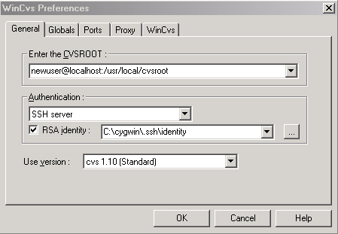

- In the Globals tab uncheck the “Prune (remove) empty directories”

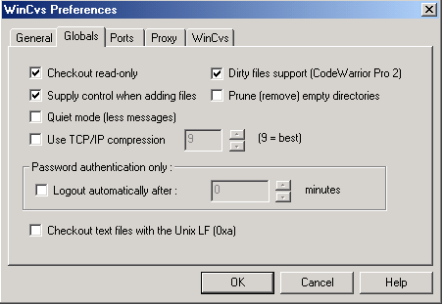

- In the Ports tab, check the “Check for an alternate rsh name”.

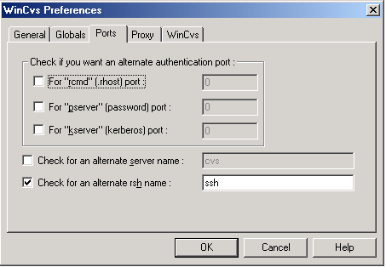

- In WinCvs tab, point the HOME folder to a suitable folder that does not run the risk of being deleted. Preferrably set it to the .ssh directory in the ssh folder.

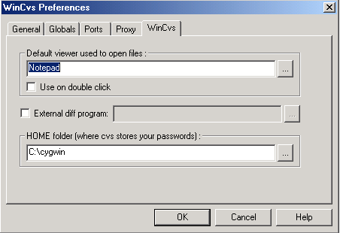

Create a Dev directory that will act as the root of all development.

Click on View→Browse Location→Change… link to change the browser’s location. Select the Dev directory created in the previous step.

Now choose Create – Checkout module and select the cvs module

e.g. “Checkout vzwaims module” results in the creation of the a directory vzwaims and all its subdirectories.

- Close wincvs and create a batch file wincvs.bat in the same folder where wincvs is installed . The batch file should have the following 2 line entry

1. start ssh -L 22:mercedes.netpace.com:32970 -i d:/CVSHOME/.ssh/identity -l username -p 32970 mercedes.netpace.com

2. start wincvs.exe

replace username with your username setup on cvs

- Create a shortcut to this batch file for easy and always run this batch file to access cvs instead of using wincvs.exe directly

