Get It Now User Guide Requirements

Template Guidelines

- All “live” GIN and newly submitted applications will have an associated user guide created.
- Use the Template starting on Page 3 to create the User Guide. Do not change font type or font size.
- The final audience will be the subscriber. Keep this in mind when creating Template sections.
- Do not use marketing pitches in verbiage. Guide is not intended as sales collateral.
- Each guide must be submitted in a Word document format. Final format will be Acrobat .pdf file.
- User guide should not exceed 4 pages.
- Do not reference BREW anywhere in the user guide. Use Get It Now instead.
- Be sure to include correct Trademarks, Copyrights and Registered icons in the guide. Verizon Wireless will be using these submissions so accuracy is your responsibility.
- All application screenshots must be in a .gif format and be 150X200 in size.

Template sections

Title - Application Name
Application Logo (if any) – Must be no wider than 120 pixels and in .gif format
Company Logo – Must be no wider than 120 pixels and in .gif format

Universal Information -This is information that can be used across all handsets. The following sections fall under Universal Information and should be created in the following order:

- Product Description /Objective/ Story Line / Introduction to Application or Game features – Use this section to describe the application along with any story lines, plots, or introductions to game features.

- Using the Application – This section details how the application works on the wireless phone. Explain what buttons to push to obtain a specific result. Also include any application default and set up features. Give a web address that users can access to view the detailed business and legal terms of use.

- Tips & Tricks/ Cheats – This section will be used to provide the customer with any help to complete or use any game or application more effectively, efficiently or skillfully.

- Frequently Asked Questions – List all FAQs related to the application in this section.

- Troubleshooting – Provide any pertinent information that would allow subscribers to self-solve application issues.

- Developer’s Website – List a “working” web site address where a customer can get additional help about the application.

- Disclaimer/Copyright Information/Trademark Ownership Information – Explain any known limitations and/or requirements related to the use of the application. Identify wireless services that apply, if any (i.e. airtime for use, txt messaging for notification, etc.) List any copyright or trademark stipulations.

Do not proceed

Below will be added to Verizon User Guides later…

Device Specific Information - In instances where handsets have varying keypads and user interfaces it is necessary to outline these differences. We refer to this information as Device Specific Information and require that each handset, where applicable, be illustrated with detailed instructions for the Set up/Start and Navigation/Key Function categories.

- Navigation / Key Function - Provided with the template are .jpg images of all current Get It Now handsets. Highlight all key functions and Navigation options for each handset based on the application specifications. (Use format in template example)

- Set up/Start Instructions from the wireless phone (Get It Now ->Application) – This section describes the launching of the application from the user’s perspective

 |  | 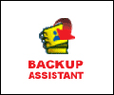
 | Backup Assistant

Product Description

Backup Assistant is a wireless service that saves a copy of your phone's address book to a secure web site. If your phone is lost, stolen or damaged, Backup Assistant restores your saved address book to a new phone - wirelessly!

Schedule daily automatic backups or manually backup anytime, anywhere! Login to your web account and get full access to your address book. You can view, print, add, delete and edit contacts. Changes are sent to your phone with one click! www.verizonwireless.com/backupassistant.

Screenshots

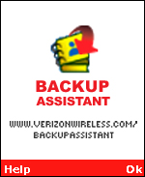 | 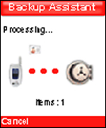 | 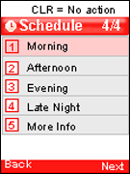 | 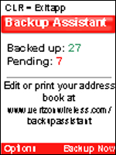

Using the Application

Setting up Backup Assistant on your phone-
- In Get It Now, find and launch Backup Assistant. At the Welcome screen, press Ok, the right “Soft Key” to continue.

- Backup Assistant automatically contacts the Backup Assistant service to determine if an account has already been established with the phone number.

- Next, you will create an account associated with your phone number.

When prompted, select a four-digit Personal Identification Number (PIN) that you will use to view your address book on the Backup Assistant web portal, and to authorize a “Restore” to your phone when the need arises.

- Backup Assistant will ask you to verify the PIN you assigned to your account, and will remind you to record your PIN for future use.

- As a convenience, Backup Assistant will offer you the option to have your PIN sent directly to your phone via TXT Message should you forget it.

This simple step ensures that a Restore can be done quickly, even in the event that you have forgotten your PIN.

- With your account established and your PIN selected, the registration process is complete.

Choose Next to set your Backup Assistant schedule.

- Backup Assistant will automatically wake up and check for changes in your address book at a random time within the period you select. For best results you may want to select a time frame that your phone will be on but you expect light use.

Select Next by pressing the right Soft Key.

- Congratulations! You’ve now created a Backup Assistant account and set a daily schedule for backing up your address book.

Press Next to begin your first Backup.

- When you begin a Backup, Backup Assistant will initiate a connection with the service and open the account for your phone number.

Pressing the left Soft Key at any time cancels the Backup.

- When the account is verified, the Backup process begins. The flying card animation in the center of the screen shows the progress of the Backup. The number of items will also count up.

The time required for this first Backup depends on the number of entries in your address book. Subsequent Backups should take significantly less time, because Backup Assistant will transmit only the additions you have made since your last Backup.

Pressing the left Soft Key at any time cancels the Backup.

- Backup Assistant returns to the activity summary screen, which will display the status of your address book – how many contacts have been backed up and how many changes are pending. After a backup the Pending number should be 0.

Using Backup Assistant
Once Backup Assistant has been configured and has performed its first Backup, there’s very little you need to do to enjoy the peace of mind that comes with having a secure archive of your address book. On the schedule you selected, the Backup Assistant application checks with your phone’s address book to see if any changes have occurred since the last Backup. If changes are detected, the application will launch (approximately 20-25 seconds after the phone’s clock registers the scheduled time) and the Backup process will start. If no changes are detected, Backup Assistant sleeps until the next daily automatic backup is triggered.

In Get It Now, find and launch Backup Assistant. The activity summary screen will display the number of Backed up contacts and the number of Pending changes.

From here, you can initiate a Backup or change your settings via the Options menu.

If Pending is zero, then there are no address book changes that require backing up.

Using the Options menu
The Options menu gives you the ability to view and change your settings to accommodate your preferences.

In the Backup Assistant Main page –

Press the left Soft Key to view the Options Menu.

When the Options menu is visible, you can:
- Change your Backup schedule settings
- View the phone number with which the account is associated
- Change your PIN
- Get Help
- View information about Backup Assistant

To access any of these options, press the corresponding number on your phone’s keypad.

Restoring the address book
In general use, the Restore feature is only used when a customer loses or damages their phone and buys or receives a new phone.

When restoring the address book, Backup Assistant carefully compares and merges any contact information on the new phone with that stored in the data vault. In the rare case where a conflict between the phone and data vault occurs, the phone data is assumed to be more current.

- On your new phone, download the Backup Assistant application from the Get It Now catalog, then launch the application.

Press the OK, right Soft Key to enter the program.

- The Backup Assistant application will establish a connection with the service. The service checks to see if there is an account associated with the phone number. If the service determines that an account exists and this is the application’s first launch, it knows that a Restore is appropriate.

- Before the Restore begins, Backup Assistant will request your PIN. This is done to prevent unauthorized modifications to your address book. In rare cases, a phone number may have been used before; if this is the case, the PIN will fail. You will be prompted to reset the phone number and create a new account.

Enter your PIN and press the right Soft Key to begin the restoration. If you have forgotten your PIN, press #. If you authorized it during the setup, Backup Assistant will retrieve your PIN for you.

NOTE: You must have selected this option when you initially set up Backup Assistant.

- When you begin a Restore, Backup Assistant will initiate a connection with the service, authenticate the account, and begin restoring the data. Pressing the left Soft Key at any time cancels the Restore.

- At the conclusion of the Restore, the activity summary screen provides information regarding the Restore.

www.verizonwireless.com/backupassistant

A user with an active Backup Assistant account can log in and manage their personal data vault via the secure web portal: www.verizonwireless.com/backupsssistant The same mobile number and Personal Identification Number (PIN) chosen by the user during sign-up are used to gain access to the portal.

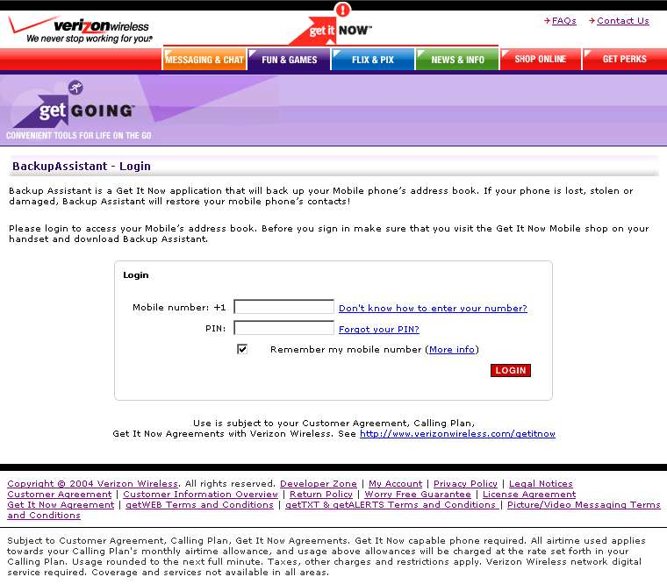
Figure 1: Backup Assistant login screen

Within the portal, all address book data from the last successful Backup are displayed. Users can add, delete, and edit contacts as well as print their entire address book in either a list or business card format.

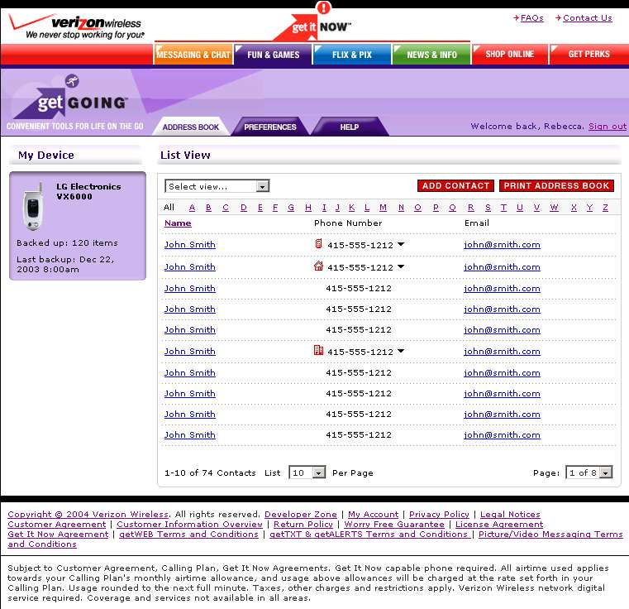
Figure 2: Backup Assistant Address Book View

Users can add a new contact by selecting Add Contact button, the new contact window will appear and the user is free to input contact information. Backup Assistant knows which model of Verizon Wireless phone a user has and only presents those fields available on the handset.

To edit or delete an existing contact, simply select the contacts name in the address book view. This is where you can create, edit, or delete a contact. (Figure 3).

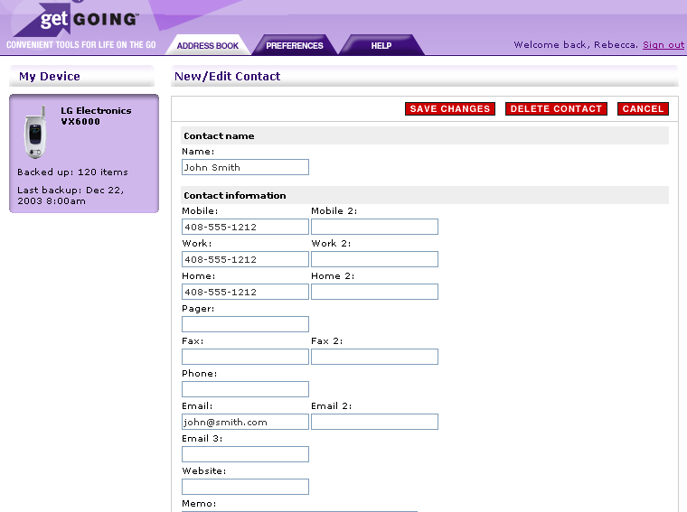
Figure 3: Backup Assistant New/Edit Contact View

Multiplayer Options

N/A

Tips and Tricks

N/A

FAQs

What is Backup Assistant and why would I want it?
Imagine losing your phone and having to replace it with a new one. Then imagine having to key in all of your friends, family, and business contacts into your address book all over again. Want to save yourself some time and stress? Get yourself Backup Assistant!

Backup Assistant is a wireless service that saves a copy of your phone's address book to a secure web site. If your phone is lost, stolen or damaged, Backup Assistant restores your saved address book to a new phone - wirelessly!

Backup Assistant creates a copy of your phone's address book on a secure, password-protected web site. You can schedule a daily automatic backup of your address book or you can manually backup anytime, anywhere.

By logging into your account at www.verizonwireless.com/backupassistant, you have full access to your phone's address book. You can view, print, add, delete and edit contacts. Once changes are made, they can be pushed to your phone at the click of a button!

How do I get Backup Assistant?
To get Backup Assistant, you need to download Backup Assistant to your Get It Now enabled handset.

To find Backup Assistant -
- Open the Get It Now Shop on your handset
- Select getGOING
- Select Business/Tools
- Find Backup Assistant
- Download it to your phone!

What Get It Now enabled handsets offer Backup Assistant?
To see if your handset offers Backup Assistant, visit the “detail” page for Backup Assistant at the www.verizonwireless.com/getitnow website for an up-to-date list.

How do I change the schedule of my automatic backups?
To change the schedule of your automatic backups, go to the Options menu of Backup Assistant on your phone and select "Set schedule". You can set the schedule to backup:
- Morning
- Afternoon
- Evening
- Late Night
An automatic backup will only occur if there have been changes to your phone's address book since your last backup.

How do I start a backup?
To start a backup of your phone's address book, open Backup Assistant on your phone. From the main screen, press "Backup Now".

If there are no changes to your phone's address book, then no backup will be needed.

How much does Backup Assistant Costs?
Backup Assistant is a $1.99 monthly subscription charge that will appear on your monthly Verizon Wireless service bill.

How do I restore my address book to my new phone?
If you have used Backup Assistant to backup your address book in the past, you will be able to restore your address book to a new phone. To restore, you simply download Backup Assistant from the Get It Now service. Backup Assistant will guide you through a few simple steps to restore your address book. See restoring your phone's address book.

What does "Awaiting backup:" mean?
On the main screen of Backup Assistant on your phone, there is a red number under "Awaiting backup:” This number indicates the total number of changes that you have made to your address book since the last backup. If the number is 0, your address book is completely backed up.

What does "Backed up:" mean?
On the main screen of Backup Assistant on your phone, there is a green number under "Backed up:” This number indicates the total number of contact entries that are safely backed up in your account.

Can I try Backup Assistant before I buy it?
Yes! There is a one day free demo of Backup Assistant. The demo will allow you to backup your phone and see how Backup Assistant works. To be able to restore your phone book, you must purchase Backup Assistant.

Can I access my contact data from a computer?
Yes! You can access and manage your phone's address book at www.verizonwireless.com/backupassistant. There you can view, edit, delete, print and add contacts.

What information do I need to log on at www.verizonwireless.com/backupassistant ?
All you need is your mobile number and you’re PIN, which is created when you set up Backup Assistant on your phone.

How do I find the correct format for entering my mobile number when I login on the web?
When you login to your account on the web, you'll need to use the full, international format of your mobile number.
To find the exact format of your mobile number that you'll need to login to your account on the web, do the following steps:
- Open Backup Assistant on your phone
- Choose Options
- Choose View mobile #

How do I print out all the contacts in my phone's address book?
You can print out all the contacts of your address book by logging into your account at www.verizonwireless.com/backupassistant. Once you have logged in, click "Print Address Book".

How do I edit a contact from my Backup Assistant web account?
To edit a contact from your Backup Assistant web account, double-click a contact's name. All address book fields will be displayed. You can add, delete or edit fields.
- To save changes, select the Save Changes button at the top of the contact view.
- To cancel changes, select the Cancel Changes button at the top of the contact view.

How do I create a new contact from my Backup Assistant web account?
From your Backup Assistant web address book, select the Add New Contact button. Once you have entered the contact, select the Save Contact button.

How do I delete a contact from my Backup Assistant web account?
From your Backup Assistant web address book, select the contact you wish to delete. Then select the Delete Contact button.

What is the “Auto Sync" button on my Backup Assistant web account?
The AutoSync button allows you to automatically synchronize your web address book changes with your mobile phone's address book. The AutoSync button appears in the My Device box on the right of your web address book. When you select AutoSync, Backup Assistant will wake up your phone and synchronize with your phone's address book. This ensures that your phone has the latest contact information. Each time the AutoSync button is used, there is a standard TXT messaging cost applied to your monthly Verizon Wireless phone bill.

How do I disable the " AutoSync" button?
To disable the AutoSync button, select the Preferences tab in the top menu bar. Select the Off button next to AutoSync and then select Update User Info.

Troubleshooting

While most address book fields are supported by Backup Assistant, there are some address book fields and settings that are not supported by BREW or Backup Assistant because only a reference id is available and it is not persistent. The following fields and settings are not supported:

Groups/Category, Ringer, SMS Ringer, Picture ID, Secret, Speed Dial, and Voice Dial

These are not backed up so if a user does a restore, the backed up fields are written to the phone and all non-supported fields will be empty. User will need to reset these for each contact.

Backup Assistant Web Issues/constraints:

- Valid phone field characters: 0123456789*#PT
- Valid email field characters: must contact @ and ‘.’
- Can not create a contact without at least one character in name field.
- Number of contacts limited to Phone Max – 5.
- Can not save contact without at least one phone number.

Disclaimer

Upon acceptance of these terms and conditions and upon completion of the registration process (including selection of a username and password), You will become a subscriber to the Backup Assistant Service as described on www.verizonwireless.com\getitnow. The Backup Assistant Service is also subject to the terms of your Customer Agreement and Calling Plan.
The Backup Assistant Service may be terminated immediately without liability upon sending notice to the e-mail address You provided during your registration. You may end your use of the Backup Assistant Service at any time by terminating service with Verizon Wireless or removing the Backup Assistant application from Your handset no refunds shall be granted for any fees paid in advance. Upon termination You will no longer have access to data, messages, files and other material You previously stored.

