Secure Cloud Guard
"Data Encryption in Cloud and DDoS Attack Detection Using AI/ML"
A Hybrid Machine Learning and Cryptographic Framework for Selective Image Encryption and Real-Time DDoS Detection in Cloud-IoT Environments

Interim Review – 1: Project Idea & Design Proposal
Science and Technology Advancement – Assessment Review (STAAR)


Department of Computer Science and Engineering
C.V. Raman Global University, Bhubaneswar
Odisha, 752054, India
Name | Registration No.
Sashi Bhusan Prusty | 2301020812
Tasha Pattnaik | 2301020388
Parbhu Datta Biswal | 2301020766
Aditya Padhi | 2301020330
Under the supervision of
DR SAMPA SAHOO

Table of Contents
Contents | Page no.
List of Figures | 3
List of Abbreviations | 3
1. Problem Specification | 4
2. Introduction | 4
3. Literature Survey | 5
4. Research Gap | 6
5. Proposed Solution (with Block Diagram) | 7
5.0 Ideation — Improving on the Base Paper | 7
5.1 Objectives | 8
5.2 Planned Methodology | 8
5.3 Technology Stack | 13
5.4 Planned Team Division of Work | 14
5.5 Planned Implementation Roadmap | 14
6. Results and Discussion (Expected Outcomes) | 15

List of Figures
Figures | Page no.
Fig. 1 — Proposed SecureCloudGuard system architecture (block diagram) | 8
Fig. 2 — Planned AES-256 selective encryption and decryption flow | 9
Fig. 3 — Planned DDoS attack detection flow (threshold + Random Forest + Bayesian prediction) | 11
Fig. 4 — What a DDoS attack is: a botnet flooding a target until legitimate users are shut out | 12

List of Abbreviations
Abbreviation | Full Form
AES | Advanced Encryption Standard
DDoS | Distributed Denial of Service
ML | Machine Learning
SVM | Support Vector Machine
RF | Random Forest
DP | Differential Privacy
IoT | Internet of Things
TLS | Transport Layer Security
SSL | Secure Sockets Layer
FPR | False Positive Rate
DAG | Directed Acyclic Graph
CPD | Conditional Probability Distribution
SDN | Software-Defined Networking
HyMLCPP | Hybrid Machine Learning and Cryptography-based Predictive Probability model
MLPAM | Machine Learning and Probabilistic Analysis-based Model
HELR | Homomorphic Encryption-aware Logistic Regression
IV | Initialization Vector

1. Problem Specification
Cloud-IoT systems continuously exchange sensitive images and traffic data that remain vulnerable to unauthorized access, tampering, and Distributed Denial-of-Service (DDoS) attacks. Full-image AES encryption before upload is computationally expensive for real-time pipelines, while conventional rule- or threshold-based intrusion detection struggles against subtle, evolving attack patterns. Sharing aggregated cloud statistics for research or billing also risks exposing individual user data, and most existing defences are purely reactive, detecting attacks only after damage has occurred. We aim to design a lightweight, integrated framework that simultaneously secures data confidentiality, ensures availability against DDoS, preserves statistical privacy, and predicts attacks before they escalate.

2. Introduction
Organizations increasingly migrate sensitive data — including medical images, defence records, and IoT sensor feeds — to third-party cloud infrastructure to reduce cost and improve availability. Once data leaves local control, however, it becomes exposed to a wide range of threats: unauthorized access by the cloud provider or co-tenants, tampering of images in transit or storage, and availability attacks such as Distributed Denial-of-Service (DDoS) that prevent legitimate data from ever reaching the cloud. Traditional defences typically address only one of these concerns at a time — full-image encryption is robust but computationally expensive, while rule-based intrusion detection is fast but brittle against evolving attack patterns. Neither approach considers the privacy risk created when aggregated cloud statistics are shared for research, billing, or auditing purposes, and almost none offer any predictive capability before an attack actually begins.
To address this, we propose SecureCloudGuard — an integrated pipeline that will treat confidentiality, availability, and privacy as one connected problem rather than three separate ones. As currently planned, the framework will perform selective image encryption by decomposing an image into eight bit-planes and using a Support Vector Machine (SVM) classifier to identify and encrypt only the four to five most information-dense planes with AES-256, substantially reducing computation time compared to encrypting the entire image. In parallel, we intend to train a Random Forest classifier to detect DDoS attacks from network traffic features and benchmark it against a simple threshold-based detector. A differential-privacy mechanism is planned to add calibrated Gaussian noise to any aggregated statistic before it is shared, and a Bayesian Network will be built to estimate the posterior probability of a future attack from observed traffic evidence, moving the system from reactive to predictive defence. We plan to unify all four modules in an interactive Streamlit dashboard so that encryption, detection, and prediction can eventually be demonstrated end-to-end on a single image or traffic stream.
Our design will closely follow and benchmark against the Hybrid Machine Learning and Cryptography-based Predictive Probability (HyMLCPP) model proposed by Pathak et al. [1], adapting its multi-layer philosophy into a scaled-down, demonstrable academic project. This report presents our problem specification, a survey of related work, the research gap we intend to address, and the proposed system architecture and methodology we plan to implement following this review.

3. Literature Survey
Eight key studies inform the design of SecureCloudGuard. The base paper, Pathak et al. [1], proposes HyMLCPP, a hybrid machine-learning and cryptography model that combines bit-plane image encryption, chaotic-map key generation, differential privacy, a Random Forest DDoS detector, and a Bayesian Network for attack prediction, reporting 99.9% detection accuracy and a 1.2% false-positive rate on a cloud-IoT testbed. This work supplies the overall four-module architecture we plan to adopt, including the idea of prioritising bit-planes 4 to 7 for encryption because they typically carry 85-89% of an image's total information content.
Gupta et al. [2] introduce MLPAM, a machine-learning and probabilistic-analysis model for privacy-preserving storage, sharing, and guilty-user detection in the cloud, achieving 97% accuracy and a 3.1% false-positive rate; we intend to use it as a design reference for our privacy-preservation module and as a baseline comparison point. Brunetta and Picazo-Sanchez [3] use a Naive Bayes distinguisher to evaluate cryptographic randomness and strength, reporting 93.1% accuracy — this supports our plan to apply machine-learning models to reason about the statistical quality of encrypted output, rather than relying purely on manual cryptanalysis. Kumari and Mrunalini [4] combine Logistic Regression and Naive Bayes for DDoS detection, achieving 97.8% accuracy, and will serve as a classical machine-learning baseline against which we plan to compare our Random Forest detector for both accuracy and interpretability.
Clinton et al. [5] convert raw software-defined-network traffic into image-like data and apply deep learning for DDoS classification, reporting 99.7% accuracy and a 3.5% false-positive rate; we plan to use this to benchmark the trade-off between the higher computational complexity of deep-learning pipelines and the lighter, more interpretable Random Forest approach we intend to adopt. Al-Ghuwairi et al. [6] propose time-series, anomaly-based intrusion detection for cloud computing using machine learning, treating traffic as a sequence of evolving features rather than isolated snapshots — this will support the traffic-feature-extraction design of our threshold-detection module. Divakar Allavarpu et al. [7] present HELR, a homomorphic-encryption-aware logistic-regression model for privacy-preserving analysis that allows computation directly on encrypted data; we plan to reference it as an alternative, more computationally expensive privacy-preserving technique in our future-work discussion. Finally, Shafique et al. [8] combine Support Vector Machines with an image-encryption technique to evaluate cryptosystem security, forming the direct basis for our plan to use an SVM classifier to decide which bit-planes require encryption.
Across these eight studies, a consistent pattern emerges: cryptographic techniques, machine-learning-based intrusion detection, and privacy-preserving mechanisms are almost always studied in isolation from one another. Only the base paper [1] attempts to unify all three concerns into a single pipeline, and even that model does not provide a demonstrable, interactive interface that a non-expert user could operate. Studies such as [4], [5], and [6] focus purely on detection accuracy without considering encryption cost, while [2] and [7] focus on privacy without considering real-time detection. This gap between isolated, high-accuracy research components and a single, usable, end-to-end system is what we intend SecureCloudGuard to address — not as a new algorithm in any one area, but as a carefully integrated combination of the strongest ideas from each of these eight works, summarised in Table 1.
# | Paper (Author, Year) | Key Contribution | Point(s) We Plan to Use
1 | Pathak et al. (2026) — HyMLCPP [1] | Hybrid ML + cryptography model combining bit-plane encryption, chaotic maps, differential privacy, Random Forest & Bayesian Network for cloud-IoT security; 99.9% accuracy, 1.2% FPR. | Base paper — overall architecture, bit-plane selective encryption, threshold + Random Forest DDoS detection, Bayesian prediction module.
2 | Gupta et al. (2021) — MLPAM [2] | ML + probabilistic model for privacy-preserving storage, sharing, and guilty-user detection; 97% accuracy, 3.1% FPR. | Reference for our privacy-preservation design and baseline accuracy/FPR comparison.
3 | Brunetta & Picazo-Sanchez (2022) [3] | Naive Bayes distinguisher to evaluate cryptographic randomness/strength; 93.1% accuracy. | Justifies our ML-based approach to reasoning about encrypted-output quality; comparison baseline.
4 | Kumari & Mrunalini (2022) [4] | Logistic Regression + Naive Bayes for DDoS detection; 97.8% accuracy. | Baseline classical-ML DDoS detector we will compare against our Random Forest model.
5 | Clinton et al. (2024) [5] | Converts SDN traffic into image data, applies Deep Learning for DDoS classification; 99.7% accuracy, 3.5% FPR. | Benchmark for the trade-off between deep-learning complexity and our lighter Random Forest approach.
6 | Al-Ghuwairi et al. (2023) [6] | Time-series anomaly-based intrusion detection for cloud computing using ML. | Supports the traffic feature-extraction and time-series design of our threshold module.
7 | Divakar Allavarpu et al. (2024) — HELR [7] | Homomorphic Encryption-aware Logistic Regression for privacy-preserving analysis of sensitive records. | Alternative privacy-preserving technique we will reference in future work.
8 | Shafique et al. (2021) [8] | Combines SVM with image-encryption technique to evaluate cryptosystem security. | Basis for using an SVM classifier to decide which bit-planes we will encrypt.
Table 1 — Summary of Literature Survey

4. Research Gap
Building on the literature survey in Section 3, we have identified the following gaps in existing cloud-IoT security research, which our proposed project aims to address:
- Fragmented security models: Most existing works [2]–[8] address confidentiality, availability, or privacy in isolation; only the base paper [1] integrates all three, and even it lacks an interactive, demonstrable interface for a real user.
- Computational overhead of full encryption: Full-image AES encryption, used implicitly in most cryptography-focused works [3], [8], is computationally expensive and unsuitable for real-time cloud-IoT pipelines; selective, information-density-based encryption remains underexplored outside the base paper.
- Reactive rather than predictive detection: Detection-focused studies [4]–[6] classify traffic as attack or normal only after it is observed; few incorporate a probabilistic model that forecasts the likelihood of a future attack from partial evidence.
- Privacy of aggregated statistics: Differential-privacy techniques are rarely combined with DDoS detection and selective encryption in the same pipeline; most privacy-preserving works [2], [7] treat privacy as a separate concern from intrusion detection.
- Lack of demonstrable prototypes: Very few surveyed works provide an accessible, end-to-end interactive demonstration — such as a dashboard — that lets a non-expert user observe encryption, detection, and prediction happening together in real time.
We intend to design SecureCloudGuard specifically to close these five gaps within a single, lightweight, and demonstrable academic prototype, rather than proposing an entirely new algorithm in any one sub-area.

5. Proposed Solution

5.0 Ideation — How SecureCloudGuard Will Improve on the Base Paper
Our starting point is the HyMLCPP model of Pathak et al. [1], which we treat as the base paper for this project. Rather than simply reproducing it, we plan to scale it down into a demonstrable academic prototype and improve on it in three concrete ways. First, the base paper reports strong offline accuracy but does not describe any interactive way for a user to see the system working; we plan to close this by building a live Streamlit dashboard where encryption, detection, and prediction can all be observed on demand. Second, most works that inspired our design — including [2] and [7] — study privacy and detection separately; we intend to run our differential-privacy module and our DDoS detector on the same pipeline so that privacy protection is not bolted on afterward. Third, we plan to explicitly benchmark two DDoS detectors — a lightweight threshold method and a Random Forest classifier — side by side, so the project produces its own evidence for the speed-vs-accuracy trade-off rather than relying only on the single-model results reported in prior work.
We plan to organize SecureCloudGuard into four cooperating layers: the input/user layer, the encryption pipeline, the DDoS-detection pipeline, and the cloud/dashboard layer that will tie everything together. The block diagram of the system architecture we intend to build is shown in Fig. 1.
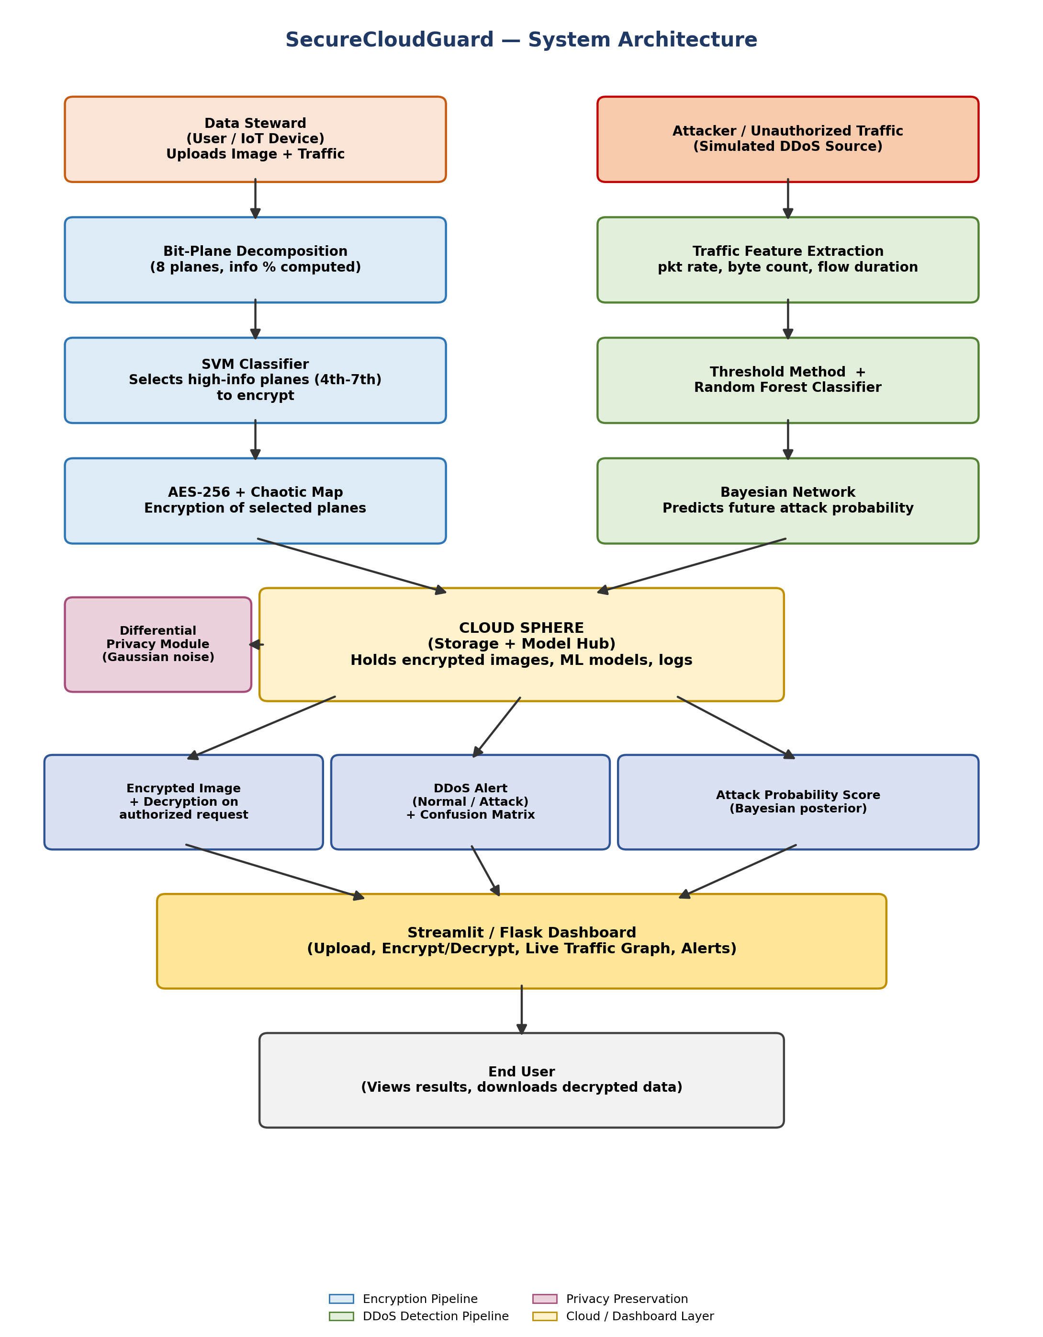
Fig. 1 — Proposed SecureCloudGuard system architecture (block diagram)

5.1 Objectives
- To design a selective image-encryption module that identifies and encrypts only high-information bit-planes, reducing encryption time versus full AES-256.
- To build and compare two DDoS detection methods — a threshold-based detector and a Random Forest classifier — on a standard intrusion dataset.
- To implement a differential-privacy mechanism that protects sensitive data statistics shared or aggregated in the cloud.
- To build a Bayesian Network that estimates the probability of a future DDoS attack from observed traffic features.
- To integrate all modules into a single interactive dashboard for demonstration and evaluation.

5.2 Planned Methodology

Phase I — Data Collection & Pre-processing
- Collect a small image set (grayscale, 8-bit) to test the encryption pipeline.
- Download a standard network-traffic/DDoS dataset such as CICIDS2017, the Kaggle SDN dataset, or NSL-KDD.
- Clean, normalize, and encode traffic features (packet count, byte count, flow duration, packet rate).

Phase II — Selective Image Encryption
- Bit-Plane Decomposition: split each 8-bit grayscale image into 8 binary planes and compute the % of information in each plane.
- SVM Classification: train a linear-kernel SVM to classify planes as 'encrypt' or 'skip' based on information density — planes 4-7 typically carry ~85-89% of the total information and will be prioritized.
- Encryption: apply AES-256 (with a chaotic logistic-map-based key/IV generator) only to the selected planes, then reassemble the image for storage.
- Metric we plan to measure: total encryption time of selective encryption vs full-image AES-256.
Fig. 2 shows the encryption/decryption flow we plan to implement for this module, from the original plaintext image through to the partially-encrypted composite that would be sent to the cloud.
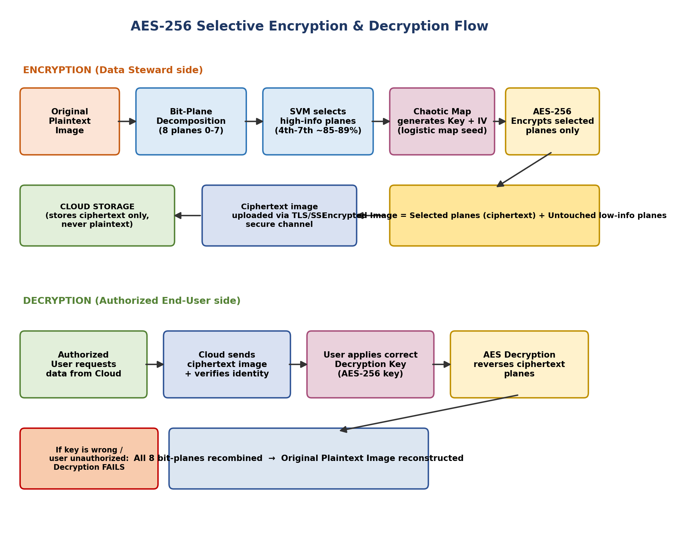
Fig. 2 — Planned AES-256 selective encryption and decryption flow
- The original image will be split into 8 bit-planes (0th = least significant, 7th = most significant).
- The SVM classifier will identify which planes carry the most information (typically planes 4-7, ~85-89% of total information) — only these will be marked for encryption.
- A chaotic logistic map will generate a highly sensitive key/IV seed, which feeds into AES-256 to encrypt only the selected planes — this is what is expected to make the process faster than full-image AES.
- The final 'encrypted image' will be a combination of the ciphertext planes plus the untouched low-information planes, transmitted to the cloud over TLS/SSL.
- The cloud is designed to never store plaintext — only this partially-encrypted composite image.
- On the decryption side, only a user with the correct AES-256 key will be able to reverse the ciphertext planes; all 8 planes will then be recombined to reconstruct the original image exactly.
- If the key is wrong or the requester is unauthorized, decryption is designed to fail and the plaintext will never be exposed.

Why Chaotic-Map Noise for Key Generation?
We are also specifically choosing AES-256 over the more common AES-128. AES-256 uses a 256-bit key instead of a 128-bit one, which gives it a far larger key space and a wider security margin against brute-force and future cryptanalytic advances — an appropriate choice given that SecureCloudGuard is meant to protect sensitive images (e.g., medical or IoT-sensor data) rather than low-value data. The extra key length does add some computational cost per encryption round, which is exactly why we are pairing it with selective bit-plane encryption: encrypting only 4-5 of 8 planes with the stronger AES-256 cipher is intended to keep the overall pipeline fast while still using the more secure key size on the planes that matter.
A plain AES-256 key is only as unpredictable as the random-number generator used to create it. Standard pseudo-random generators (PRNGs) can, over many runs, exhibit subtle statistical patterns that a well-resourced attacker could eventually study. We plan to generate our AES-256 key/IV pair using a chaotic logistic map instead of a plain PRNG, because chaotic systems display the 'butterfly effect': two starting seed values that differ by an extremely small amount (e.g. 0.0000001) produce completely uncorrelated, unpredictable output sequences. This gives our design three intended benefits: (a) a fresh, highly sensitive key can be derived deterministically from a small numeric seed for every encryption run, instead of reusing a static key; (b) even if part of the output sequence were somehow observed, the non-linear, non-periodic behaviour of the chaotic map is expected to make reconstructing the rest of the keystream computationally impractical; and (c) this choice follows the base paper, Pathak et al.'s HyMLCPP [1], which reports that chaotic-map-driven key generation improves resistance to statistical and brute-force cryptanalysis compared with linear PRNGs. To be clear about its role: the chaotic map itself does not encrypt anything — AES-256 still performs the actual encryption. The chaotic map's job is only to generate the key/IV in a way that is cheap to compute but extremely hard for an outsider to predict or reverse-engineer.

Phase III — DDoS Detection
- Method 1 — Threshold Detector: define a traffic-volume threshold (e.g., ~150 units) derived from regression analysis of normal traffic; flag traffic exceeding it as a potential attack.
- Method 2 — Random Forest Classifier: train an ensemble of decision trees on labelled traffic features (packet rate, byte count, flow duration) to classify traffic as Normal or DDoS Attack, evaluated using multiple train/test splits and k-fold cross-validation.
- Generate confusion matrices and compute Accuracy, Precision, Recall, and F1-score for each split once trained.
Fig. 3 shows how we plan to process incoming traffic — a mix of normal users and a simulated attacker — through both detectors and the Bayesian predictor.
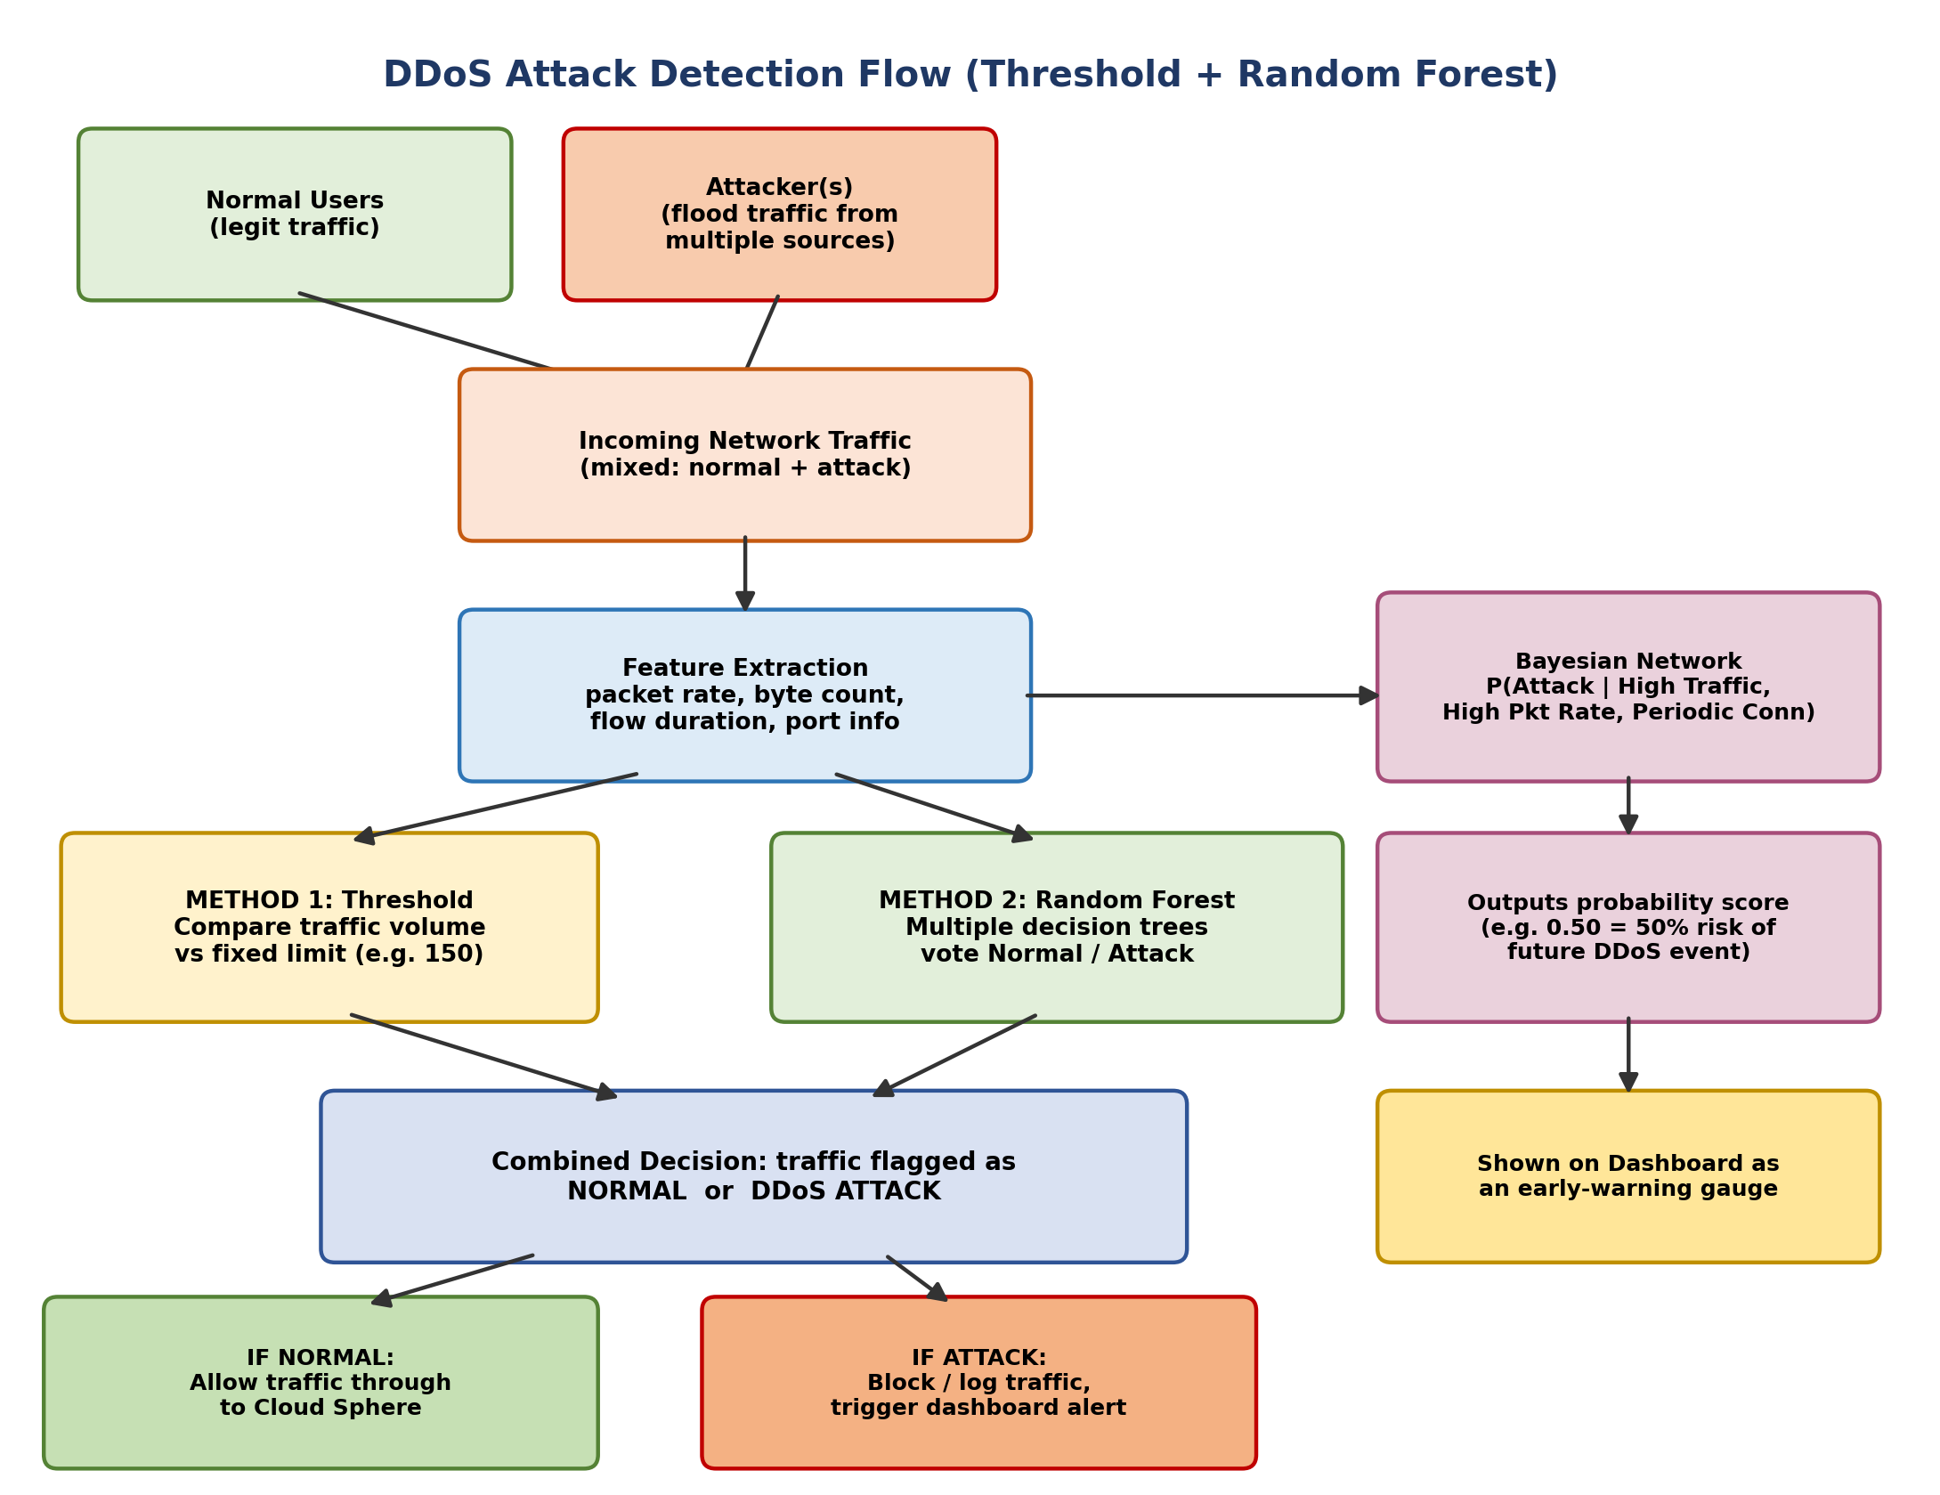
Fig. 3 — Planned DDoS attack detection flow (threshold + Random Forest + Bayesian prediction)
- Both normal users and a simulated attacker will send traffic toward the system at the same time (in the demo, simulated with a Python script generating random 'normal' values and a burst of abnormally high values).
- Key features will be extracted from this traffic: packet rate, byte count, flow duration, and port usage.
- Method 1 (Threshold): if the traffic volume crosses a fixed cut-off (e.g., ~150 units, derived from regression on normal traffic), it will be flagged as suspicious — fast but expected to be less accurate on subtle attacks.
- Method 2 (Random Forest): many decision trees will vote independently on whether the traffic pattern looks like an attack, based on training on a labelled dataset (e.g., CICIDS2017) — slower to train but expected to be more accurate on complex/evolving attacks.
- If either method flags an attack, the system is designed to block/log the traffic and raise a dashboard alert; if traffic is normal, it will be allowed through to the Cloud Sphere for storage/processing.
- In parallel, the Bayesian Network will continuously combine traffic-volume, packet-rate, and connection-pattern evidence to output a probability score (e.g., 'a 62% chance of a DDoS event in the near future'), giving the system a predictive, not just reactive, capability.

What Is a DDoS Attack, and Why Are We Focusing Specifically On It?
A Distributed Denial-of-Service (DDoS) attack works by flooding a server, network link, or cloud endpoint with traffic from many sources at once — often a botnet of compromised devices — until it exhausts the target's bandwidth, connections, or processing capacity. Once that happens, legitimate users and devices simply cannot get through. Fig. 4 illustrates this at a conceptual level: an attacker controls a botnet of hijacked devices, which together flood the target with junk requests, overwhelming it and locking out real users.
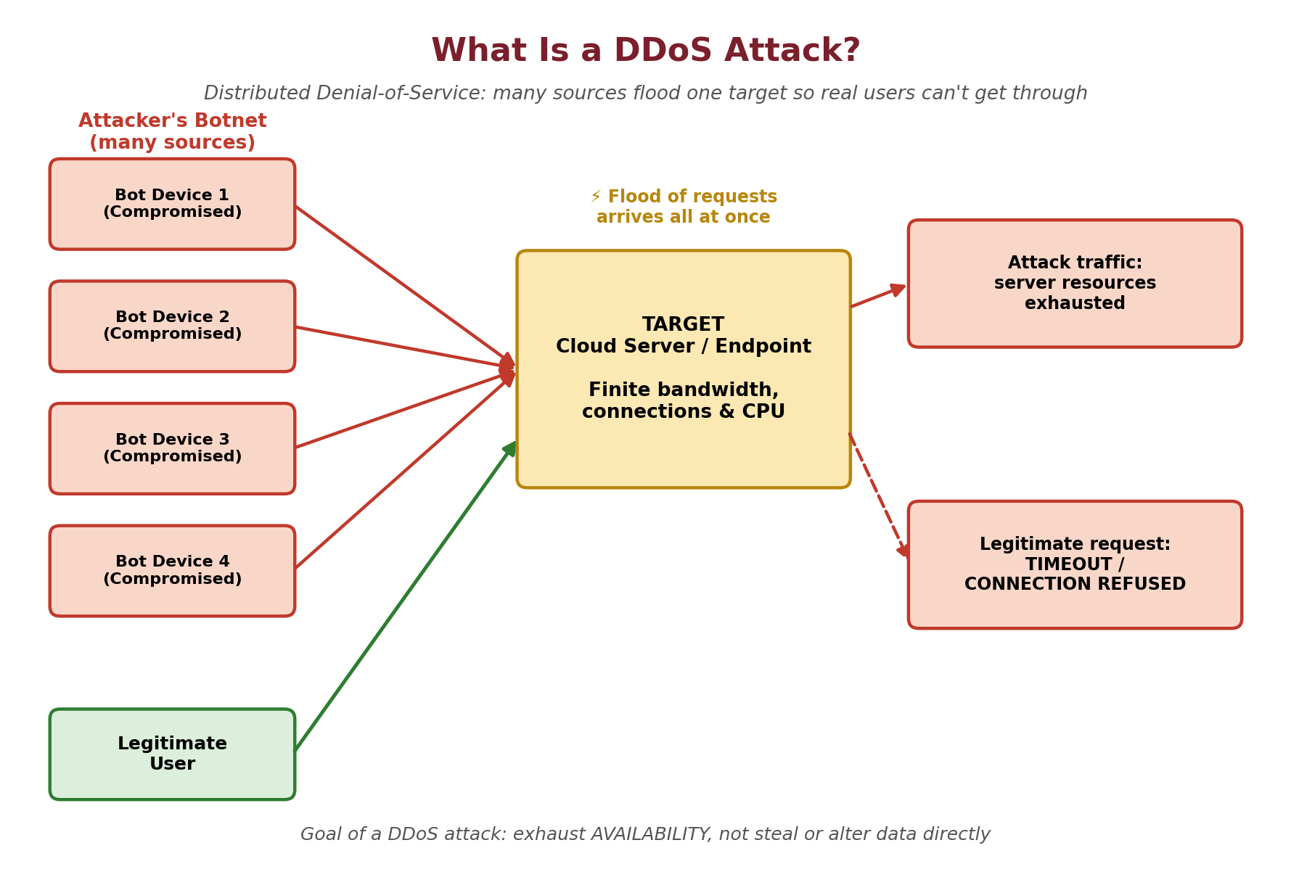
Fig. 4 — What a DDoS attack is: a botnet flooding a target until legitimate users are shut out
This is fundamentally different from an attack like Man-in-the-Middle (MITM), which mainly threatens the confidentiality and integrity of data already in transit rather than the availability of the service itself. A DDoS attack instead threatens availability directly — for a pipeline like SecureCloudGuard, that means images, sensor readings, and traffic may never even reach the encryption or monitoring stage in the first place if the cloud endpoint is knocked offline.
We are choosing to focus specifically on DDoS, rather than trying to cover every possible attack category in one project, for four reasons: first, it directly matches the scope of our base paper — Pathak et al.'s HyMLCPP [1] specifically targets DDoS, so keeping our own detector in the same category lets us make a fair, apples-to-apples comparison against its reported 99.9% accuracy and 1.2% false-positive rate; second, well-labelled public datasets for DDoS/traffic classification already exist (CICIDS2017, NSL-KDD, the Kaggle SDN dataset), which keeps the project realistic within an academic timeframe; third, IoT devices — a core part of our problem statement — are particularly exposed to DDoS, both as easy targets (limited compute/security hardening) and as unwilling participants recruited into botnets; and fourth, DDoS is an availability problem that pairs naturally with our confidentiality-focused encryption module, letting one project meaningfully address two of the three classic security pillars (confidentiality and availability) side by side, which is exactly the integration gap we identified in Section 4.
Table 2 places DDoS alongside MITM, the one other attack category directly relevant to our pipeline, since our AES-256 selective encryption already partially addresses it.
Attack Type | What It Primarily Targets | How This Project Addresses It
DDoS | Availability — floods the system so legitimate traffic cannot get through. | Included as a dedicated module. Matches the base paper's scope, has strong public datasets, and directly affects resource-constrained IoT devices in our problem statement.
Man-in-the-Middle (MITM) | Confidentiality/integrity of data while in transit. | Partially addressed — our AES-256 selective encryption plus TLS/SSL already reduces this risk, so we are not building a separate MITM detector in this iteration.
Table 2 — DDoS vs MITM: the two attack categories most relevant to this project

Phase IV — Privacy Preservation & Attack Prediction
- Differential Privacy: before publishing or sharing any aggregated statistic, add calibrated Gaussian noise N(0, σ²) so individual contributions cannot be reverse-engineered; tune epsilon (ε) and delta (δ) to balance privacy vs utility.
- Bayesian Network: model the relationship between High Network Traffic, High Packet Rate, Periodic Connection, and DDoS Occurrence as a Directed Acyclic Graph, and compute the posterior probability of an attack given evidence using pgmpy.

Dashboard (Planned)
- Build a Streamlit (or Flask) web app with an image-upload + encrypt/decrypt panel, a live/simulated traffic chart, a DDoS alert banner, and a probability gauge from the Bayesian model.
- Store encrypted images and logs in a local 'cloud' folder or a free-tier cloud bucket (e.g., Firebase Storage / AWS S3 free tier) to simulate the Cloud Sphere.

5.3 Technology Stack
We plan to use the following tools and libraries:
Component | Tool / Library | Purpose
Language | Python 3.10+ | Core implementation
Image Processing | OpenCV, NumPy, Pillow | Bit-plane decomposition, image handling
Cryptography | PyCryptodome (AES-256) | Selective encryption/decryption
ML — Classification | scikit-learn (SVM, Random Forest) | Encryption-block selection & DDoS detection
Probabilistic Model | pgmpy | Bayesian Network for attack prediction
Privacy | NumPy (custom Gaussian mechanism) | Differential privacy noise injection
Dataset | CICIDS2017 / Kaggle SDN / NSL-KDD | DDoS detection training & evaluation
Visualization | Matplotlib, Seaborn | Confusion matrices, ROC/accuracy graphs
Frontend / Dashboard | Streamlit (or Flask + HTML/CSS) | Interactive demo interface
Storage (simulated cloud) | Local filesystem / Firebase / AWS S3 (free tier) | Encrypted image & log storage

5.4 Planned Team Division of Work
As a four-member team, we plan to split ownership across the modules described above so that each phase has a clear, primary owner while remaining reviewable by the whole team: one member will lead the selective image-encryption module (bit-plane decomposition, SVM classification, AES-256 implementation); one will lead the DDoS-detection module (dataset preprocessing, threshold detector, Random Forest classifier); one will lead the privacy and prediction module (differential-privacy mechanism and Bayesian Network); and one will lead the dashboard integration and overall documentation. All members will collaborate on testing, evaluation, and the final report once each module is functional.

5.5 Planned Implementation Roadmap
Once this design is approved, we plan to follow this roadmap:
- Step 1: Set up the Python environment and install OpenCV, scikit-learn, PyCryptodome, pgmpy, and Streamlit.
- Step 2: Download and explore the chosen DDoS dataset (CICIDS2017 / Kaggle SDN / NSL-KDD); perform cleaning and feature selection.
- Step 3: Implement bit-plane extraction and information-density calculation for each of the 8 bit-planes; visualize each plane.
- Step 4: Train the SVM classifier to select encryption-worthy planes; implement AES-256 encryption restricted to those planes.
- Step 5: Benchmark selective-encryption time against full-image AES-256 encryption time.
- Step 6: Preprocess the traffic dataset; implement the threshold-based DDoS detector as a baseline.
- Step 7: Train the Random Forest classifier on multiple train/test splits; generate confusion matrices and classification reports.
- Step 8: Implement the differential-privacy noise mechanism and test it on an aggregated statistic such as mean packet count.
- Step 9: Build the Bayesian Network with pgmpy; define conditional probability distributions and query posterior attack probability.
- Step 10: Integrate all modules into a Streamlit dashboard with upload, encrypt/decrypt, live traffic simulation, and alert display.
- Step 11: Evaluate the complete system, generate comparison tables and graphs, and prepare the final report and presentation.

6. Results and Discussion (Expected Outcomes)
As this report is being submitted at the design and ideation stage, ahead of Interim Review-1, the system has not yet been implemented or tested. This section therefore discusses the outcomes we expect once development begins, based on the benchmarks reported by the base paper and related literature reviewed in Section 3.
- One project, two problems solved together: we plan to address data confidentiality (via selective AES-256 encryption) and data availability (via DDoS detection) jointly, instead of treating them separately as in most existing systems.
- Selective beats full encryption: by encrypting only the 4-5 most information-dense bit-planes, we expect to cut computation time versus full-image AES-256 without weakening protection of the meaningful content.
- Two DDoS detectors compared head-to-head: we intend to evaluate a fast, simple Threshold method against a more accurate, ML-based Random Forest, illustrating the classic speed-vs-accuracy trade-off in intrusion detection.
- Privacy by design: our planned Gaussian-noise differential-privacy mechanism is intended to protect any statistics shared or aggregated from the cloud, so individual data cannot be reverse-engineered.
- Prediction, not just detection: the Bayesian Network we plan to build will estimate the probability of a future attack from current traffic evidence, aiming to make the system proactive rather than purely reactive.
- Demoable by design: we plan to bring all four modules together into one interactive Streamlit dashboard so the working prototype can be demonstrated end-to-end at later reviews.
- Grounded in real research: every design choice is traceable to a specific published paper (Section 3), giving the project strong academic backing as we move into implementation.

6.1 Anticipated Challenges and Mitigation Plan
- Dataset imbalance: DDoS datasets like CICIDS2017 are often heavily skewed toward normal traffic; we plan to address this with stratified train/test splits and, if needed, class-weighting or resampling before training the Random Forest classifier.
- Privacy-utility trade-off: adding differential-privacy noise can reduce the usefulness of aggregated statistics if ε is set too low; we plan to test a small range of ε values and report the accuracy retained at each, rather than picking one value arbitrarily.
- Bit-plane selection accuracy: if the SVM misclassifies which planes are information-dense, encryption strength could be affected; we plan to validate plane selection visually (viewing each plane) before trusting the classifier's output.
- Integration complexity: combining four modules (encryption, detection, privacy, prediction) into one dashboard is expected to be the most time-consuming step; we plan to treat it as its own final stage of the roadmap, with dedicated end-to-end testing, so it isn't rushed alongside the individual modules.
We look forward to presenting the working prototype, along with actual experimental results and comparison data, at the subsequent review stages.

