SmartRestaurant
An ML-Based Demand Forecasting and Inventory Decision Support System for Sri Lankan Fast-Food Restaurants
CSE5015 Computing Project, HD in Computing & Software Engineering
Final report (DRAFT, 4 October 2026), Team ForeSight
Student number | Name | Role
CL/HDCSE/CMU/133/40 / st20345351 | R. M. Nimansa Pansiluni Rathnayake | Project Manager and Backend Developer
CL/HDCSE/CMU/133/96 / st20345396 | H. D. Dewmi Nethmini | System Analyst and Database Developer
CL/HDCSE/CMU/133/114 / st20345409 | S. G. M. Senugi Yewanthi Gunasekara | UI/UX Engineer and Frontend Developer
CL/HDCSE/CMU/133/127 / st20345416 | H. Sashini Madushi Pinto | Software Engineer and Machine Learning Developer
CL/HDCSE/CMU/133/130 / st20345419 | W. W. P. Himaya Poojani | QA Engineer and System Integration Developer

Supervisor: [TEAM: supervisor name]. Submission date: [TEAM: date].
About this draft. This draft was assembled from the project's code, planning documents, test log and ML
evaluation in the repository (docs/). Every figure, number and result in it can be traced to those sources.
Text marked [TEAM: ...] must be completed or checked by the team. The literature review in particular needs
more sources before submission. Follow the university's rules on declaring the use of AI tools for both the
software and this report (see the declaration below).

Contents
Contents
Declaration
Abstract
Acknowledgements
Abbreviations
1. Introduction
1.1 Context
1.2 Aim
1.3 Objectives
1.4 Research questions
1.5 Structure of the report
2. Background
3. Problem statement
4. Literature review
4.1 Forecasting perishable demand
4.2 Machine learning for food service
4.3 Commercial systems
4.4 Gap
5. Requirements and scope
5.1 Users and roles
5.2 Functional requirements
5.3 Non-functional requirements
5.4 Scope and exclusions
5.5 Key assumptions
6. Methodology
6.1 Development approach
6.2 Technology choices
6.3 Data strategy
6.4 Evaluation design
7. System design
7.1 Architecture
7.2 Service layer
7.3 Data model
7.4 Key interactions
7.5 Decision workflows
7.6 Interface design
7.7 Security design
8. Machine-learning approach
8.1 Problem formulation
8.2 Features
8.3 Models
8.4 Training, selection and versioning
8.5 Evaluation tool
8.6 Decision layer
9. Implementation
9.1 Code base
9.2 Main features as built
9.3 Deployment
10. Testing
10.1 Strategy
10.2 Results
10.3 Defects found by testing
10.4 What was not tested
11. Results and evaluation
11.1 Model comparison on the hold-out
11.2 Cross-validation
11.3 Contextual factors (ablation)
11.4 Requirements
11.5 Objectives and research questions
12. Discussion
13. Limitations
14. Conclusions and recommendations
15. References
Appendix A. Coverage of the proposal's 47 functions
Appendix B. Running the system
Appendix C. Hold-out error per item (XGBoost vs naive baseline)
Appendix D. Team contributions

Right-click the table of contents and choose "Update field" if page numbers are missing.

Declaration
We declare that this report and the system it describes are the work of Team ForeSight, except where stated and
acknowledged. [TEAM: replace with the university's standard declaration wording.]
Use of AI tools. [TEAM: state, as the university requires, which AI tools were used, for which parts of the
software and of this report, and how the output was checked.]

Abstract
Fast-food restaurants prepare perishable food before demand is known. Preparing too much creates waste; preparing too
little causes stock-outs and lost customers. In Sri Lankan outlets these decisions are usually made from recent sales
and experience, and the sales records that could support better decisions are kept but not analysed.
This project built SmartRestaurant, a web-based decision support system that forecasts daily demand for each menu
item seven days ahead and converts the forecast into decisions: how many portions to prepare, which ingredients will
run short, which alerts to raise and how much to reorder. The system has three roles (System Administrator, Food
Production Manager, Inventory and Procurement Manager), 23 pages, 89 JSON API endpoints and 30 database tables, and
implements all 47 functions listed in the approved proposal, two of them partly. It is built with Python, Flask, MariaDB (MySQL
compatible), pandas, scikit-learn and XGBoost, with a Vue and Bootstrap front end.
No real restaurant data was available, so the system was trained and demonstrated on two years of synthetic sales
generated for ten menu items with Sri Lankan calendar effects (Poya days and other public holidays, school holidays,
promotions, monsoon rain). On a 56-day hold-out the XGBoost model reached a mean absolute error of 9.20 portions per
item per day against 13.88 for a same-weekday-last-week baseline (33.7% lower) and within 0.93 portions of the best
achievable error on this data. A six-window rolling cross-validation confirmed that Random Forest and XGBoost beat both
baselines in every window but are not meaningfully different from each other. A feature ablation showed that
promotions improved the forecast in every window and holidays in four of six, while weather added nothing, because
only a seasonal average is known at forecast time.
332 automated tests, scripted browser walkthroughs of all three roles in Chromium, Firefox and WebKit, a security
checklist and a security and quality audit were run. Forecasts are produced in 0.27 s and every page responds in
under 0.25 s. The main limitation is the synthetic data: the
results show that the forecasting and decision pipeline works and which kinds of context it can use, not how accurate
it would be in a real restaurant. Validation on real sales data and a usability study with restaurant staff are the
most important next steps.
Keywords: demand forecasting, decision support, food waste, inventory management, XGBoost, Random Forest, Sri Lanka

Acknowledgements
[TEAM: supervisor, lecturers, anyone who helped.]

Abbreviations
Term | Meaning
API | Application Programming Interface
CSRF | Cross-Site Request Forgery
CV | Cross-validation
FEFO | First Expired, First Out
FR / NFR | Functional / Non-Functional Requirement
MAE | Mean Absolute Error (portions per item per day)
MAPE / WAPE | Mean / Weighted Absolute Percentage Error
ML | Machine Learning
MVC | Model-View-Controller
RBAC | Role-Based Access Control
RMSE | Root Mean Squared Error
UAT | User Acceptance Testing
UML | Unified Modelling Language

1. Introduction

1.1 Context
Imagine an ordinary Friday evening in a Sri Lankan fast-food restaurant. As the dinner rush builds, the kitchen
prepares more of the popular items (burgers, fried chicken, kottu, fries) based on experience. Demand rarely matches
the plan exactly. On some nights food and opened ingredients are left over at closing time and must be thrown away;
on others a popular item sells out early and customers leave. Both outcomes come from the same decision: how much to
prepare and how much stock to hold before the actual demand is known.
Restaurants already record the data that could inform this decision: daily sales per item, stock received and used,
and in many cases promotions and the dates of holidays. The patterns in that data, such as which days are busy, how
demand changes on Poya days or during school holidays, and how much a discount lifts sales, are too spread out to
judge by eye or in a simple spreadsheet. Machine learning can learn such patterns from history, but a forecast on its
own does not help the kitchen. It becomes useful only when it is turned into a concrete recommendation: prepare 114
chicken burgers, expect to run 17.5 kg short of chicken, order 80 kg from the usual supplier.

1.2 Aim
The aim stated in the proposal is twofold: to establish whether machine learning can produce reliable food-demand
forecasts in the Sri Lankan fast-food setting, and to examine how those forecasts can be converted into decision
support that restaurant staff will actually use.

1.3 Objectives
The proposal does not list numbered objectives; the following are derived from its aim and requirements.
[TEAM: confirm or adjust.]
# | Objective | Where it is addressed
O1 | Build item-level daily demand forecasts from sales history and Sri Lankan contextual data (calendar, holidays, promotions, weather) | Chapters 8, 11
O2 | Compare machine-learning models with simple baselines and select a model on honest, out-of-sample evidence | Sections 8.4, 11.1-11.2
O3 | Convert forecasts into preparation quantities, ingredient requirements, shortage alerts and reorder suggestions | Sections 8.6, 7.5
O4 | Record actual outcomes (prepared, served, waste, stock movements) so forecasts can be evaluated and improved | Chapter 9, Section 11.4
O5 | Provide a secure, role-based web interface usable on desktop and phone | Chapters 7, 9, 10
O6 | Evaluate the system against the functional and non-functional requirements | Chapters 10, 11

1.4 Research questions
- RQ1. Can a machine-learning model forecast daily item demand more accurately than the simple rules a restaurant
would otherwise use (same day last week, average of recent same weekdays)?
- RQ2. Which contextual factors (holidays, promotions, weather) improve the forecast, and where?
- RQ3. How can a forecast be turned into preparation and purchasing decisions that staff can check and act on?

1.5 Structure of the report
Chapters 2 to 4 give the background, the problem and the literature. Chapter 5 sets out the requirements and scope,
Chapter 6 the methodology. Chapters 7 to 9 describe the design, the machine-learning approach and the implementation.
Chapter 10 covers testing, Chapter 11 the results, Chapter 12 the discussion and Chapter 13 the limitations. Chapter 14
concludes and recommends future work.

2. Background
Sri Lanka's fast-food sector has grown quickly over the past decade with urbanisation, rising incomes and a shift
toward convenient dining among young professionals and students. International chains compete with many local
outlets, especially in Colombo, Kandy and Galle, which keeps margins under pressure. [TEAM: add a source for the
market growth figures if one is quoted.]
Fast food differs from most retail because food is perishable and is prepared before demand is known. A batch of fried
chicken or burger patties may stay fresh for only a few hours. Two problems follow. Food waste comes mainly from
over-preparation: unsold food and opened ingredients cannot be reused. Stock-outs come from under-preparation:
customers are turned away, and a customer who cannot get what they came for may not return. Waste is visible;
stock-outs are not, but may cost more over time.
Both problems come from the difficulty of estimating demand. Most outlets rely on recent sales, rules of thumb or a
manager's experience. This works for obvious patterns, such as busier weekends, but breaks down when several factors
combine, for example a rainy Friday during the school holidays with a promotion running, and it gives no structured
way to turn an estimate into a preparation quantity or a purchase order.
Sri Lanka adds its own context. Every full-moon (Poya) day is a public holiday on which many people avoid meat and
alcohol, so demand for meat dishes may fall while other items rise. The calendar also has the Sinhala and Tamil New
Year, Vesak, several religious holidays whose dates move every year, long school vacations, and two monsoon seasons
that bring heavy rain. Findings from other countries do not transfer automatically to this setting.

3. Problem statement
The business process studied is the daily decision of which products a fast-food restaurant should prepare, in what
quantities, and how to manage the raw-material inventory they need. Today these decisions are typically made from
recent sales, experience and intuition, without a forecasting procedure.
This leads to two recurring outcomes. When demand is overestimated, perishable food (fried chicken, burger patties,
cut vegetables) is overproduced and discarded at closing time, wasting the ingredients and the labour. When demand is
underestimated, items sell out early and customers are turned away or switch to other products. Both outcomes
come from the same cause: preparation and inventory decisions are made without a reliable advance estimate of demand.
This is a limitation of the process, not of staff effort. Experience handles simple patterns but not the combined
effect of several factors at once, and it offers no method for converting an estimate into a quantity to prepare or
an ingredient order. At the same time, restaurants already collect the data that could support better decisions,
but use it for record-keeping rather than planning. SmartRestaurant addresses this by using existing operational data
to forecast demand and to support preparation and inventory decisions.

4. Literature review
[TEAM: this chapter is still based only on the sources cited in the proposal. A final report needs a wider
review (typically 15 or more sources): demand forecasting in food service and retail, machine learning versus
statistical methods, food waste in restaurants, inventory decision support, and anything on Sri Lanka. Add the
sources and complete the reference list in Chapter 15.]

4.1 Forecasting perishable demand
Arunraj and Ahrens (2015) combined a seasonal ARIMA model with external regressors (SARIMAX) and quantile regression
to forecast daily banana sales at a German discount retailer, outperforming several benchmarks. The study shows that
statistical forecasting adds value for perishable goods, and that calendar and promotion effects matter. It is set in
retail rather than food service, however, and it stops at forecast accuracy: it does not connect the forecast to a
preparation or ordering decision.

4.2 Machine learning for food service
A 2026 preprint by Naeem et al. trained machine-learning models on restaurant food-waste data, with Random Forest
performing best (R² = 0.817). The paper has not yet been peer reviewed and its authors state that the waste variable
is assumption-based rather than measured, so its results are indicative only. More broadly, the forecasting
literature suggests that tree-based machine-learning and hybrid methods may do better than purely statistical models
when several contextual variables interact. Random Forest (Breiman, 2001) and gradient-boosted trees such as XGBoost
(Chen and Guestrin, 2016) are widely used for this kind of tabular data because they capture non-linear effects and
interactions without manual feature engineering. Given the small number of restaurant-specific studies, this should
be read as a general tendency rather than a proven advantage, which is why this project compares both models against
simple baselines (Hyndman and Athanasopoulos, 2021). [TEAM: add restaurant or food-service forecasting studies.]

4.3 Commercial systems
Toast, a widely used restaurant platform, documents inventory functions based on recipe-based stock depletion and par
levels to flag low-stock items and support reordering (Toast Support Center, n.d.). This goes beyond sales tracking,
but it is rules-based: depletion is calculated from recipes and current stock, and reorders are triggered when stock
falls below a fixed level, rather than being predicted from context such as weather, promotions or holidays. Whether
such platforms are affordable and suitable for smaller Sri Lankan outlets was not established by the sources
reviewed. [TEAM: add one or two further systems, e.g. other POS or inventory products used in Sri Lanka.]

4.4 Gap
Academic studies reviewed focus mainly on forecast accuracy; commercial systems manage stock with fixed rules. Limited
evidence was found of systems that combine machine-learning demand forecasts with ingredient-level preparation and
purchasing decisions, and none for Sri Lankan fast-food restaurants. SmartRestaurant addresses this gap by linking an
item-level forecast directly to preparation quantities, ingredient requirements, alerts and reorder suggestions, using
data a typical local outlet can realistically collect.

5. Requirements and scope

5.1 Users and roles
Role | Responsibilities in the system
System Administrator | Users and roles, menu, recipes, restaurant information, settings and alert configuration, data import, model training and activation, monitoring, analytics and reports
Food Production Manager (kitchen) | Daily forecast, preparation recommendations, recording prepared, served and wasted quantities and ingredient usage, ingredient requirements, pre-orders and daily orders, availability, stock requests, shortage reports
Inventory and Procurement Manager | Ingredients, suppliers, stock in and out, wastage, adjustments, expiry, reorder suggestions, purchase orders, kitchen stock requests, alerts, inventory data check

Figure 1 shows the use cases of each role.
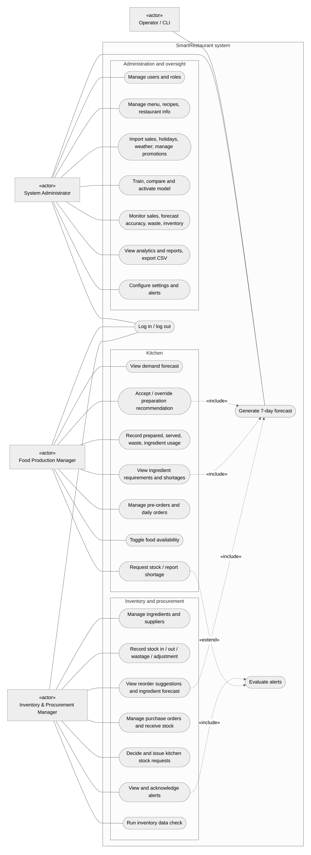
Figure 1. Use case diagram. Actors are drawn as boxes labelled «actor»; «include» marks use cases that always rely
on the forecast or on alert evaluation.

5.2 Functional requirements
ID | Requirement (from the proposal)
FR1 | Authorised login with role-based access for the three roles
FR2 | Import or enter historical sales data per menu item
FR3 | Record or import contextual data (day of week, holidays, promotions, weather)
FR4 | Generate item-level demand forecasts for a defined short-term period
FR5 | Convert forecasts into recommended preparation quantities
FR6 | Estimate ingredient requirements from forecasts and recipe data
FR7 | Compare forecast requirements to current stock and flag shortages
FR8 | Record actual sales, preparation quantities and waste
FR9 | Record stock movements: stock-in, stock-out, adjustments and wastage
FR10 | Display forecasts, recommendations and alerts on a dashboard
FR11 | Store forecasts and outcomes for future evaluation
FR12 | View basic operational reports, including waste and inventory trends

The proposal's function tables list 47 role functions (14 administrator, 15 kitchen, 18 inventory). They were turned
into 56 user stories with acceptance criteria (docs/REQUIREMENTS.md); Appendix A maps every function to its
implementation.

5.3 Non-functional requirements
ID | Requirement | Measurable target used in this project
NFR1 | Usability: simple enough for non-technical staff | A first-time user completes the daily kitchen task in about five minutes; pages usable at phone width
NFR2 | Performance: forecasts within a few seconds | Forecast run for all items under 5 s; any page or API request under 3 s
NFR3 | Reliability: handles missing or incomplete data | Missing history falls back to a labelled baseline; failed runs are recorded with a readable reason
NFR4 | Accessibility: standard browsers, desktop and mobile | No horizontal scrolling at 360, 768 and 1280 px
NFR5 | Security: authentication and RBAC | Server-side role check on every route, CSRF on all writes, hashed passwords, lockout
NFR6 | Maintainability: periodic model updates | Versioned models with activation and rollback; layered code with enforced import rules
NFR7 | Scalability: future multiple outlets | Every table carries outlet_id
NFR8 | Data integrity: input validation | Validation in the service layer, database constraints as the backstop; upper limits so that no single entry can distort the forecast

5.4 Scope and exclusions
In scope: one restaurant (outlet); seven-day item-level forecasts; preparation, ingredient, alert and reorder
decisions; recording of outcomes; internal supplier and purchase-order records; dashboards and reports.
Out of scope, as approved in the proposal: multiple branches, automatic ordering or any integration with supplier
systems, point-of-sale and payments, staff scheduling, accounting, and continuous automatic retraining (models are
retrained periodically by the administrator).

5.5 Key assumptions
Assumption | Reason
Synthetic data | No real restaurant sales history could be obtained in the project period. A generator produces two years of realistic data with known effects (Section 6.3); it is labelled "Synthetic demo data" on every page.
Location Colombo | Holidays and weather follow Colombo.
Forecast horizon 7 days | Covers next-day preparation and supplier lead times of a few days.
One builder for the software | [TEAM: describe the actual division of work, as required by the module.]

6. Methodology

6.1 Development approach
The project followed an Agile life cycle, as proposed. Work was planned as vertical slices, each ending with
something that ran end to end: foundation (models, login, role checks), data and forecasting, preparation
recommendation and kitchen recording, stock, requirements and alerts, the inventory interface, and administration and
monitoring (docs/PLAN.md). Requirements were prioritised into tiers: M1 (the core demo loop, never cut), M2
(the rest of the minimum viable product), S (stretch) and X (postponed), with a pre-agreed "trim ladder" of
features to drop if the schedule slipped. After the core was finished, a scope change on 21 September 2026 brought
every remaining function of the proposal into scope; these were built in three further tiers. Each feature followed
the same order: service and its tests, then the API, then the page.
Object-Oriented Analysis and Design was used for the analysis and design, documented with UML use case, class,
sequence and activity diagrams (Figures 1 and 3 to 10) and an entity-relationship diagram (docs/DATABASE.md).
Git and GitHub were used for version control, with one commit per finished work package.
[TEAM: describe meetings, task allocation, the board or tracker used, and how the team reviewed work.]

6.2 Technology choices
Layer | Technology | Why
Back end | Python 3.14, Flask 3.1, Flask-SQLAlchemy, Flask-Migrate, Flask-Login, Flask-WTF | Proposal stack; small, well-documented, suits a layered design
Database | MariaDB 11.8 (MySQL compatible) | The proposal specifies MySQL; MariaDB is a drop-in replacement and was available on the server
Data and ML | pandas, NumPy, scikit-learn 1.9 (Random Forest), XGBoost 3.4, joblib | Proposal stack; tree models suit tabular data with interacting features
Front end | Jinja2 pages with Vue 3, Bootstrap 5 and Chart.js, stored locally (no build step, no CDN) | Responsive interface without a separate single-page application; works offline at the demo
Testing | pytest, pytest-cov, Playwright (headless Chromium, Firefox and WebKit) | Unit, integration, API, timing and browser tests
Deployment | gunicorn behind nginx (HTTPS, Let's Encrypt certificate) on an Ubuntu server, as an unprivileged systemd service; MariaDB instance for the project | Simple demo deployment; a local copy is the fallback

6.3 Data strategy
No real sales history from a Sri Lankan restaurant could be obtained during the project. Rather than build on a small
or unrelated public dataset, the team generated synthetic data whose structure is known, which also makes it
possible to check whether the model recovers that structure. The generator (app/seed/generate.py) produces daily
sales for ten menu items from 1 September 2024 to the day before the demo (763 days, 7,630 item-days), together with
preparation and waste records. Expected demand for an item on a day is
expected = base(item) × weekday × month × holiday × promotion × rain × trend
where Friday to Sunday are 15-30% above Monday to Thursday; April and December are 15% higher; public holidays add
15%; Poya days reduce meat dishes by 35% and raise other food by 10%; school holidays lift some items by 10%; a
promotion with discount d% raises demand by 2d%; rain lowers demand by up to 16% (32% for drinks); and a 10% upward
trend runs over the two years. Actual sales are drawn as Poisson(expected × noise) with log-normal noise. Because the
expected value is known, the noise floor (the error of a perfect model) can be computed and reported.
The holiday calendar (data/holidays_lk.csv) lists Poya days, public holidays and approximate school vacations.
The Poya days and movable holidays are the dates declared in the government calendars (checked on 4 October 2026; an
earlier version computed Poya days from the astronomical full moon and put 19 of them a day late). The data are
loaded through the same import services as real data would be, so real sales can replace them through the CSV import
without code changes.

6.4 Evaluation design
Forecast accuracy is measured with MAE (in portions, the main criterion), RMSE, MAPE, WAPE, R² and bias. Evaluation is
always chronological: a model is tested only on days after the data it was trained on, and the weather used for
test days is the seasonal estimate that would be known when forecasting, not the weather that actually happened.
Three levels of evidence are used:
- Hold-out: the last 56 days, used to select the model shipped in the system.
- Rolling-origin cross-validation: six consecutive 28-day windows, each with the models retrained on all earlier
days, to check that the comparison does not depend on one period (Hyndman and Athanasopoulos, 2021).
- Feature ablation: the selected algorithm trained with calendar and history features, then with holidays,
promotions and weather added one group at a time, with errors broken down on holiday, promotion and wet days.
The decision layer and the rest of the system were evaluated with hand-calculated test cases, automated tests,
scripted browser walkthroughs, a security checklist and a security and quality audit (Chapter 10).

7. System design

7.1 Architecture
SmartRestaurant is a layered Model-View-Controller web application (Figure 2, from docs/ARCHITECTURE.md).
- View: Jinja2 page templates per role; each page mounts a small Vue component that calls the JSON API and draws
charts with Chart.js.
- Controller: Flask blueprints for the pages (auth, admin, kitchen, inventory) and for the API
(/api/v1). Controllers only parse the request, check the role, call one service method and map errors to HTTP
status codes (422 validation, 404 not found, 409 conflict).
- Model: a service layer that holds all business logic, validation and transactions; the ml package
(pure Python on DataFrames, no database or web code); and SQLAlchemy models that only describe tables.
These rules are enforced by an automated architecture test: controllers may not import models or the ml package or
commit transactions, services may not know about HTTP, the ml package may not import Flask or the database, and
only the forecasting service may call it. A command-line interface (flask smartrest ...) gives administrators and
operators access to seeding, training, forecasting, evaluation and checks through the same services.
Browser (Vue page) --fetch JSON--> API controller --> role check, CSRF --> service --> SQLAlchemy --> MariaDB
\--> ml package --> model files

Figure 2. Layers and request path (the full diagram is in docs/ARCHITECTURE.md, section 2).

7.2 Service layer
Eight services each own one area (Figure 3). The arrows show which services call which; the graph has no cycles, and
an automated test fails if a service imports one it is not allowed to.
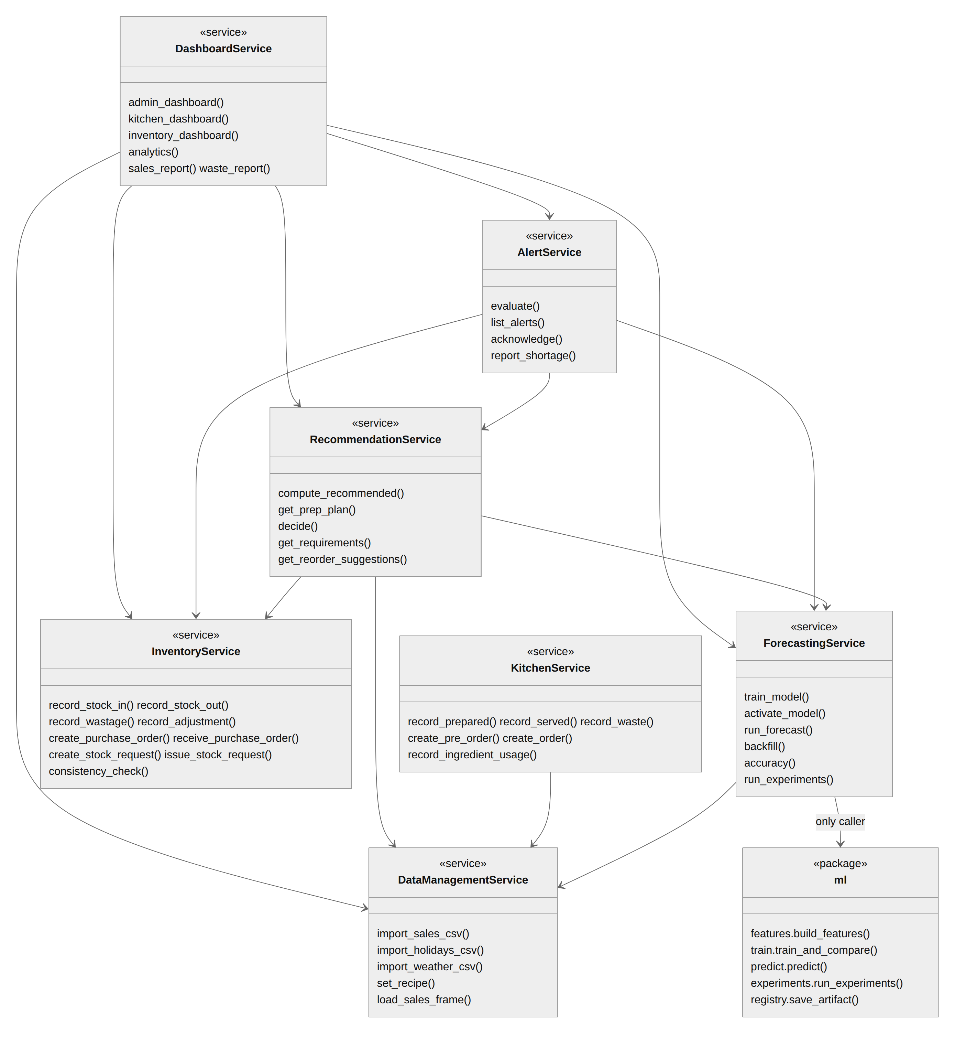
Figure 3. Service layer and ml package with their main operations; arrows are the actual imports.
AuthService and the settings and audit helpers call no other service and are omitted.

7.3 Data model
The database has 30 tables. Figures 4 and 5 show the main classes; the full entity-relationship diagram is in
docs/DATABASE.md. Design decisions worth noting:
- Stock is never stored as a running total. Each delivery is a batch with an expiry date, and every change is an
immutable movement (stock-in, stock-out, wastage, adjustment). Current stock is derived from batches and checked
against the movements by the inventory data check.
- Forecasts are never overwritten. A new run inserts new rows and marks the old ones as no longer latest, so every
forecast that was ever shown can be compared with what actually happened (FR11).
- Recommendations store the numbers behind them (forecast, buffer, pre-orders, batch size, recommended and final
quantity, override reason), so every kitchen decision can be audited.
- Money and quantities are exact decimals; every table carries outlet_id for a future multi-outlet version (NFR7).
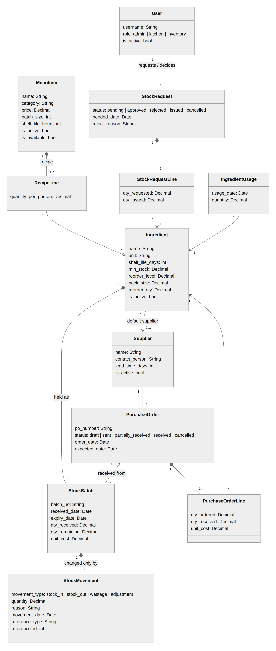
Figure 4. Menu, recipes, stock and procurement.
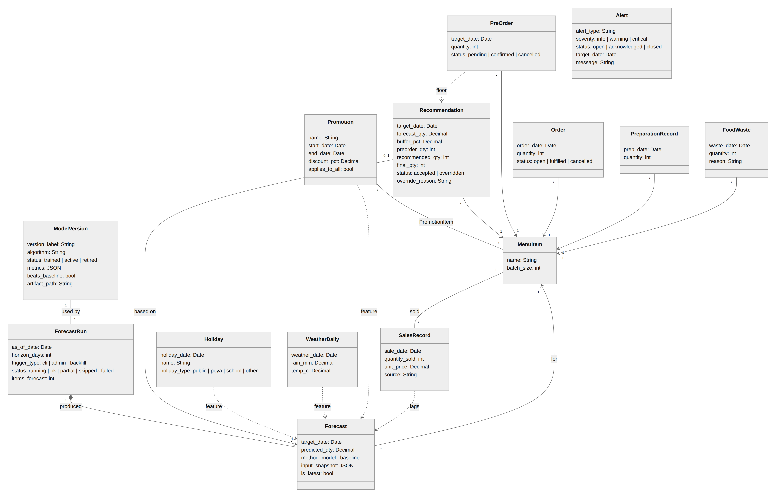
Figure 5. Demand data, forecasting and kitchen decisions. Dashed arrows show which data feed the forecast.

7.4 Key interactions
Figures 6 to 8 show the three most important flows: producing the forecast, a kitchen decision on it, and receiving
stock that clears an alert.
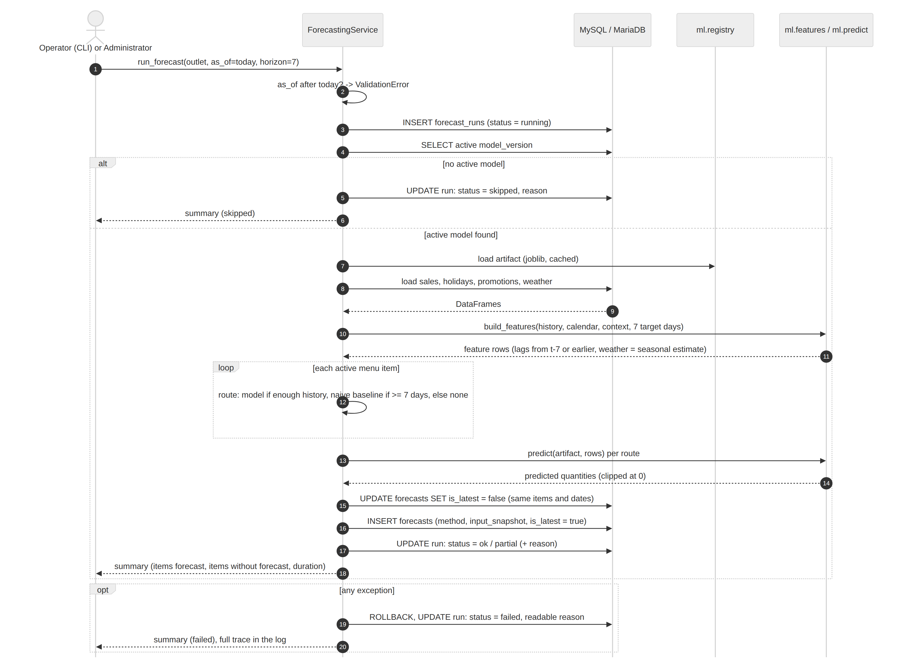
Figure 6. Generating the seven-day forecast, including the skipped (no active model) and failed paths.
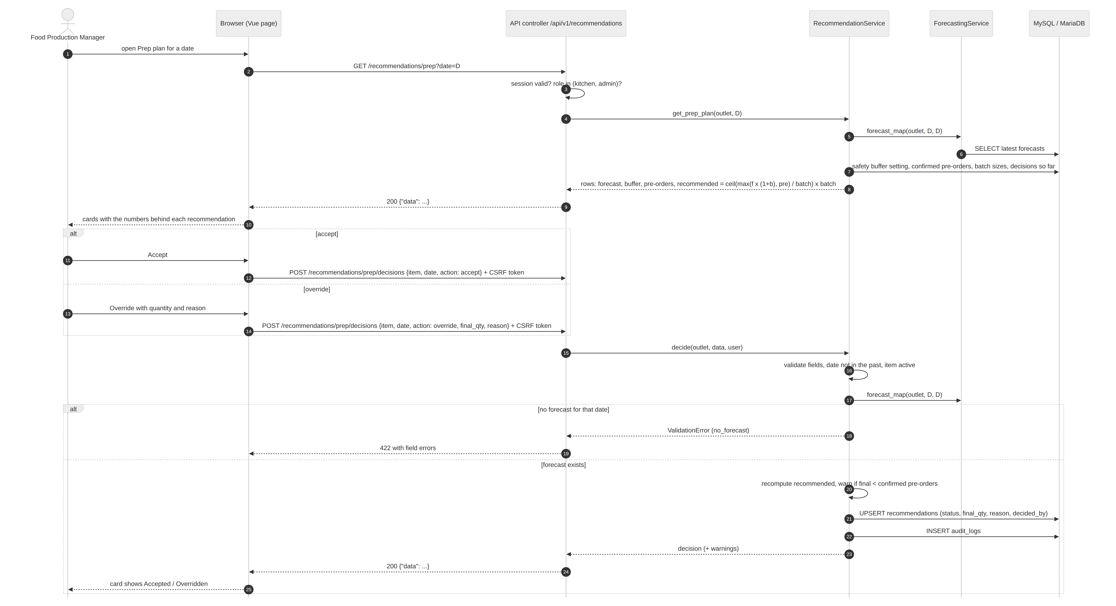
Figure 7. The kitchen opens the prep plan and accepts or overrides a recommendation.
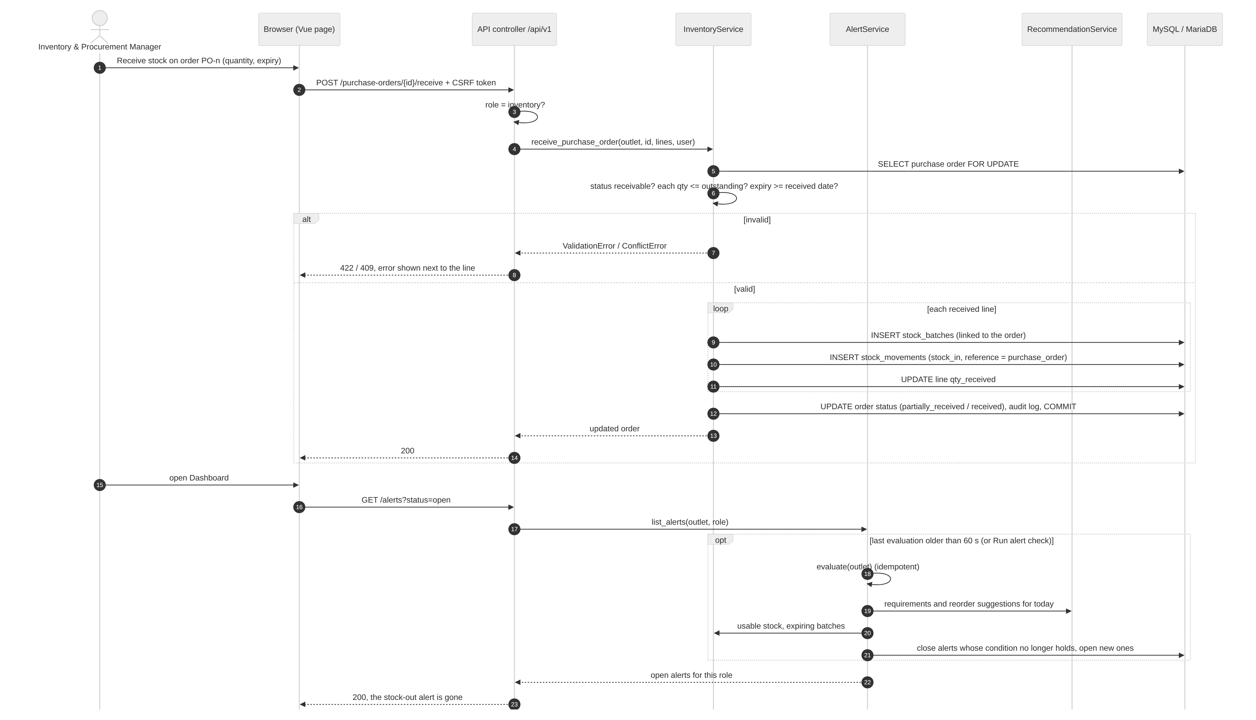
Figure 8. Receiving a purchase order; the stock-out alert closes on the next alert evaluation.

7.5 Decision workflows
Figure 9 shows the daily cycle that links the forecast to purchasing; Figure 10 the kitchen stock request.
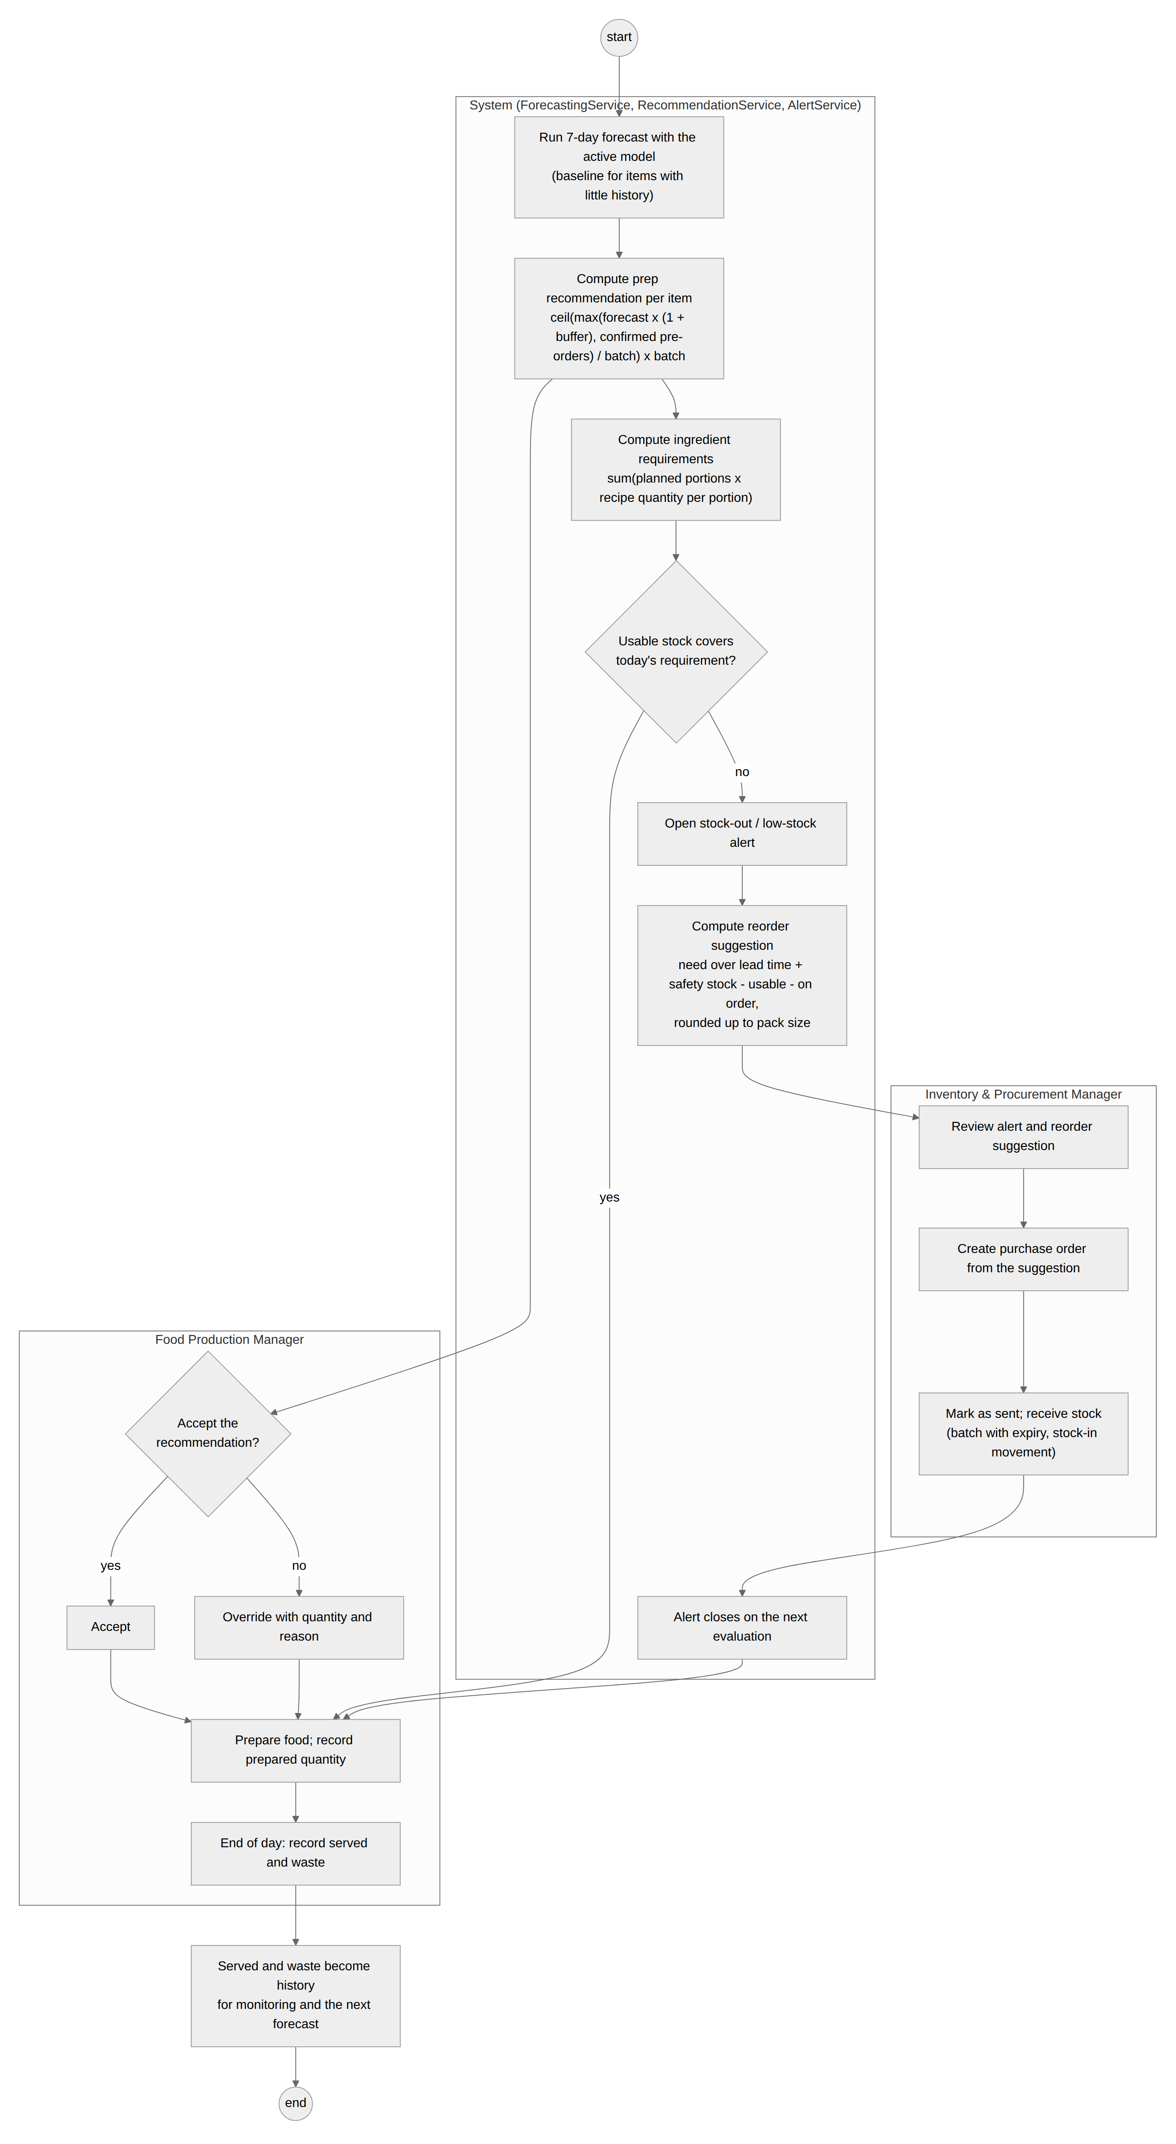
Figure 9. The daily forecast-to-purchase cycle across the system and the two manager roles.
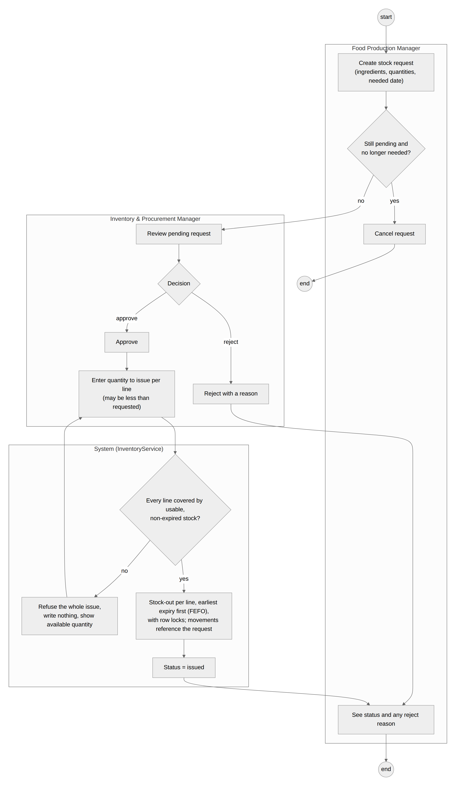
Figure 10. A kitchen stock request: issuing is all-or-nothing across lines and never uses expired stock.

7.6 Interface design
The interface follows one layout for all roles: a sidebar with the role's pages, a top bar with the "Synthetic demo
data" label and the alert bell, and pages built from shared components (stat tiles, tables, cards, charts). Each role
has an accent colour. Kitchen pages are designed for phone use in the kitchen (large buttons, one card per item), and
every number in a recommendation is shown next to it so staff can see why the system suggests it. The page designs
and components are specified in docs/UI_PLAN.md.

7.7 Security design
Passwords are stored as salted scrypt hashes and must be 8 to 128 characters, must not contain the username and
must not be letters only. Logins give the same message for an unknown user, a wrong password and a deactivated
account, and are locked after five failures for one username from one address (or twenty from one address over any
usernames), so that someone guessing from outside cannot lock staff out of the restaurant's own terminal. Every page
and API route declares the roles allowed, and the server checks them on every request. All writes require a CSRF
token; output is escaped (no raw HTML is inserted from data); queries are parameterised by SQLAlchemy. Every
response carries a Content-Security-Policy that allows no inline script and no framing, together with
X-Content-Type-Options and Referrer-Policy headers. Sessions expire after 30 minutes of inactivity; logging out,
a password reset or a deactivation ends the session on the server, so a copied session cookie stops working too.
Cookies are HttpOnly and SameSite, and logged-in pages are not cached. Every number entered has an upper limit,
every date range a request can ask for is bounded, uploads are capped at 5 MB, and CSV exports neutralise cells that a
spreadsheet would run as formulas. The demonstration server is reached only over HTTPS (TLS 1.2 and 1.3, Let's
Encrypt certificate): plain HTTP is redirected, browsers are told to keep using HTTPS (HSTS), the session cookie is
marked Secure, and form posts over HTTPS must come from the application's own pages. The application and its
database run as an unprivileged user in a restricted systemd service, and gunicorn accepts connections only from the
local web server. Secrets live in an environment file that is not in the repository.

8. Machine-learning approach

8.1 Problem formulation
The target is the quantity sold per menu item per day. Each morning the system forecasts the next seven days for
every active item. Forecasting is direct, not recursive: every history feature is lagged by at least seven days, so
the forecast for day t uses only sales up to t-7, and the same model serves all seven days without feeding its
own predictions back in. This also prevents leakage by construction.

8.2 Features
Group | Features
Calendar | day of week, weekend flag, month
Holidays | public holiday, Poya day, school holiday (flags)
Promotion | discount percentage on that item and day
Weather | rain (mm) and temperature (°C); when forecasting, the average for that month from past data
History | sales 7, 14, 21 and 28 days earlier; mean of the 7 and 28 days ending 7 days earlier
Item | one-hot indicator of the menu item

Missing history is handled explicitly (NFR3): a missing lag is filled from the next weekly lag, then from the rolling
means, then from the item's own average, and the forecast is flagged as "lags imputed". An item with less than 35 days
of history (a setting) uses the naive baseline instead of the model; an item with less than a week gets no forecast,
and the run reports it as partial with the reason.

8.3 Models
Model | Description
naive_lag7 | Same weekday last week (baseline)
seasonal_mean4 | Mean of the last four same weekdays (baseline)
Random Forest | 300 trees, minimum 3 samples per leaf (Breiman, 2001; scikit-learn)
XGBoost | 300 boosted trees, depth 5, learning rate 0.05, 80% row and column sampling (Chen and Guestrin, 2016)

Hyperparameters were set to reasonable values and not tuned, to keep the comparison simple and avoid overfitting the
single hold-out; a search is left as future work.

8.4 Training, selection and versioning
Training uses all usable history except the last 56 days. The model with the lowest hold-out MAE is selected (ties
go to the simpler model), then refitted on all history for use. A model is shipped only with its comparison: the
stored metrics, whether it beats the naive baseline, and a sentence explaining the choice. If no learned model beats
the baseline, the baseline is used and the system says so. Each trained model is a version with its metrics,
features, parameters, library versions and file; the administrator activates a version from the Models page, and the
previous one is kept for rollback (NFR6). Forecasts for past days (the backfill used for accuracy monitoring) use the
copy of the model fitted before the hold-out, so monitored accuracy is genuinely out-of-sample.

8.5 Evaluation tool
flask smartrest evaluate runs the cross-validation and the feature ablation of Section 6.4 on the current data
without storing or activating anything (app/ml/experiments.py). Its full-feature hold-out result reproduces the
shipped model's metrics exactly, which an automated test checks.

8.6 Decision layer
The forecast is converted into decisions by explicit, tested formulas:
- Preparation quantity: recommended = ⌈ max(forecast × (1 + buffer), confirmed pre-orders) ÷ batch size ⌉ ×
batch size, with a 10% safety buffer by default. Example: forecast 101.7 chicken burgers, buffer 10%, batch 6 gives
⌈111.9 ÷ 6⌉ × 6 = 114. The kitchen accepts it or overrides it with a quantity and a mandatory reason.
- Ingredient requirements: the sum over menu items of planned portions × recipe quantity per portion, compared with
usable (unexpired) stock; a gap is a shortage and raises an alert.
- Reorder suggestion: need over the supplier lead time + minimum stock − usable stock − quantity already on order,
rounded up to the pack size and the minimum order quantity; never negative.
- Alerts: low stock, critically low stock, projected stock-out, expiry warning, waste risk, failed forecast and
manually reported shortage. Alerts are re-evaluated when read (at most once a minute) and close themselves when the
condition no longer holds.

9. Implementation

9.1 Code base
Part | Contents | Lines of code
app/models | 30 tables | 514
app/services | 8 services plus settings, audit and validation helpers | 2,930
app/controllers | page and API blueprints (23 pages, 89 API endpoints) | 652
app/ml | features, training, prediction, experiments, model registry | 455
app/seed | catalogue and synthetic data generator | 241
app/static/js | Vue page components and shared code (libraries excluded) | 1,228
app/templates | 28 Jinja2 templates
tests | unit, integration, API, timing and browser tests | 3,391

Lines of code exclude blank lines and comments. Database changes are versioned with Alembic migrations.

9.2 Main features as built
Kitchen. The dashboard shows the day's plan, alerts and a demand chart. The forecast page shows seven days per item.
The prep plan (Figure 11) shows one card per item with the forecast, buffer, confirmed pre-orders, batch size and
recommendation; the manager accepts, overrides with a reason, marks an item unavailable and records prepared
quantities. The ingredients page shows requirements against usable stock, with buttons to request stock or report a
shortage (Figure 12). End-of-day pages record served quantities, waste with a reason, and ingredient usage (expected
usage is shown; recording never changes stock). Pre-orders (confirmed ones raise the preparation quantity) and daily
orders share one page; stock requests have their own.
Inventory. The dashboard shows stock status, alerts, reorder suggestions and pending kitchen requests (Figure 13).
Pages cover ingredients and stock with batches and expiry, stock movements (stock-in, stock-out with earliest-expiry
first, wastage, adjustment to a counted quantity), the ingredient demand forecast, reorder suggestions with every
term shown (Figure 14), purchase orders created directly from suggestions and received in full or in part, suppliers,
kitchen requests (approve, reject with a reason, issue) and the inventory data check.
Administration. The dashboard summarises sales, forecasts, waste, stock and alerts. Further pages manage users
and roles, the menu and recipes, restaurant information, settings and alert types, and data import (sales, holidays,
weather CSV with a dry run and row-level errors) and promotions. The Models page (Figure 15) trains, compares,
activates and runs forecasts; Monitoring shows sales, forecast accuracy per item, waste and inventory with CSV
export; Analytics shows weekday patterns, holiday and promotion effects, error and waste trends.
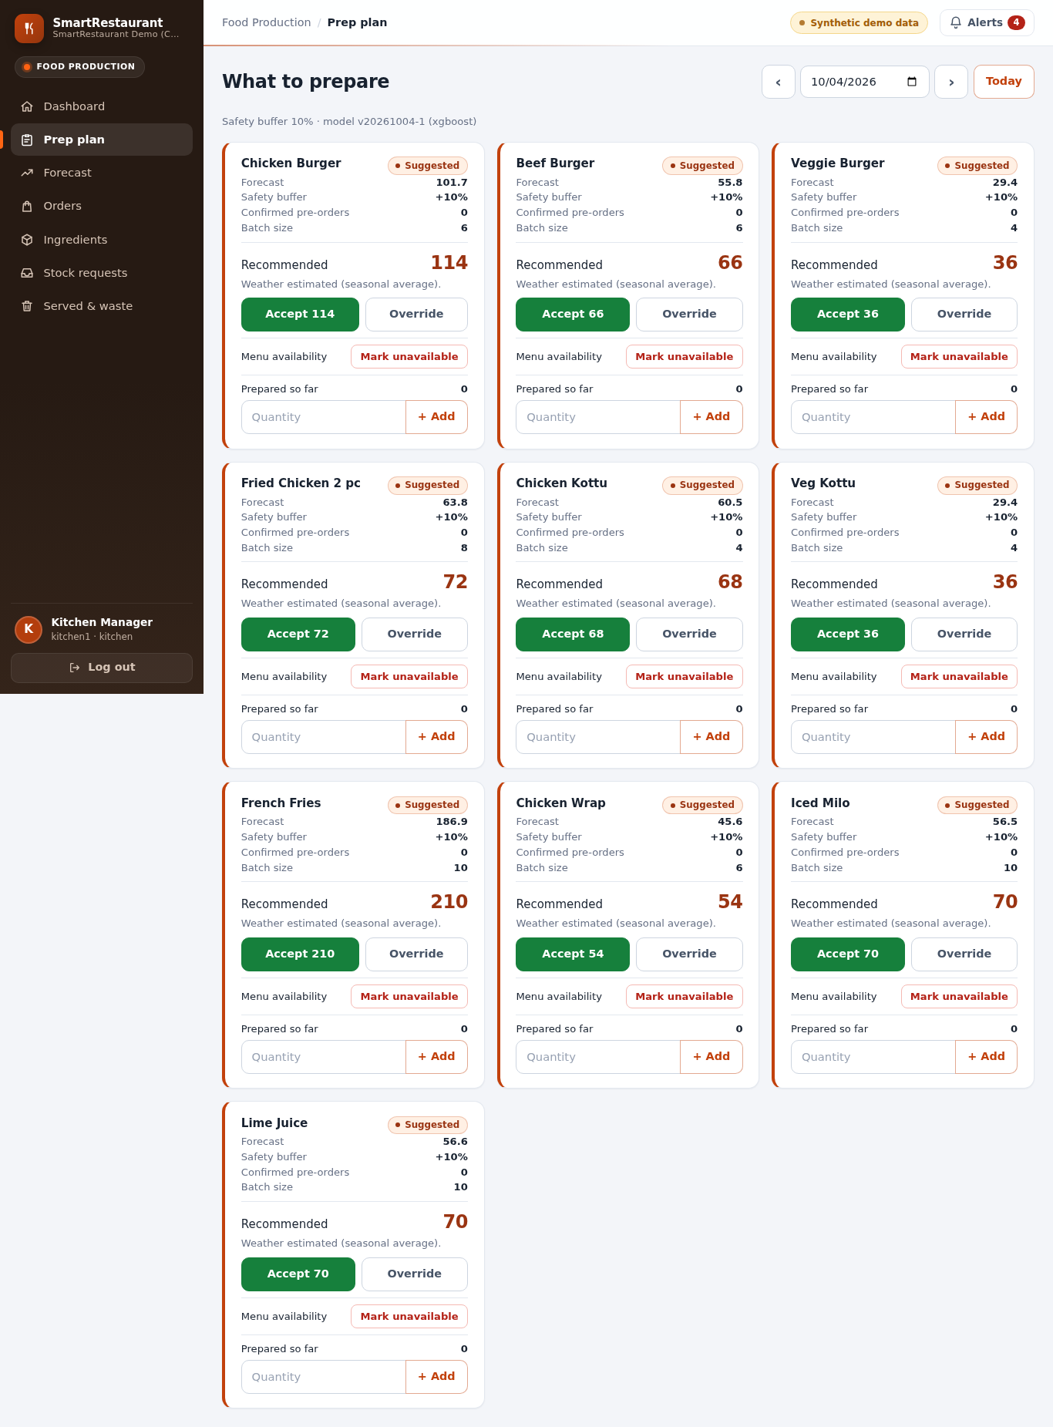
Figure 11. Kitchen prep plan: each recommendation shows the numbers behind it.
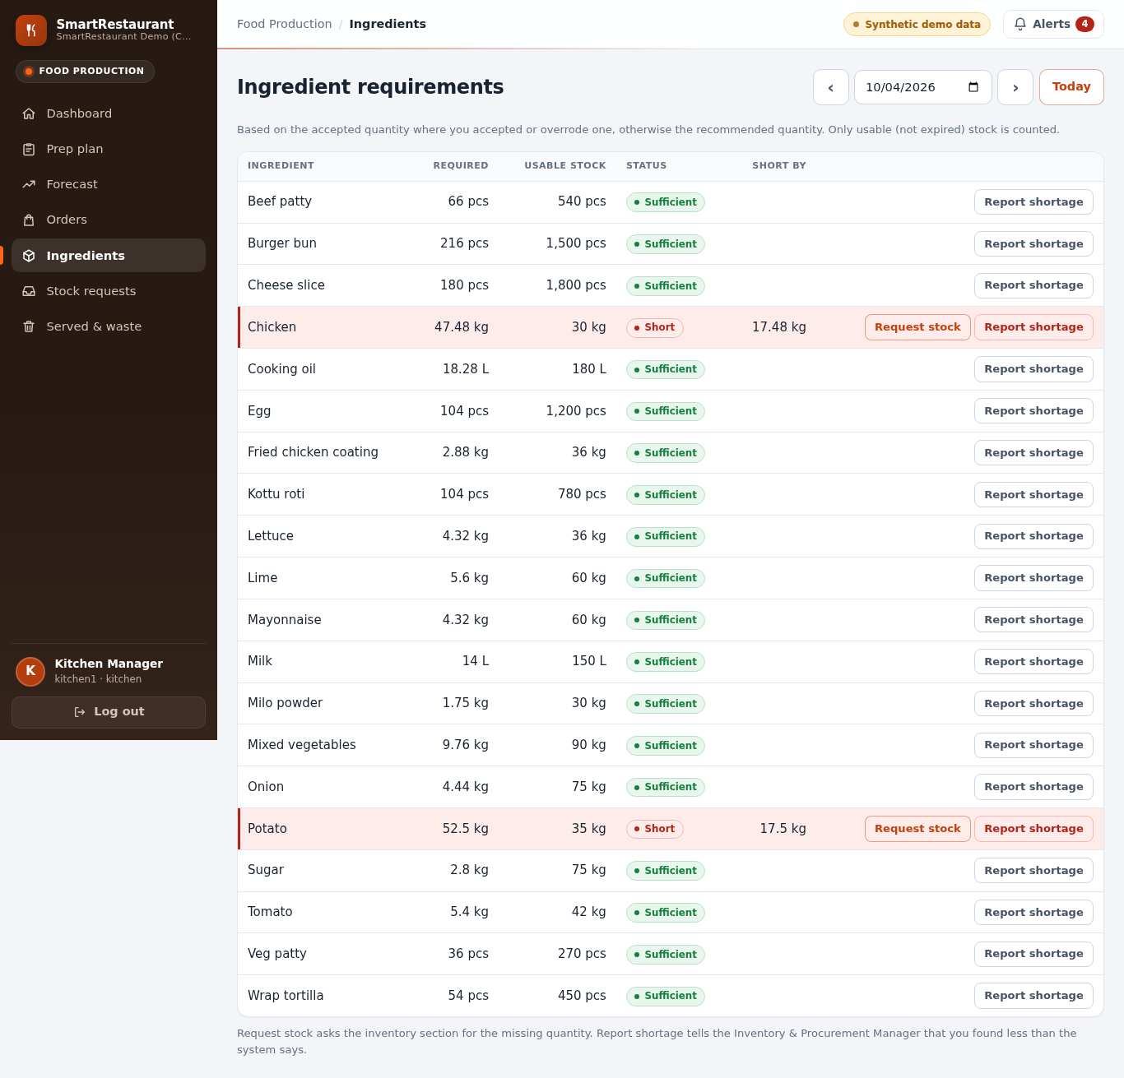
Figure 12. Ingredient requirements against usable stock, with shortages highlighted.
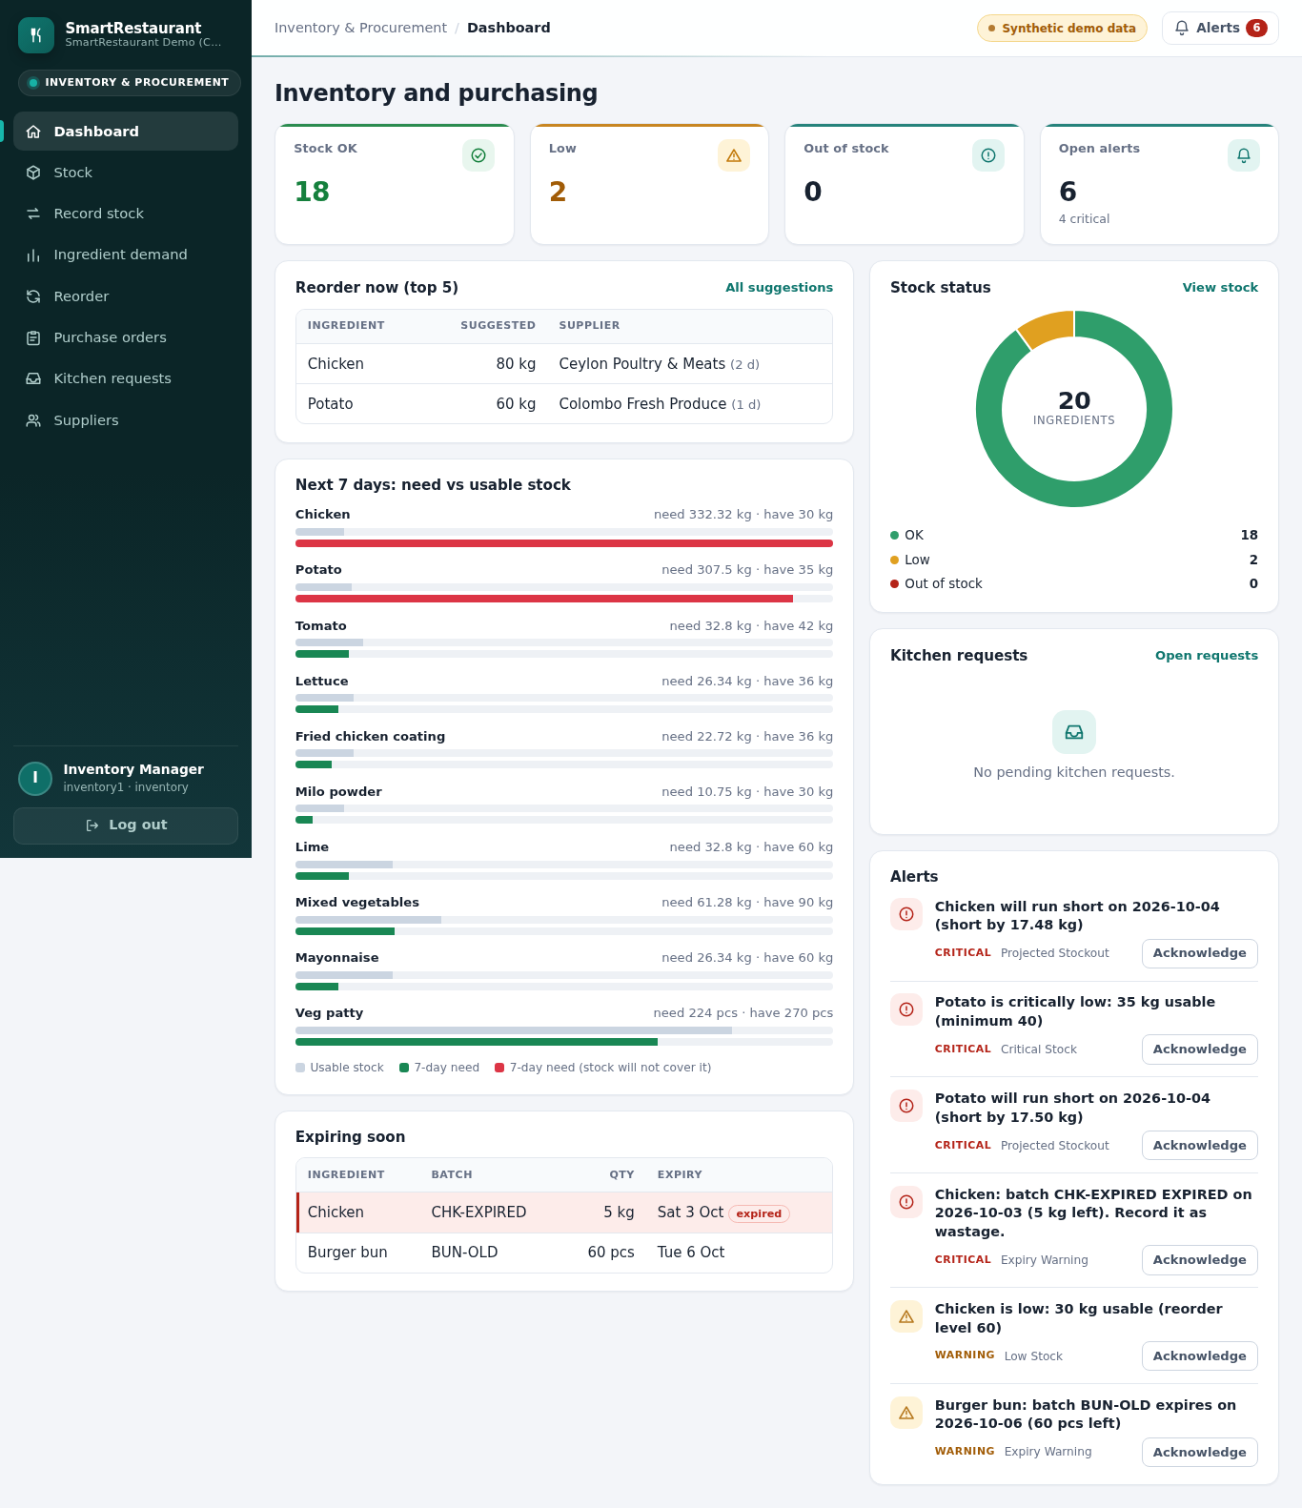
Figure 13. Inventory dashboard with alerts, reorder suggestions and kitchen requests.
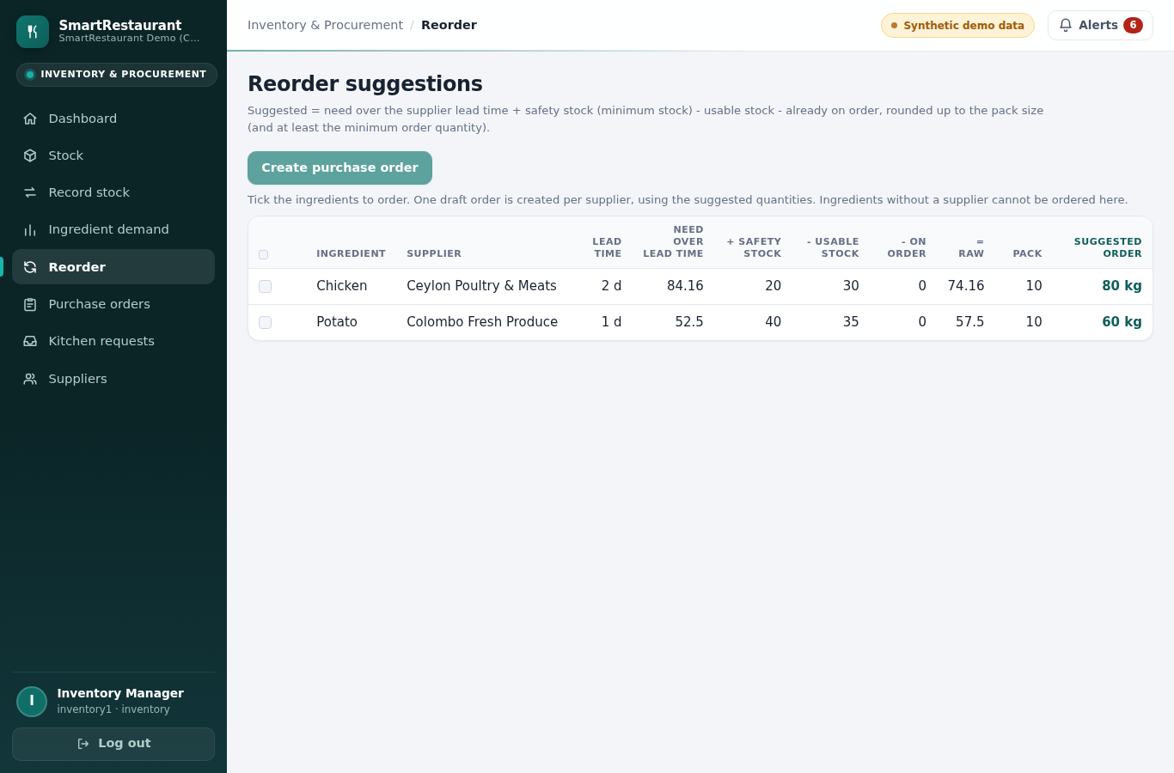
Figure 14. Reorder suggestions with every term of the calculation.
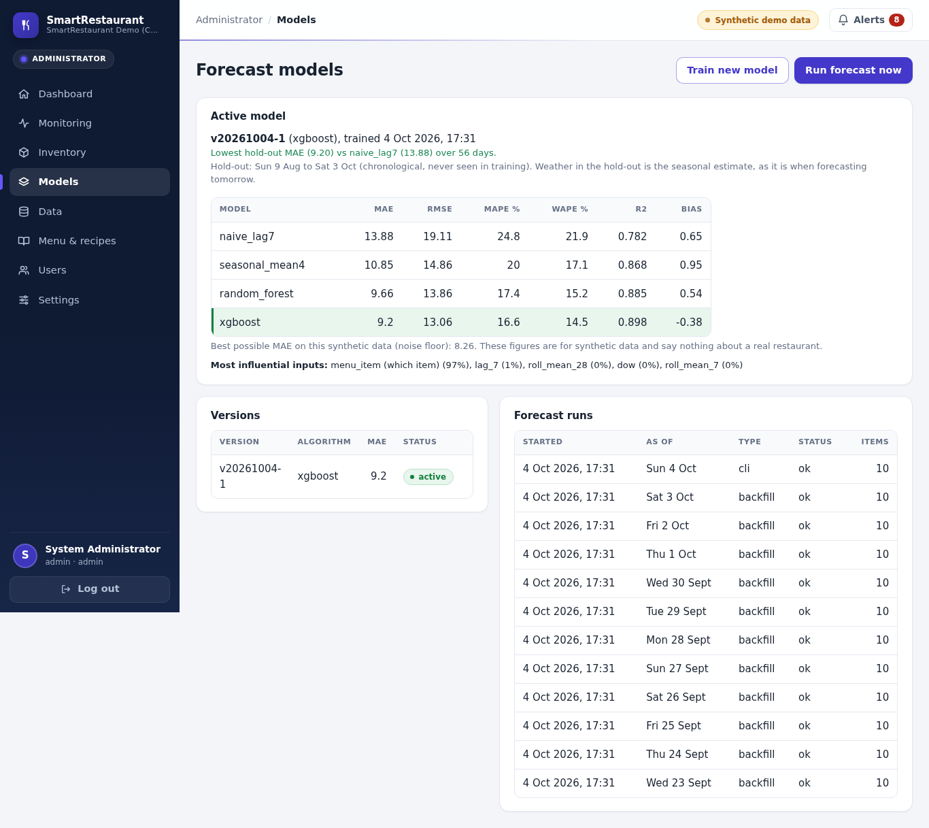
Figure 15. Administrator's Models page: active model, comparison with the baselines, versions and forecast runs.
Figure 16. The prep plan at phone width (390 px).

9.3 Deployment
The demonstration runs on an Ubuntu server at https://smartrest.developerstudio.space: nginx terminates HTTPS and
forwards requests to gunicorn, which runs with the project's own MariaDB instance as an unprivileged systemd service.
One command
(flask smartrest demo-reset) rebuilds the demo state in about 20 seconds: seed data, synthetic history, training and
activation, a 56-day backfill, today's forecast and alerts. There is deliberately no background scheduler; forecasts
are run from the Models page or the command line, which matches the proposal's periodic (not automatic) model updates.
A local copy and a database dump are kept as the fallback for the demonstration.
[TEAM: confirm that this URL (or the local copy) is the setup used at the presentation.]

10. Testing

10.1 Strategy
Testing followed the plan in docs/TESTING.md; results are recorded in docs/TEST_LOG.md. Test levels:
Level | What it checks | Tool
Unit | Formulas (preparation quantity), features (lags, no leakage, missing data), metrics, training, experiments | pytest, in-memory SQLite
Integration | Each service with a database: kitchen recording, requirements, reorder, alerts, stock and earliest-expiry logic, imports, forecast runs, purchase orders, stock requests, reports | pytest, SQLite and MariaDB
API and security | Every route for every role, login and lockout, CSRF, validation, escaping, response format | pytest with the Flask test client
Database | Constraints, concurrency (two simultaneous stock-outs), migrations match the models | pytest on MariaDB
Performance | Forecast run time and page and API response times on the full demo data | pytest
Browser (scripted UAT) | Each role's daily tasks at phone and desktop widths in headless Chromium, Firefox and WebKit; no console errors | Playwright
Security and quality audit | CSRF, sessions, headers, lockout, malformed and extreme input, uploads, escaping, outlet isolation, every proposal function | Scripted probes against an isolated copy of the demo data
Architecture | Import rules between layers and the service dependency graph | pytest

Expected values were calculated by hand before the code was run (docs/TESTING.md section 4) and never copied
from the program's output. Examples: 54 burgers with a 10% buffer and batches of 6 give 60; the chicken requirement
for the test plan is 15.48 kg with 3.48 kg short; a reorder case gives 25 kg (15 kg when 10 kg are already on order);
stock-out of 5 kg takes 4 kg from the earliest-expiring batch and 1 kg from the next.

10.2 Results
Measure | Result
Automated tests | 332 in total: 320 fast tests and 10 MariaDB tests, all passing on 7 October 2026, and 2 timing tests, passing at their last run on 4 October 2026 (not re-run because they write to the demo database)
Coverage of services and ML | 95% (target 80%), measured over the fast and MariaDB tests on 7 October 2026
Route-by-role matrix | Every route checked for anonymous, administrator, kitchen and inventory users; a route without a declared rule fails the test
Browser walkthroughs | Kitchen (390 px), inventory (1280 px) and administrator scripts pass in Chromium, Firefox and WebKit; all pages without horizontal scrolling at 360, 768 and 1280 px; no JavaScript errors
Concurrency | Two parallel stock-outs of 8 kg against 10 kg: exactly one succeeds and stock never goes negative; the same for purchase-order receipts and stock-request issues
Forecast run, 10 items × 7 days (NFR2) | 0.27 s (target under 5 s)
Slowest page or API request (NFR2) | 0.23 s (target under 3 s; re-measured on the demo server on 4 October 2026)
Model training | about 11 s on a 2-core server

The security checklist (password hashing, server-side role checks, CSRF, escaping, parameterised queries, lockout with
a generic message, session settings, no secrets in Git) passed in full (docs/TEST_LOG.md section 4). A security and
quality audit on 4 October 2026 then probed the running system with about 90 scripted checks. It found no critical or
high-severity issues. Its medium and low findings, listed with the other defects in Section 10.3, were fixed, covered
by 56 new automated tests and deployed to the demo server after a verified database backup (docs/TEST_LOG.md
sections 13 and 14). A second review on 7 October 2026 also examined the deployment. It rated three issues high: the
demonstration ran over plain HTTP on a public port, the application and its database ran as the administrator (root)
account on a server shared with other websites, and one forecast request accepted an unbounded date range. All three
were fixed the same day (Section 10.3), after a verified backup.

10.3 Defects found by testing
Defect | Fix
trigger is a reserved word in MySQL/MariaDB, so the first migration failed | Column renamed trigger_type
Under MariaDB 11, a locking read after a snapshot read can fail (error 1020) when two stock-outs run at once | Stock-out, wastage and alert evaluation retry on a fresh snapshot
Backfilled forecasts used the model refitted on all history, so monitored accuracy looked better than it was (MAE 7.9 instead of 9.4) | Backfill uses the model fitted before the hold-out
Feature importance showed one menu-item column at 91% | Item indicators reported together as "which menu item"
A shared chart component hid every other bar label; a page overflowed a 360 px screen by 5 px | Both fixed and covered by the browser test
Pre-order validation reported some errors only after others were fixed | All rules checked in one pass
Poya dates in the holiday file were computed and 19 were one day late | Replaced by the declared dates; data and model rebuilt
Audit: an extreme value was accepted and flowed into the decisions (one pre-order of 1,000,000,000 portions produced a reorder suggestion of 999,999,999,100 burger buns); a value beyond a column's range caused a server error on MariaDB | Upper limits on every quantity and price, at most 3 decimal places for stock; the sales import rejects a day more than ten times the item's usual level
Audit: the ingredient forecast and the forecast run had no upper bound on their number of days (100,000 days held a server worker for minutes and wrote forecasts up to the year 2300) | Windows limited to 1-31 and 1-14 days; a bad value is refused before a run is recorded
Audit: wrongly typed input (a number as a name, the text "false" as a yes/no value) caused server errors in the user administration | Every field checked for type and format
Audit: logging out did not end a copied session; anyone could lock a user out by failing logins; no security headers; CSV exports could carry spreadsheet formulas | Sessions ended on the server; lockout per username and address; Content-Security-Policy and related headers; formula cells neutralised
Audit: the documented fast-test command also ran the timing tests, which write to the demo database | Timing tests run only when requested
Review: the demonstration server used plain HTTP on a public port, so passwords and session cookies crossed the network unencrypted | HTTPS through nginx with a Let's Encrypt certificate; HTTP redirected; Secure session cookie; the old port closed
Review: the application and its database ran as root on a server shared with other websites | A dedicated unprivileged user and restricted systemd services; gunicorn reachable only through nginx
Review: the forecast list accepted any date range (year 1 to 9999 built about 3.6 million dates and a 51 MB response for one logged-in request) | Range limited to 62 days, longer requests refused; 15 new tests

10.4 What was not tested
There was no test with real restaurant staff and no usability score (SUS), so the five-minute target of NFR1 was not
measured; the browser walkthroughs were run by the developer. The browsers were tested headless in their three
engines (Chromium, Firefox and WebKit); Edge uses the Chromium engine and was not tested separately, and no test ran
on a real phone. There was no accessibility audit, load test or external penetration test (the audit in Section 10.2
was internal).
[TEAM: run the usability test in docs/usability/ (plan, printable kit, answer key, analysis script) and paste the tables from docs/usability/RESULTS.md here; then update the NFR1 row in section 11.4.]

11. Results and evaluation
All results in this chapter are on synthetic data (Section 6.3). They show that the pipeline works and which
contextual factors the model can use when such effects exist; they are not evidence of accuracy in a real restaurant.
Full tables are in docs/ML_EVALUATION.md.

11.1 Model comparison on the hold-out
Hold-out: 9 August to 3 October 2026 (56 days, 560 item-days); training: 6,790 item-days.
Model | MAE | RMSE | MAPE % | WAPE % | R² | Bias
naive_lag7 (baseline) | 13.88 | 19.11 | 24.8 | 21.9 | 0.782 | 0.65
seasonal_mean4 | 10.85 | 14.86 | 20.0 | 17.1 | 0.868 | 0.95
Random Forest | 9.66 | 13.86 | 17.4 | 15.2 | 0.885 | 0.54
XGBoost (selected) | 9.20 | 13.06 | 16.6 | 14.5 | 0.898 | -0.38

XGBoost reduced the error of the naive baseline by 33.7% and beat it for every one of the ten items (Appendix C).
The noise floor of the data is an MAE of 8.26, so the selected model is within 0.93 portions of the best possible.
Bias is close to zero, so the forecast does not systematically over- or under-prepare. The overall WAPE of 14.5% meets
the planned target of about 15%. The accuracy monitoring page, which compares stored forecasts with actual sales for
the 56 backfilled days, agrees with these figures.

11.2 Cross-validation
Six consecutive 28-day windows from 19 April to 3 October 2026, each with models retrained on all earlier days:
Model | MAE mean | MAE std | WAPE % mean | Windows beating naive | Windows won
naive_lag7 | 13.86 | 1.53 | 22.0 | - | 0
seasonal_mean4 | 11.04 | 1.38 | 17.5 | 6 of 6 | 0
Random Forest | 9.63 | 0.77 | 15.3 | 6 of 6 | 3
XGBoost | 9.45 | 0.83 | 15.0 | 6 of 6 | 3

Both learned models beat both baselines in every window, by 3.2 to 5.7 portions. Random Forest and XGBoost each won
three windows and their difference (0.18) is much smaller than the variation between windows (about 0.8), so they
should be regarded as equivalent: XGBoost was selected on the hold-out, but the evidence does not show it is the
better algorithm. The hardest window (late April to mid May, covering New Year, Vesak and Adhi Poson) left XGBoost 2.2
portions above the noise floor, against 0.7 to 1.1 in the others.

11.3 Contextual factors (ablation)
Feature set | CV MAE (mean ± std) | Windows improved | Hold-out MAE
calendar + history | 10.24 ± 0.97 | - | 9.96
+ holidays | 9.99 ± 1.13 | 4 of 6 | 9.69
+ promotions | 9.36 ± 0.79 | 6 of 6 | 9.12
+ weather (shipped model) | 9.45 ± 0.83 | 3 of 6 | 9.20

Error (MAE) on ... | calendar + history | + holidays | + promotions | + weather
holiday days (370 item-days) | 11.29 | 10.74 | 10.19 | 10.51
promotion item-days (46) | 32.03 | 35.19 | 18.36 | 18.52
wet days, ≥ 5 mm (670) | 10.24 | 10.24 | 9.49 | 9.49

Promotions matter most: adding the discount improved every window and almost halved the error on promotion days.
Holidays help modestly and mainly on holiday days. Weather adds nothing at forecast time, because the model
only knows the monthly average, not tomorrow's rain, so it cannot tell a wet day from a dry one. Feature importance
would have hidden these results: "which menu item" takes 97% of the importance and every contextual feature is under
1%, yet removing promotions clearly changes the forecasts.

11.4 Requirements
Requirement | Status | Evidence
FR1 login and roles | Met | Route-by-role test; lockout, timeout
FR2 sales history | Met | CSV import with dry run and row errors; generator uses the same import
FR3 contextual data | Met | Holiday and weather import; promotions page
FR4 item-level forecasts | Met | Seven-day forecasts for all items; Figures 6, 15
FR5 preparation quantities | Met | Prep plan with accept and override; hand-calculated tests
FR6 ingredient requirements | Met | Requirements page and ingredient forecast
FR7 shortages flagged | Met | Shortage rows and projected stock-out alerts
FR8 actual sales, preparation, waste | Met | Served, prepared and waste recording
FR9 stock movements | Met | Stock-in, stock-out, wastage, adjustment as immutable movements
FR10 dashboards | Met | Dashboard per role with forecasts, recommendations and alerts
FR11 forecasts and outcomes stored | Met | Forecast history kept; accuracy monitoring
FR12 reports | Met | Sales, waste, forecast accuracy, inventory trend and movements, with CSV
NFR1 usability | Partly | Designed for phone use and shows reasons; not measured with real users
NFR2 performance | Met | 0.27 s forecast; 0.23 s slowest request
NFR3 missing data | Met | Imputed lags, baseline fallback, partial and failed runs with reasons
NFR4 browsers and mobile | Met | 360 to 1280 px verified in Chromium, Firefox and WebKit (Edge shares the Chromium engine); headless browsers, no real phone
NFR5 security | Met | Security checklist passed; audit and review findings fixed; HTTPS deployment (Section 10.3)
NFR6 maintainability | Met | Model versions with rollback; enforced layers; 332 tests
NFR7 scalability | Met (design) | outlet_id on every table; one outlet implemented, as scoped
NFR8 data integrity | Met | Service validation with upper limits, sales-import outlier check, database constraints, stock data check

Of the 47 functions in the proposal, 45 are fully implemented and 2 partly: food preparation management is covered by
the accept or override decision and prepared-quantity recording without a separate status workflow, and expiry
tracking by batches with expiry dates and expiry alerts without a dedicated page (Appendix A).

11.5 Objectives and research questions
 | Outcome
O1, RQ1 | Achieved on synthetic data: both learned models beat the simple rules in every test window, by about a third on the hold-out
O2 | Achieved: selection on a chronological hold-out, confirmed by cross-validation; the shipped model is versioned with its evidence
RQ2 | Answered on synthetic data: promotions help most, holidays modestly, weather not without a weather forecast
O3, RQ3 | Achieved: explicit, tested formulas turn the forecast into preparation, ingredient, alert and reorder decisions, shown with their inputs and with a human accept or override step
O4 | Achieved: outcomes recorded and compared with forecasts in monitoring
O5 | Achieved: role-based, responsive interface; security checklist and audit passed
O6 | Achieved, except the usability study with real users (Section 10.4)

12. Discussion
Forecasting. On data with the kind of structure expected in a Sri Lankan fast-food outlet, tree-based models
captured weekday, holiday and promotion effects and cut the error of a same-day-last-week rule by about a third. The
cross-validation is the more important result: it shows the advantage holds across six different periods rather than
one convenient hold-out. It also shows that the choice between Random Forest and XGBoost matters little here; what
matters is using a learned model with the right context instead of a fixed rule.
Context. The ablation answers the proposal's question about contextual factors more precisely than feature
importance could. Promotions are the most valuable input, which makes sense because they are planned in advance and
known exactly. Holidays help on the days they occur. Weather is the instructive negative result: a feature that
clearly affects demand in the data is useless if its value is not known at forecast time. For a restaurant this means
that recording promotions and holidays accurately is worth more than recording past weather, and that weather would
need a real forecast to help.
From forecast to decision. The decision layer is deliberately simple and transparent. Each recommendation shows the
forecast, buffer, pre-orders and batch size it came from, the kitchen can override it with a reason, and every
decision is stored with its inputs. This design responds to the gap in the literature: commercial systems use fixed
rules, research stops at accuracy, and SmartRestaurant connects the two while keeping a person in charge of the final
quantity. The fixed 10% buffer is a pragmatic choice; a buffer derived from forecast uncertainty would trade waste
against stock-outs more precisely.
Synthetic data. Using generated data was a necessity, and it has a hidden benefit: because the true demand is
known, the noise floor shows how close the model is to the best possible, which real data cannot show. The cost is
that the effects were written by the team, so their size says nothing about a real restaurant. The holiday calendar
correction (Section 10.3) also shows why data quality matters: a one-day error in 19 Poya dates would have taught the
model the wrong days.
Comparison with the literature. Like Arunraj and Ahrens (2015), the results show that calendar and promotion
effects matter for perishable demand; like the preprint of Naeem et al. (2026), Random Forest performs well, though
here it is not distinguishable from XGBoost. Unlike both, the project evaluates the forecast inside a decision process.
[TEAM: extend once more sources are added to Chapter 4.]

13. Limitations
- Synthetic data. Accuracy, and the size of each contextual effect, are not evidence about a real restaurant.
- Sales are not limited by stock-outs in the generator; in reality sales understate demand on days an item sells out.
- No usability study with restaurant staff; NFR1 is not measured.
- No prediction intervals: the safety buffer is a fixed percentage.
- Weather is only a seasonal estimate at forecast time; no weather service is used.
- No hyperparameter search and one model for all items.
- School vacation dates are approximate; other holidays follow the declared calendar.
- Single outlet, no supplier integration and no automatic scheduling of forecasts, as scoped.
- Browsers tested headless only (Chromium, Firefox and WebKit, no real phone); no accessibility audit or load test.

14. Conclusions and recommendations
SmartRestaurant shows that a machine-learning forecast can be turned into concrete, explainable decisions for a
fast-food kitchen and its stock room: how much to prepare, what will run short, what to order and when to act. Every
function in the approved proposal is implemented, the system is secure and responsive, and its behaviour is covered by
332 automated tests and scripted walkthroughs. On synthetic data with Sri Lankan calendar effects, learned models cut
the error of a simple weekly rule by about a third in every test period, promotions and holidays were shown to improve
the forecast while weather did not, and the selected model came within one portion of the best achievable error.
The question the project cannot yet answer is how well this works in a real restaurant. The recommendations, in order
of importance:
- Validate on real data. Import a real outlet's sales history through the existing CSV import and run
flask smartrest evaluate; the same tables then report real accuracy and real effects.
- Run a usability study with kitchen and inventory staff (task timing and SUS) and run the system alongside the
current process for a few weeks, measuring waste and stock-outs before and after.
- Use a weather forecast as input, and re-run the ablation to measure its value.
- Derive the safety buffer from forecast uncertainty (prediction intervals), item by item.
- Account for stock-outs when training, so sold-out days do not lower the forecast.
- Schedule the daily forecast automatically and extend to several outlets (the data model already supports it).

15. References
[TEAM: check every entry, complete the incomplete ones, and use the referencing style the university requires.]
Arunraj, N.S. and Ahrens, D. (2015) 'A hybrid seasonal autoregressive integrated moving average and quantile
regression for daily food sales forecasting', International Journal of Production Economics, 170, pp. 321-335.
Breiman, L. (2001) 'Random forests', Machine Learning, 45(1), pp. 5-32.
Chen, T. and Guestrin, C. (2016) 'XGBoost: a scalable tree boosting system', in Proceedings of the 22nd ACM SIGKDD
International Conference on Knowledge Discovery and Data Mining. New York: ACM, pp. 785-794.
Hyndman, R.J. and Athanasopoulos, G. (2021) Forecasting: principles and practice. 3rd edn. Melbourne: OTexts.
Available at: https://otexts.com/fpp3/ [TEAM: add access date]
Naeem, et al. (2026) [TEAM: complete: authors, title, preprint server, identifier, URL, access date; note that it is
a preprint.]
Pedregosa, F. et al. (2011) 'Scikit-learn: machine learning in Python', Journal of Machine Learning Research, 12,
pp. 2825-2830.
Toast Support Center (n.d.) [TEAM: complete: page title on inventory, URL, access date.]
Sri Lanka holiday calendars used for data/holidays_lk.csv: Government Printing Department desk calendars and gazette
notices (documents.gov.lk); Central Bank of Sri Lanka, Bank holidays 2024 and 2025 (cbsl.gov.lk); published 2025
and 2026 public holiday lists. [TEAM: give these in the required style with access dates.]

Appendix A. Coverage of the proposal's 47 functions
Role | Function | Implemented as
Admin | System Dashboard | Admin dashboard (/admin)
Admin | User Account Management | Users page: create, edit, deactivate, reset password
Admin | Role & Access Management | Role on the user form; server-side role checks; last admin protected
Admin | Menu Management | Menu & recipes page
Admin | Recipe/BOM Management | Recipe editor per menu item
Admin | Restaurant Information Management | Settings > Restaurant information
Admin | System Settings & Alert Configuration | Settings page: buffer, horizons, thresholds, alert types on or off
Admin | Sales & Revenue Monitoring | Monitoring > Sales, CSV
Admin | Food Demand Forecast Monitoring | Monitoring > Demand forecast and Forecast accuracy
Admin | Inventory Demand Forecast Monitoring | Inventory page > Ingredient demand
Admin | Food Waste Monitoring | Monitoring > Waste
Admin | Inventory Monitoring | Inventory page: stock levels, batches, movements
Admin | System Analytics | Analytics page
Admin | System Reports | Report tabs with CSV export (sales, waste, accuracy, inventory trend, movements, stock levels)
Kitchen | Kitchen Dashboard | Kitchen dashboard (/kitchen)
Kitchen | Daily Order Management | Orders > Daily orders
Kitchen | Pre-Order Management | Orders > Pre-orders; confirmed ones raise the preparation quantity
Kitchen | Food Demand Forecast | Forecast page
Kitchen | Preparation Recommendations | Prep plan: accept or override with reason
Kitchen | Food Preparation Management | Partly: decisions plus prepared recording; no separate planned/in-progress/done workflow
Kitchen | Preparation Quantity Recording | Prep plan "Add" prepared quantity
Kitchen | Ingredient Requirements | Ingredients page
Kitchen | Ingredient Usage Recording | Served & waste > Ingredient usage (expected vs recorded)
Kitchen | Actual Food Usage Recording | Served quantity recording
Kitchen | Sales/Served Quantity Recording | Served & waste page
Kitchen | Food Waste Recording | Served & waste page, with reason
Kitchen | Kitchen Stock Requests | Stock requests page
Kitchen | Food Availability Management | Mark available / unavailable on the prep plan
Kitchen | Shortage Reporting | Report shortage on the Ingredients page (critical alert)
Inventory | Inventory Dashboard | Inventory dashboard (/inventory)
Inventory | Ingredient Management | Stock page: add and edit ingredients
Inventory | Stock Management | Stock page and Record stock
Inventory | Stock-In Recording | Record stock > Stock in; purchase-order receipt
Inventory | Stock-Out Recording | Record stock > Stock out (earliest expiry first)
Inventory | Stock Level Monitoring | Stock page with status per ingredient
Inventory | Minimum Stock Level Management | Ingredient minimum stock
Inventory | Reorder Level Management | Ingredient reorder level, pack size, minimum order
Inventory | Ingredient Demand Forecast | Ingredient demand page
Inventory | Low-Stock Alerts | Low, critical and projected stock-out alerts
Inventory | Reorder Recommendations | Reorder page with every term
Inventory | Supplier Management | Suppliers page
Inventory | Purchase Order Management | Purchase orders: create from suggestions, send, receive in part, cancel
Inventory | Expiry Tracking | Partly: batches with expiry dates, expiry alerts, expired stock excluded from use; no dedicated expiry page
Inventory | Inventory Wastage Recording | Record stock > Wastage
Inventory | Stock Adjustment Management | Record stock > Adjustment to counted quantity, reason required
Inventory | Kitchen Stock Request Management | Kitchen requests: approve, reject with reason, issue
Inventory | Inventory Data Validation | Data check: movements against batches

Appendix B. Running the system
python -m venv .venv && . .venv/bin/activate && pip install -r requirements.txt
cp .env.example .env # set SECRET_KEY, DATABASE_URL, SEED_PASSWORD
flask db upgrade # create the tables
flask smartrest demo-reset # seed, synthetic history, train, backfill, forecast, alerts (about 20 s)
flask run # http://127.0.0.1:5000; log in as admin, kitchen1 or inventory1
flask smartrest evaluate # cross-validation and ablation (read-only)
pytest -q -m "not mysql" # fast tests

A 17-minute demonstration script covering every function is in docs/DEMO_NEW_FEATURES.md; an 8-minute version is in
README.md.

Appendix C. Hold-out error per item (XGBoost vs naive baseline)
Item | XGBoost MAE | XGBoost WAPE % | Naive MAE | Naive WAPE %
Chicken Burger | 11.61 | 12.3 | 22.11 | 23.5
Beef Burger | 7.96 | 15.4 | 12.04 | 23.3
Veggie Burger | 6.09 | 20.7 | 8.95 | 30.4
Fried Chicken 2 pc | 8.87 | 13.8 | 15.88 | 24.7
Chicken Kottu | 8.89 | 15.9 | 11.86 | 21.2
Veg Kottu | 4.85 | 17.0 | 6.68 | 23.4
French Fries | 19.64 | 12.2 | 27.66 | 17.2
Chicken Wrap | 7.72 | 18.4 | 10.66 | 25.4
Iced Milo | 8.62 | 15.6 | 12.98 | 23.5
Lime Juice | 7.72 | 14.9 | 10.02 | 19.4

Appendix D. Team contributions
[TEAM: required by most modules. For each member: what they designed, built, tested and wrote, with evidence such as
commits, documents or test runs.]

