**Slide 1**

1. **What is a system?**

A set of detailed methods, procedures and routines established or formulation to carry out specific activity, perform a duty or solve a problem.

Collection of components that are organized for a common purpose

1. **What is an Information System ?**

It is a set of components for collect, store and process data and for provide information.

1. **What are the Integrating New Technologies into Traditional Systems?**

Ecommerce andWeb Systems.

Enterprise Resource Planning Systems.

Wireless Systems.

Open Source Software.

Need for Systems Analysis and Design.

1. **What are the benefits of Ecommerce and Web Systems?**

Increasing user awareness of the availability of a service, product, industry, person, or group.

The possibility of 24-hour access for users. ( 24x7 )

Improving the usefulness and usability of interface design.

Creating a system that can extend globally rather than remain local.

1. **What is an enterprise resource planning system?**

Performs integration of many information systems existing on different management levels and within different functions.

1. **What are the steps of Systems Development Life Cycle?**

Identifying Problems, Opportunities, and Objectives

Determining Human Information Requirements

Analyzing System Needs

Designing the Recommended System

Developing and Documenting Software

Testing and Maintaining the System

Implementing and Evaluating the System

**Slide 2**

1. **What is Programming ?**

Series of instructions to a computer to accomplish a task. Instructions should be understood by a dumb machine and brilliant mind simultaneously. Programming languages are used to write programs.

1. **What is a programming language?**

A language (set of commands) for programming computers.

1. **What are the Programming Language Generations?**

First Generation

Second Generation (early 1950s): Assembly languages

Third Generation (mid 1950s - present): High level,

Fourth Generation(1970s - ):

Fifth Generation (1980s - ):

1. **How to Building a Program**

Developing the algorithm.

Writing the program.

Documenting the program.

Testing and debugging the program.

1. **What is an Algorithm?**

A detailed description of the exact methods used for solving a particular problem.

**Slide 3**

1. **What are the Bad Programming Habits**

Not clear idea about what is to be done .

Write program with no planning; Start from the beginning and write to the end .

No systematic debugging; Considered it finished if it works on one example .

Undesirable Results !

Do not know how to program.

Programs with numerous bugs that take extremely long time to debug, or even failure to complete.

Any change of requirement invites rewriting of the entire program again.

1. **What is structured programming?**

Structured programming (sometimes known as modular programming) is a programming paradigm that facilitates the creation of programs with readable code and reusable components.

1. **What are the advantages of structured programming**?

* Application programs are easier to read and understand.
* Application programs are less likely to contain logic errors.
* Errors are more easily found.
* Higher productivity during application program development.
* Improved application program design.
* Application programs are more easily maintained.
* Programs that meet the needs of the customer
* Easy to handle change in program specifications in the future

1. **What are the disadvantages of structured programming?**

* Since it is Machine-Independent, So it takes time to convert into machine code.
* The converted machine code is not the same as for assembly language.
* The program depends upon changeable factors like data-types. Therefore it needs to be updated with the need on the go.
* Usually the development in this approach takes longer time as it is language-dependent. Whereas in the case of assembly language, the development takes lesser time as it is fixed for the machine.

1. **What are the Seven Important Concepts of Structured Programming**

Structured Walkthrough

Stepwise Refinement

Modular Design

Bottom Up Coding

Testing

White Box and Black BoxTesting

Structured Programming Documents

1. **What is Object Oriented Programming ?**

⦁ Object-oriented programming (OOP) is an engineering approach for building software systems

⦁ Based on the concepts of classes and objects that are used for modeling the real world entities

1. **What are the Advantages of OOP**

Better suited for team development

Facilitates utilizing and creating reusable software components

Easier GUI programming

Easier software maintenance

Improved software-development productivity:

Improved software maintainability:

Faster development:.

Lower cost of development:

Higher-quality software:

1. **What are the Advantages of OOP**

Steep learning curve:

Larger program size

Slower programs

Not suitable for all types of problems

1. **What are objects ?**

Real world entities

1. **What are classes?**

A blueprint to create objects.

1. **What is a message in OOP?**

A request for an object to perform one of its operations (methods)

1. **What are The Principles of OOP**

⦁ Inheritance- It is the process by which one class capture the properties and behaviors of object of another class.

⦁ Abstraction- It is the concept in OOP that shows only essential attributes and hide unnessary information .

⦁ Encapsulation- It is the wrapping up of attributes and methods into a single unit. To achieve this use access modifiers.

⦁ Polymorphism- Poly means many morphism means forms Polymorphism means many forms.

1. **Compare and contrast between structured programming and object oriented programming**

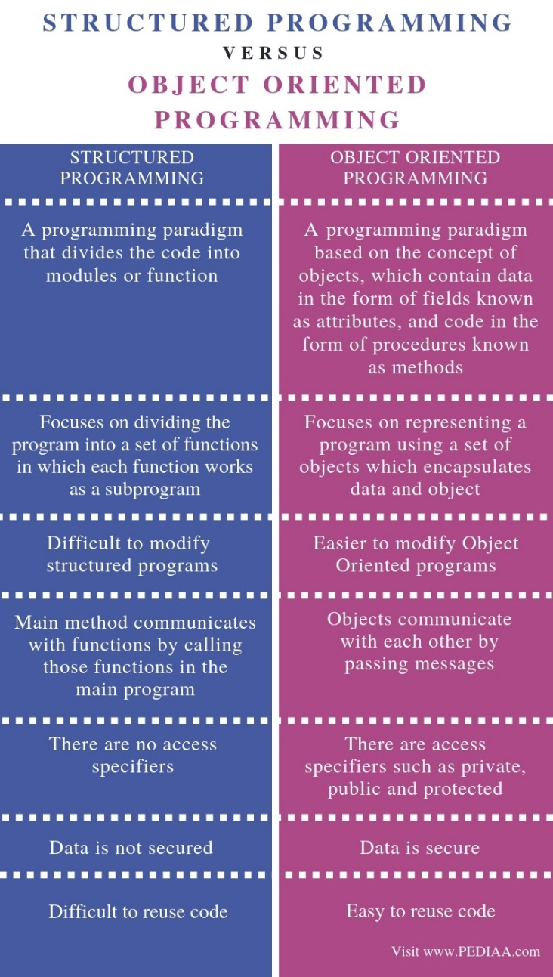

**Slide 4.I**

1. **What are the Principles of Innovation**

⦁ First: *Innovation starts when people convert problems to ideas*.

⦁ Second: *Innovation also needs a system*.

⦁ Third: *Passion is the fuel,and pain is the hidden ingredient*.

⦁ Fourth: *Co-locating drives more effective exchanges*.

⦁ Fifth: *Differences should be leveraged*.

1. **What are the Internal driving forces?**

*Entrepreneurship*

⦁ Entrepreneurs don't seek stability, but seek opportunities at risk.

*Business objectives*

⦁ Maximize the benefits, including the maximization of economic benefits or social effect.

*Enterprise innovation culture*

⦁ Requires enterprises to have a new attitude to update the Technology.

1. **What are the External driving forces**

*Market driven by competition*

⦁ Under the domestic market and international market competition, enterprises maintain its competitiveness only through caring out constant innovation and meet the times.

*Market driven demand*

⦁ The scale and structure of the market demand directly affect the industrial structure and economic growth of a country

*New economies*

⦁ Gaining new customers, entering new markets, and ultimately discovering new economies

*Technology development*

⦁ Drives enterprises to carry out technological innovation in an all-round way.

*Digital literacy*

⦁ Human interactions take new shapes on social networks and media and are capable of sparking new ideas, which eventually leads to innovation.

*Government intervention*

⦁ Formulate strong innovation policies of industrial and systems of innovative investment.

⦁ Guide public funds and private investment, services of enterprise innovation, protection of intellectual property and maintenance of innovative market order

⦁ Accelerate the development and commercialization of new technologies

⦁ Supports innovation and entrepreneurship in the manufacturing sector

⦁ Enhances the vitality and potential of the supply chain of emerging industries, and achieves industrial transformation and upgrading

1. **What are various types of technologies?**

⦁ Generic, Basic & KeyTechnologies

⦁ Embodied & DisembodiedTechnologies

⦁ System & InfraTechnologies

⦁ Hybrid & EmergingTechnologies

⦁ Disruptive & SustainingTechnologies

1. **Identify Disruptive & Sustaining Technologies and prepare an analysis report**

Disruptive technology is about change and creating new markets; it changes the way businesses operate and the way people live. Sustaining technology, on the contrary, refers to new technologies that foster improved product performance

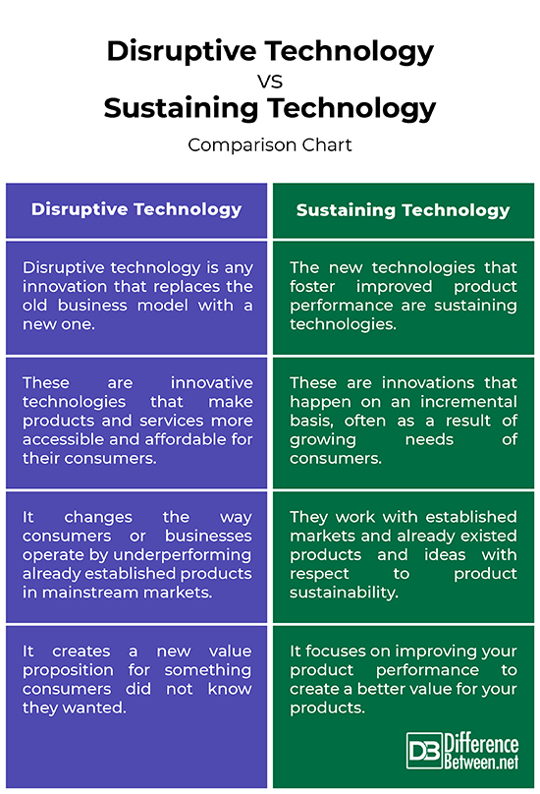

1. **What is technology portfolio?**

A technology portfolio is a compilation of information about a firm's investments in Information Technology. The information is organized to show how these investments support the firm's goals and to demonstrate the relationships among current and planned investments.

1. **What should be included in a technology portfolio?**

Work Samples. To prove your capabilities to employers, show what you've already created. ...

A Blog. ...

Links to Your Other Public Profiles. ...

An (Awesome) Bio. ...

Testimonials. ...

A Call to Action. ...

Final Thoughts.

1. **National technology policy aim at managing national technology portfolio / technology base with following objectives:**

* Should lead to sustainable technological progress / advancement.
* Should provide to long-term technological competitiveness, more efficiency, more productivity, more value generation and should lead to improvement in living standards of masses.
* Should seek development, acquisition, absorption and diffusion of appropriate technologies
* The cost of technological change / improvement to the nation should be manageable and optimal.
* Dependence on inappropriate and older technologies should be reduced.
* There should be increased role and contribution of renewable energy technologies.
* Should help in better disaster management.
* Should facilitate better law & order, internal security.
* Should help in conservation of resources, facilitate recycling, and help in strengthening of resources.
* Should help in better environment management; and protection and growth of flora and fuana.
* Should help in creating right and supportive economic environment and infrastructure.

**Slide 4.II**

1. **What is a Technology Lifecycle**

* The technology life-cycle describes the commercial gain of a product through the expense of research and development phase, and the financial return during its "vital life".
* The biological concept of a life Cycle (i.e. Birth, Growth,Maturity & Death) can also be applied to a technology and the product, service or process associated with it.
* The TLC associated with a product or technological service is different from product life-cycle (PLC) dealt with in product life-cycle management. PLC is concerned with the life of a product in the market-place in respect of timing of introduction, marketing measures and business costs.
* The technology life cycle is concerned with the time and cost of developing the technology, the timeline of recovering cost and modes of making the technology yield a profit proportionate to the costs and risks involved.
* The TLC may, further, be protected during its cycle with patents and trademark seeking to lengthen the cycle and to maximize the profit from it.
* The development of a competitive product or process can have a major effect on the lifespan of the technology, making it shorter.
* Some technologies, such as steel, paper or cement manufacturing, have a long lifespan (with minor variations in technology incorporated with time) whilst in other cases, such as electronic or pharmaceutical products, the lifespan may be quite short.

1. **What are the stages of The technology life cycle?**

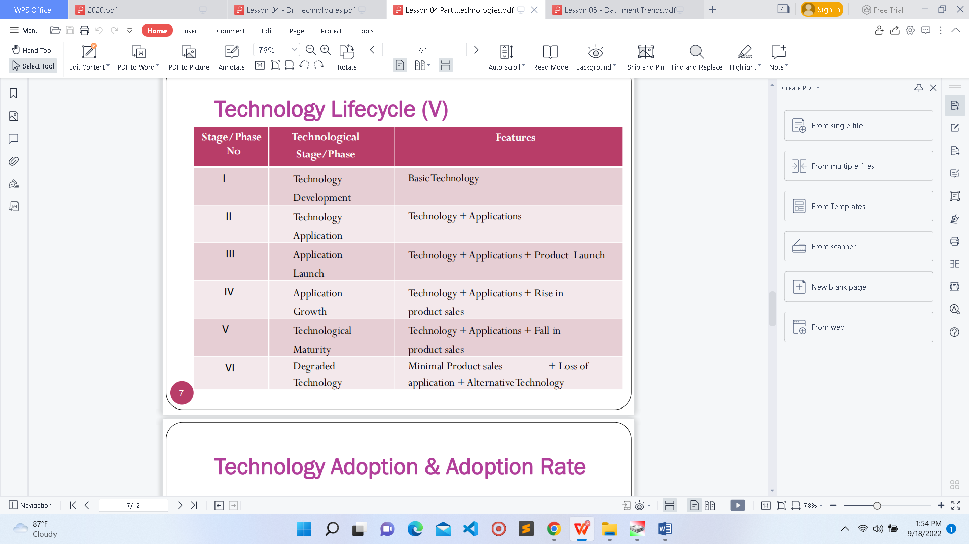

1. **What is Adoption Rate?**

Speed at which new technology is acquired and used by the public.. Ph It is represented by the number of people who start using new technology in a particular period.

1. **What are the Examples of an adoption rate:**

Innovation

Early adopters

Invitations only

Unsought products

Failed products

Early & late majority

Laggards

Internal adoption

Function & features

1. **How to Measure Adoption Rate**

**Quantitative Measure**

⦁ Formula:

**Adoption Rate = ((end – start)/ start) * 100**

Example: A product that starts with 100 customers and grows to

1100 customers in a month.

**Adoption Rate = ((1100 – 100)/ 100) * 100**

**= 1000 %**

1. **Factors Blocking Emerging Technology Adoption within Companies?**

⦁Company culture and associates resistance

⦁Lack of support from the leadership team

⦁Lack of transparency or very complex projects

⦁Lack of Governance and Results Communication

⦁Lack of collaboration between teams

⦁Lack of processes and procedures

⦁Imposition or inadequate adoption speed

⦁Misalignment between “acquiring technology” versus “technology adoption”.

1. **Imagine you are a manager of a toy manufacturing company and your company is introducing a new AI based toy to the market. Explain the things that you can do to improve the product adoption rate.**

**Provide a good impression to the customer**

When the customer buys the product, you must build a good impression and desire in the

customer to buy the product again. You must give a best experience to the customer after he

bought it.

**Add new features**

When adding new AI features we must add them to attract kids to the toy. Because kids

interest in new features different from others. You can use the latest technology and produce it

creatively and uncommon.

**Giving a best price**

A.I based toys can be costly. So if we can provide it some reasonable price it is better. Because

customers tend to buy the product lower price with good quality. Then customers also pay their

attention about it.

**Do some marketing strategies**

You can broadcast some commercials using television, and social media like Facebook ,

Instagram, YouTube etc. Also you can advertising some banners about the item attractively and

creatively.

**Provide service after sale**

People are not familiar with AI features. So they have no idea to repair it. If there have some

issues after the customer purchase it company can repair it. As well as you can give some

warranty period.

**Getting User feedbacks**

After the customer purchase the item you can get some feedback about the product. Then you

can fix bugs and improve the product quality. It will useful when adding new features also.

1. **What are the Examples of Data Sources**

E-mails

Credit card

swipes

RFID tags

Digital video

surveillance

Radiology scans

Blogs

1. **What are the** **Difficulties in Managing Data**

⦁Amount of data increases exponentially.

⦁Data are scattered and collected by many individuals using various methods and devices.

⦁Data come from many sources.

⦁Data security, quality and integrity are critical

1. **What is DIKW pyramid?**

The DIKW Pyramid represents the relationships between data, information, knowledge and wisdom.

* Data- Row facts
* Information – Data has been clean of errors and easy to measure analyze data for a specific purpose.
* Knowledge – Help to understand how to apply information to achieve goal.
* Wisdom – Knowledge applied in action.

1. **What is a database?**

A **database** is an organized collection of data, which can be accessed by electronic means

1. **What is a A** **database management system?**

It is a set of programs that provide users with tools to add, delete, access, and analyze data stored in one location. Database management system (DBMS) provides all users with access to all the data

1. **What are the problems that DBMSs minimize?**

**⦁**Data redundancy

⦁Data isolation

⦁Data inconsistency

1. **What are the problems that DBMSs maximize?**

Data security

Data integrity

Data independence

1. **Types of Databases**

⦁Centralized database

⦁Cloud database

⦁Commercial database

⦁Distributed database

⦁End-user database

⦁Graph database

⦁NoSQL database

⦁Object-oriented database

⦁Open-source database

⦁Operational database

⦁Personal database

⦁Relational database

1. **Most popular database management systems**

⦁MySQL

⦁MariaDB

⦁MongoDB

⦁Redis

⦁PostgreSQL

1. **What is a Data warehouse**

⦁Data warehouse is a repository of historical data organized organized by business dimension or subject.

⦁Data warehouses are multidimensional.

1. **What are the Benefits of data warehouse:**

⦁End users can access data quickly and easily via Web browsers because they are located in one place.

⦁End users can conduct extensive analysis with data in ways that may not have been possible before.

⦁End users have a consolidated view of organizational data.

1. **What is a data mart?**

A **data mart** is a small data warehouse, designed for the end-user needs in a strategic business unit (SBU) or a department

1. **Data governance** is an approach to managing data and information across an entire organization. **Master data management** is a method that organizations use in data governance. **Master data** are a set of core data that span all enterprise information systems.
2. **What are data management steps in data governance?**

Data requirements

Data administration

Metadata Management

Data quality

Privacy security

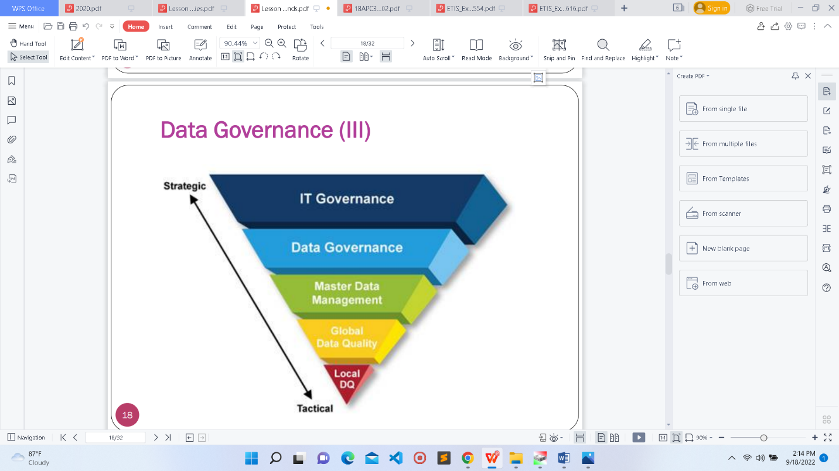

1. **What is Knowledge management?**

It is a process that helps organizations manipulate important knowledge that is part of the organization’s memory, usually in an unstructured format.

1. **What are the types if knowledge management?**

Explicit Knowledge (above the waterline)

Tacit Knowledge (below the waterline)

1. **What is Knowledge management systems?**

* It refer to the use of information technologies to systematize, enhance, and expedite intra-firm and inter-firm knowledge management.

⦁ A process of more effectively collecting, sharing, maintaining or

managing,and deploying organizational knowledge

1. **What are the functions of Knowledge Management System Cycle?**

Create ,capture, refine , store , manage, disseminate

1. **Components of Knowledge Management Technology Framework**

⦁ Decision Support System

⦁ Workflow

⦁ Project Management

⦁ Data Mining

⦁ Knowledge Management

⦁ Document Management

⦁ Groupware

1. **Key Functions of Knowledge Management Technology Framework**

⦁ Knowledge Flow

⦁ Information mapping

⦁ Information sources

⦁ Information and knowledge exchange

⦁ Intelligent agent and network mining

⦁ Finding knowledge

1. **What is Data mining?**

It isdefined as a process of uncovering patterns and

finding anomalies and relationships to predict outcomes. **Data mining** is an essential part of **knowledge management.**

1. **Aims of data mining**

⦁ To discover structure inside unstructured **data**

⦁ To extract meaning from noisy **data**

⦁ To discover patterns in apparently random **data**

⦁ To use all this information to better understand trends, patterns, correlations, and ultimately predict customer behavior, market and competition trends

1. **Processes which include in data mining**

⦁ Data Integration - Business understanding, Data understanding

⦁ Data Preparation - Data cleaning

⦁ Data Transformation – Smoothing, Aggregation, Generalization, Normalization,Attribute construction

⦁ Modelling - Determine data patterns

⦁ Pattern Evaluation - Evaluate against the business objectives

⦁ Data Presentation/Deployment - Ship data mining discoveries to everyday business operations

1. **Data Mining Techniques/Applications Used in Knowledge Management**

⦁ Classification

⦁ Clustering

⦁ Regression

⦁ Association Rules

⦁ Outer detection

⦁ Sequential Patterns

⦁ Prediction

1. **Data MiningTools**

⦁ MonkeyLearn | No-code text mining tools

⦁ RapidMiner | Drag and drop workflows or data mining in Python

⦁ Oracle Data Mining | Predictive data mining models

⦁ IBM SPSS Modeler | A predictive analytics platform for data scientists

⦁ Weka | Open-source software for data mining

⦁ Knime | Pre-built components for data mining projects

⦁ H2O | Open-source library offering data mining in Python

⦁ Orange | Open-source data mining toolbox

⦁ Apache Mahout | Ideal for complex and large-scale data mining

⦁ SAS Enterprise Miner | Solve business problems with data mining

1. **Advantages and disadvantages of Data Mining**

Advantages

Marketing /retail

Manufacturing

Make decisions in marketing

Criminal identification

To identify patterns and customer behavior

Disadvantage

Cost

Security issues

Limitations

Misuse of information