DYNAMate – User Manual

# Specifications

**Operation Limits**

|  |  |  |
| --- | --- | --- |
| **Parameter** | **Value** | **Units** |
| Maximum Voltage |  |  |
| Trigger | 5000 | Volts |
| Sensor Input | 150 |
| DC Input | 36 |
| USB | 10 |
| Temperature Range | -10 to +70 | °C |

**Power Requirements**

|  |  |  |
| --- | --- | --- |
| **Parameter** | **Value** | **Units** |
| DC Input Voltage | 9-36 | Volts |
| Current Consumption | 450 | mA |

**Data Acquisition**

|  |  |  |
| --- | --- | --- |
| **Parameter** | **Value** | **Units** |
| Resolution | 16 | bit |
| Sample Rate | 4000 downsampled to 1000 | Hz |
| Conversion Time | 4 | µs |
| Analog Bandwidth | 250 | Hz |
| CMRR, DC to 60 Hz | 100 | dB |
| Gain Error | 115 | ppm |
| SNR | 75 | dB |
| Crosstalk | -65 | dB |

**Filters and Amplification**

|  |  |  |
| --- | --- | --- |
| **Parameter** | **Value** | **Units** |
| Filter Bank – low-pass | 32, 64, 128 | Hz |
| Roll-off | 80 | dB/dec |
| High-pass | 0.01 | Hz |
| Roll-off | 40 | dB/dec |
|  |  |  |
| Input Amplifier |  |  |
| Gain | x5, x50 |  |
| Output Amplifier |  |  |
| Gain | x1, x10, x100, x1000 |  |
| Calibrated Sensitivity Scales | 100, 10, 1, 0.1, 0.01 | mm/s |

# Package Contents

|  |
| --- |
| **22” Equipment Case** |
| 1xDynaMate DAQ System |
| 8x 4.5 3-component Sensors |
| 1x Power Supply with US and EU standard plugs |
| 1x USB Interface Cable |
| 1x Leveling gauge |
| 1x USB Drive with Software |
| **60” Cable Case** |
| 10x 25m Sensor cables |
| 20x Sensor Platforms |
| 10x Sensor Brackets with foam spacers |
| Hex-head #8-32 screws for mounting brackets |
| Spare bracket strip |

# Inputs and Operation

## Back Panel

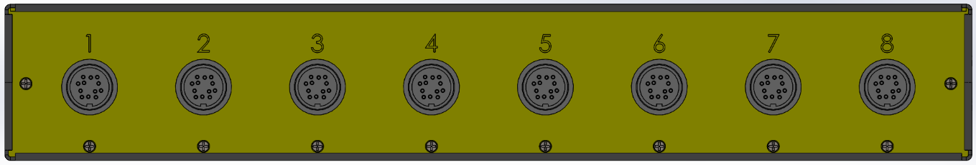

The back panel contains the input ports for attaching the provided sensors. The ports are numbered form 1-8 and correspond to the panels in the data logging software. All sensor ports, sensors and corresponding cables use polarized connectors to ensure proper mating. Every port has 20kOhm input resistance and has the following pinout:

|  |  |  |
| --- | --- | --- |
|  | Pin | Signal |
| A  B  C D E F G H  J K  L  M | Z-  X+  X-  Y+  Y-  N\C  CAL+  Cal-  N\C  Z+  N\C  N\C |

## Front Panel

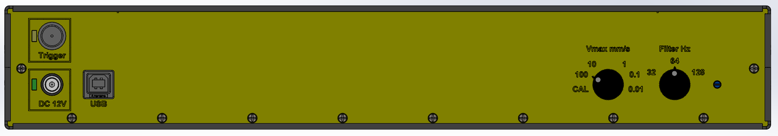

The front panel contains the data, power supply and control interfaces of the data acquisition unit. The two knobs on the right side of the panel control the currently selected amplification and filter cutoff. The amplification controls the maximum recordable velocity before clipping occurs, and it supports 100, 10, 1, 0.1 and 0.01 mm/s with the provided sensors. The CAL setting of the amplification knob enables the internal calibration pulse generator which is used to verify sensor function. Calibration constants will vary if sensors different from the provided are used.

On the left side of the panel are the data and power interface ports. Computer connection is achieved using the USB 2.0 port, which also powers the internal ADC. Amplifiers and filters are powered by the DC 12V plug (5.5mm/2.55mm barrel connector). The nominal power supply voltage is 12V, however the system can support a supply voltage between 9 and 36V. A red/green LED is provided beside the power supply port that monitors the polarity of the provided power supply, it will illuminate green when the power supply meets requirements, and red otherwise.

The trigger input is a 75ohm coaxial BNC connector, and should be used with matching coaxial cable. It is internally isolated from the rest of the circuitry for up to 5kV. While external power is connected to the unit, and the trigger input is not connected to an external trigger, the center pin of the coax is kept at 5V DC through an internal pull up resistor, while the bayonet is at 0V. Triggering condition occurs when the two pins are shorted and 0V appears on the center pin of the connector (with respect to the connector sleeve).

## Fuse Location

In case of a short or overcurrent through the power supply unit, the internal protective fuse will blow to preserve the electronics. The fuse is MINI-ATO 2A rated auto fuse and is located behind the power supply port. To replace the fuse the top lid should be removed by removing the 8 screws (4 on each side of the lid) and the fuse replaced. The following picture shows the location of the fuse:

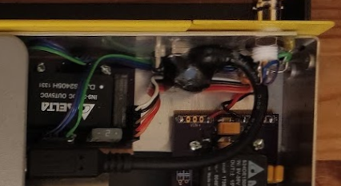

2A MINI-ATO Fuse

## Sensor installation

The kit contains two types of sensor platforms. A short option that fits between the legs of the sensor, and a long option that is larger than the footprint of the sensor. Selection of which platform is be used is depended on the intended application, and available mounting surface. To properly install the sensor unit, the mounting surface (concrete, metal or wood) should be cleaned of all debris and grease. Using the provided leveling gauge, the platform should then be placed on the surface, and using shims it must be leveled. Using fast setting epoxy (or other suitable adhesive) the platform and shims should then be secured in place, by thoroughly covering the bottom of the platform with adhesive and then proper time should be given for the adhesive to set. Once the platform is secured the sensor is mounted on top using the provided brackets, screws and foam insulators.

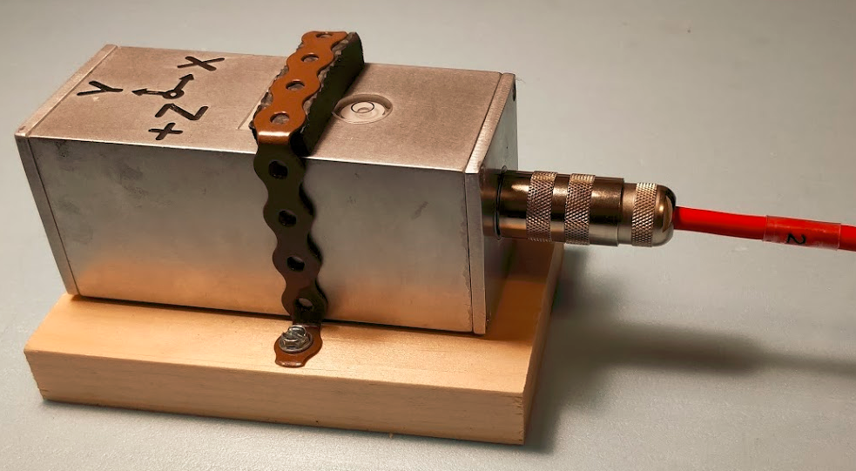

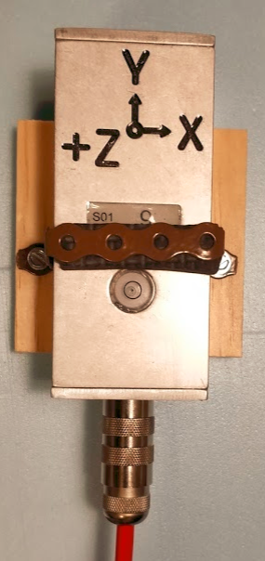

# User Interface

## Main UI Window

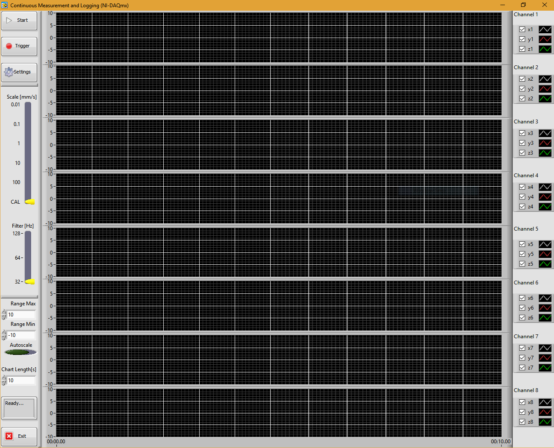

The user interface consists of a control panel situated on the left-hand side of the screen, signal monitoring panels for all 8 channels in the middle of the screen and a legend on the right-hand side. The Legend panels list the names of each channel and allow the turning visualization for each channel/component individually by toggling the provided checkboxes. The signal visualization charts are synchronized with the time axis at the bottom of the screen and have individual amplitude scales for each channel (the scales can be different between channels but not within the components for any given channel). The time axis displays time in seconds, and the amplitude is in mm/s.

By default, the chart displays will fill out right to left with new samples entering from the right. By right clicking each chart the display format can be changed. Under the right click menu auto scales can be toggled individually for each channel, and for either axis: amplitude or time. It also allows the data of that specific chart to be copied to the clipboard in ascii format.

The provided controls are described in the following table:

|  |  |  |
| --- | --- | --- |
|  | Start/Stop button  Force Trigger  Settings button  Currently selected amplification scale in mm/s  Currently selected filter  Max amplitude  Min amplitude  Toggle Auto scale  For all charts  Chart duration  Status Display  Close the application | All controls are disabled until the Start button is pressed, once the system is running the start button will toggle to the stop button, which terminates the current acquisition task and disables other controls.  The trigger can be forced, which will toggle a data recording based on the last setting configured in the settings menu.  Logging configuration can be modified through the Settings window  The current hardware configuration is displayed in the two bar controls, which are read only, as those settings can only be changed using the knobs provided on the DAQ unit.  The displayed chart amplitude will scale according to the currently selected amplification, and it will always be displayed in mm/s.  Any change to the max/min amplitude controls will affect all chart displays at the same time and disable autoscaling for all charts. If it is required scales can be set individually for each chart by clicking the number displayed on the corresponding axis and entering the required values. Autoscaling can be either set individually for each chart by right clicking the chart or the amplitude scale, and then selecting the auto scale option, or at the same time for all charts by clicking the autoscale control.  The length of data displayed at a time can be adjusted for all charts at the same time by using the chart Length control.  The status display will show the current state of the unit, as well as potential error messages relevant to the operation of the unit.  The application can be closed by clicking the exit button, which will be terminating the current acquisition session, and close any open logging files. |

## Configuration Window

The configuration window allows the user to set the data logging path and file name, triggering conditions and the required logging length. All logged data is saved in TDMS format. It can be opened in Microsoft Excel, using the provided plugin. A filename and path are specified using this dialog. Each time a trigger condition occurs, a new filename is created using the provided filename, by concatenating the filename with the timestamp of file creation. Each file will contain a maximum number of samples determined by the specified Record length.

## Trigger Conditions

Four different triggering options are supported:

1. Always Log – As soon as the start button is pressed all data will be recorded to the specified file
2. External Trigger – Logging will start based on the external trigger
3. Based on channel - By specifying a channel number and a threshold, logging will begin as soon as the given channel crosses the specified threshold. Channel numbers go from 0 to 23, where 0 corresponds to x1, and 23 corresponds to z8
4. Forced Trigger – When in either External Trigger or Channel trigger, pressing the Trigger button on the Main UI will start the logging process, bypassing any trigger requirements.

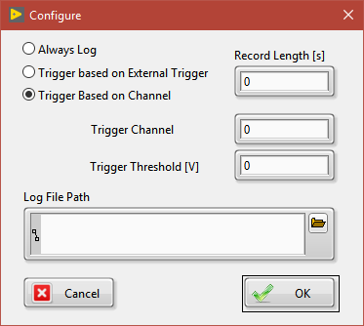

## Software Installation

1. Install LabView Redistributable:

LVRTE2017_f2Patch-64std.exe(64bit) or LVRTE2017_f2Patch.exe (32bit)

1. Install NI-DAQmx Redistributable: NIDAQ1710f0Runtime.exe
2. Install TDMS Excel Plug-In: nitdmexcel_17-0-0.exe
3. Run DynaMate.exe from the DYNAMate folder