DYNAMate Process v1.6

User Manual

Aleksandar Mihaylov

University of Western Ontario

Contents

Description 1

User Interface Description 2

Startup and Operation 3

Configuring sensor information 4

Saving Data 4

Configuring processing parameters 5

# Description

DYNAMate Process is a helper Graphical User Interface used to process the data outputted from the DYNAMate DAQ System. It allows the user to process and investigate TDMS files and includes the following features:

|  |  |
| --- | --- |
| * Visualize the recorded data * Extend the sensors’ frequency range down to 0.5Hz * Produce a smoothed amplitude spectrum * Interactively investigate events in the data using the Zoom and Pan tools provided * Annotate the data and its spectrum using the Data Tips tool | * Generate Displacement and Acceleration waveforms from the recorded Velocity data * Produce PNG images of the data including all annotations * Save All generated waveforms and spectra as an Excel xlsx file |

# User Interface Description

1

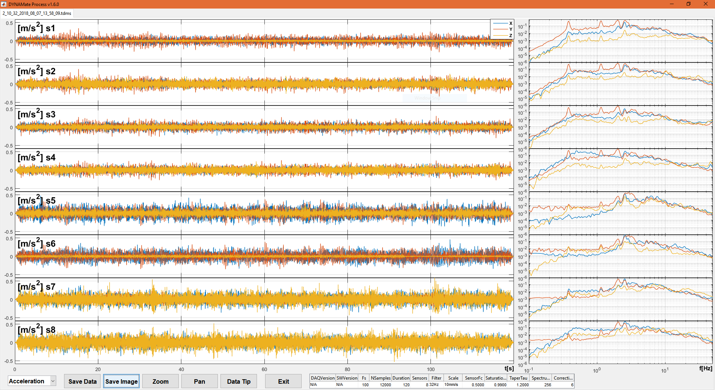

7

12

13

14

16

3

2

4

9

5

10

11

15

6

8

|  |  |  |  |
| --- | --- | --- | --- |
| 1 | Tab control with open files | 9 | Acceleration/Velocity/Displacement selector |
| 2 | Time waveform graphs, one channel per row | 10 | Save Buttons |
| 3 | Frequency graphs, one channel per row | 11 | Zoom button (hold SHIFT to zoom out) |
| 4 | Legend | 12 | Pan button |
| 5 | First channel’s amplitude scale | 13 | Data tip button (hold SHIFT to add more than one annotation) |
| 6 | First channels frequency amplitude scale | 14 | Exit button |
| 7 | Time axis for all channels’ waveforms | 15 | Configuration Table (DAQ and Processing parameters) Read Only |
| 8 | Frequency scale for all channels’ spectra | 16 | Channel Name and Units ([mm/s], [m/s2] or [mm]) |

# Startup and Operation

Upon Startup the software will display a splash screen while loading the MATLAB Runtime in the background. This Runtime is used to facilitate program operation. Once the runtime loads the user will be present with an Open File Dialog. In this dialog, the user can select one or multiple TDMS files for processing. Each file will be processed in turn and will generate one tab in the tabular environment of the GUI. Before data loading begins the program will look for the file “sensor_configuration.txt” in the folder that contains the selected data files. This file describes which channels are in use and what sensors (SensorID, or serial number) are connected to each channel. This allows the software to trim the input data to only the used section of channels and determine sensor parameters that are needed during the response extension processing step. If this file cannot be found or there is an error made in its composition the dialog in Figure 1 will appear. At this point the operator can either exit to fix the sensor_configuration file or accept default settings (All 8 channels active, all sensor elements have the same characteristics, i.e. 4.5Hz corner frequency) and continue with processing.

During loading the user will be asked if sensor frequency response extension is required using the dialog shown in Figure 2. If the user answers “Yes” or “Yes to All”, sensor response correction will be applied to the current file, and in the case of “Yes to All”, to all subsequent files. The opposite holds for selecting “No” and “No to All”. If the correction is requested, then a check for saturation on each channel is performed, as the correction procedure does not function correctly under saturation conditions. If saturation is detected, then a warning dialog will be presented (Figure 3). The warning dialog cannot be closed until loading is complete and shows to the operator the channels (in the format “name_component”) that are suspected of saturation, and to which file those channels belong. Correction will still be performed on the rest of the channels that satisfy saturation criteria.

|  |  |  |
| --- | --- | --- |
| Figure | Figure | Figure |

Once all the processing is complete, indicated by the loading bar present on screen during loading, the UI is generated and presented on the screen. At this point all processing is complete and data analysis can begin. The displayed graphs can be changed between acceleration, velocity and displacement using the provided drop-down menu.

To zoom on a section of the waveform or spectrum, select the zoom tool and drag a box around the section in interest. All graphs will follow the selection and adjust accordingly. It is possible to select horizontal or vertical zoom only by using the context(right-click) menu as seen in Figure 4. To zoom out, hold the SHIFT key and click on the center of the required zoom out operation. Double-clicking will revert the graph to its original display size, which is the view defined at program Startup. Pressing the Zoom button again will disable the tool.

To pan/move the waveform or spectrum, select the pan tool and drag the waveform or spectra. All graphs will follow the new view and adjust accordingly. It is possible to select horizontal or vertical pan only by using the context(right-click) menu as seen in Figure 5. Double-clicking will revert the graph to its original display state. Pressing the Pan button again will disable the tool.

To annotate the graphs, either time waveforms and spectra (as in Figure 6), select the Data Tip tool. Clicking on any chart line will generate an information box containing amplitude and time/frequency data for the selected point. Successive clicks or dragging of the selected point will move the selection along the originally selected line. To generate more than one Data Tip, hold the SHIFT key. Annotation will be removed when switching between Acceleration/Velocity/Displacement views.

|  |  |  |
| --- | --- | --- |
| Figure | Figure | Figure |

# Configuring sensor information

|  |  |
| --- | --- |
| Figure | Sensor configuration can be specified by placing a file named sensor_configuration.txt in the same folder as the data files that are to be loaded. DYNAMate process assumes that all files in that directory share the same sensor configuration, i.e. they are consecutive recording for the same test conditions. The format of this file can be seen in Figure 7. The first column specifies the Channel number, the second column gives that channel a name (best chosen based on sensor location during the test), the third column gives the sensor serial number as written on the sensor, and the last column specifies the order of components for that sensor (leave as is). Data is delimited using Tab, with consecutive Tabs treated as one.  Only channels whose name is not “NA” (Not Available) will be used by the software and are used to signify unused DAQ channels. This also permits, for example, to have sensors attached in Ch 2 and 3, and then 6 and 7, with the software treating them as 4 consecutive channels. |

# Saving Data

Saving data with DYNAMate Process requires the operator to press the Save Data button and select an output filename. To do this, when the save button is pressed a File Save Dialog will appear, which will default to the same directory from which the files are selected, and a filename that matches the filename used to load the data. The extension will be changed from TDMS to XLSX. Pressing the save button for a given tab will save all data (Acceleration Velocity and Displacement) related to the currently displayed tab. Saving will produce “Filename.XLSX” containing 7 sheets: ‘Configuration’ (Configuration Information), 3 sheets for the Acceleration, Velocity and Displacement time waveforms and 3 sheets for the spectra of Acceleration, Velocity and Displacement (with a prefix ‘FFT_’). The configuration sheet contains sensor and processing information as well as some signal statistics (see Figure 8 for details). The data sheets display appropriate sensor names, components and units.

Pressing the Save Image button will produce a Save File Dialog, similar to the Save Data Button, however the filename will be suffixed by the currently displayed data type (Acceleration, Velocity or Displacement). The result is, example FileName_Velocity.PNG, that contains an image of the current working environment, including Data Tips.

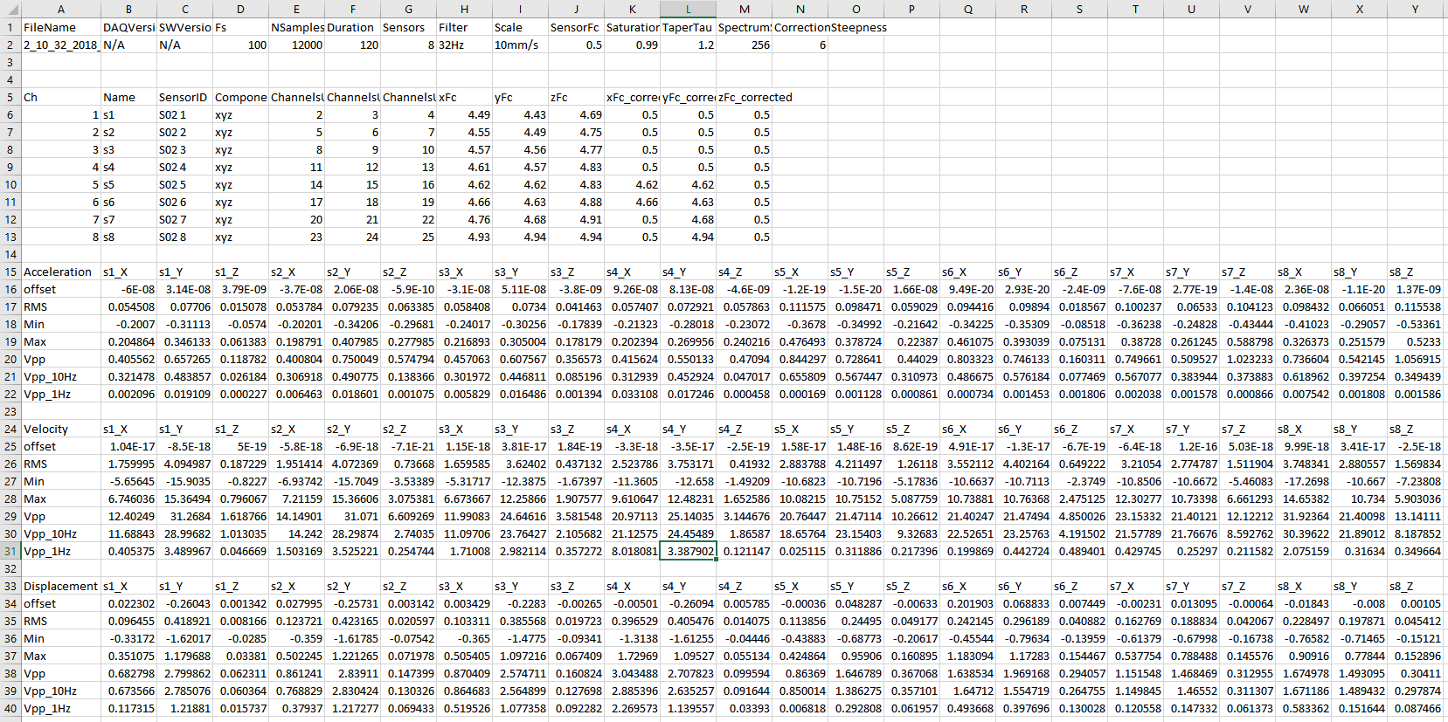

Corrected Sensor Corner Frequencies.   
  
Cells that still display the original frequency indicate the channel had saturation and the response correction was omitted.

Detected Sensor Corner Frequencies

Signal Statistics for Acceleration, Velocity and Displacement processed time waveforms.  
  
Vpp indicates the maximum minus minimum value of the signal over the length of the signal. The value is given for Full, 10Hz and 1 Hz bandwidth versions of the signal

Detected Sensor Configuration

Processing and DAQ configuration

Figure

# Configuring processing parameters

|  |  |
| --- | --- |
| Figure | To configure the processing parameters, edit the DYNAMate.cfg file (Figure 9), located in the Startup directory of the software. The accessible parameters are:   * **taper_tau** – duration as a fraction (0-1) of the total signal length of the taper applied at the beginning and end of the signal. Specify 0 to disable. * **specSmoothN** – sharpness of the window used to smooth the spectrum graphs. Specify 0 to disable. * **corrSteepnes** – drop off rate for the corrected response, equal to (value-2)*5 dB/dec * **SatThreshold** – Saturation detection threshold as a fraction of the scale used to record the data, i.e. at threshold 0.99, and scale selected of 10mm/s any signal with values greater than 9.9mm/s will be considered possibly saturated |