BRUTAL ALARM
ESP32-Based Smart Alarm Clock

Technical Documentation

Platform | Lolin32 Lite (ESP32)
Display | SSD1306 OLED 128x64
Audio | MAX98357A I2S DAC
RTC | DS3231 Real-Time Clock
Language | C++ / Arduino Framework
Version | 1.0

2025

Table of Contents

1. Introduction
The Brutal Alarm is an embedded alarm clock system built on the Lolin32 Lite development board (ESP32 microcontroller). Unlike conventional alarm clocks that can be silenced with a single tap, this device enforces a mandatory 60-second awake period before the user is permitted to stop the alarm. The name reflects the device's core philosophy: no shortcuts to consciousness.
During the mandatory lock period, both the alarm tone volume and the LED brightness escalate progressively from their minimum values to full intensity, creating an increasingly unpleasant sensory experience that motivates the user to fully wake up and remain alert.
The firmware is written in C++ using the Arduino framework for the ESP32. It integrates I2S digital audio, I2C peripherals (RTC and OLED display), PWM-controlled LED, and a debounced multi-button interface all managed through a finite state machine.

2. Project Objectives
The following goals were established at the start of the project:
- Design and build a functional embedded alarm clock on the ESP32 platform.
- Enforce a mandatory 60-second alarm duration that cannot be bypassed by the user.
- Implement progressive volume and LED brightness escalation over the lock period.
- Provide accurate timekeeping via a hardware RTC (DS3231) with battery backup.
- Display current time, alarm time, and alarm status on an SSD1306 OLED screen.
- Allow the user to configure the alarm time through a simple button-based menu.
- Prevent accidental re-triggering of the alarm within the same minute.
- Generate tone output via I2S DAC (MAX98357A) without using the ESP32 internal DAC.
- Write clean, maintainable firmware using a finite state machine architecture.
- Resolve known hardware issues (RTC time-loss during I2S current spikes) with hardware fixes.

3. Hardware Overview

3.1 Component List
The table below lists all hardware components used in the project:

Component | Model / Value | GPIO / Interface | Notes
Microcontroller | Lolin32 Lite | — | ESP32-based dev board with LiPo charger
OLED Display | SSD1306 128x64 | SDA=16, SCL=4 (Wire0) | I2C, address 0x3C
Real-Time Clock | DS3231 (ZS-042) | SDA=33, SCL=32 (Wire1) | Battery backup via CR2032
I2S DAC / Amp | MAX98357A | BCLK=26, LRC=27, DIN=25 | Drives 4-8 Ohm speaker directly
Speaker | 4 Ohm / 3W | Connected to MAX98357A | Standard small speaker
LED | Generic (red/white) | GPIO 2 (PWM) | PWM brightness control
Button MODE | Tactile push button | GPIO 22 (INPUT_PULLUP) | Change state / save / stop alarm
Button HOURS | Tactile push button | GPIO 18 (INPUT_PULLUP) | Increment alarm hour
Button MINS | Tactile push button | GPIO 23 (INPUT_PULLUP) | Increment alarm minute
RTC Battery | CR2032 (3V) | ZS-042 board | Remove charging resistor before use!

3.2 Important Hardware Notes
The DS3231 module commonly sold as 'ZS-042' includes a charging circuit intended for rechargeable LIR2032 cells. Using a non-rechargeable CR2032 battery without modification will cause the battery to overheat and potentially rupture. Before installing a CR2032, the SMD resistor on the charging path must be removed.
WARNING | Remove the SMD charging resistor from the ZS-042 module before inserting a CR2032 battery. Failure to do so may cause battery damage or a safety hazard.

The Lolin32 Lite does not enter programming mode automatically. When flashing firmware, GPIO 0 must be held LOW at the moment the RESET button is pressed. Release GPIO 0 once the upload begins.

4. Wiring Diagram

4.1 Pin Assignment Summary
Lolin32 Lite --> Peripheral
─────────────────────────────────────────────
GPIO 16 (SDA) --> SSD1306 OLED SDA (Wire0)
GPIO 4 (SCL) --> SSD1306 OLED SCL (Wire0)
GPIO 33 (SDA) --> DS3231 RTC SDA (Wire1)
GPIO 32 (SCL) --> DS3231 RTC SCL (Wire1)
GPIO 26 (BCLK) --> MAX98357A BCLK
GPIO 27 (LRC) --> MAX98357A LRC
GPIO 25 (DATA) --> MAX98357A DIN
GPIO 22 --> Button MODE (other pin to GND)
GPIO 18 --> Button HOURS (other pin to GND)
GPIO 23 --> Button MINS (other pin to GND)
GPIO 2 --> LED (with 220-ohm series resistor to GND)
3.3V --> VCC of all peripherals
GND --> GND of all peripherals

4.2 Wiring Schematic
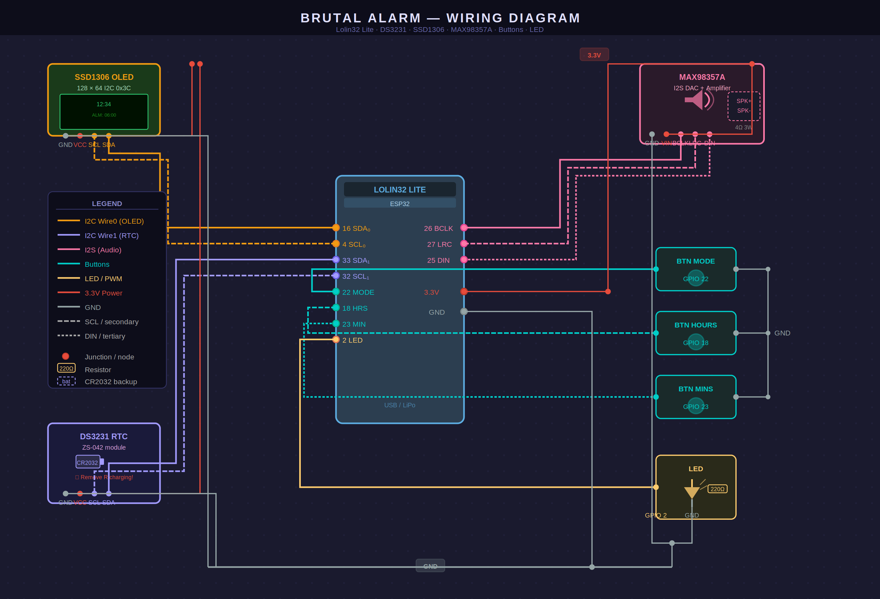

5. Software Architecture

5.1 Overview
The firmware is structured as a single .ino file following the Arduino execution model: a setup() function that runs once on boot, and a loop() function that executes continuously. The internal logic is divided into clearly separated modules implemented as standalone functions.
The following libraries are used:
- Adafruit SSD1306 — OLED display driver
- Adafruit GFX Library — graphics primitives for the display
- RTClib (Adafruit) — DS3231 real-time clock driver
- ESP32 Arduino core driver/i2s.h — I2S peripheral driver (built-in)

5.2 Global Data Structures
The firmware uses a small set of global variables. The most important are listed below:
Variable | Type | Purpose
state | SystemState (enum) | Tracks which FSM state is active
alarmHour / alarmMinute | uint8_t | Stores the configured alarm time
alarmStartMs | uint32_t | Timestamp (ms) when alarm was triggered
alarmFired | bool | Prevents re-triggering within the same minute
tonePhaseCounter | uint32_t | Continuous phase accumulator for tone generation
btnMode / btnHours / btnMins | Button (struct) | Debounce state for each button
pressedMode / pressedHours / pressedMins | bool | Single-event flags set by debounce logic

6. State Machine

6.1 States
The system operates as a three-state finite state machine (FSM). The active state determines which logic runs during each loop() iteration.

State | Description
STATE_NORMAL | Idle state. Displays current time and alarm time. Monitors for alarm trigger condition. Pressing MODE enters setting mode.
STATE_SETTING | Alarm configuration mode. HOURS increments the alarm hour, MINS increments the alarm minute, MODE saves and returns to NORMAL.
STATE_ALARM | Active alarm state. Plays escalating tone via I2S, ramps LED brightness, displays countdown. MODE button only works after 60 seconds.

6.2 State Transitions
The transitions between states are driven by button presses and the alarm trigger condition:
- NORMAL → SETTING: MODE button pressed
- SETTING → NORMAL: MODE button pressed (saves alarm time)
- NORMAL → ALARM: current time matches alarm time AND alarmFired == false
- ALARM → NORMAL: MODE button pressed AND lock period (60 s) has elapsed

6.3 State Diagram
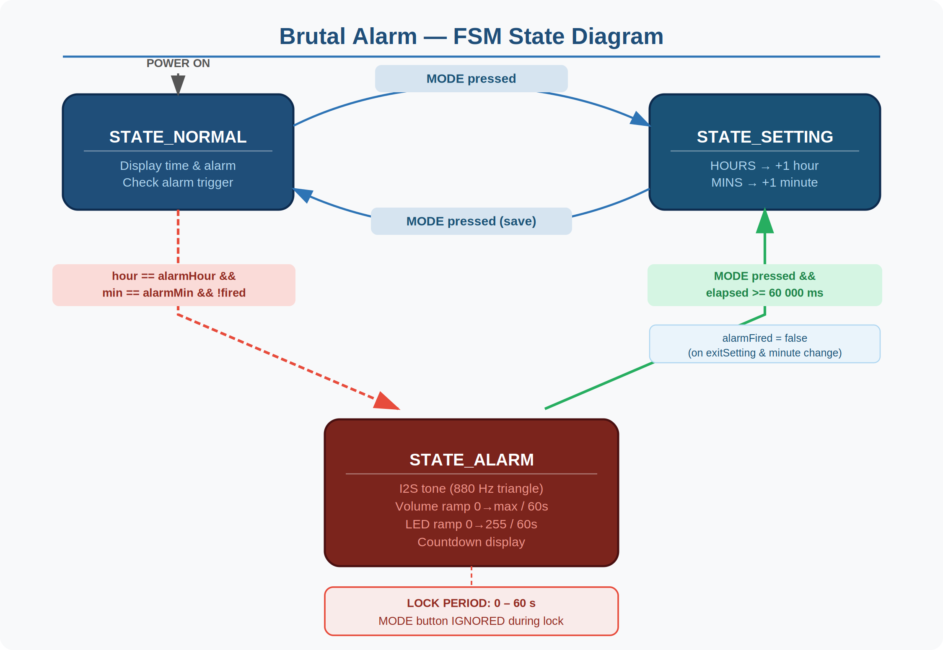
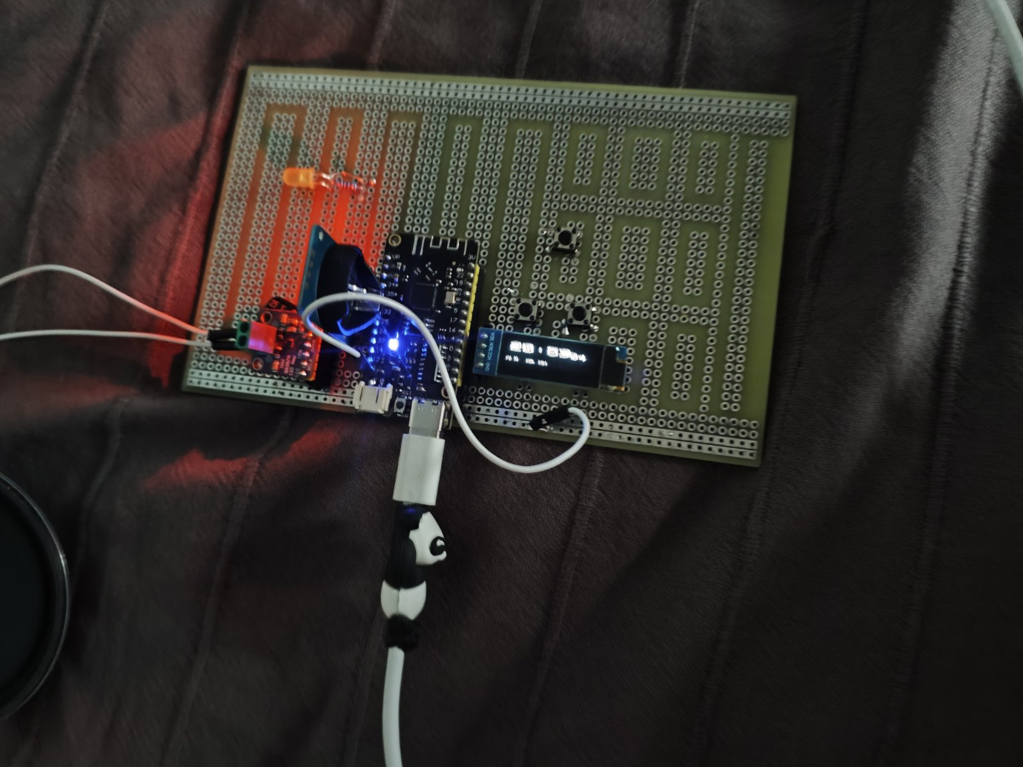

7. Program Flow Diagram
The diagram below illustrates the high-level execution flow of the firmware, from power-on through the main loop:
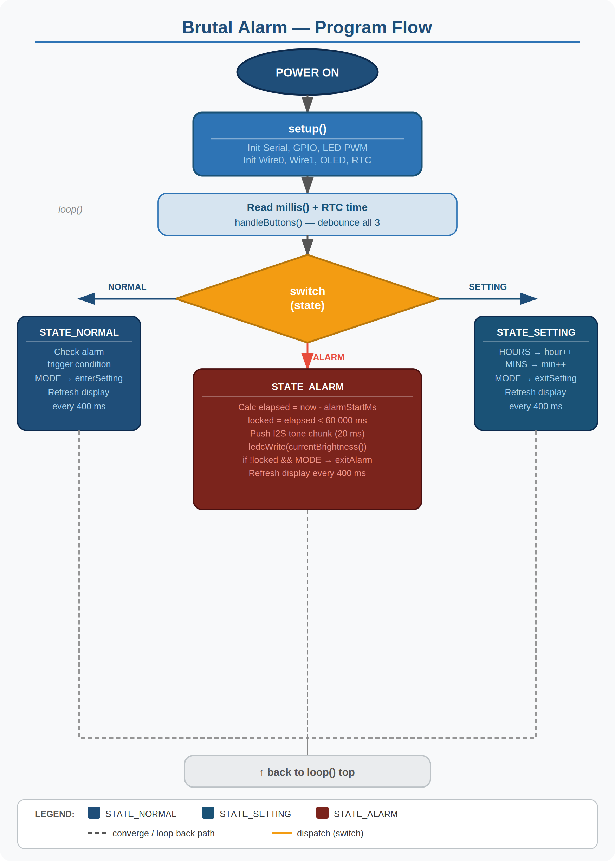
Summary of the main loop flow:
- Read current timestamp from millis() and read current time from DS3231 RTC.
- Call handleButtons() — debounce all three buttons and set press flags.
- Dispatch to the handler for the active FSM state (switch-case).
- In STATE_NORMAL: check alarm trigger condition; refresh display every 400 ms.
- In STATE_SETTING: handle button presses to modify alarm time; refresh display every 400 ms.
- In STATE_ALARM: push a tone chunk every 20 ms; update LED brightness; refresh display every 400 ms.
- Repeat indefinitely.

8. Detailed Module Explanations

8.1 I2C Bus Initialization
The firmware uses two separate I2C buses. This is necessary because the OLED and the RTC are on different GPIO pairs. Wire0 (GPIO 16/4) serves the OLED; Wire1 (GPIO 33/32) serves the RTC. Both buses are initialized at 400 kHz (fast mode) for reliable communication. Using two buses eliminates address conflicts and allows independent timing for each peripheral.

8.2 OLED Display Module
The Adafruit SSD1306 library drives the 128x64 pixel OLED. Display updates are deliberately rate-limited to every 400 ms (DISPLAY_REFRESH_MS) to avoid excessive I2C traffic while the I2S audio subsystem is active.
Three display layouts are used, one per state:
- NORMAL: Large clock (HH:MM) with seconds in the top-right corner; alarm time at the bottom.
- SETTING: Centred alarm time in large font; button legend at the bottom.
- ALARM: 'ALARM!' header; countdown timer or 'MODE = stop' prompt below.

8.3 RTC Module
The DS3231 is a temperature-compensated, battery-backed real-time clock. It communicates over I2C and provides second-resolution time. At startup, the firmware checks the lostPower() flag; if the RTC lost power (battery flat or first boot), it resets to the firmware compilation timestamp.
The CR2032 battery backup prevents time loss during power interruptions. The backup does not supply the main logic — only the RTC oscillator circuit draws from it.
NOTE | If the RTC resets to compile time on every boot, the CR2032 battery is flat or missing.

8.4 I2S Audio Module
The MAX98357A receives audio data over the I2S digital audio interface and amplifies it directly to a speaker. The ESP32's hardware I2S peripheral (I2S_NUM_0) is configured in master transmit mode at 16 kHz, mono, 16-bit.
The I2S driver is installed only when an alarm triggers (initI2S) and uninstalled when the alarm stops (stopI2S). This approach minimises power consumption and avoids DMA buffer noise during normal operation. Audio data is pushed in 20 ms chunks by calling i2s_write() with a non-blocking timeout of 0.

8.5 LED PWM Module
The LED on GPIO 2 is controlled via the ESP32's LEDC (LED Control) PWM peripheral using the ESP32 Arduino core 3.x API: ledcAttach() binds the pin to a PWM channel, and ledcWrite() sets the duty cycle. Brightness is an 8-bit value (0–255) calculated by currentLedBrightness() as a linear interpolation over the 60-second ramp period.

8.6 Button Debounce Module
Hardware buttons produce electrical noise ('bounce') when pressed. The firmware implements software debouncing for all three buttons using the Button struct. A press event is registered only when the stable state transitions from HIGH to LOW and has remained stable for at least DEBOUNCE_MS (50 ms). The event is stored as a boolean flag cleared by the consuming state handler.

9. Explanation of Every Important Function

setup()
Runs once on boot. Initialises serial, configures GPIO modes, attaches LED PWM, starts both I2C buses, initialises the OLED and RTC, and checks for RTC time loss. Does NOT start I2S — that is deferred to alarm trigger time.

loop()
Main execution loop. Reads millis() and the current RTC time, calls handleButtons(), then dispatches to the appropriate state handler via a switch-case on the state variable. All time-sensitive tasks use non-blocking timing based on millis() comparisons.

handleButtons() / updateButton()
handleButtons() calls updateButton() for each of the three buttons. updateButton() implements the debounce logic: if the raw GPIO reading has been stable for at least DEBOUNCE_MS milliseconds and a falling edge is detected (HIGH to LOW), it sets the corresponding pressed flag. The flag is consumed (cleared) by the state handler after processing.

enterAlarm() / exitAlarm()
enterAlarm() sets alarmFired = true (prevents re-triggering), changes the state to STATE_ALARM, records alarmStartMs, resets the tone phase counter, and calls initI2S(). exitAlarm() calls stopI2S(), turns off the LED, and returns to STATE_NORMAL.

enterSetting() / exitSetting()
enterSetting() switches to STATE_SETTING with a short 200 ms delay to absorb the triggering button press. exitSetting() resets alarmFired to prevent an immediate alarm trigger if the saved time matches the current time, and returns to STATE_NORMAL.

initI2S() / stopI2S()
initI2S() configures the ESP32 I2S peripheral with the correct clock, format, and DMA parameters, assigns the physical pins, and zeroes the DMA buffer. stopI2S() zeroes the buffer first (to avoid a click) and then uninstalls the I2S driver to free DMA resources.

pushToneChunk(amplitude)
Generates one 20 ms chunk of a triangle wave at 880 Hz with the given amplitude and writes it to the I2S DMA buffer via i2s_write(). The triangle waveform is computed sample-by-sample using a modular phase accumulator (tonePhaseCounter). Triangle waves are computationally cheap and produce a clear, piercing tone suitable for an alarm.

currentAmplitude()
Returns the current tone amplitude as a linear ramp from TONE_AMP_MIN (200) to TONE_AMP_MAX (16000) over the first 60 seconds of the alarm. After 60 seconds the amplitude is clamped to the maximum.

currentLedBrightness()
Returns the current LED brightness (0–255) as a linear ramp over the first 60 seconds of the alarm. Uses the same timing logic as currentAmplitude() but scales to the 8-bit PWM range.

updateDisplay(now)
Renders the NORMAL state display. Clears the buffer, draws the time in size-3 font, the seconds counter in size-2 font, a horizontal divider line, and the configured alarm time at the bottom. Calls display.display() to push the buffer to the OLED hardware.

10. Alarm Algorithm

10.1 Trigger Condition
The alarm is checked every loop iteration in STATE_NORMAL. It fires when all three of the following conditions are true simultaneously:
- now.hour() == alarmHour — the current hour matches the configured alarm hour.
- now.minute() == alarmMinute — the current minute matches the configured alarm minute.
- alarmFired == false — the alarm has not already fired during this minute.
The alarmFired flag prevents the alarm from re-triggering during the same minute. The flag is cleared when the minute value of the RTC changes.

10.2 Lock Period (60 seconds)
Immediately upon entering STATE_ALARM, the firmware records the current millis() value as alarmStartMs. During each iteration in STATE_ALARM, elapsed time is computed:
uint32_t elapsed = now_ms - alarmStartMs;
bool locked = (elapsed < ALARM_LOCK_MS); // ALARM_LOCK_MS = 60000
While locked == true, any MODE button press is ignored. The display shows a countdown timer. Once the 60-second period expires, the MODE button becomes active and the display changes to show 'MODE = stop'.

10.3 Volume and Brightness Ramp
Both amplitude and brightness are computed as a linear interpolation between their minimum and maximum values over the 60-second ramp period:
// Amplitude
int32_t amp = TONE_AMP_MIN + (TONE_AMP_MAX - TONE_AMP_MIN) * elapsed / ALARM_RAMP_MS;

// Brightness
uint8_t bright = (uint8_t)(255UL * elapsed / ALARM_RAMP_MS);
After 60 seconds, both are clamped to their maximum values (amplitude = 16000, brightness = 255). The ramp and the lock period share the same 60-second duration by design.

10.4 Tone Generation
A triangle wave at 880 Hz is generated in 20 ms chunks and streamed to the I2S peripheral. The phase accumulator (tonePhaseCounter) is never reset between chunks, ensuring a phase-continuous waveform with no clicks or discontinuities during amplitude changes.

11. User Manual

11.1 Powering On
Connect the Lolin32 Lite to a USB power source or a LiPo battery. The OLED will display the current time (HH:MM:SS) and the configured alarm time at the bottom of the screen.

11.2 Setting the Alarm Time
- Press the MODE button once. The display switches to 'SET ALARM' mode showing the current alarm time in large digits.
- Press the HOURS button to increment the hour (wraps from 23 to 0).
- Press the MINS button to increment the minute (wraps from 59 to 0).
- Press MODE again to save the alarm time and return to the clock display.

11.3 When the Alarm Fires
At the configured time, the alarm activates automatically:
- The display shows 'ALARM!' and a countdown timer (seconds remaining in the lock period).
- A 880 Hz triangle tone begins playing through the speaker, starting quietly.
- The LED begins to glow, starting dimly.
Over the next 60 seconds, both the tone volume and the LED brightness increase steadily to their maximum values. The MODE button is disabled during this period.

11.4 Stopping the Alarm
After the 60-second lock period expires, the display changes to show 'MODE = stop'. Press the MODE button once to silence the alarm and turn off the LED. The clock display resumes.
INFO | The alarm will not fire again during the same minute. It will fire again the next day when the clock reaches the same hour and minute.

11.5 Uploading New Firmware
- Connect GPIO 0 to GND (use a jumper wire or press FLASH button if present).
- Press the RESET button briefly.
- Start the upload from the Arduino IDE.
- Once 'Connecting...' appears in the IDE, release GPIO 0.

12. Testing

12.1 Test Cases
# | Test Description | Expected Result | Result
1 | Power on with good RTC battery | Clock displays correct time immediately
2 | Power on with flat RTC battery | Clock resets to compile timestamp
3 | Enter alarm setting mode | Display switches to SET ALARM screen
4 | Increment hour past 23 | Hour wraps to 00
5 | Increment minute past 59 | Minute wraps to 00
6 | Save alarm time with MODE | Returns to clock, alarm time updated
7 | Alarm trigger at set time | Sound and LED activate simultaneously
8 | Press MODE during lock period | Button press ignored, countdown continues
9 | Observe volume ramp over 60 s | Volume increases steadily to maximum
10 | Observe LED ramp over 60 s | Brightness increases steadily to full
11 | Press MODE after lock period | Alarm stops, LED off, clock resumes
12 | Verify alarm does not re-fire | No second alarm in the same minute
13 | I2C OLED during alarm | No display artefacts or freezes during alarm
14 | RTC time retention after power cut | Time correct after reconnecting power

12.2 Known Issues and Resolutions
- RTC time loss during I2S operation: resolved by installing a CR2032 battery and removing the SMD charging resistor on the ZS-042 module.
- ESP32 Arduino core 3.x API breaking change: ledcSetup/ledcAttachPin replaced by ledcAttach/ledcWrite. Code updated accordingly.
- Button debounce flickering at 10 ms threshold: resolved by increasing DEBOUNCE_MS to 50 ms.

13. Conclusion
The Brutal Alarm project successfully demonstrates the integration of multiple hardware peripherals on the ESP32 platform within a coherent firmware architecture. The finite state machine approach provided a clean separation of concerns, making the code maintainable and straightforward to debug.
Key engineering challenges encountered during development included managing two independent I2C buses, adapting to the breaking API changes in ESP32 Arduino core 3.x, preventing RTC time loss caused by current spikes from the I2S peripheral, and implementing phase-continuous tone generation with dynamic amplitude.
All challenges were resolved. The resulting device meets all project objectives: it enforces a 60-second mandatory alarm period, provides progressively escalating audio and visual stimulus, accurately tracks time via the DS3231 RTC, and offers a simple user interface for alarm configuration.
Possible directions for future development include:
- Adding persistent storage (NVS or EEPROM) to retain the alarm time across power cycles.
- Implementing multiple alarm slots with day-of-week scheduling.
- Adding Wi-Fi NTP time synchronisation as a primary timekeeping source.
- Replacing the triangle wave with a more complex alarm sound generated from stored WAV data in SPI flash.
- Adding a snooze function with a configurable penalty.

14. References
- Espressif Systems. ESP32 Technical Reference Manual. https://www.espressif.com/sites/default/files/documentation/esp32_technical_reference_manual_en.pdf
- Espressif Systems. ESP32 Arduino Core Documentation. https://docs.espressif.com/projects/arduino-esp32/
- Adafruit Industries. Adafruit SSD1306 Library. https://github.com/adafruit/Adafruit_SSD1306
- Adafruit Industries. RTClib. https://github.com/adafruit/RTClib
- Maxim Integrated (Analog Devices). DS3231 Datasheet. https://www.analog.com/media/en/technical-documentation/data-sheets/ds3231.pdf
- Maxim Integrated. MAX98357A Datasheet. https://www.analog.com/media/en/technical-documentation/data-sheets/max98357a-max98357b.pdf
- Wemos / LOLIN. Lolin32 Lite Schematic. https://www.wemos.cc/en/latest/d32/d32_lite.html
- Arduino. Arduino Reference — Wire Library. https://www.arduino.cc/reference/en/libraries/wire/

