**Experiment no.9 Reg.no.125010005**

**Date: 19th April 2024 Name: Achyuta.M**

**Simulation of a Two-unit operation**

**Objective:**

To design a two-unit operation involving a reactor and a filter and to calculate the output filtrate amount (kg) and verify the mass balance.

**Software used:**

Superpro designer – Batch operation of Vessel procedure and filter.

**Input:**

|  |  |  |
| --- | --- | --- |
| Component | Initial(kg/batch) | Input(kg/batch) |
| Compound A | 0.00 | 50.01 |
| Compound B | 0.00 | 60.00 |
| Heptane | 0.00 | 147.61 |
| N2 | 2.04 | 0.00 |
| O2 | 0.62 | 0.00 |
| Product C | 0.00 | 0.00 |
| TOTAL | 2.67 | 257.62 |

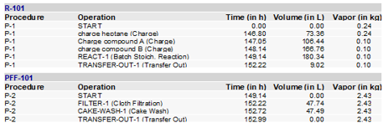

**Procedure:**

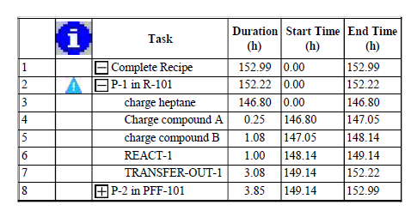

**Flowsheet:**

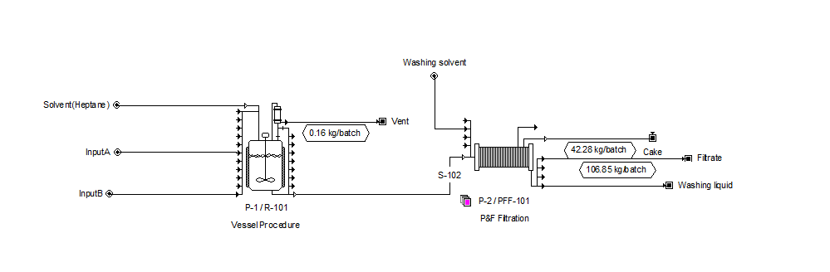

**Results:**

Fig-Gantt Chart-

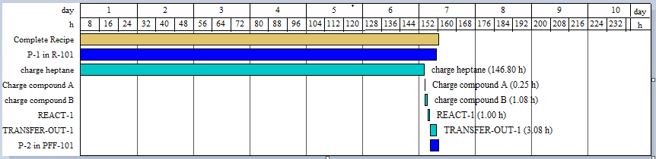

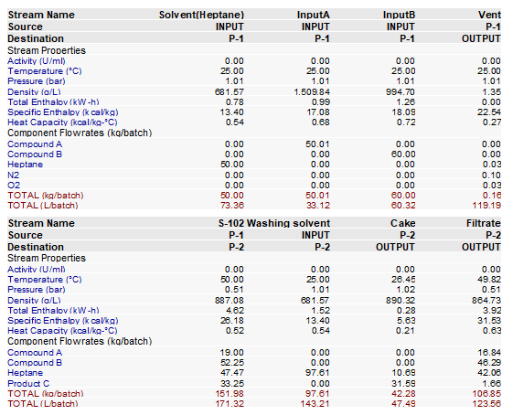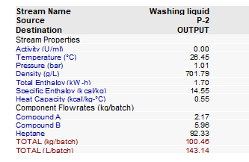

**Verification:**

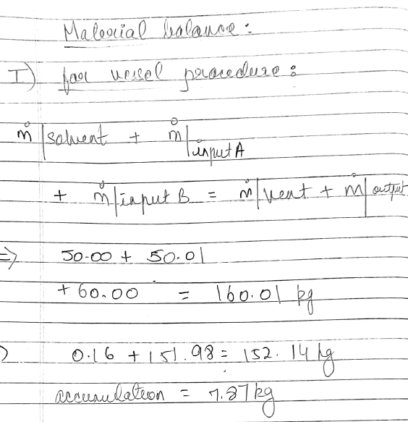

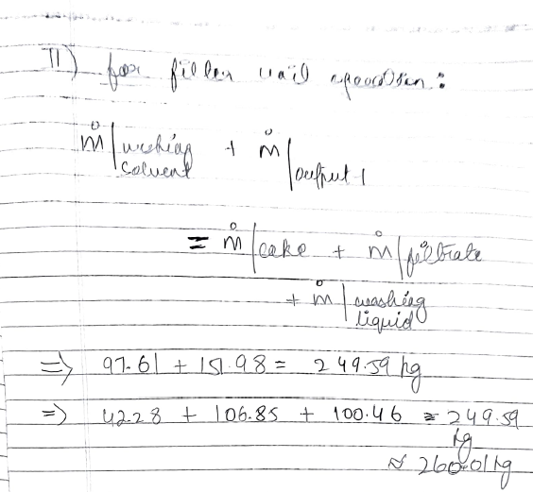

**Specific learning:**

SuperPro software allowed me to connect 2 unit operations, schedule each operation and calculate the final product properties.

This generated accurate data of the output amount and properties, which can allow us to design real-life operations.