**Experiment No. 07 Reg.no.125010005**

**Date:24th March 2024 Achyuta.M**

**Simulation of a Distillation Column**

**Objective**

Develop a simple process flow sheet to estimate distillate and bottom composition of a

distillation column

**Input:**

* Total feed rate: 100 kmol/hr
* Feed temperature: 70 ͦ C
* Feed pressure: 1 atm
* Number of stages: 20
* Feed introduced at stage 10
* Reflux ratio: 3
* Distillate flow rate: 85% of feed flow rate
* Total condenser and reboiler at 1 atm pressure

**Software used:**

Superpro designer- Simulation of continuous Short-Cut distillation

**Flowsheet**

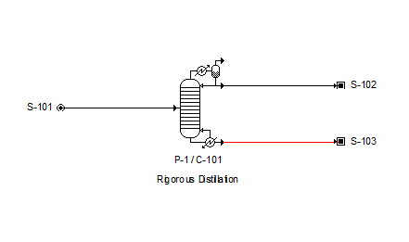

**Results:**

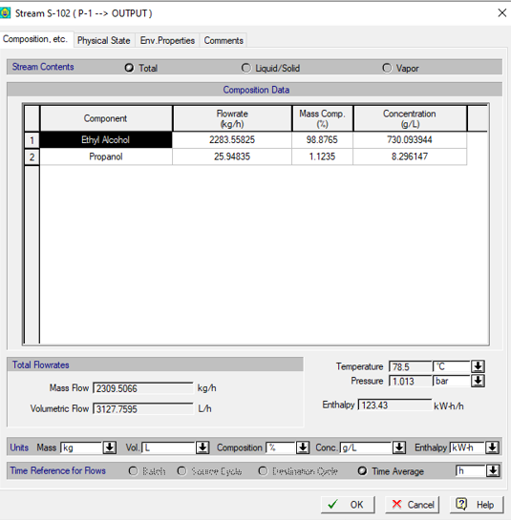

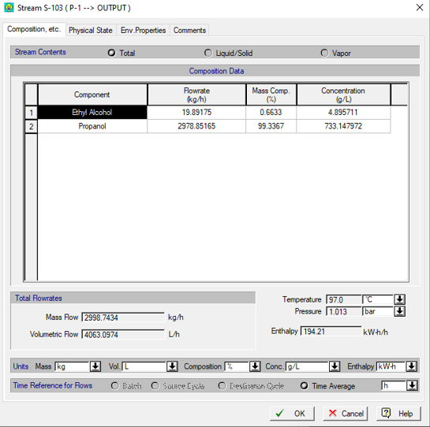

**Verification:**

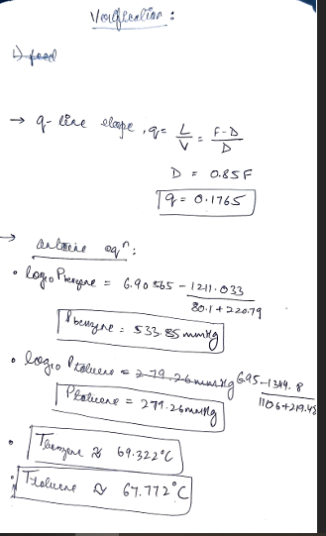

**Specific learning**

SuperPro Designer provides dedicated unit operation modules for distillation columns, allowing users to select the appropriate distillation configuration (e.g., binary, multicomponent, extractive, or azeotropic) based on process requirements.

Accurate representation of the VLE data is crucial for distillation simulation. SuperPro Designer offers options to input experimental VLE data or use thermodynamic models (e.g., Raoult's law, NRTL etc.) to estimate VLE behavior.