**Experiment no.11 Reg.no.125010005**

**Date: 22nd April Name:Achyuta.M**

**Modelling a reactor and a separator**

**Objective:**

To design a simulation using Superpro Designer, a CSTR and a centrifuge and to find the final composition and temperature in the product stream.

3MeOH + Soyabean Oil --------> 3Biodiesel + Glycerin

**Input:**

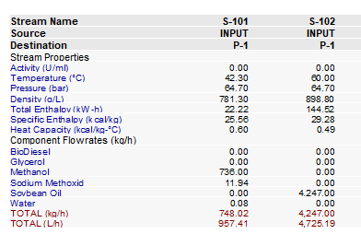

**Flowsheet:**

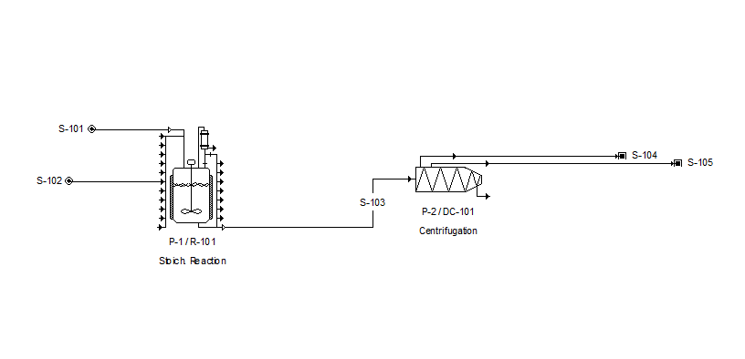

**Results:**

**Output stream 1:**

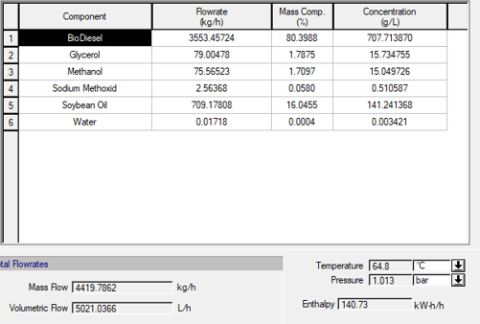

**Output stream 2:**

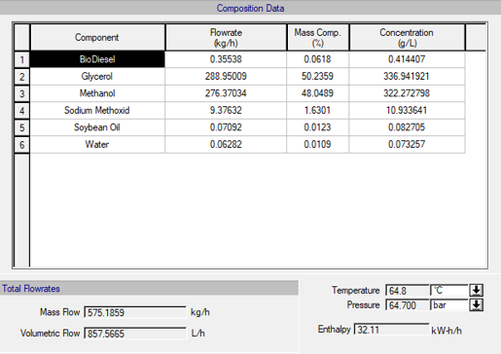

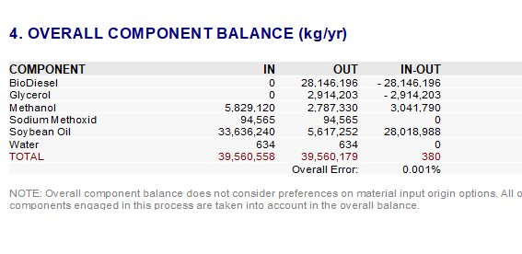

**Verification:**

**Methanol component balance:**

**Input : 5829120 kg/yr**

**Output: 2787330 kg/yr**

**Methanol accumulated= Input- Output = 3041790 kg/yr**

**Specific learning:**

We can now design a simulation where we add a reactor and a separation operation. We can separate it further and purify and obtain Biodiesel and glycerol. We can set real-life physical parameters and test the feasibility of production of biodiesel.