Build & Evaluate a Linear Regression Model (House Price Predictor)

The objective of this project is to build and evaluate a Linear Regression model using the California Housing dataset. The project demonstrates the complete Machine Learning workflow including data loading, exploratory data analysis (EDA), preprocessing, model training, prediction, evaluation, and visualization.
TOOLS AND TECHNOLOGIES USED:-
• Python
• pandas
• NumPy
• scikit-learn
• matplotlib
• seaborn
• Jupyter Notebook
• VS Code

DATASET INFORMATION

The California Housing dataset was used for this project. It contains information about housing districts in California including income, house age, average rooms, population, and location data.

Exploratory Data Analysis (EDA)

EDA was performed to understand the structure and relationships within the dataset. The following steps were completed:

• Checked dataset information and data types
• Verified missing values
• Generated statistical summaries
• Created correlation heatmap
• Visualized house price distribution

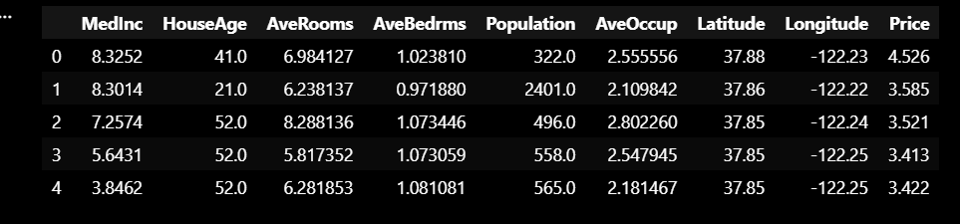

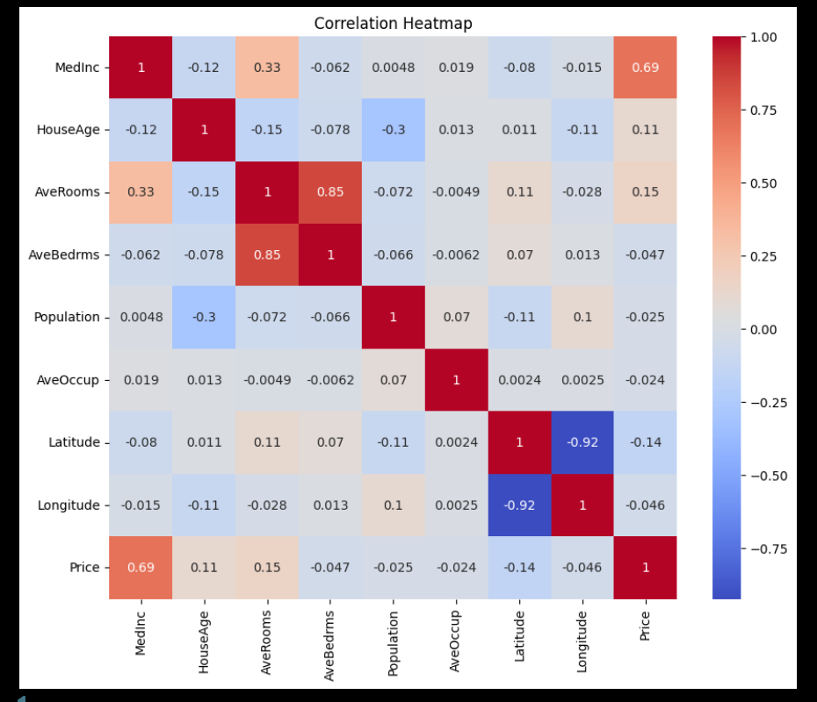

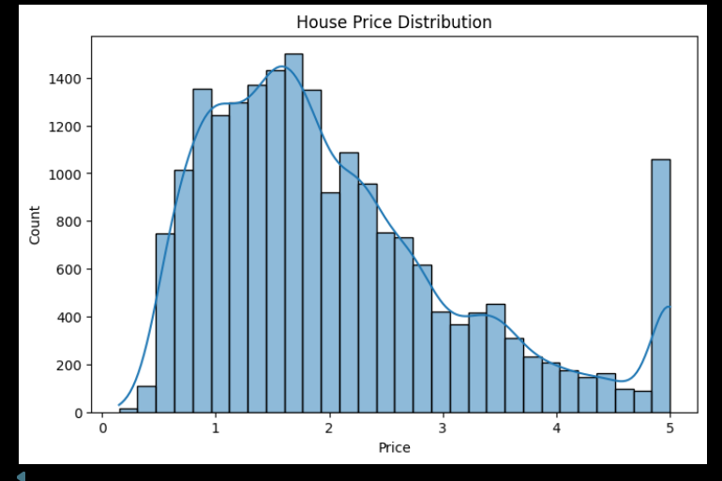

MODEL USED

Linear Regression was used as the Machine Learning model for predicting house prices. The dataset was split into training and testing sets using an 80:20 ratio.

EVALUATION METRICS

MAE: 0.53332001304956555
RMSE: 0.7455813830127763
R² Score: 0.575787706032451

VISUALIZATION:-

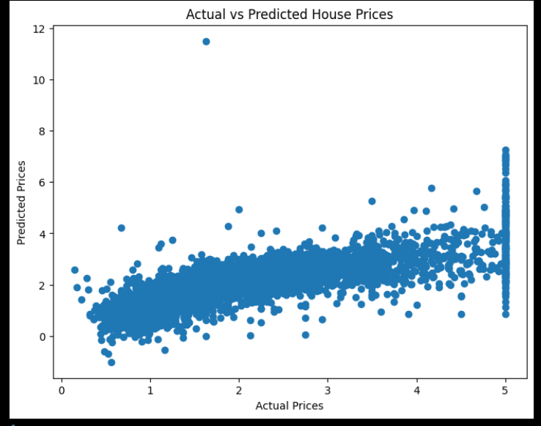

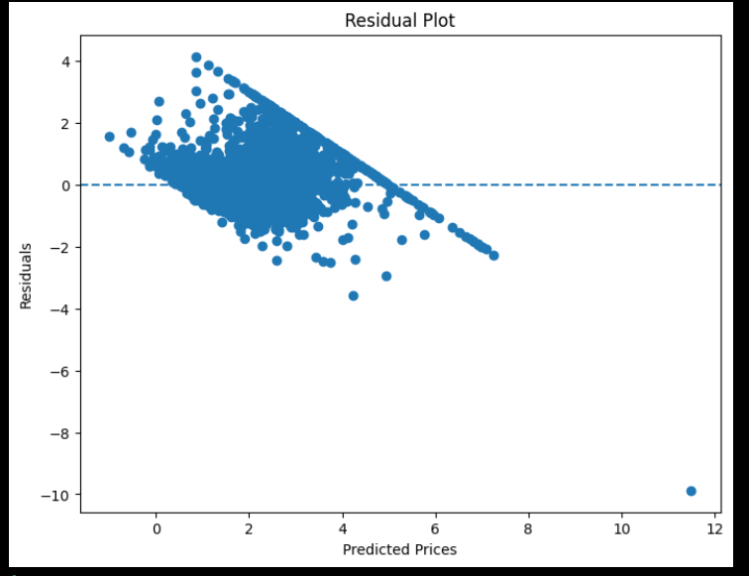

CONCLUSION:-

The Linear Regression model was successfully trained and evaluated on the California Housing dataset. The project demonstrated the complete Machine Learning workflow from data preprocessing to model evaluation. The model achieved satisfactory prediction performance and provided practical understanding of regression analysis.

