Github : <https://github.com/sasi1081/test_py_app>

Docker hub: <https://hub.docker.com/repository/docker/sasi1081/pythonflask/tags?page=1>

Read ME file to explain the approach taken:

**Provisioned Jenkins server in AWS and ran the CI build and test on it**

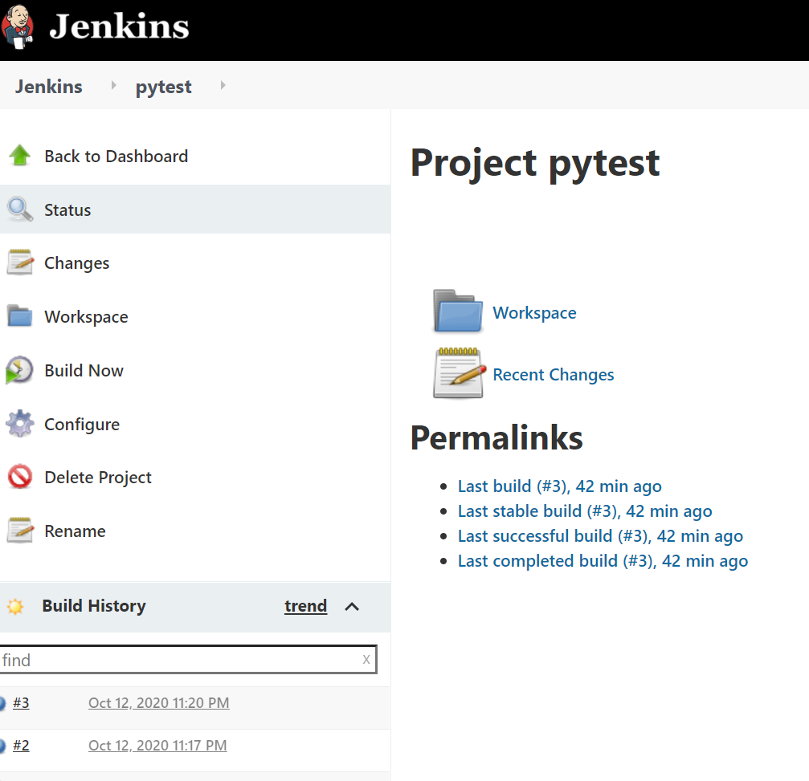

**Provisioned a Docker build job to create the docker image**

docker pull sasi1081/pythonflask:latest

<https://hub.docker.com/repository/docker/sasi1081/pythonflask/tags?page=1>

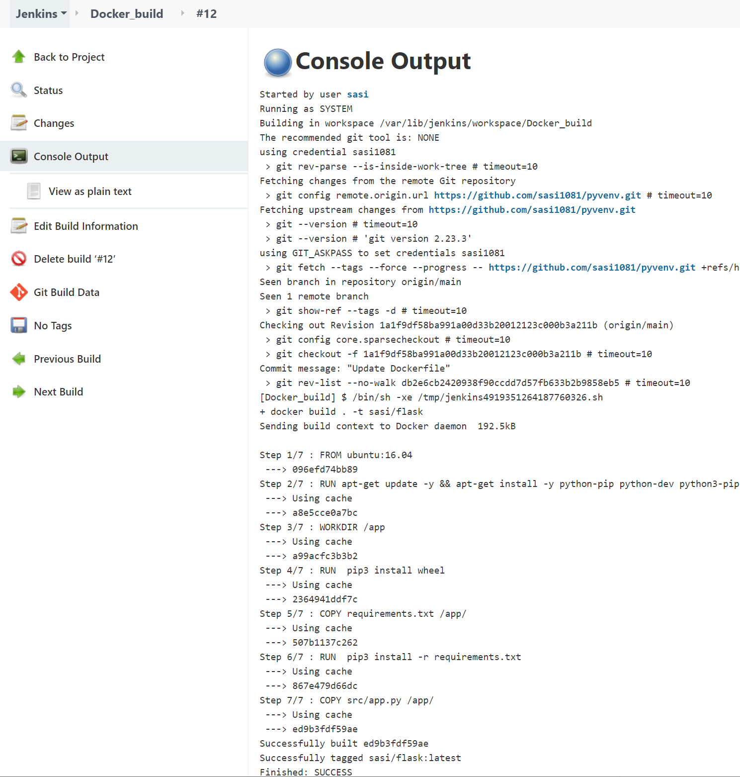

EKS cluster provisioning.

Please note I have used AWS terraform doc to provision the EKS cluster. I have worked in Kubernetes cluster however I have not provisioned EKS via Terraform. Good I learnt a bit while doing this exercise.

<https://github.com/sasi1081/ekstest.git>

**To run the application inside EKS**:

I <https://github.com/sasi1081/test_py_app/blob/main/Deploy_service.yaml>

#aws eks --region region update-kubeconfig --name cluster_name

# git clone <https://github.com/sasi1081/test_py_app.git>

# kubectl create -f [Deploy_service.yaml](https://github.com/sasi1081/test_py_app/blob/main/Deploy_service.yaml)

I have tested and it worked fine as shown below:

