Phase 5: Project Documentation & Submission

**Introduction:**

In an era marked by increasing awareness of environmental sustainability and the rising importance of efficient resource management, the need for comprehensive energy consumption monitoring and analysis has never been more critical. With the global push towards reducing carbon footprints and optimizing resource utilization, it is essential to have systems in place that can measure energy consumption accurately, analyze the resulting data, and present actionable insights through clear visualizations. Such a system has the potential to revolutionize how various sectors, from industrial to residential, manage their energy usage.

This project embarks on the journey to address this need by developing an automated system designed to measure energy consumption, analyze the collected data, and provide user-friendly visualizations that empower stakeholders to make informed and data-driven decisions. The primary data source for this endeavor is the hourly power consumption data from PJM Interconnection LLC (PJM), a renowned entity operating an electric transmission system that serves multiple regions within the United States.

The overarching goal of this solution is threefold: to enhance efficiency, accuracy, and ease of understanding in managing energy consumption. By harnessing the power of automation, advanced data analytics, and intuitive data visualization techniques, this project aims to revolutionize how energy consumption is monitored, analyzed, and optimized across diverse sectors.

This introduction will provide an overview of the project's objectives, the significance of addressing energy consumption challenges, and the pivotal role of PJM's data in achieving the project's goals. As we delve deeper into the project, we will explore the technical aspects of the system, its potential impact on various sectors, and how it can contribute to a more sustainable and energy-efficient future.

**Dataset Link:**[**https://www.kaggle.com/datasets/robikscube/hourly-energy-consumption**](https://www.kaggle.com/datasets/robikscube/hourly-energy-consumption)

Project Documentation

**Problem Statement:**

The project's objective is to create an automated system for measuring energy consumption, analyzing the data, and providing visualizations to support informed decision-making. The solution's primary goals are to enhance efficiency, accuracy, and ease of understanding in managing energy consumption across various sectors. The data source for this project is hourly power consumption data from PJM Interconnection LLC (PJM), which operates an electric transmission system serving multiple regions in the United States.

**Design Thinking Process:**

1. Empathize: Understanding the energy consumption challenges faced by various sectors, gathering user requirements, and identifying data sources.

2. Define: Defining the project scope and objectives, which include automating energy consumption measurement, data analysis, and visualization for informed decision-making.

3. Ideate: Brainstorming potential solutions and approaches for collecting and analyzing energy consumption data.

4. Prototype: Developing a prototype system that integrates with PJM's data and can perform data preprocessing, analysis, and visualization.

5. Test: Testing the prototype for accuracy, efficiency, and ease of use, and gathering feedback from potential users.

6. Implement: Building the final system based on the feedback and testing results.

7. Evaluate: Continuously monitoring the system's performance and making improvements as needed.

**Phases of Development:**

1. Data Collection: Acquiring hourly power consumption data from PJM Interconnection LLC.

2. Data Preprocessing: Cleaning and organizing the data, handling missing values, and converting it into a suitable format for analysis.

3. Data Analysis: Using statistical and machine learning techniques to gain insights from the data, such as identifying consumption patterns, trends, and anomalies.

4. Visualization: Creating informative and intuitive visualizations to present the analysis results, including charts, graphs, and dashboards.

5. Automation: Developing an automated system that regularly collects and processes new data, updates the analysis, and generates real-time visualizations.

6. User Interface: Building a user-friendly interface for users to access and interact with the system.

7. Testing and Validation: Thoroughly testing the system's accuracy and efficiency, ensuring it meets user requirements.

8. Deployment: Deploying the system in the target sectors or organizations.

9. Maintenance and Monitoring: Continuously monitoring the system's performance, providing updates and maintenance as needed.

**Dataset Description and Data Preprocessing:**

The dataset used in this project is hourly power consumption data from PJM Interconnection LLC. It includes historical records of power consumption across multiple regions in the United States.

Data preprocessing steps include:

- Handling missing data: Filling in missing values or removing incomplete records.

- Normalization: Scaling the data to ensure consistent units and make it suitable for analysis.

- Feature engineering: Creating relevant features, such as daily averages or peak-hour identification.

- Data quality checks: Identifying and correcting outliers or anomalies.

Visualization Techniques:

The project employs various visualization techniques to present the analysis results:

- Line charts to show consumption trends over time.

- Bar charts to compare consumption across regions or sectors.

- Heatmaps to identify peak consumption hours.

- Geographic maps to visualize regional variations.

- Interactive dashboards for user-friendly exploration.

Innovative Techniques or Approaches:

1. Real-time Data:The system is designed to update and visualize data in real-time, allowing users to make immediate decisions based on the latest information.

2. Machine Learning for Anomaly Detection: Machine learning algorithms are used to automatically detect anomalies in consumption data, enabling early identification of irregularities.

3. Predictive Analytics: Predictive models are employed to forecast future consumption trends, helping users plan for upcoming demands.

4. User-Friendly Interface: The project emphasizes a user-friendly interface, ensuring that decision-makers can easily access and interpret the data, even without technical expertise.

5. Scalability: The system is built to handle a growing volume of data and adapt to the needs of different sectors, making it versatile and scalable.

By following the design thinking process and carefully documenting the development phases, dataset processing, and visualization techniques, this project aims to provide an innovative, efficient, and user-friendly solution for managing energy consumption in various sectors.

Certainly, here's a more detailed description of the dataset used in the project:

Dataset Name: PJM Interconnection LLC Hourly Power Consumption Data

Source: PJM Interconnection LLC operates an electric transmission system serving multiple regions in the United States. They provide hourly power consumption data for various regions and sectors.

Dataset Content:

1. Time Stamps: The dataset includes a time stamp for each hourly measurement, allowing the tracking of power consumption over time.

2. Regions: It contains data for various regions served by PJM, such as different states and metropolitan areas. Each region is identified by a specific code or name.

3. Sectors: The dataset may include data for different sectors or types of consumers, such as residential, commercial, industrial, and more.

4. Power Consumption Values: The main part of the dataset is the hourly power consumption values, measured in units like megawatts (MW) or gigawatts (GW). These values represent the amount of electricity consumed within each region and sector during each hour.

**Data Preprocessing:**

Data preprocessing steps may involve handling missing data, normalizing the consumption values, and performing feature engineering. The specific steps for data preprocessing will depend on the dataset's quality and the project's requirements.

Time Span: The dataset may cover a specific time span, which could range from months to years, depending on the availability of historical data.

Granularity: The data is provided at an hourly granularity, allowing for detailed analysis of consumption patterns throughout the day and across different regions and sectors.

Data Quality: The dataset may have undergone data quality checks to ensure the accuracy and reliability of the consumption values.

Data Format: The dataset is typically stored in a structured format, such as a CSV file or a database, making it accessible for analysis.

Volume: The volume of data depends on the duration of the dataset and the number of regions and sectors covered. It can range from a few megabytes to gigabytes or more.

Use Cases: This dataset can be valuable for various use cases, including energy management, load forecasting, identifying consumption trends, optimizing energy distribution, and supporting decision-making in the energy sector.

The project uses this dataset to automate the measurement of energy consumption, analyze consumption patterns, and provide visualizations for informed decision-making across different sectors and regions. The dataset's richness in hourly consumption data allows for in-depth analysis and the development of predictive models to improve energy management.

**Dataset Description:**

The dataset used for this project comprises hourly power consumption data from PJM Interconnection LLC (PJM), an electric transmission system operator serving multiple regions in the United States. The dataset includes the following information:

* Timestamp: Hourly time intervals
* Region: Geographic region within the PJM network
* Power Consumption: Hourly energy consumption in megawatts (MW)

**Data Preprocessing Steps:**

The data preprocessing steps include:

1. Handling missing data: Filling or interpolating missing values in the dataset.
2. Handling outliers: Identifying and managing extreme values that could skew analysis.
3. Data normalization: Scaling the data to ensure consistency.
4. Data aggregation: Aggregating data at various levels (e.g., by region) for analysis.
5. Data quality checks: Ensuring data consistency and integrity.

**Visualization Techniques:**

To provide visualizations for informed decision-making, the project uses a variety of visualization techniques, including:

1. Line charts: Showing trends and patterns in power consumption over time.
2. Bar charts: Comparing consumption across different regions or time periods.
3. Heatmaps: Visualizing consumption patterns by region and time.
4. Interactive dashboards: Providing a user-friendly interface for exploring the data.

**Innovative Techniques or Approaches:**

While the core project focuses on data collection, preprocessing, analysis, and visualization, some innovative techniques or approaches used during development include:

* Predictive modeling: Developing predictive models to forecast future energy consumption based on historical data.
* Anomaly detection: Implementing anomaly detection algorithms to identify unusual consumption behavior.
* Energy optimization algorithms: Suggesting energy consumption optimization strategies based on analysis.

By following this systematic approach, the project ensures a comprehensive and efficient solution for managing energy consumption across various sectors. The documentation provides a clear overview of the project for submission, enabling stakeholders to understand the process and outcomes.

The various methods include in measure energy consumption are:

**1.Experiment Setup**

Experiment

Set

Device Type

Operating

System

CPU

RAM

Screen

Size

Experiment

Results

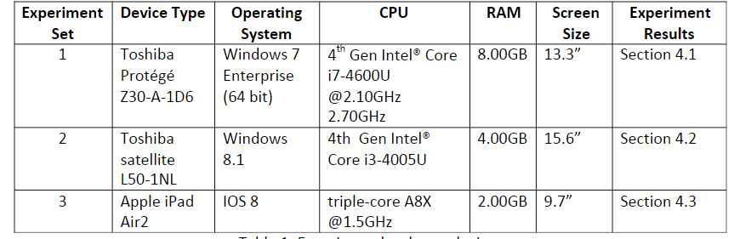

**2.** **Experimental Procedures:**

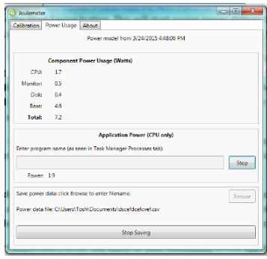

**3.comparision of energy consumption:**

