AURORA HIGHER EDUCATION AND RESEARCH ACADEMY
(Deemed to be University) · Bhongir, Yadadri - 508116
SCHOOL OF ENGINEERING
DEPARTMENT OF ARTIFICIAL INTELLIGENCE & DATA ENGINEERING
――――――――――――――――――――――――――――――――――――――――――――――――
LABORATORY REPORT
Lab 1: Node.js and Express Server
Course: Backend Development Fundamentals · Year II Term II · Aurora
Faculty: Joel Prashanth D

Student Name: | Sasidhar Reddy
Section / Branch: | AIDE-313-2B / Artificial Intelligence & Data Engineering
GitHub Repository: | https://github.com/sasi9603-hack/BACKEND_AIDE_SASIDHARREDDY
Submission Folder: | lab-01/

CERTIFICATE
This is to certify that the lab report for "Lab 1: Node.js and Express server" has been completed and submitted by Sasidhar Reddy (Section: AIDE-313-2B) in partial fulfillment of the requirements for the laboratory curriculum in Backend Development Fundamentals (Year II Term II) at Aurora Higher Education and Research Academy. This report is an authentic record of bonafide academic work carried out under supervision and guidance.
Date: 30-Oct-2026  Place: Bhongir | Faculty Signature: __________________  (Joel Prashanth D)

1. Objective
Set up a Node.js project and build a small web server, first with the built-in http module and then with Express. Understand package initialization, dependency management, RESTful routing, status codes, and error handling.
2. Lab Tasks Overview
Task | Requirement / Description
Task 1 | Create project folder, run npm init -y, and explain each field of package.json.
Task 2 | Install Express with npm install express and locate it inside node_modules.
Task 3 | Write a plain server with http.createServer that replies 'Hello' and listen on port 3000.
Task 4 | Rewrite it with Express: const app = express() and app.listen(3000).
Task 5 | Add routes: GET / (welcome text), GET /about (JSON with name and section) and GET /time (current date/time using new Date()).
Task 6 | Return a 404 message for any unknown path.
Task 7 | Open every route in the browser and log which status code each one returns.

3. Task 1: Package.json Fields Detailed Explanation
Executing npm init -y generates package.json. The significance of each field is explained below:
- "name": The unique, lower-case identifier for the package/project (e.g., 'lab-01').
- "version": Current semantic version following MAJOR.MINOR.PATCH format (e.g., '1.0.0').
- "description": A brief, human-readable summary of project purpose and scope.
- "main": The primary entry point executed when the package is required or imported (e.g., 'app.js').
- "scripts": CLI command aliases runnable via 'npm run <script-name>' (e.g., start, dev, start:plain).
- "keywords": Search tags/indexing keywords used if published to the npm public registry.
- "author": Name and contact info of the developer/maintainer ('Sasidhar Reddy').
- "license": Legal terms governing usage and distribution (e.g., 'ISC', 'MIT').
- "dependencies": Lists runtime packages and required version ranges (e.g., 'express': '^5.3.0').
4. Task 2: Express Installation & Node Modules Inspection
Running 'npm install express' downloads Express and its required dependency tree into the 'node_modules/' directory. Locating Express inside 'lab-01/node_modules/express/' reveals:
• package.json: Contains metadata specifying Express 5.3.0, author TJ Holowaychuk, and main entry 'lib/express.js'.
• lib/ folder: Houses the internal modules including application.js, request.js, response.js, and router/.
• package-lock.json: Generated at the root to lock cryptographic hashes (integrity) and exact dependency versions for reproducible builds.
5. Task 3: Plain HTTP Server (server-http.js)
Implementation of raw Node.js HTTP server utilizing standard library 'http' module:
const http = require("http");
const PORT = 3000;
// Task 3: Plain HTTP server using Node.js built-in http module
const server = http.createServer((req, res) => {
res.writeHead(200, { "Content-Type": "text/plain" });
res.end("Hello");
});
server.listen(PORT, () => {
console.log(`Plain HTTP server running at http://localhost:${PORT}`);
});

6. Tasks 4–7: Express Server Implementation (app.js)
Implementation of Express application incorporating routes, status code logging, dynamic port, and 404 handler:
const express = require("express");
const app = express();
const PORT = process.env.PORT || 3000;
// Logging middleware to log route access and status code (Task 7)
app.use((req, res, next) => {
res.on("finish", () => {
console.log(`[${req.method}] ${req.originalUrl} - Status: ${res.statusCode}`);
});
next();
});
// Task 5: GET / (welcome text)
app.get("/", (req, res) => {
res.status(200).send("Welcome to my Node.js and Express server!");
});
// Task 5: GET /about (JSON with name and section)
app.get("/about", (req, res) => {
res.status(200).json({
name: "Sasidhar Reddy",
section: "AIDE-313-2B"
});
});
// Task 5: GET /time (current date and time using new Date())
app.get("/time", (req, res) => {
res.status(200).json({
currentDateTime: new Date()
});
});
// Task 6: Return a 404 message for any unknown path
app.use((req, res) => {
res.status(404).send("404 - Page Not Found");
});
// Task 4: Rewrite it with Express: const app = express() and app.listen(3000)
app.listen(PORT, () => {
console.log(`Express server running at http://localhost:${PORT}`);
});

7. Endpoints Verification Table (Task 7)
Method | Route Path | Status Code | Response Description
GET | / | 200 OK | Plain welcome message confirming server operation
GET | /about | 200 OK | JSON object with student Name and Section
GET | /time | 200 OK | JSON object containing ISO timestamp from new Date()
GET | /unknown | 404 Not Found | Catch-all handler returning 404 Page Not Found

8. Output Screenshots
Figure 1: Plain HTTP Server Output (Task 3: http.createServer replying 'Hello' on port 3000)



Figure 2: Express GET / Welcome Route Output (Task 5: Status 200 OK)



Figure 3: Express GET /about Route Output (Task 5: Status 200 OK with JSON details)

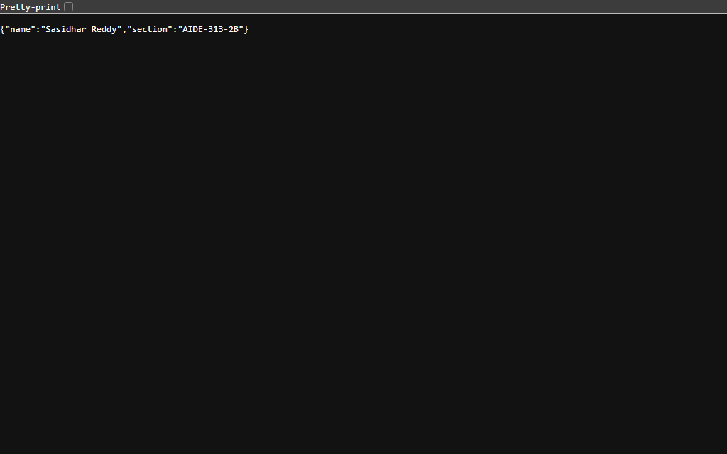

Figure 4: Express GET /time Route Output (Task 5: Status 200 OK with new Date() timestamp)

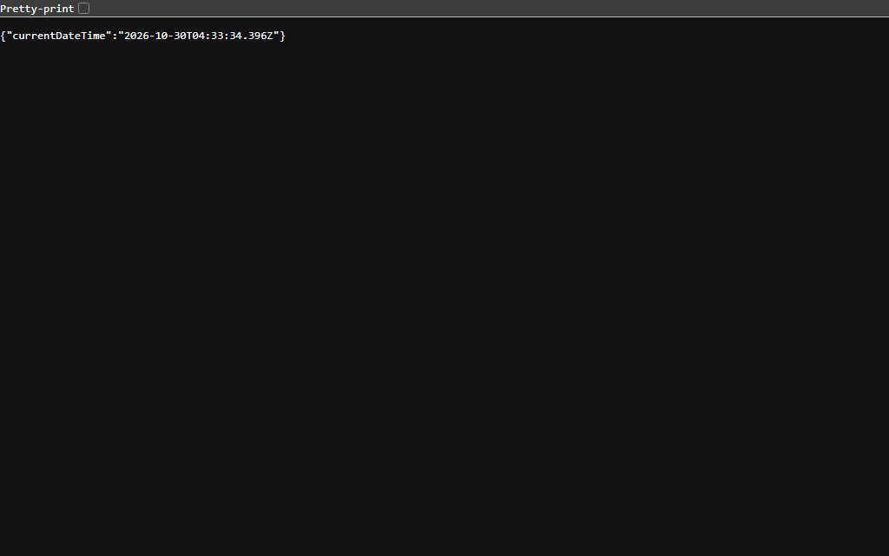

Figure 5: Unknown Route Catch-All 404 Output (Task 6: Status 404 Not Found)



9. Viva Questions & Model Answers
Q1: What is the difference between package.json and node_modules?
• package.json is the project manifest file tracked in Git. It records metadata, scripts, and lists the names and semantic version ranges of direct dependencies. It acts as the blueprint so any developer or deployment server can recreate the environment by executing 'npm install'.
• node_modules is the physical directory where npm downloads, extracts, and stores the actual JavaScript code, binaries, and nested transitive dependencies. It is large and environment-dependent, and must never be committed to Git (excluded via .gitignore).
Q2: What does app.listen do?
In Express, app.listen(port, [callback]) is a convenience wrapper around Node's underlying http.createServer(app).listen(port, callback). It binds the application to the specified TCP port on the host machine and starts an event loop listener waiting for incoming network connections. Once invoked, the server accepts connections and routes HTTP requests through Express middleware and route handlers.
Q3: What do request and response represent?
• req (Request): An instance of http.IncomingMessage (augmented by Express). Represents the incoming HTTP request from the client/browser, containing HTTP method (req.method), URL path (req.url / req.path), headers (req.headers), query parameters (req.query), route parameters (req.params), and request body (req.body).
• res (Response): An instance of http.ServerResponse (augmented by Express). Represents the HTTP response that the server formulates and sends back to the client, providing helper methods to set headers, status codes (res.status(200)), and payload data (res.send(), res.json(), res.end()).
10. Notes: Problems Faced and Solutions
1. Port Conflict (EADDRINUSE)
Problem: Running both plain server and Express server simultaneously on port 3000 caused 'Error: listen EADDRINUSE: address already in use :::3000'.
Solution: Added dynamic environment port binding (process.env.PORT || 3000) and created separate npm run scripts ('npm start' and 'npm run start:plain') to ensure servers are executed sequentially or on configurable ports.
2. Accurate Date Formatting in JSON
Problem: String interpolation with Date() can produce inconsistent time formats across different locales.
Solution: Passed new Date() directly inside res.json({ currentDateTime: new Date() }), which leverages native toJSON() to format ISO 8601 UTC strings reliably.
3. Catch-All 404 Route Interception
Problem: Placing the 404 middleware before endpoint definitions intercepted all incoming requests before matching /about or /time.
Solution: Placed the 404 middleware at the very bottom of the Express middleware pipeline so it only executes when no preceding route matches.

